POSEIDON v46.3
196 Ekran Görselli Kullanım Kataloğu
Screen ID • Domain • Alan/Aksiyon • API • Prototip Görseli
Konu | Kontrollü Değer
Controlled inventory | 196 ekran / 2.316 field-level contract
Kaynak | v46.3 çalışan TR/EN prototip + controlled screen contract
Amaç | Analiz, UX, development ve QA için görsel ekran envanteri
Kullanım | Davranış/alan/trace için 11.01 Traceability; canlı UX için 12.01 Prototype
Statü | CONTROLLED CANDIDATE — UAT/Final Freeze bekleniyor

1. Katalog Kullanım Notu
Bu katalog, 196 ekranın prototip snapshot'larını tek kontrollü envanterde gösterir. Ekran sayısı backend servis sayısı değildir. Alan kuralları, role/state permission, offline, audit ve test trace için Controlled Implementation Traceability Matrix esas alınır.

2. Ekran İndeksi
# | Screen ID | Screen | Domain | Fields | Actions
1 | safety-inbox | Safety Inbox | Safety & Learning | 0 | 4
2 | why-engine | Why is MV Atlas CONDITIONAL? | Regulatory Control | 0 | 1
3 | inspection-memory | Inspection & Vetting Memory | Regulatory Control | 0 | 1
4 | executive-dashboard | Executive Safety & Fleet Dashboard | Role Dashboards | 0 | 4
5 | master-dashboard | Master Command Dashboard | Role Dashboards | 0 | 4
6 | dpa-dashboard | DPA Safety Bridge Dashboard | Role Dashboards | 0 | 4
7 | chief-engineer-dashboard | Chief Engineer Technical Safety Dashboard | Role Dashboards | 0 | 4
8 | chief-officer-dashboard | Chief Officer Operations Dashboard | Role Dashboards | 0 | 4
9 | crew-dashboard | Crew Today Dashboard | Role Dashboards | 0 | 4
10 | auditor-dashboard | Auditor Assurance Dashboard | Role Dashboards | 0 | 4
11 | admin-dashboard | Platform Administration Dashboard | Role Dashboards | 0 | 4
12 | fleet-dashboard | Fleet Overview | Role Dashboards | 0 | 4
13 | vessel-dashboard | MV ATLAS — Vessel Overview | Role Dashboards | 0 | 4
14 | command-center | Global Search & Command Center | Regulatory Control | 0 | 0
15 | workflow-engine | Workflow & Approval Engine | Platform & Administration | 0 | 1
16 | notification-escalation | Notification & Escalation Engine | Operations & Readiness | 0 | 1
17 | data-trust-center | Data Trust Center | Platform & Administration | 0 | 1
18 | management-of-change | Management of Change | Regulatory Control | 4 | 1
19 | offline-conflict-center | Offline Sync & Conflict Resolution | Operations & Readiness | 0 | 1
20 | cyber-readiness-dashboard | Cyber Readiness Dashboard | Role Dashboards | 0 | 0
21 | fatigue-intelligence | Fatigue & Work/Rest Intelligence | Regulatory Control | 0 | 1
22 | safety-barrier-health | Safety Barrier Health | Regulatory Control | 0 | 0
23 | emergency-role-readiness | Emergency Role Readiness | Crew & Competence | 0 | 1
24 | tenant-configuration | Tenant Configuration & Onboarding | Regulatory Control | 0 | 1
25 | system-health | System & Integration Health | Regulatory Control | 0 | 1
26 | production-readiness | Production Readiness Gate | Platform & Administration | 0 | 1
27 | my-safety-impact | My Safety Impact | Safety & Learning | 0 | 0
28 | recognition-review | Recognition Review | Safety & Learning | 6 | 1
29 | safety-culture-pulse | Safety Culture Pulse | Safety & Learning | 0 | 1
30 | confidential-reporting | Confidential / Anonymous Reporting | Safety & Learning | 3 | 1
31 | requirement-master | Requirement Master | Regulatory Control | 10 | 1
32 | applicability-rule-builder | Applicability Rule Builder | Regulatory Control | 8 | 1
33 | operational-control-library | Operational Control Library | Regulatory Control | 0 | 0
34 | verification-gates | Verification Gates | Regulatory Control | 0 | 1
35 | regulatory-source-governance | Regulatory Source Governance | Regulatory Control | 0 | 1
36 | dangerous-goods-response | Dangerous Goods Emergency Response | Regulatory Control | 0 | 1
37 | bulk-cargo-readiness | IMSBC / Grain Cargo Readiness | Regulatory Control | 0 | 1
38 | special-ship-profile | Special Ship / Code Profiles | Regulatory Control | 0 | 0
39 | regulatory-coverage-matrix | Regulatory Coverage Matrix | Regulatory Control | 0 | 2
40 | vessel-compliance-passport | MV ATLAS — Digital Compliance Passport | Regulatory Control | 0 | 4
41 | control-effectiveness | Control Effectiveness Engine | Regulatory Control | 0 | 1
42 | evidence-quality | Evidence Quality Score | Regulatory Control | 0 | 1
43 | regulatory-change-radar | Regulatory Change Radar | Regulatory Control | 0 | 1
44 | future-regulation-sandbox | Future Regulation Sandbox | Regulatory Control | 0 | 1
45 | regulatory-ai-governance | Regulatory & Safety AI Boundaries | Regulatory Control | 0 | 0
46 | ism-complete-map | ISM Complete Product Map | Regulatory Control | 0 | 1
47 | regulatory-corpus | Maritime Regulatory Corpus | Regulatory Control | 0 | 0
48 | cert-document-register | Certificates & Required Documents Register | Regulatory Control | 8 | 1
49 | psc-readiness-2026 | PSC Readiness 2026 | Regulatory Control | 0 | 1
50 | regulatory-change-register | Regulatory Version & Change Register | Regulatory Control | 0 | 1
51 | regulatory-impact | Regulatory Change Impact | Regulatory Control | 0 | 1
52 | customer-value | Customer Success & Value | Fleet Intelligence | 0 | 1
53 | excel-migration | Excel-to-POSEIDON Migration Wizard | Regulatory Control | 0 | 1
54 | pilot-mode | 30-Day Pilot Mode | Fleet Intelligence | 0 | 1
55 | poseidon-today | POSEIDON Today | Core Safety Operations | 0 | 6
56 | my-vessel | MV Atlas | Regulatory Control | 0 | 0
57 | operations-workspace | Operations | Operations & Readiness | 0 | 0
58 | people-workspace | People | Crew & Competence | 0 | 0
59 | technical-workspace | Technical Readiness | Technical Safety | 0 | 0
60 | safety-workspace | Safety & Emergency | Safety & Learning | 0 | 0
61 | compliance-workspace | Compliance | Regulatory Control | 0 | 0
62 | audit-ready | Audit Ready | Regulatory Control | 0 | 1
63 | industry-assurance | SIRE / TMSA Readiness | Regulatory Control | 4 | 5
64 | mobile-operations | Mobile / Offline Operations | Regulatory Control | 0 | 4
65 | integration-hub | Integration Hub | Safety & Learning | 0 | 0
66 | commercial-packages | Commercial Packages | Core Safety Operations | 0 | 3
67 | seven-minute-demo | 7-Minute Buyer Demo | Core Safety Operations | 0 | 1
68 | production-home | Operational Command Home | Operations & Readiness | 8 | 6
69 | regulatory-library | Compliance Center | Regulatory Control | 8 | 6
70 | isps-security | ISPS Security Control | Regulatory Control | 17 | 6
71 | bwm-compliance | Ballast Water Compliance | Regulatory Control | 19 | 6
72 | colreg-navigation | COLREG Navigation | Operations & Readiness | 21 | 6
73 | loadline-control | Load Line Control | Regulatory Control | 16 | 6
74 | imdg-control | Dangerous Goods Control | Operations & Readiness | 21 | 6
75 | statutory-readiness | Statutory Certificate & PSC Readiness | Regulatory Control | 19 | 6
76 | safety-command | Safety Command | Safety & Learning | 17 | 8
77 | vessel-type-hub | Gemi Tipi Merkezi | Regulatory Control | 0 | 0
78 | tanker-workspace | Tanker Operasyon Alanı | Crew & Competence | 8 | 13
79 | oil-tanker-workspace | Oil / Product Tanker | Operations & Readiness | 8 | 10
80 | chemical-tanker-workspace | Chemical Tanker | Operations & Readiness | 8 | 10
81 | gas-tanker-workspace | Liquefied Gas Tanker | Operations & Readiness | 12 | 9
82 | bulk-workspace | Bulk Carrier Operasyon Alanı | Crew & Competence | 8 | 10
83 | container-workspace | Container Operasyon Alanı | Operations & Readiness | 8 | 10
84 | tug-workspace | Römorkör Operasyon Alanı | Crew & Competence | 8 | 10
85 | fleet-vessels | Fleet & Vessels | Fleet Intelligence | 27 | 6
86 | dpa-bridge | DPA Bridge | Safety & Learning | 17 | 8
87 | masters-command | Master's Command | Safety & Learning | 17 | 9
88 | cargo-applicability | Cargo Applicability Engine | Regulatory Control | 14 | 7
89 | ship-operations | Ship Operations | Technical Safety | 23 | 6
90 | competency-pool | Personel Yetkinlik Havuzu | Crew & Competence | 11 | 13
91 | competency-management | Yetkinlik Yönetimi | Crew & Competence | 23 | 9
92 | crew-competence | Crew & Competence | Regulatory Control | 24 | 6
93 | emergency-readiness | Emergency Readiness | Regulatory Control | 17 | 6
94 | events-learning | Events & Learning | Safety & Learning | 19 | 7
95 | asset-reliability | Asset Reliability | Technical Safety | 23 | 7
96 | controlled-knowledge | Controlled Knowledge | Operations & Readiness | 20 | 6
97 | assurance-review | Assurance & Review | Regulatory Control | 20 | 6
98 | ism-certification | ISM Certification | Regulatory Control | 21 | 6
99 | safety-intelligence | POSEIDON Safety Intelligence | Safety & Learning | 21 | 7
100 | regulatory-control | Regulatory Control Center | Regulatory Control | 21 | 15
101 | regulatory-trace | Regulatory Traceability | Regulatory Control | 21 | 6
102 | applicability | Applicability Engine | Regulatory Control | 21 | 7
103 | evidence-graph | Evidence Graph | Regulatory Control | 21 | 6
104 | ism-requirements | ISM Requirement Library | Regulatory Control | 21 | 8
105 | regulatory-versioning | Regulatory Versions & Change Impact | Regulatory Control | 21 | 7
106 | ism-atomic | ISM Atomic Controls | Regulatory Control | 21 | 8
107 | regulatory-schema | Common Regulatory Schema | Regulatory Control | 21 | 6
108 | solas-control | SOLAS Control Library | Regulatory Control | 21 | 8
109 | solas-chapters | SOLAS Chapter Map | Core Safety Operations | 21 | 6
110 | stcw-control | STCW Control Library | Operations & Readiness | 21 | 8
111 | crew-eligibility | Crew Eligibility Engine | Regulatory Control | 24 | 10
112 | safe-manning | Minimum Safe Manning & Assignment Gate | Regulatory Control | 13 | 9
113 | watchkeeping | Watchkeeping & Rest | Operations & Readiness | 24 | 6
114 | marpol-control | MARPOL Control Library | Core Safety Operations | 22 | 8
115 | environmental-ops | Environmental Operations | Operations & Readiness | 22 | 6
116 | environmental-records | Environmental Records & Evidence | Regulatory Control | 22 | 7
117 | mlc-control | MLC Control Library | Core Safety Operations | 23 | 8
118 | seafarer-welfare | Seafarer Welfare & MLC | Core Safety Operations | 23 | 6
119 | mlc-certification | MLC Certification & DMLC | Regulatory Control | 21 | 6
120 | cyber-control | Cyber Safety Control Library | Regulatory Control | 22 | 8
121 | cyber-readiness | Cyber Readiness | Platform & Administration | 22 | 6
122 | cyber-incident | Cyber Incident Response | Safety & Learning | 22 | 8
123 | unified-regulatory | Unified Regulatory Control Center | Regulatory Control | 21 | 8
124 | auditor-mode | Auditor / Regulatory View | Regulatory Control | 20 | 9
125 | safety-digital-twin | MV Atlas • Safety Digital Twin | Regulatory Control | 17 | 8
126 | command-bridge | Command Bridge | Core Safety Operations | 17 | 12
127 | departure-readiness | Departure Readiness Gate | Regulatory Control | 23 | 9
128 | departure-signoff | Departure Review & Sign-off | Operations & Readiness | 23 | 9
129 | voyage-live | Voyage Live Center | Regulatory Control | 23 | 11
130 | watch-handover | Watch Handover | Crew & Competence | 20 | 7
131 | arrival-readiness | Arrival Readiness Gate | Regulatory Control | 23 | 6
132 | fleet-control-tower | Fleet Control Tower | Safety & Learning | 21 | 8
133 | fleet-risk-clusters | Fleet Risk Clusters | Regulatory Control | 19 | 6
134 | fleet-learning | Fleet Learning | Regulatory Control | 19 | 8
135 | safety-performance | Safety Performance Intelligence | Safety & Learning | 19 | 6
136 | management-governance | Management Governance | Regulatory Control | 20 | 8
137 | management-review | Management Review | Regulatory Control | 20 | 7
138 | pms-command-center | PMS Command Center | Technical / PMS 2.0 | 8 | 6
139 | equipment-hierarchy | Equipment Hierarchy | Technical / PMS 2.0 | 16 | 8
140 | equipment-component-profile | Equipment & Component Profile | Technical / PMS 2.0 | 20 | 10
141 | job-pool | Maintenance Job Pool | Technical / PMS 2.0 | 18 | 9
142 | maintenance-plan | Maintenance Plan | Technical / PMS 2.0 | 20 | 10
143 | work-order-center | Work Order Center | Technical / PMS 2.0 | 14 | 10
144 | work-order-detail | Work Order Detail & Execution | Technical / PMS 2.0 | 24 | 12
145 | running-hours-meter | Running Hours & Meter Readings | Technical / PMS 2.0 | 16 | 8
146 | condition-monitoring | Condition Monitoring | Technical / PMS 2.0 | 18 | 9
147 | spare-parts-catalog | Spare Parts Catalog | Technical / PMS 2.0 | 18 | 9
148 | critical-spares | Critical Spares Readiness | Technical / PMS 2.0 | 14 | 8
149 | maintenance-history | Maintenance History | Technical / PMS 2.0 | 12 | 6
150 | drydock-planning | Drydock Planning | Technical / PMS 2.0 | 18 | 10
151 | reliability-analytics | Reliability Analytics | Technical / PMS 2.0 | 12 | 6
152 | crew-roster | Crew Roster | Crew Operations | 16 | 8
153 | crew-profile | Crew Profile | Crew Operations | 28 | 10
154 | crew-assignments | Crew Assignment & Sign-on/off | Crew Operations | 18 | 10
155 | crew-certificates | Crew Certificates & Endorsements | Crew Operations | 24 | 10
156 | training-position-matrix | Training–Position Matrix | Crew Operations | 18 | 10
157 | crew-rotation-planner | Crew Rotation Planner | Crew Operations | 14 | 8
158 | ocimf-crew-matrix | OCIMF Crew Matrix | Crew Operations | 18 | 8
159 | certificate-command-center | Certificate Intelligence Center | Certificate Intelligence | 10 | 8
160 | survey-planner | Survey Planner | Certificate Intelligence | 18 | 10
161 | renewal-workflow | Certificate Renewal Workflow | Certificate Intelligence | 20 | 10
162 | connector-catalog | Connector Catalog | Integration Hub 2.0 | 14 | 8
163 | integration-mapping | Integration Mapping & Transformation | Integration Hub 2.0 | 18 | 10
164 | integration-events | Integration Event Monitor | Integration Hub 2.0 | 14 | 8
165 | poseidon-copilot | POSEIDON Copilot | Maritime Intelligence | 8 | 8
166 | decision-center | Decision Center | Maritime Intelligence | 14 | 10
167 | recommendation-inbox | Recommendation Inbox | Maritime Intelligence | 12 | 8
168 | mobile-task-center | Mobile Task Center | Mobile / Offline 2.0 | 10 | 8
169 | qr-asset-scan | QR Asset Scan | Mobile / Offline 2.0 | 8 | 6
170 | technical-requisition | Technical Requisition | Technical Supply | 18 | 10
171 | inventory-stock | Inventory & Stock | Technical Supply | 16 | 8
172 | supplier-order-tracking | Supplier / Order Tracking | Technical Supply | 14 | 8
173 | tug-command | Römorkör Komuta Merkezi | Tug Operations | 12 | 8
174 | tug-job-intake | Römorkör İş Talebi / Job Intake | Tug Operations | 18 | 10
175 | tug-job-board | Römorkör İş Panosu | Tug Operations | 14 | 10
176 | tug-job-detail | Römorkör İş Detayı | Tug Operations | 22 | 12
177 | tug-assignment | Römorkör Atama ve Çakışma Kontrolü | Tug Operations | 18 | 10
178 | tug-readiness | Römorkör Operasyon Hazırlığı | Tug Operations | 18 | 10
179 | towage-plan | Römorkaj / Çekme Operasyon Planı | Tug Operations | 22 | 12
180 | towage-risk-briefing | Römorkaj Risk ve Brifing | Tug Operations | 20 | 10
181 | towage-execution | Römorkaj Operasyon Yürütme | Tug Operations | 24 | 14
182 | tug-equipment-readiness | Römorkör Ekipman Hazırlığı | Tug Operations | 18 | 10
183 | tug-crew-readiness | Römorkör Mürettebat Hazırlığı | Tug Operations | 16 | 10
184 | tug-daily-log | Römorkör Günlük Operasyon Defteri | Tug Operations | 14 | 8
185 | tug-operation-history | Römorkör Operasyon Geçmişi | Tug Operations | 10 | 6
186 | noon-report | Noon Report & Daily Position | Operations & Readiness | 20 | 4
187 | deck-daily-log | Deck Daily Log | Operations & Readiness | 18 | 4
188 | engine-daily-log | Engine Daily Log | Operations & Readiness | 20 | 4
189 | fuel-bunker-log | Fuel, Bunker & ROB Log | Operations & Readiness | 22 | 4
190 | port-activity-sof | Port Activity & Statement of Facts | Operations & Readiness | 18 | 4
191 | operational-downtime | Operational Downtime & Loss of Hire | Operations & Readiness | 14 | 4
192 | service-engineer-report | Service & Engineer Report | Technical / PMS 2.0 | 16 | 4
193 | pre-survey-checklist | Pre-Survey Checklist | Certificate Intelligence | 16 | 4
194 | risk-assessment | Risk Assessment Workspace | Safety & Learning | 20 | 4
195 | risk-template-library | Risk Template Library | Safety & Learning | 14 | 4
196 | high-risk-work | Fleet High-Risk Work | Safety & Learning | 12 | 3

3. Görsel Katalog
001 Safety Inbox
Screen ID: safety-inbox | Domain: Safety & Learning | 0 alan / 4 aksiyon
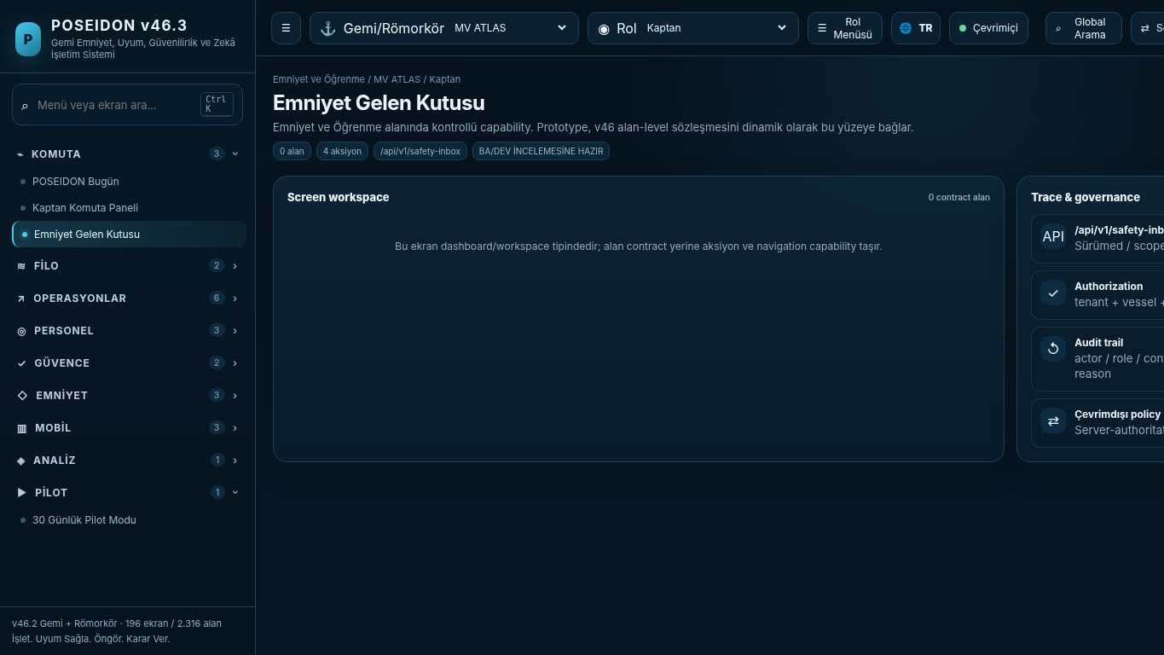
API projection: /api/v1/safety-inbox | Status: READY FOR BA/DEV REVIEW
———————————————————————————————————————————————————————
002 Why is MV Atlas CONDITIONAL?
Screen ID: why-engine | Domain: Regulatory Control | 0 alan / 1 aksiyon
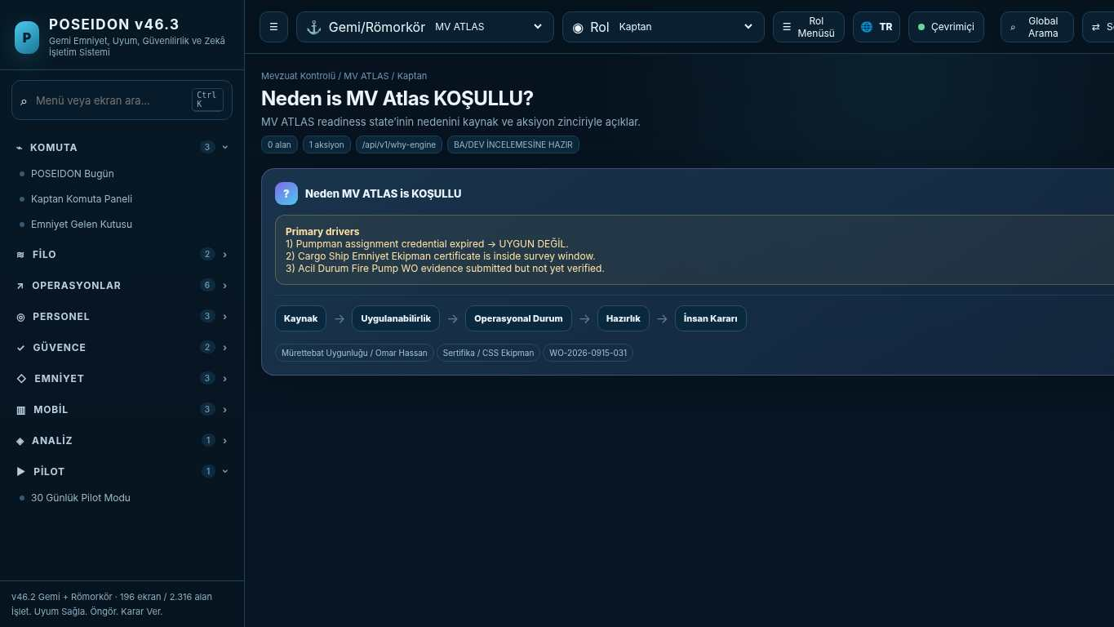
API projection: /api/v1/why-engine | Status: READY FOR BA/DEV REVIEW

003 Inspection & Vetting Memory
Screen ID: inspection-memory | Domain: Regulatory Control | 0 alan / 1 aksiyon
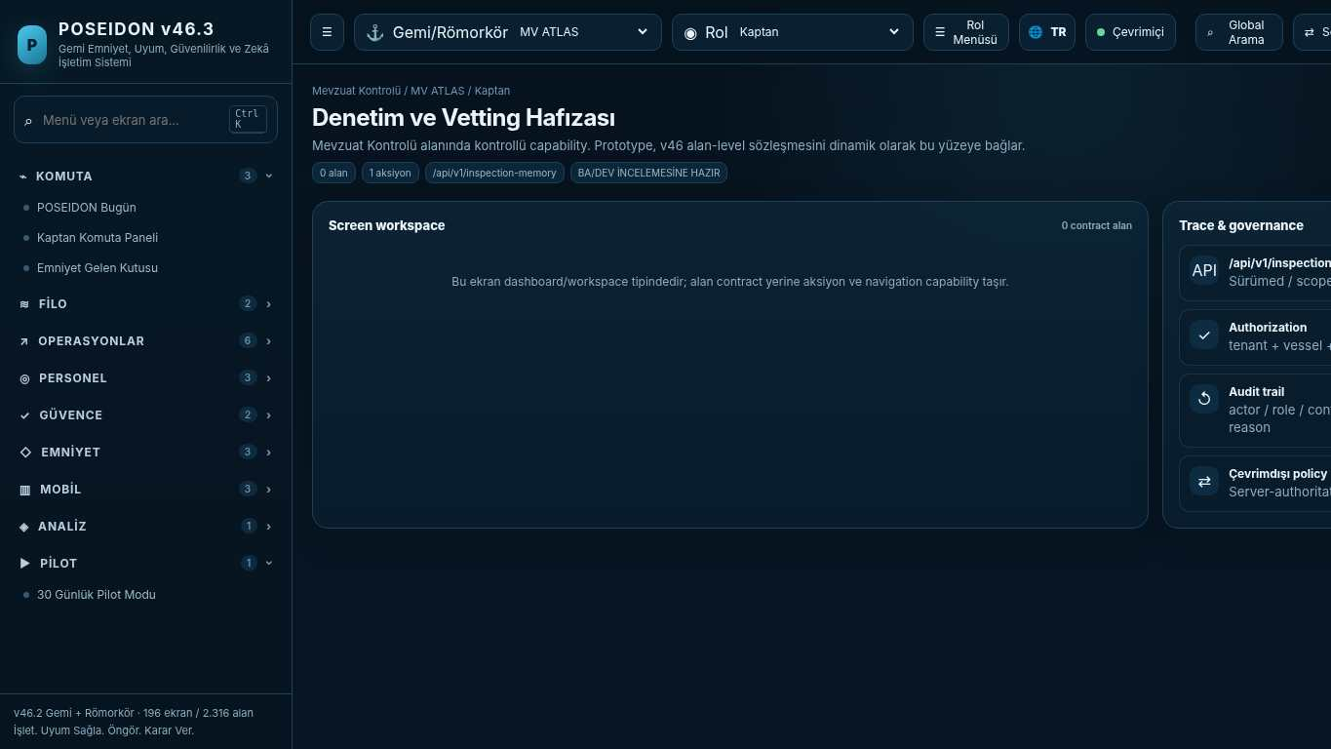
API projection: /api/v1/inspection-memory | Status: READY FOR BA/DEV REVIEW
———————————————————————————————————————————————————————
004 Executive Safety & Fleet Dashboard
Screen ID: executive-dashboard | Domain: Role Dashboards | 0 alan / 4 aksiyon
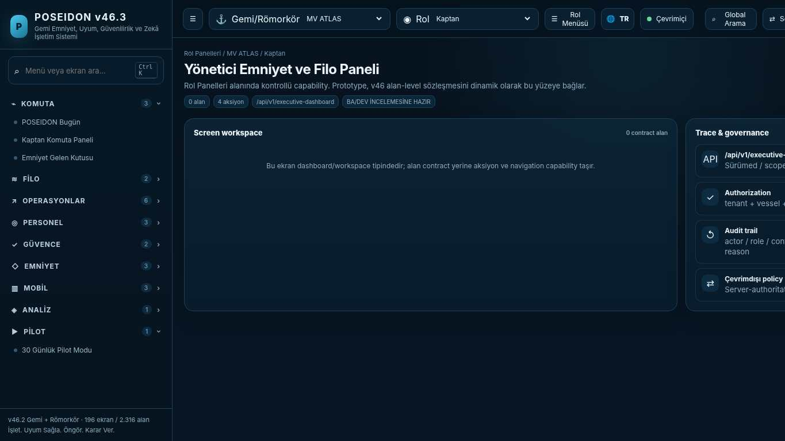
API projection: /api/v1/executive-dashboard | Status: READY FOR BA/DEV REVIEW

005 Master Command Dashboard
Screen ID: master-dashboard | Domain: Role Dashboards | 0 alan / 4 aksiyon
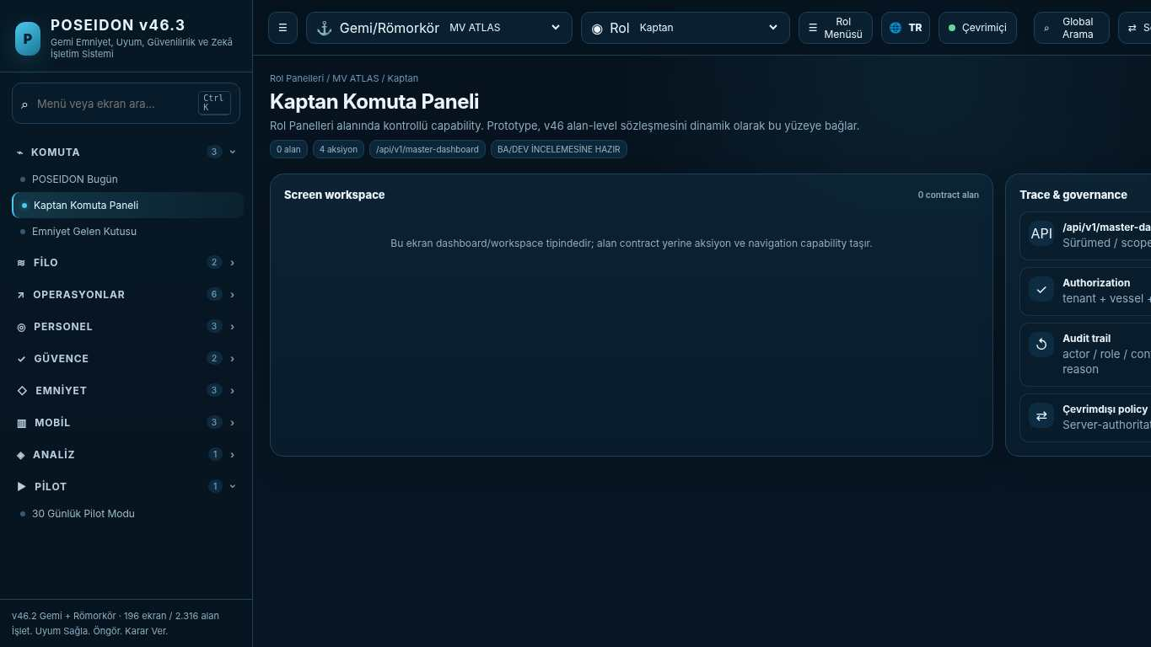
API projection: /api/v1/master-dashboard | Status: READY FOR BA/DEV REVIEW
———————————————————————————————————————————————————————
006 DPA Safety Bridge Dashboard
Screen ID: dpa-dashboard | Domain: Role Dashboards | 0 alan / 4 aksiyon
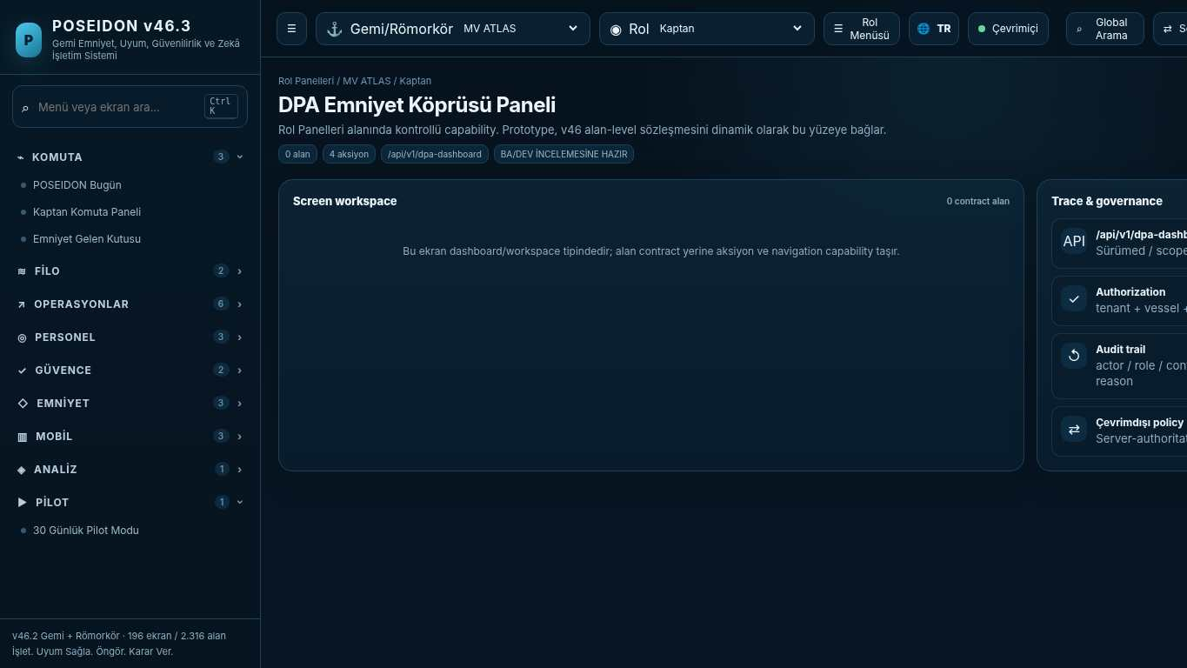
API projection: /api/v1/dpa-dashboard | Status: READY FOR BA/DEV REVIEW

007 Chief Engineer Technical Safety Dashboard
Screen ID: chief-engineer-dashboard | Domain: Role Dashboards | 0 alan / 4 aksiyon
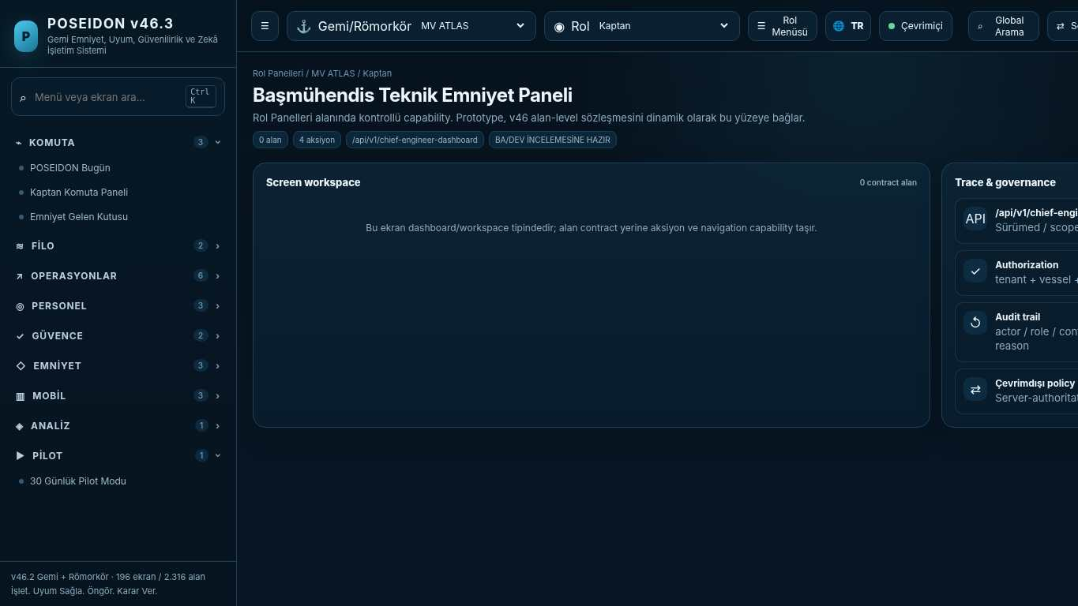
API projection: /api/v1/chief-engineer-dashboard | Status: READY FOR BA/DEV REVIEW
———————————————————————————————————————————————————————
008 Chief Officer Operations Dashboard
Screen ID: chief-officer-dashboard | Domain: Role Dashboards | 0 alan / 4 aksiyon
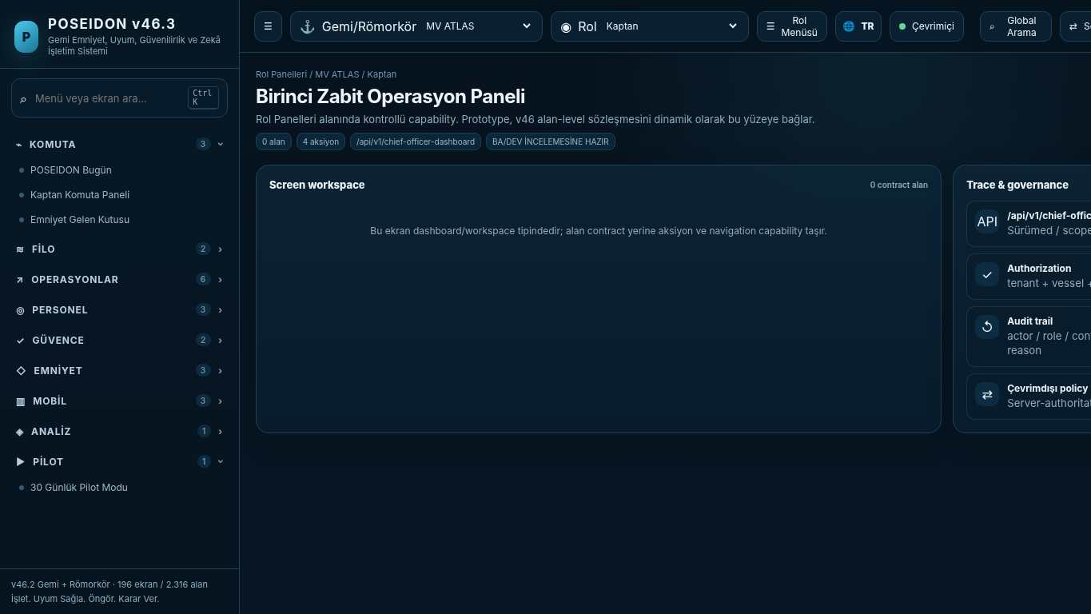
API projection: /api/v1/chief-officer-dashboard | Status: READY FOR BA/DEV REVIEW

009 Crew Today Dashboard
Screen ID: crew-dashboard | Domain: Role Dashboards | 0 alan / 4 aksiyon
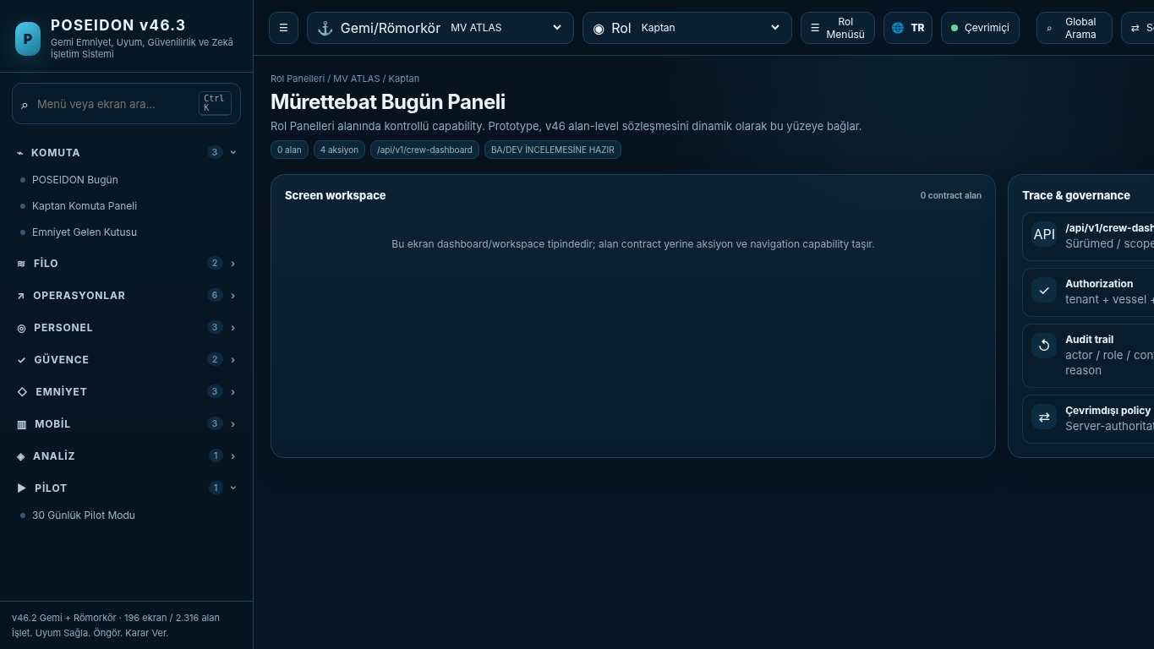
API projection: /api/v1/crew-dashboard | Status: READY FOR BA/DEV REVIEW
———————————————————————————————————————————————————————
010 Auditor Assurance Dashboard
Screen ID: auditor-dashboard | Domain: Role Dashboards | 0 alan / 4 aksiyon
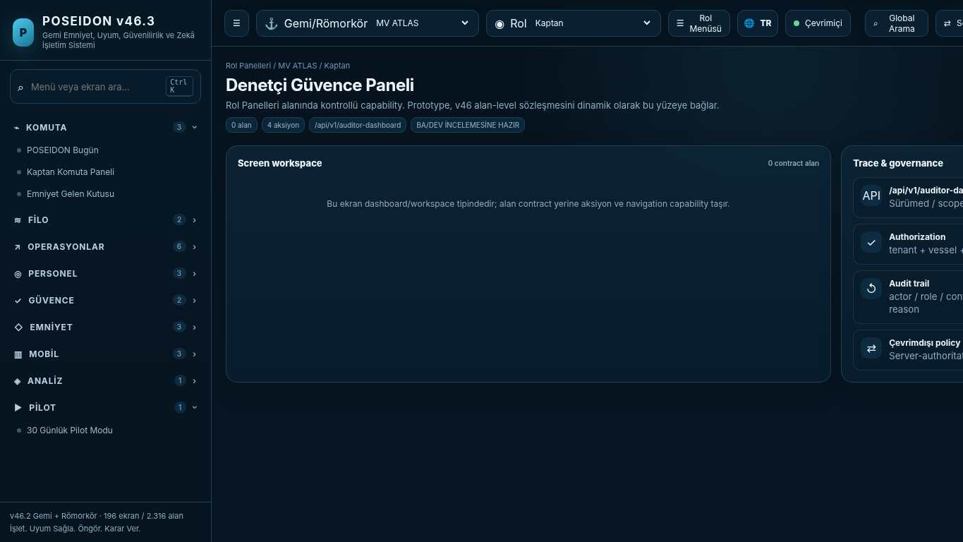
API projection: /api/v1/auditor-dashboard | Status: READY FOR BA/DEV REVIEW

011 Platform Administration Dashboard
Screen ID: admin-dashboard | Domain: Role Dashboards | 0 alan / 4 aksiyon
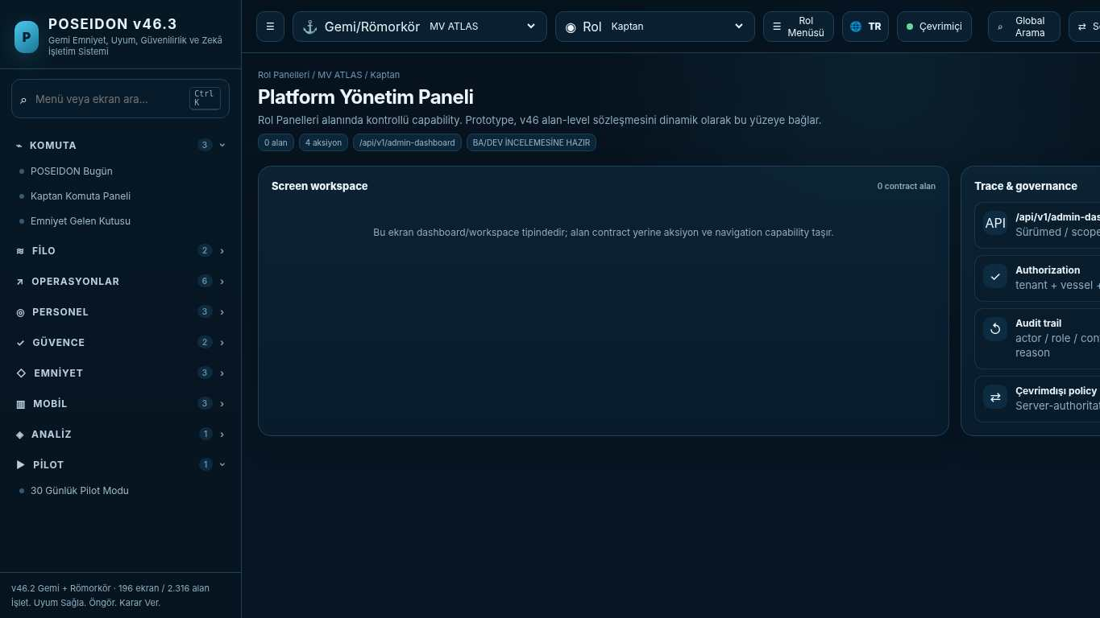
API projection: /api/v1/admin-dashboard | Status: READY FOR BA/DEV REVIEW
———————————————————————————————————————————————————————
012 Fleet Overview
Screen ID: fleet-dashboard | Domain: Role Dashboards | 0 alan / 4 aksiyon
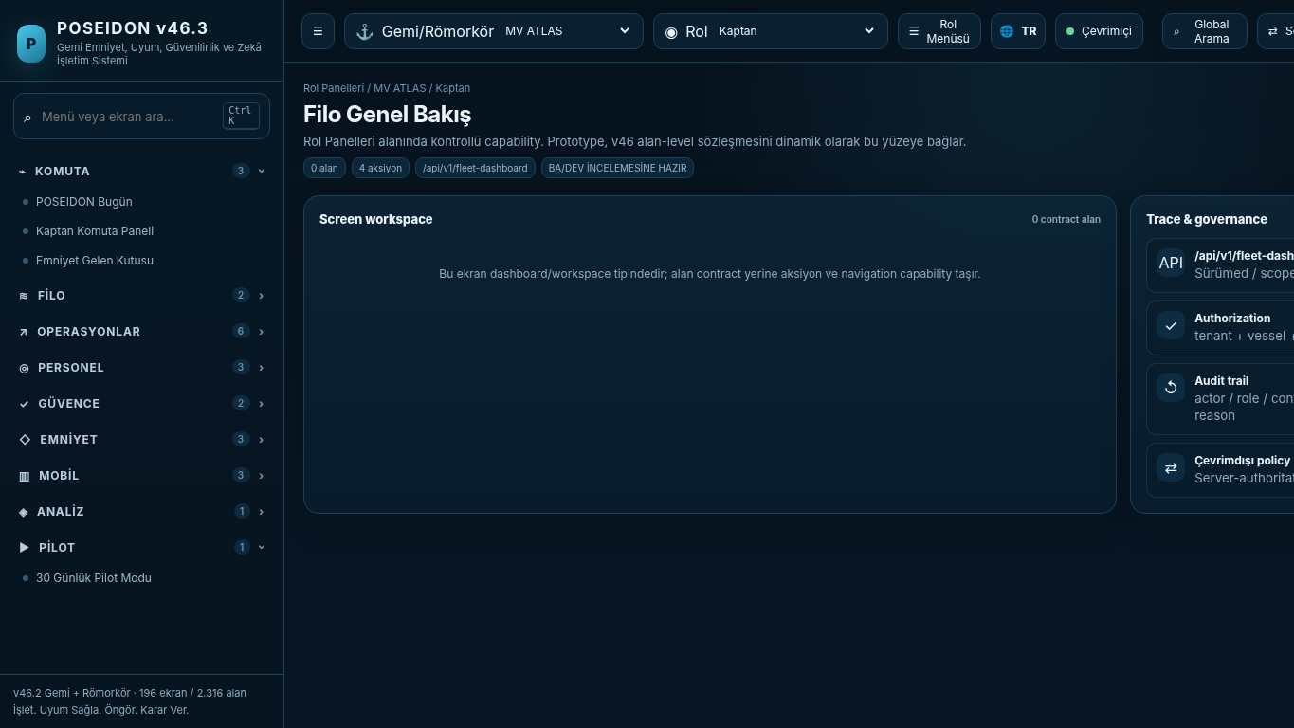
API projection: /api/v1/fleet-dashboard | Status: READY FOR BA/DEV REVIEW

013 MV ATLAS — Vessel Overview
Screen ID: vessel-dashboard | Domain: Role Dashboards | 0 alan / 4 aksiyon
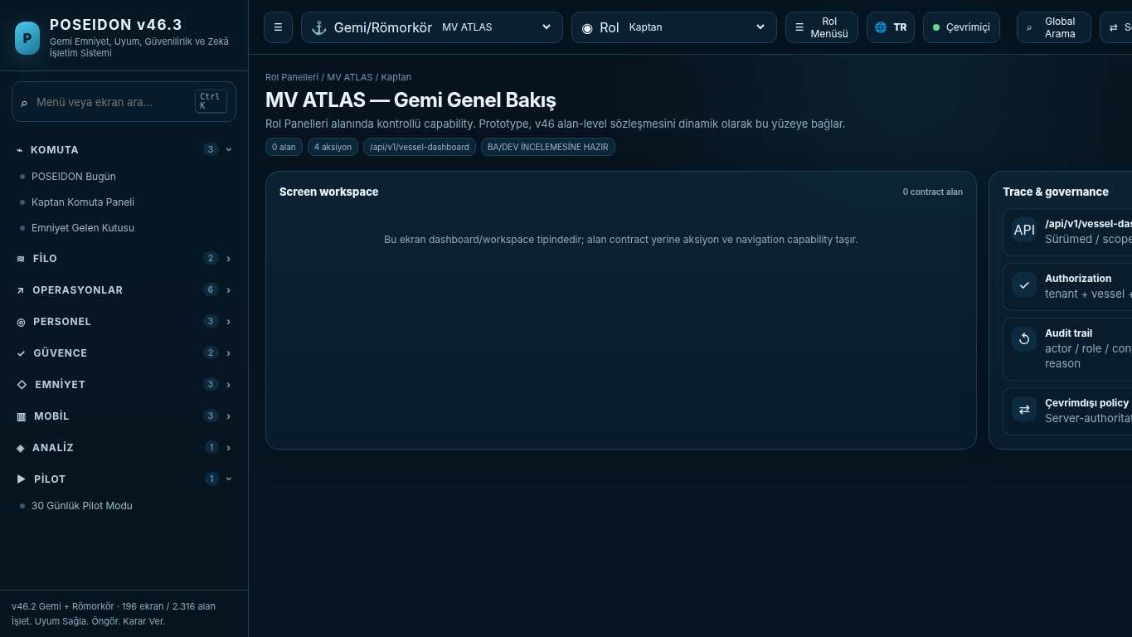
API projection: /api/v1/vessel-dashboard | Status: READY FOR BA/DEV REVIEW
———————————————————————————————————————————————————————
014 Global Search & Command Center
Screen ID: command-center | Domain: Regulatory Control | 0 alan / 0 aksiyon
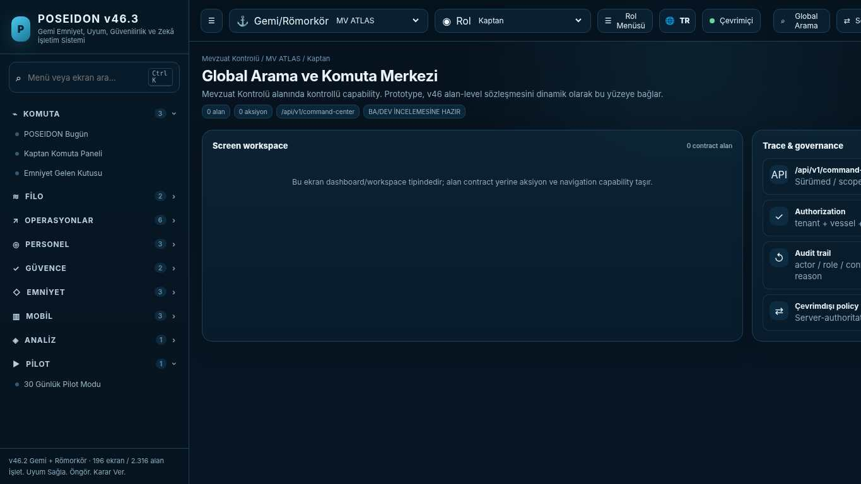
API projection: /api/v1/command-center | Status: READY FOR BA/DEV REVIEW

015 Workflow & Approval Engine
Screen ID: workflow-engine | Domain: Platform & Administration | 0 alan / 1 aksiyon
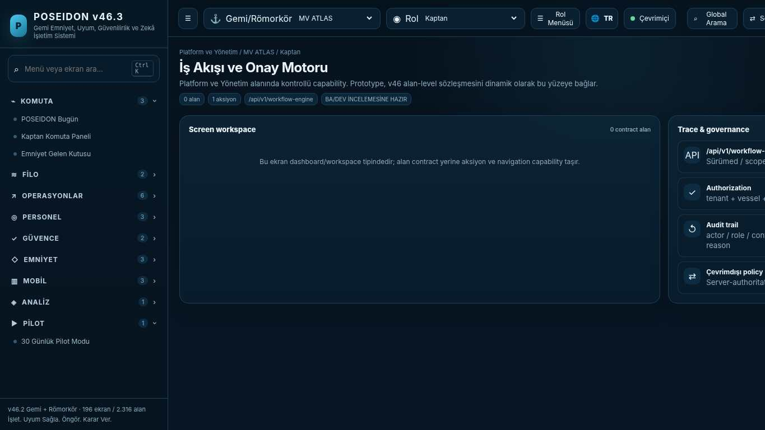
API projection: /api/v1/workflow-engine | Status: READY FOR BA/DEV REVIEW
———————————————————————————————————————————————————————
016 Notification & Escalation Engine
Screen ID: notification-escalation | Domain: Operations & Readiness | 0 alan / 1 aksiyon
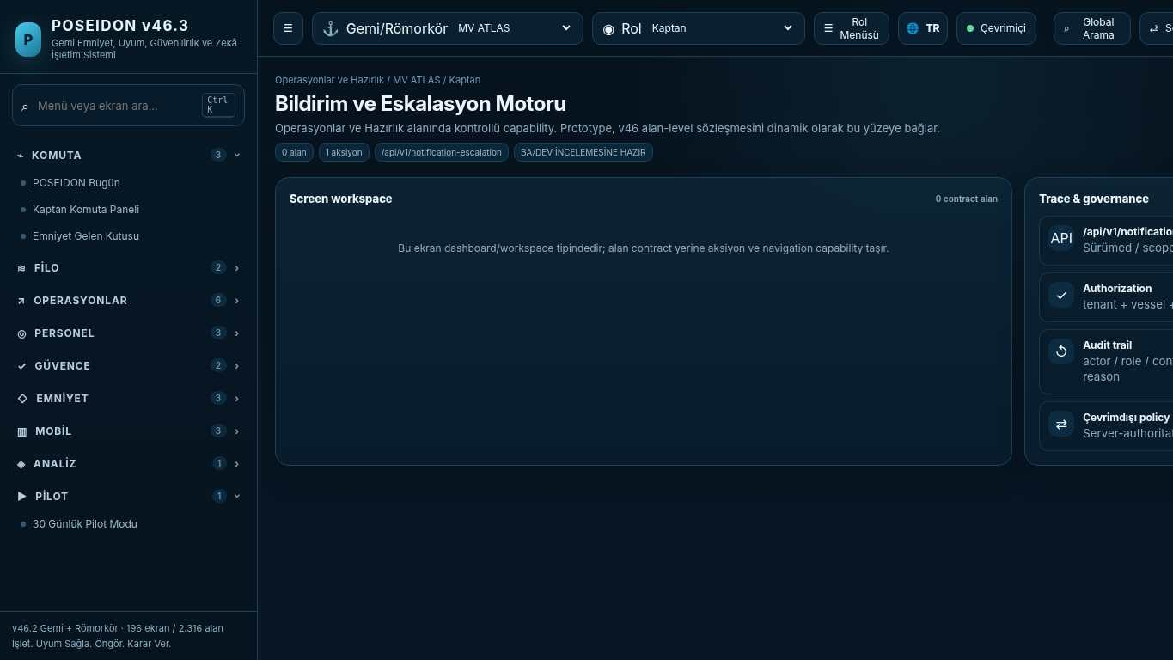
API projection: /api/v1/notification-escalation | Status: READY FOR BA/DEV REVIEW

017 Data Trust Center
Screen ID: data-trust-center | Domain: Platform & Administration | 0 alan / 1 aksiyon
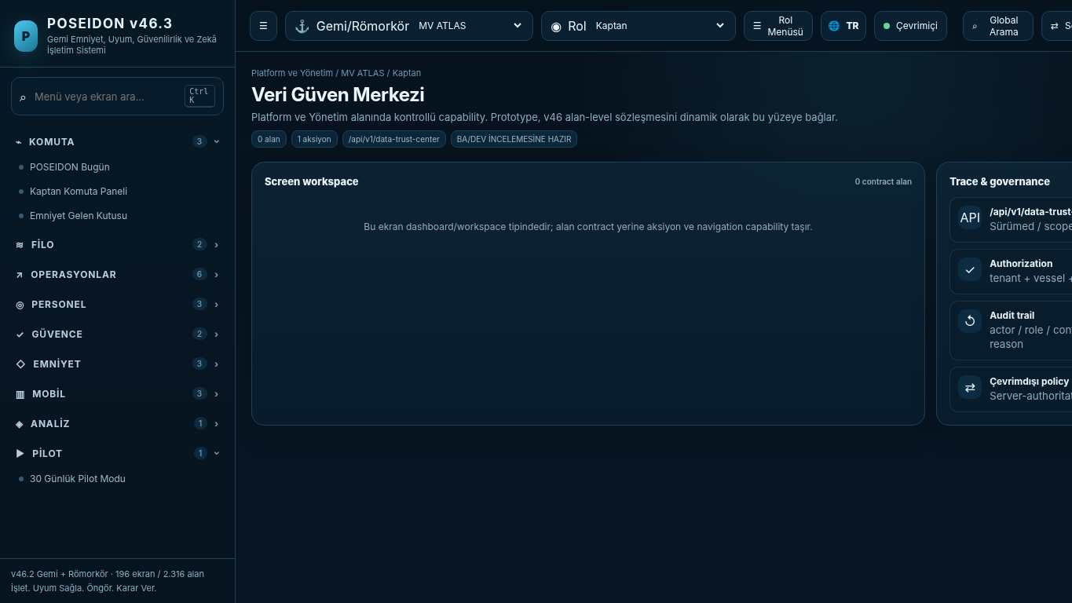
API projection: /api/v1/data-trust-center | Status: READY FOR BA/DEV REVIEW
———————————————————————————————————————————————————————
018 Management of Change
Screen ID: management-of-change | Domain: Regulatory Control | 4 alan / 1 aksiyon
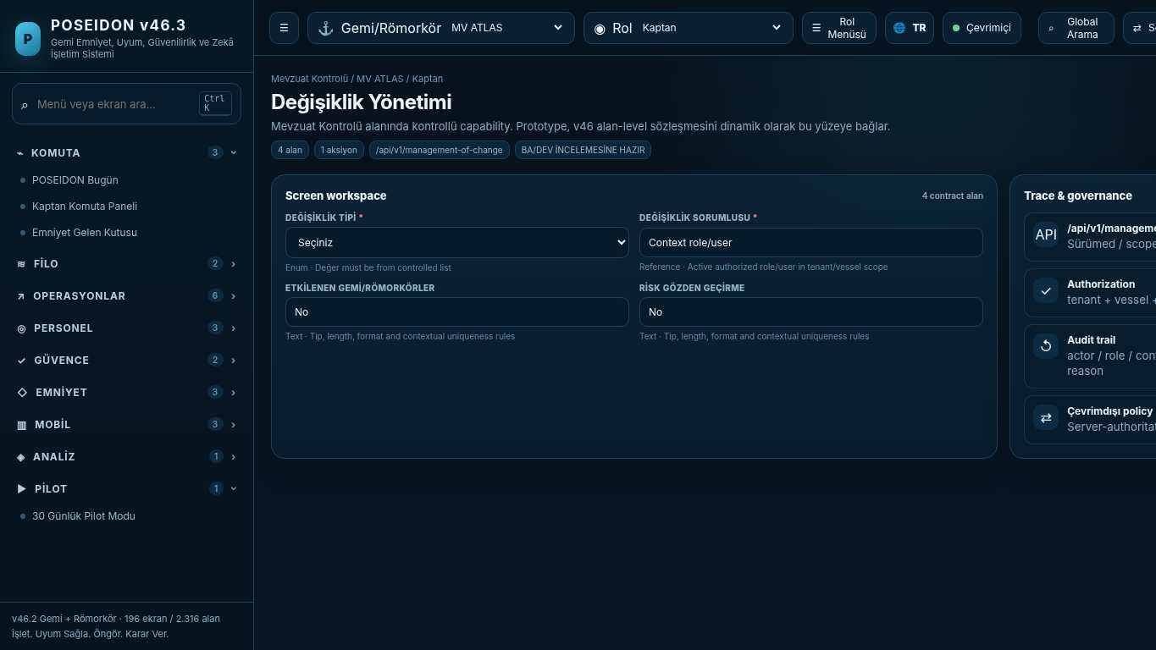
API projection: /api/v1/management-of-change | Status: READY FOR BA/DEV REVIEW

019 Offline Sync & Conflict Resolution
Screen ID: offline-conflict-center | Domain: Operations & Readiness | 0 alan / 1 aksiyon
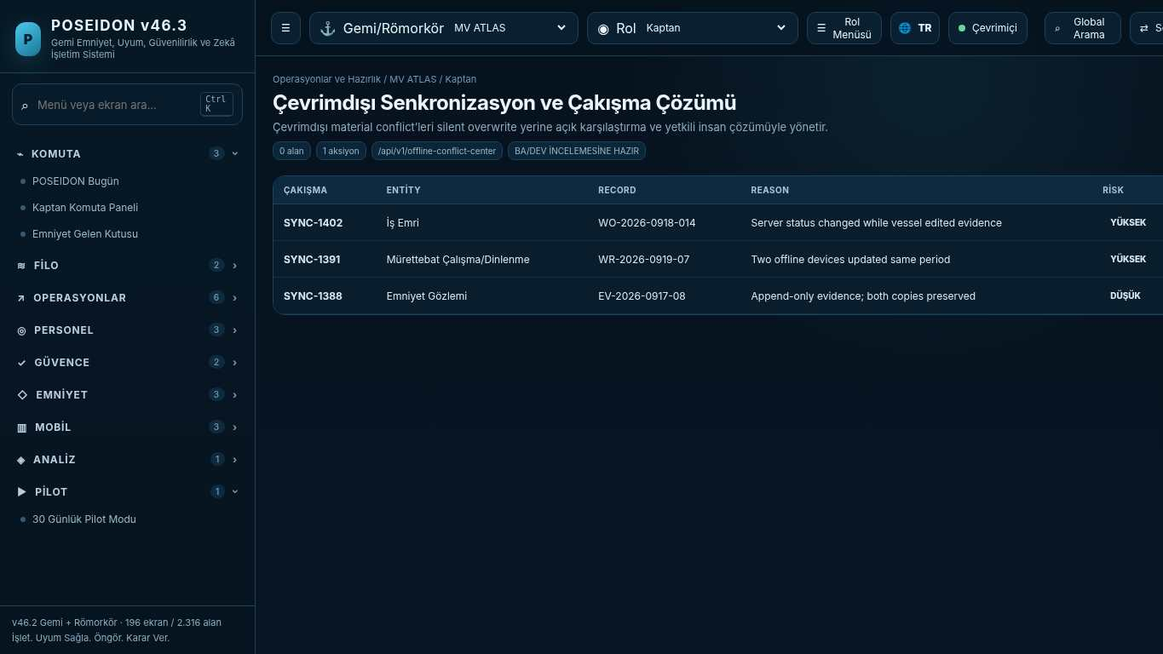
API projection: /api/v1/offline-conflict-center | Status: READY FOR BA/DEV REVIEW
———————————————————————————————————————————————————————
020 Cyber Readiness Dashboard
Screen ID: cyber-readiness-dashboard | Domain: Role Dashboards | 0 alan / 0 aksiyon
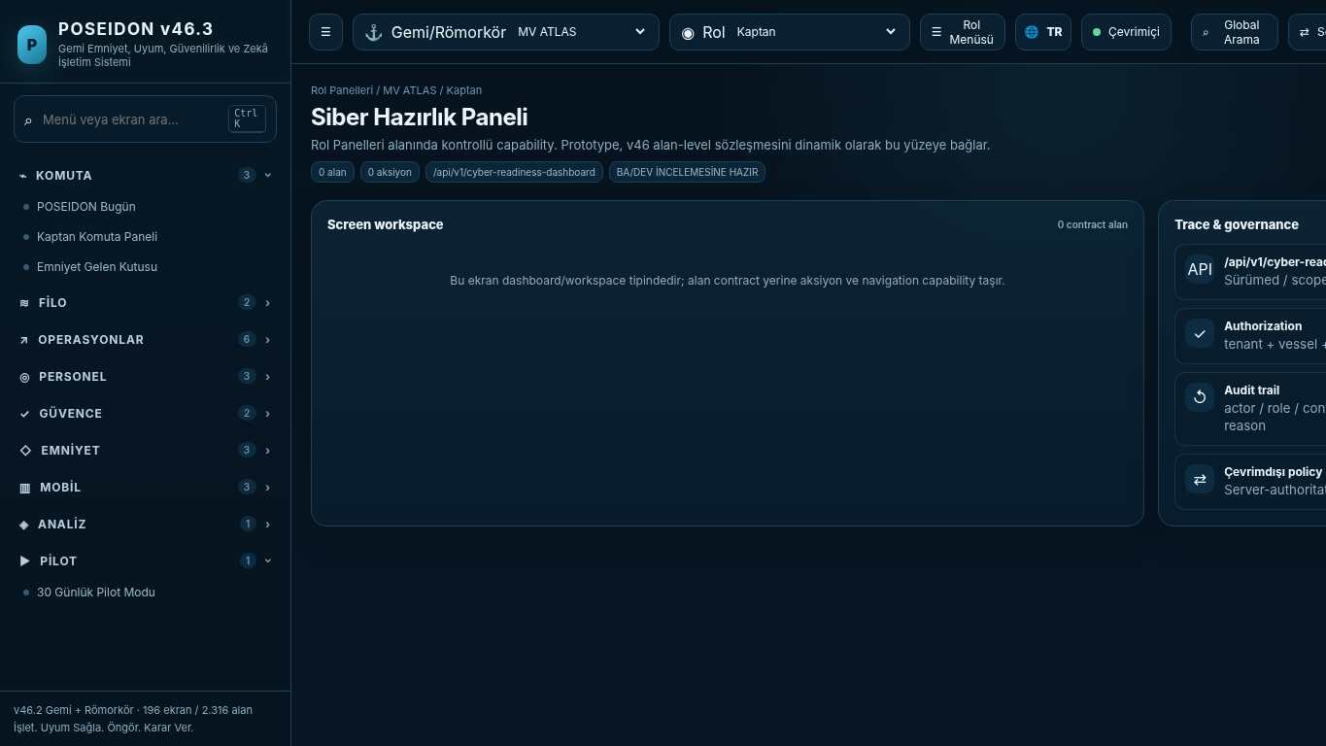
API projection: /api/v1/cyber-readiness-dashboard | Status: READY FOR BA/DEV REVIEW

021 Fatigue & Work/Rest Intelligence
Screen ID: fatigue-intelligence | Domain: Regulatory Control | 0 alan / 1 aksiyon
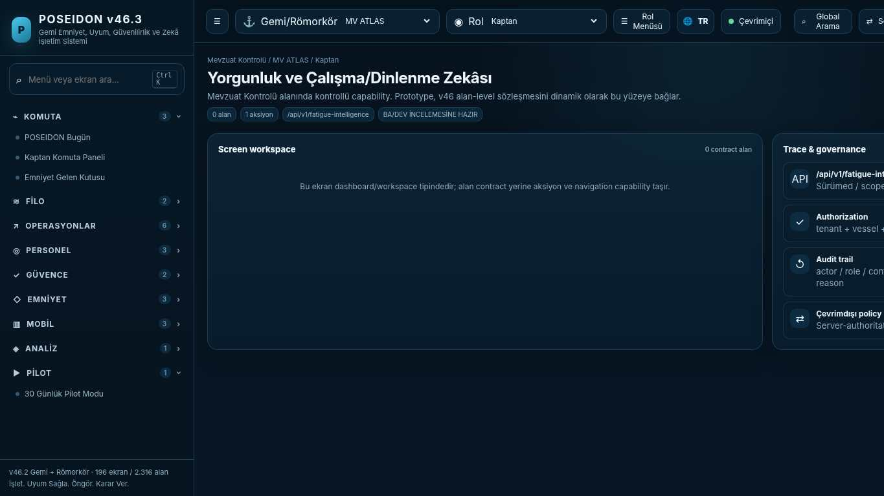
API projection: /api/v1/fatigue-intelligence | Status: READY FOR BA/DEV REVIEW
———————————————————————————————————————————————————————
022 Safety Barrier Health
Screen ID: safety-barrier-health | Domain: Regulatory Control | 0 alan / 0 aksiyon
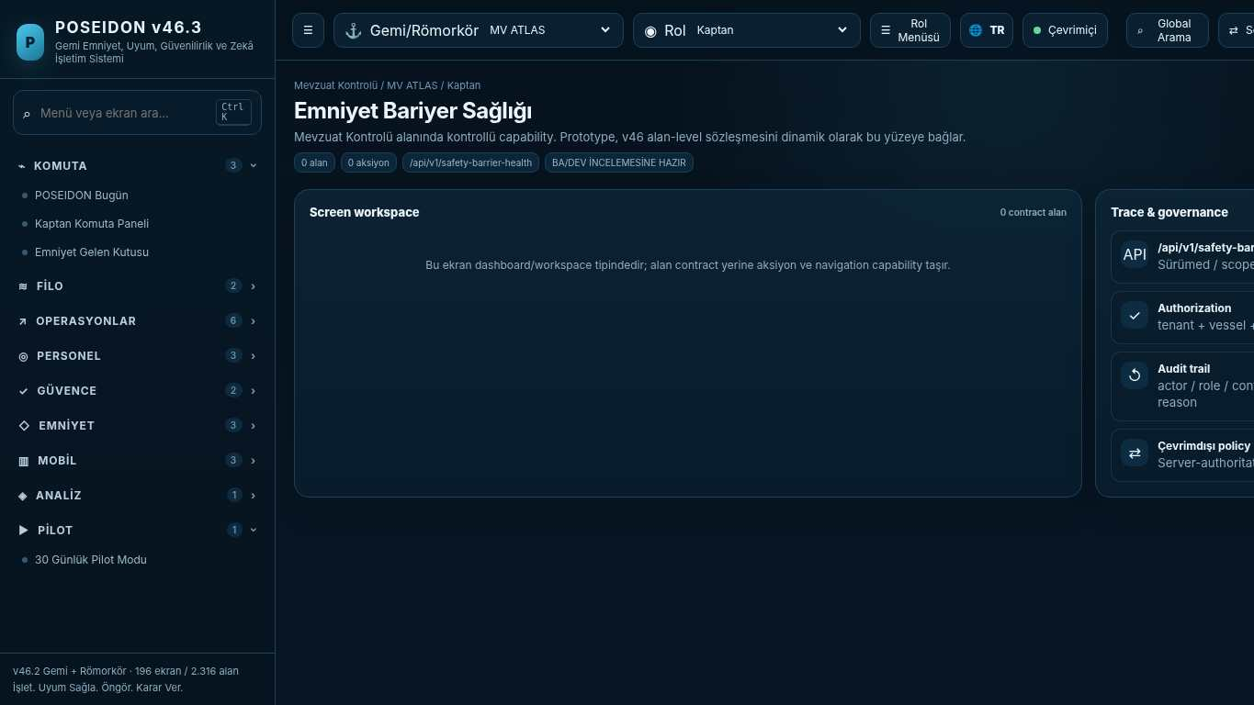
API projection: /api/v1/safety-barrier-health | Status: READY FOR BA/DEV REVIEW

023 Emergency Role Readiness
Screen ID: emergency-role-readiness | Domain: Crew & Competence | 0 alan / 1 aksiyon
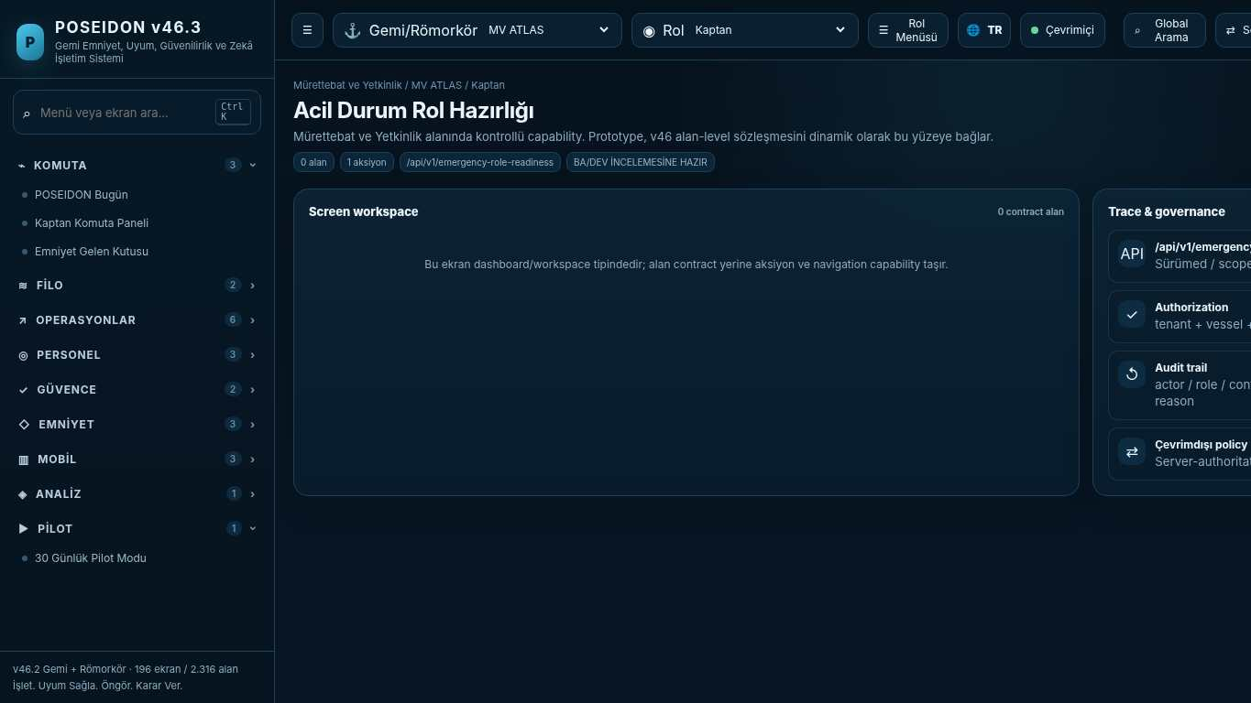
API projection: /api/v1/emergency-role-readiness | Status: READY FOR BA/DEV REVIEW
———————————————————————————————————————————————————————
024 Tenant Configuration & Onboarding
Screen ID: tenant-configuration | Domain: Regulatory Control | 0 alan / 1 aksiyon
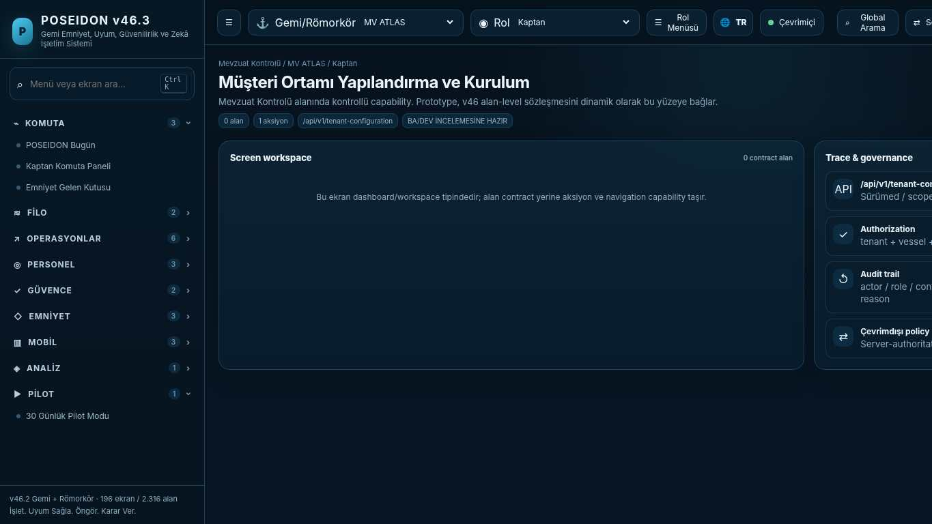
API projection: /api/v1/tenant-configuration | Status: READY FOR BA/DEV REVIEW

025 System & Integration Health
Screen ID: system-health | Domain: Regulatory Control | 0 alan / 1 aksiyon
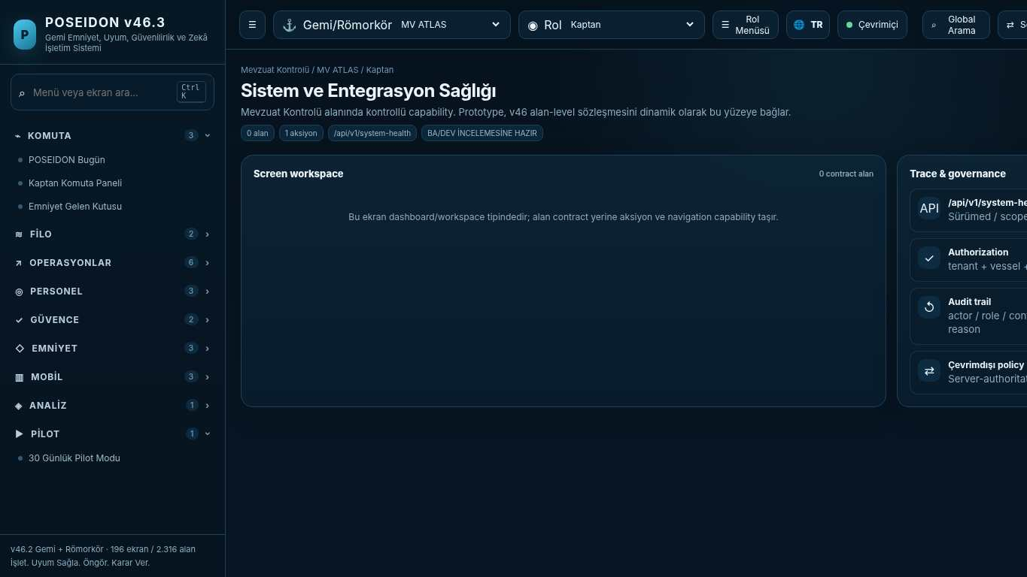
API projection: /api/v1/system-health | Status: READY FOR BA/DEV REVIEW
———————————————————————————————————————————————————————
026 Production Readiness Gate
Screen ID: production-readiness | Domain: Platform & Administration | 0 alan / 1 aksiyon
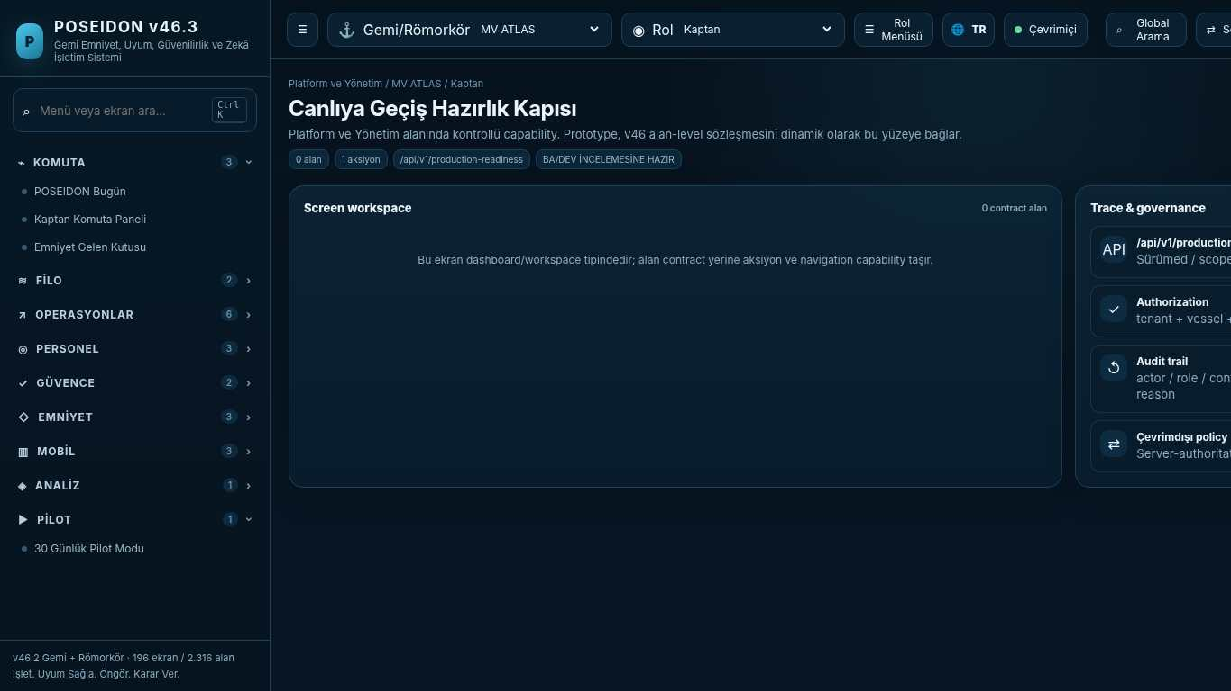
API projection: /api/v1/production-readiness | Status: READY FOR BA/DEV REVIEW

027 My Safety Impact
Screen ID: my-safety-impact | Domain: Safety & Learning | 0 alan / 0 aksiyon
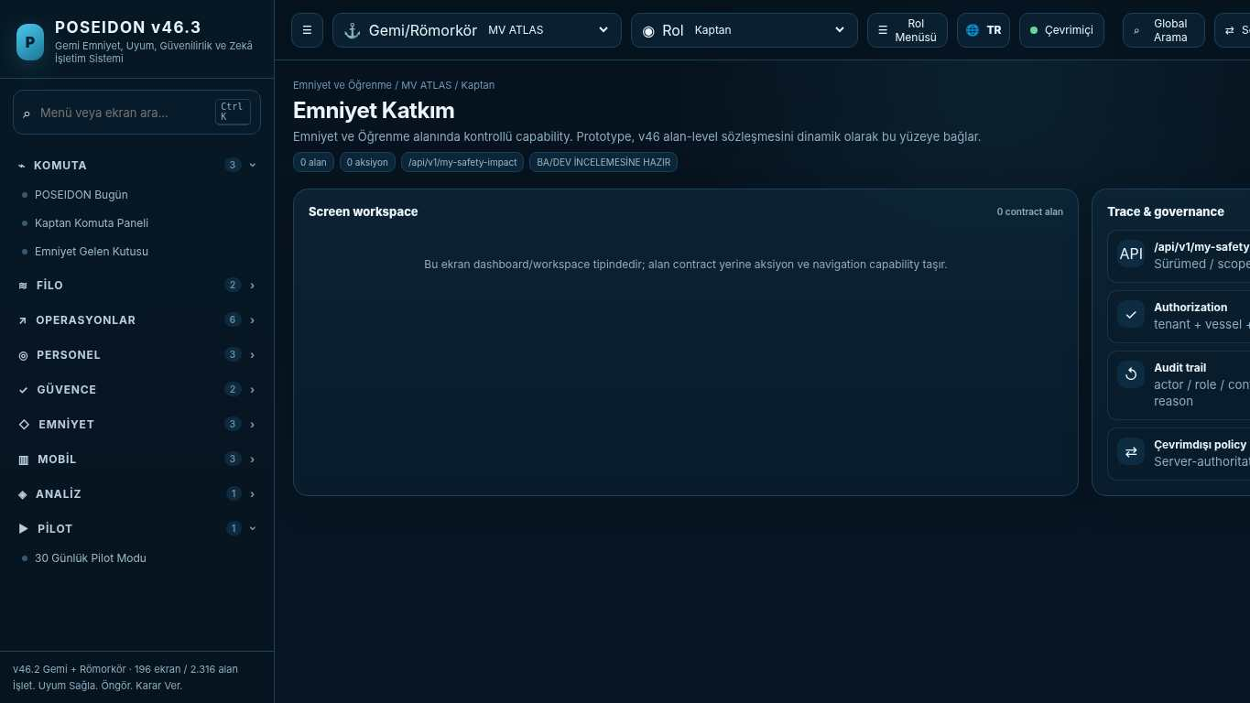
API projection: /api/v1/my-safety-impact | Status: READY FOR BA/DEV REVIEW
———————————————————————————————————————————————————————
028 Recognition Review
Screen ID: recognition-review | Domain: Safety & Learning | 6 alan / 1 aksiyon
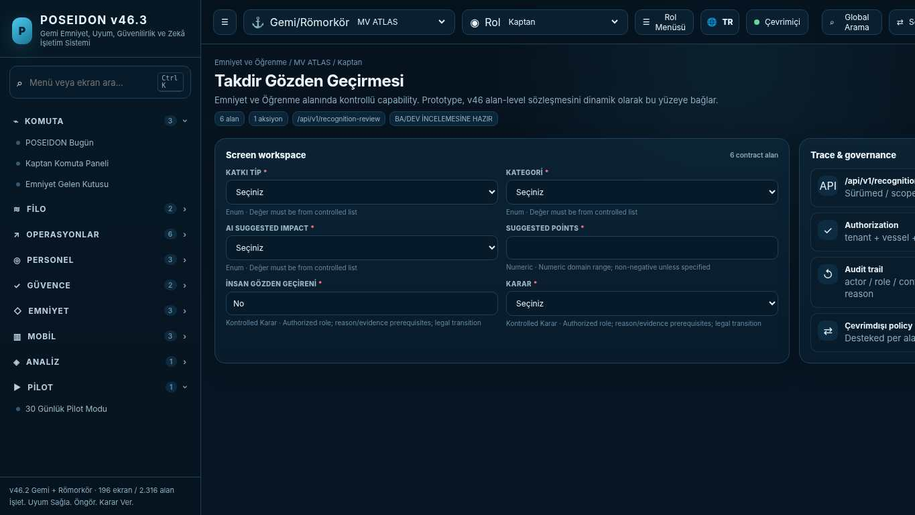
API projection: /api/v1/recognition-review | Status: READY FOR BA/DEV REVIEW

029 Safety Culture Pulse
Screen ID: safety-culture-pulse | Domain: Safety & Learning | 0 alan / 1 aksiyon
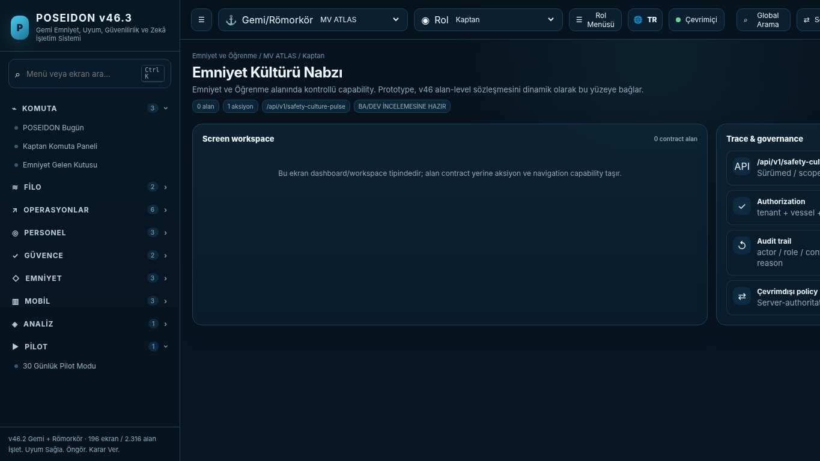
API projection: /api/v1/safety-culture-pulse | Status: READY FOR BA/DEV REVIEW
———————————————————————————————————————————————————————
030 Confidential / Anonymous Reporting
Screen ID: confidential-reporting | Domain: Safety & Learning | 3 alan / 1 aksiyon
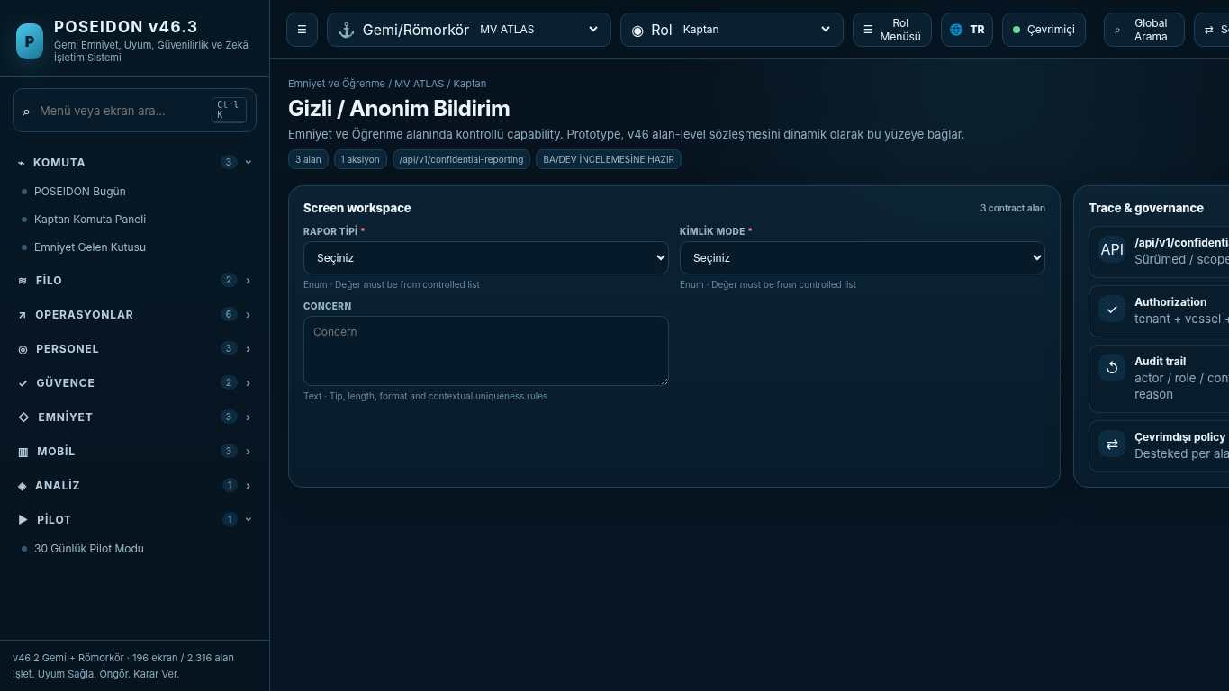
API projection: /api/v1/confidential-reporting | Status: READY FOR BA/DEV REVIEW

031 Requirement Master
Screen ID: requirement-master | Domain: Regulatory Control | 10 alan / 1 aksiyon
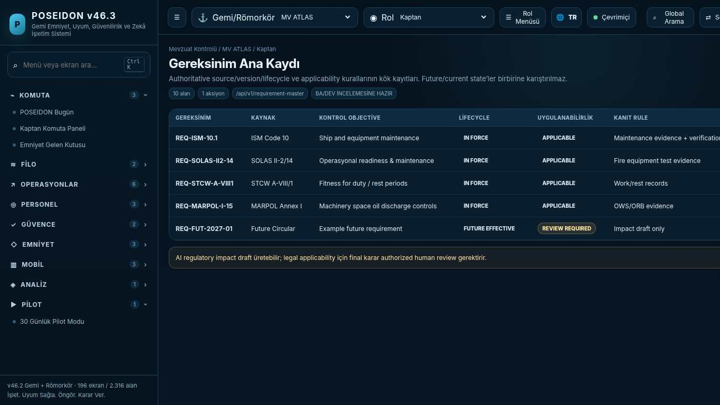
API projection: /api/v1/requirement-master | Status: READY FOR BA/DEV REVIEW
———————————————————————————————————————————————————————
032 Applicability Rule Builder
Screen ID: applicability-rule-builder | Domain: Regulatory Control | 8 alan / 1 aksiyon
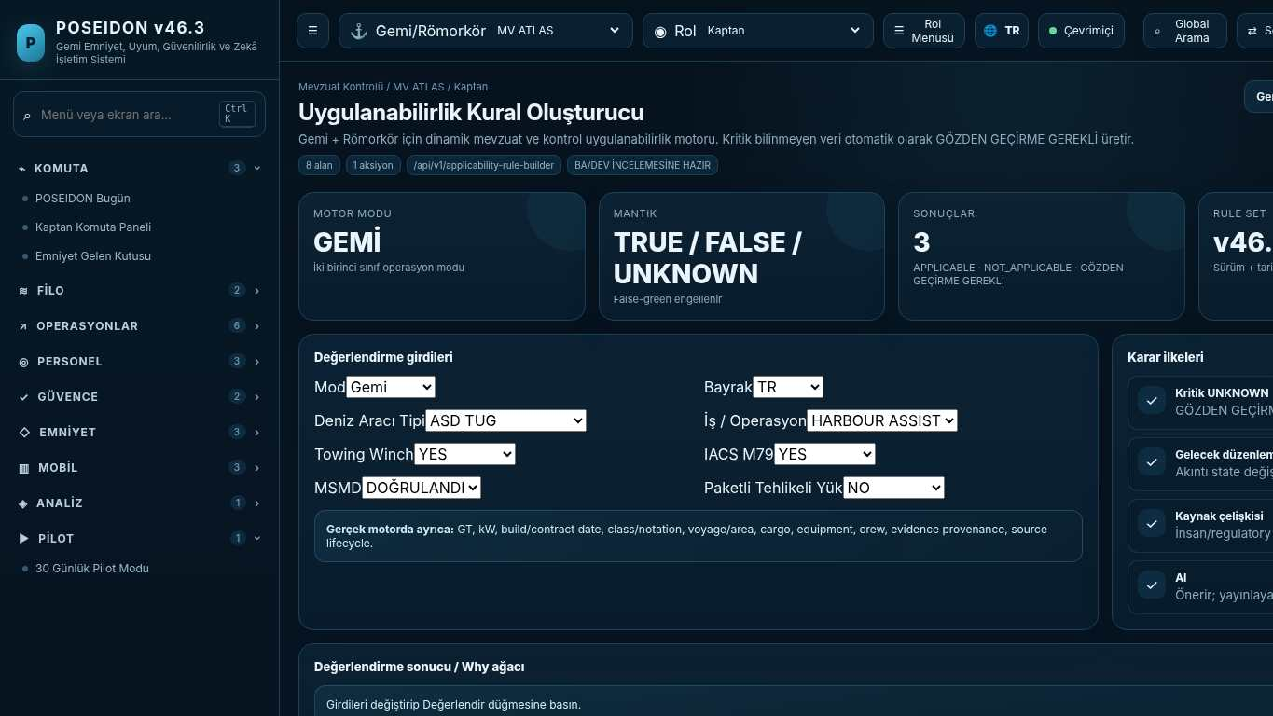
API projection: /api/v1/applicability-rule-builder | Status: READY FOR BA/DEV REVIEW

033 Operational Control Library
Screen ID: operational-control-library | Domain: Regulatory Control | 0 alan / 0 aksiyon
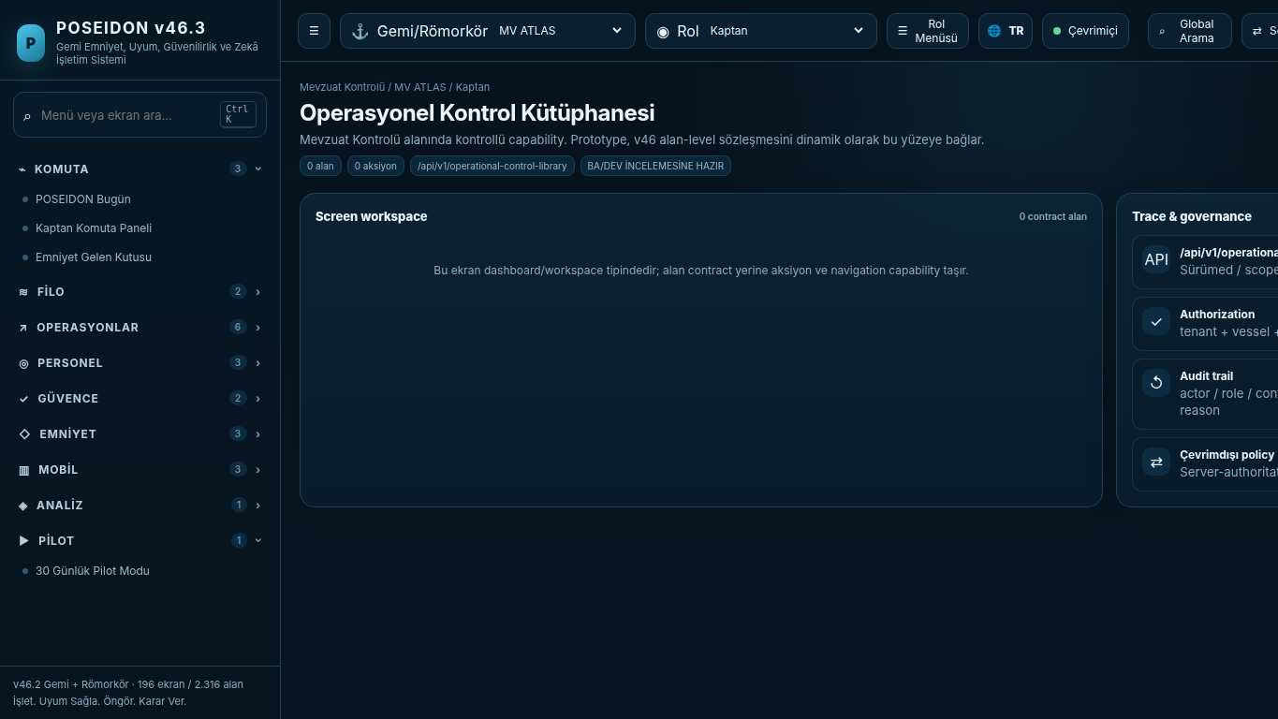
API projection: /api/v1/operational-control-library | Status: READY FOR BA/DEV REVIEW
———————————————————————————————————————————————————————
034 Verification Gates
Screen ID: verification-gates | Domain: Regulatory Control | 0 alan / 1 aksiyon
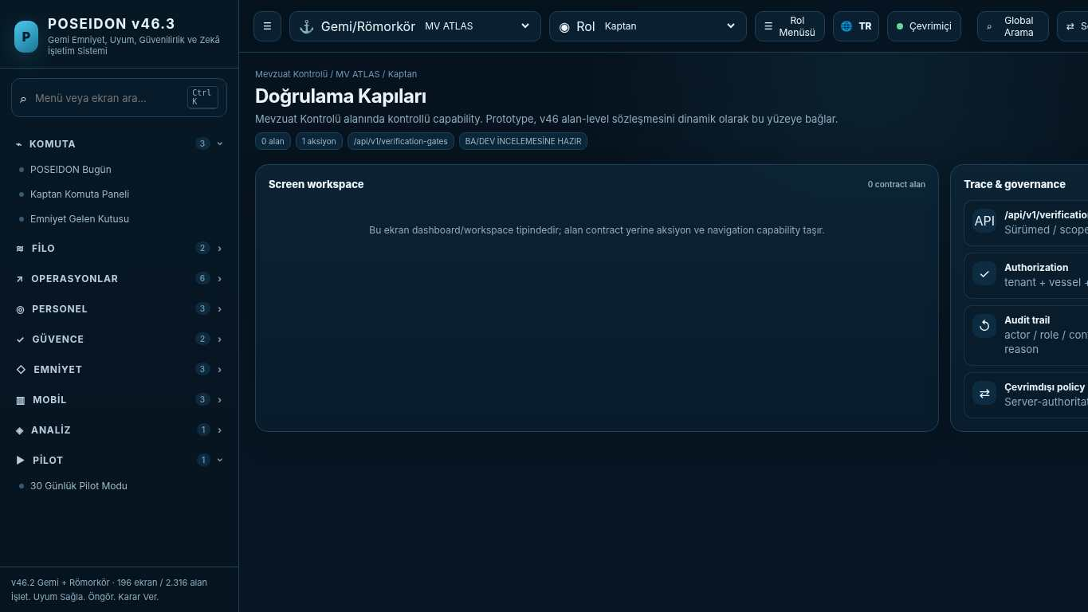
API projection: /api/v1/verification-gates | Status: READY FOR BA/DEV REVIEW

035 Regulatory Source Governance
Screen ID: regulatory-source-governance | Domain: Regulatory Control | 0 alan / 1 aksiyon
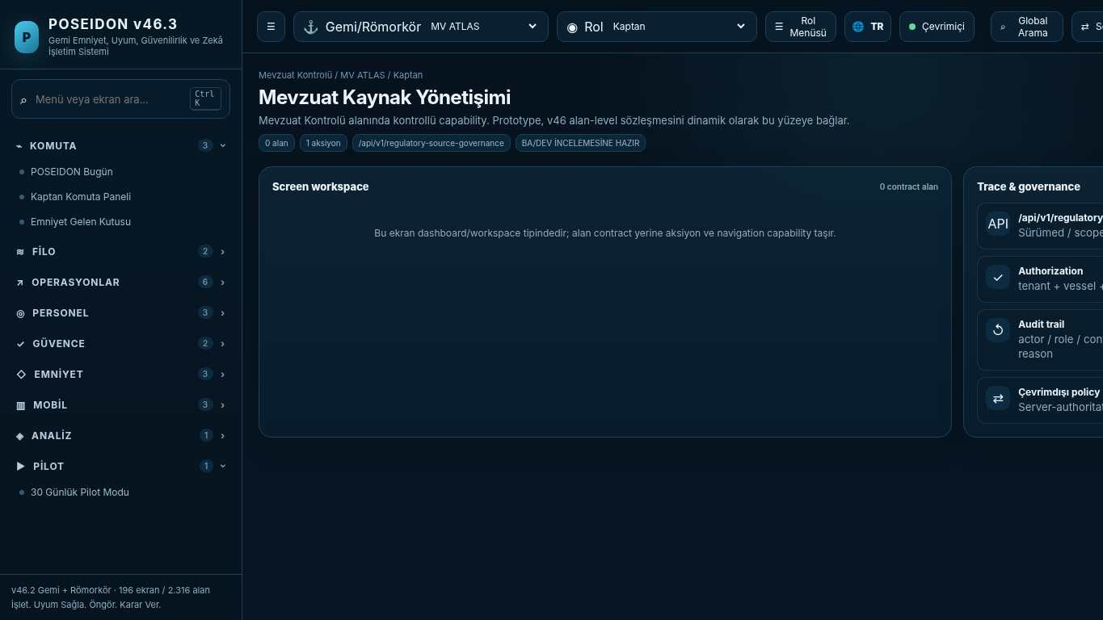
API projection: /api/v1/regulatory-source-governance | Status: READY FOR BA/DEV REVIEW
———————————————————————————————————————————————————————
036 Dangerous Goods Emergency Response
Screen ID: dangerous-goods-response | Domain: Regulatory Control | 0 alan / 1 aksiyon
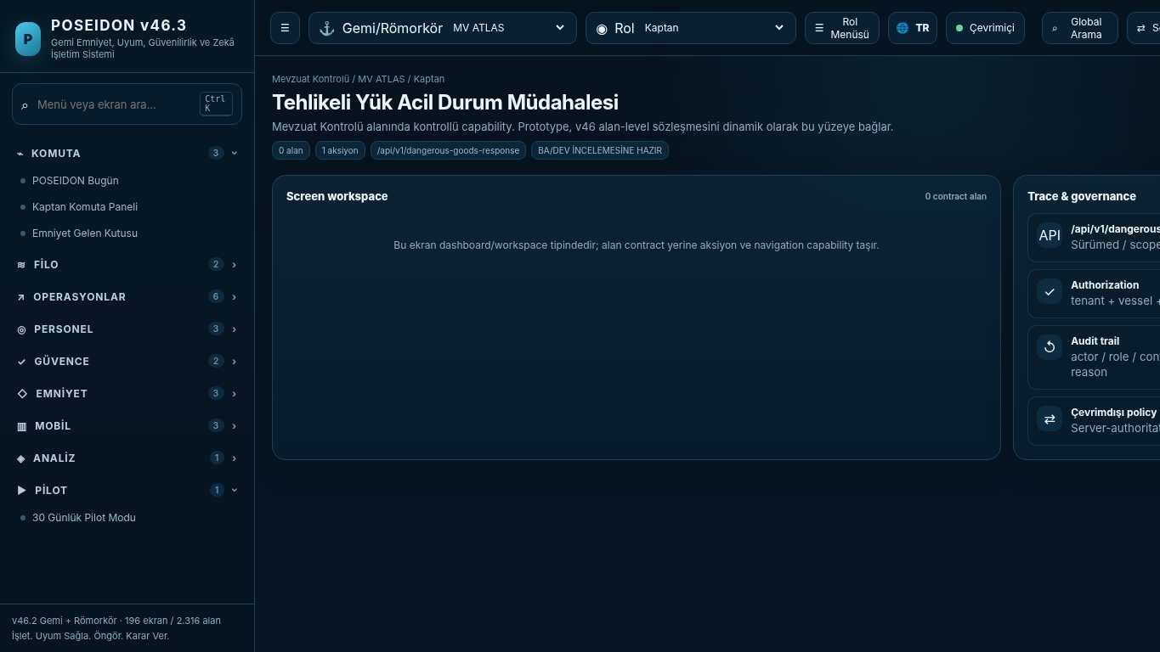
API projection: /api/v1/dangerous-goods-response | Status: READY FOR BA/DEV REVIEW

037 IMSBC / Grain Cargo Readiness
Screen ID: bulk-cargo-readiness | Domain: Regulatory Control | 0 alan / 1 aksiyon
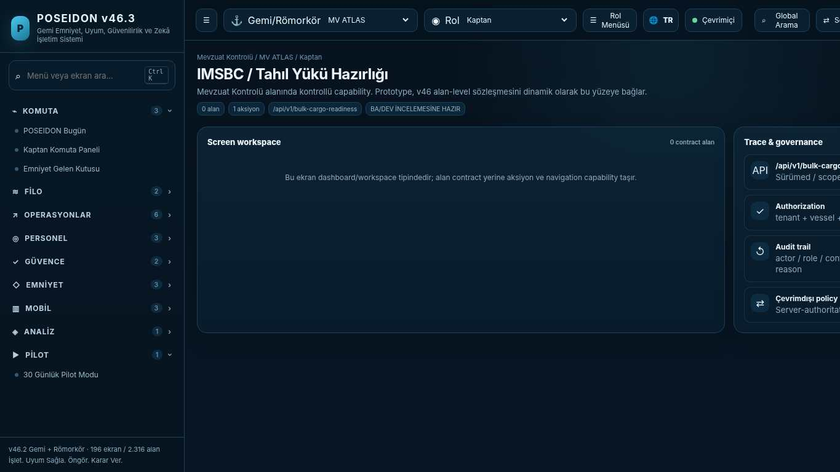
API projection: /api/v1/bulk-cargo-readiness | Status: READY FOR BA/DEV REVIEW
———————————————————————————————————————————————————————
038 Special Ship / Code Profiles
Screen ID: special-ship-profile | Domain: Regulatory Control | 0 alan / 0 aksiyon
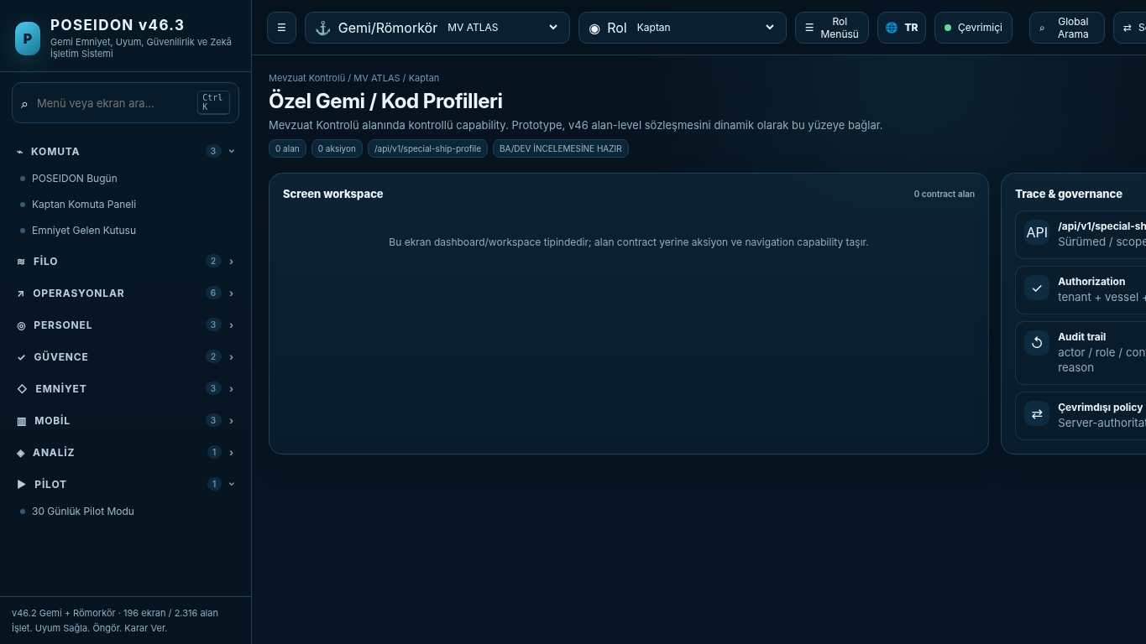
API projection: /api/v1/special-ship-profile | Status: READY FOR BA/DEV REVIEW

039 Regulatory Coverage Matrix
Screen ID: regulatory-coverage-matrix | Domain: Regulatory Control | 0 alan / 2 aksiyon
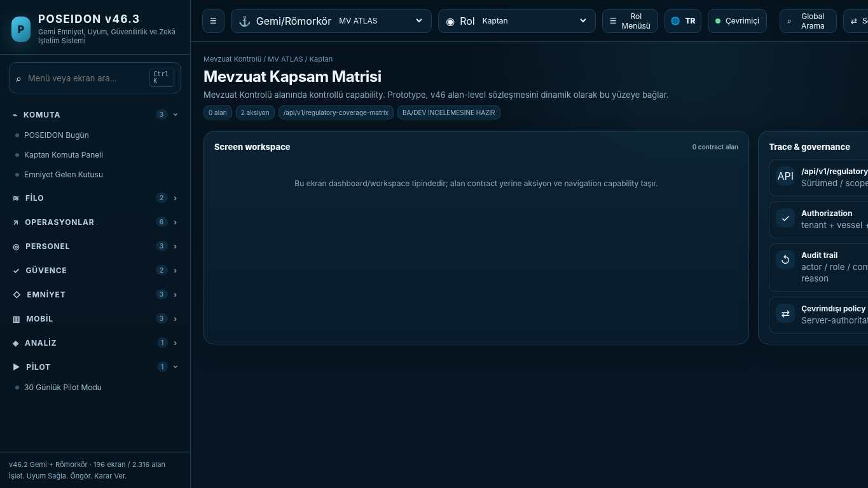
API projection: /api/v1/regulatory-coverage-matrix | Status: READY FOR BA/DEV REVIEW
———————————————————————————————————————————————————————
040 MV ATLAS — Digital Compliance Passport
Screen ID: vessel-compliance-passport | Domain: Regulatory Control | 0 alan / 4 aksiyon
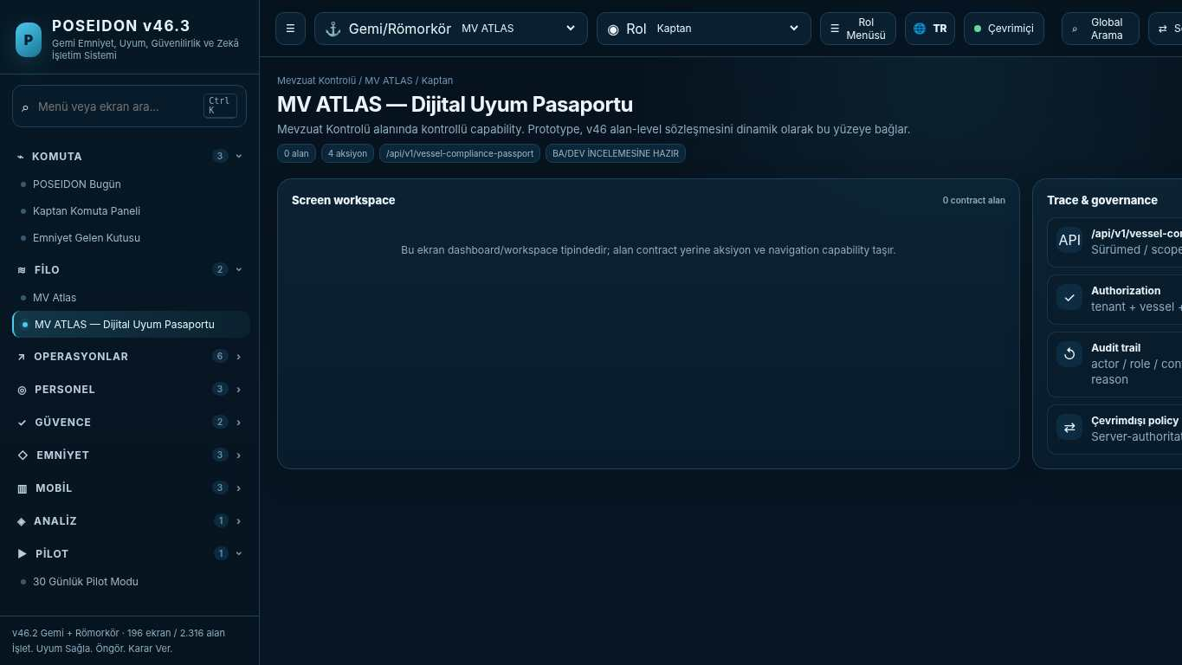
API projection: /api/v1/vessel-compliance-passport | Status: READY FOR BA/DEV REVIEW

041 Control Effectiveness Engine
Screen ID: control-effectiveness | Domain: Regulatory Control | 0 alan / 1 aksiyon
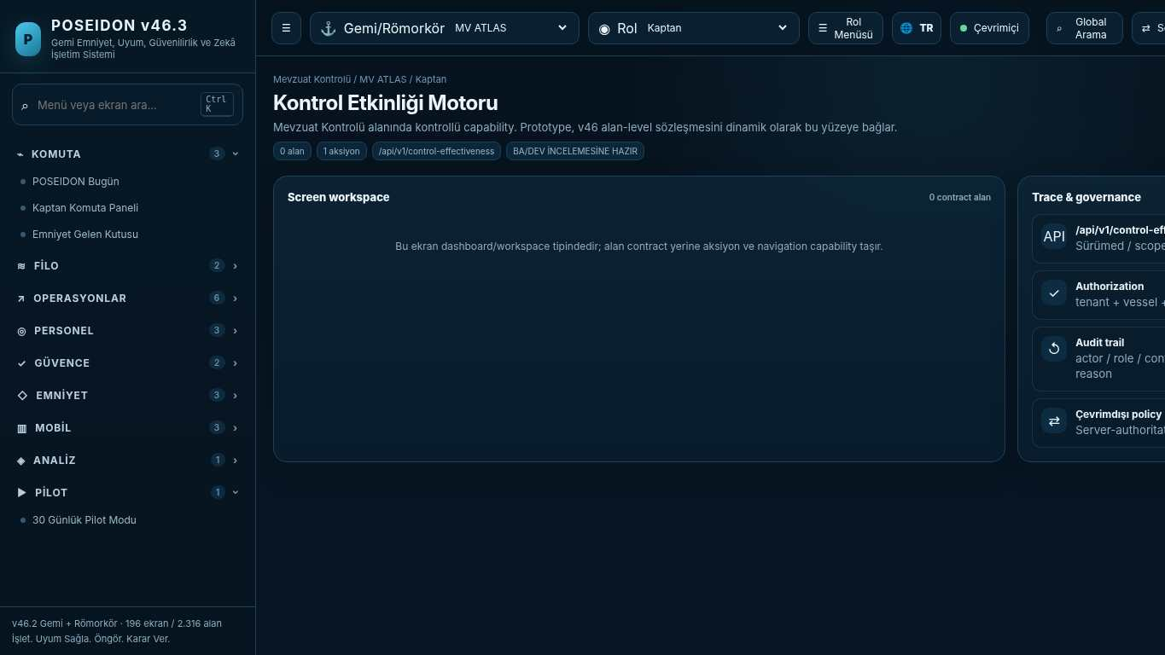
API projection: /api/v1/control-effectiveness | Status: READY FOR BA/DEV REVIEW
———————————————————————————————————————————————————————
042 Evidence Quality Score
Screen ID: evidence-quality | Domain: Regulatory Control | 0 alan / 1 aksiyon
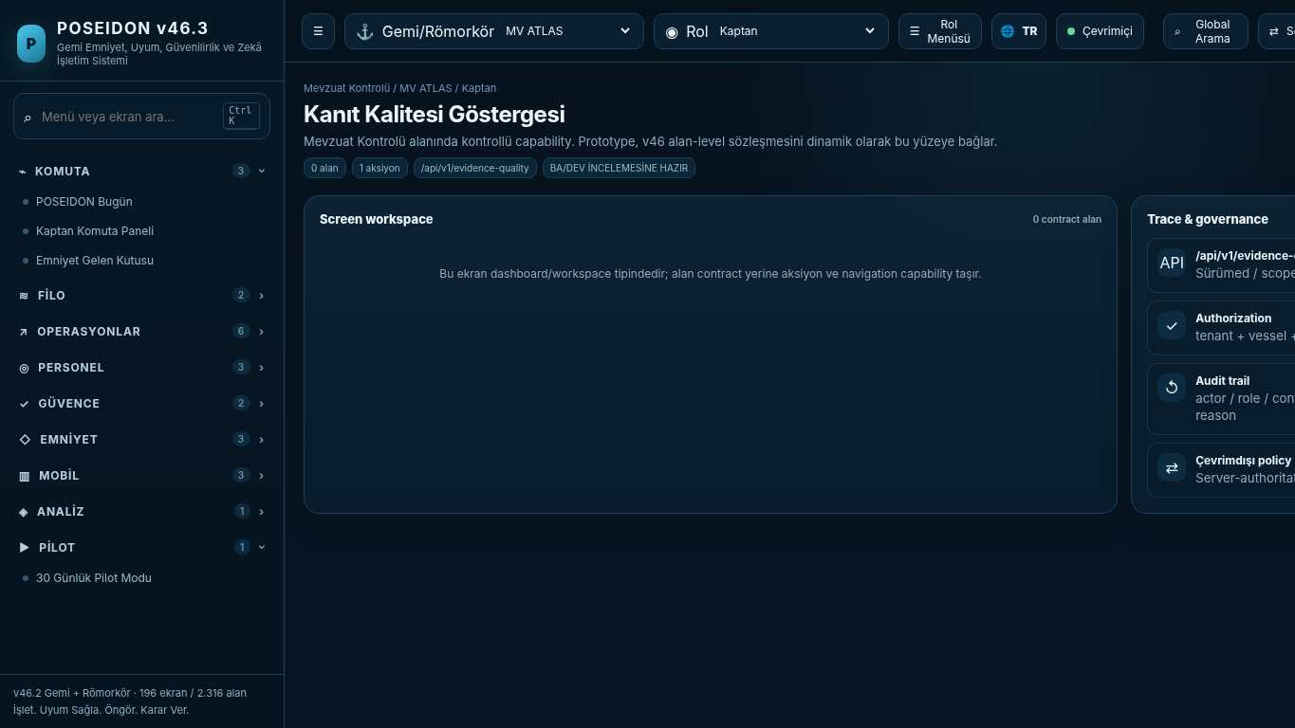
API projection: /api/v1/evidence-quality | Status: READY FOR BA/DEV REVIEW

043 Regulatory Change Radar
Screen ID: regulatory-change-radar | Domain: Regulatory Control | 0 alan / 1 aksiyon
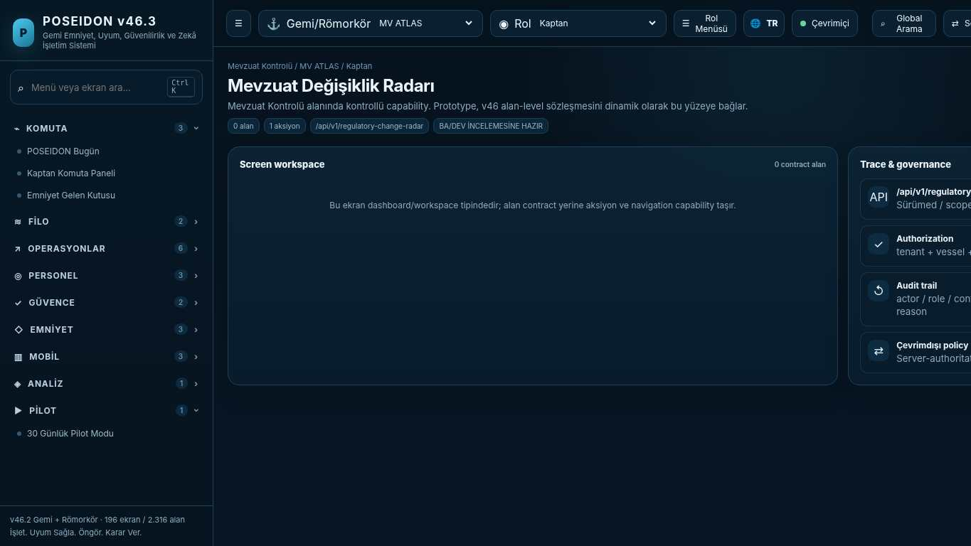
API projection: /api/v1/regulatory-change-radar | Status: READY FOR BA/DEV REVIEW
———————————————————————————————————————————————————————
044 Future Regulation Sandbox
Screen ID: future-regulation-sandbox | Domain: Regulatory Control | 0 alan / 1 aksiyon
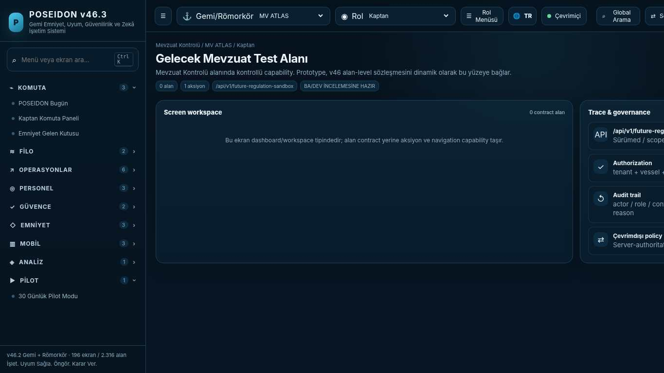
API projection: /api/v1/future-regulation-sandbox | Status: READY FOR BA/DEV REVIEW

045 Regulatory & Safety AI Boundaries
Screen ID: regulatory-ai-governance | Domain: Regulatory Control | 0 alan / 0 aksiyon
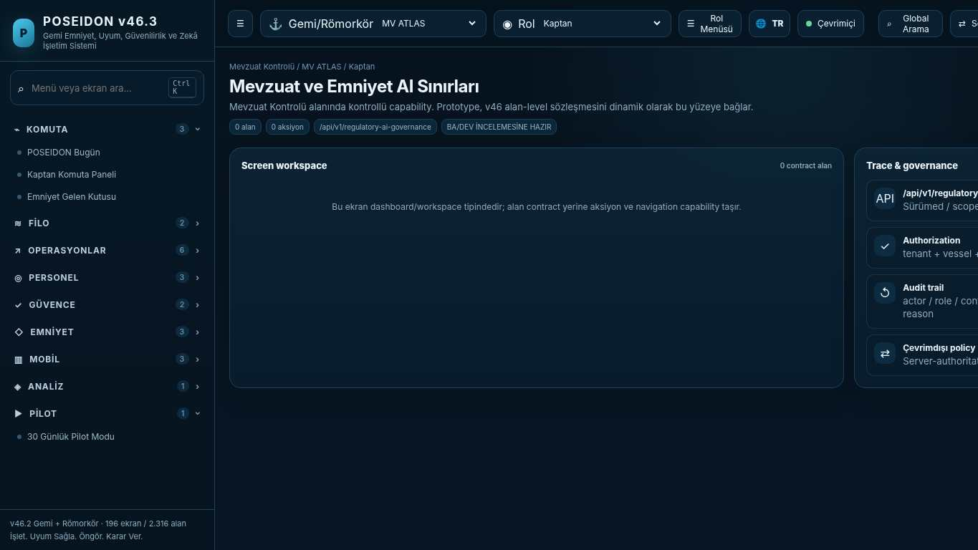
API projection: /api/v1/regulatory-ai-governance | Status: READY FOR BA/DEV REVIEW
———————————————————————————————————————————————————————
046 ISM Complete Product Map
Screen ID: ism-complete-map | Domain: Regulatory Control | 0 alan / 1 aksiyon
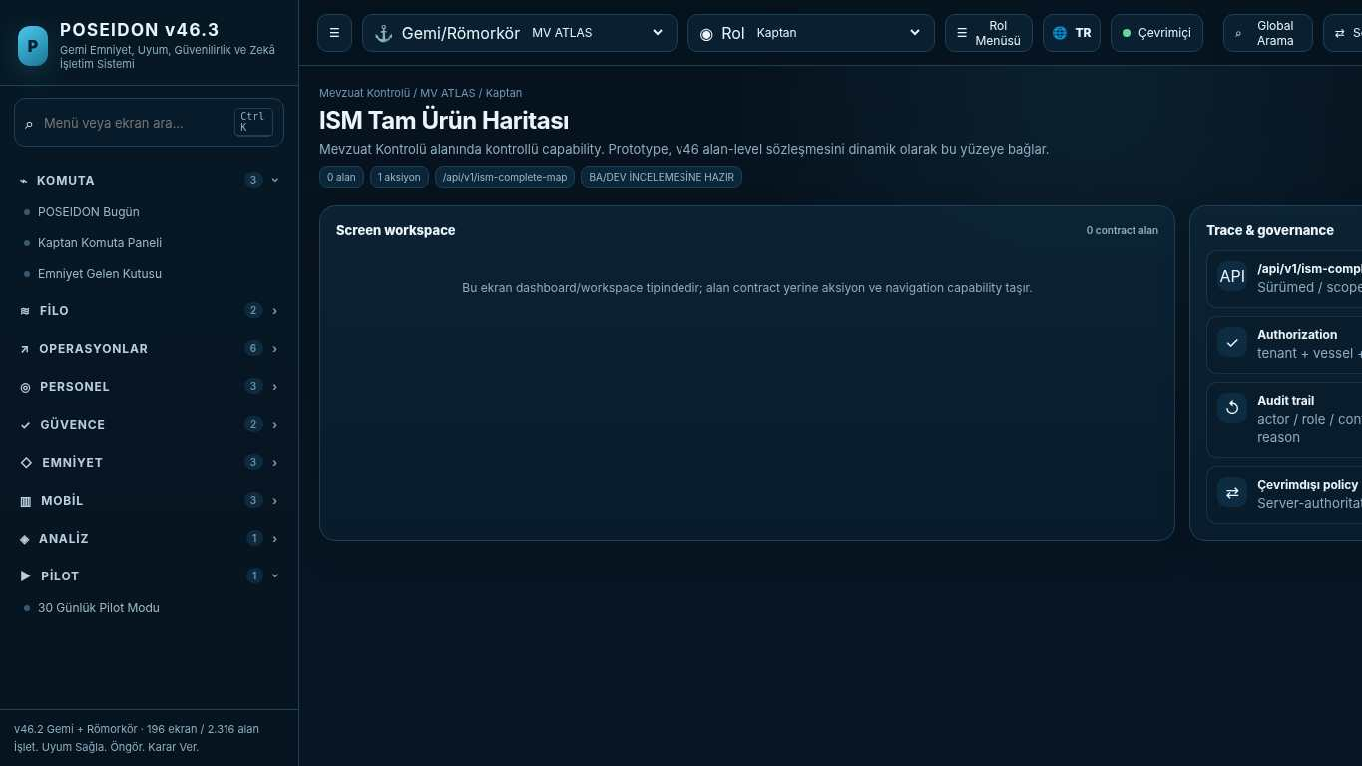
API projection: /api/v1/ism-complete-map | Status: READY FOR BA/DEV REVIEW

047 Maritime Regulatory Corpus
Screen ID: regulatory-corpus | Domain: Regulatory Control | 0 alan / 0 aksiyon
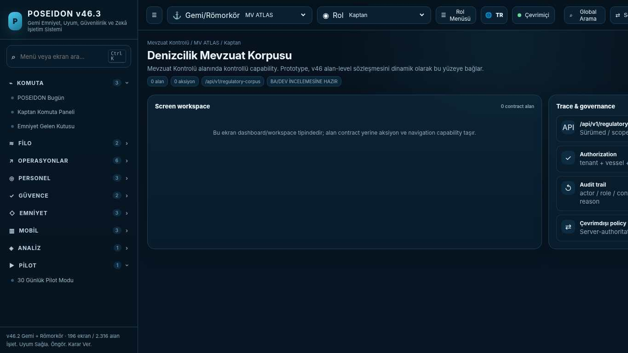
API projection: /api/v1/regulatory-corpus | Status: READY FOR BA/DEV REVIEW
———————————————————————————————————————————————————————
048 Certificates & Required Documents Register
Screen ID: cert-document-register | Domain: Regulatory Control | 8 alan / 1 aksiyon
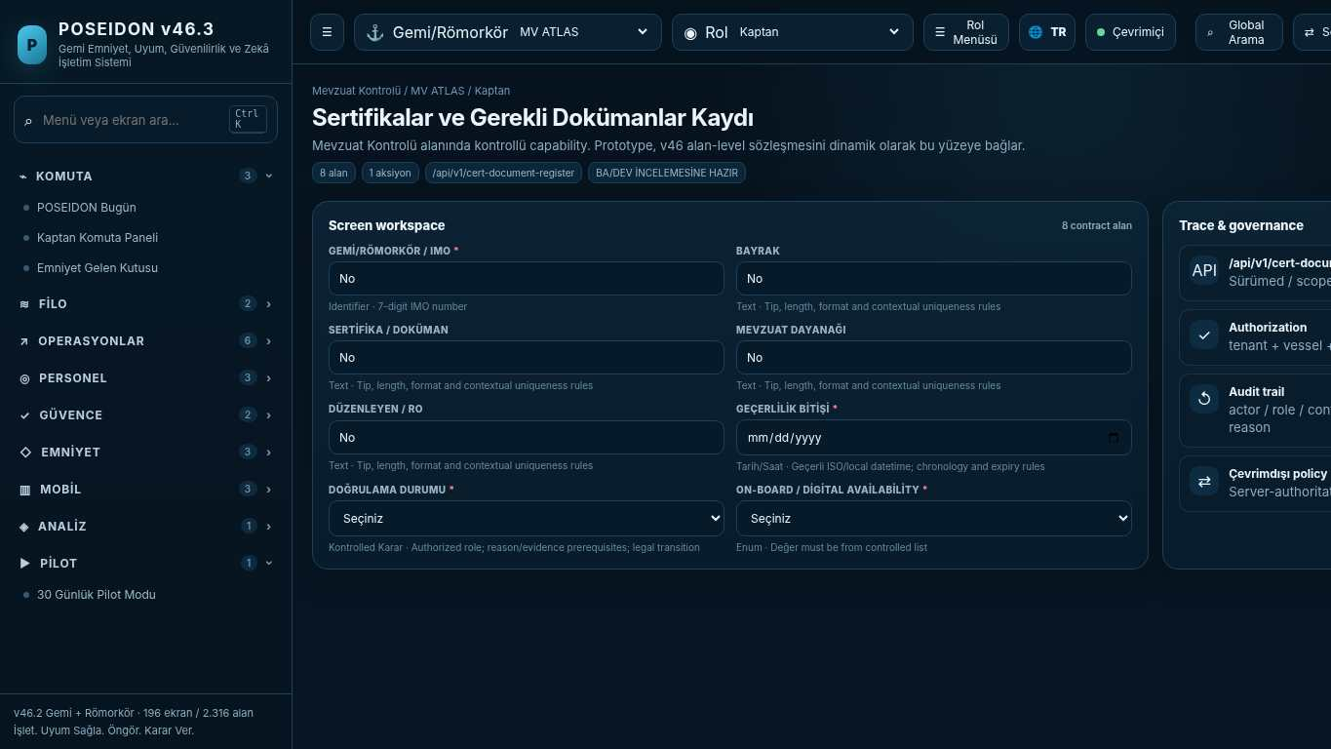
API projection: /api/v1/cert-document-register | Status: READY FOR BA/DEV REVIEW

049 PSC Readiness 2026
Screen ID: psc-readiness-2026 | Domain: Regulatory Control | 0 alan / 1 aksiyon
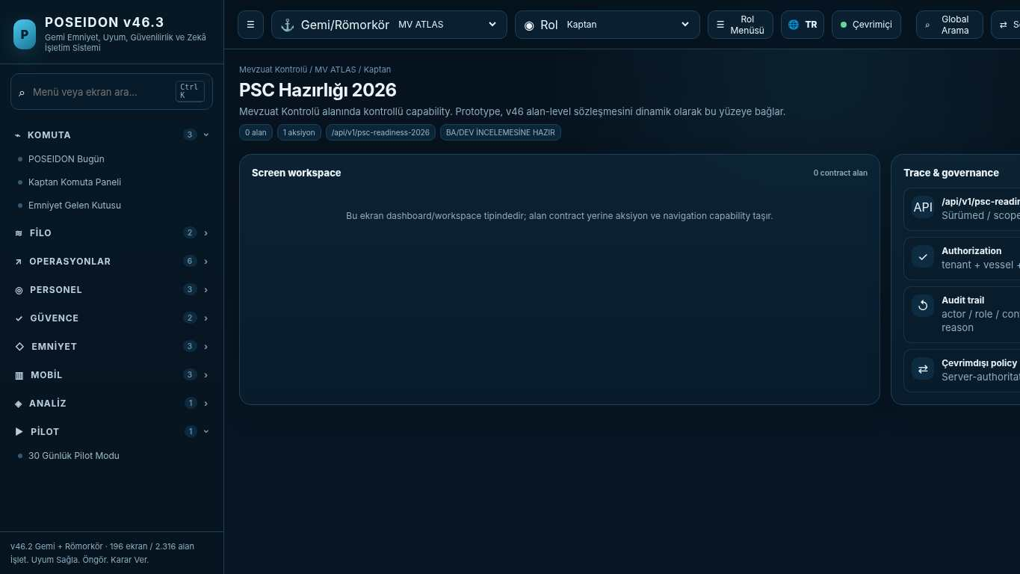
API projection: /api/v1/psc-readiness-2026 | Status: READY FOR BA/DEV REVIEW
———————————————————————————————————————————————————————
050 Regulatory Version & Change Register
Screen ID: regulatory-change-register | Domain: Regulatory Control | 0 alan / 1 aksiyon
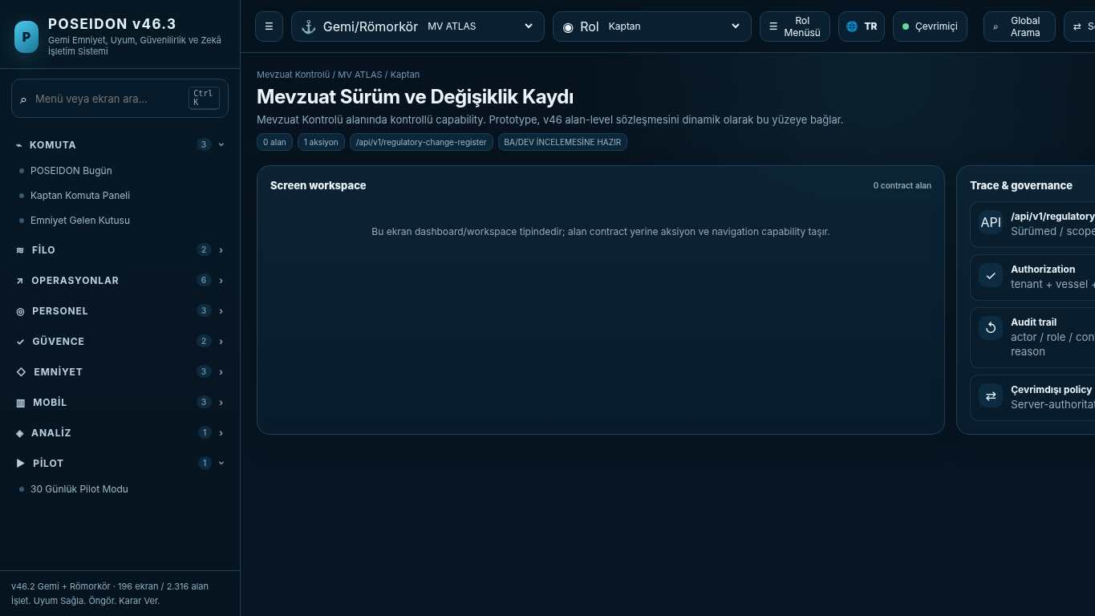
API projection: /api/v1/regulatory-change-register | Status: READY FOR BA/DEV REVIEW

051 Regulatory Change Impact
Screen ID: regulatory-impact | Domain: Regulatory Control | 0 alan / 1 aksiyon
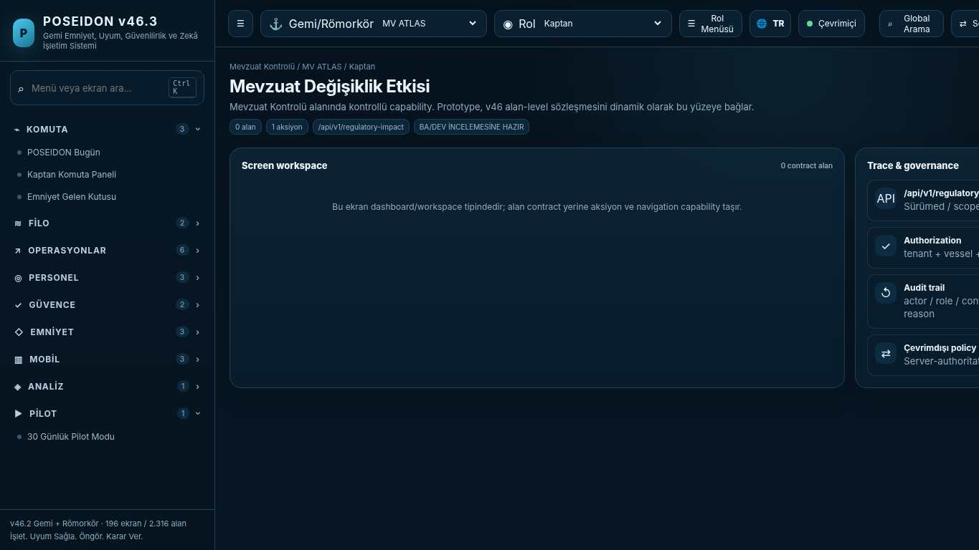
API projection: /api/v1/regulatory-impact | Status: READY FOR BA/DEV REVIEW
———————————————————————————————————————————————————————
052 Customer Success & Value
Screen ID: customer-value | Domain: Fleet Intelligence | 0 alan / 1 aksiyon
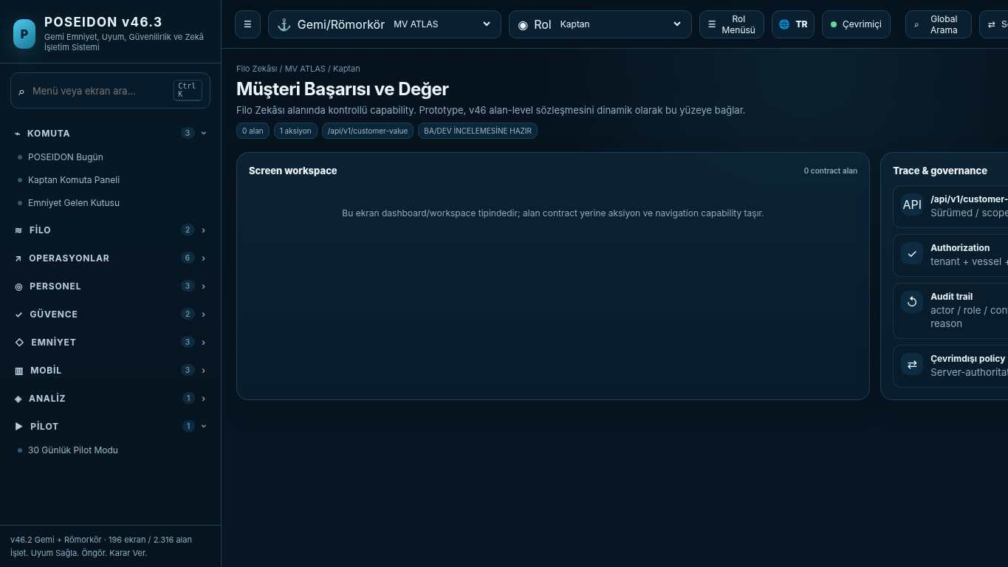
API projection: /api/v1/customer-value | Status: READY FOR BA/DEV REVIEW

053 Excel-to-POSEIDON Migration Wizard
Screen ID: excel-migration | Domain: Regulatory Control | 0 alan / 1 aksiyon
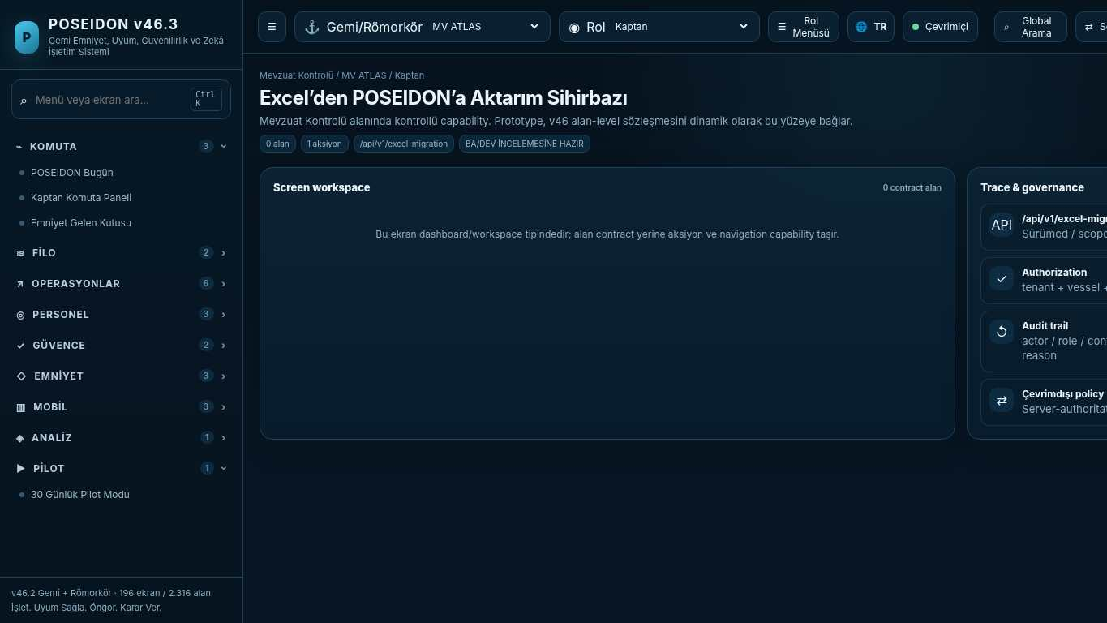
API projection: /api/v1/excel-migration | Status: READY FOR BA/DEV REVIEW
———————————————————————————————————————————————————————
054 30-Day Pilot Mode
Screen ID: pilot-mode | Domain: Fleet Intelligence | 0 alan / 1 aksiyon
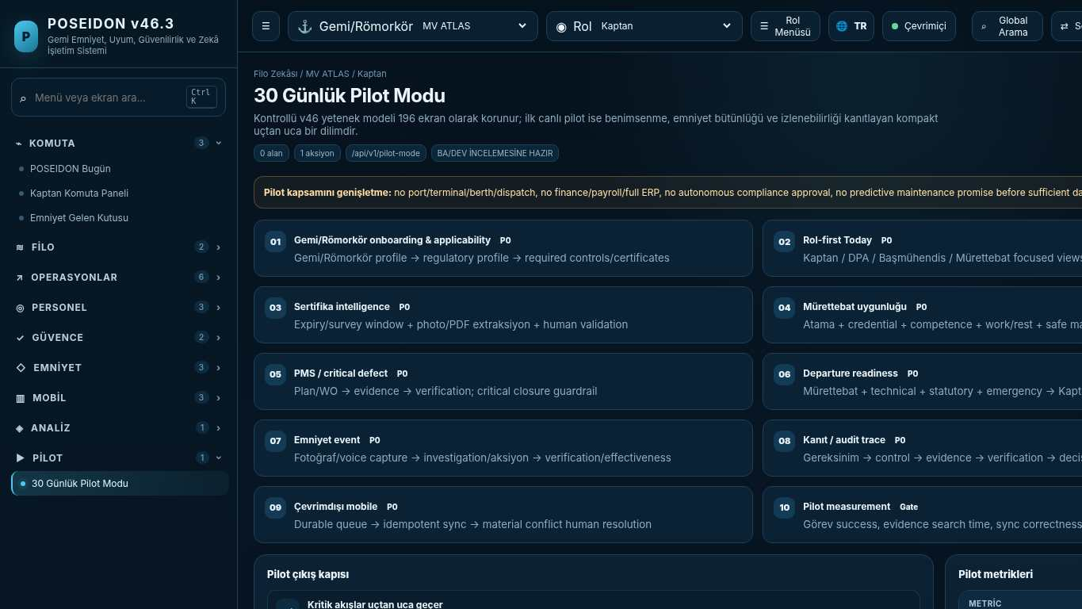
API projection: /api/v1/pilot-mode | Status: READY FOR BA/DEV REVIEW

055 POSEIDON Today
Screen ID: poseidon-today | Domain: Core Safety Operations | 0 alan / 6 aksiyon
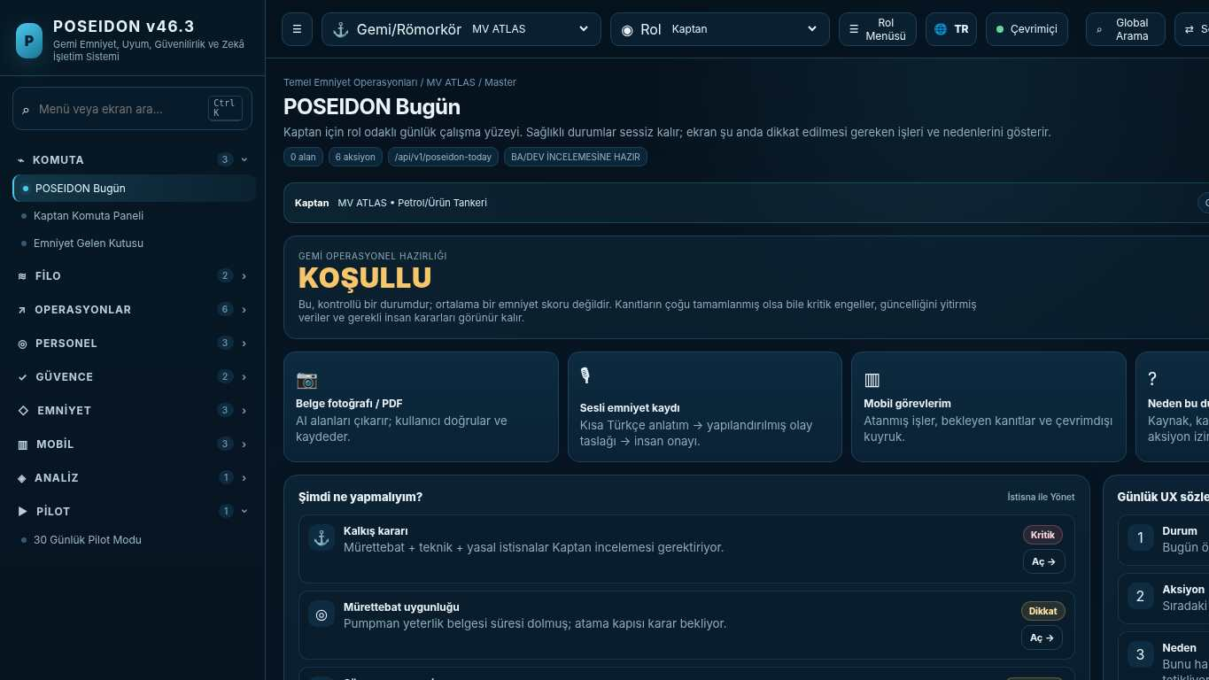
API projection: /api/v1/poseidon-today | Status: READY FOR BA/DEV REVIEW
———————————————————————————————————————————————————————
056 MV Atlas
Screen ID: my-vessel | Domain: Regulatory Control | 0 alan / 0 aksiyon
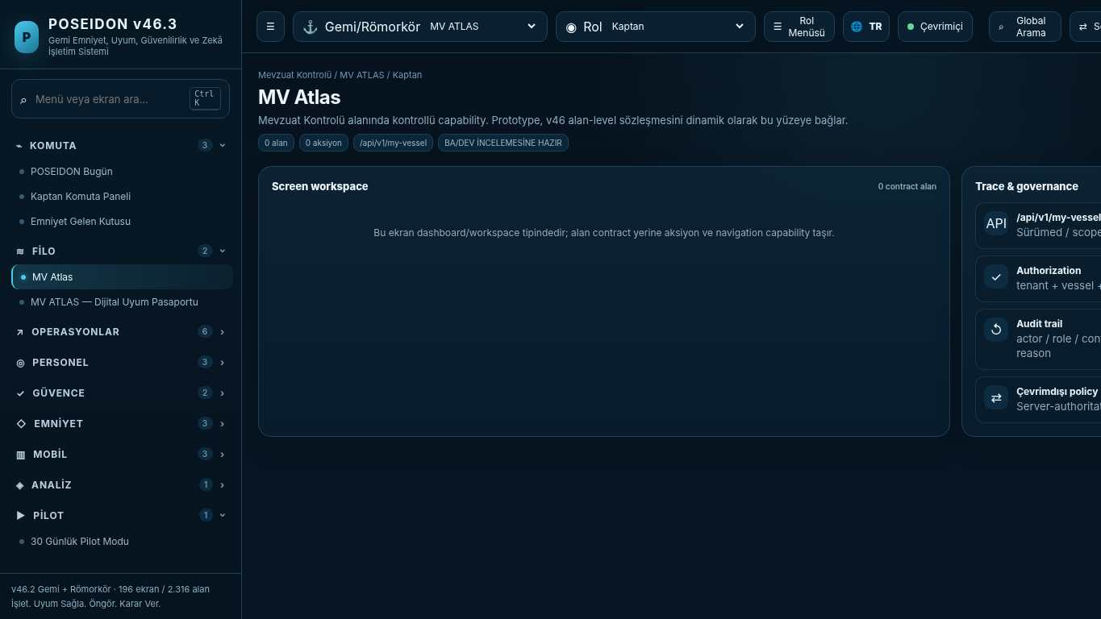
API projection: /api/v1/my-vessel | Status: READY FOR BA/DEV REVIEW

057 Operations
Screen ID: operations-workspace | Domain: Operations & Readiness | 0 alan / 0 aksiyon
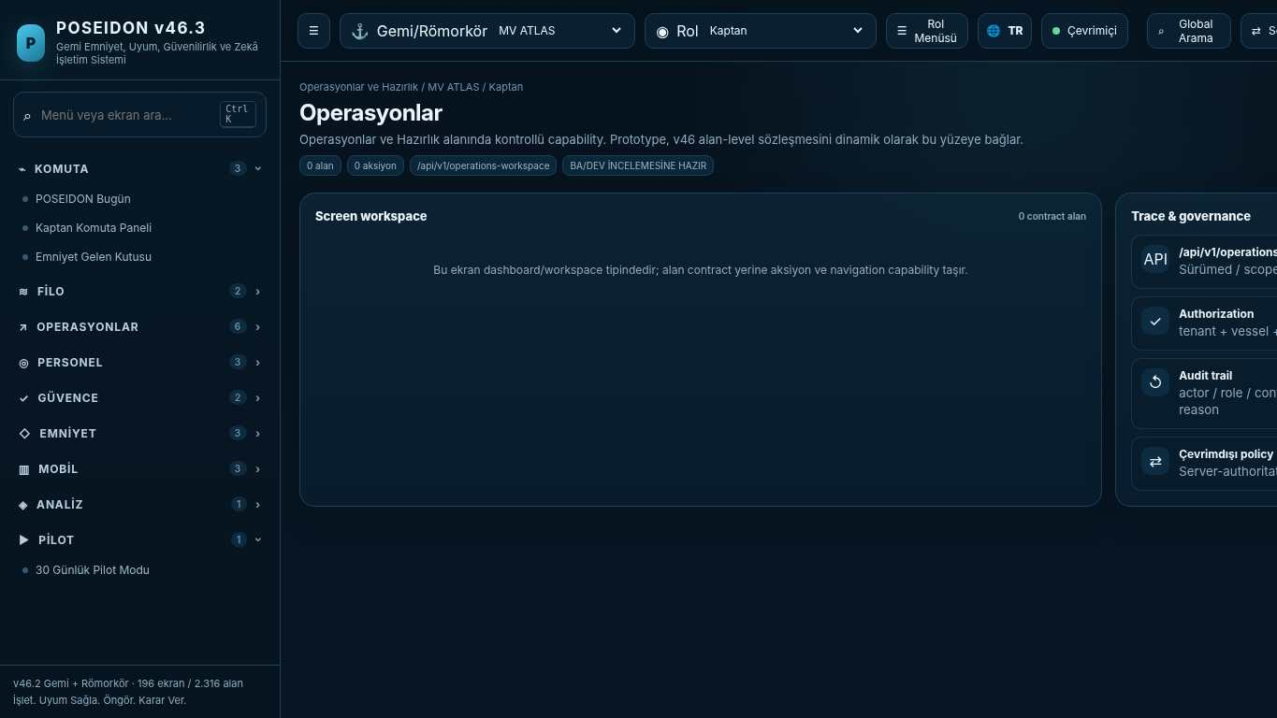
API projection: /api/v1/operations-workspace | Status: READY FOR BA/DEV REVIEW
———————————————————————————————————————————————————————
058 People
Screen ID: people-workspace | Domain: Crew & Competence | 0 alan / 0 aksiyon
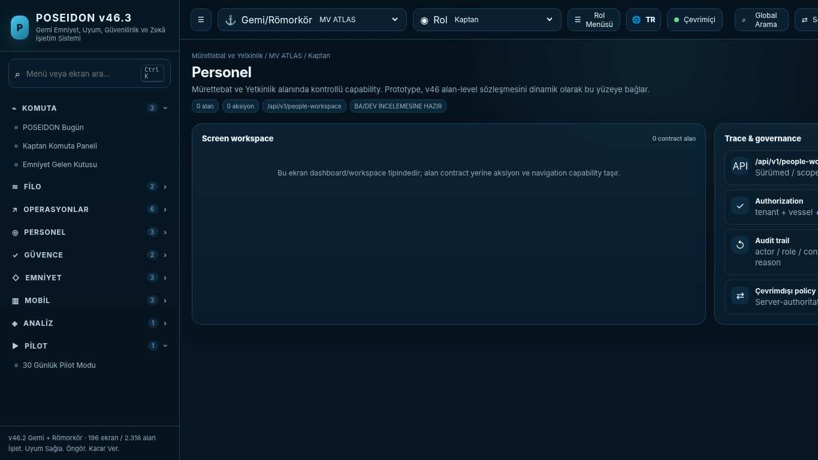
API projection: /api/v1/people-workspace | Status: READY FOR BA/DEV REVIEW

059 Technical Readiness
Screen ID: technical-workspace | Domain: Technical Safety | 0 alan / 0 aksiyon
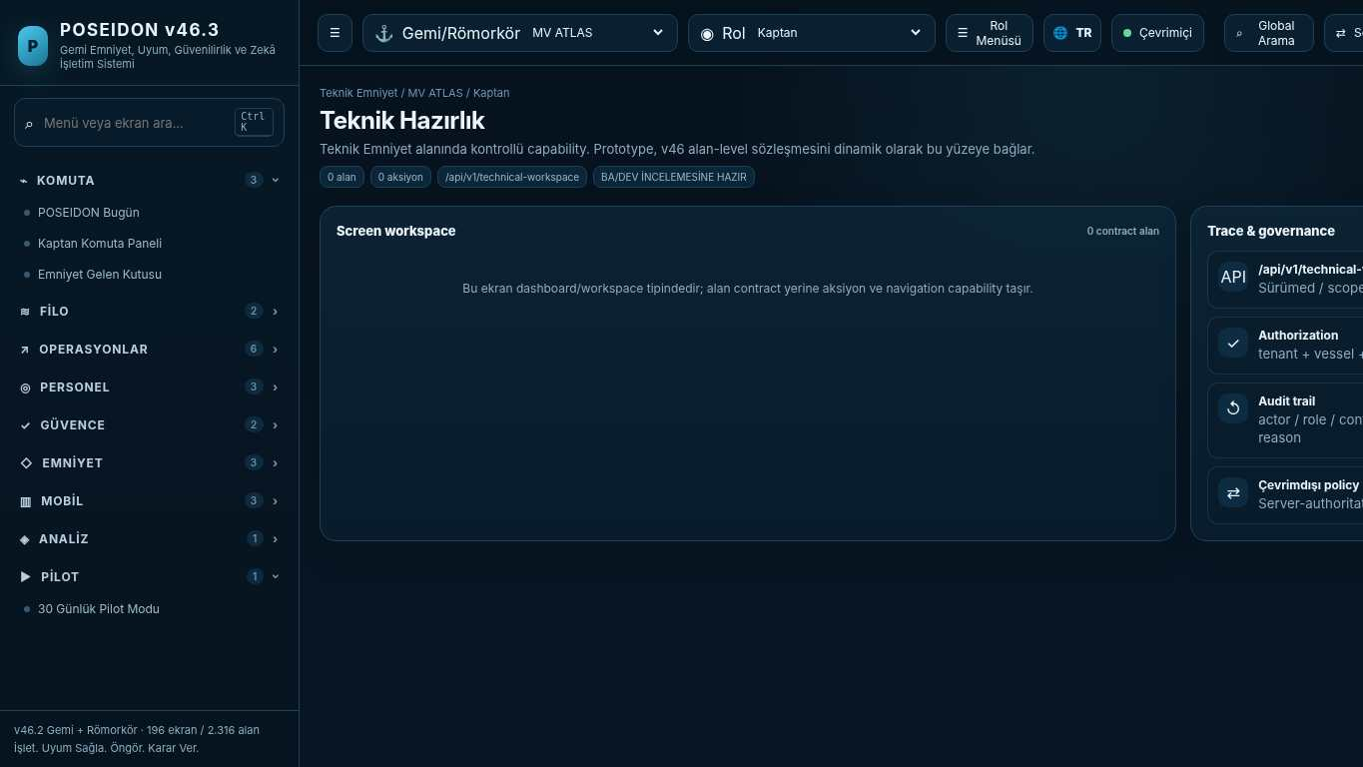
API projection: /api/v1/technical-workspace | Status: READY FOR BA/DEV REVIEW
———————————————————————————————————————————————————————
060 Safety & Emergency
Screen ID: safety-workspace | Domain: Safety & Learning | 0 alan / 0 aksiyon
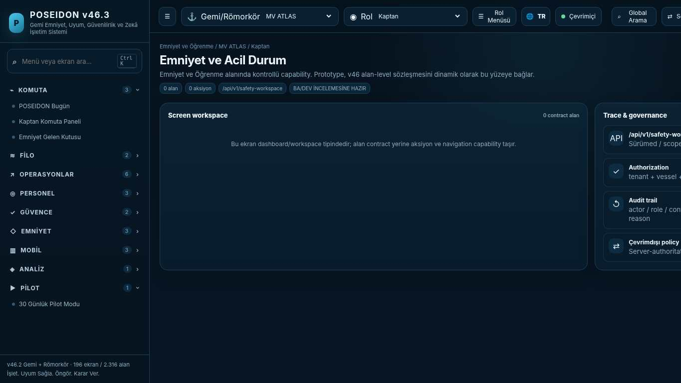
API projection: /api/v1/safety-workspace | Status: READY FOR BA/DEV REVIEW

061 Compliance
Screen ID: compliance-workspace | Domain: Regulatory Control | 0 alan / 0 aksiyon
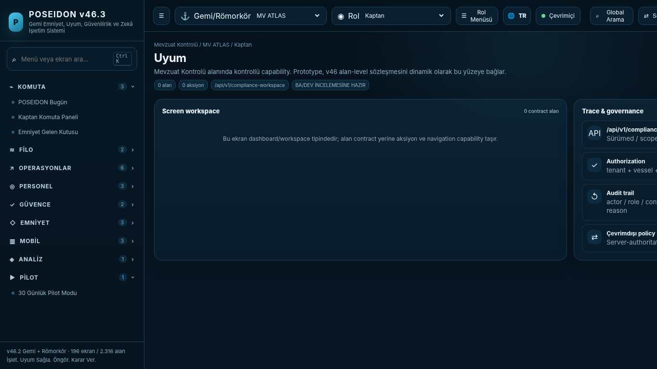
API projection: /api/v1/compliance-workspace | Status: READY FOR BA/DEV REVIEW
———————————————————————————————————————————————————————
062 Audit Ready
Screen ID: audit-ready | Domain: Regulatory Control | 0 alan / 1 aksiyon
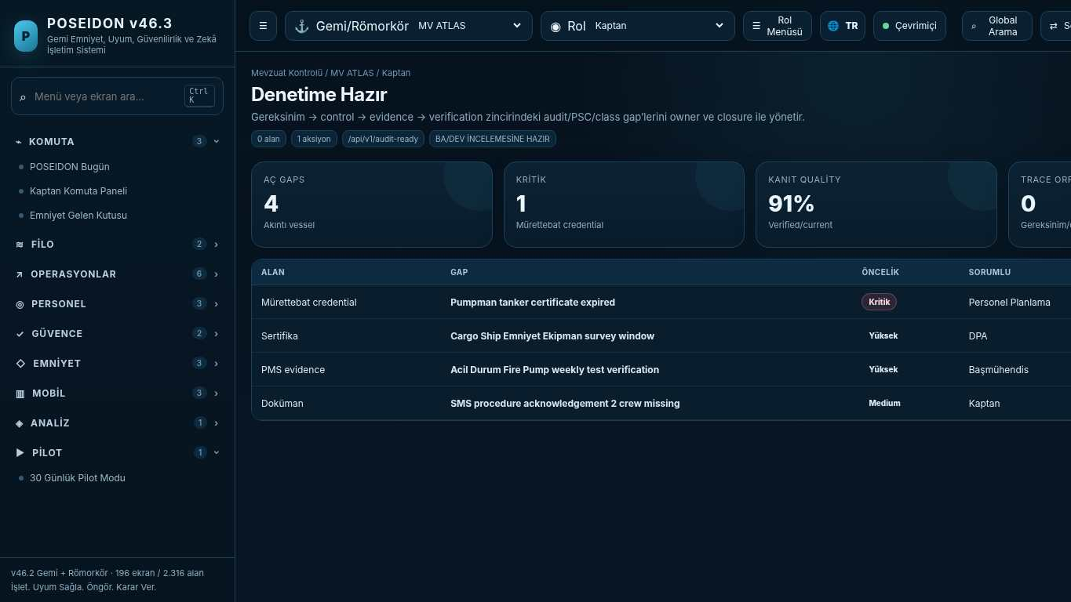
API projection: /api/v1/audit-ready | Status: READY FOR BA/DEV REVIEW

063 SIRE / TMSA Readiness
Screen ID: industry-assurance | Domain: Regulatory Control | 4 alan / 5 aksiyon
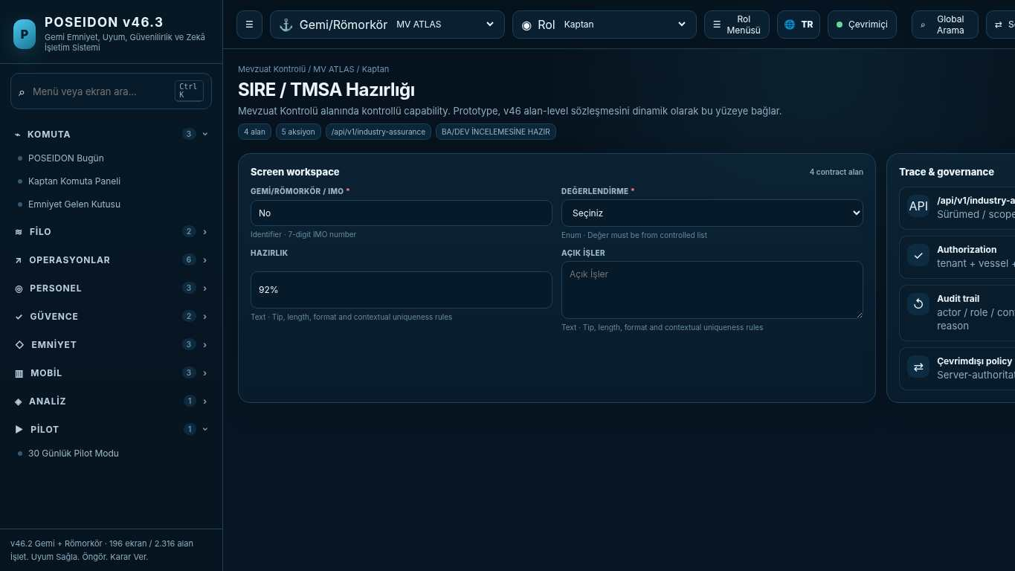
API projection: /api/v1/industry-assurance | Status: READY FOR BA/DEV REVIEW
———————————————————————————————————————————————————————
064 Mobile / Offline Operations
Screen ID: mobile-operations | Domain: Regulatory Control | 0 alan / 4 aksiyon
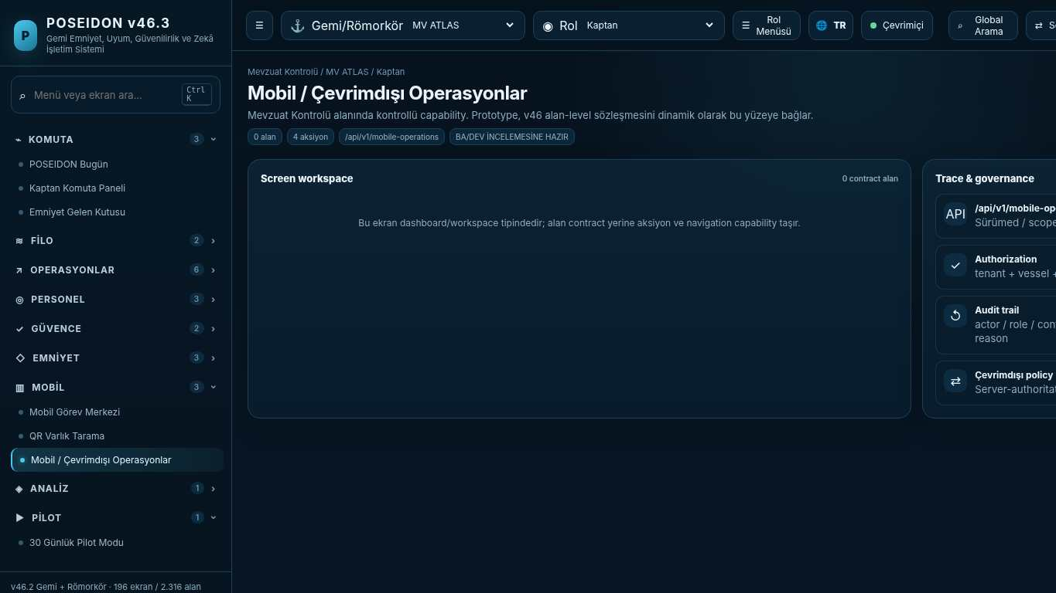
API projection: /api/v1/mobile-operations | Status: READY FOR BA/DEV REVIEW

065 Integration Hub
Screen ID: integration-hub | Domain: Safety & Learning | 0 alan / 0 aksiyon
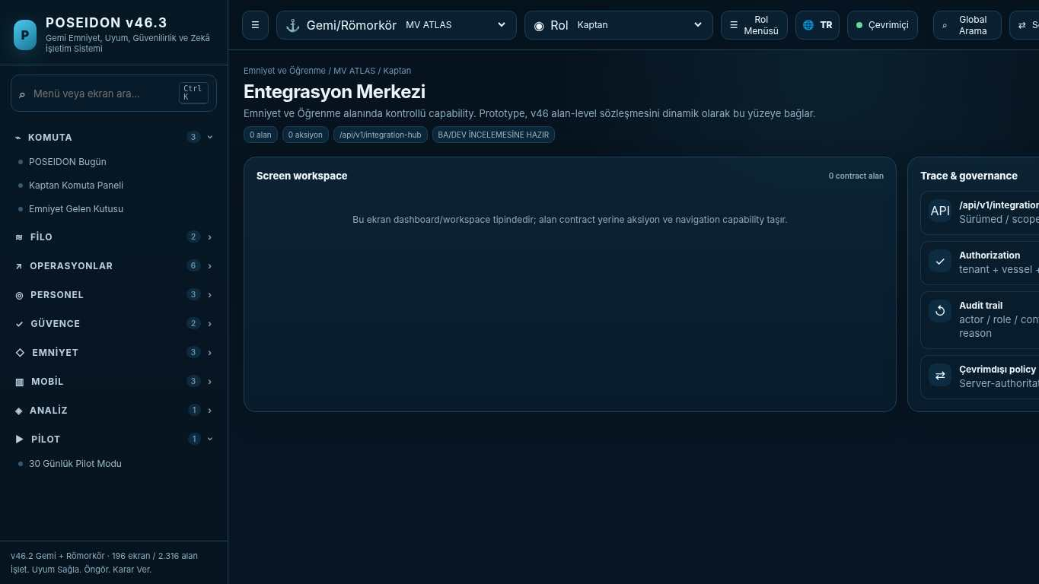
API projection: /api/v1/integration-hub | Status: READY FOR BA/DEV REVIEW
———————————————————————————————————————————————————————
066 Commercial Packages
Screen ID: commercial-packages | Domain: Core Safety Operations | 0 alan / 3 aksiyon
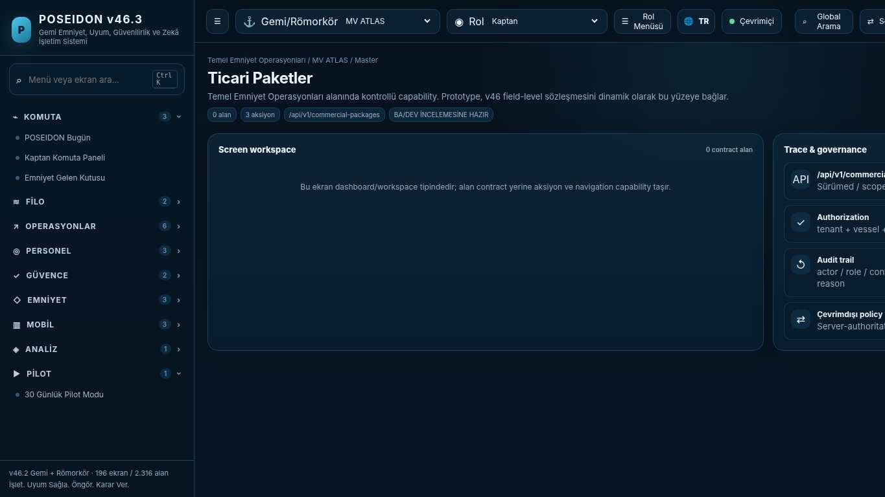
API projection: /api/v1/commercial-packages | Status: READY FOR BA/DEV REVIEW

067 7-Minute Buyer Demo
Screen ID: seven-minute-demo | Domain: Core Safety Operations | 0 alan / 1 aksiyon
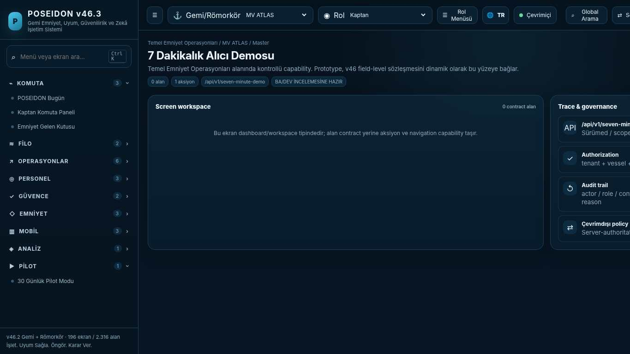
API projection: /api/v1/seven-minute-demo | Status: READY FOR BA/DEV REVIEW
———————————————————————————————————————————————————————
068 Operational Command Home
Screen ID: production-home | Domain: Operations & Readiness | 8 alan / 6 aksiyon
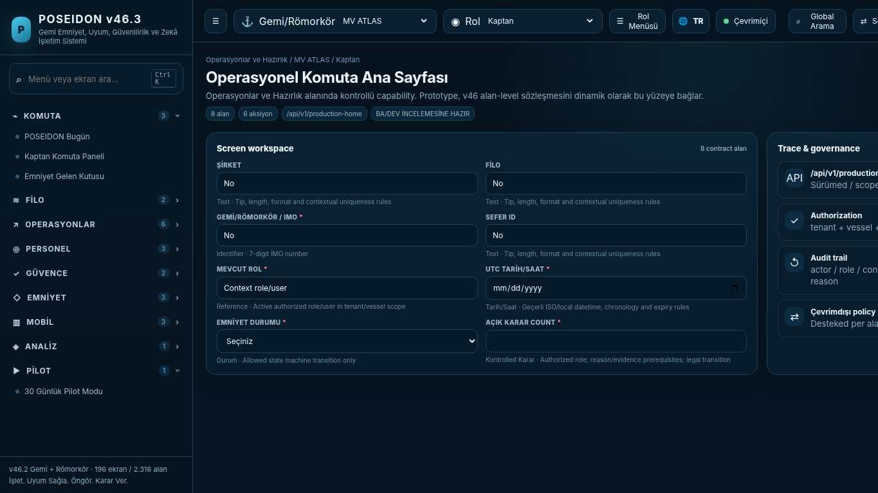
API projection: /api/v1/production-home | Status: READY FOR BA/DEV REVIEW

069 Compliance Center
Screen ID: regulatory-library | Domain: Regulatory Control | 8 alan / 6 aksiyon
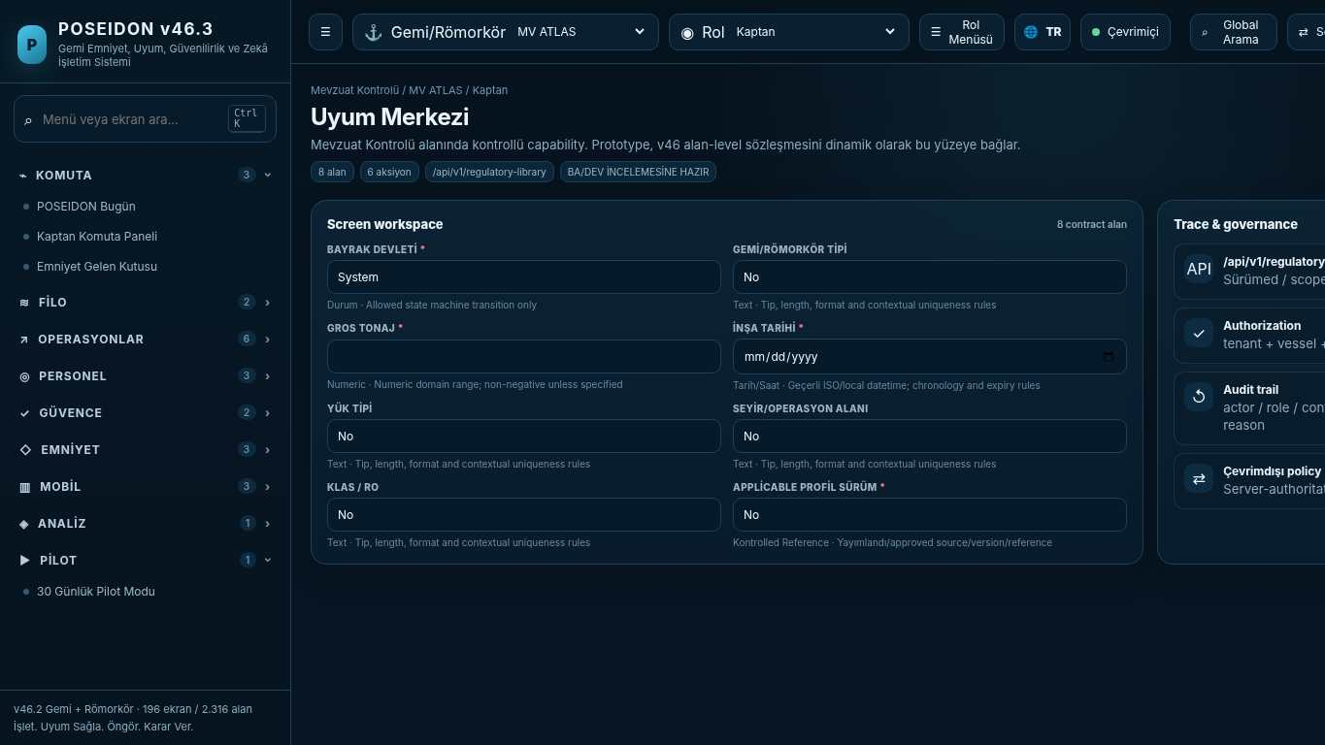
API projection: /api/v1/regulatory-library | Status: READY FOR BA/DEV REVIEW
———————————————————————————————————————————————————————
070 ISPS Security Control
Screen ID: isps-security | Domain: Regulatory Control | 17 alan / 6 aksiyon
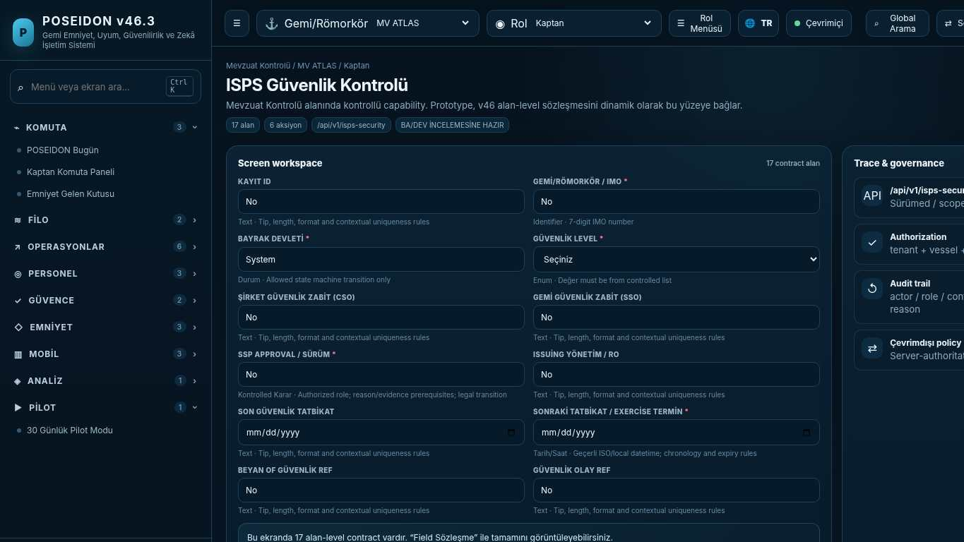
API projection: /api/v1/isps-security | Status: READY FOR BA/DEV REVIEW

071 Ballast Water Compliance
Screen ID: bwm-compliance | Domain: Regulatory Control | 19 alan / 6 aksiyon
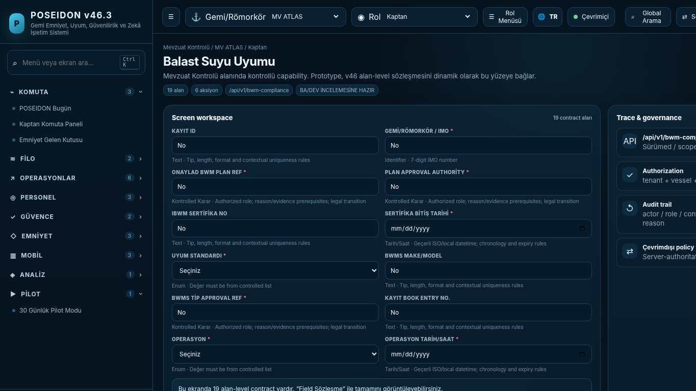
API projection: /api/v1/bwm-compliance | Status: READY FOR BA/DEV REVIEW
———————————————————————————————————————————————————————
072 COLREG Navigation
Screen ID: colreg-navigation | Domain: Operations & Readiness | 21 alan / 6 aksiyon
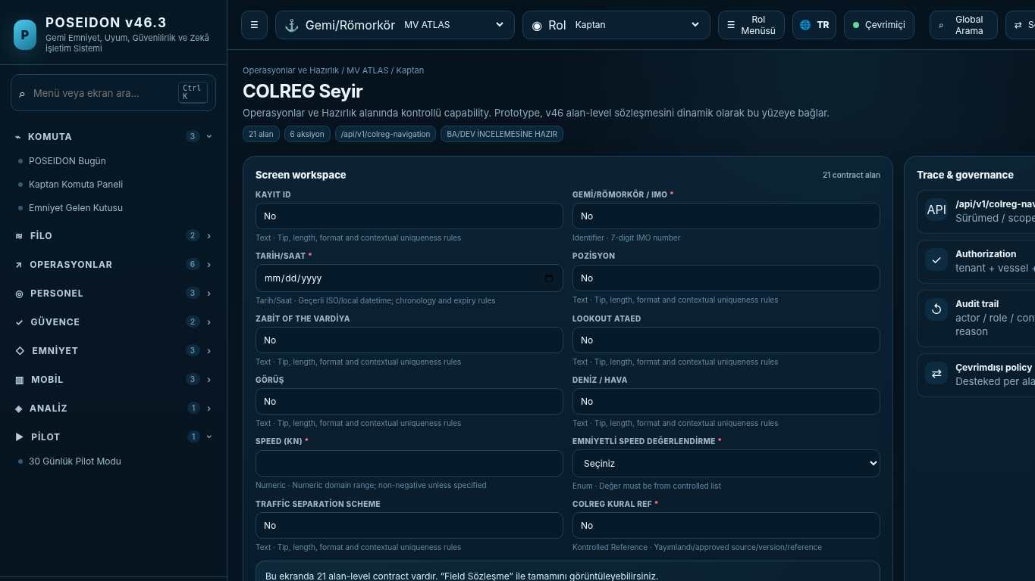
API projection: /api/v1/colreg-navigation | Status: READY FOR BA/DEV REVIEW

073 Load Line Control
Screen ID: loadline-control | Domain: Regulatory Control | 16 alan / 6 aksiyon
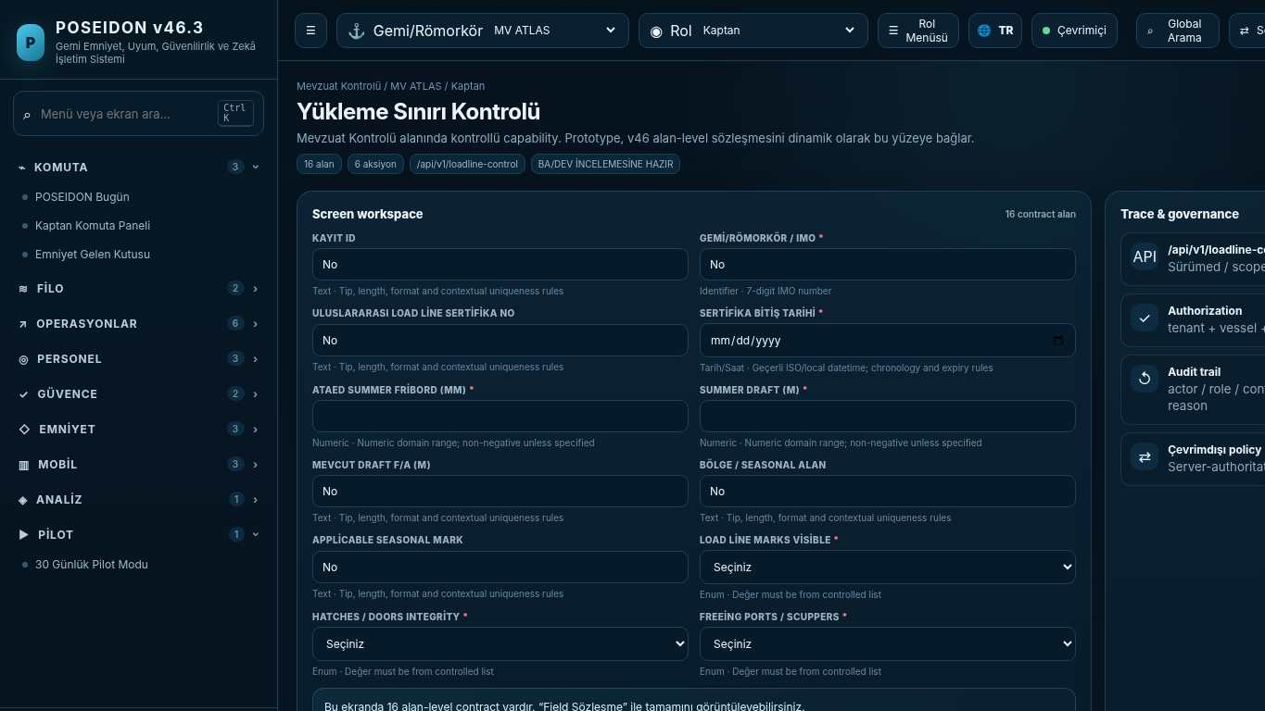
API projection: /api/v1/loadline-control | Status: READY FOR BA/DEV REVIEW
———————————————————————————————————————————————————————
074 Dangerous Goods Control
Screen ID: imdg-control | Domain: Operations & Readiness | 21 alan / 6 aksiyon
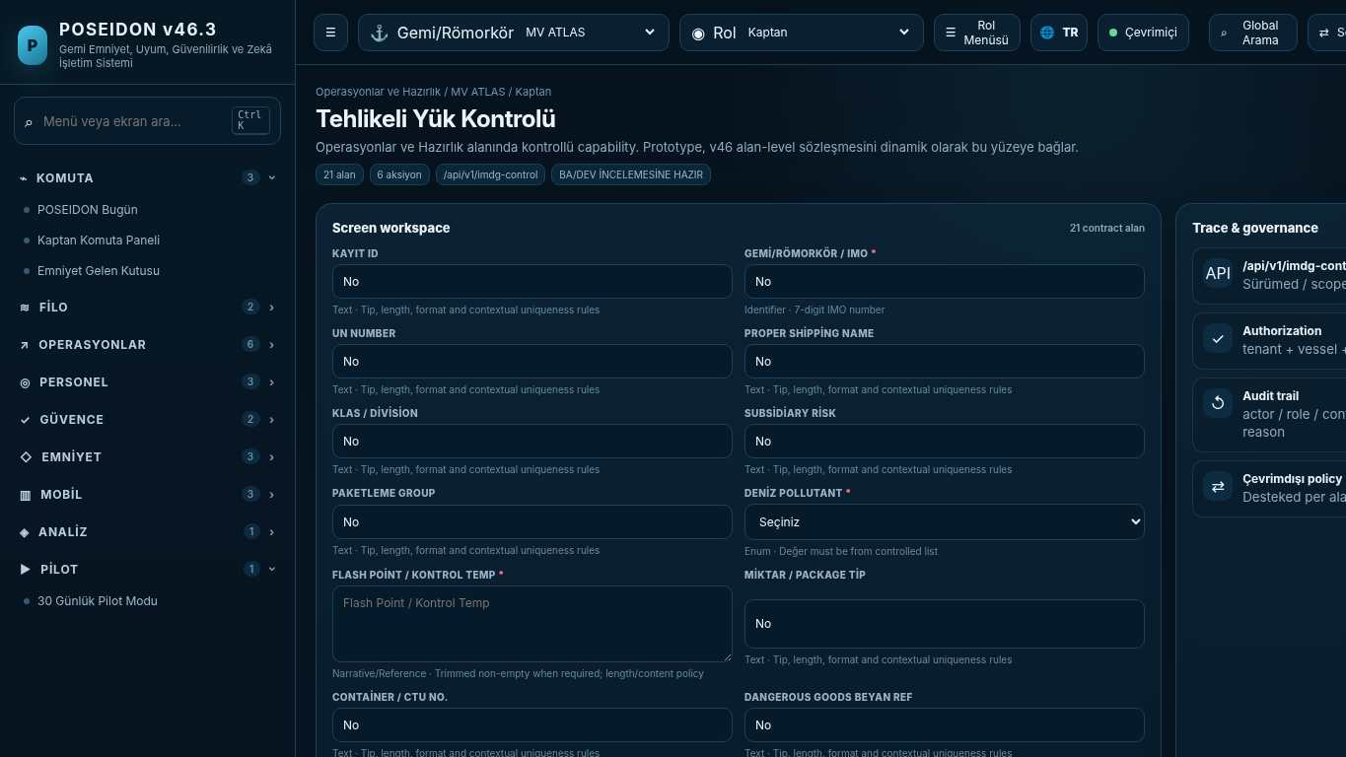
API projection: /api/v1/imdg-control | Status: READY FOR BA/DEV REVIEW

075 Statutory Certificate & PSC Readiness
Screen ID: statutory-readiness | Domain: Regulatory Control | 19 alan / 6 aksiyon
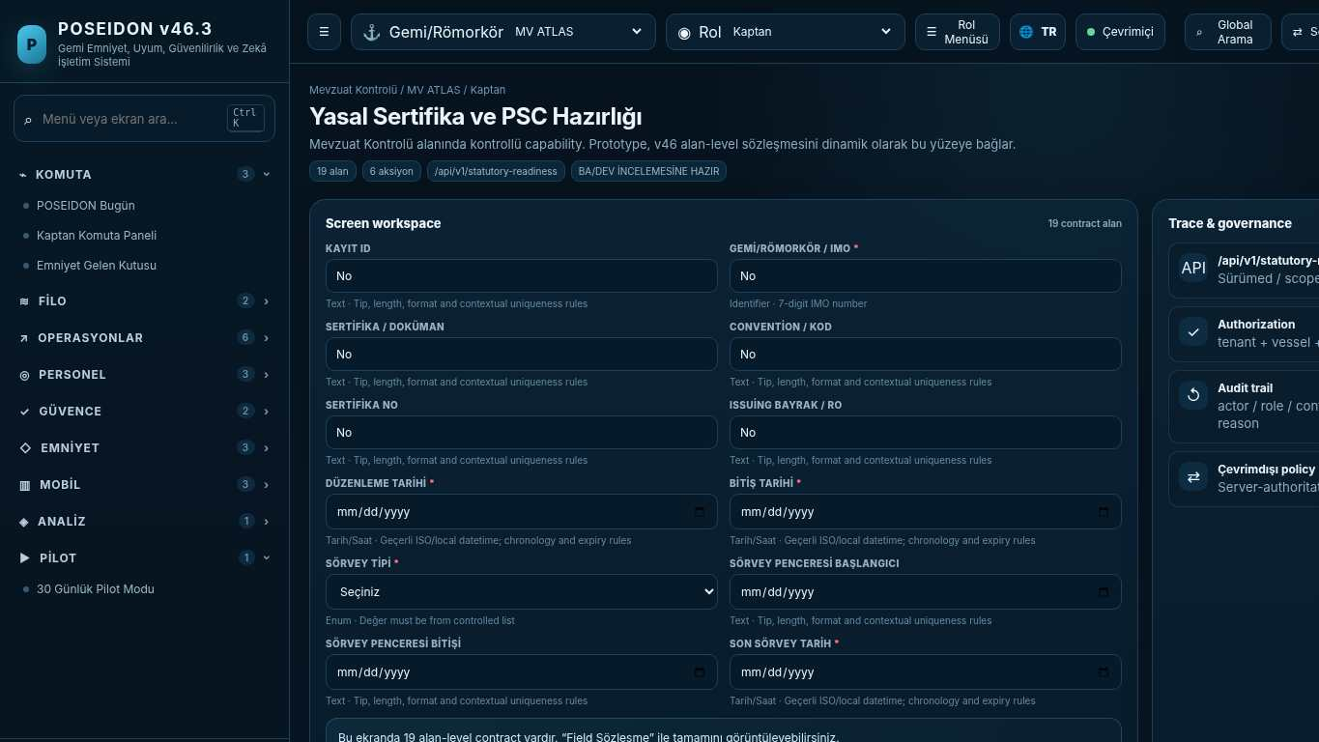
API projection: /api/v1/statutory-readiness | Status: READY FOR BA/DEV REVIEW
———————————————————————————————————————————————————————
076 Safety Command
Screen ID: safety-command | Domain: Safety & Learning | 17 alan / 8 aksiyon
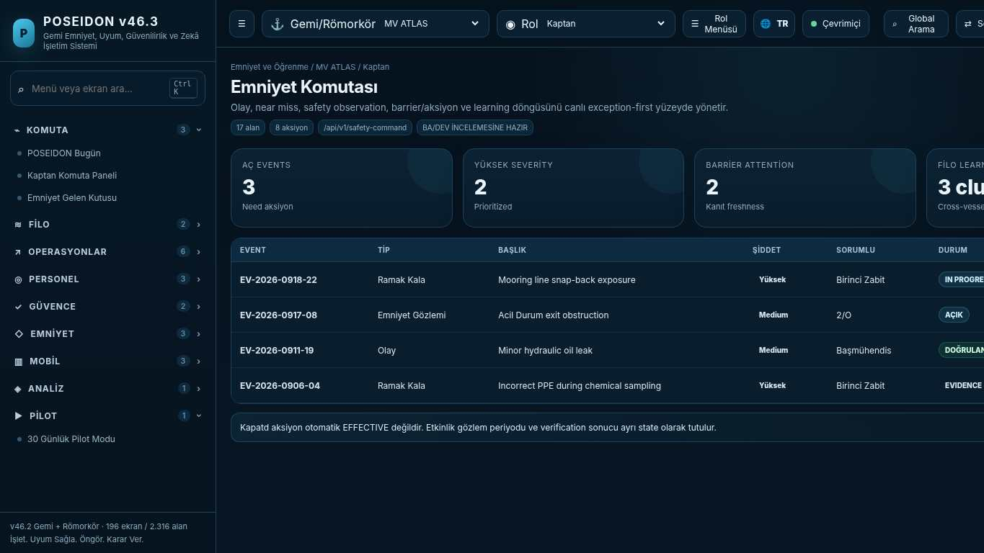
API projection: /api/v1/safety-command | Status: READY FOR BA/DEV REVIEW

077 Gemi Tipi Merkezi
Screen ID: vessel-type-hub | Domain: Regulatory Control | 0 alan / 0 aksiyon
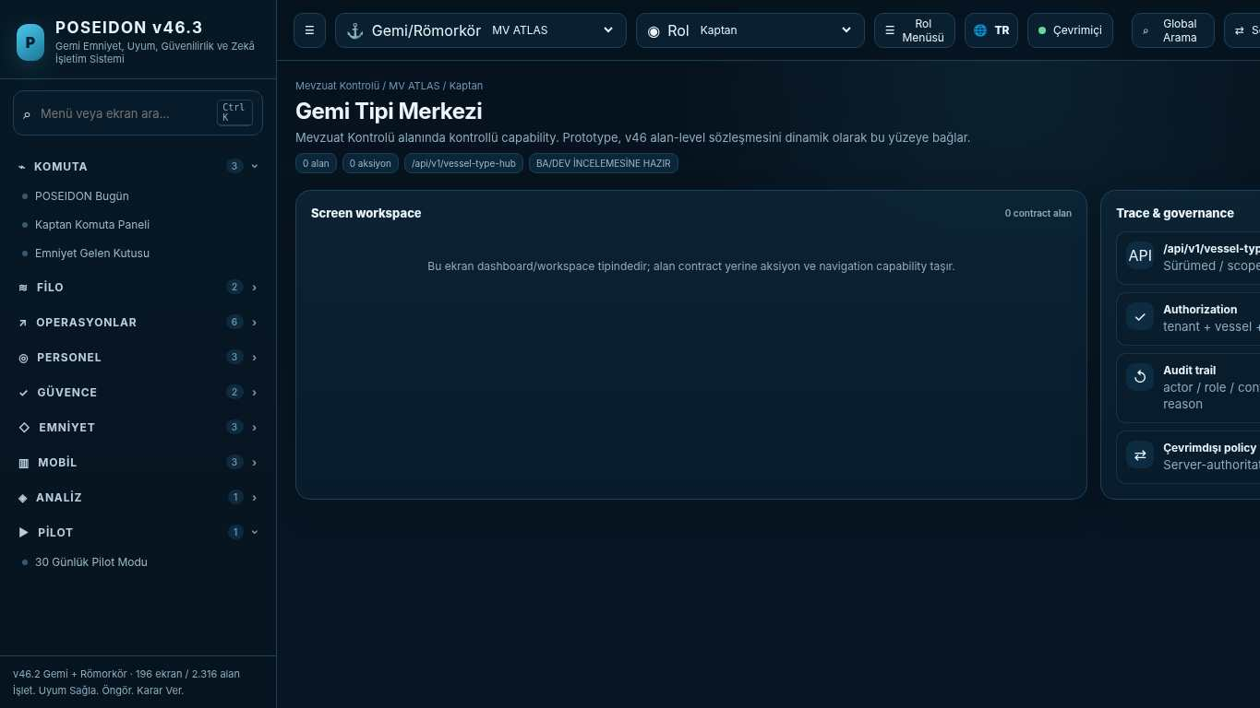
API projection: /api/v1/vessel-type-hub | Status: READY FOR BA/DEV REVIEW
———————————————————————————————————————————————————————
078 Tanker Operasyon Alanı
Screen ID: tanker-workspace | Domain: Crew & Competence | 8 alan / 13 aksiyon
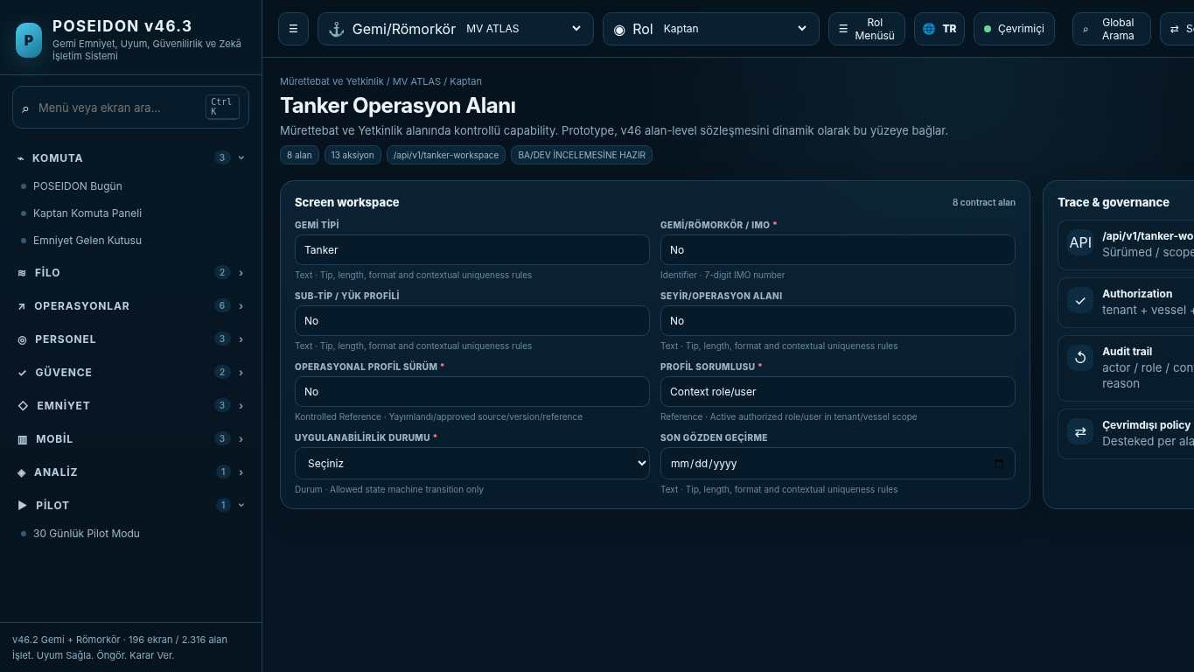
API projection: /api/v1/tanker-workspace | Status: READY FOR BA/DEV REVIEW

079 Oil / Product Tanker
Screen ID: oil-tanker-workspace | Domain: Operations & Readiness | 8 alan / 10 aksiyon
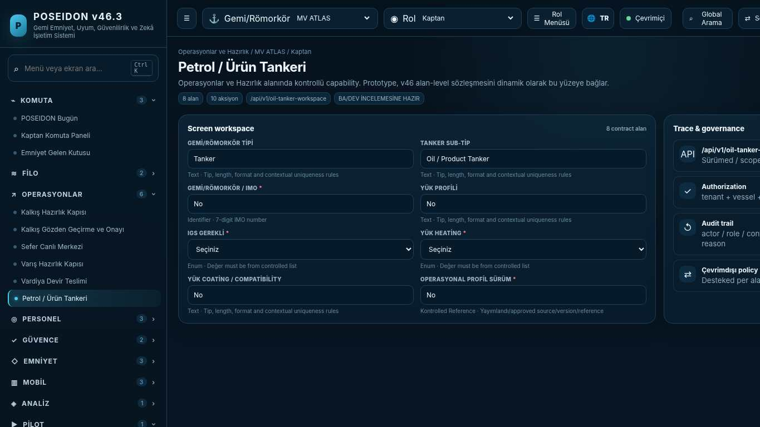
API projection: /api/v1/oil-tanker-workspace | Status: READY FOR BA/DEV REVIEW
———————————————————————————————————————————————————————
080 Chemical Tanker
Screen ID: chemical-tanker-workspace | Domain: Operations & Readiness | 8 alan / 10 aksiyon
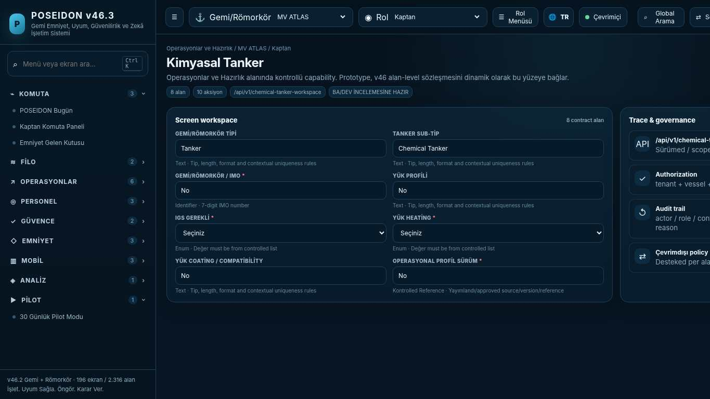
API projection: /api/v1/chemical-tanker-workspace | Status: READY FOR BA/DEV REVIEW

081 Liquefied Gas Tanker
Screen ID: gas-tanker-workspace | Domain: Operations & Readiness | 12 alan / 9 aksiyon
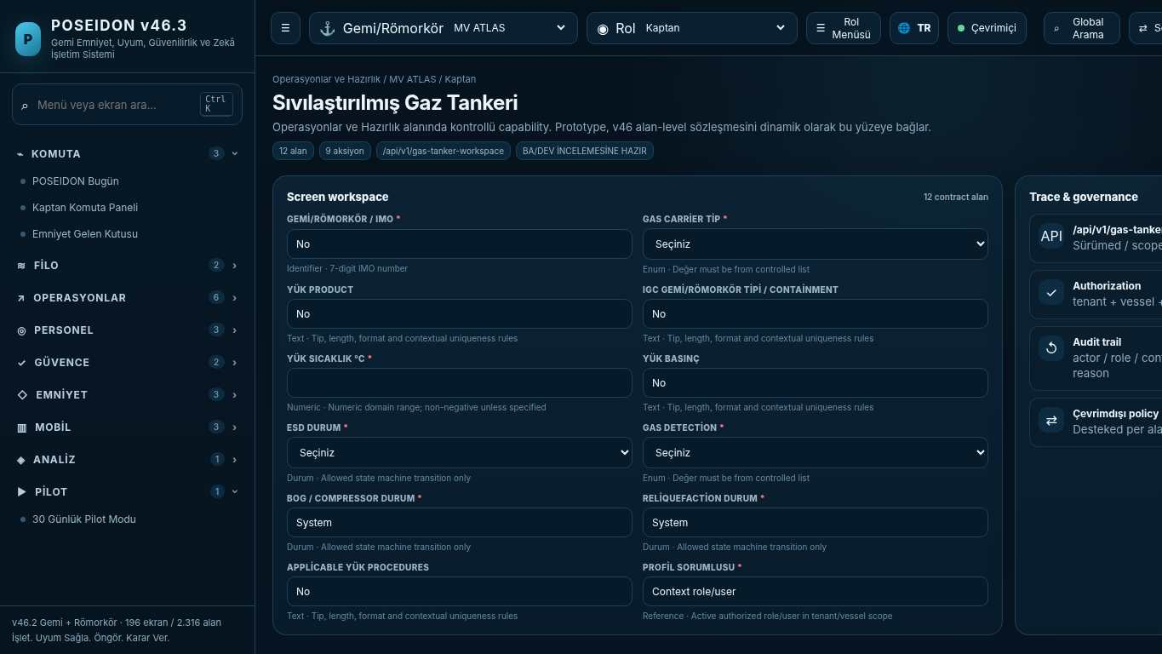
API projection: /api/v1/gas-tanker-workspace | Status: READY FOR BA/DEV REVIEW
———————————————————————————————————————————————————————
082 Bulk Carrier Operasyon Alanı
Screen ID: bulk-workspace | Domain: Crew & Competence | 8 alan / 10 aksiyon
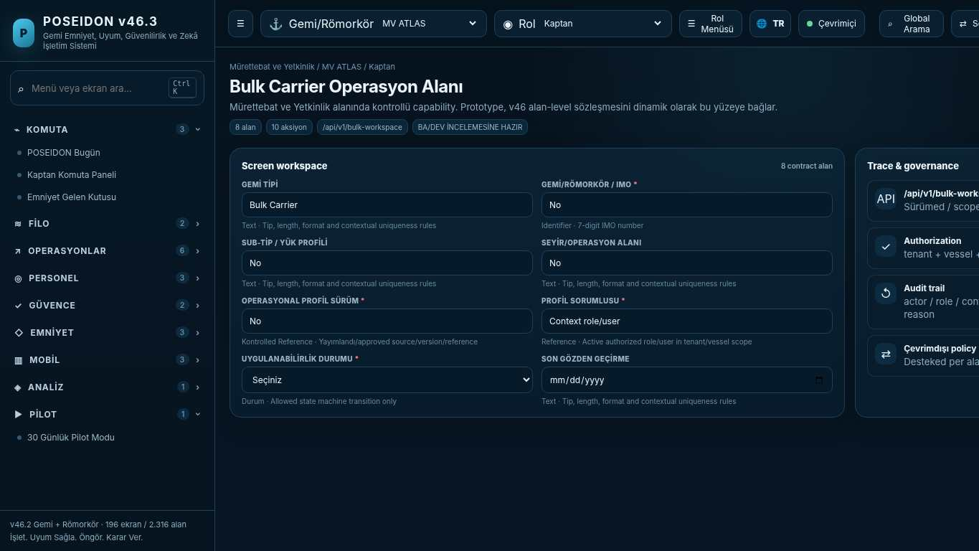
API projection: /api/v1/bulk-workspace | Status: READY FOR BA/DEV REVIEW

083 Container Operasyon Alanı
Screen ID: container-workspace | Domain: Operations & Readiness | 8 alan / 10 aksiyon
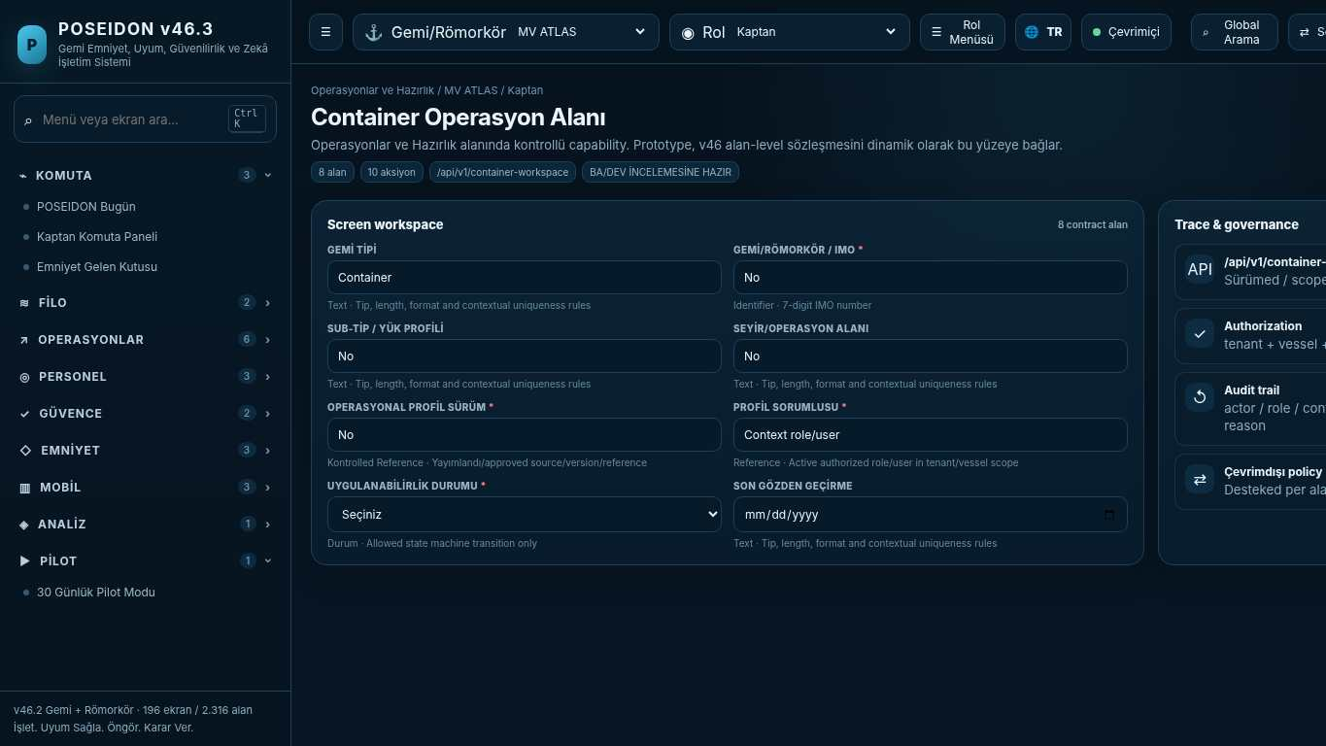
API projection: /api/v1/container-workspace | Status: READY FOR BA/DEV REVIEW
———————————————————————————————————————————————————————
084 Römorkör Operasyon Alanı
Screen ID: tug-workspace | Domain: Crew & Competence | 8 alan / 10 aksiyon
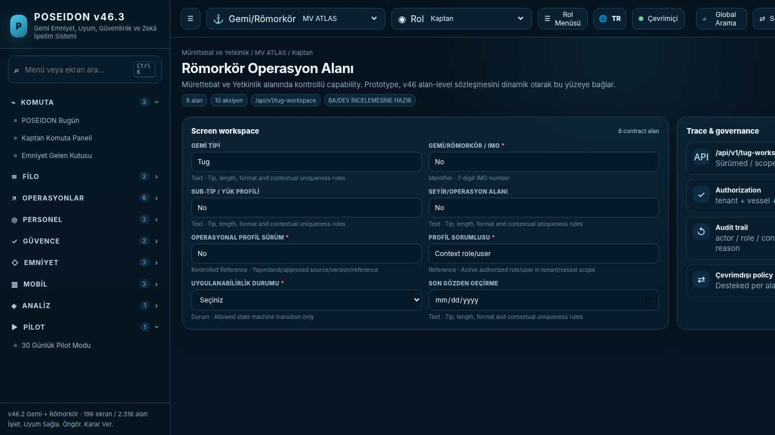
API projection: /api/v1/tug-workspace | Status: READY FOR BA/DEV REVIEW

085 Fleet & Vessels
Screen ID: fleet-vessels | Domain: Fleet Intelligence | 27 alan / 6 aksiyon
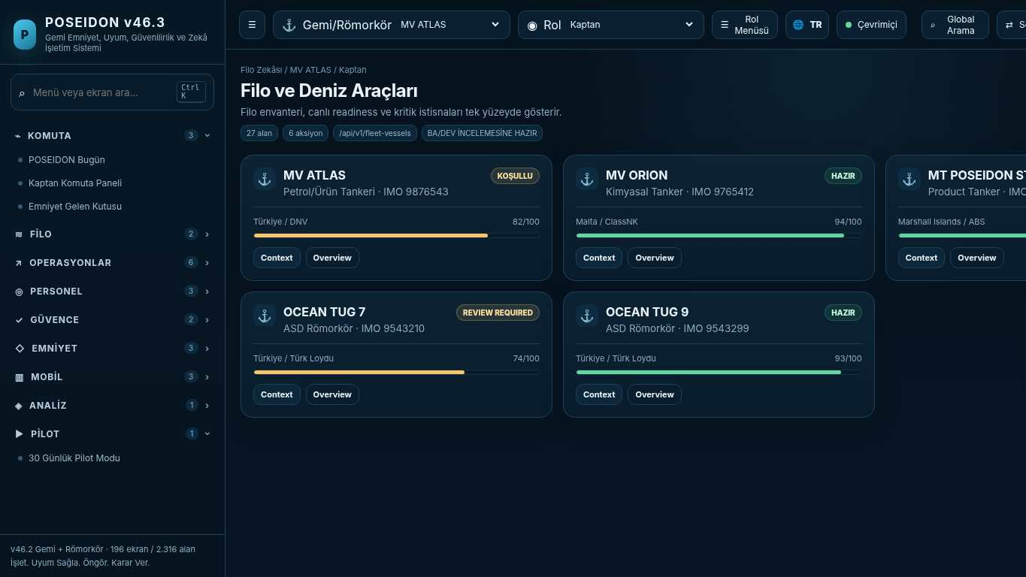
API projection: /api/v1/fleet-vessels | Status: READY FOR BA/DEV REVIEW
———————————————————————————————————————————————————————
086 DPA Bridge
Screen ID: dpa-bridge | Domain: Safety & Learning | 17 alan / 8 aksiyon
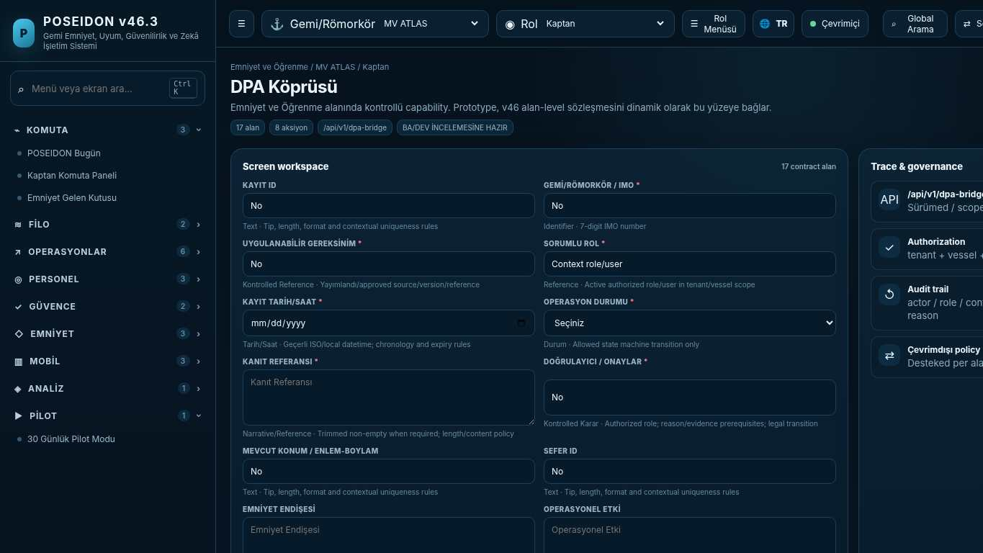
API projection: /api/v1/dpa-bridge | Status: READY FOR BA/DEV REVIEW

087 Master's Command
Screen ID: masters-command | Domain: Safety & Learning | 17 alan / 9 aksiyon
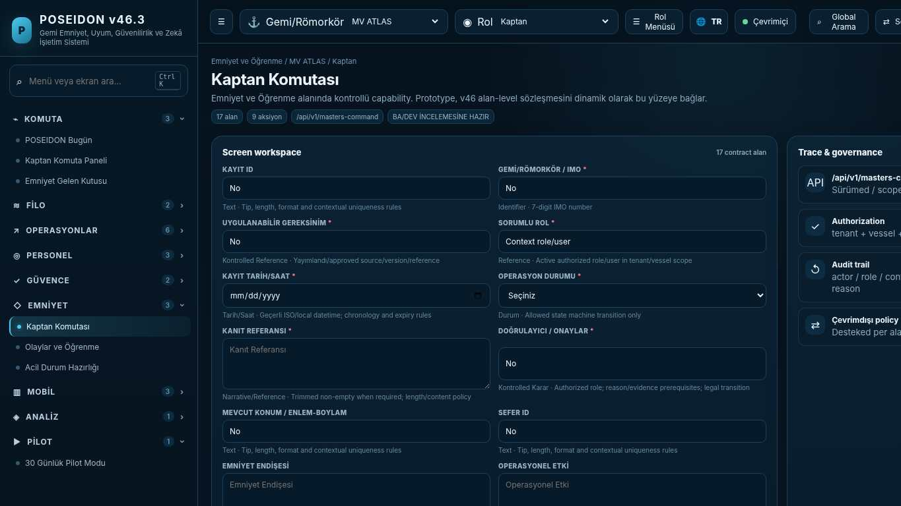
API projection: /api/v1/masters-command | Status: READY FOR BA/DEV REVIEW
———————————————————————————————————————————————————————
088 Cargo Applicability Engine
Screen ID: cargo-applicability | Domain: Regulatory Control | 14 alan / 7 aksiyon
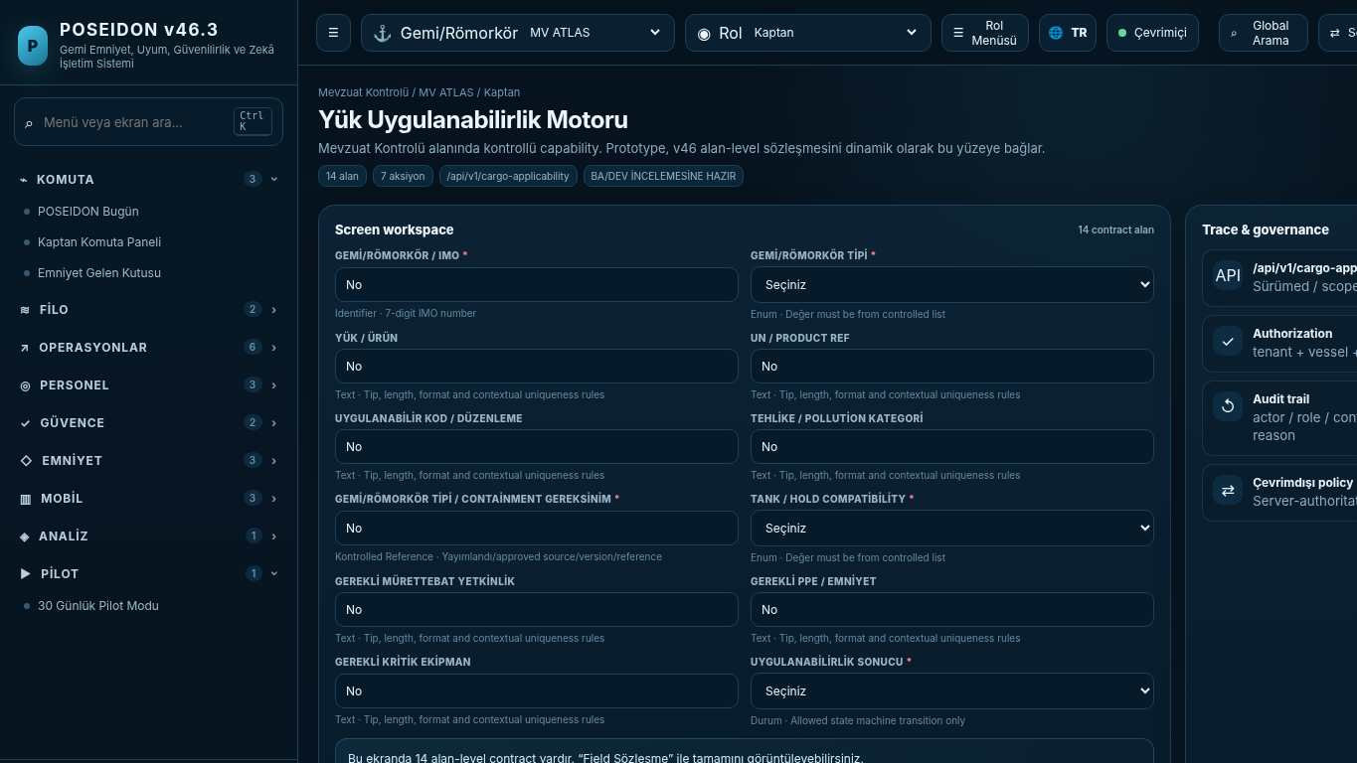
API projection: /api/v1/cargo-applicability | Status: READY FOR BA/DEV REVIEW

089 Ship Operations
Screen ID: ship-operations | Domain: Technical Safety | 23 alan / 6 aksiyon
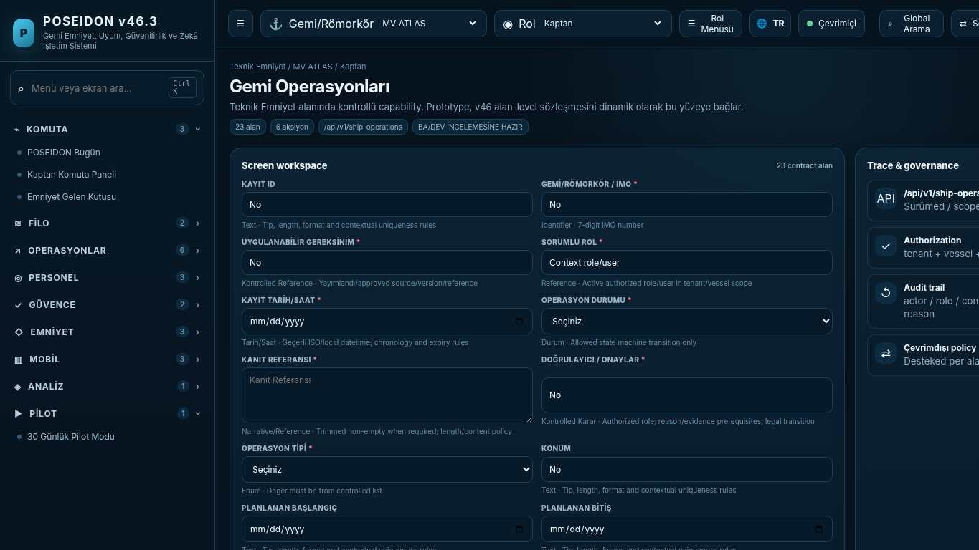
API projection: /api/v1/ship-operations | Status: READY FOR BA/DEV REVIEW
———————————————————————————————————————————————————————
090 Personel Yetkinlik Havuzu
Screen ID: competency-pool | Domain: Crew & Competence | 11 alan / 13 aksiyon
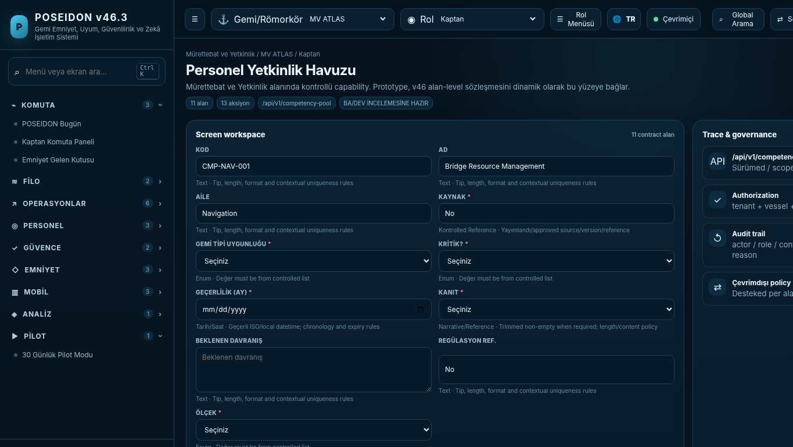
API projection: /api/v1/competency-pool | Status: READY FOR BA/DEV REVIEW

091 Yetkinlik Yönetimi
Screen ID: competency-management | Domain: Crew & Competence | 23 alan / 9 aksiyon
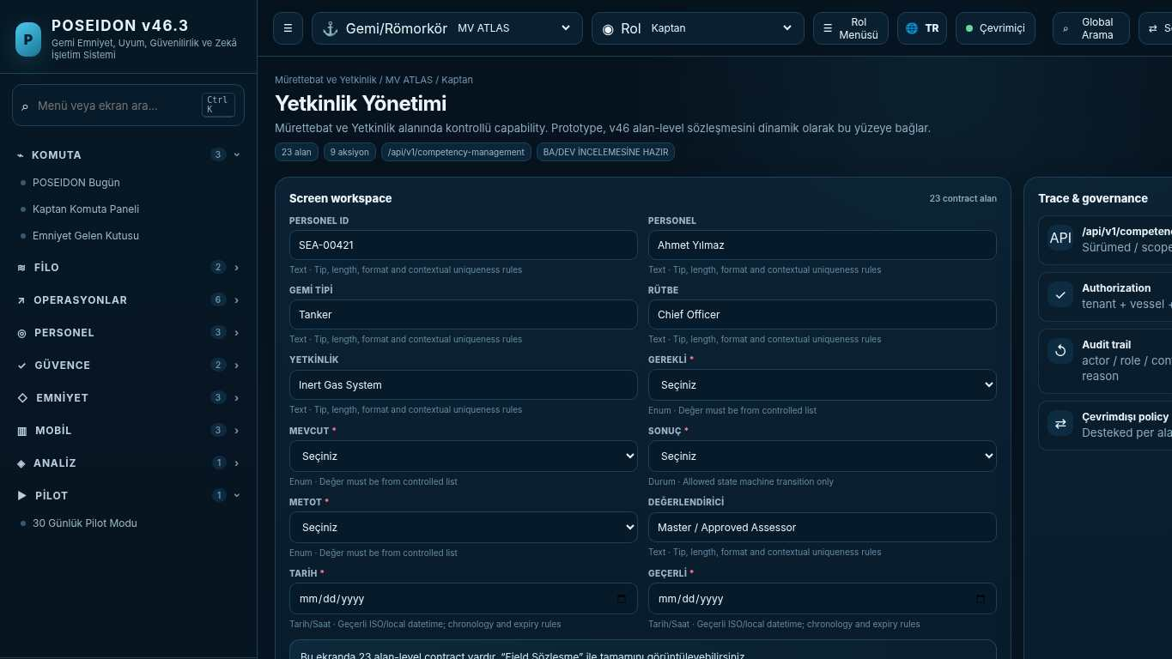
API projection: /api/v1/competency-management | Status: READY FOR BA/DEV REVIEW
———————————————————————————————————————————————————————
092 Crew & Competence
Screen ID: crew-competence | Domain: Regulatory Control | 24 alan / 6 aksiyon
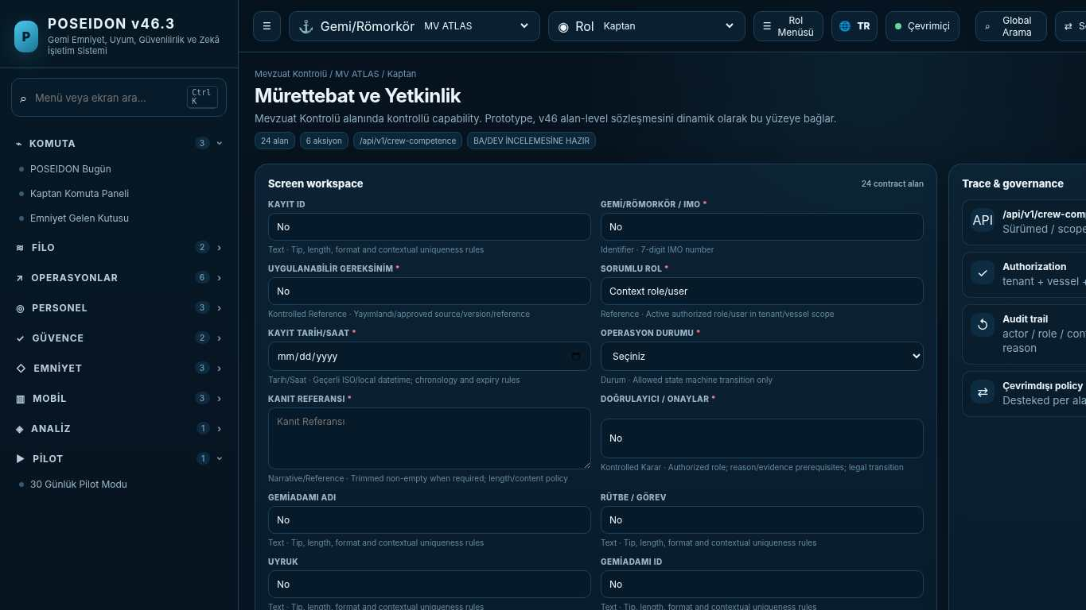
API projection: /api/v1/crew-competence | Status: READY FOR BA/DEV REVIEW

093 Emergency Readiness
Screen ID: emergency-readiness | Domain: Regulatory Control | 17 alan / 6 aksiyon
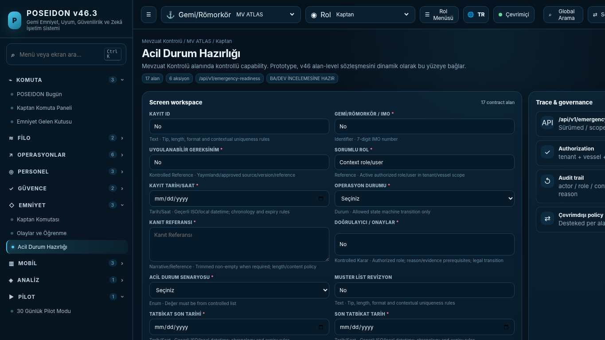
API projection: /api/v1/emergency-readiness | Status: READY FOR BA/DEV REVIEW
———————————————————————————————————————————————————————
094 Events & Learning
Screen ID: events-learning | Domain: Safety & Learning | 19 alan / 7 aksiyon
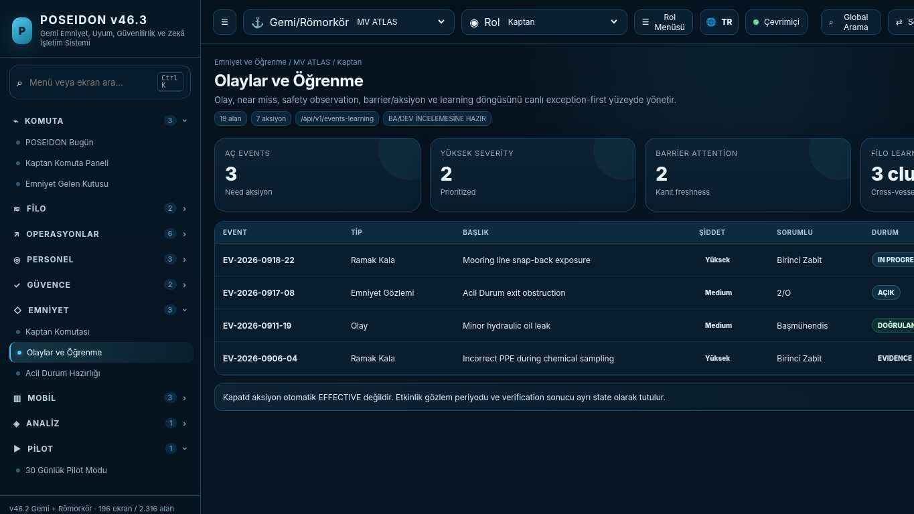
API projection: /api/v1/events-learning | Status: READY FOR BA/DEV REVIEW

095 Asset Reliability
Screen ID: asset-reliability | Domain: Technical Safety | 23 alan / 7 aksiyon
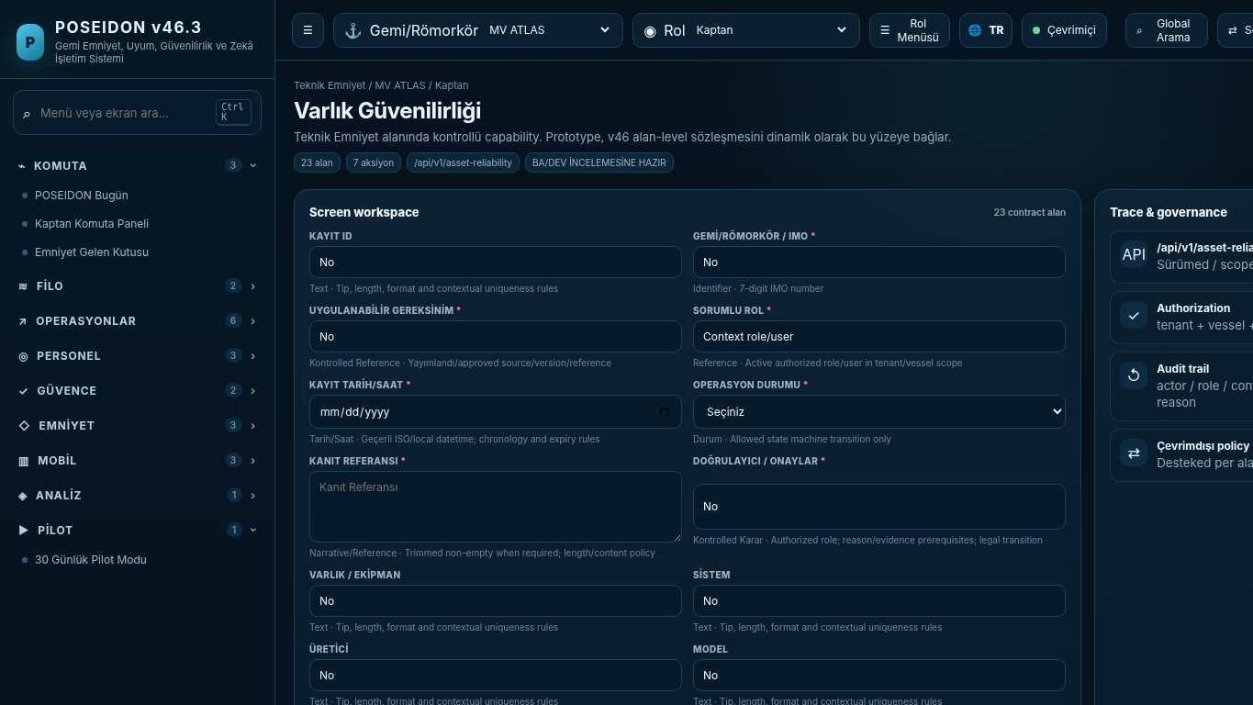
API projection: /api/v1/asset-reliability | Status: READY FOR BA/DEV REVIEW
———————————————————————————————————————————————————————
096 Controlled Knowledge
Screen ID: controlled-knowledge | Domain: Operations & Readiness | 20 alan / 6 aksiyon
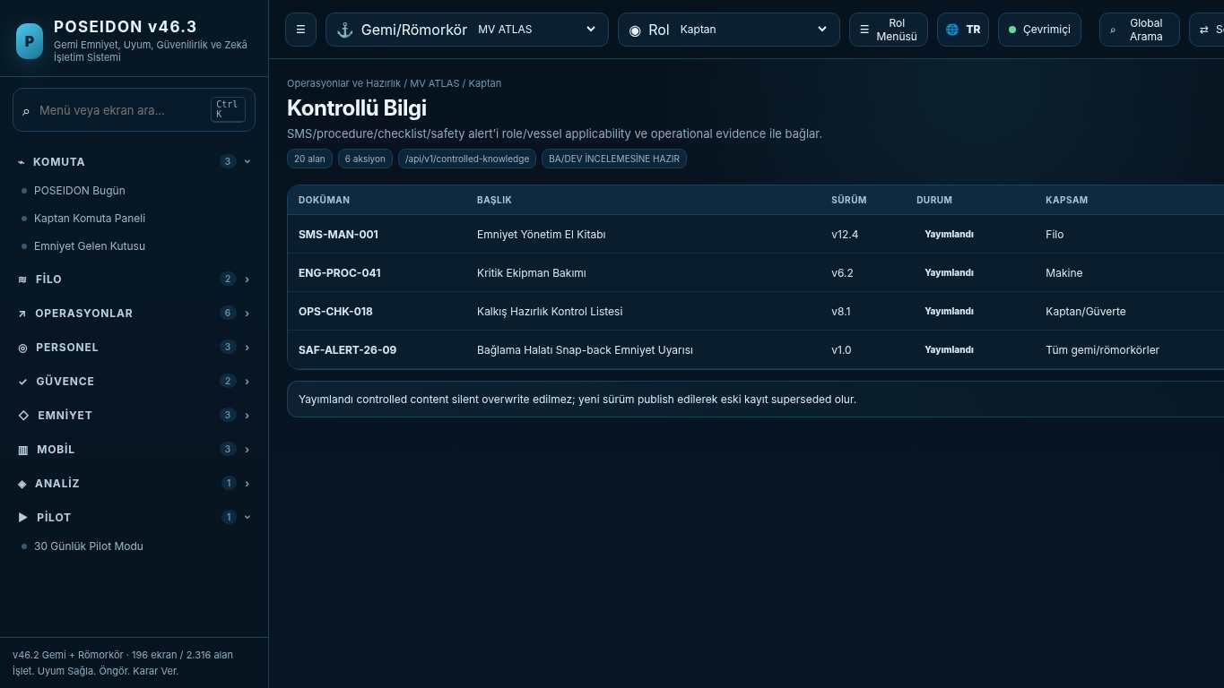
API projection: /api/v1/controlled-knowledge | Status: READY FOR BA/DEV REVIEW

097 Assurance & Review
Screen ID: assurance-review | Domain: Regulatory Control | 20 alan / 6 aksiyon
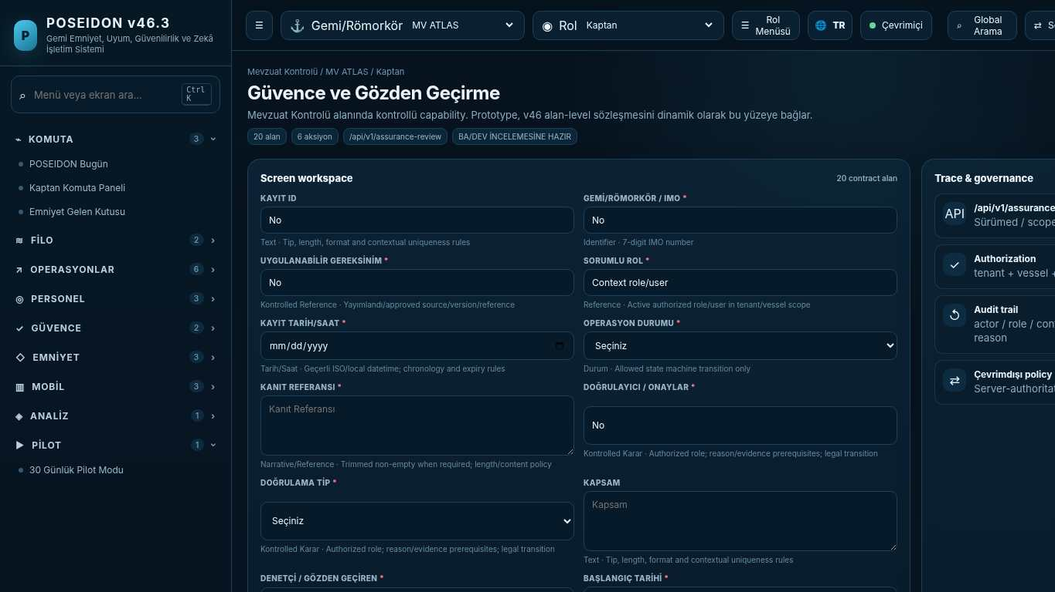
API projection: /api/v1/assurance-review | Status: READY FOR BA/DEV REVIEW
———————————————————————————————————————————————————————
098 ISM Certification
Screen ID: ism-certification | Domain: Regulatory Control | 21 alan / 6 aksiyon
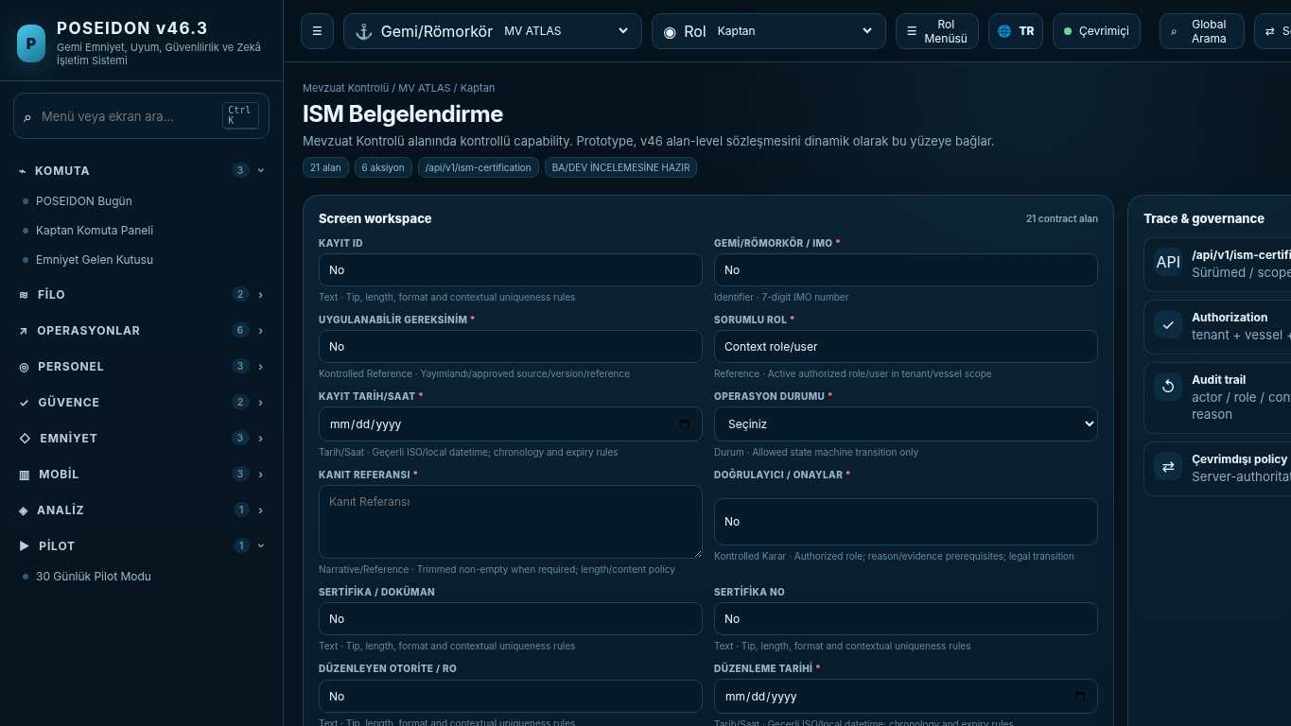
API projection: /api/v1/ism-certification | Status: READY FOR BA/DEV REVIEW

099 POSEIDON Safety Intelligence
Screen ID: safety-intelligence | Domain: Safety & Learning | 21 alan / 7 aksiyon
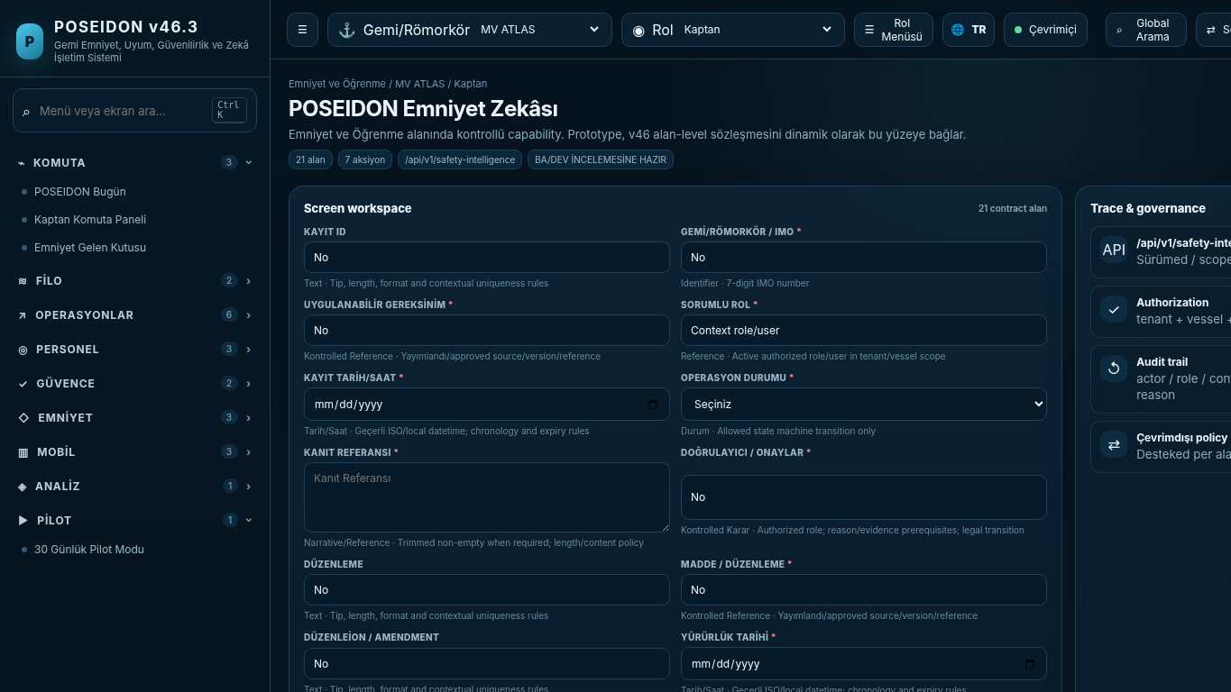
API projection: /api/v1/safety-intelligence | Status: READY FOR BA/DEV REVIEW
———————————————————————————————————————————————————————
100 Regulatory Control Center
Screen ID: regulatory-control | Domain: Regulatory Control | 21 alan / 15 aksiyon
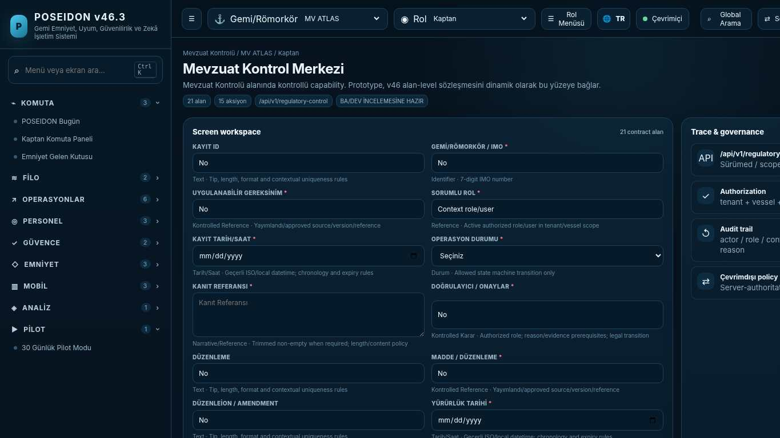
API projection: /api/v1/regulatory-control | Status: READY FOR BA/DEV REVIEW

101 Regulatory Traceability
Screen ID: regulatory-trace | Domain: Regulatory Control | 21 alan / 6 aksiyon
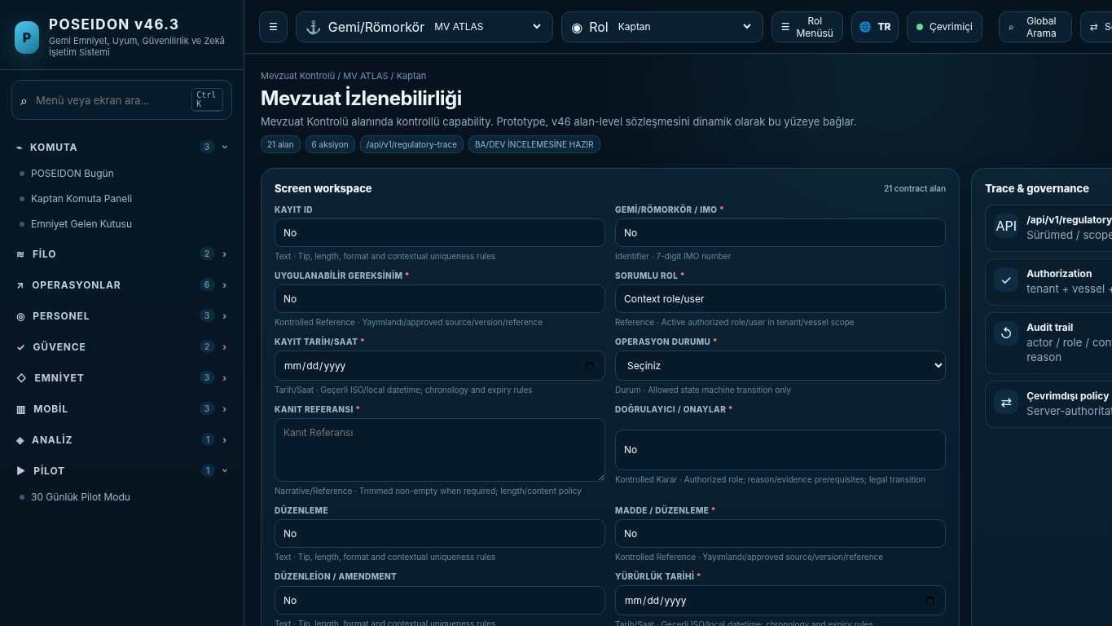
API projection: /api/v1/regulatory-trace | Status: READY FOR BA/DEV REVIEW
———————————————————————————————————————————————————————
102 Applicability Engine
Screen ID: applicability | Domain: Regulatory Control | 21 alan / 7 aksiyon
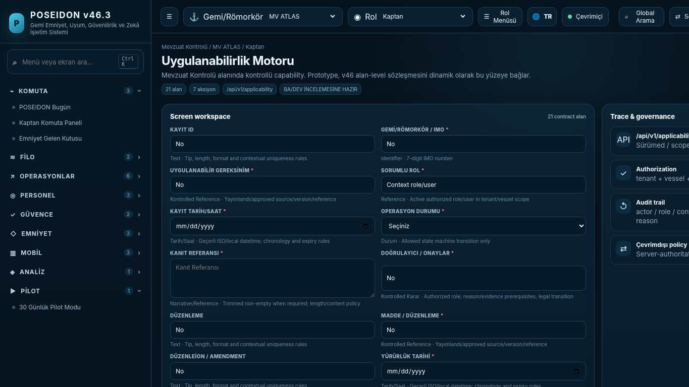
API projection: /api/v1/applicability | Status: READY FOR BA/DEV REVIEW

103 Evidence Graph
Screen ID: evidence-graph | Domain: Regulatory Control | 21 alan / 6 aksiyon
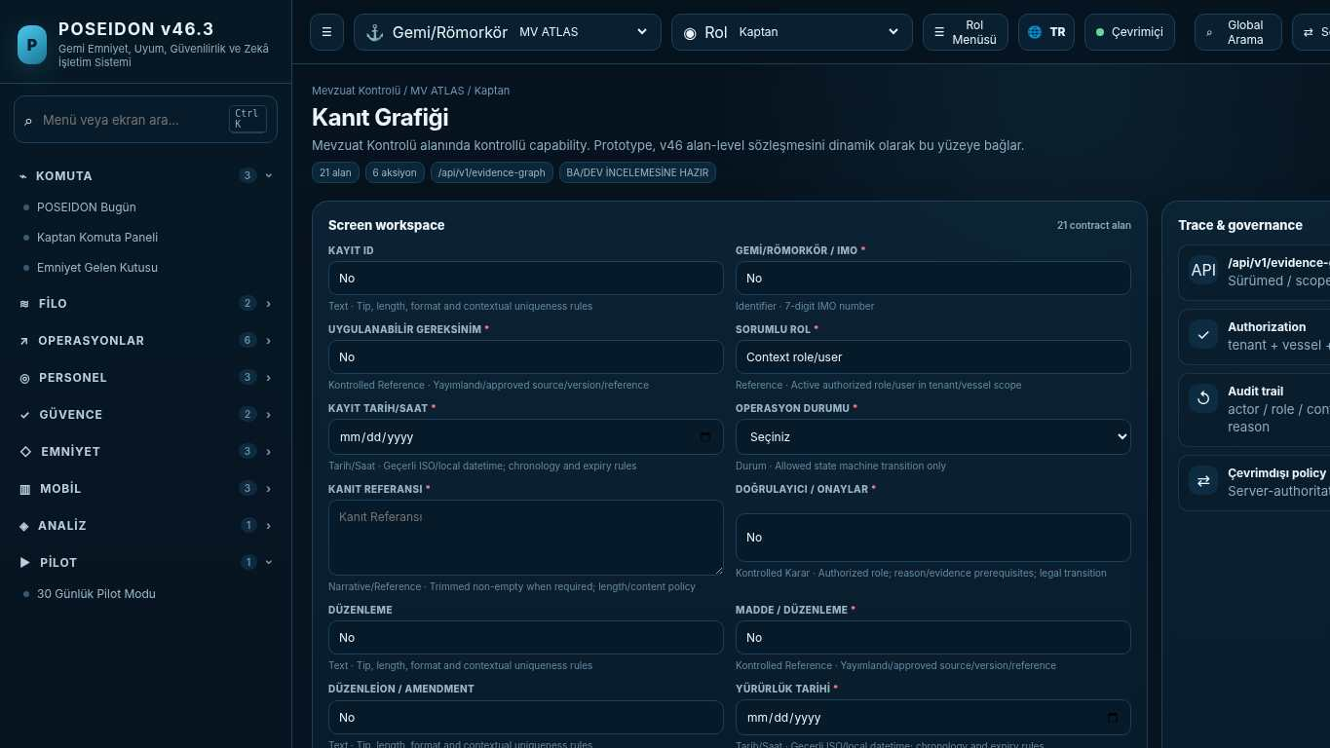
API projection: /api/v1/evidence-graph | Status: READY FOR BA/DEV REVIEW
———————————————————————————————————————————————————————
104 ISM Requirement Library
Screen ID: ism-requirements | Domain: Regulatory Control | 21 alan / 8 aksiyon
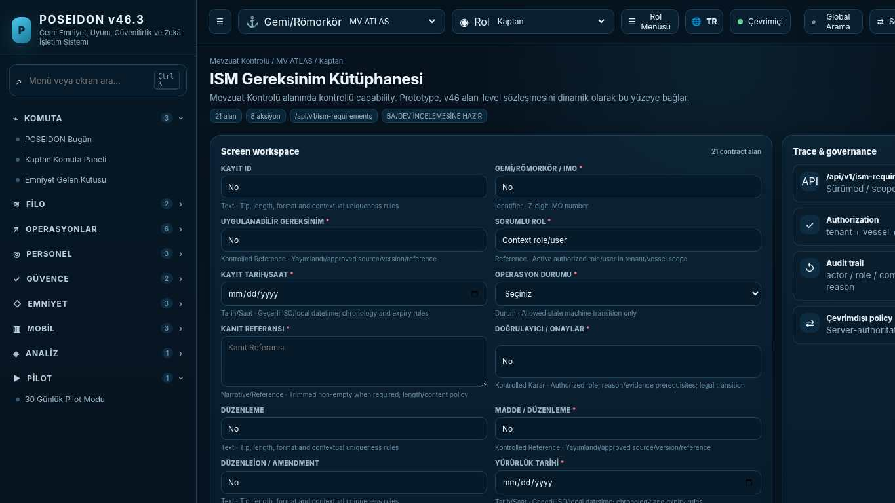
API projection: /api/v1/ism-requirements | Status: READY FOR BA/DEV REVIEW

105 Regulatory Versions & Change Impact
Screen ID: regulatory-versioning | Domain: Regulatory Control | 21 alan / 7 aksiyon
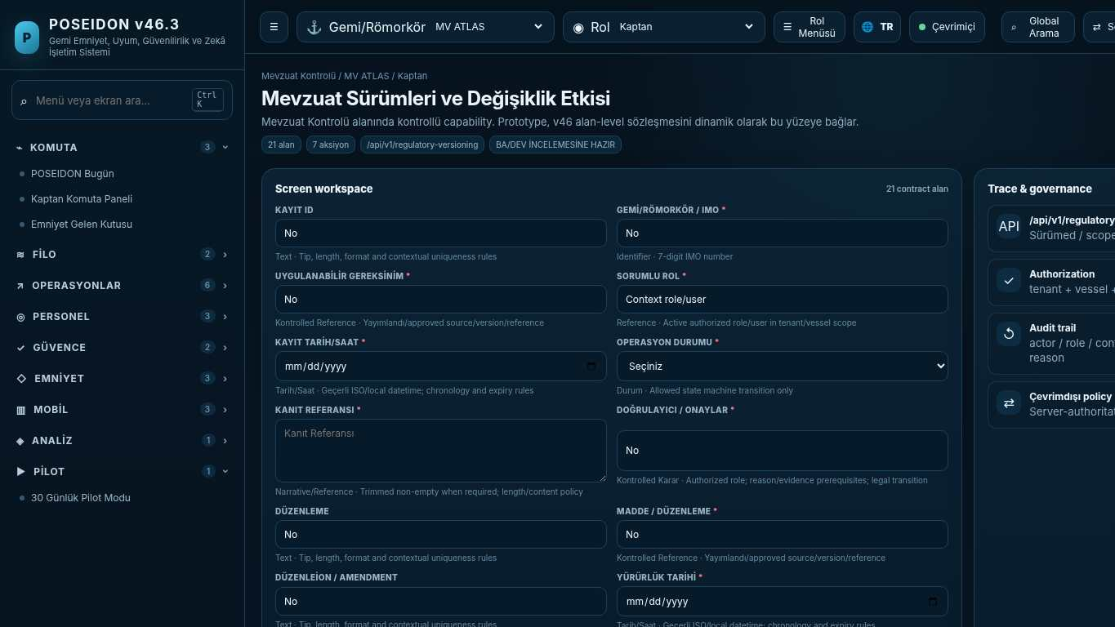
API projection: /api/v1/regulatory-versioning | Status: READY FOR BA/DEV REVIEW
———————————————————————————————————————————————————————
106 ISM Atomic Controls
Screen ID: ism-atomic | Domain: Regulatory Control | 21 alan / 8 aksiyon
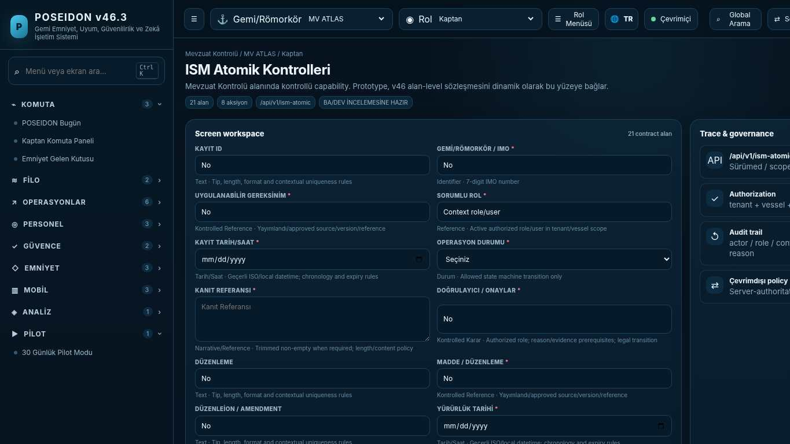
API projection: /api/v1/ism-atomic | Status: READY FOR BA/DEV REVIEW

107 Common Regulatory Schema
Screen ID: regulatory-schema | Domain: Regulatory Control | 21 alan / 6 aksiyon
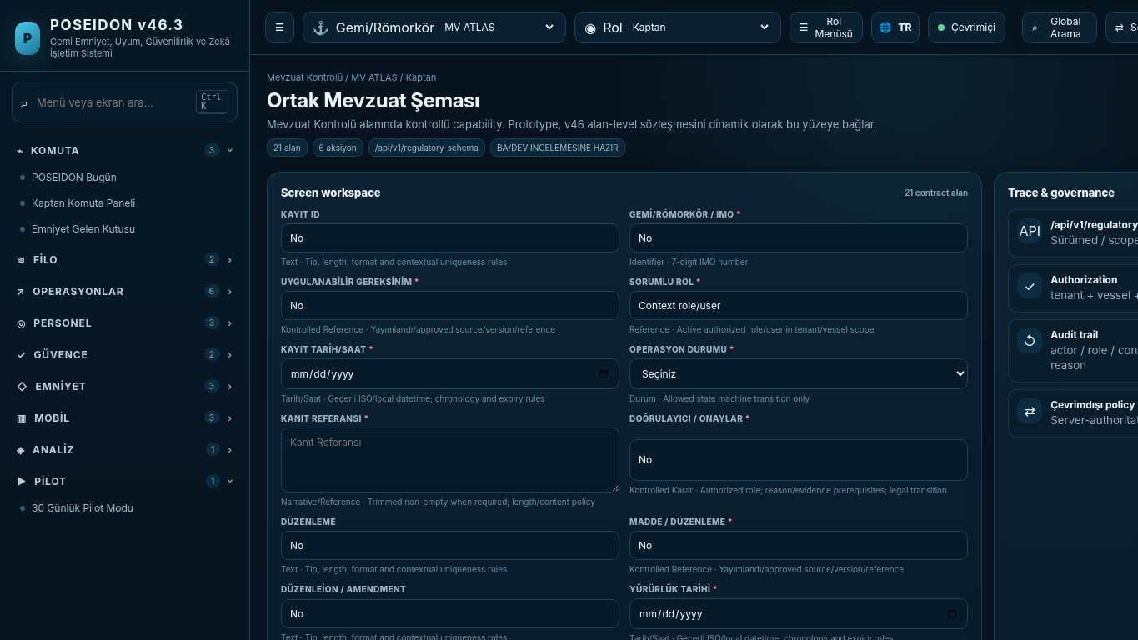
API projection: /api/v1/regulatory-schema | Status: READY FOR BA/DEV REVIEW
———————————————————————————————————————————————————————
108 SOLAS Control Library
Screen ID: solas-control | Domain: Regulatory Control | 21 alan / 8 aksiyon
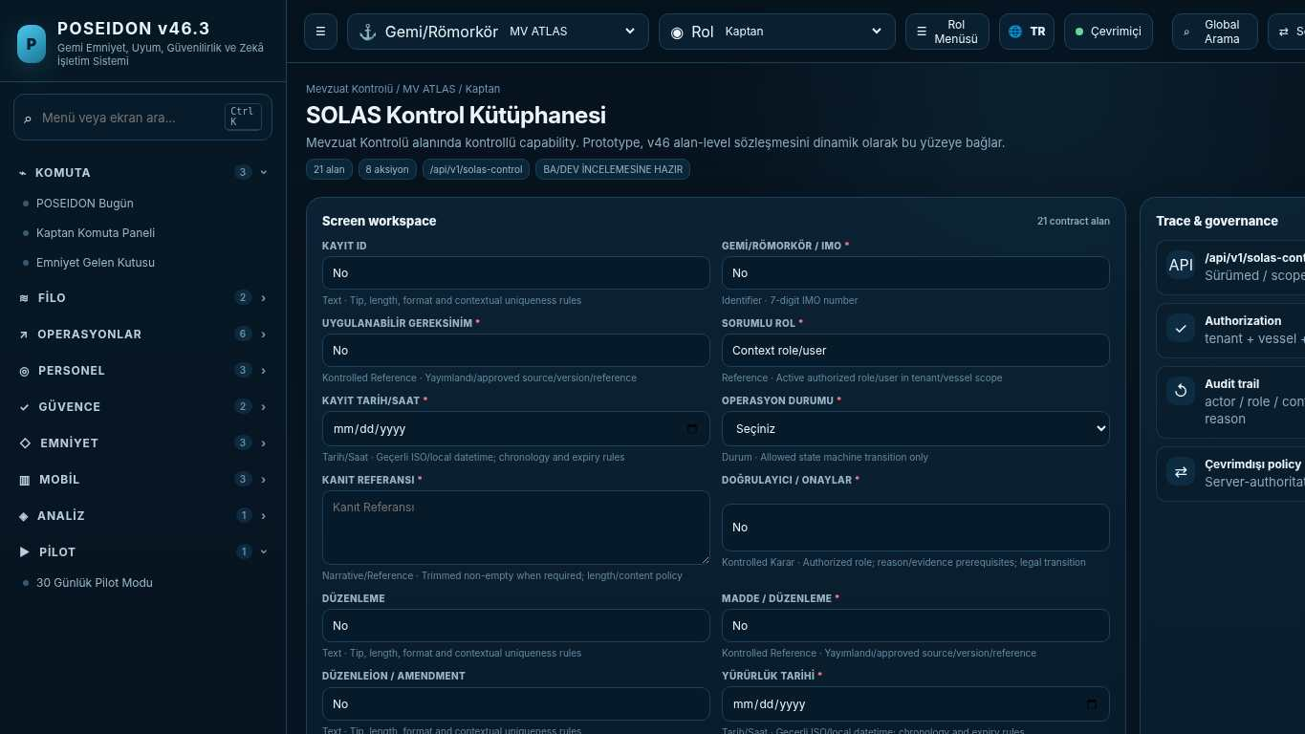
API projection: /api/v1/solas-control | Status: READY FOR BA/DEV REVIEW

109 SOLAS Chapter Map
Screen ID: solas-chapters | Domain: Core Safety Operations | 21 alan / 6 aksiyon
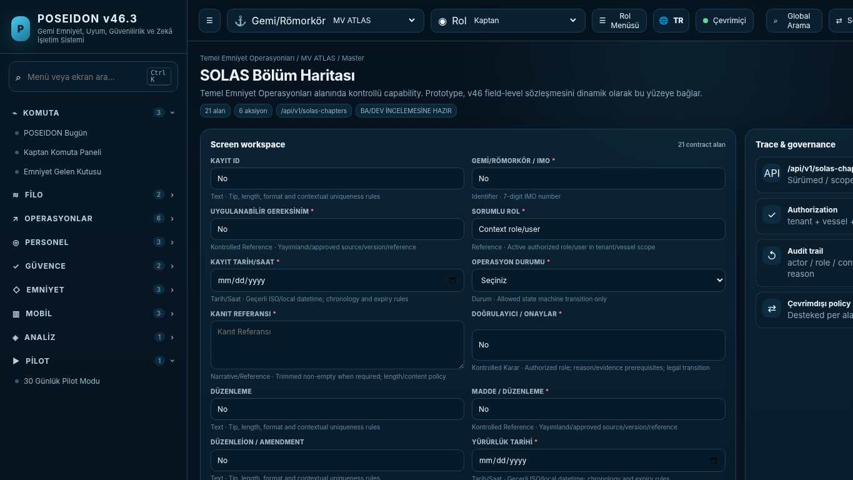
API projection: /api/v1/solas-chapters | Status: READY FOR BA/DEV REVIEW
———————————————————————————————————————————————————————
110 STCW Control Library
Screen ID: stcw-control | Domain: Operations & Readiness | 21 alan / 8 aksiyon
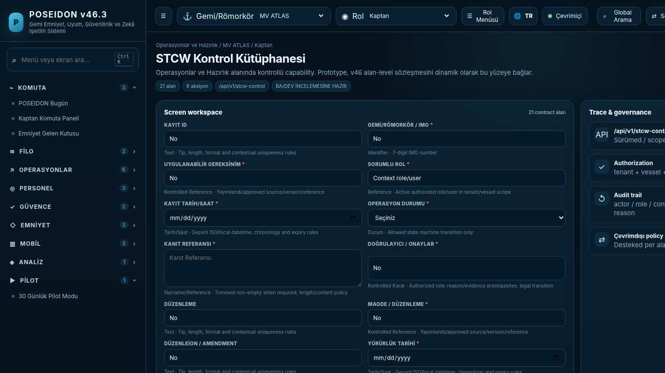
API projection: /api/v1/stcw-control | Status: READY FOR BA/DEV REVIEW

111 Crew Eligibility Engine
Screen ID: crew-eligibility | Domain: Regulatory Control | 24 alan / 10 aksiyon
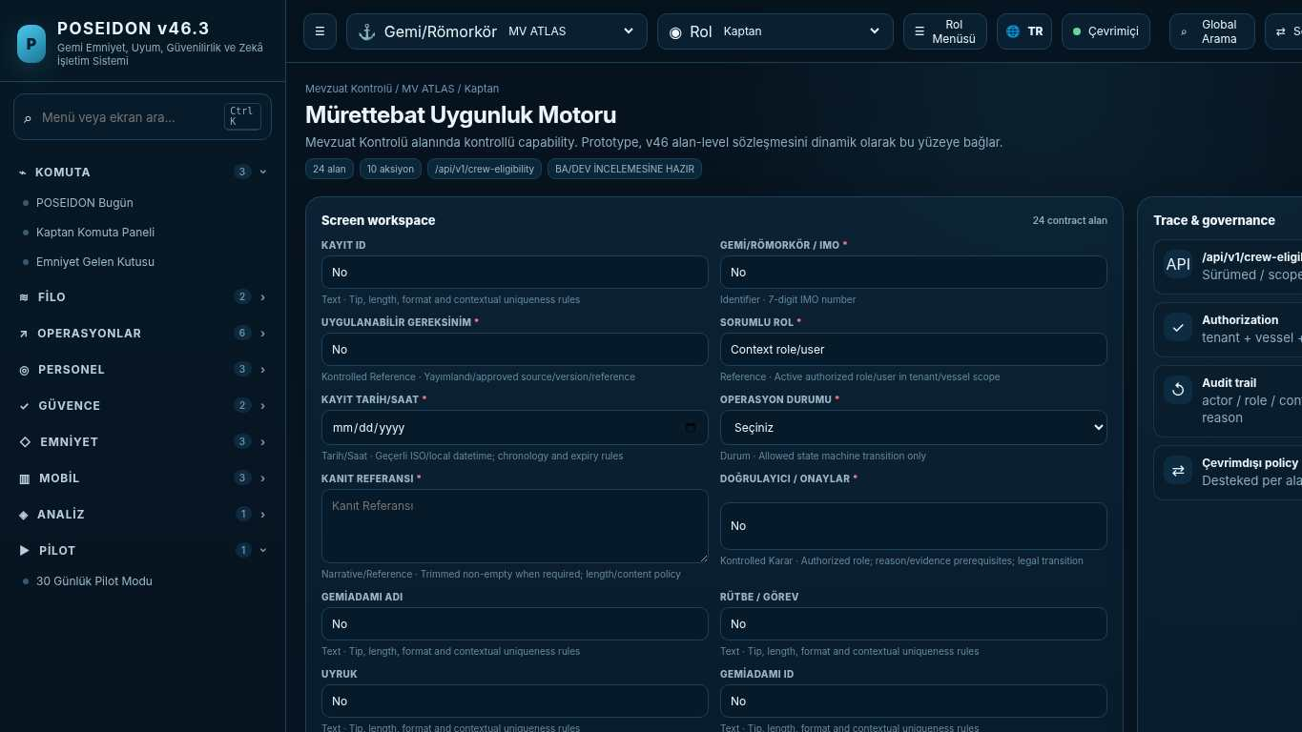
API projection: /api/v1/crew-eligibility | Status: READY FOR BA/DEV REVIEW
———————————————————————————————————————————————————————
112 Minimum Safe Manning & Assignment Gate
Screen ID: safe-manning | Domain: Regulatory Control | 13 alan / 9 aksiyon
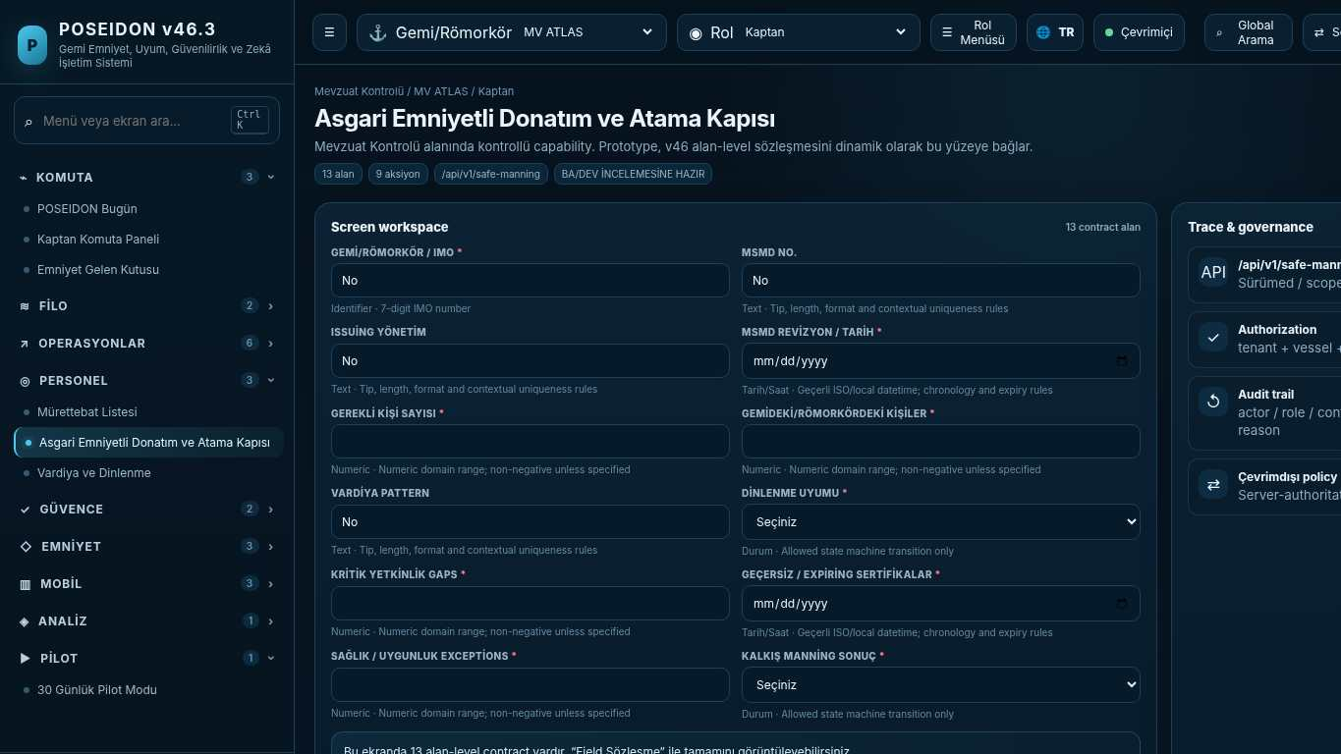
API projection: /api/v1/safe-manning | Status: READY FOR BA/DEV REVIEW

113 Watchkeeping & Rest
Screen ID: watchkeeping | Domain: Operations & Readiness | 24 alan / 6 aksiyon
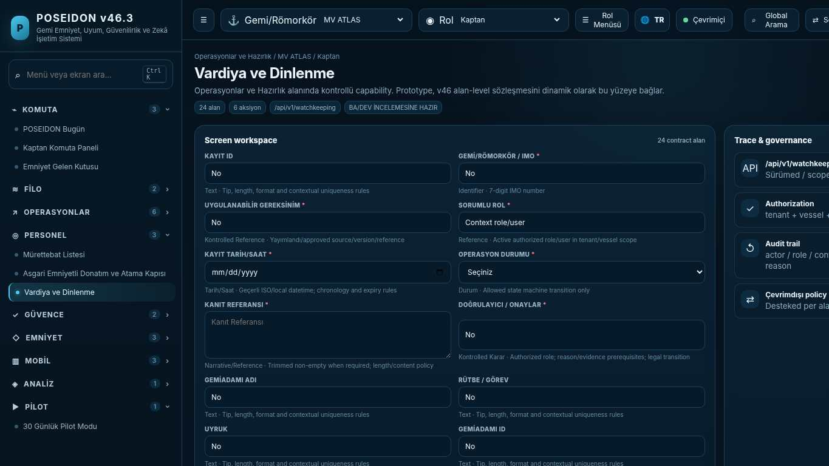
API projection: /api/v1/watchkeeping | Status: READY FOR BA/DEV REVIEW
———————————————————————————————————————————————————————
114 MARPOL Control Library
Screen ID: marpol-control | Domain: Core Safety Operations | 22 alan / 8 aksiyon
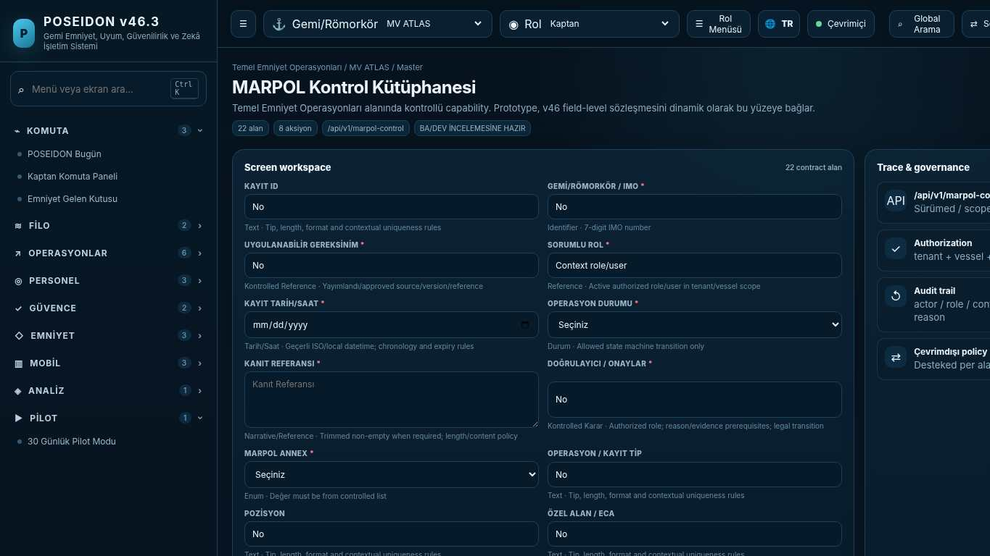
API projection: /api/v1/marpol-control | Status: READY FOR BA/DEV REVIEW

115 Environmental Operations
Screen ID: environmental-ops | Domain: Operations & Readiness | 22 alan / 6 aksiyon
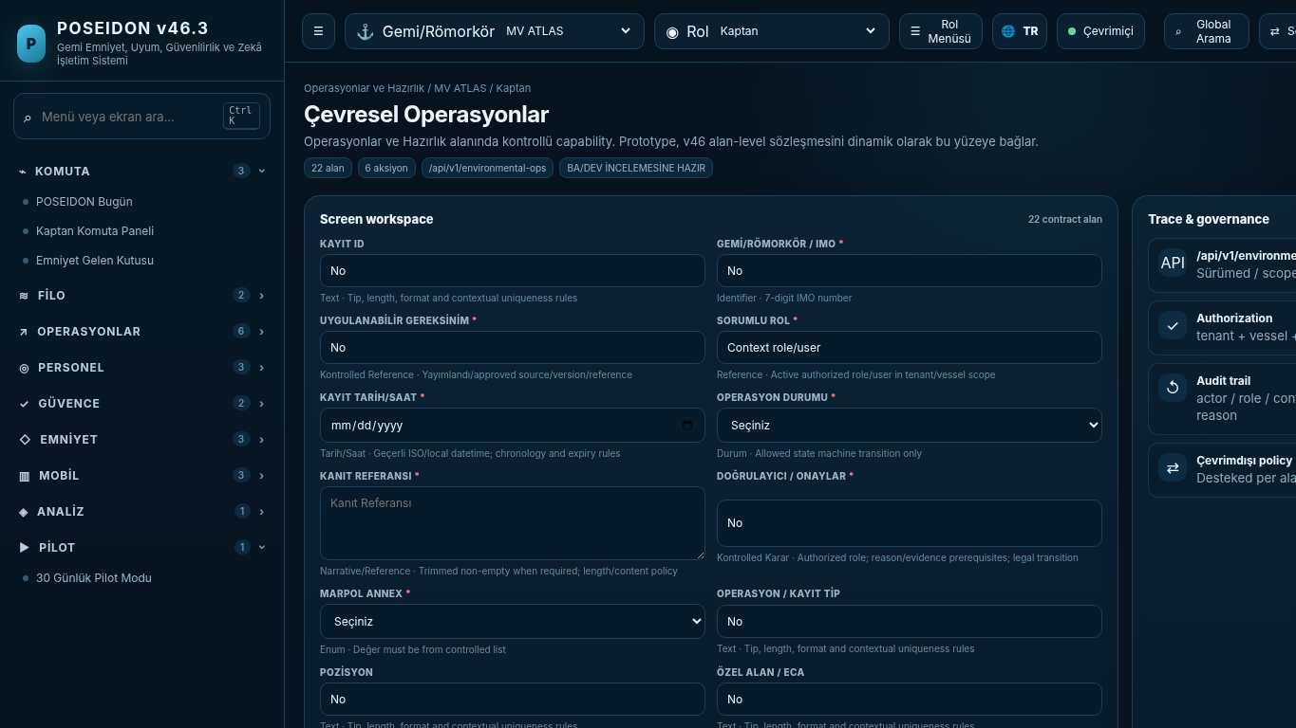
API projection: /api/v1/environmental-ops | Status: READY FOR BA/DEV REVIEW
———————————————————————————————————————————————————————
116 Environmental Records & Evidence
Screen ID: environmental-records | Domain: Regulatory Control | 22 alan / 7 aksiyon
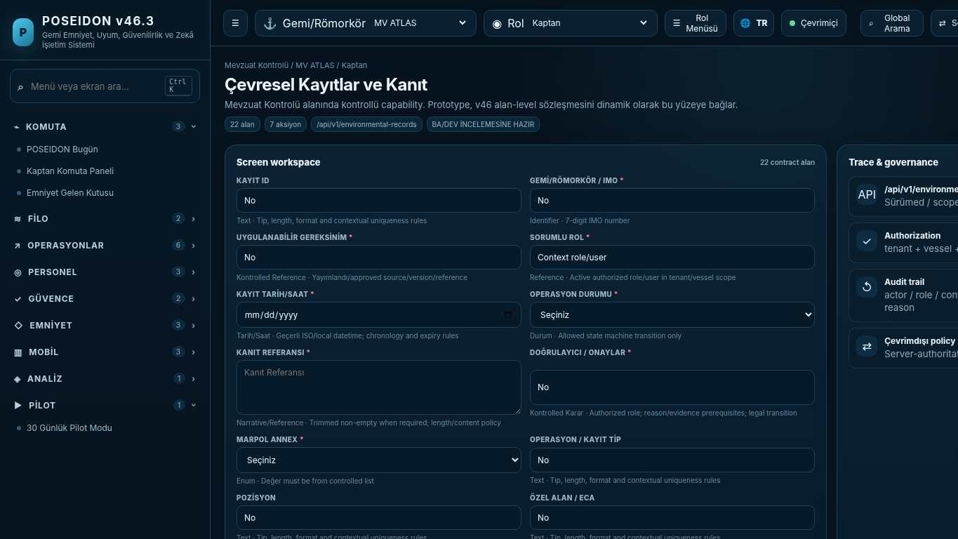
API projection: /api/v1/environmental-records | Status: READY FOR BA/DEV REVIEW

117 MLC Control Library
Screen ID: mlc-control | Domain: Core Safety Operations | 23 alan / 8 aksiyon
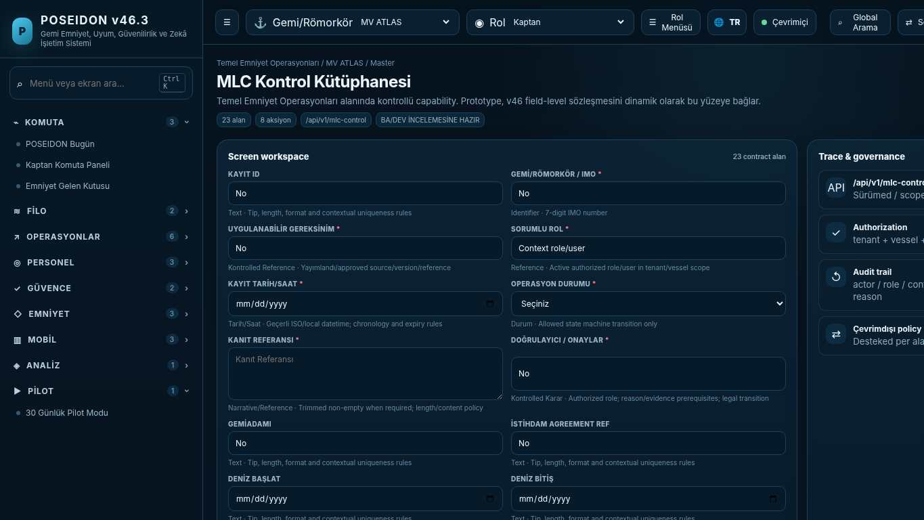
API projection: /api/v1/mlc-control | Status: READY FOR BA/DEV REVIEW
———————————————————————————————————————————————————————
118 Seafarer Welfare & MLC
Screen ID: seafarer-welfare | Domain: Core Safety Operations | 23 alan / 6 aksiyon
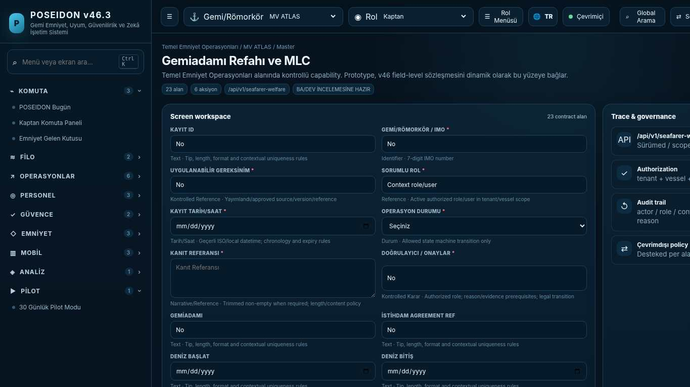
API projection: /api/v1/seafarer-welfare | Status: READY FOR BA/DEV REVIEW

119 MLC Certification & DMLC
Screen ID: mlc-certification | Domain: Regulatory Control | 21 alan / 6 aksiyon
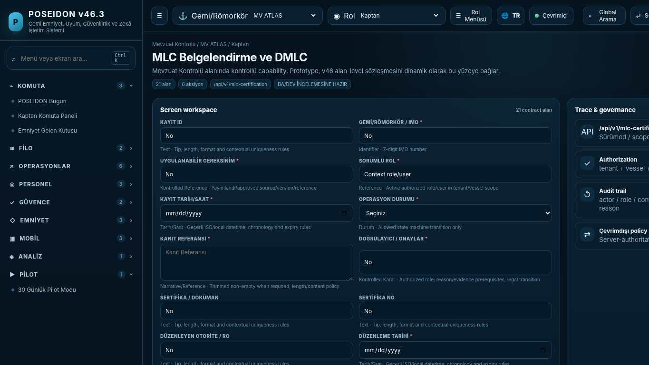
API projection: /api/v1/mlc-certification | Status: READY FOR BA/DEV REVIEW
———————————————————————————————————————————————————————
120 Cyber Safety Control Library
Screen ID: cyber-control | Domain: Regulatory Control | 22 alan / 8 aksiyon
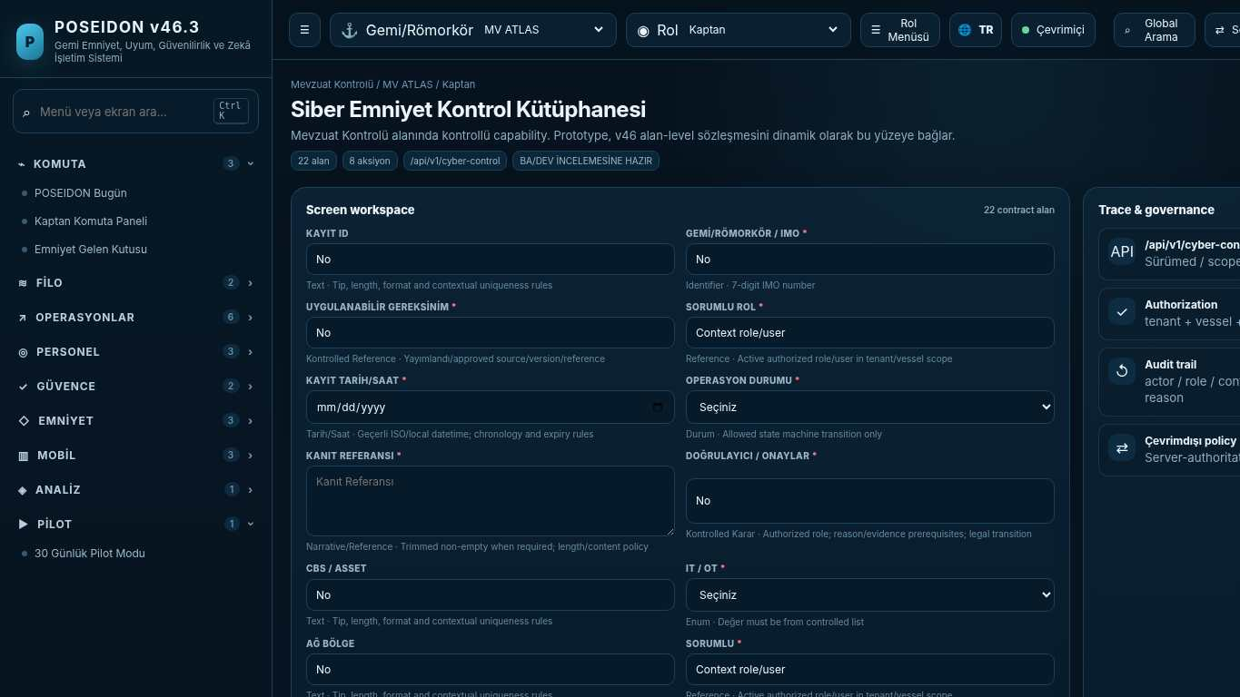
API projection: /api/v1/cyber-control | Status: READY FOR BA/DEV REVIEW

121 Cyber Readiness
Screen ID: cyber-readiness | Domain: Platform & Administration | 22 alan / 6 aksiyon
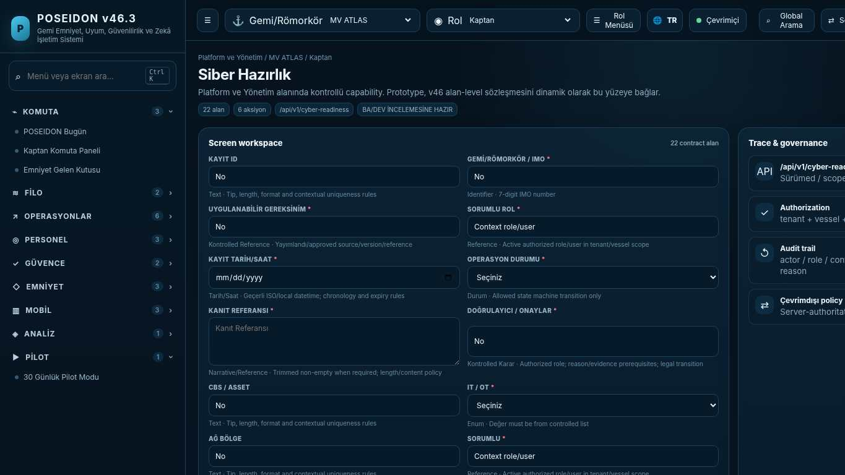
API projection: /api/v1/cyber-readiness | Status: READY FOR BA/DEV REVIEW
———————————————————————————————————————————————————————
122 Cyber Incident Response
Screen ID: cyber-incident | Domain: Safety & Learning | 22 alan / 8 aksiyon
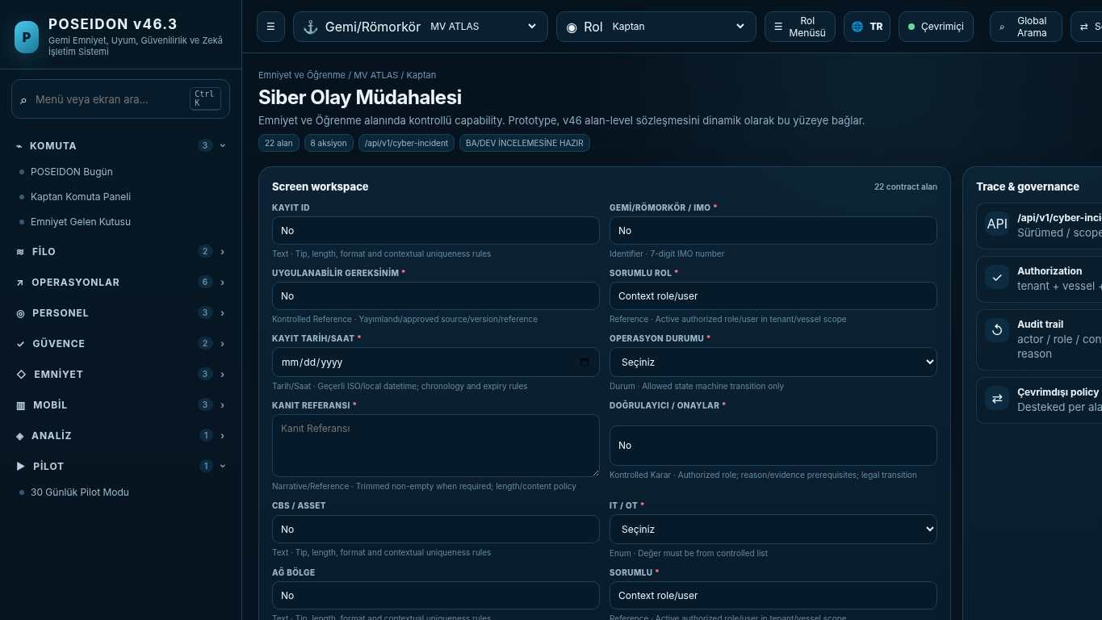
API projection: /api/v1/cyber-incident | Status: READY FOR BA/DEV REVIEW

123 Unified Regulatory Control Center
Screen ID: unified-regulatory | Domain: Regulatory Control | 21 alan / 8 aksiyon
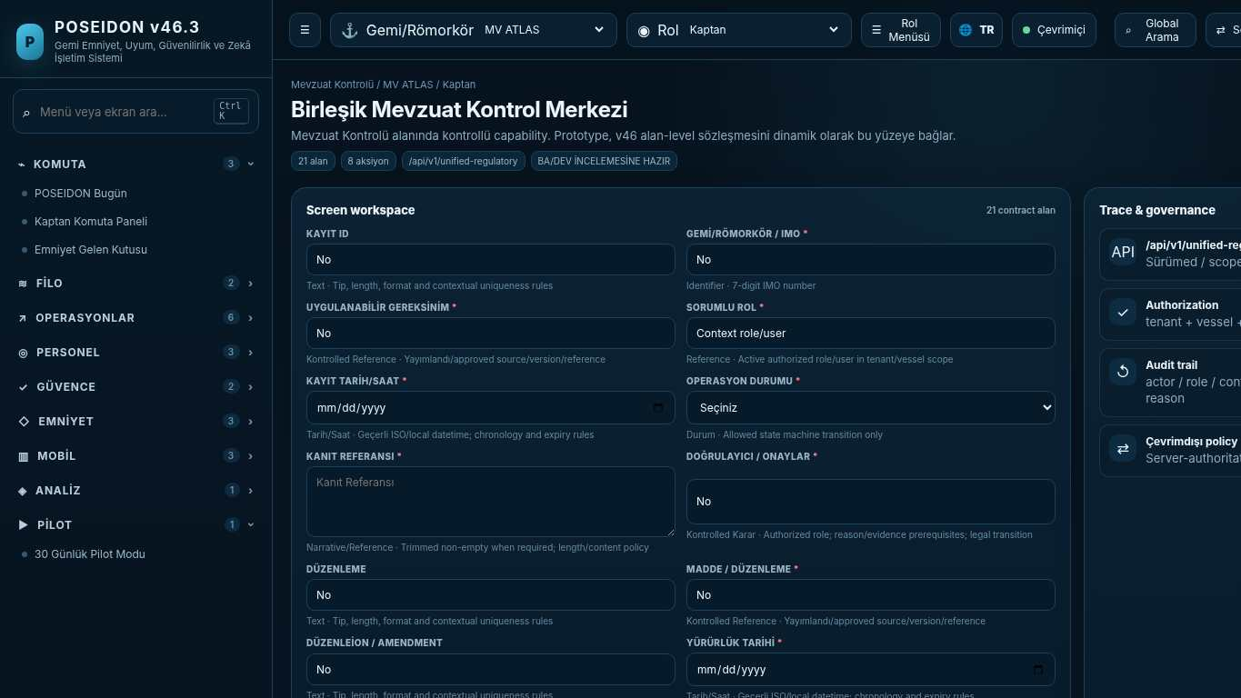
API projection: /api/v1/unified-regulatory | Status: READY FOR BA/DEV REVIEW
———————————————————————————————————————————————————————
124 Auditor / Regulatory View
Screen ID: auditor-mode | Domain: Regulatory Control | 20 alan / 9 aksiyon
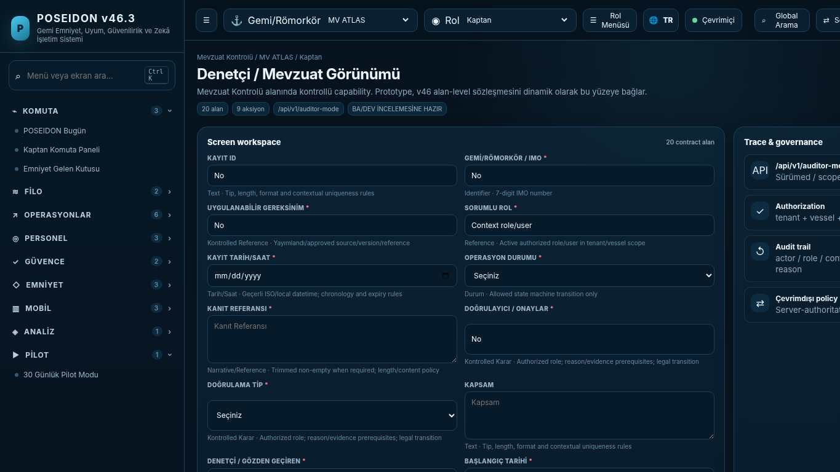
API projection: /api/v1/auditor-mode | Status: READY FOR BA/DEV REVIEW

125 MV Atlas • Safety Digital Twin
Screen ID: safety-digital-twin | Domain: Regulatory Control | 17 alan / 8 aksiyon
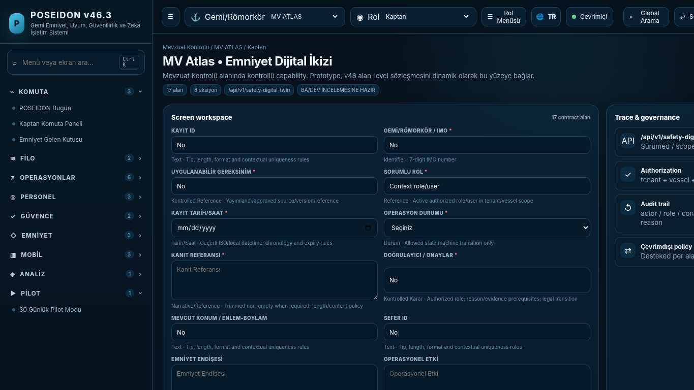
API projection: /api/v1/safety-digital-twin | Status: READY FOR BA/DEV REVIEW
———————————————————————————————————————————————————————
126 Command Bridge
Screen ID: command-bridge | Domain: Core Safety Operations | 17 alan / 12 aksiyon
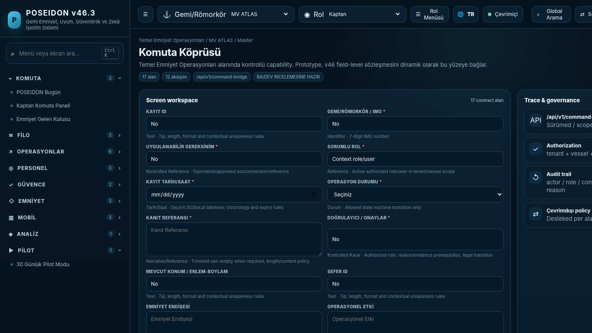
API projection: /api/v1/command-bridge | Status: READY FOR BA/DEV REVIEW

127 Departure Readiness Gate
Screen ID: departure-readiness | Domain: Regulatory Control | 23 alan / 9 aksiyon
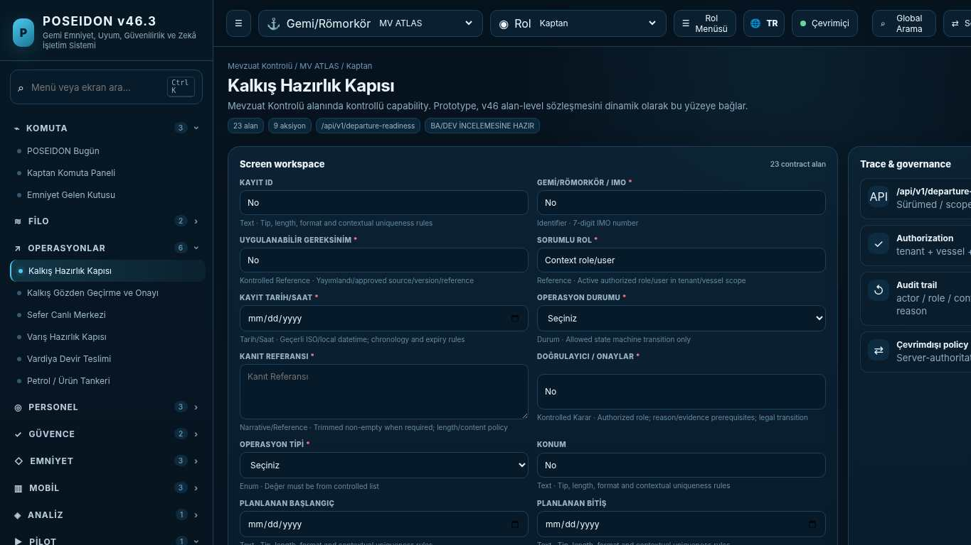
API projection: /api/v1/departure-readiness | Status: READY FOR BA/DEV REVIEW
———————————————————————————————————————————————————————
128 Departure Review & Sign-off
Screen ID: departure-signoff | Domain: Operations & Readiness | 23 alan / 9 aksiyon
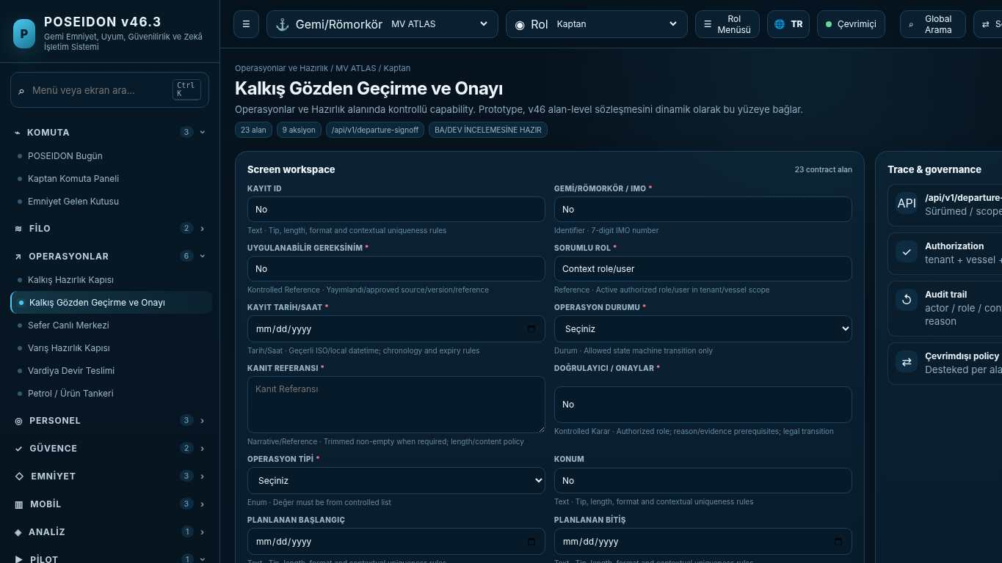
API projection: /api/v1/departure-signoff | Status: READY FOR BA/DEV REVIEW

129 Voyage Live Center
Screen ID: voyage-live | Domain: Regulatory Control | 23 alan / 11 aksiyon
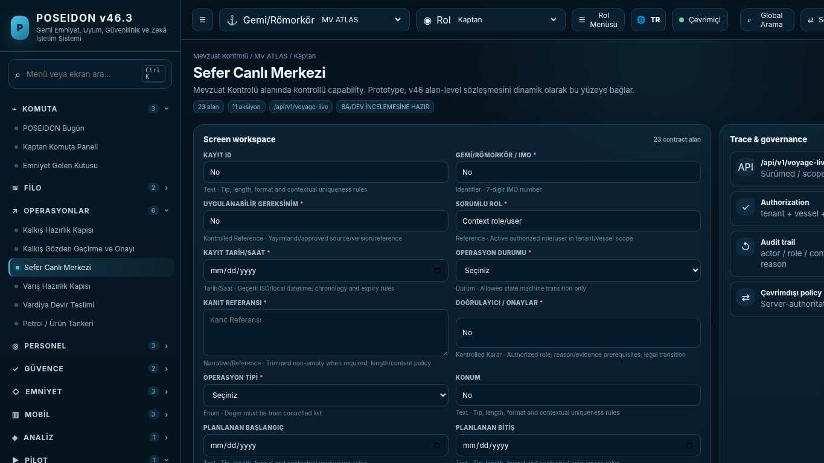
API projection: /api/v1/voyage-live | Status: READY FOR BA/DEV REVIEW
———————————————————————————————————————————————————————
130 Watch Handover
Screen ID: watch-handover | Domain: Crew & Competence | 20 alan / 7 aksiyon
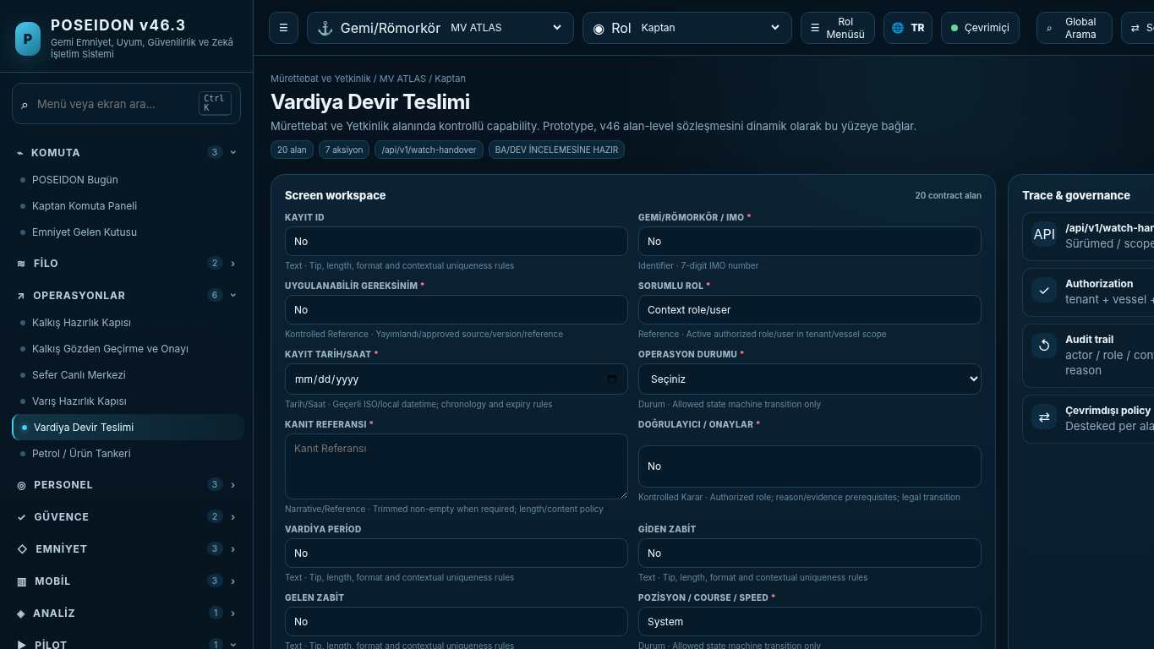
API projection: /api/v1/watch-handover | Status: READY FOR BA/DEV REVIEW

131 Arrival Readiness Gate
Screen ID: arrival-readiness | Domain: Regulatory Control | 23 alan / 6 aksiyon
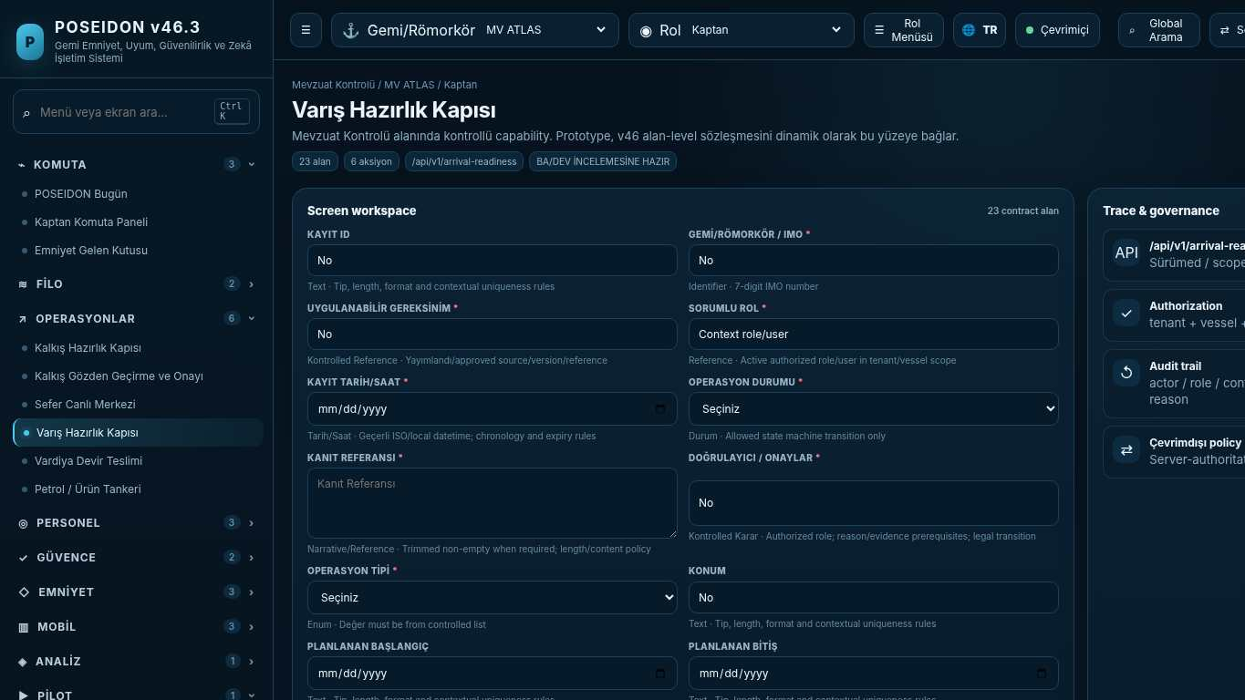
API projection: /api/v1/arrival-readiness | Status: READY FOR BA/DEV REVIEW
———————————————————————————————————————————————————————
132 Fleet Control Tower
Screen ID: fleet-control-tower | Domain: Safety & Learning | 21 alan / 8 aksiyon
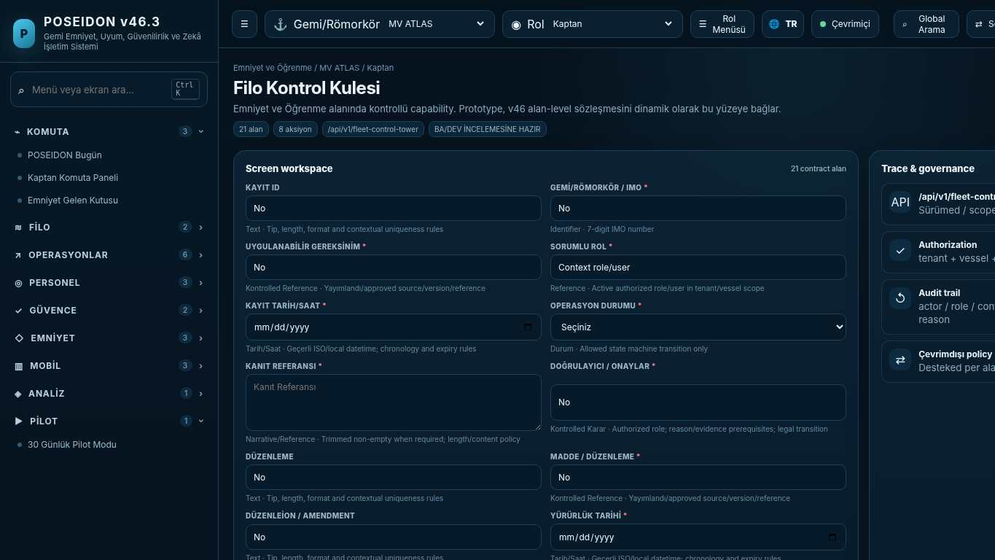
API projection: /api/v1/fleet-control-tower | Status: READY FOR BA/DEV REVIEW

133 Fleet Risk Clusters
Screen ID: fleet-risk-clusters | Domain: Regulatory Control | 19 alan / 6 aksiyon
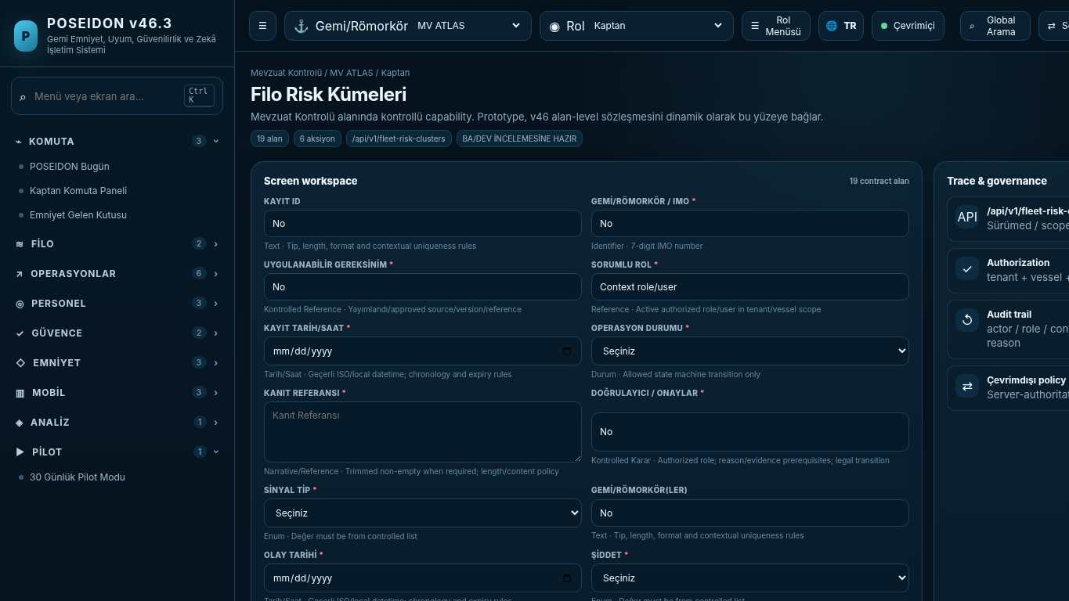
API projection: /api/v1/fleet-risk-clusters | Status: READY FOR BA/DEV REVIEW
———————————————————————————————————————————————————————
134 Fleet Learning
Screen ID: fleet-learning | Domain: Regulatory Control | 19 alan / 8 aksiyon
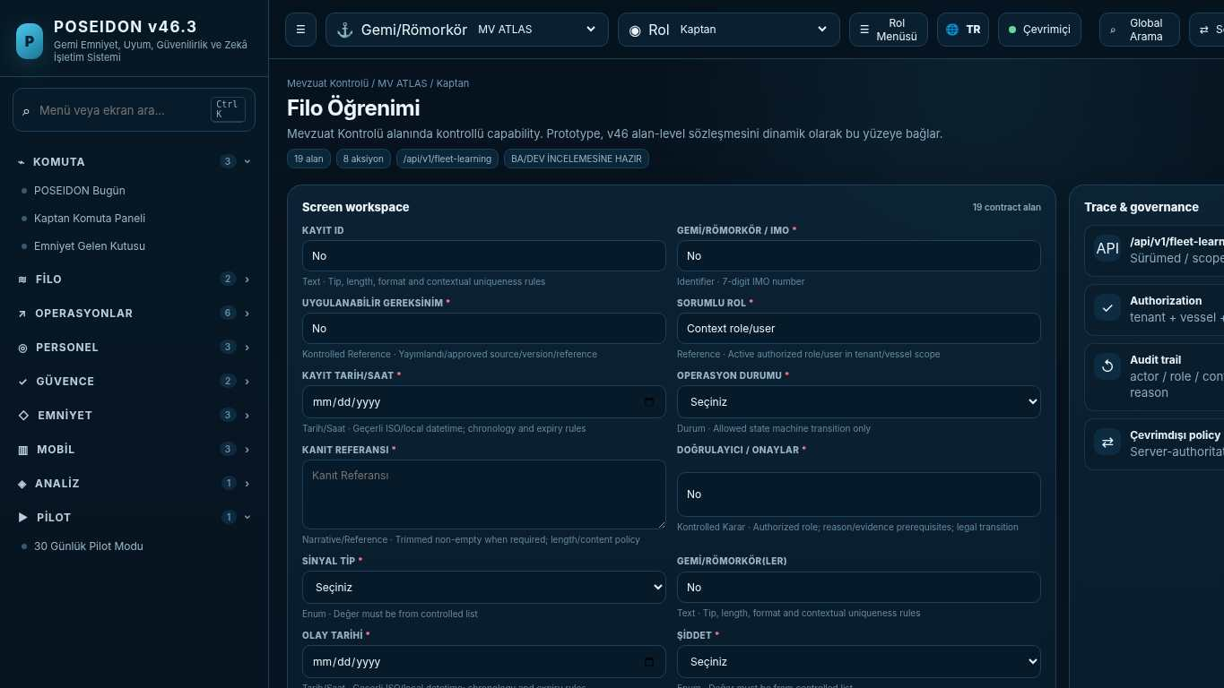
API projection: /api/v1/fleet-learning | Status: READY FOR BA/DEV REVIEW

135 Safety Performance Intelligence
Screen ID: safety-performance | Domain: Safety & Learning | 19 alan / 6 aksiyon
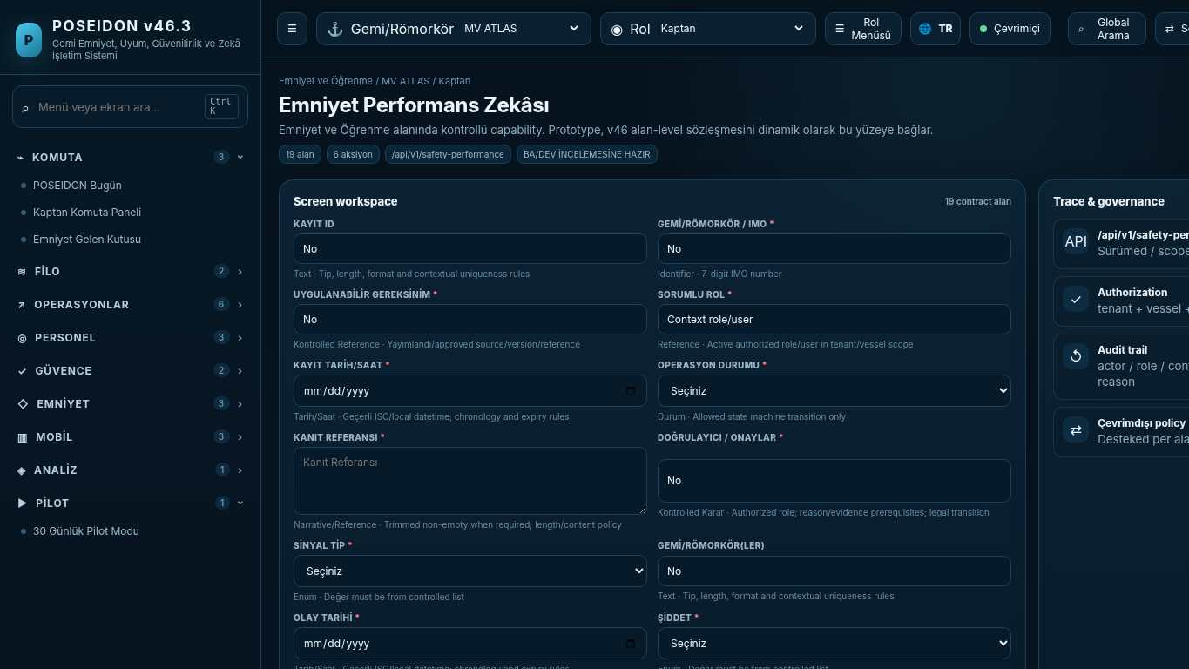
API projection: /api/v1/safety-performance | Status: READY FOR BA/DEV REVIEW
———————————————————————————————————————————————————————
136 Management Governance
Screen ID: management-governance | Domain: Regulatory Control | 20 alan / 8 aksiyon
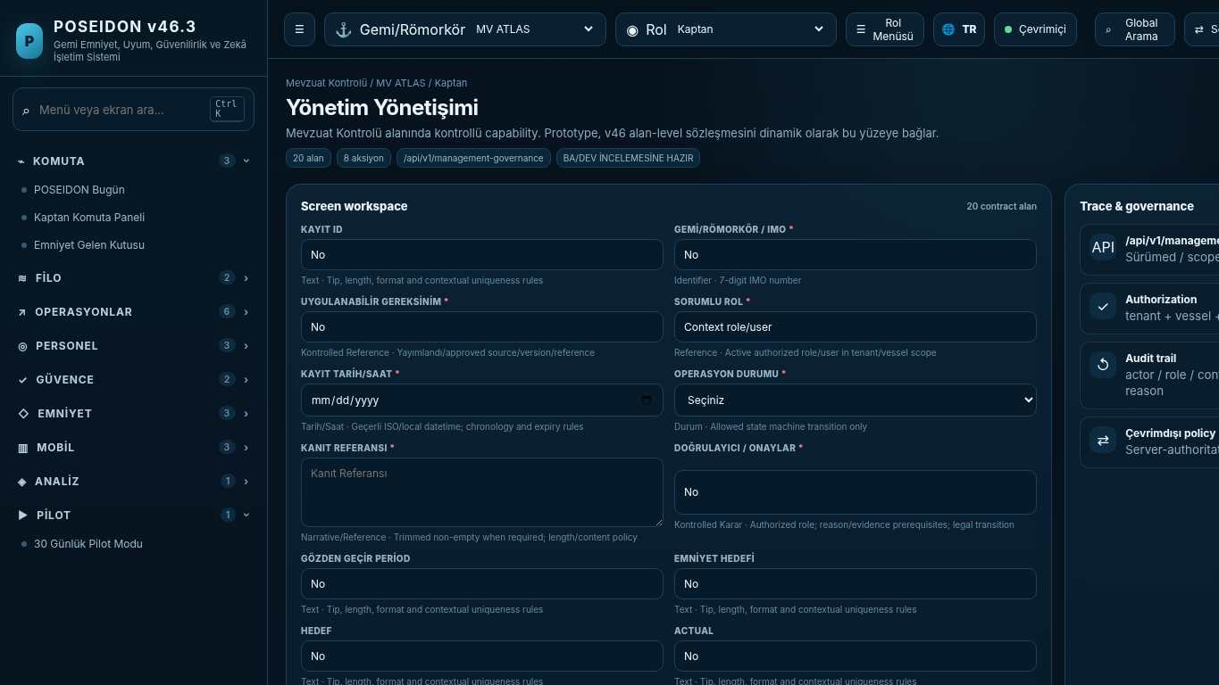
API projection: /api/v1/management-governance | Status: READY FOR BA/DEV REVIEW

137 Management Review
Screen ID: management-review | Domain: Regulatory Control | 20 alan / 7 aksiyon
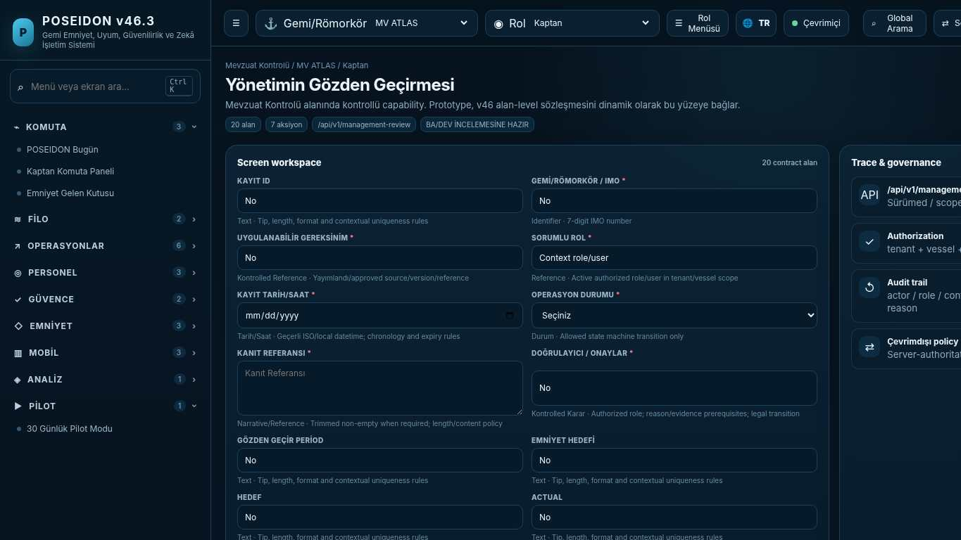
API projection: /api/v1/management-review | Status: READY FOR BA/DEV REVIEW
———————————————————————————————————————————————————————
138 PMS Command Center
Screen ID: pms-command-center | Domain: Technical / PMS 2.0 | 8 alan / 6 aksiyon
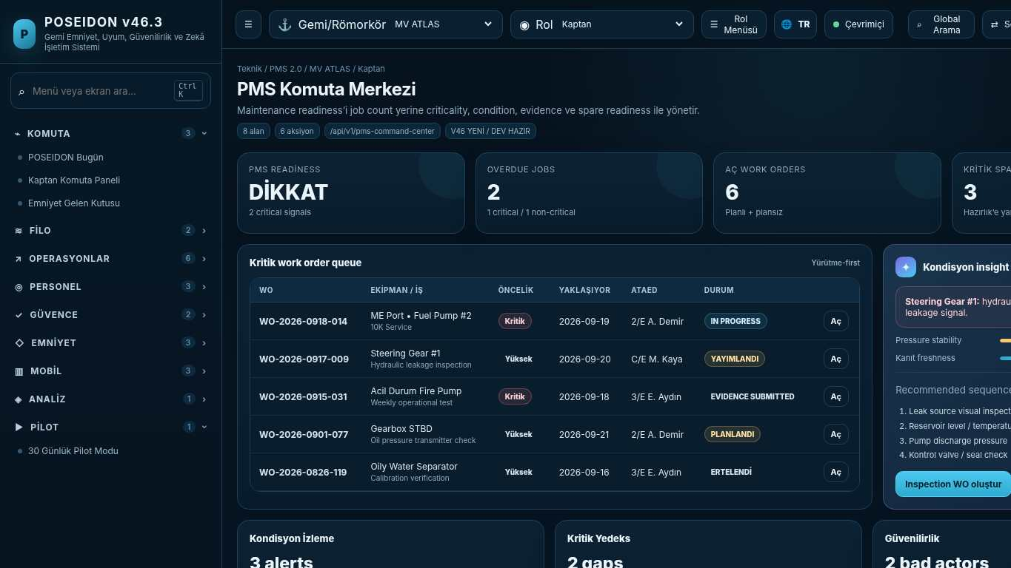
API projection: /api/v1/pms-command-center | Status: V46 NEW / DEV READY

139 Equipment Hierarchy
Screen ID: equipment-hierarchy | Domain: Technical / PMS 2.0 | 16 alan / 8 aksiyon
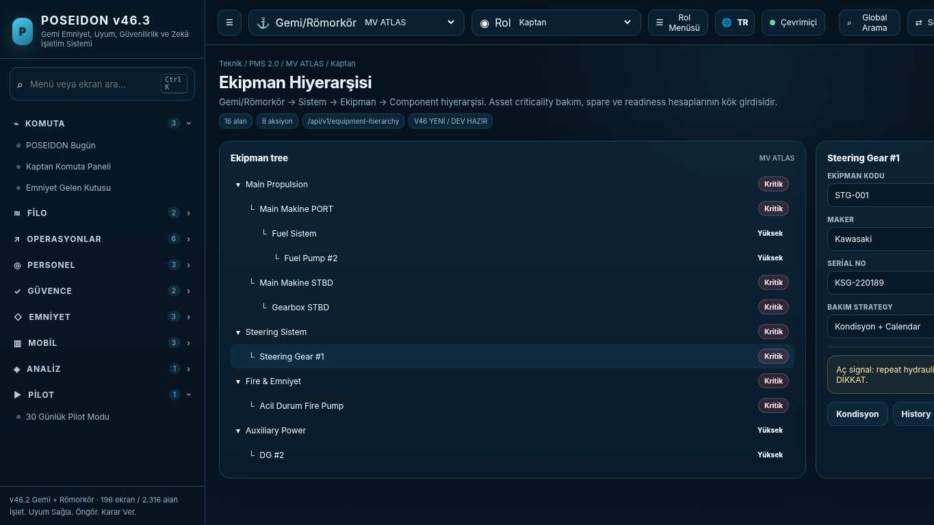
API projection: /api/v1/equipment-hierarchy | Status: V46 NEW / DEV READY
———————————————————————————————————————————————————————
140 Equipment & Component Profile
Screen ID: equipment-component-profile | Domain: Technical / PMS 2.0 | 20 alan / 10 aksiyon
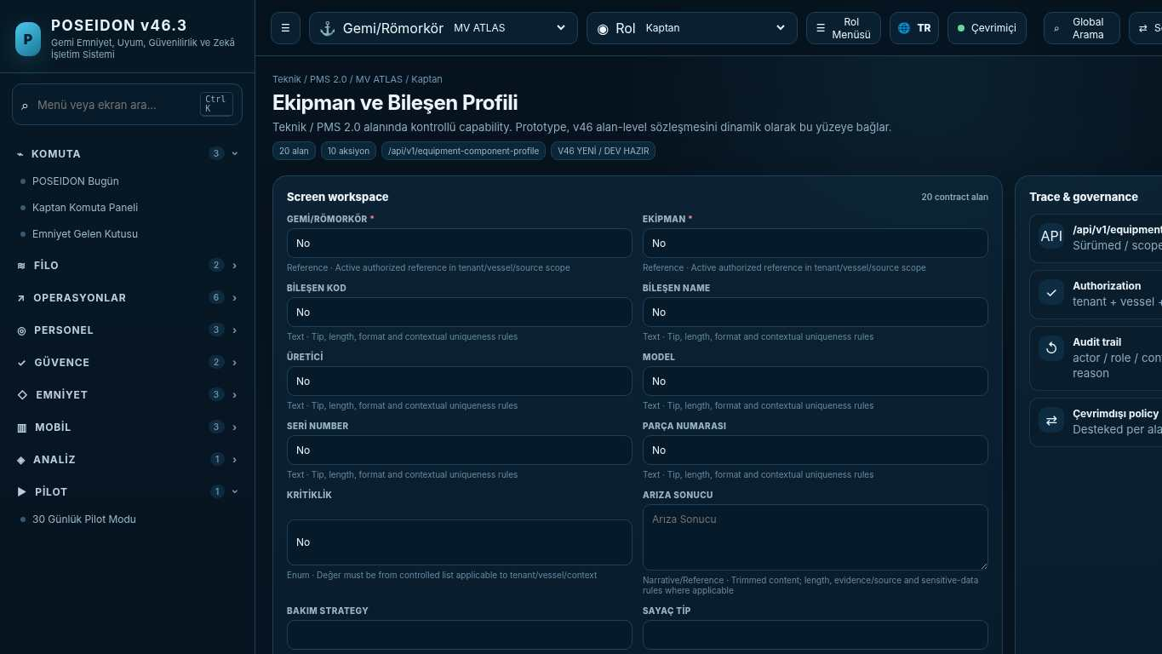
API projection: /api/v1/equipment-component-profile | Status: V46 NEW / DEV READY

141 Maintenance Job Pool
Screen ID: job-pool | Domain: Technical / PMS 2.0 | 18 alan / 9 aksiyon
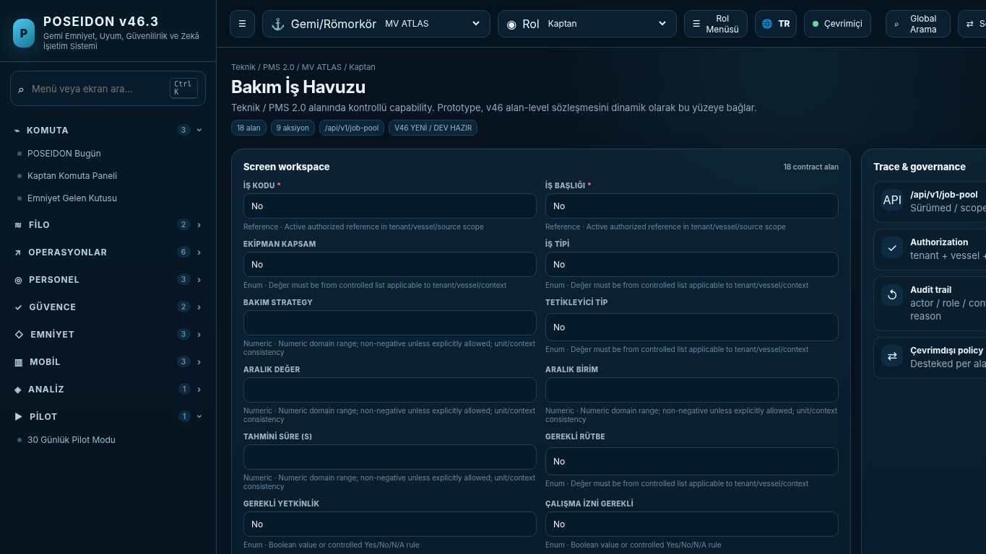
API projection: /api/v1/job-pool | Status: V46 NEW / DEV READY
———————————————————————————————————————————————————————
142 Maintenance Plan
Screen ID: maintenance-plan | Domain: Technical / PMS 2.0 | 20 alan / 10 aksiyon
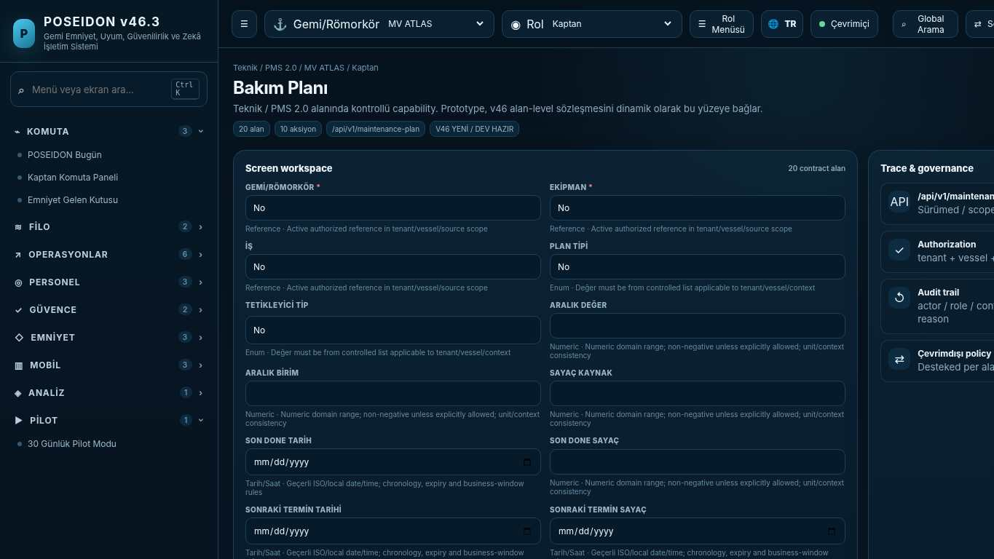
API projection: /api/v1/maintenance-plan | Status: V46 NEW / DEV READY

143 Work Order Center
Screen ID: work-order-center | Domain: Technical / PMS 2.0 | 14 alan / 10 aksiyon
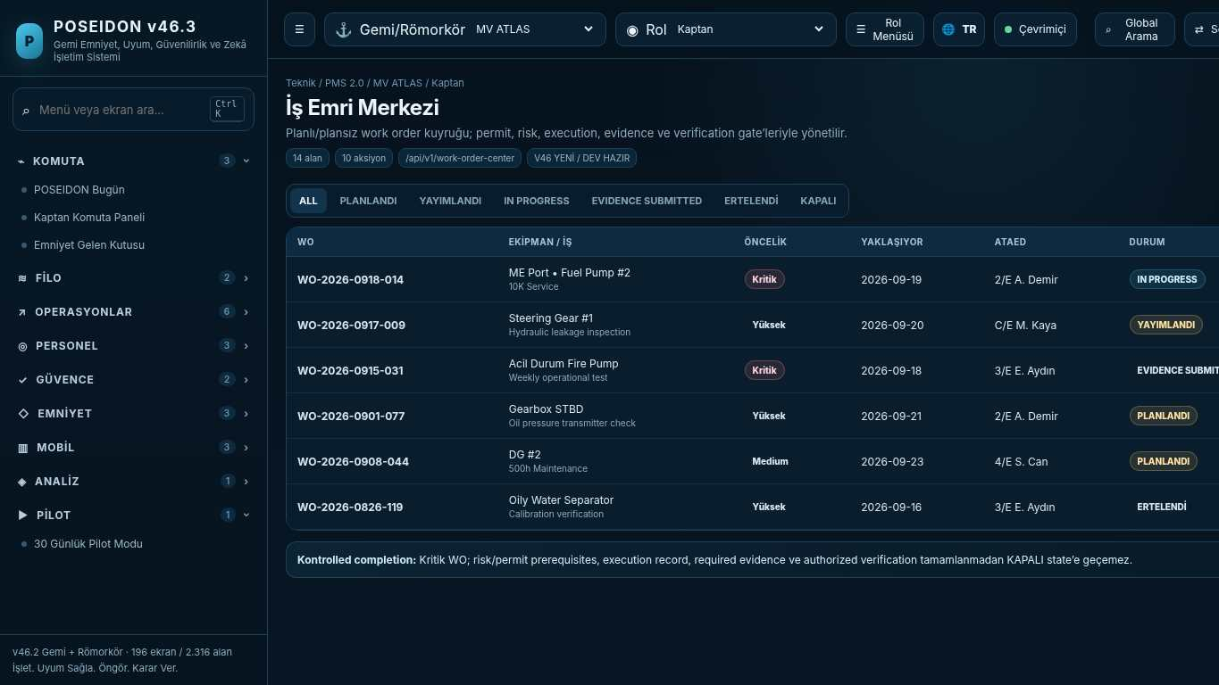
API projection: /api/v1/work-order-center | Status: V46 NEW / DEV READY
———————————————————————————————————————————————————————
144 Work Order Detail & Execution
Screen ID: work-order-detail | Domain: Technical / PMS 2.0 | 24 alan / 12 aksiyon
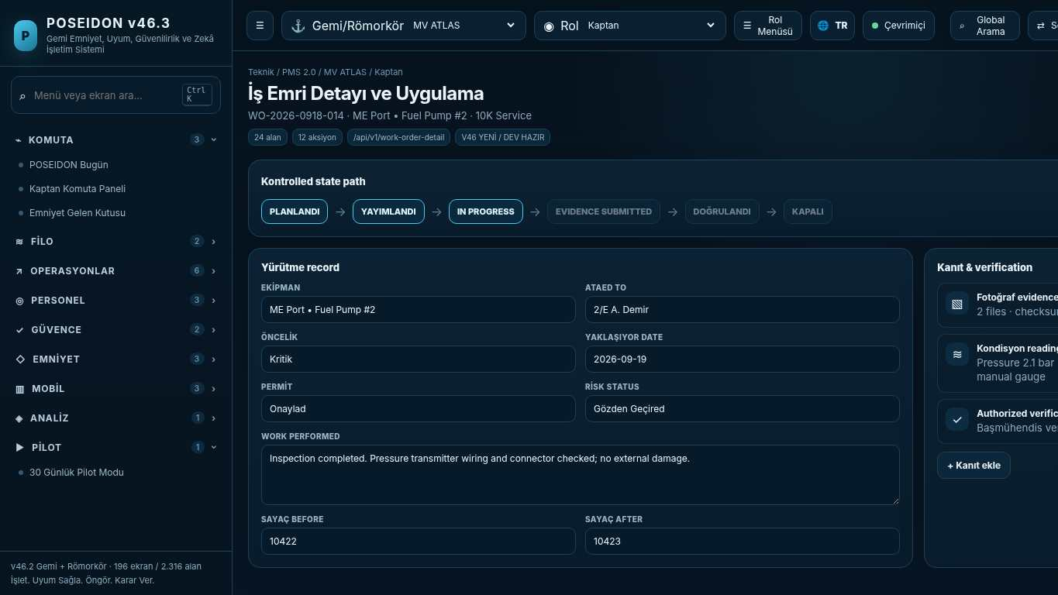
API projection: /api/v1/work-order-detail | Status: V46 NEW / DEV READY

145 Running Hours & Meter Readings
Screen ID: running-hours-meter | Domain: Technical / PMS 2.0 | 16 alan / 8 aksiyon
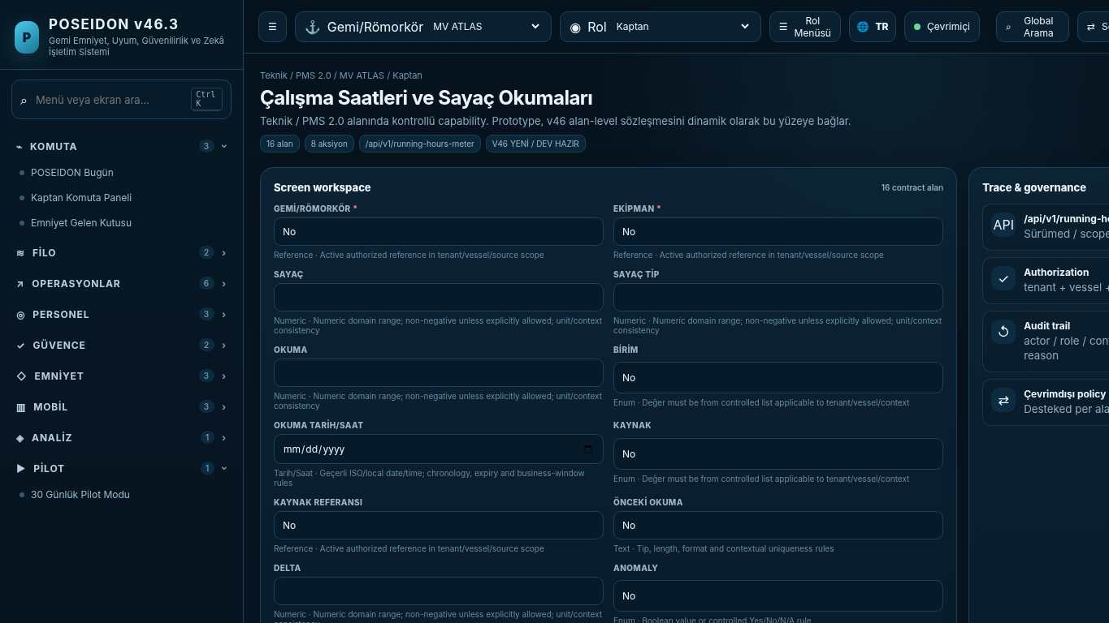
API projection: /api/v1/running-hours-meter | Status: V46 NEW / DEV READY
———————————————————————————————————————————————————————
146 Condition Monitoring
Screen ID: condition-monitoring | Domain: Technical / PMS 2.0 | 18 alan / 9 aksiyon
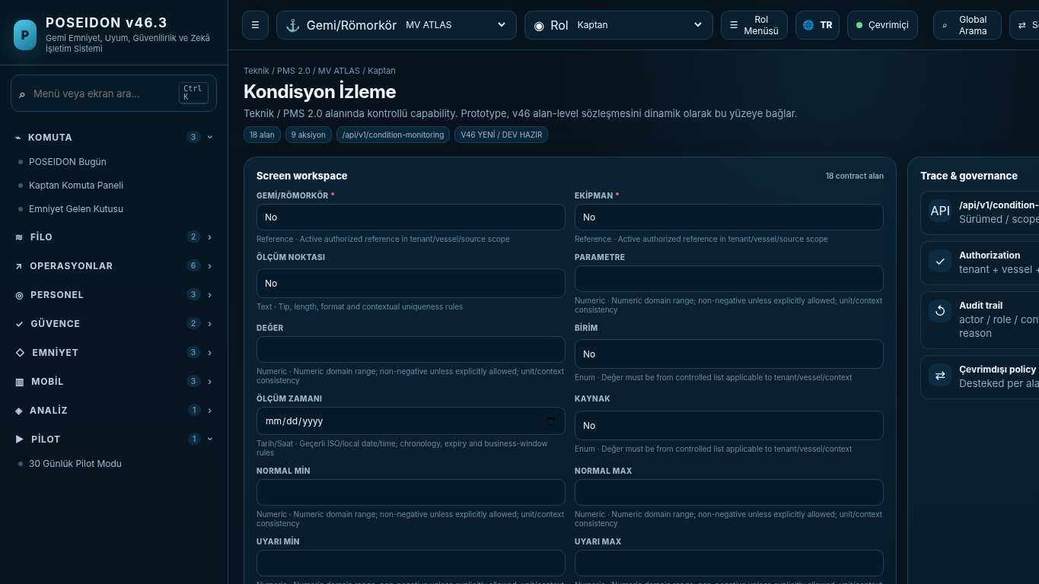
API projection: /api/v1/condition-monitoring | Status: V46 NEW / DEV READY

147 Spare Parts Catalog
Screen ID: spare-parts-catalog | Domain: Technical / PMS 2.0 | 18 alan / 9 aksiyon
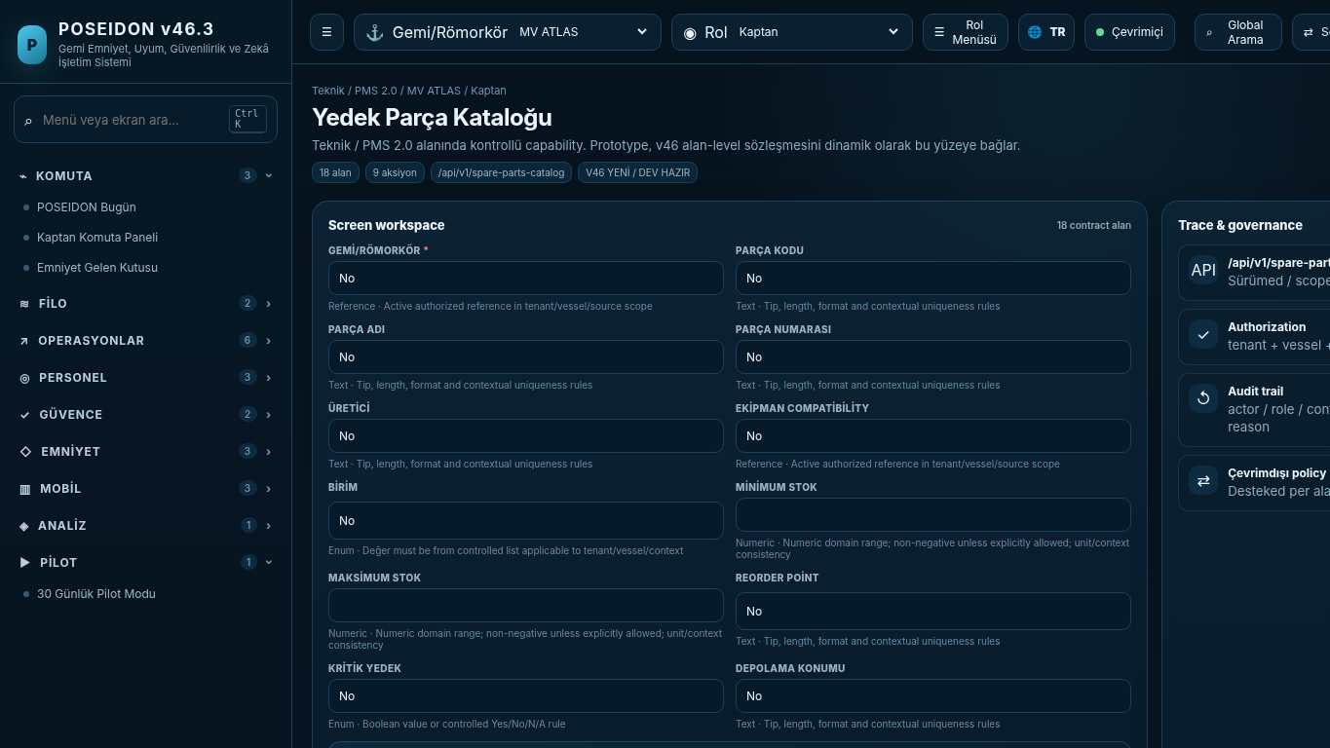
API projection: /api/v1/spare-parts-catalog | Status: V46 NEW / DEV READY
———————————————————————————————————————————————————————
148 Critical Spares Readiness
Screen ID: critical-spares | Domain: Technical / PMS 2.0 | 14 alan / 8 aksiyon
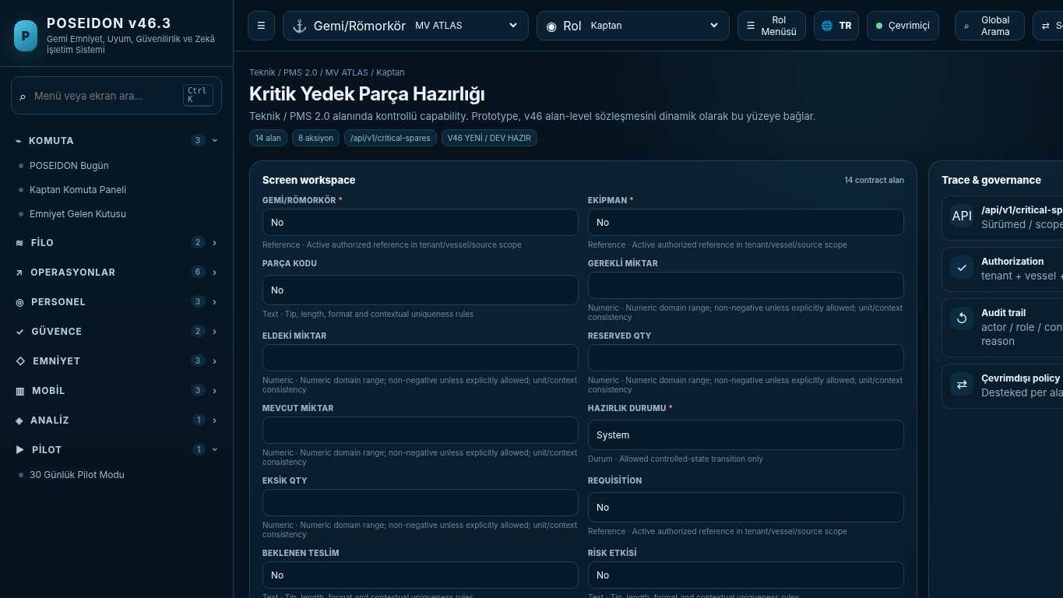
API projection: /api/v1/critical-spares | Status: V46 NEW / DEV READY

149 Maintenance History
Screen ID: maintenance-history | Domain: Technical / PMS 2.0 | 12 alan / 6 aksiyon
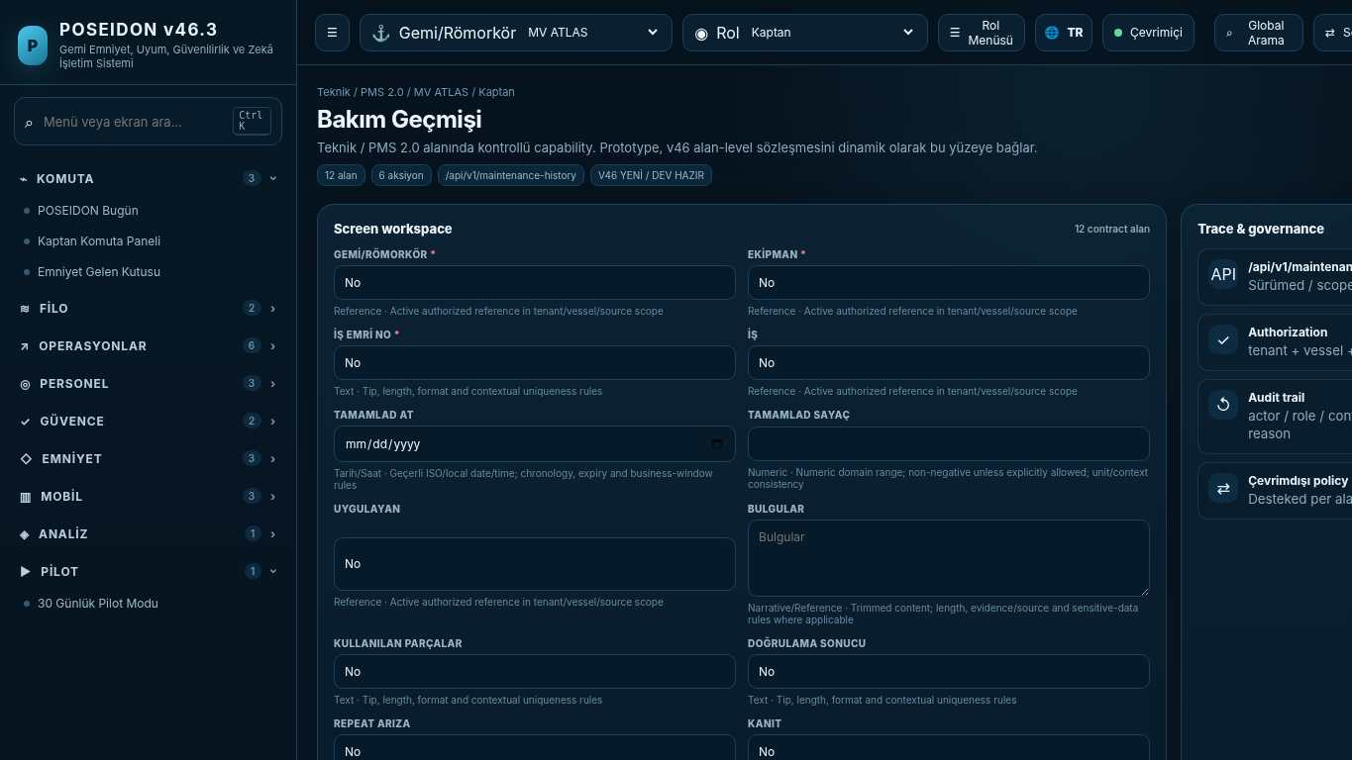
API projection: /api/v1/maintenance-history | Status: V46 NEW / DEV READY
———————————————————————————————————————————————————————
150 Drydock Planning
Screen ID: drydock-planning | Domain: Technical / PMS 2.0 | 18 alan / 10 aksiyon
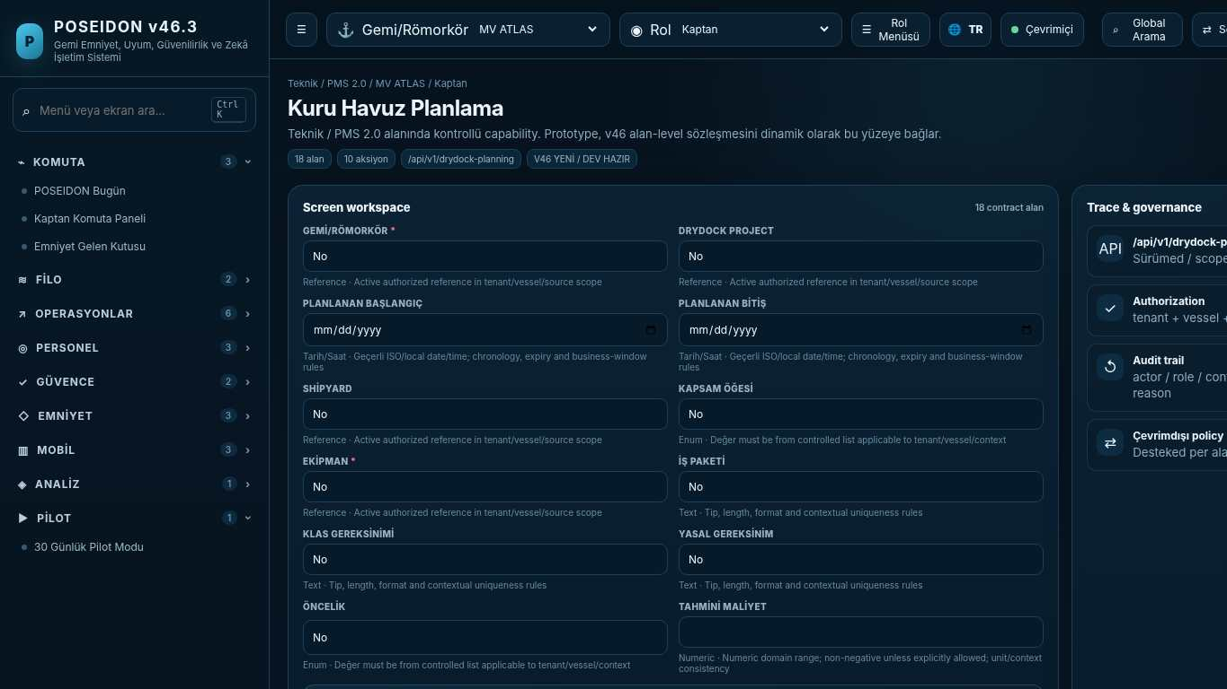
API projection: /api/v1/drydock-planning | Status: V46 NEW / DEV READY

151 Reliability Analytics
Screen ID: reliability-analytics | Domain: Technical / PMS 2.0 | 12 alan / 6 aksiyon
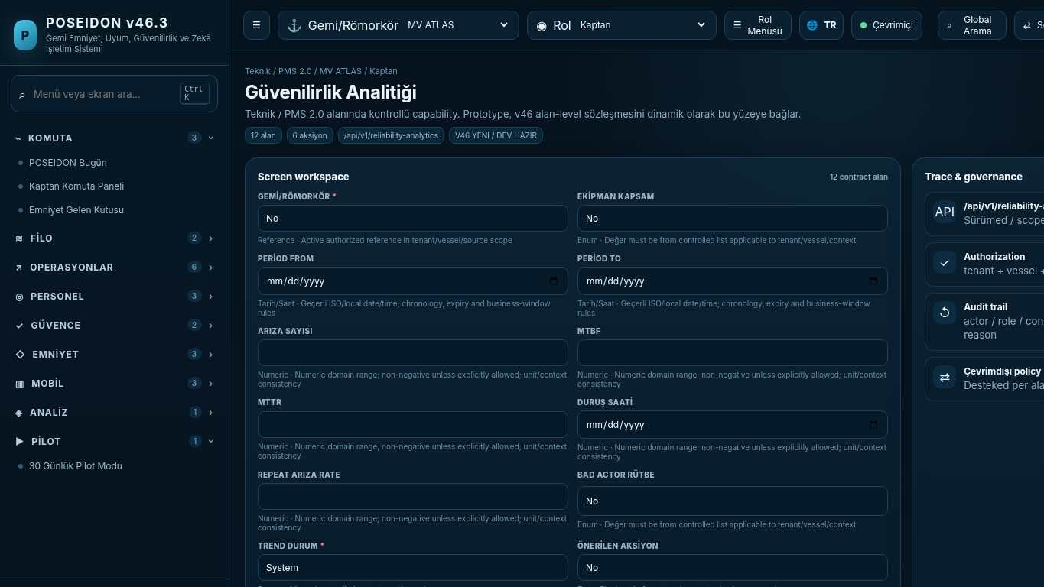
API projection: /api/v1/reliability-analytics | Status: V46 NEW / DEV READY
———————————————————————————————————————————————————————
152 Crew Roster
Screen ID: crew-roster | Domain: Crew Operations | 16 alan / 8 aksiyon
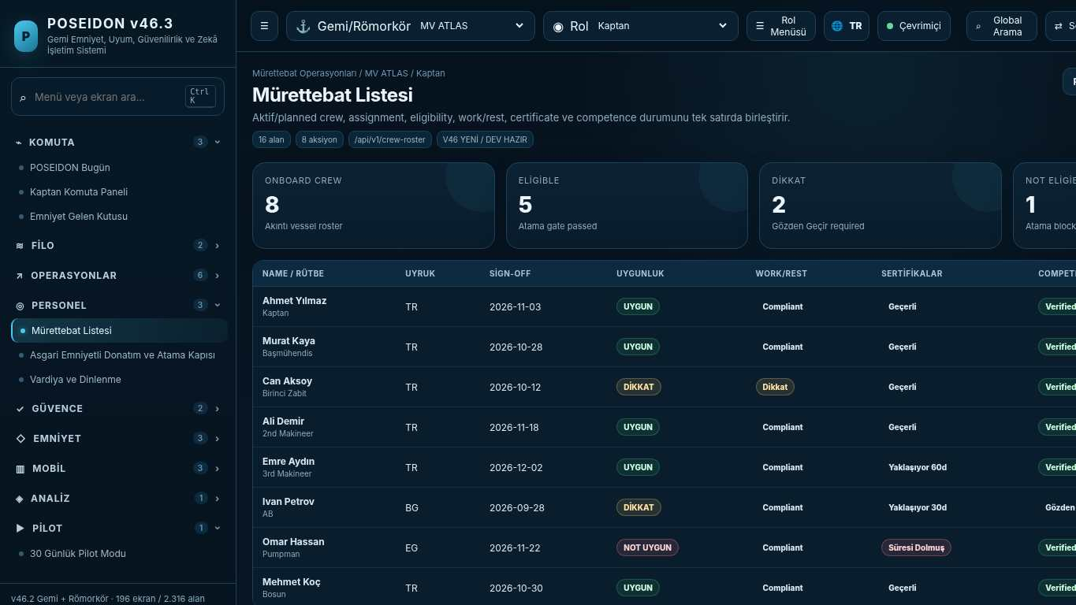
API projection: /api/v1/crew-roster | Status: V46 NEW / DEV READY

153 Crew Profile
Screen ID: crew-profile | Domain: Crew Operations | 28 alan / 10 aksiyon
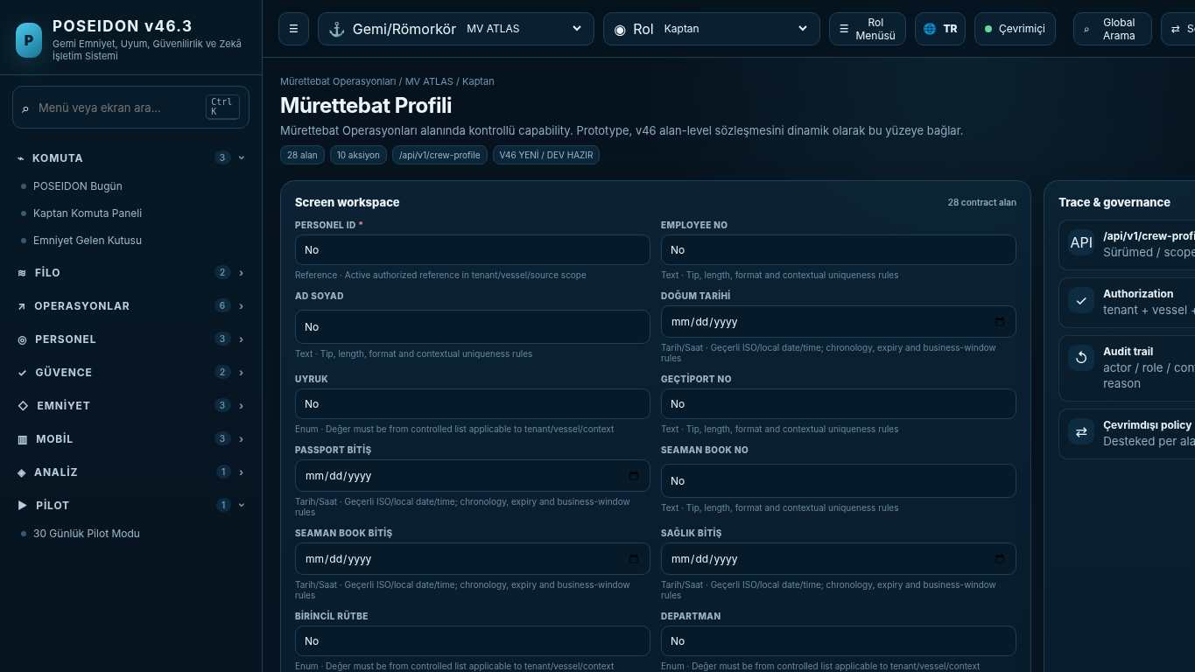
API projection: /api/v1/crew-profile | Status: V46 NEW / DEV READY
———————————————————————————————————————————————————————
154 Crew Assignment & Sign-on/off
Screen ID: crew-assignments | Domain: Crew Operations | 18 alan / 10 aksiyon
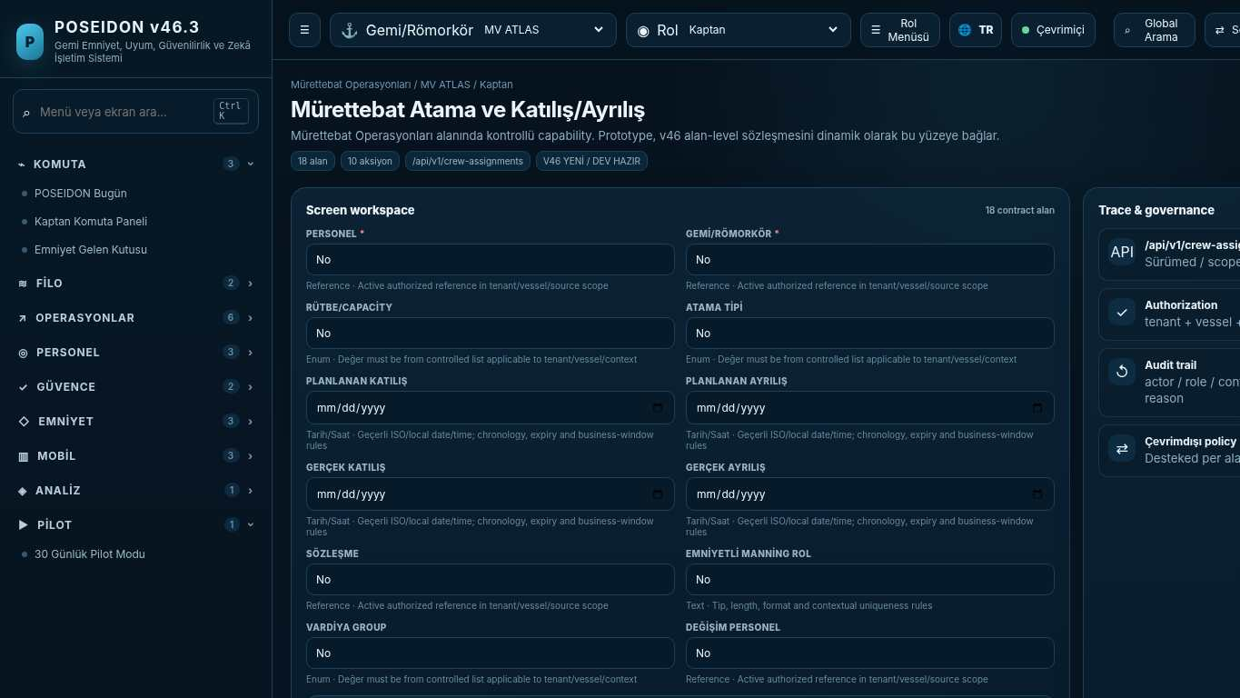
API projection: /api/v1/crew-assignments | Status: V46 NEW / DEV READY

155 Crew Certificates & Endorsements
Screen ID: crew-certificates | Domain: Crew Operations | 24 alan / 10 aksiyon
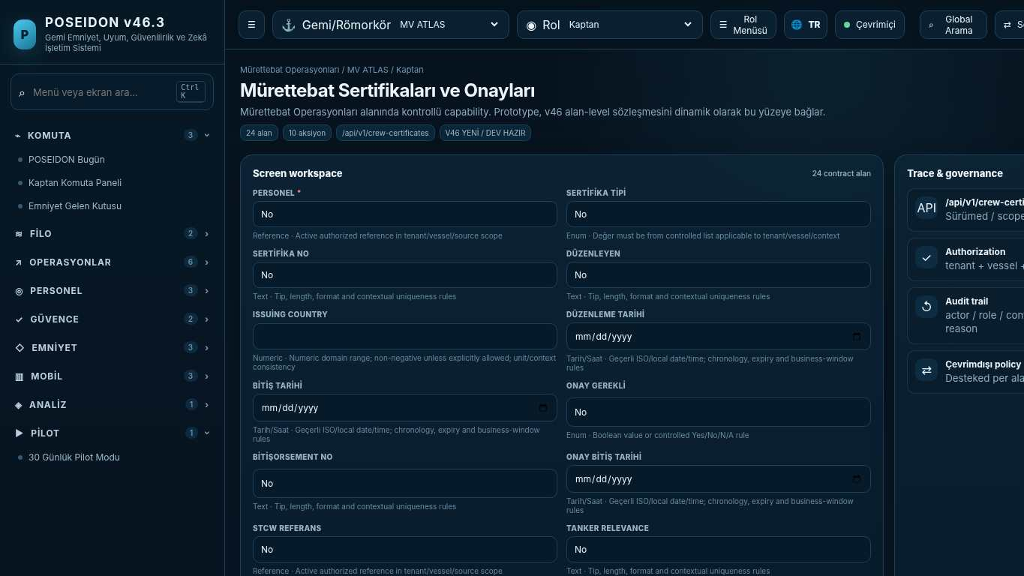
API projection: /api/v1/crew-certificates | Status: V46 NEW / DEV READY
———————————————————————————————————————————————————————
156 Training–Position Matrix
Screen ID: training-position-matrix | Domain: Crew Operations | 18 alan / 10 aksiyon
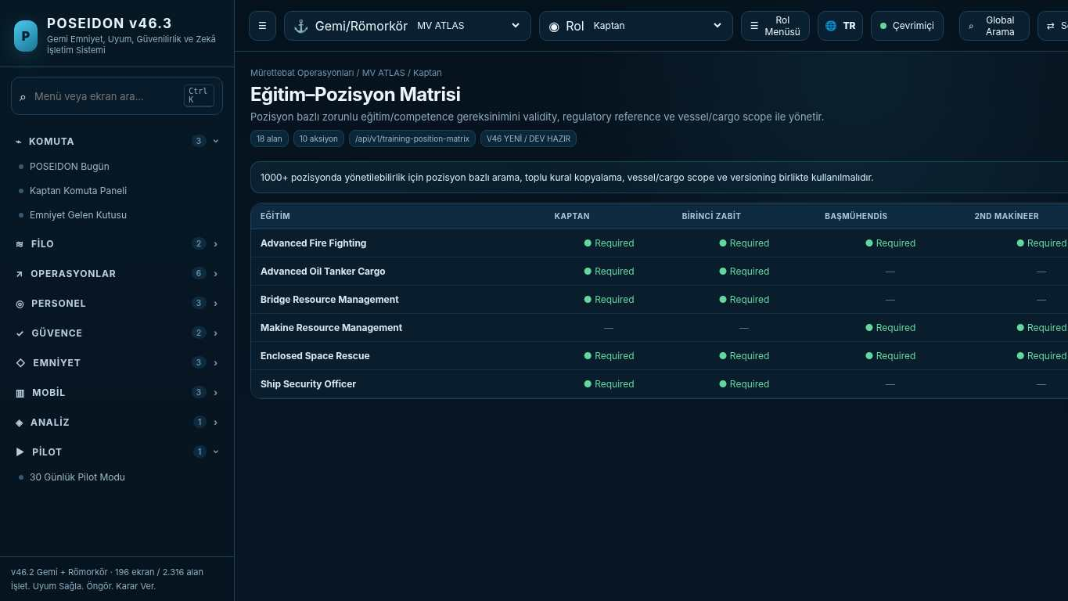
API projection: /api/v1/training-position-matrix | Status: V46 NEW / DEV READY

157 Crew Rotation Planner
Screen ID: crew-rotation-planner | Domain: Crew Operations | 14 alan / 8 aksiyon
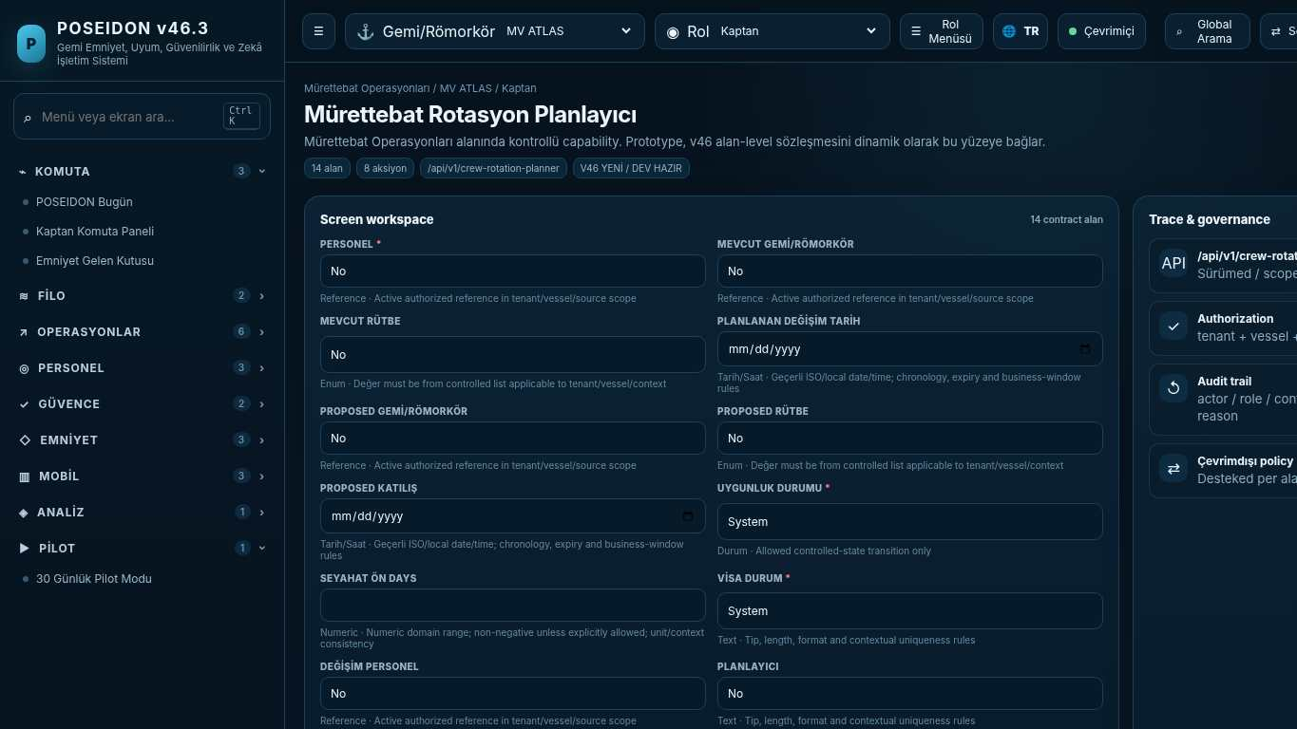
API projection: /api/v1/crew-rotation-planner | Status: V46 NEW / DEV READY
———————————————————————————————————————————————————————
158 OCIMF Crew Matrix
Screen ID: ocimf-crew-matrix | Domain: Crew Operations | 18 alan / 8 aksiyon
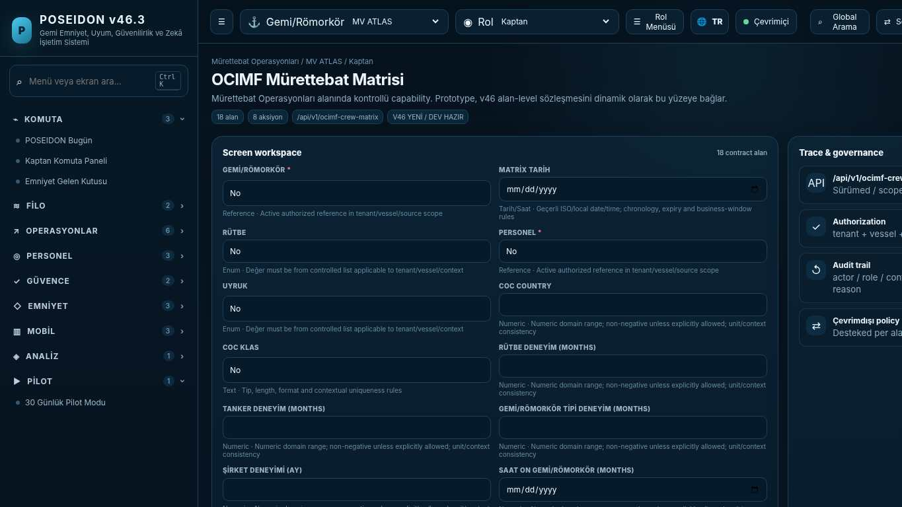
API projection: /api/v1/ocimf-crew-matrix | Status: V46 NEW / DEV READY

159 Certificate Intelligence Center
Screen ID: certificate-command-center | Domain: Certificate Intelligence | 10 alan / 8 aksiyon
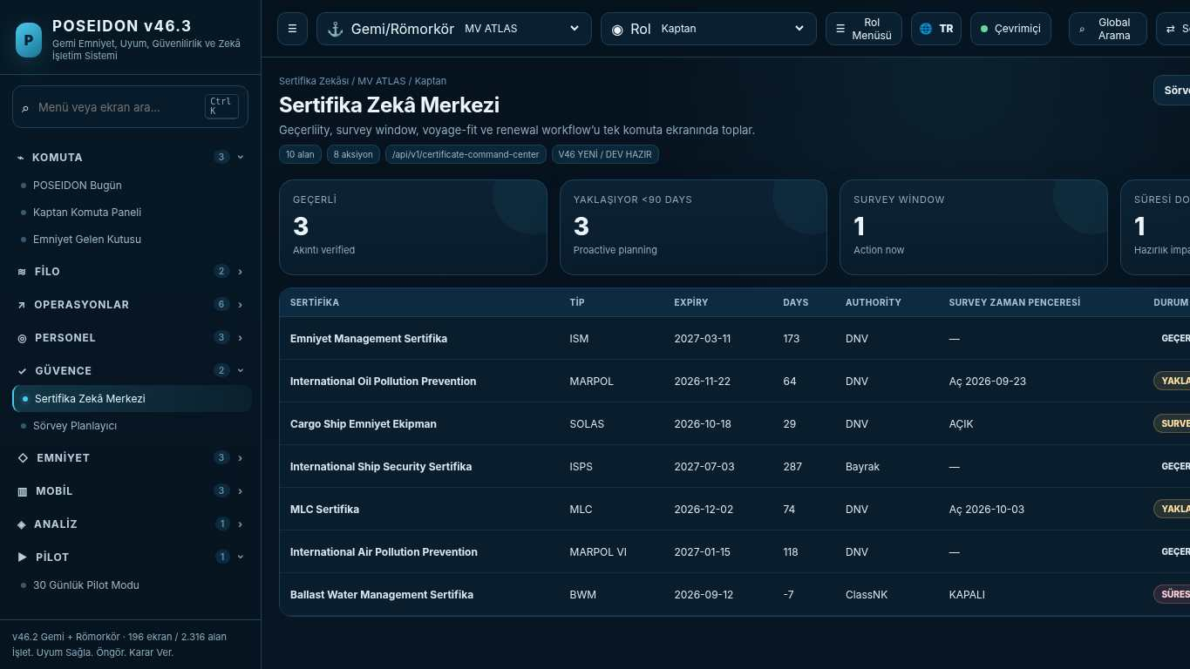
API projection: /api/v1/certificate-command-center | Status: V46 NEW / DEV READY
———————————————————————————————————————————————————————
160 Survey Planner
Screen ID: survey-planner | Domain: Certificate Intelligence | 18 alan / 10 aksiyon
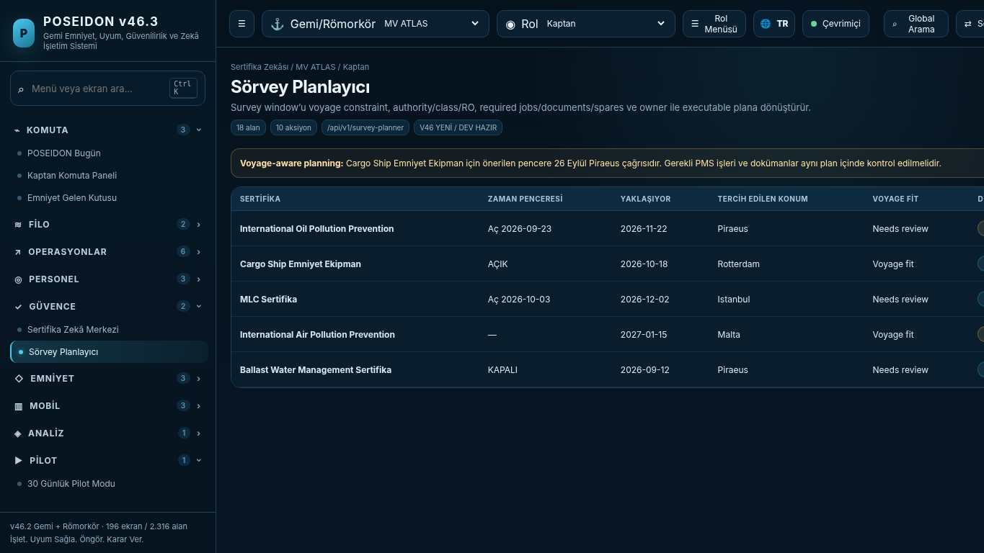
API projection: /api/v1/survey-planner | Status: V46 NEW / DEV READY

161 Certificate Renewal Workflow
Screen ID: renewal-workflow | Domain: Certificate Intelligence | 20 alan / 10 aksiyon
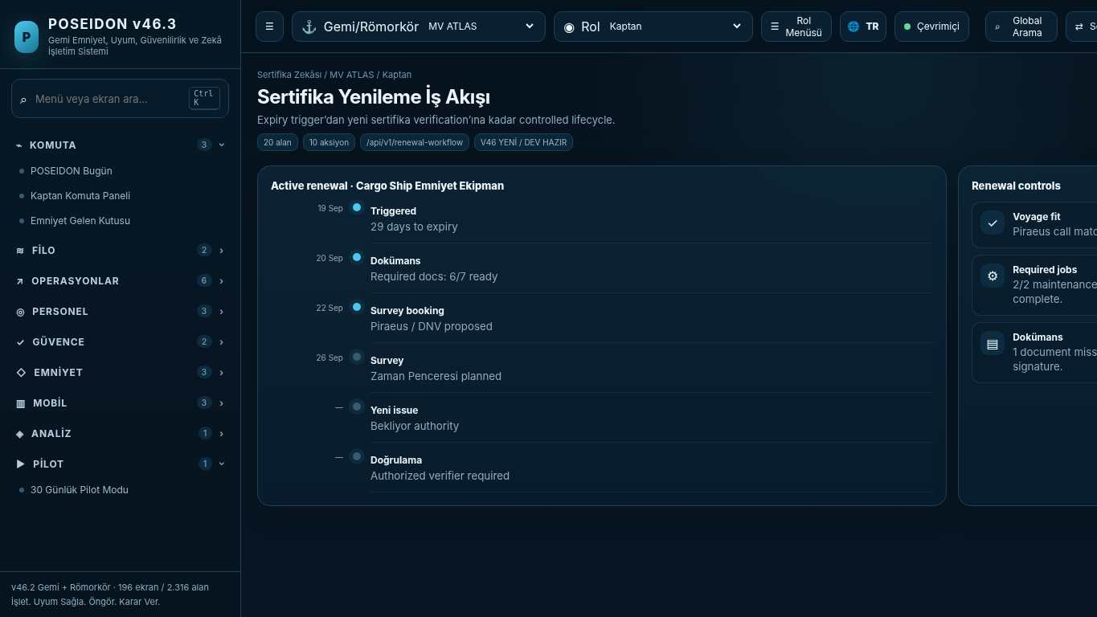
API projection: /api/v1/renewal-workflow | Status: V46 NEW / DEV READY
———————————————————————————————————————————————————————
162 Connector Catalog
Screen ID: connector-catalog | Domain: Integration Hub 2.0 | 14 alan / 8 aksiyon
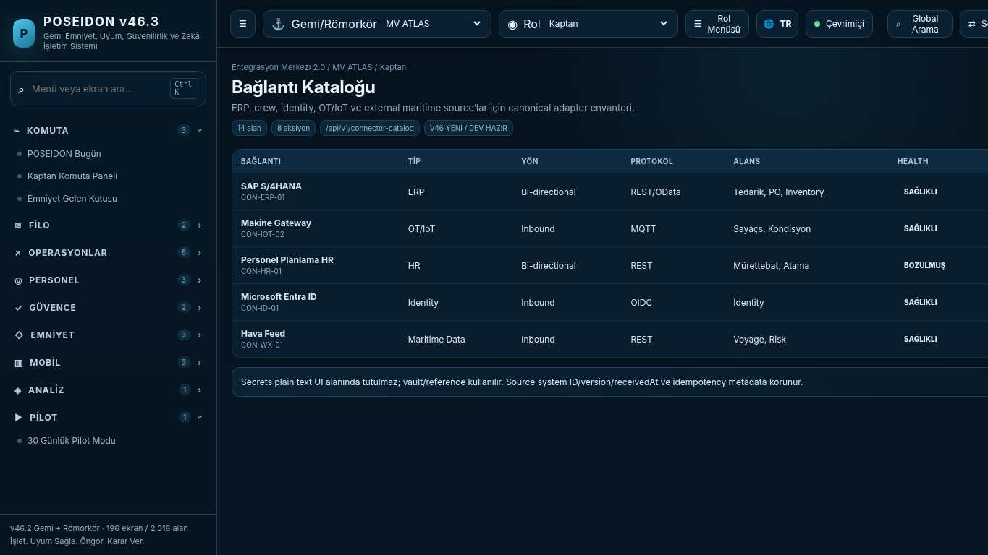
API projection: /api/v1/connector-catalog | Status: V46 NEW / DEV READY

163 Integration Mapping & Transformation
Screen ID: integration-mapping | Domain: Integration Hub 2.0 | 18 alan / 10 aksiyon
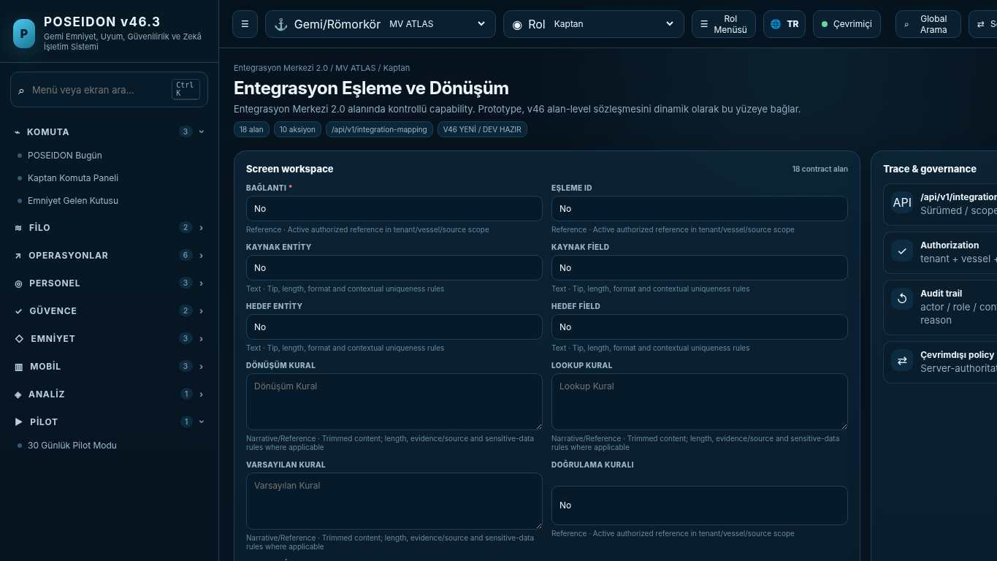
API projection: /api/v1/integration-mapping | Status: V46 NEW / DEV READY
———————————————————————————————————————————————————————
164 Integration Event Monitor
Screen ID: integration-events | Domain: Integration Hub 2.0 | 14 alan / 8 aksiyon
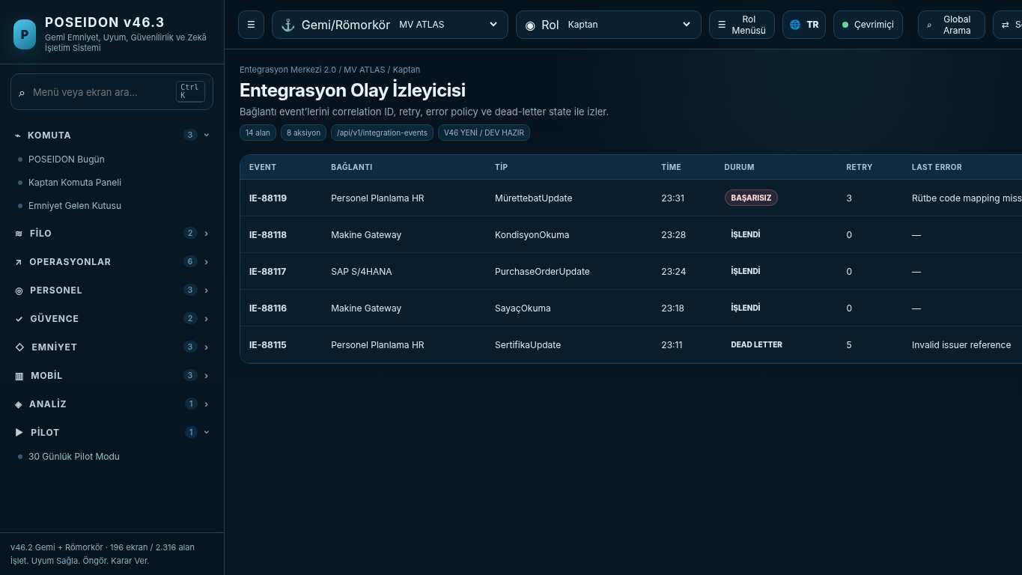
API projection: /api/v1/integration-events | Status: V46 NEW / DEV READY

165 POSEIDON Copilot
Screen ID: poseidon-copilot | Domain: Maritime Intelligence | 8 alan / 8 aksiyon
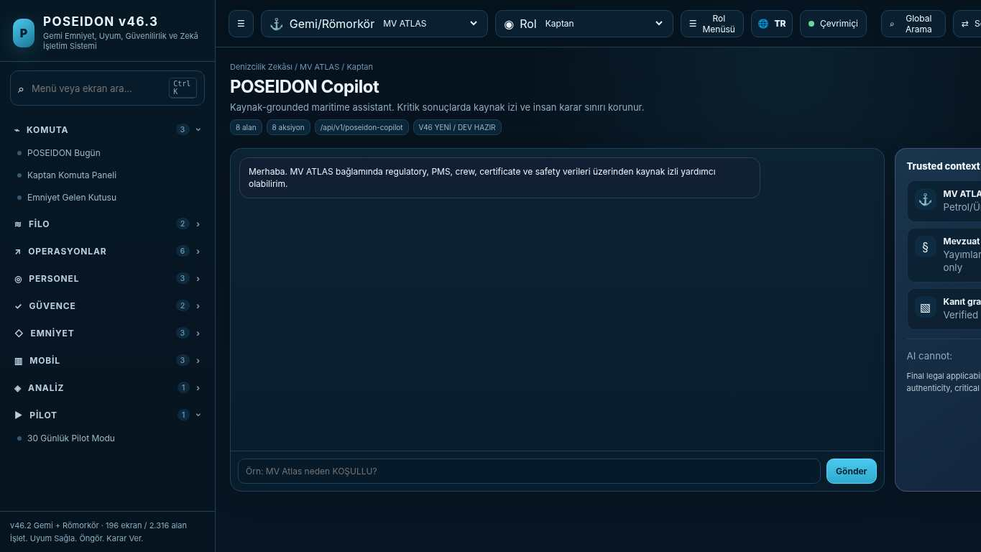
API projection: /api/v1/poseidon-copilot | Status: V46 NEW / DEV READY
———————————————————————————————————————————————————————
166 Decision Center
Screen ID: decision-center | Domain: Maritime Intelligence | 14 alan / 10 aksiyon
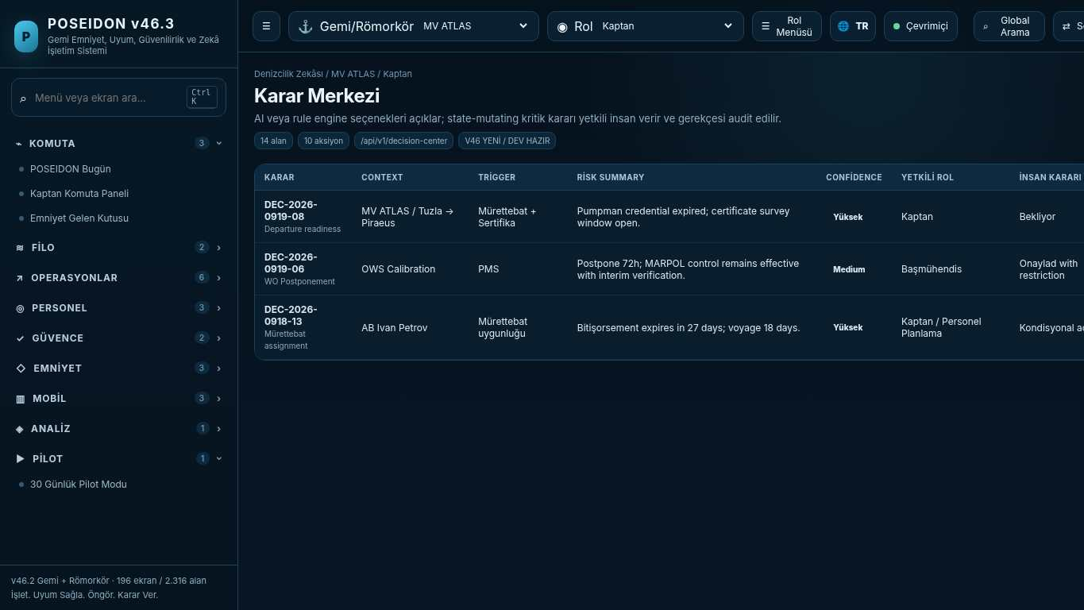
API projection: /api/v1/decision-center | Status: V46 NEW / DEV READY

167 Recommendation Inbox
Screen ID: recommendation-inbox | Domain: Maritime Intelligence | 12 alan / 8 aksiyon
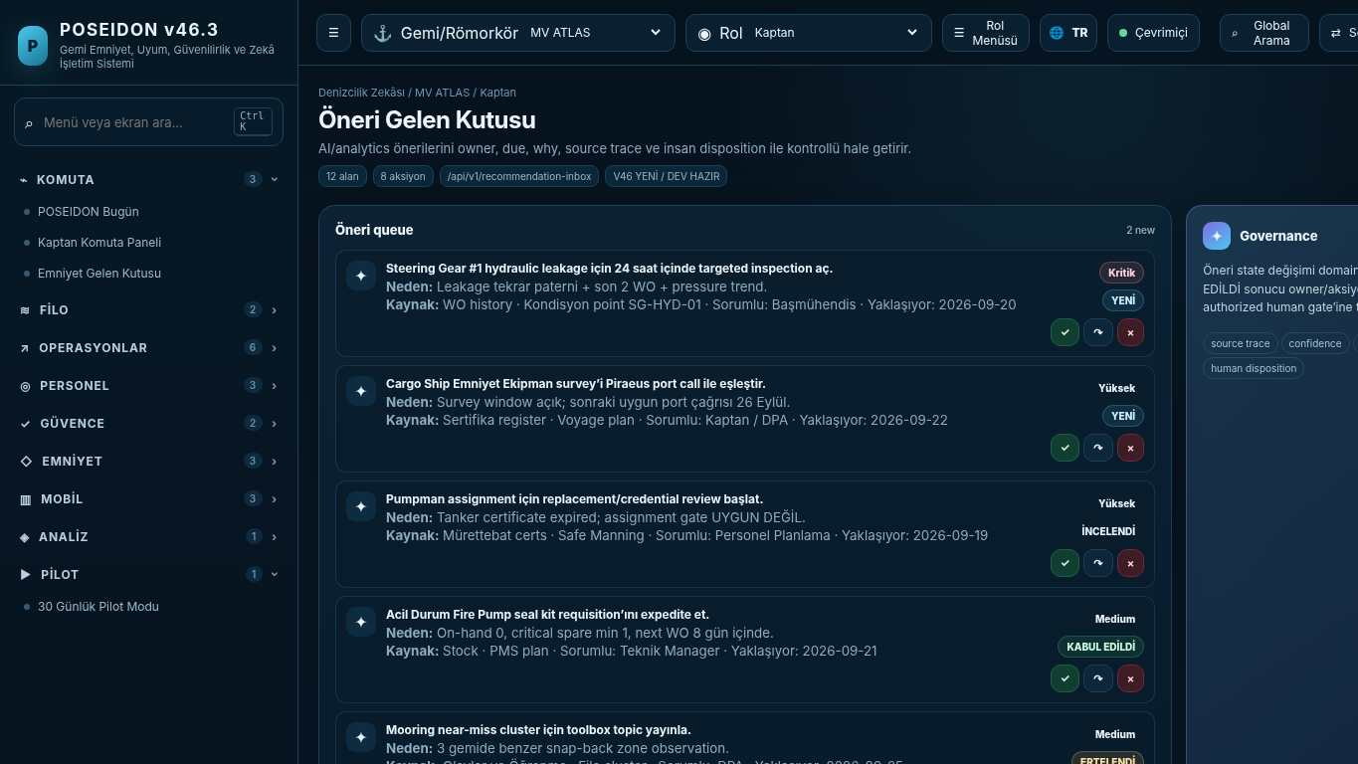
API projection: /api/v1/recommendation-inbox | Status: V46 NEW / DEV READY
———————————————————————————————————————————————————————
168 Mobile Task Center
Screen ID: mobile-task-center | Domain: Mobile / Offline 2.0 | 10 alan / 8 aksiyon
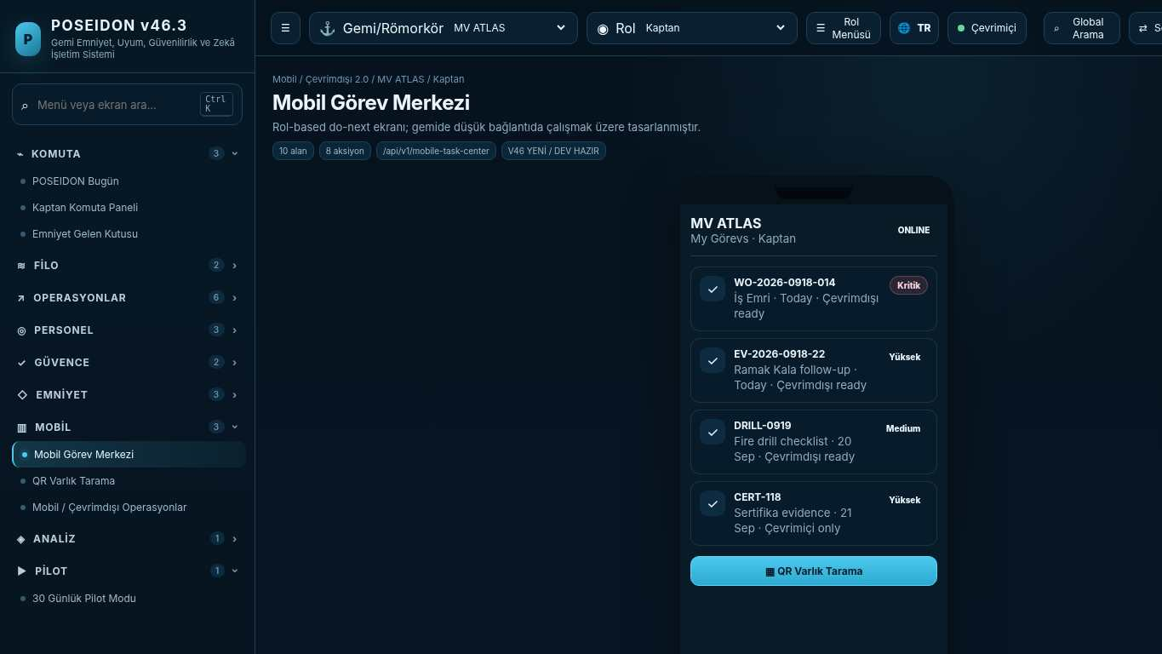
API projection: /api/v1/mobile-task-center | Status: V46 NEW / DEV READY

169 QR Asset Scan
Screen ID: qr-asset-scan | Domain: Mobile / Offline 2.0 | 8 alan / 6 aksiyon
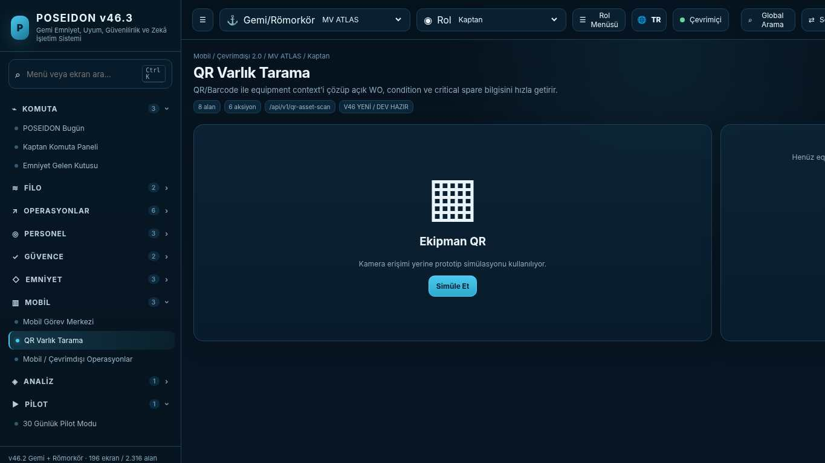
API projection: /api/v1/qr-asset-scan | Status: V46 NEW / DEV READY
———————————————————————————————————————————————————————
170 Technical Requisition
Screen ID: technical-requisition | Domain: Technical Supply | 18 alan / 10 aksiyon
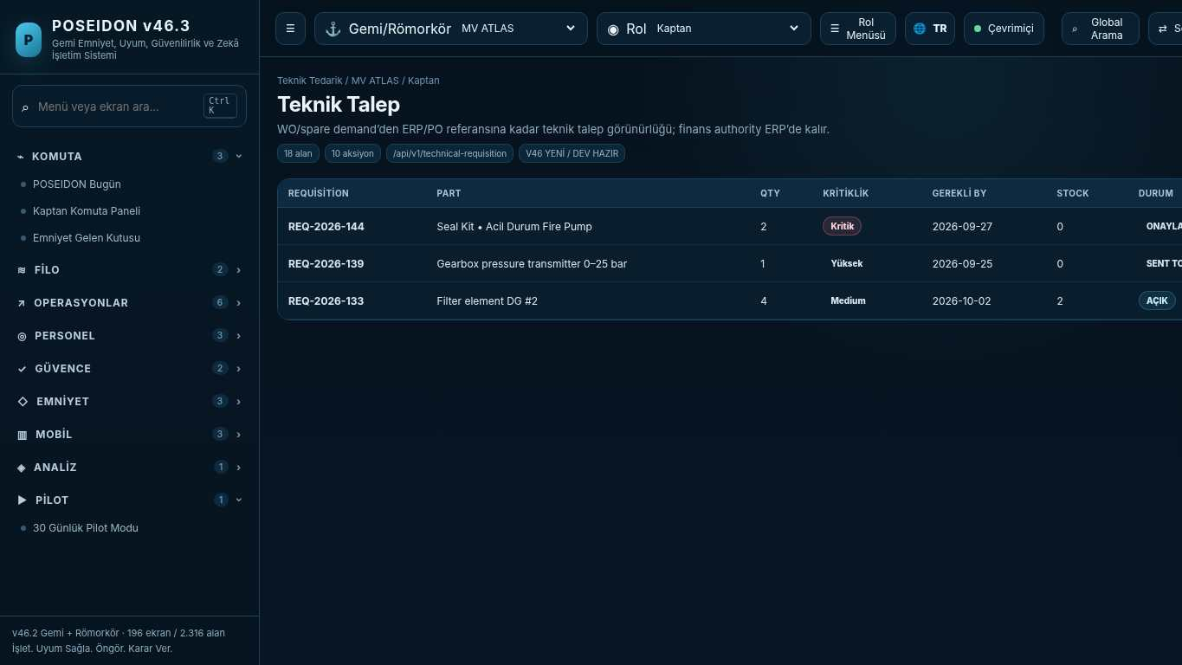
API projection: /api/v1/technical-requisition | Status: V46 NEW / DEV READY

171 Inventory & Stock
Screen ID: inventory-stock | Domain: Technical Supply | 16 alan / 8 aksiyon
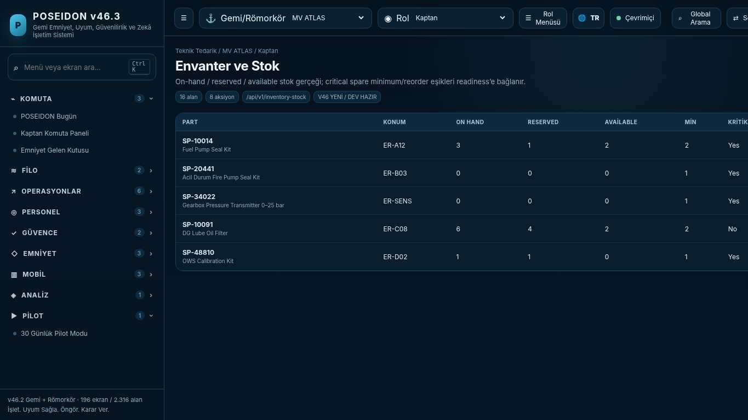
API projection: /api/v1/inventory-stock | Status: V46 NEW / DEV READY
———————————————————————————————————————————————————————
172 Supplier / Order Tracking
Screen ID: supplier-order-tracking | Domain: Technical Supply | 14 alan / 8 aksiyon
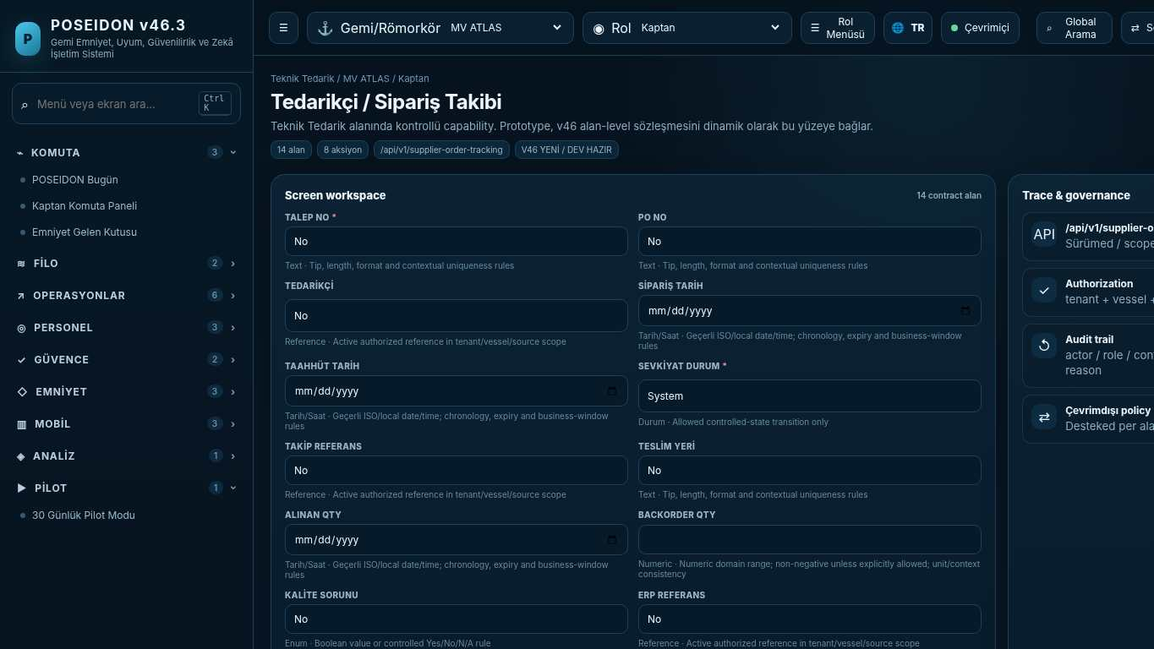
API projection: /api/v1/supplier-order-tracking | Status: V46 NEW / DEV READY

173 Römorkör Komuta Merkezi
Screen ID: tug-command | Domain: Tug Operations | 12 alan / 8 aksiyon
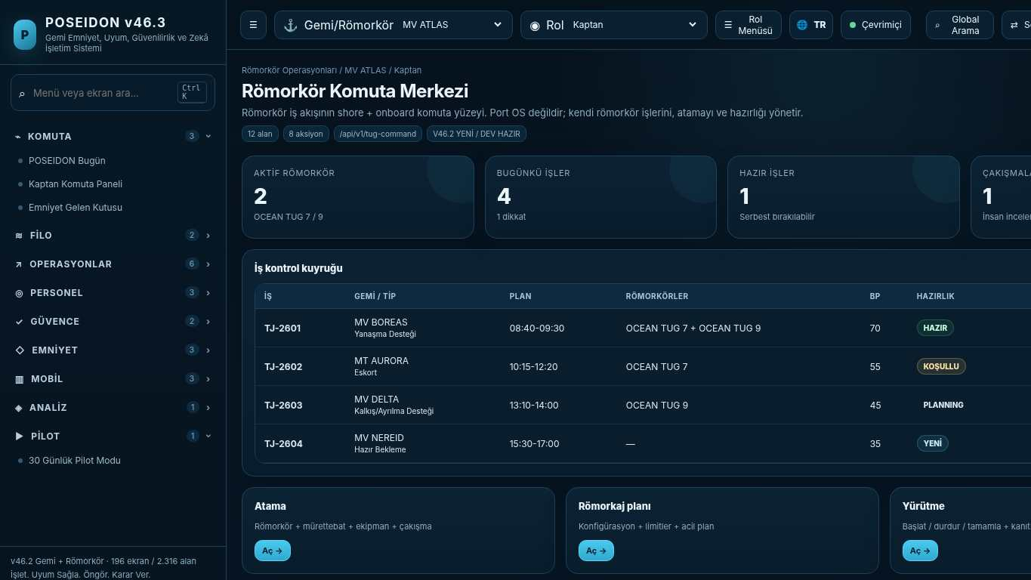
API projection: /api/v1/tug-command | Status: V46.2 NEW / DEV READY
———————————————————————————————————————————————————————
174 Römorkör İş Talebi / Job Intake
Screen ID: tug-job-intake | Domain: Tug Operations | 18 alan / 10 aksiyon
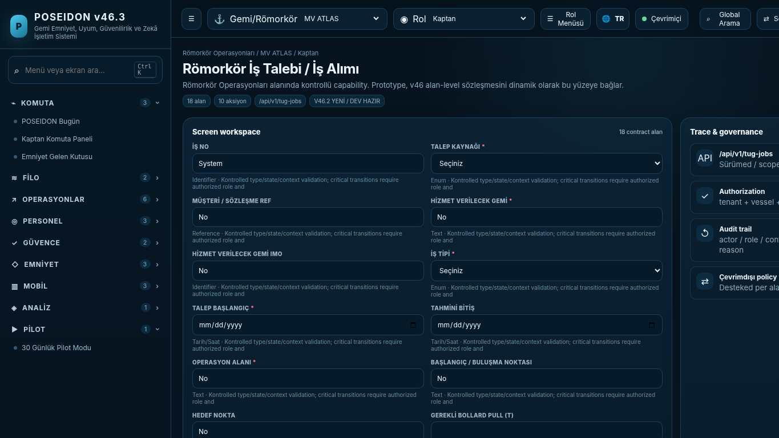
API projection: /api/v1/tug-jobs | Status: V46.2 NEW / DEV READY

175 Römorkör İş Panosu
Screen ID: tug-job-board | Domain: Tug Operations | 14 alan / 10 aksiyon
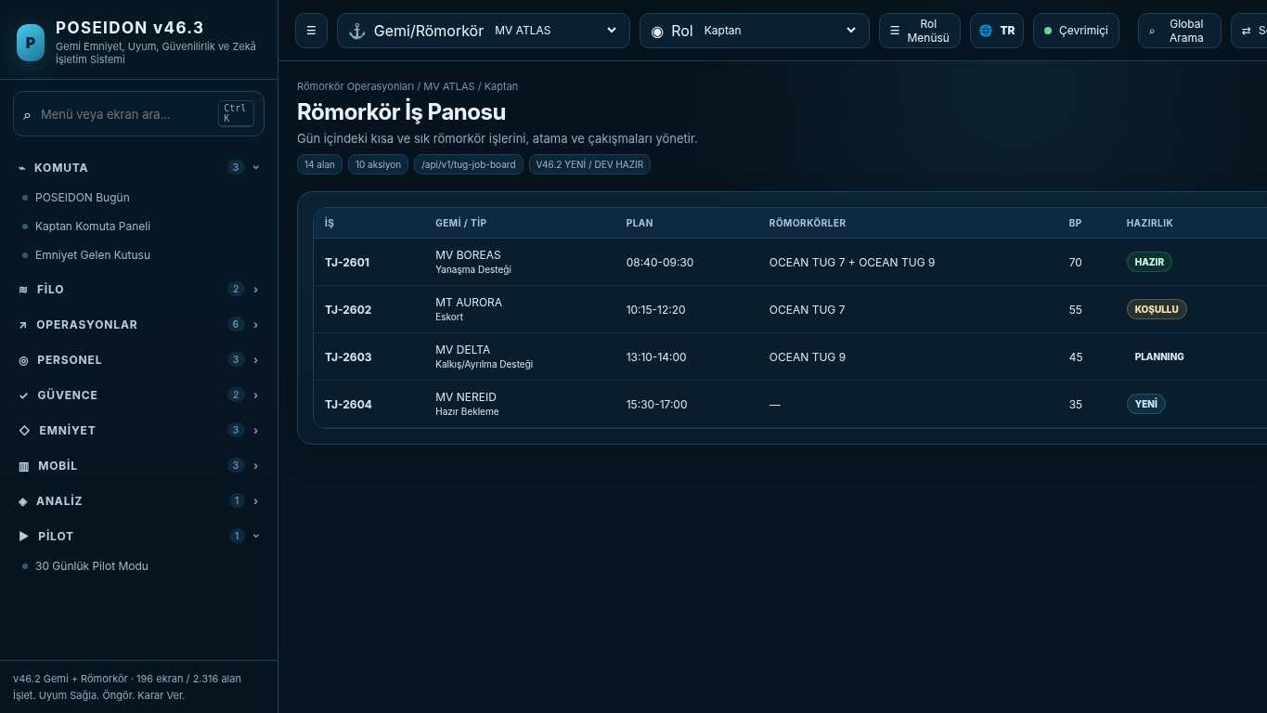
API projection: /api/v1/tug-job-board | Status: V46.2 NEW / DEV READY
———————————————————————————————————————————————————————
176 Römorkör İş Detayı
Screen ID: tug-job-detail | Domain: Tug Operations | 22 alan / 12 aksiyon
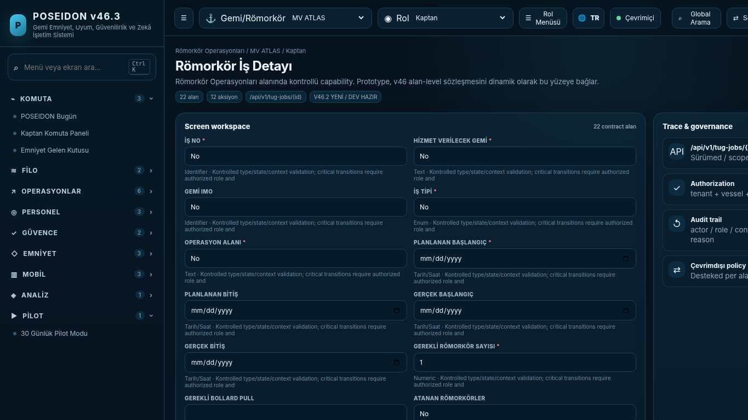
API projection: /api/v1/tug-jobs/{id} | Status: V46.2 NEW / DEV READY

177 Römorkör Atama ve Çakışma Kontrolü
Screen ID: tug-assignment | Domain: Tug Operations | 18 alan / 10 aksiyon
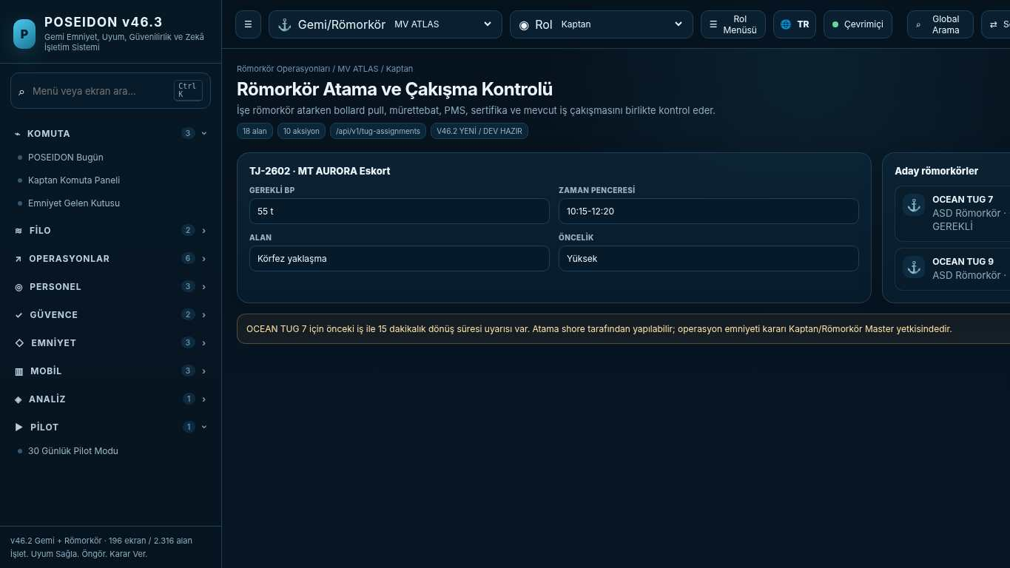
API projection: /api/v1/tug-assignments | Status: V46.2 NEW / DEV READY
———————————————————————————————————————————————————————
178 Römorkör Operasyon Hazırlığı
Screen ID: tug-readiness | Domain: Tug Operations | 18 alan / 10 aksiyon
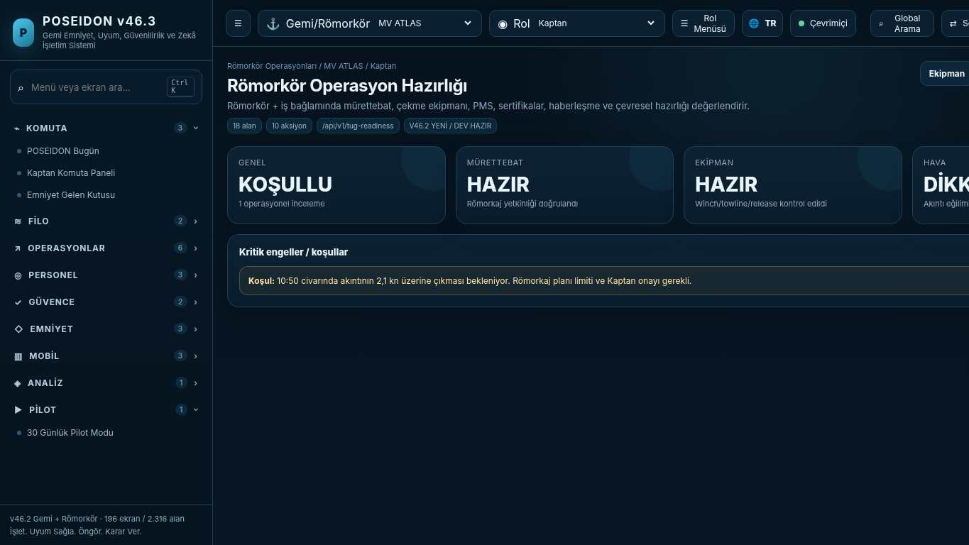
API projection: /api/v1/tug-readiness | Status: V46.2 NEW / DEV READY

179 Römorkaj / Çekme Operasyon Planı
Screen ID: towage-plan | Domain: Tug Operations | 22 alan / 12 aksiyon
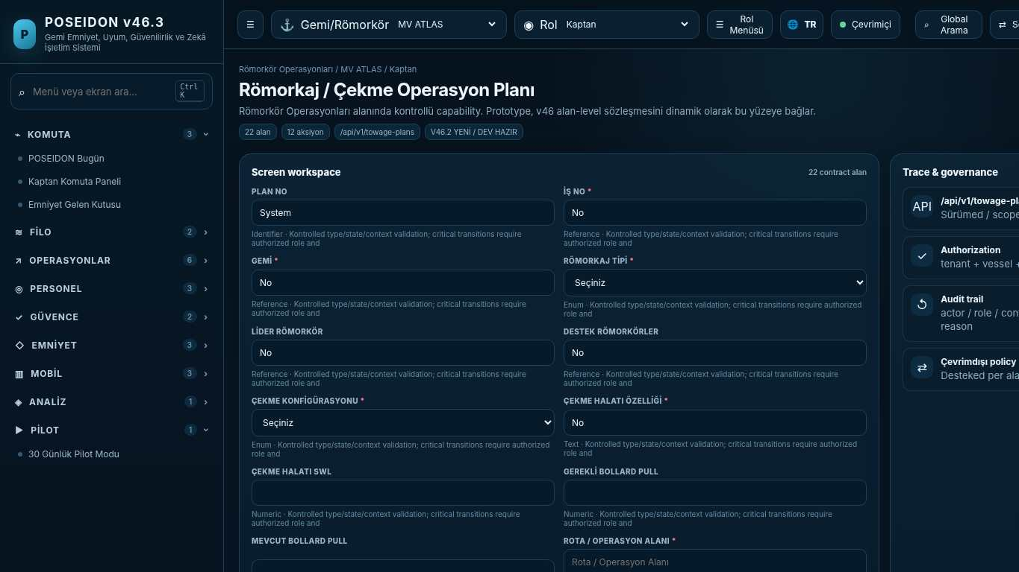
API projection: /api/v1/towage-plans | Status: V46.2 NEW / DEV READY
———————————————————————————————————————————————————————
180 Römorkaj Risk ve Brifing
Screen ID: towage-risk-briefing | Domain: Tug Operations | 20 alan / 10 aksiyon
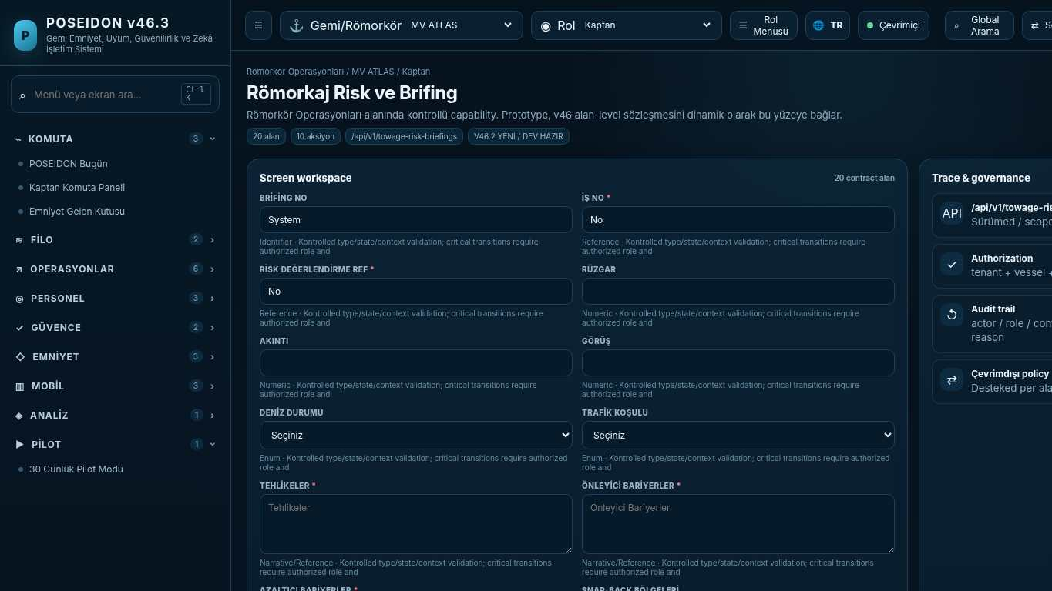
API projection: /api/v1/towage-risk-briefings | Status: V46.2 NEW / DEV READY

181 Römorkaj Operasyon Yürütme
Screen ID: towage-execution | Domain: Tug Operations | 24 alan / 14 aksiyon
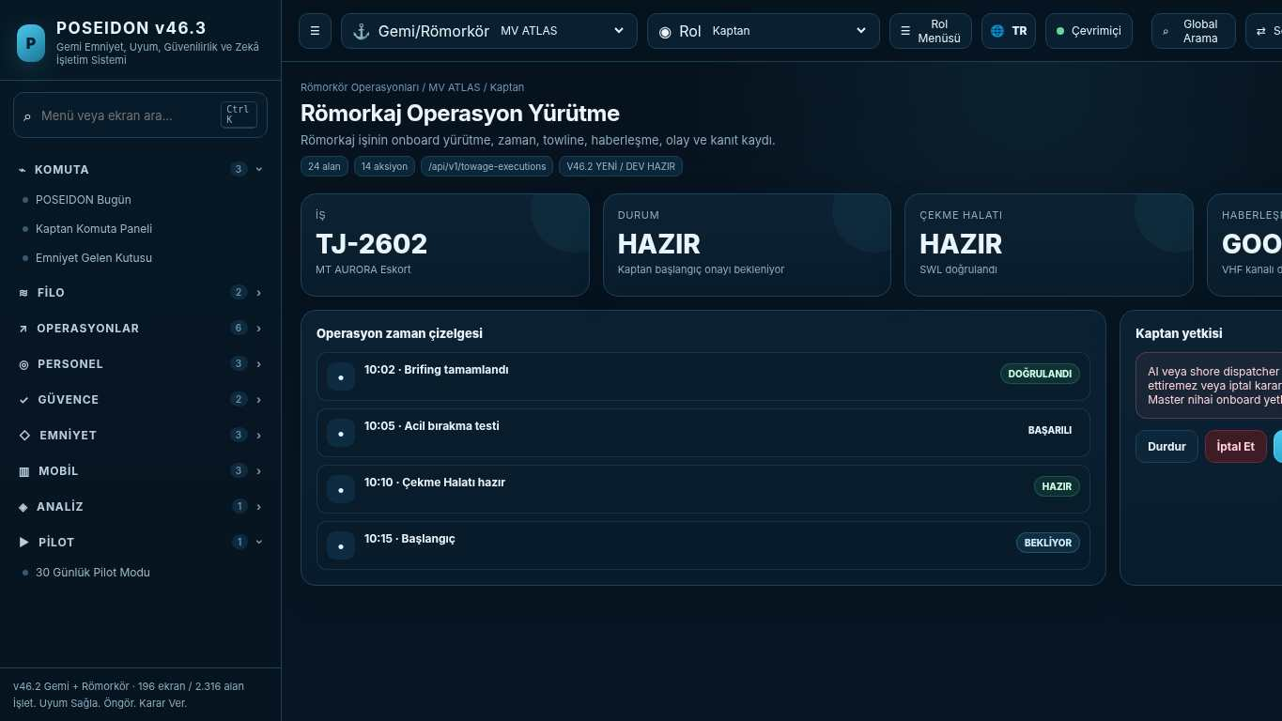
API projection: /api/v1/towage-executions | Status: V46.2 NEW / DEV READY
———————————————————————————————————————————————————————
182 Römorkör Ekipman Hazırlığı
Screen ID: tug-equipment-readiness | Domain: Tug Operations | 18 alan / 10 aksiyon
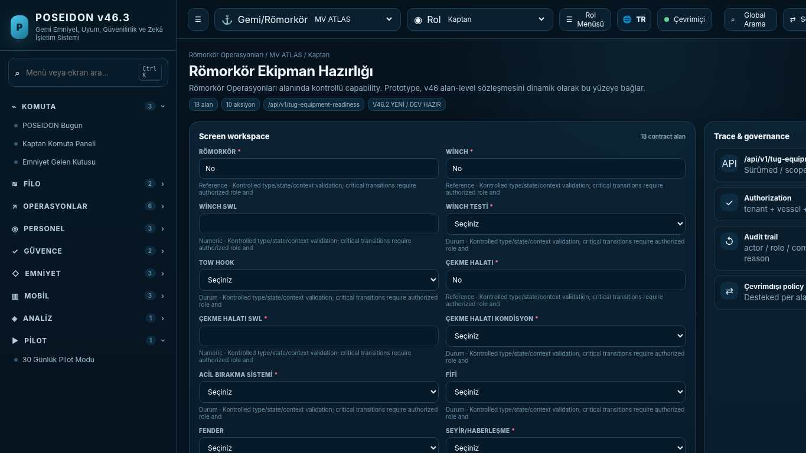
API projection: /api/v1/tug-equipment-readiness | Status: V46.2 NEW / DEV READY

183 Römorkör Mürettebat Hazırlığı
Screen ID: tug-crew-readiness | Domain: Tug Operations | 16 alan / 10 aksiyon
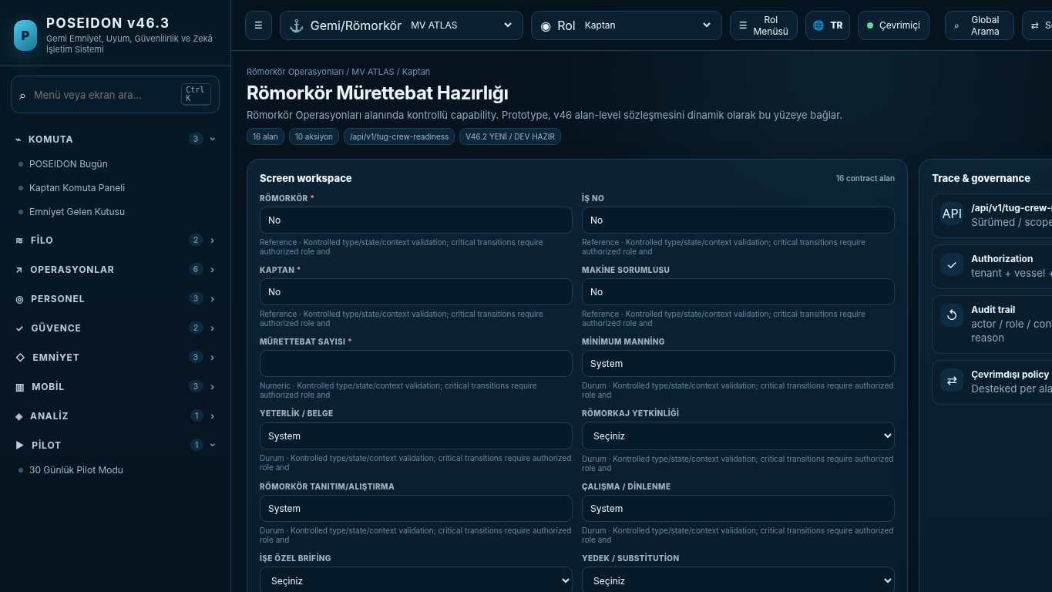
API projection: /api/v1/tug-crew-readiness | Status: V46.2 NEW / DEV READY
———————————————————————————————————————————————————————
184 Römorkör Günlük Operasyon Defteri
Screen ID: tug-daily-log | Domain: Tug Operations | 14 alan / 8 aksiyon
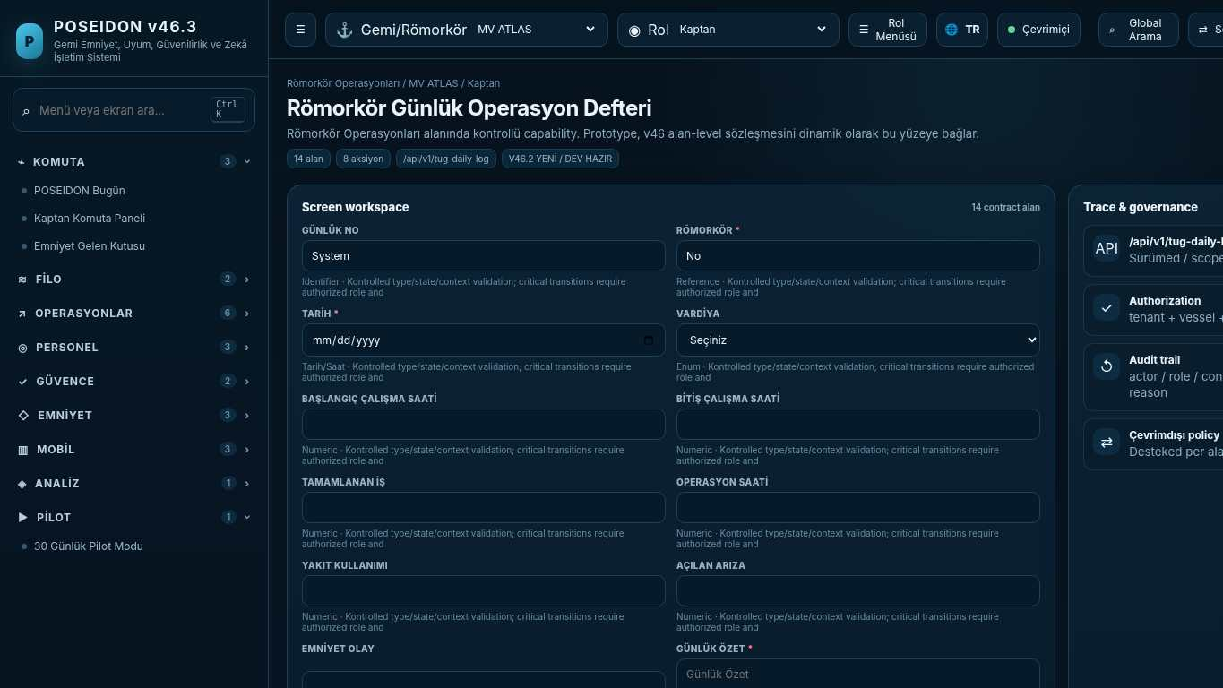
API projection: /api/v1/tug-daily-log | Status: V46.2 NEW / DEV READY

185 Römorkör Operasyon Geçmişi
Screen ID: tug-operation-history | Domain: Tug Operations | 10 alan / 6 aksiyon
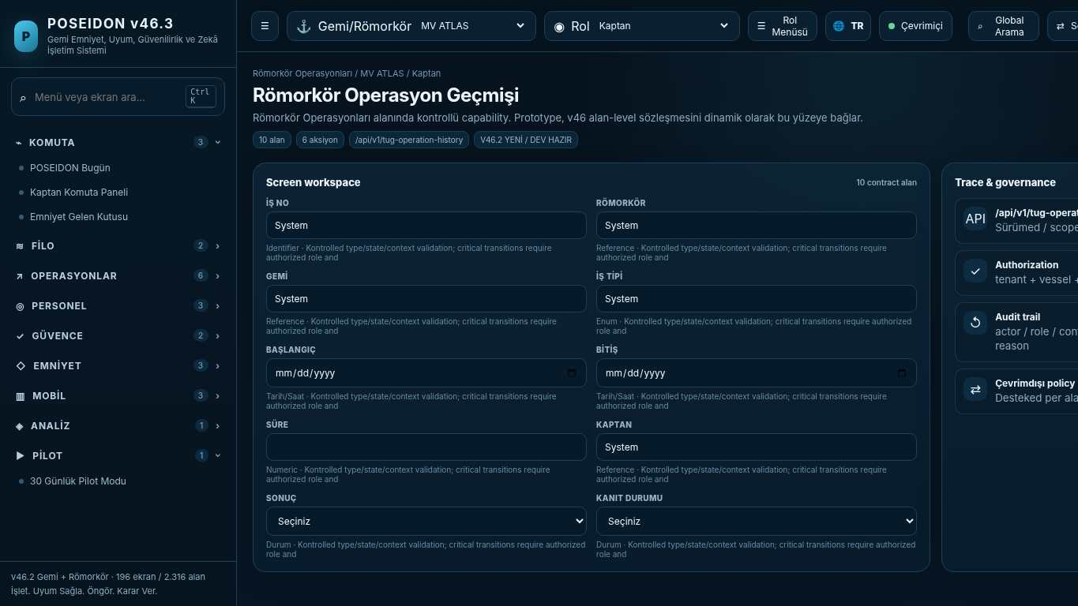
API projection: /api/v1/tug-operation-history | Status: V46.2 NEW / DEV READY
———————————————————————————————————————————————————————
186 Noon Report & Daily Position
Screen ID: noon-report | Domain: Operations & Readiness | 20 alan / 4 aksiyon
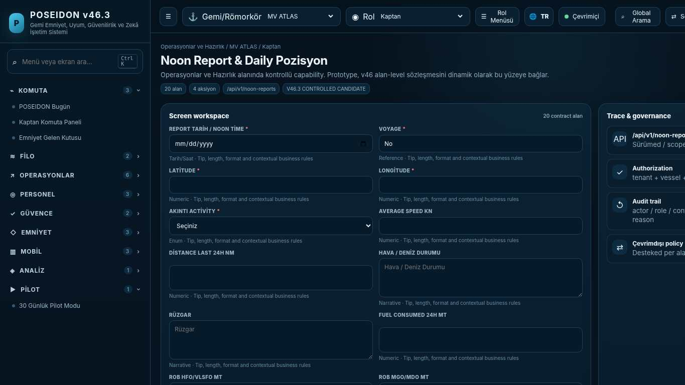
API projection: /api/v1/noon-reports | Status: V46.3 CONTROLLED CANDIDATE

187 Deck Daily Log
Screen ID: deck-daily-log | Domain: Operations & Readiness | 18 alan / 4 aksiyon
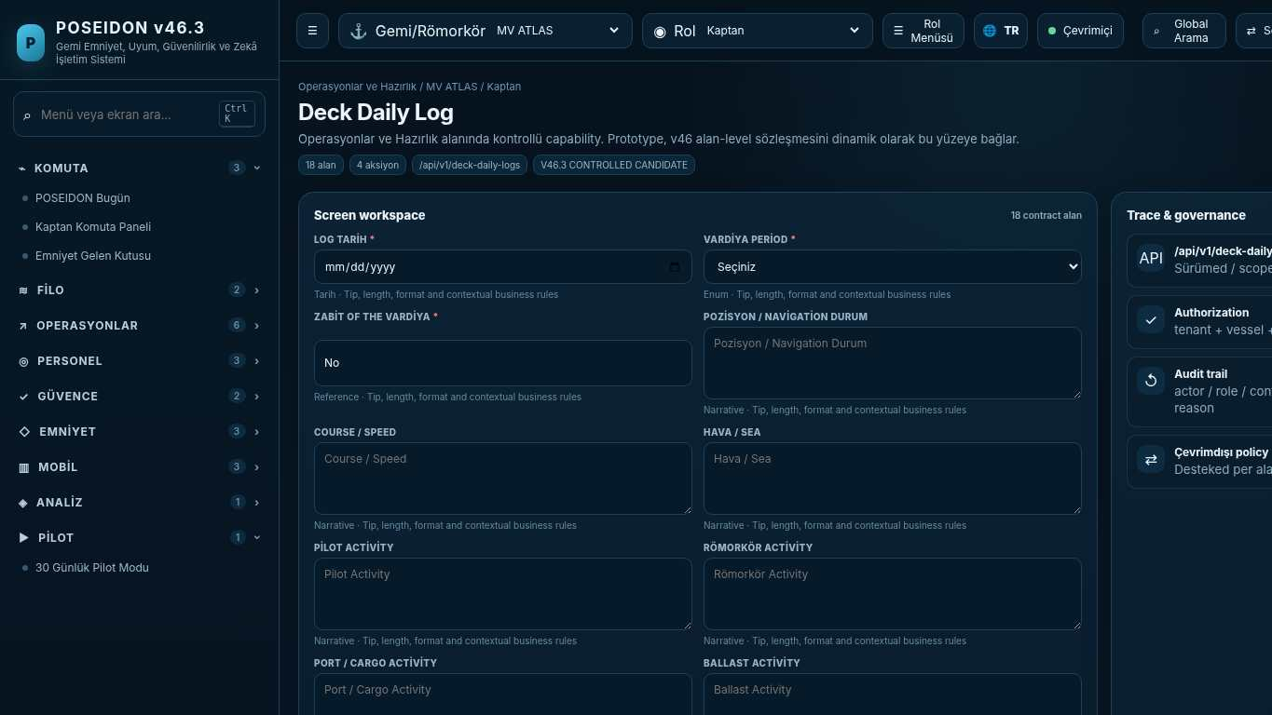
API projection: /api/v1/deck-daily-logs | Status: V46.3 CONTROLLED CANDIDATE
———————————————————————————————————————————————————————
188 Engine Daily Log
Screen ID: engine-daily-log | Domain: Operations & Readiness | 20 alan / 4 aksiyon
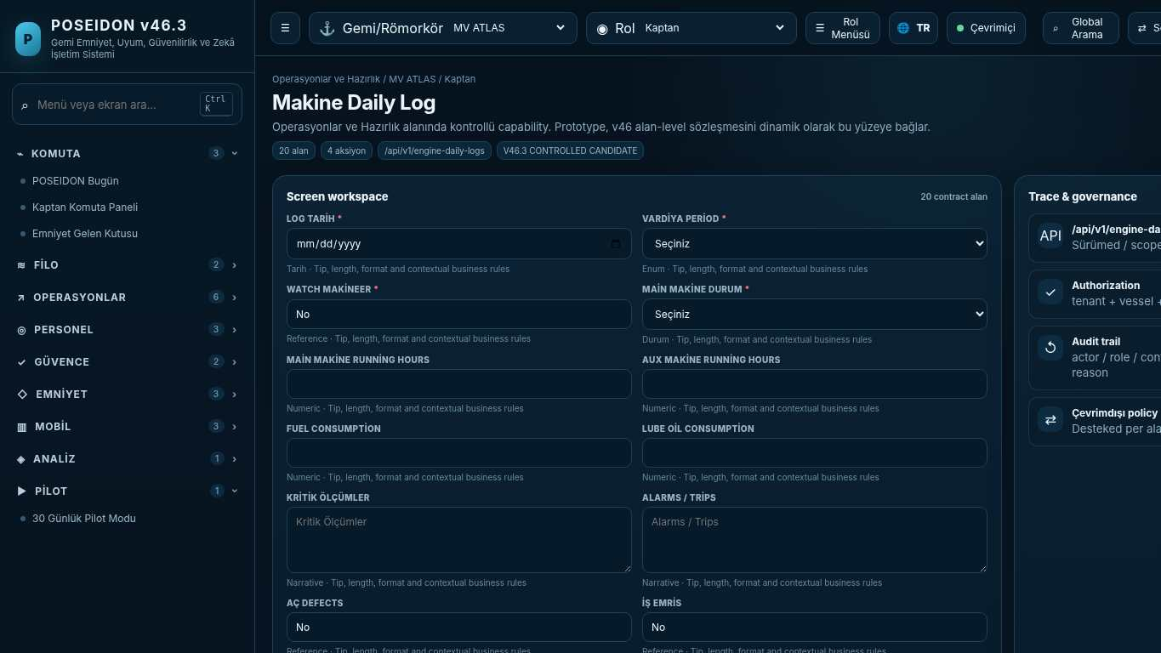
API projection: /api/v1/engine-daily-logs | Status: V46.3 CONTROLLED CANDIDATE

189 Fuel, Bunker & ROB Log
Screen ID: fuel-bunker-log | Domain: Operations & Readiness | 22 alan / 4 aksiyon
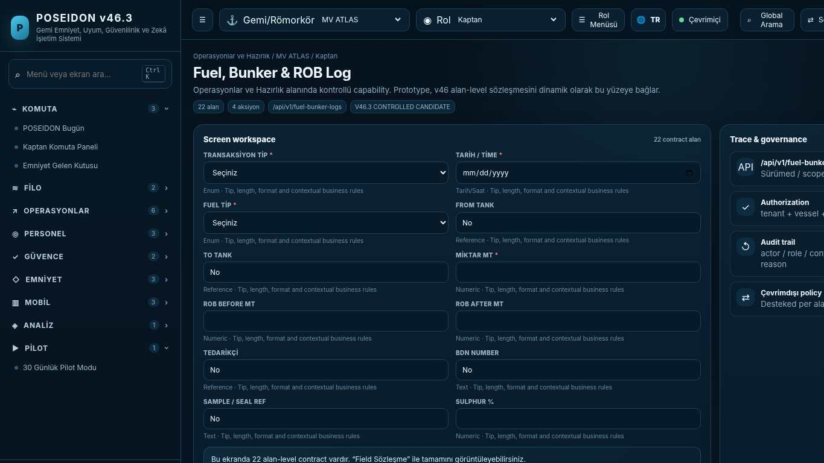
API projection: /api/v1/fuel-bunker-logs | Status: V46.3 CONTROLLED CANDIDATE
———————————————————————————————————————————————————————
190 Port Activity & Statement of Facts
Screen ID: port-activity-sof | Domain: Operations & Readiness | 18 alan / 4 aksiyon
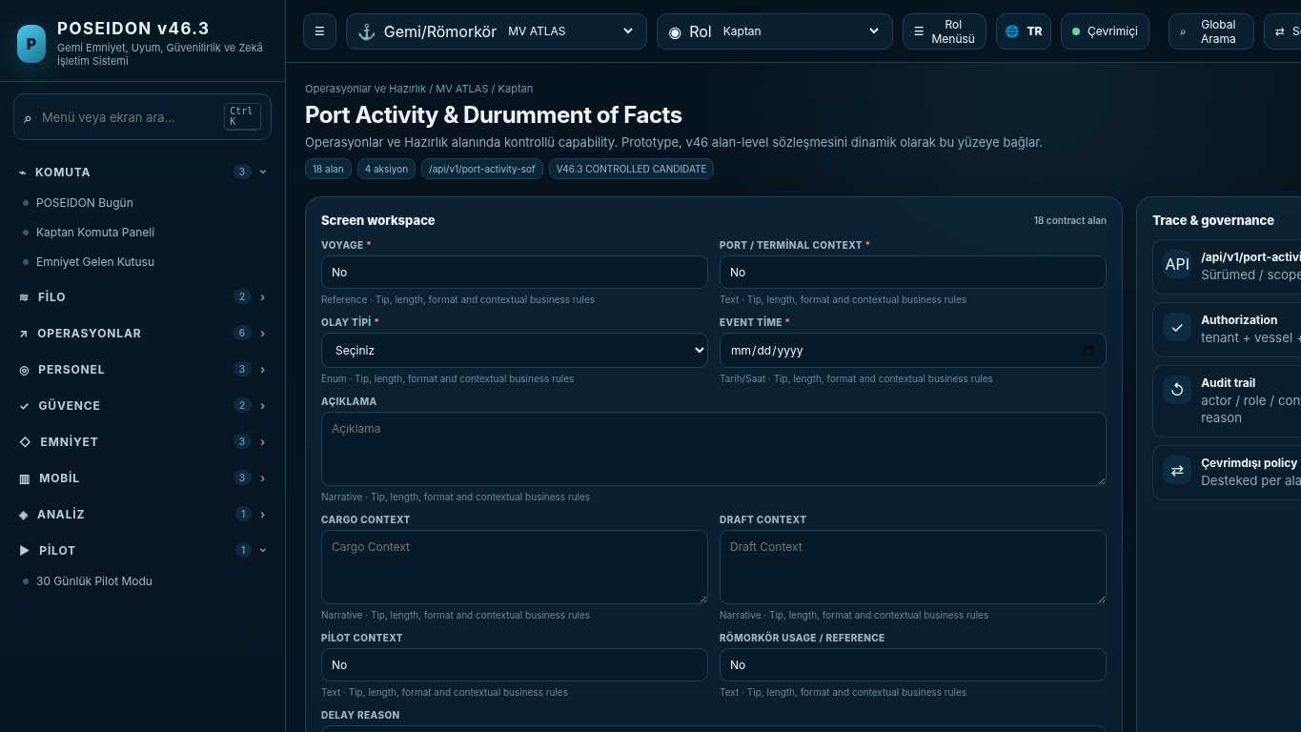
API projection: /api/v1/port-activity-sof | Status: V46.3 CONTROLLED CANDIDATE

191 Operational Downtime & Loss of Hire
Screen ID: operational-downtime | Domain: Operations & Readiness | 14 alan / 4 aksiyon
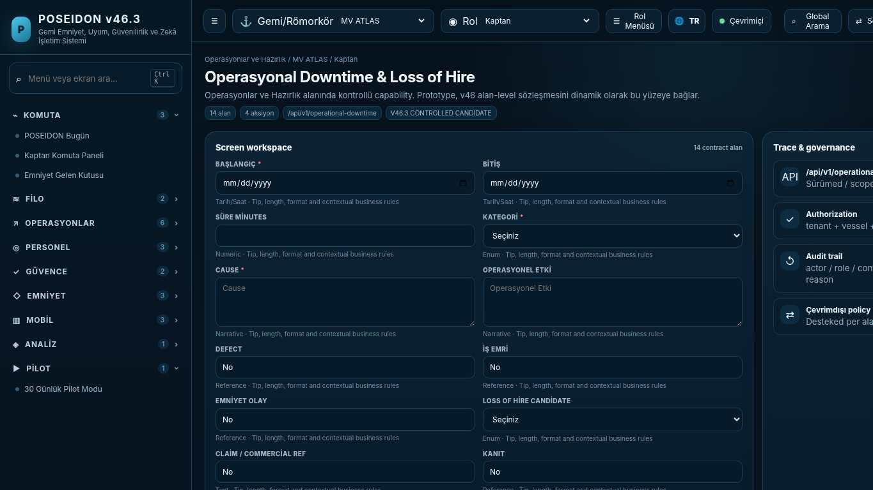
API projection: /api/v1/operational-downtime | Status: V46.3 CONTROLLED CANDIDATE
———————————————————————————————————————————————————————
192 Service & Engineer Report
Screen ID: service-engineer-report | Domain: Technical / PMS 2.0 | 16 alan / 4 aksiyon
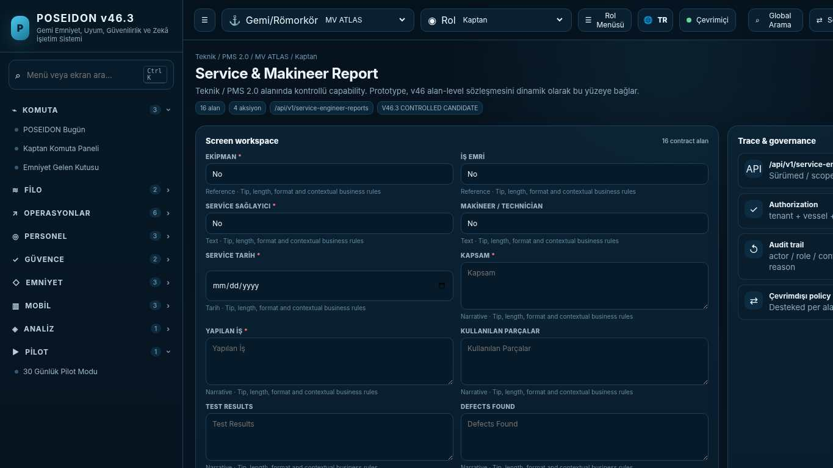
API projection: /api/v1/service-engineer-reports | Status: V46.3 CONTROLLED CANDIDATE

193 Pre-Survey Checklist
Screen ID: pre-survey-checklist | Domain: Certificate Intelligence | 16 alan / 4 aksiyon
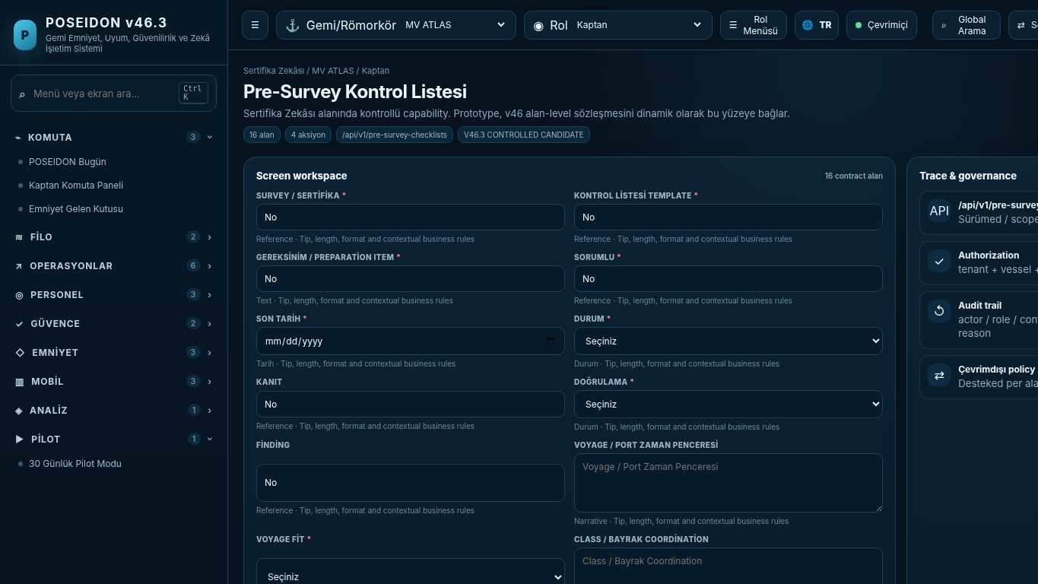
API projection: /api/v1/pre-survey-checklists | Status: V46.3 CONTROLLED CANDIDATE
———————————————————————————————————————————————————————
194 Risk Assessment Workspace
Screen ID: risk-assessment | Domain: Safety & Learning | 20 alan / 4 aksiyon
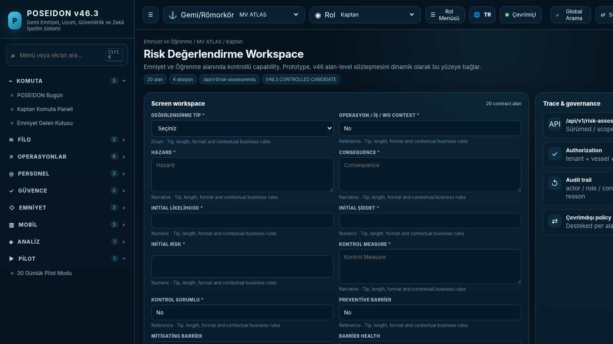
API projection: /api/v1/risk-assessments | Status: V46.3 CONTROLLED CANDIDATE

195 Risk Template Library
Screen ID: risk-template-library | Domain: Safety & Learning | 14 alan / 4 aksiyon
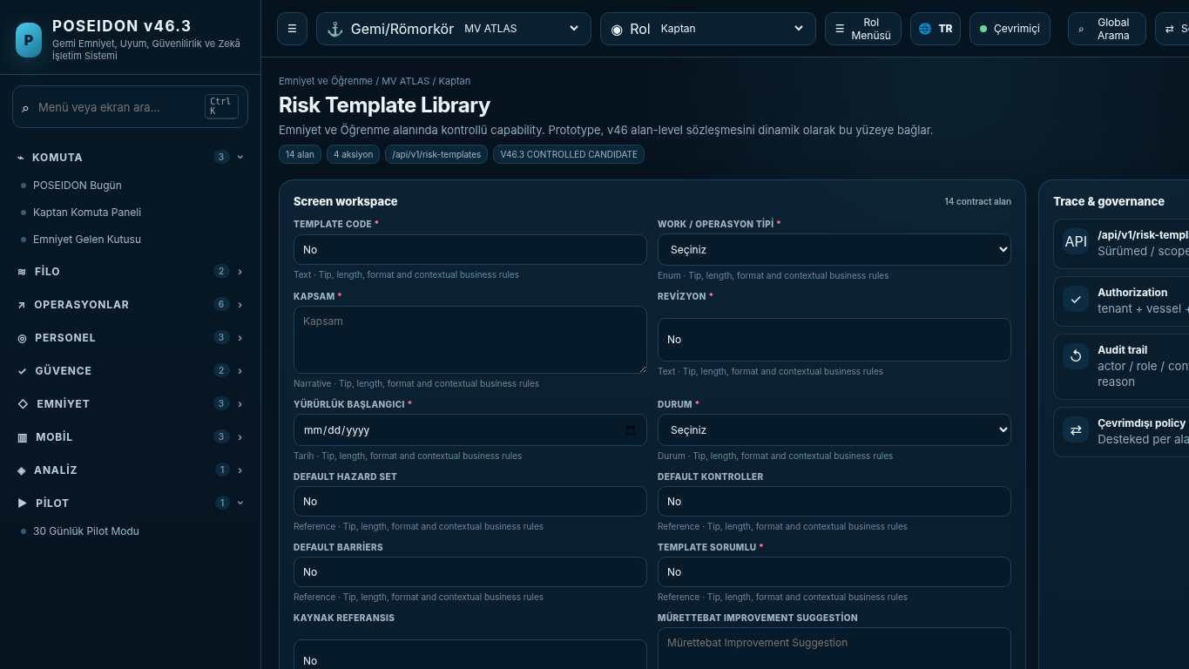
API projection: /api/v1/risk-templates | Status: V46.3 CONTROLLED CANDIDATE
———————————————————————————————————————————————————————
196 Fleet High-Risk Work
Screen ID: high-risk-work | Domain: Safety & Learning | 12 alan / 3 aksiyon
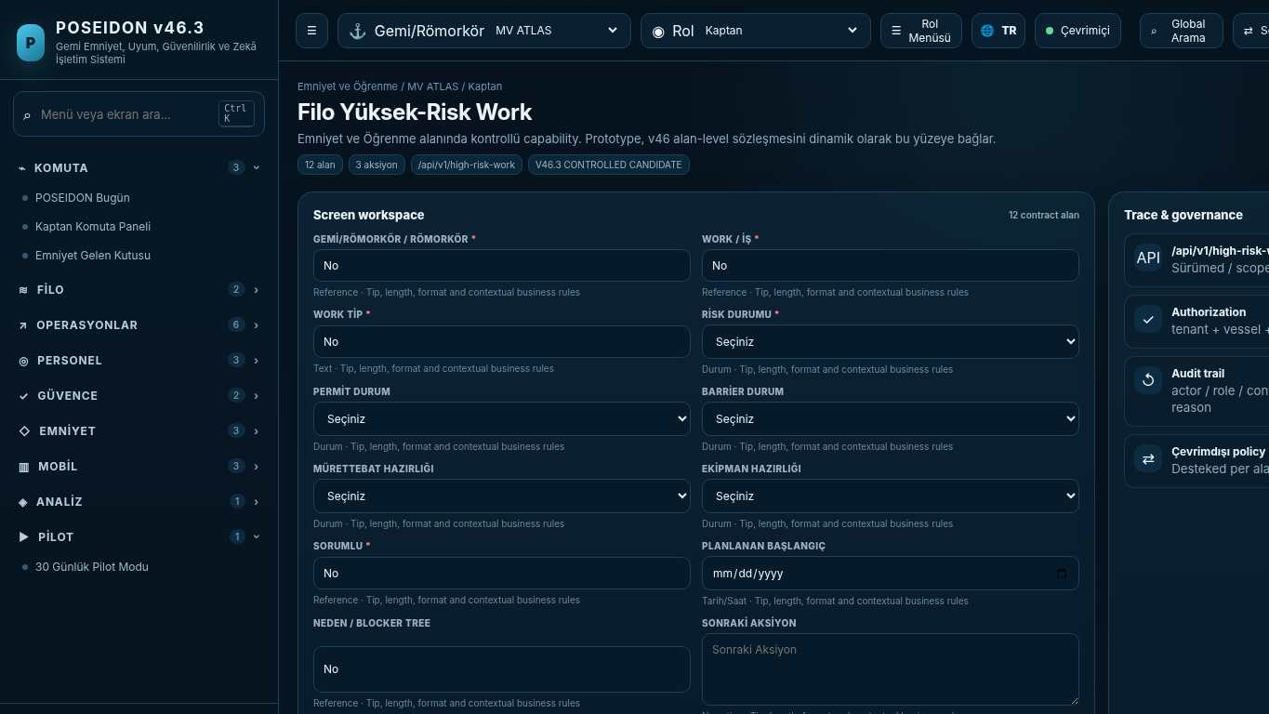
API projection: /api/v1/high-risk-work | Status: V46.3 CONTROLLED CANDIDATE

