Computer Architecture Documentation
Introduction to Computer Architecture
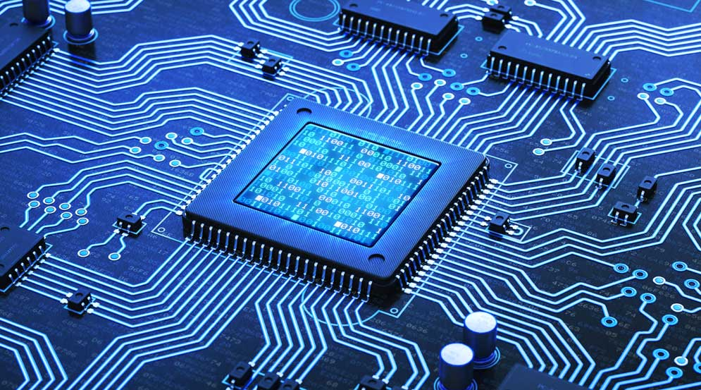
Computer Architecture refers to the design, structure, and behavior of a computer system. It defines how hardware and software interact to execute tasks efficiently. It includes components such as the CPU, memory units, input/output devices, and communication buses.
Key Components of Computer Architecture
- Central Processing Unit (CPU): Executes instructions.
- Memory (RAM & Cache): Stores data temporarily for fast access.
- Storage: Holds data permanently.
- I/O Devices: Enable communication with the external world.
- System Bus: Connects different components for data transfer.

CPU and Cores
- Central Processing Unit (CPU)
The CPU is the brain of the computer. It processes instructions received from software and coordinates all operations. A CPU mainly consists of:
- ALU (Arithmetic Logic Unit): Performs mathematical and logical operations.
- CU (Control Unit): Manages and controls the execution of instructions.
- Registers: Small storage locations for quick data access
- CPU Cores
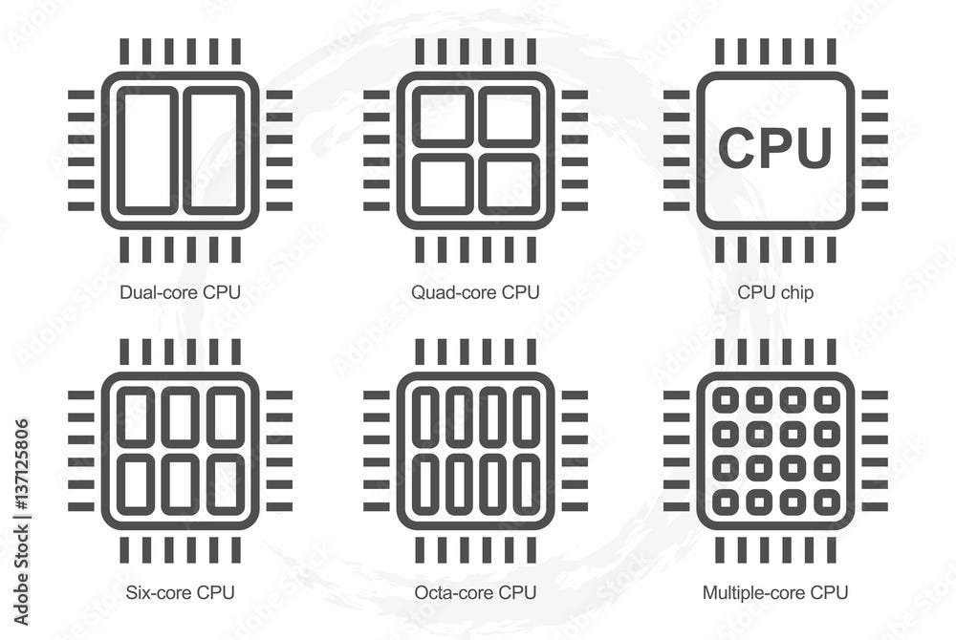
A core is an independent processing unit within a CPU. Each core can execute its own instructions.
- Single-core: One task at a time.
- Dual-core / Quad-core / Octa-core: Multiple tasks processed simultaneously.
More cores improve multitasking, parallel processing, and overall system performance.

RAM and Cache Memory

- RAM (Random Access Memory)
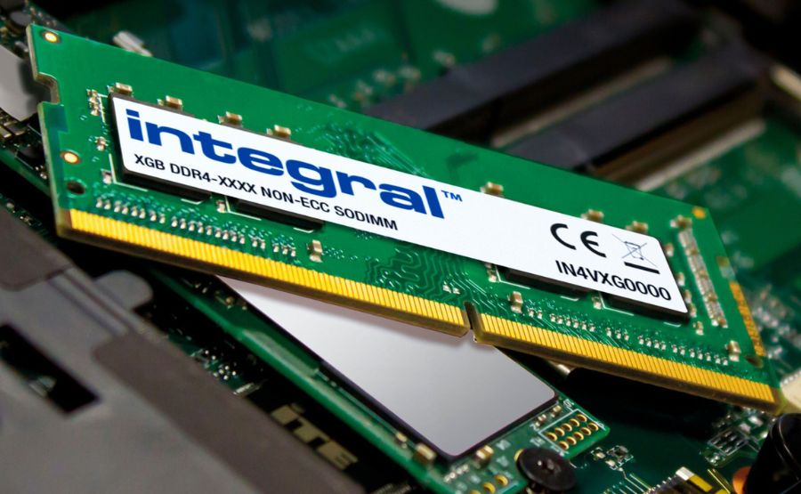
RAM is the primary memory used to store data and instructions temporarily while the system is running. It is volatile (data is lost when power is off).

Types of RAM
- DRAM (Dynamic RAM): Common in computers, slower but affordable.
- SRAM (Static RAM): Faster and used in cache memory, but more expensive.
Functions of RAM
- Loads the operating system.
- Stores active applications and currently used data.
- Provides fast access to the CPU.
- Cache Memory
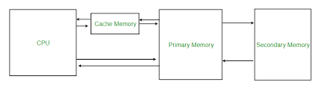
Cache is a very high-speed memory located inside or very close to the CPU. It stores copies of frequently used data and instructions to reduce access time.
Cache Levels
L1 Cache: Fastest, smallest, built into the CPU core.
L2 Cache: Larger but slightly slower.
L3 Cache: Shared among CPU cores, improves performance in multi-core processors.
Importance of Cache
- Reduces CPU waiting time.
- Provides faster data retrieval.
- Increases overall system efficiency.

