**Advanced Software Engineering**

**Lab#2**

The steps followed in creating a Mobile web client application are as follows :

1) Created an account in jsfiddle.net with username kadiyala9999

2) Then wrote an HTML code and chosen Google Direction Service

3) After that I have chosen Google Direction Service JavaScript.

4) I initiated map using following Jquery function

$('#control').ready(function() {

initialize(17.3660, 78.4760);

5) When user click submit I initiated jquery submit function and calculate Route

$('#submit').click(function(){

calcRoute();

});

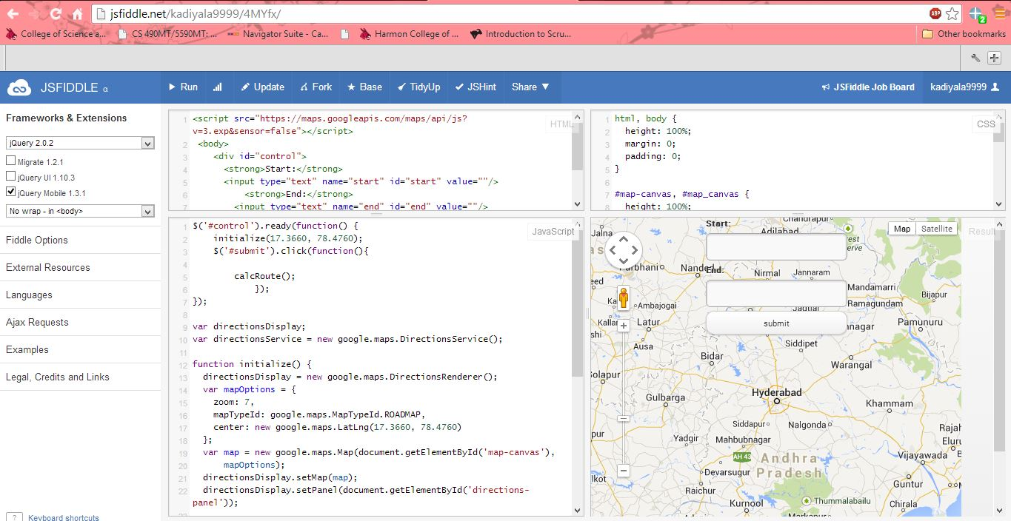

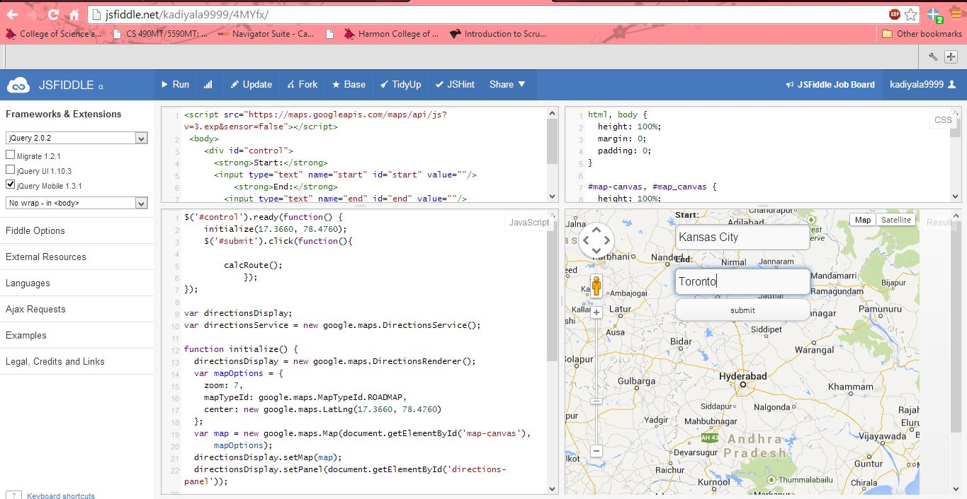

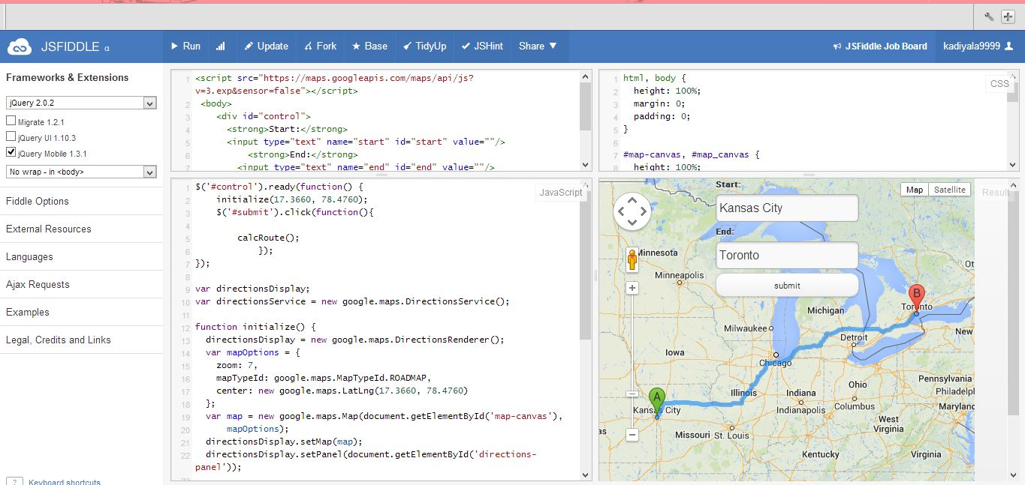

Then click on the option debug on mobile that shows as follows in the result window.

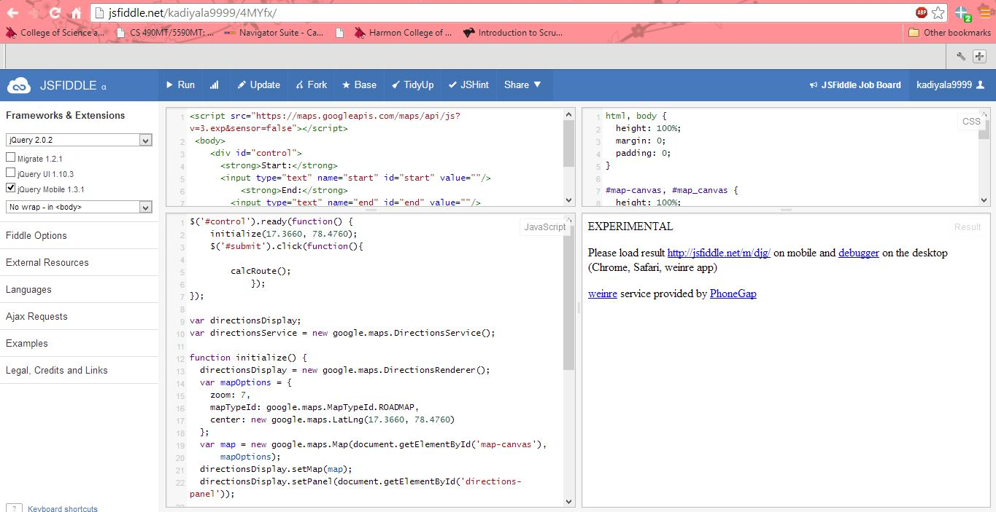

Then click on the link <http://jsfiddle.net/m/djg/> in the experimental section that shows as below .

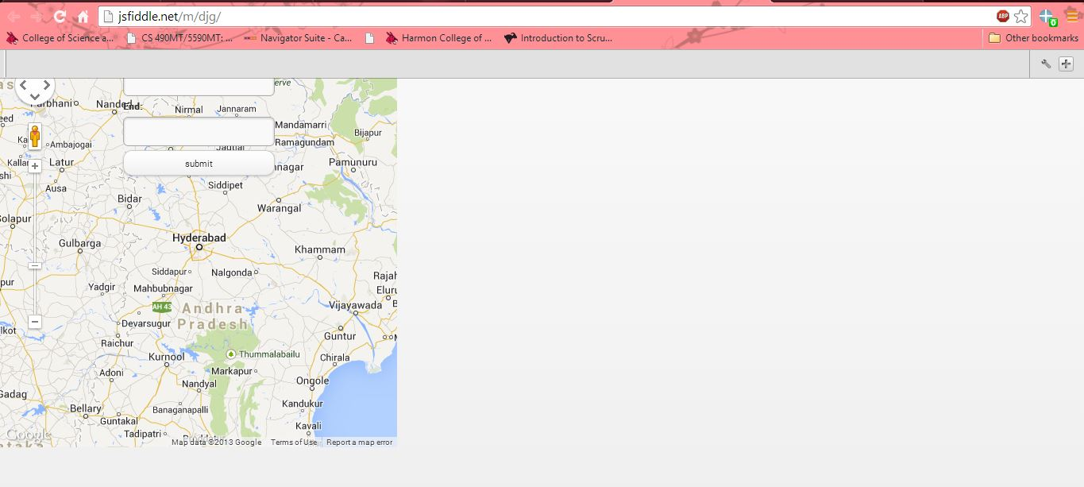

**Jsfiddle Link**

<http://jsfiddle.net/kadiyala9999/4MYfx/>