**Advanced Software Engineering**

**Lab#2**

The steps followed in creating a Mobile web client application are as follows :

1) Created an account in jsfiddle.net with username kadiyala9999

2) Then wrote an HTML code and chosen Google Direction Service

3) After that I have chosen Google Direction Service JavaScript.

4) I initiated map using following Jquery function

$('#control').ready(function() {

initialize(17.3660, 78.4760);

5) When user click submit I initiated jquery submit function and calculate Route

$('#submit').click(function(){

calcRoute();

});

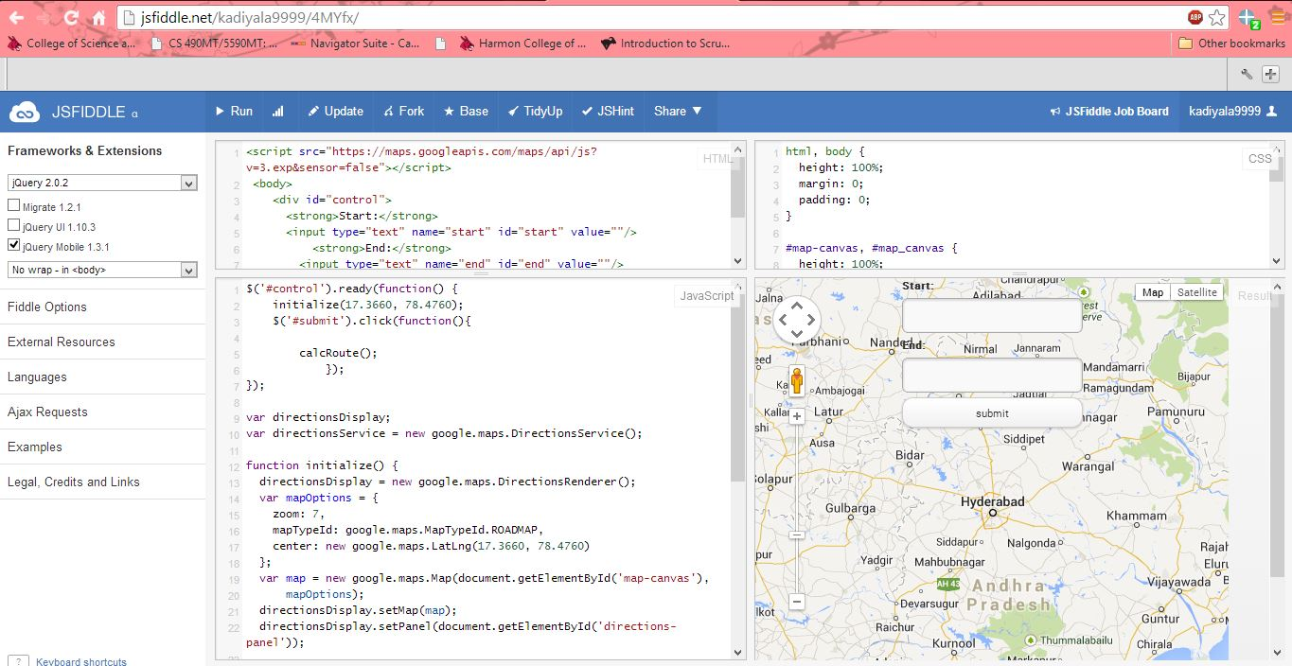

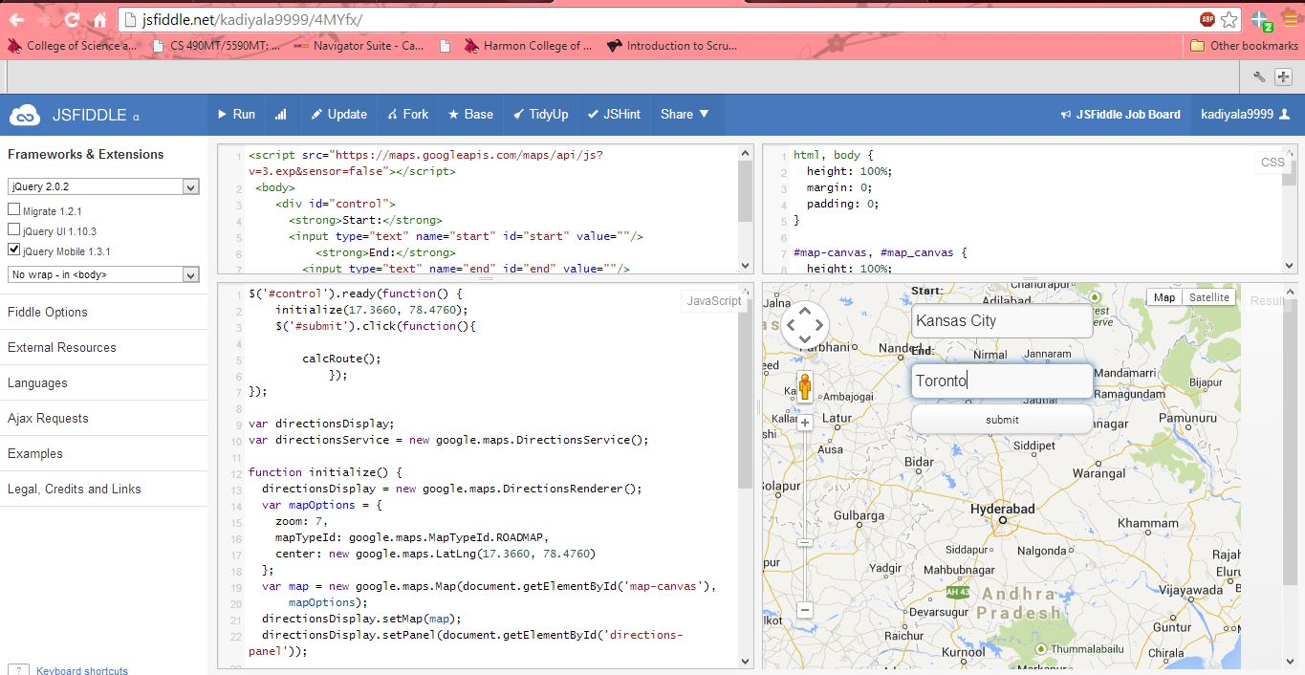

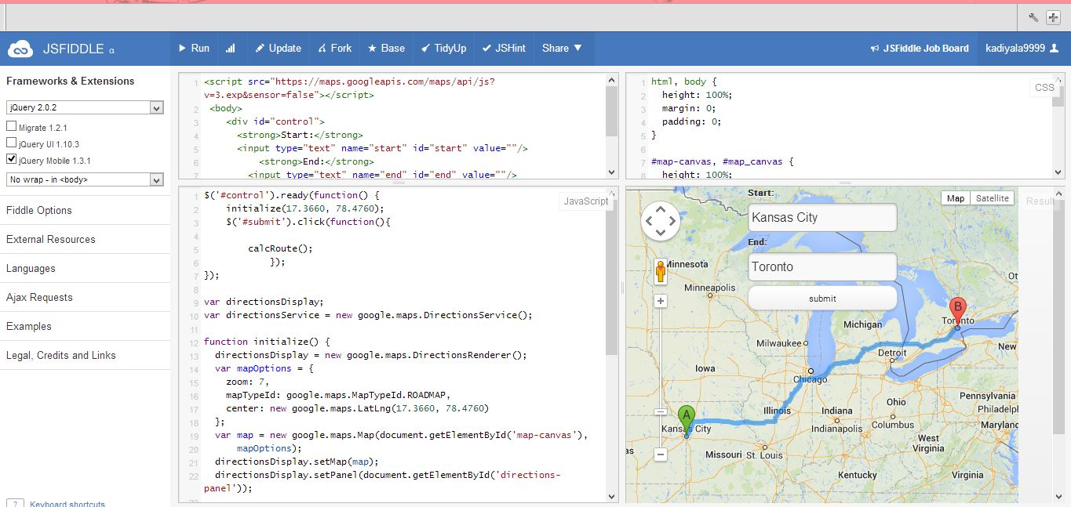

Then click on the option debug on mobile that shows as follows in the result window.

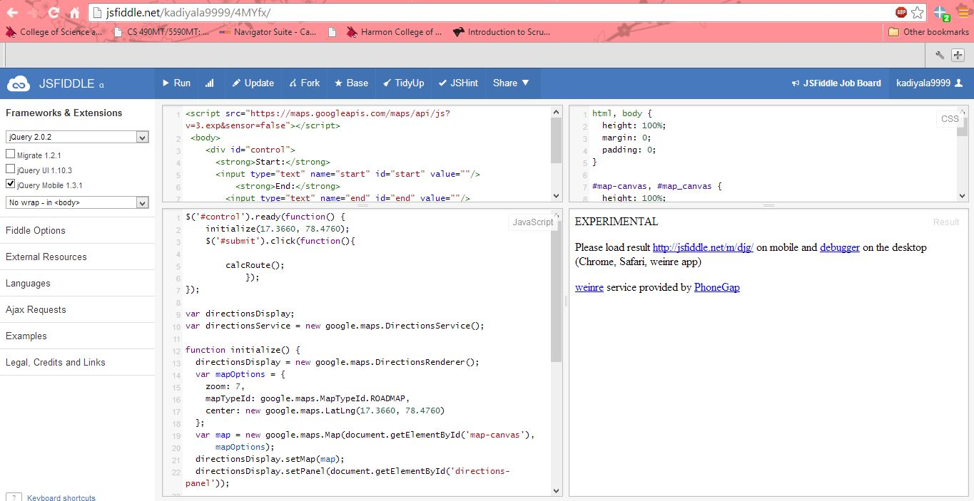

Then click on the link <http://jsfiddle.net/m/djg/> in the experimental section that shows as below .

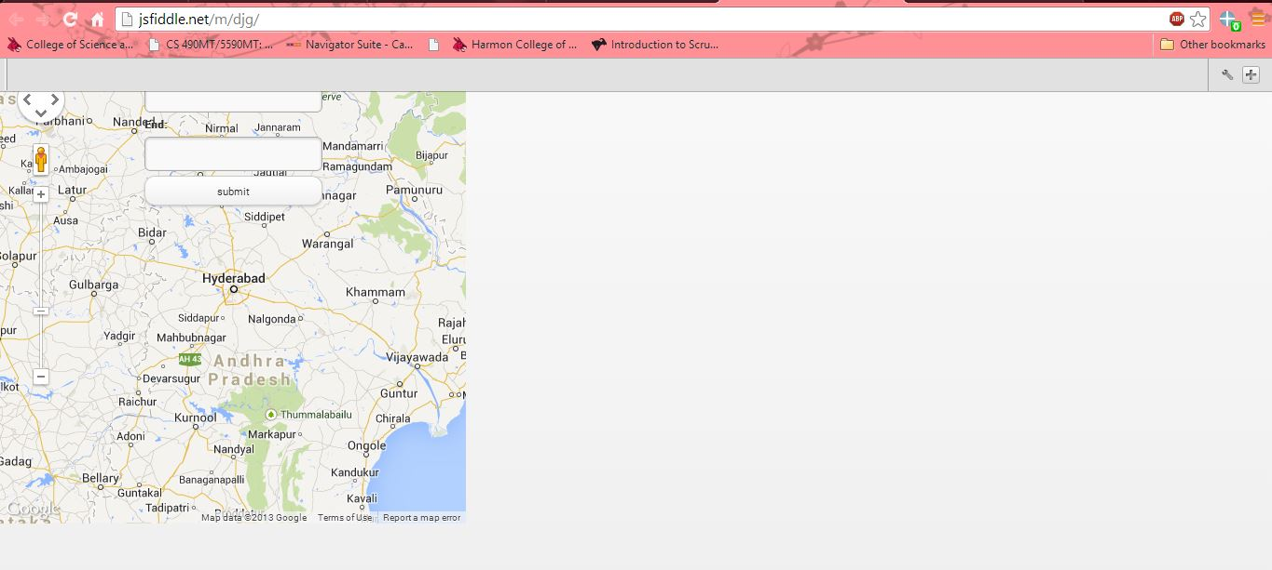

**Jsfiddle Link**

<http://jsfiddle.net/kadiyala9999/4MYfx/>

**Writing a HTML Code**

<script src="https://maps.googleapis.com/maps/api/js?v=3.exp&sensor=false"></script>

<body>

<div id="control">

<strong>Start:</strong>

<input type="text" name="start" id="start" value=""/>

<strong>End:</strong>

<input type="text" name="end" id="end" value=""/>

<input type="submit" id="submit" value="submit"/>

</div>

<div id="map-canvas" style="width:500px;height:500px"></div>

</body>

**Writing CSS Code :**

html, body {

height: 100%;

margin: 0;

padding: 0;

}

#map-canvas, #map_canvas {

height: 100%;

}

@media print {

html, body {

height: auto;

}

#map-canvas, #map_canvas {

height: 650px;

}

}

#panel {

position: absolute;

top: 5px;

left: 50%;

margin-left: -180px;

z-index: 5;

background-color: #fff;

padding: 5px;

border: 1px solid #999;

}

**Writing JavaScript Code :**

$('#control').ready(function() {

initialize(17.3660, 78.4760);

$('#submit').click(function(){

calcRoute();

});

});

var directionsDisplay;

var directionsService = new google.maps.DirectionsService();

function initialize() {

directionsDisplay = new google.maps.DirectionsRenderer();

var mapOptions = {

zoom: 7,

mapTypeId: google.maps.MapTypeId.ROADMAP,

center: new google.maps.LatLng(17.3660, 78.4760)

};

var map = new google.maps.Map(document.getElementById('map-canvas'),

mapOptions);

directionsDisplay.setMap(map);

directionsDisplay.setPanel(document.getElementById('directions-panel'));

var control = document.getElementById('control');

control.style.display = 'block';

map.controls[google.maps.ControlPosition.TOP_CENTER].push(control);

}

function calcRoute() {

var start = document.getElementById('start').value;

var end = document.getElementById('end').value;

var request = {

origin: start,

destination: end,

travelMode: google.maps.TravelMode.DRIVING

};

directionsService.route(request, function(response, status) {

if (status == google.maps.DirectionsStatus.OK) {

directionsDisplay.setDirections(response);

}

});

}