Realizing Continuous Integration

Kevin A. Lee
kevin.lee@buildmeister.com

Synopsis
The practice of Continuous Integration is a hot topic in the software development world. Although often linked with Agile processes such as eXtreme programming or Scrum, the concept and practices of Continuous Integration are really nothing new, just a refinement of well-known software development best practices. In this article I will discuss what Continuous Integration is all about, its benefits to a project and organization, and also define some best practices for achieving it.

What is Continuous Integration?
Continuous integration is, first and foremost, a process backed by a set of tools. Martin Fowler and Matthew Foemmel define it as :
… a fully automated and reproducible build, including testing, that runs many times a day. This allows each developer to integrate daily thus reducing integration problems.
To illustrate that continuous integration is really nothing new, Grady Booch supplies a more generic definition in the second edition of his book, Object-Oriented Analysis and Design with Applications:
The macro process of object-oriented development is one of "continuous integration"... At regular intervals, the process of "continuous integration" yields executable releases that grow in functionality at every release...It is through these milestones that management can measure progress and quality, and hence anticipate, identify, and then actively attach risks on an ongoing basis.
To me Continuous Integration is not so much about applying individual techniques as the application of a “state of mind”. Anybody who was worked on a complex software development project will be familiar with the issues of integrating the changes made by multiple developers. The later that integration is delayed the more potential there is for risk and failure in the integration process. Continuous Integration tries to mitigate this risk by frequently integrating small changes into an evolving code base. However there is more to Continuous Integration than at first appears. It is a skill that needs to be learned and practiced. In this article I will attempt to describe how to learn and achieve such a skill.
The implementation of a central repository for all members of a development team, that contains:
- the latest code (at least), and
- the latest executables
with automated process for building and testing all project assets that:
- can be run many times a day
- is self sufficient
I believe it is best to think of continuous integration as a mindset or statement of intent that allows you to reduce risk by frequently integrating incremental software development changes. Basically, it represents the realization and refinement of a common software development best practice: the daily build and smoke test.

Agile SCM
- Builds and integration. An automated build process is a key factor of successful agile development. The build process typically monitors the Active Development Line for commits and, if found, automatically executes (after a grace period) an integration build and unit test. Notification of the success or failure of this build is a key communication factor in agile teams.
- Deployment. Agile projects deploy testable applications frequently, particularly where application server environments are in use (e.g. J2EE/Microsoft.NET application servers). Therefore the deployment of frequent incremental baselines or change requests needs to be supported by the SCM tool, as well as the ability to report and query on the versions of the application in each of the environments.
Although SCM characteristics such as these are typical in agile processes, they are just as likely to be

Recommendations
Given all that we have discussed so far, let us now consider how a balance between governance rigor and agility can be achieved for agile projects (using an enterprise SCM toolset) in an enterprise organization. In this section I list a number of recommendations. Each recommendation could be implemented in its own right; however I believe that the majority would typically need to implemented to successfully implement Agile SCM.

1. Implement a simplified branching strategy.
Agile projects implement simple branching strategies. In most SCM tools branches can be created easily and cheaply. There is therefore often a temptation to define a more complex branching strategy than is strictly necessary. agile projects actively encourage continuous integration and refactoring, but if developers are isolated on a branch, problematic or complex merges can occur. This is particularly true in the case of namespace refactoring (renaming, adding, or deleting files or directories). Consequently, most agile projects implement a specific branch to act as the Active Development Line and which the developers work on directly.
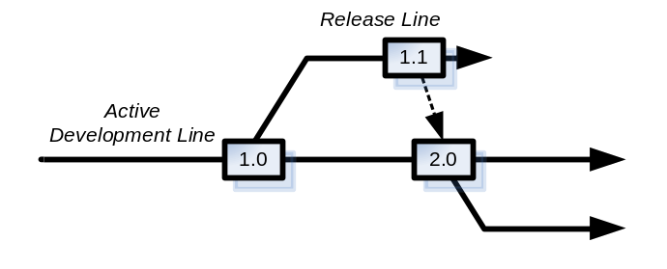
Figure 1 - Agile branching
One of the main reasons for creating branches is for support after the release of the application has been made (either internally or externally). If issues are found that need to be resolved a decision needs to be made on whether to fix the issue on the Active Development Line or create a Release Line to collect the fixes. A diagram illustrating this structure is provided in Figure 2. Although it is possible to fix on the Active Development Line, the customer would receive new features as well as the fix. This is not necessarily an issue if the features have been continually tested and can be “configured” to be enabled. However, if this is not possible then use the Release Line approach. You should still try and make the Release Line short lived though, use it infrequently and integrate any changes back in as early as possible.
2.

3. Perform incremental check-in.
When developing a new feature or change request, there is always a temptation to delay check-in (or commit) until the work has been fully completed and unit tested. Although this approach sounds fine in principal it actively delays integration potentially causing unexpected rework. In agile projects, if test driven development is implement correctly, then the skeleton unit tests for a feature or change request are developed first; then code is implemented to make the unit-tests pass. This is a process that is repeated over time, with incremental functionality added to the unit-tests and implementing code. Since this is a continual process, with buildable and testable code throughout, the feature or change request can actually be checked in to the repository before it is complete! Although it might not be fully functional (and worth acceptance testing), continually integrating the code will highlight any issues at an early stage and can save significant effort and rework in the long term.

4. Automate the build process.
Single branch development and incremental check-in can only work when automated builds and tests are executed frequently. Most agile projects configure their build process to execute on every developer check-in (or commit). As well as compiling code, such a build process also validates new code to see if it conforms to pre-defined coding conventions and executes unit tests where necessary. In agile development methods, this practice is often called continuous integration. Its desired result is to expose integration problems as early as possible so that they are easy to address, and also to have a built, tested, and potentially releasable build at every stage of the project. Continuous integration is often intricately linked with the practice of test-driven development. This is because developers need to implement unit tests for all aspects of their code to validate not only that the build has been compiled, but also that it conforms to some minimum level of functional quality. In SCM terms, the agile project's build process is set to monitor the project’s integration branch and then execute a build script on check-in. This is typically carried out by build execution tools such as CruiseControl or IBM Rational BuildForge - there are also a large number of similar tools.

5. Stage and re-use pre-built binaries.
Building any reasonably complex software application can take time, from several minutes to several hours. In agile projects, developers will be delivering and integrating small changes frequently; therefore they obviously cannot wait for a two-hour build to complete before getting any feedback. To avoid this situation, agile projects typically "stage" and re-use pre-built binaries, and only rebuild the whole system when necessary (for example, nightly or weekly). This can effectively create a build pipeline where the output of one build process can trigger the start of another – a process which is illustrated in Figure 2.
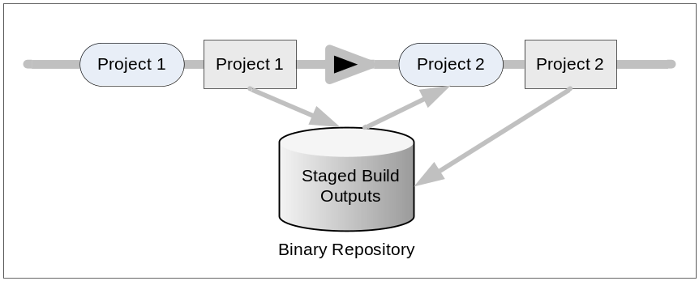
Figure 2 - Build pipeline
There are a number of ways of staging binaries. The SCM tool itself is often used to stage binaries, with labels or baselines placed down on related versions to indicate a composite set of re-usable binaries. For C/C++ projects, the ClearCase clearmake or ElectricCloud ElectricAccelerator utility have build-avoidance mechanism that can be used to automate much of this staging and re-use process (as well as reducing the overall build time). For Java projects, an alternate approach is to stage pre-built libraries in a dependency management tool such as Apache Ivy or Apache Maven. These tools are particularly appropriate where a project re-uses a significant amount of open-source components or where there are issues with transitive dependencies (i.e., where libraries are dependent on other libraries).

6. Release and deploy continually.
When it comes to releasing your application, try to release all your files rather than releasing individual sets. Most agile projects prefer to deploy the whole or composite application each time rather than just the individual files that have changed. Although this is not a hard and fast rule, releasing the whole application in the same way each time tends to make the process more repeatable and prevents problems with missing files. This practice is more important for agile projects than traditional ones, because they produce executable, testable, and releasable applications to be deployed at the end of every iteration. Note that this also depends on the deployment type of the application. If it is Web portal, then this approach is recommended, however if it is a consumer application (running on, say, Microsoft Windows), then obviously a full release cannot be made to the customer each time and therefore patches (containing individual files) will be required. It is good practice to define a Deployment Unit (a consolidated set of deployable files and installation scripts) that is to be deployed rather than deploy the individual files themselves. This approach typically simplifies the deployment process and makes deployment roll-back (on failure) much simpler.
If your application needs to be deployed to multiple environments, then you should secure and lock down environments to only those users that are directly permitted access to them. As an example developers might have permission to deploy (or invoke deployment to) Development and Integration Test Environments, build engineers would have permission to deploy to System or Acceptance Test Environments and deployment engineers (who are usually in the operations department) would have permission to deploy to the Production Environment. It is good practice to define your deployment lifecycle early on and automate it as much as possible. An example of a typical deployment lifecycle is illustrated in Figure 3.
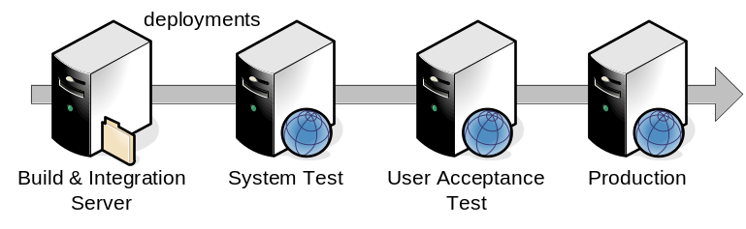
Figure 3 - Typical Deployment Lifecycle
Most agile projects tend to delay the realities and consequences of continuous deployment until a later iteration. However doing so can cause rework since the application might need to be implemented to allow configuration for more complex environments (particularly production). It is therefore good practice to implement deployment strategies at an early stage. For more information on deployment strategies see The Buildmeister’s Guide – Achieving Agile Software Delivery [Lee07].
7.

Summary
In this whitepaper, I have discussed the concept of Agile SCM and described a number of recommendations regarding how it can be implemented within the context of an enterprise organization. Hopefully, this discussion has convinced you that Agile SCM can be achieved in your own environment. It is worth noting that the implementation of an Agile SCM environment is not something that should just be restricted to agile projects. There are many projects that do not consider themselves as agile, but yet have similar SCM requirements. These tend to be smaller IS/IT projects where the configuration of a similar environment would be very practical. It is probable that larger projects could learn something by implementing more lightweight and well-designed SCM process based on some of the practices described here.
In summary, there is no reason why an enterprise SCM toolset, cannot be used to support the implementation of agile development methods. The key is to define and implement an Agile SCM process that focuses on supporting, rather than restricting, the agile team. It can be a tricky exercise to find the right governance model for such a team, but a general recommendation would be to start with a more open process, only implementing restriction where necessary. Feedback is also an essential part of agile development methods. One of the ways that SCM can help with this feedback mechanism is via an automated build and testing (and deployment) process. It is therefore recommended that you invest a significant amount of time looking at this aspect of your overall process.

References
- [AgileM01] Kent Beck et al. Manifesto for Agile Software Development. http://agilemanifesto.org/
- [Berczuk03] Stephen P. Berczuk and Brad Appleton, Software Configuration Management Patterns. Effective Teamwork, Practical Integration. Addison Wesley 2003. See also Brad Appleton et al., Streamed Lines: Branching Patterns for Parallel Software Development. PLoP Conference: 1998. www.cmcrossroads.com/bradapp/acme/branching/
- [Lee07] Kevin A. Lee. The Buildmeister’s Guide – Achieving Agile Software Delivery. Lulu Press 2007.

About the author
 | Kevin A. Lee has over 15 years of experience in defining, architecting and implementing software technology solutions. Although a Technologist at heart his real passion is in applying technology to help solve real world business problems. Kevin’s expertise and interests include Technical Sales, Solution Architecture, Java Development, Application Lifecycle Management and the application of Agile Development practices.  Kevin is the author of a number of publications including The Buildmeister's Guide - Achieving Agile Software Delivery and The Java Developer's Guide to Accelerating and Automating the Build Process. He has also published a number of articles and tutorials on the Internet and the creator of the build portal buildmeister.com. Kevin holds a B.S. in computer science from the University of East Anglia and can be contacted at kevin.lee@buildmeister.com.

? www.martinfowler.com/articles/continuousIntegration.html
? Published by Addison Wesley, 1993
? http://cruisecontrol.sourceforge.net
? www-306.ibm.com/software/rational/buildmanagement
? www.electric-cloud.com/products/electricaccelerator.php
? http://ant.apache.org/ivy/
? http://maven.apache.org

