[Document Title]
Authors: Author

Table of Contents
Table of Contents 1
1. Section 1 2
2. Document Administration 3
2.1. Change History 3
2.2. External Distribution 3
3. Section 2 4
3.1. Subsection 4

Executive Summary
Insert text…

Document Administration

Change History
Document Issue | Document Date | Comments
[1.0] |  | Initial version

External Distribution
Recipient | Company | Role

Introduction
This is the Use-Case Model for the Bank of Serena Online System.

2 Overview
Brief Description
The System requires that each client has a combined username and password login.

3 Use Case Diagram
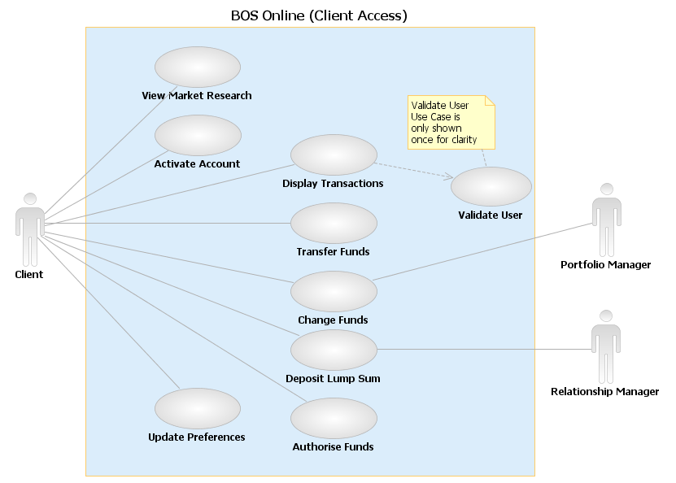

4 Actors

5 Use Cases

5.1 Validate User
Use Case ID: UC_101
This use case describes general behavior for the Bank to validate the user. It includes all steps that are the same no mater what kind of transaction the Client does.

5.2 Display Transactions
Use Case ID: UC_106
This use case allows a client to access all of their accounts and display or filter the transactions carried out for a specific account.

5.3 Transfer Funds
Use Case ID: UC_107
This use case allows a client to transfer funds between their accounts.

5.4 Change Funds
Use Case ID: UC_108
This use case allows a client to change the investment portfolio of a specific account.

5.5 Deposit Lump Sum
Use Case ID: UC_109
This use case allows a customer to deposit a lump sum into one of their accounts, either electronically or through their advisor.

5.6 Authorise Funds
Use Case ID: UC_110
This use case allows a client to electronically authorise portfolio investment decisions made by their personal advisor.

