Requirements Management Plan
for HappyBank Online
Authors: Kevin A. Lee

Table of Contents
Table of Contents 2
1. Document Administration 3
1.1. Change History 3
1.2. External Distribution 3
2. Introduction 2
2.1. Purpose 2
2.2. Scope 2
2.3. Definitions, Acronyms, and Abbreviations 2
2.4. References 3
2.5. Overview 3
3. Roles and Tools 2
3.1. Roles 2
3.2. Tools 2
4. Requirements Management 2
4.1. Traceability 2
4.2. Requirement Types 2
4.3. Document Types 4
4.4. Attributes 6
Attribute Matrix 6
Attribute Definitions 6
4.5. Reports and Measures 12
Size Metrics 12
Volatility 12
4.6. Requirements Change Management 12
Change Request Processing and Approval 12
Project Baselines 12
4.7. Security 12

Document Administration

Change History
Document Issue | Document Date | Comments
0.1 |  | Initial version

External Distribution
Recipient | Company | Role

Introduction
This section introduces the reader to what a Requirements Management Plan document is. People who are already familiar with this style of Requirements Management Plan can skip to section 3. Those new to this document type should read the rest of this section to familiarize themselves with the purpose and contents of a Requirements Management Plan before reading the details for the BOS Online project.

Purpose
The purpose of a Requirements Management Plan is to capture and describe the environment (the tools and processes) for requirements management that has been chosen for the BOS Online project. Environment means the process, tools and resources needed to guide the project.

Scope
This Requirements Management Plan document applies to the BOS Online project.

Definitions, Acronyms, and Abbreviations
Baseline: A baseline is a 'snapshot' in time of one version of each artifact. It provides an official standard on which subsequent work is to be based, and to which only authorized changes can be made.
Requirement: A requirement describes a condition or capability to which a system must conform; either derived directly from user needs, or stated in a contract, standard, specification, or other formal agreement.
Requirement attribute: Information associated with a particular requirement providing a link between the requirement and other project elements—for example, priorities, schedules, status, design elements, resources, costs, hazards.
Requirement type: Requirement types are defined in Dimensions RM. Requirement types are used to classify similar requirements so they can be efficiently managed. When you define a requirement type, you define a common set of attributes, and acceptable values.
Requirement document: A document created in Microsoft Word or that captures requirements and is used to communicate requirements of a project.
Requirements management: A systematic approach to eliciting, organizing and documenting the requirements of the system, and establishing and maintaining agreement between the customer and the project team on the changing of requirements of the system.
Dimensions RM: Dimensions RM is a software package that helps teams organize, prioritize, track, and control changing requirements of a system or application.
Suspect state: A state applied to a traceability relationship when a change occurs to one or both of the requirements in the relationship. A suspect relationship state indicates that, because of the modification to the requirement(s), the relationship may require modification as well.
Traceability: The ability to trace a project element to other related project elements, especially those related to requirements. Project elements involved in traceability are called traceability items.
Traceability item: Any project element that needs to be explicitly traced to another project element in order to keep track of the dependencies between them.

References
The following artifacts are necessary to understand this artifact.
- [GLOS] BOS Online Glossary

Overview
This section provides an overview of the sections of this document, enabling the reader to jump to the section that is most important to them.
Roles and Tools describes the company roles needed for requirements management, as well as the responsibilities of those roles. It also describes the tools to be used for requirements management and the purpose of those tools as well.
Requirements Management describes the requirement types, requirement attributes and the document types the project will maintain. It also describes the most common metrics and queries that will be available. Dimensions RM will allow for additional queries and metrics beyond the ones listed in the plan. The listed queries and metrics are simply the ones that we will start out with as saved views. Finally the plan will also discuss the access groups and their privileges.

Roles and Tools

Roles
The following table shows the roles needed to fulfill this RM Plan:
Role | Responsibility
Customer (C) | - review requirements and commit to a set  - focus on the value of the solution rather than on the number of features in the release
Project Manager (PM) | - set scope expectations with customer at the feature level  - ensure metrics are captured  - make project management decisions based on metrics
System Analyst (SA) | - create breadth view of requirements  - Vision  - Use Case Model Diagram  - Use Case Outlines  - select features to eliminate to manage timelines  - tailor or create an RM Plan  - tailor or create the requirements discipline portion of the development case  - participate in the CCB
Requirement Specifier (RS) | - high quality depth view of requirements  - Software Requirement Specification  - Detailed Use Cases
Software Architect (A) | - assign complexity, risk and effort to features  - assign use case flows to elaboration or construction
Designer | - sets the status of a use case flow to ideal designed and to tech designed.
User Interface Designer (UID) | - review use cases to ensure they don’t constrain user interface design
Test Manager (TM) | - set the status of use case flow to “quality tested” when they agree it is so
Test Analyst (TA) | - trace flows and supplemental requirements to test cases
Integrator (breadth view of Implementers/Coders) | - sets the status of a use case flow to implemented once all of the classes have been integrated for that flow
Implementer/Coder (I) | - use requirements only as a secondary source of information, relying on the design model for to drive their work
Deployment Manager (DM) | - set the status of a use case flow to accepted on behalf of the customer

Tools
The following tools will be used in the Requirements discipline:
Tool | Purpose
Dimensions RM | - Automates most of this plan.  - Captures and maintain traceability between the various requirement types listed here.  - Creates a common repository for all requirement artifacts.  - Enables scope setting, impact analysis, and all aspects of requirements management.  - Provides the central repository of all requirement artifacts
Dimensions CM | - Maintains version control of the requirement documents

Requirements Management
This section describes the various requirement types. It describes the traceability between these requirement types, the attributes of the requirement types and the accepted default values for the attributes.

Traceability
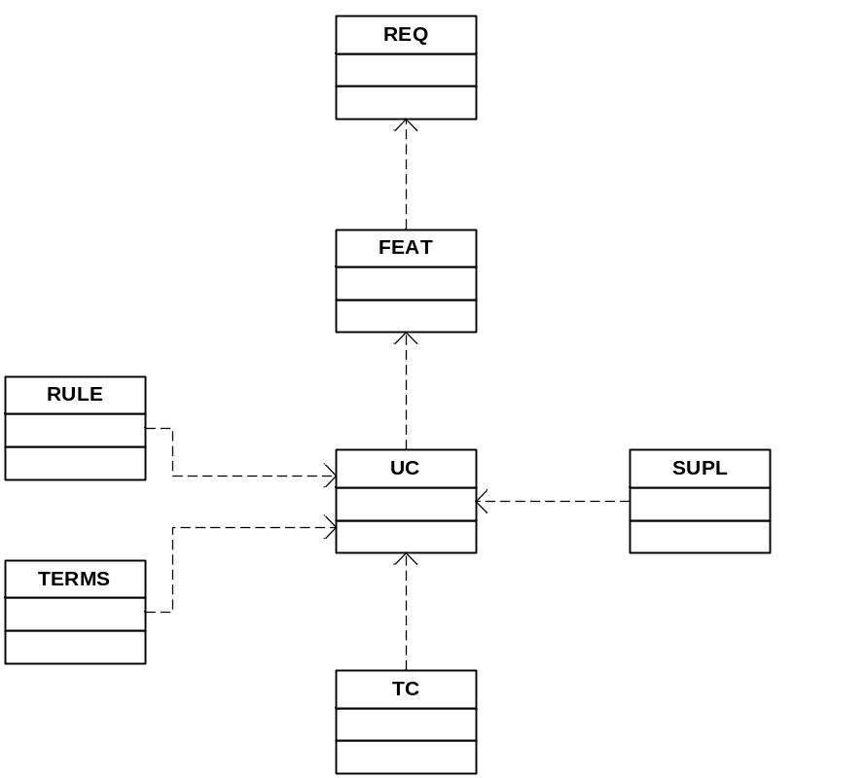
Objectives of requirements traceability

- Understand the source of requirements
- Manage the scope of the project
- Verify that all requirements of the system are fulfilled by the implementation.
- Verify that the application does only what it was intended to do
- Manage changes to requirements
- Assess the project impact of a change in a requirement
- Assess the impact of a failure of a test on requirements (i.e. if test fails the requirement may not be satisfied)

Requirement Types
Each project will identify and manage the following requirement types:

Requirement Type | Artifact Location | Description | Responsibility
Stakeholder Request (REQ) | Database Only | Requests submitted by any stakeholder including customers, users or the development team. They are never reworded, but can be split up for better traceability | The SA will be responsible for getting the REQs from the various submission avenues into Dimensions RM. All Submissions should come through TeamTrack
Feature (FEAT) | Database Only | High quality statements of what the system shall do. Unlike REQs, FEATs are written by the SA and need to be of high quality, testable, unambiguous, etc. | The SA will typically create features, but this effort can be delegated to the RS as needed.
Use Case (UC) | Database Only, Dimensions RM will generate the UCSRS document | The UC requirement type actually represents the main scenario or an alternate flow of a use case. There will be one parent UC with the name and brief description, then children UC types for all the other parts of the use case. | The UC type will be entered into Dimensions RM by the SA. The children of the UC, in other words, all of the parts of the use case will be created by the RS.
Supplementary Requirement (SUPL) | Database Only, Dimensions RM will add this type to the UCSRS | These are the non-functional or quality requirements of the system. Usability, Reliability, Performance, Supportability. They answer how well the system meets the functional requirements and tend to be very reusable | The Supplementary Requirements typically span use cases, so are the responsibility of the SA. However, the SA will need to engage the A and the UID to fully capture all of the URPS. The quality of the URPS will increase as the company matures due to their reusable nature and as we find we’ve missed some.
Terms (TERM) | Database Only, Dimensions RM will add this type to the UCSRS | The glossary terms enable the SA and the RS to write more concise requirements. The glossary terms can capture not only definitions, but range requirements, default values, and even formatting requirements | The SA and the RS will create terms as needed, but the bulk of the terms are typically created when the detailed UC is written.
Rule Set (RULE) | Database Only, Dimensions RM will add this type to the UCSRS | Rule sets cover the internal behavior of a system, which does not belong in a detailed UC, or visible behavior with a lot of different paths that would be overly complex to describe in a use case | The RS will create rule sets when they detail a use case.
Analysis Model | Visio | The Analysis Model describes the classes and subsystems of the solution, but in a technology independent manner. This is called the ideal model | The software designers are responsible for creating the analysis model.
Design | Visio | The design model is similar to the analysis model but ties the analysis model to the specific technologies chosen for the project. It is often tied to the code automatically. | The software designers are responsible for creating the design model.
Test Case (TC) | Test Director | The test cases are kept in Test Director. A reference to the test case will be maintained in Dimensions RM to enable traceability. | The test analysts are responsible for putting the test case reference into Dimensions RM

Document Types
Document Type | Artifact Location | Description | Responsibility
Vision | Created using MS Word, then put under CM using CM tool. | The vision is the breadth view of the system. The vision is a quick cut at the system, but is not complete enough to be able to drive design, test, etc. It ensures we understand the breadth of the system before picking what to do in each iteration The vision includes:  - Positioning for the project  - Stakeholder and user descriptions  - An overview of the Product (Use Case Model Survey)  - Use Case Outlines  - Project Constraints | The SA is responsible for creating the Vision for the system, and for updating it as the Vision grows and changes during Inception and Elaboration.
Use Case Software Requirements Specification (UCSRS) | Generated by Dimensions RM, then put under CM using CM tool | The UCSRS is the document that drives all project activities. It is the contract that we develop software against. The UCSRS can be generated for a single UC, or a set of UCs, such as for a team, iteration, or for the whole system. The UCSRS includes:  - Detailed Use Cases  - Rule Sets  - Terms  - Design Constraints  - Interface Requirements  - Supplemental Requirements | The RS is responsible for creating the UCSRS.
The Delta UCSRS (ΔUCSRS) | Generated by Dimensions RM, then put under CM using CM tool | The ΔUCSRS is generated exactly like the UCSRS, however only requirements modified after a certain date are included. Thus it is a skeleton of the current use case, with only the items that have to be changed going forward. | The RS is responsible for creating the ΔUCSRS and should provide the UCSRS with the ΔUCSRS for context and testing purposes.

Attributes
Attributes assigned to each requirement will be used to manage the software development process and to prioritize the features for each release.

Attribute Matrix
The following table is a listing of requirement types and the attributes associated with each requirement type. It is recommended the indicated attributes be used to manage project requirements.
Attribute | REQ | FEAT | UC | SUPL | TERM | RULE | TC
Business Priority | X
Overall Priority |  | X
Status | X | X | X
Source | X |  |  |  |  | X
Complexity |  | X |  | X
Risk |  | X |  | X
Volatility |  | X |  | X
Part |  |  | X
Effort |  | X |  | X
Analyst | X |  | X
Architect |  | X | X | X
Planned Iteration |  |  | X
Actual Iteration |  |  | X
Target  Release |  | X
Actual Release |  | X
Valid Range |  |  |  |  | X
Default Value |  |  |  |  | X
UC Type |  |  | X
URPS |  |  |  | X
* Denotes attributes that will impact the suspect state for traceability when changes occur.

No attributes have been identified for Term. If a query is discovered that needs to be supported using Term, then the attribute matrix and attribute definition will be updated.

Attribute Definitions
Setting the default value to <blank> allows us have a query for attributes that have not been set. This will allow us to process our requirements more easily, with the “unset” view getting smaller and smaller as they are set.
Attribute | Description | Acceptable Values | Default
Business Priority | This is the priority from the customer’s point of view. How much value does this requirement represent to the overall solution?  Deal Breaker: If this request can not be met, the team should cancel the project.  High Value: This request is seen as contributed above average value to the project. No more than 20% of the requirements should be labeled high value. If more than 20% are, we need to do a better job at managing our customer  Average Value: This request is seen as adding average value to the final product. The bulk of the requirements should be set here.  Nice to Have: This request may not contribute actual value to the solution, but makes the solution more attractive. Many usability requirements fall here. The project has a Usability goal of including at least 5% nice to have requests in each release | Deal Breaker  High Value  Average Value  Nice to Have | <blank>
Overall Priority | This is the overall priority for a feature based on every other attribute and our implicit understanding of the project.  High: Essential. Many requirements depend on this one, or it is considered of high value to many stakeholders. We should delay release if not ready. The main use of the system will be impacted significantly.  Medium High: Important to the effectiveness and efficiency of the system. Lack of inclusion may affect customer or user satisfaction, or even revenue, but release will not be delayed due to lack of this item.  Medium Low: Impact is to lesser used parts of the system, but those parts will be significantly hampered.  Low: Useful in less typical applications, will be used less frequently, or for which reasonably efficient workarounds can be achieved. No significant revenue or customer satisfaction impact can be expected if such an item is not included in a release. | High  Medium  Low | <blank>
Status (for all but UC) | Tracks progress during definition of the project baseline and subsequent development.  Proposed: Used to describe requirements that are under discussion but have not yet been reviewed and accepted by the "official channel," such as a working group consisting of representative for the project team, product management and user or customer community.  Approved: Capabilities that are deemed useful and feasible and have been approved for implementation by the official channel.  Postponed: Capabilities that are deemed useful and feasible but have been postponed due to project constraints by the official channel.  Rejected: Capabilities that are not deemed to be useful and or feasible and have been rejected by the official channel or the requirement is not a valid stakeholder request | Proposed  Approved  Postponed  Rejected | Proposed
Status ( for UC only) | Tracks progress of a use case flow or scenario.  Identified: The flow has been named and recognized as a flow for the system. Set by the SA.  Outlined: The use case has been roughly written in fifteen to twenty minutes total. Set by the SA.  Detailed: The flow has a high quality detailed set of steps complete with rules, terms, etc. It is ready to be designed and to drive test case writing. Set by the RS.  PID: Platform Independent Designed. A technology free UML collaboration has been created in the analysis model for this flow. Set by the Designer.  PSD: Platform Specific Designed. A UML collaboration has been created in the design mode for this flow, including the technology decisions and architectural constraints. Set by the Designer.  Implemented: The methods of the classes needed to support this flow have been implemented using the project technologies.  Func Tested: Functionality Tested. The flow has proven to grant the behavior described in the UCSRS.  Qual Tested: Quality Tested. The targeted SUPPs for testing this iteration that trace to this flow have passed test, showing the use case is of the planned quality level.  Accepted: The customer has signed off on Formal Qualification Test (FQT) accepting that the flow is of sufficient quality and behavior to grant value at the development site.  Deployed: The customer has signed off on FQT accepting that the flow sufficiently matches the results of the on site FQT. Issues discovered at this stage become change requests for future generations. | Identified  Outlined  Detailed  PID  PSD  Implemented  Func Tested  Qual Tested  Accepted  Deployed | Identified
Source | Tracks the source of the stakeholder request and business rule. If unknown, use the analysts name who entered it into Dimensions RM | Name(s) of submitter(s) | <blank>
Complexity | Set by the development team. Relative ranking on how difficult the feature or supplementary requirement will be to implement. Used in managing scope and determining development priority. | High  Average  Low | Average
Risk | Set by development team based on the probability that this requirement will cause undesirable events to the project, such as cost overruns, schedule delays or even cancellation. Remember that in the RUP we want to target the high risk requirements in the first iterations to enable our clients to walk away if things aren’t going to work.  High: The impact of the risk combined with the probability of the risk occurring is high. >75%  Medium: The impact of the risk is less severe and/or the probability of the  risk occurring is less.  Low: The impact of the risk is minimal and the probability of the risk occurring is low. <25% | High  Medium  Low | Medium
Volatility | Set by analyst and development team based on the probability the feature will change or the team’s understanding of the feature will change. Used to help establish development priorities and determine those items for which additional elicitation is the appropriate next action.  High: The feature has a high probability of changing and/or the team is not confident of their understanding of the requirement.  Medium: The feature has a medium probability of changing and/or the team is only somewhat confident in their understanding of the requirement.  Low: The feature has a low probability of changing and/or the team is confident in their understanding of the requirement. | High  Medium  Low | Medium
Part | The UC requirement will have a parent and many children UC requirements. The parent is added to Dimensions RM once the use cases have been Identified. When the use case is detailed, children will be added to represent each major part of a use case:  Name and Description: The parent UC requirement.  Main Scenario: The one and only scenario for this use case.  Pre Conditions: The state the system must be in for this use case to flow as described.  Post Conditions: The state the system will be in once the use case has finished.  Anchored Alternate Flow: A set of steps that happen at a specific step in the parent use case.  Unanchored Alternate Flow: A set of steps that can happen either at anytime during the use case, or over a range of steps in the main scenario. | Name and Description  Main Scenario  Pre Conditions  Post Conditions  Anchored Alt Flow  Unanchored Alt Flow | <Name and Description>
Effort | Set by the development team. Because some supplementary requirements require more time and resources than others, estimating the number of team or person-weeks, lines of code required or function points, for example, is the best way to gauge effort and set expectations of what can and cannot be accomplished in a given time frame. Used in managing scope and determining development priority.  High: Above average level of effort to complete  Average: Average level of effort to complete  Low: Below average level of effort to complete | High  Average  Low | Average
Analyst | Identifies the Analyst who must convert the REQ to a FEAT or who must create the UCSRS for the UC. | Name of Analyst | <blank>
Architect | Identifies the Architect who must set the attributes on the FEAT, UC, SUPL or MECH that are assigned to an architect to fill in. | Name of Architect | <blank>
Planned Iteration | Identifies the development iteration in which the flow will be implemented. It is anticipated that the development for each release will be performed over several development iterations during the project.  The iteration number assigned to each use case is used by the Project Manager to plan the activities of the project team.  The value is the numeric iteration for the project | I1  I2  E1  etc. | <blank>
Actual Iteration | The Actual iteration is set once the flow is set to Quality Tested. This allows us to see how well our plan is being met. | I1  I2  E1  etc. | <blank>
Target Release | Identifies the release that the feature or supplementary requirement is being targeted for implementation. Some people name their releases, others use a date format, other simply use numbers. | I1  I2  E1  etc. | <blank>
Actual Release | Identifies the release that the feature / use case / supplementary requirement was actually implemented. | I1  I2  E1  etc. | <blank>
Valid Range | Some glossary terms have a valid range that is acceptable for this term. It can be a number, but it can also be a list. For example, the term Supported Languages could have a valid range of English, Spanish, German, Japanese. | Text | <blank>
Default Value | Some glossary terms have a default value to be used if one is not supplied by an actor. For example, the term Supported Languages could have a default value of English | Text | <blank>
UC Type | Identifies if a use case is concrete or supporting, useful for checking for vision stability in Construction  Concrete: Use Case is Concrete (has a primary actor)  Supporting: Use Case is a shared flow that supports other use cases. | Concrete  Supporting | <blank>
UPRS | Identifies which kind of supplemental requirement we have. | Usability  Reliability  Performance  Supportability | <blank>

Reports and Measures

Size Metrics
The following items will be analyzed and compared per iteration, per project and per month:
UCs, FEATs, REQs, SUPPs, RULEs, Actors.
They will also be plotted versus total time to complete the iteration/project to look for any correlations. Separate Elaboration and Construction metrics will also be compared.

Volatility
Will show which requirements are changing the most as well as which have a high volatility attribute. We will also check for volatility after a specified time period and by iteration.

Requirements Change Management

Change Request Processing and Approval
The change request and approval will follow the standard change control procedures.

Project Baselines
The baselining of requirements documents should be established at the end of Inception, Elaboration, Construction and Transition.

Security
The following table shows the access groups and permissions by group type
Security Group | Role | Permissions
Creators | SA, RS, Designer, | CRUD
Attribute Setters | PM, A, TM, TA, Integrator, DM | R, U specific attributes
Consumers | UID
Administrators | System Administrator | CRUD

