Description of Load Testing
Load testing is a subtype of performance testing that involves collecting metrics and determining the performance and response time of a software/hardware system or device in response to an external request. This is done to establish compliance with the requirements set for that system (or device). The term "load testing" can be used with different meanings within the professional software testing community. In general, it refers to the practice of simulating expected application usage by emulating the work of multiple users simultaneously. Therefore, this type of testing is most suitable for multi-user systems, often those using a client-server architecture (e.g., web servers). However, other types of software systems can also be tested in a similar way. For example, a text or graphics editor can be forced to read a very large document, or a financial package can be made to generate a report based on data from several years. A properly designed load test yields the most accurate results.
The main goal of load testing is to create a certain expected load on the system (e.g., via virtual users) and, typically, using identical software and hardware, to observe the system's performance metrics.
Some tools for load testing are listed below:

Software | Vendor/Developer | Description
OpenSTA | Open System Testing Architecture | Free and open-source software for load/stress testing, licensed under GNU GPL. Uses a distributed application architecture based on CORBA. A Windows version is available, though it has compatibility issues with Windows Vista. Support was discontinued in 2007.
IBM Rational Performance Tester | IBM | Eclipse-based software that enables generating high-volume loads and measuring response times for client-server applications. Requires licensing.
JMeter | Apache Jakarta Project (Open Source) | Java-based cross-platform toolkit for conducting load tests using JDBC, FTP, LDAP, SOAP, JMS, POP3, HTTP, TCP connections. Allows generating a large number of requests from multiple computers and controlling the process from a single machine.
HP LoadRunner | HP | A load testing tool originally designed to emulate the work of a large number of concurrent users. Can also be used for unit or integration testing.
LoadComplete | SmartBear | Proprietary product for conducting load testing of web applications.
SilkPerformer | Micro Focus (Borland)
Siege | Joe Dog Software | Siege is a utility for load testing web servers.
Visual Studio Team System | Microsoft | Visual Studio provides a performance testing tool, including load and unit testing.
QTest | Quotium
HTTPerf
QALoad | Compuware Ltd.
(The) Grinder
WebLOAD | RadView Software | A load testing tool for web and mobile applications, including web dashboards for performance test analysis. Used for large-scale loads that can also be generated from the cloud. Licensed software.
Yandex.Tank | Yandex | A modular and extensible tool that allows using various internal load generators, notably the widely-known JMeter. This is an open-source project published by Yandex in 2012.

Key Performance Metrics
One of the results obtained during load testing and used for subsequent analysis is the application's performance metrics. The main ones are detailed below.
1. CPU Utilization, %
This metric shows the percentage of a given time interval the processor spent on calculations for a selected process. In modern systems, a process's ability to work in multiple threads is a crucial factor, enabling the processor to perform computations in parallel. Analysis of CPU usage history can explain the impact on overall system performance of factors such as processed data threads, application and operating system configuration, multithreaded computations, and others.
2. Memory (RAM) Consumption, MB
This metric shows the amount of memory used by an application. The used memory is divided into several categories:
Virtual: The amount of virtual address space used by a process. This amount implies the use of both corresponding disk space and RAM. The virtual memory system ensures that threads of one process cannot access memory belonging to another process.
Private: The amount of address space occupied by a process and not shared with other processes.
Working Set: The set of memory pages recently used by a process. When free memory is sufficient, pages remain in the set even if they are not in use. When free memory becomes scarce, used pages are moved from RAM to the hard disk (or another storage device, such as flash memory), freeing up RAM for loading other active memory pages.
Shared: The amount of physical memory used by a process that can be shared with other processes. Although memory allocated to a process should be isolated, processes sometimes need to be able to exchange information. Shared memory is the fastest method of inter-process communication.
During application operation, memory is filled with references to objects which, if unused, can be cleaned up by a special automatic process called garbage collection. The time the processor spends cleaning memory in this way can be significant when the process has occupied all available memory (in Java — the so-called "persistent Full GC") or when the process has been allocated large volumes of memory needing cleanup. During the time required for memory cleanup, the process's access to the pages of allocated memory may be blocked, which can affect the final time this process takes to process data.
3. Network Resource Consumption
This metric is not directly related to application performance; however, its indicators can point to the performance limits of the system as a whole.
4. Disk Subsystem Activity (I/O Wait Time)
Interaction with the disk subsystem can significantly affect system performance, so collecting statistics on disk activity can help identify bottlenecks in this area. A large number of read or write operations can lead to the processor idling while waiting for data to be processed from the disk, ultimately increasing CPU consumption and response time.
5. Request Execution Time, ms
The time an application takes to execute a request remains one of the most important indicators of system or application performance. This time can be measured on the server side as an indicator of the time required by the server component to process a request; and on the client side as an indicator of the total time required for serialization/deserialization, transmission, and processing of the request.
It should be noted that not every performance testing application can measure both of these times.
Load Testing Tool Apache JMeter
JMeter is a very powerful load testing tool capable of generating a large number of simultaneous requests through parallel operation across multiple computers. It supports plugins, allowing for extended functionality. Although JMeter was initially developed as a tool for testing web applications, it is now capable of conducting load tests for JDBC connections, FTP, LDAP, SOAP, JMS, POP3, IMAP, HTTP, and TCP. The program implements virtual user authorization mechanisms and supports user sessions. It provides logging of test results and diverse result visualization in the form of charts, tables, etc.
Installing Apache JMeter
Apache JMeter can be downloaded via the following link (the program requires Java 8+): https://jmeter.apache.org/download_jmeter.cgi
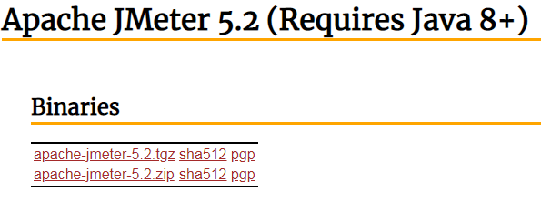
Example of Load Testing Using Apache JMeter
To demonstrate the functionality of the Apache JMeter tool, the website https://jsonplaceholder.typicode.com/ was selected. This service allows sending various web requests. By analyzing the server's response time to requests—a key performance indicator—conclusions can be drawn about the load the tested system can handle.
Navigate to the JMeter folder, then to the bin folder, and launch ApacheJMeter.jar using the Java Virtual Machine. The following window will open:
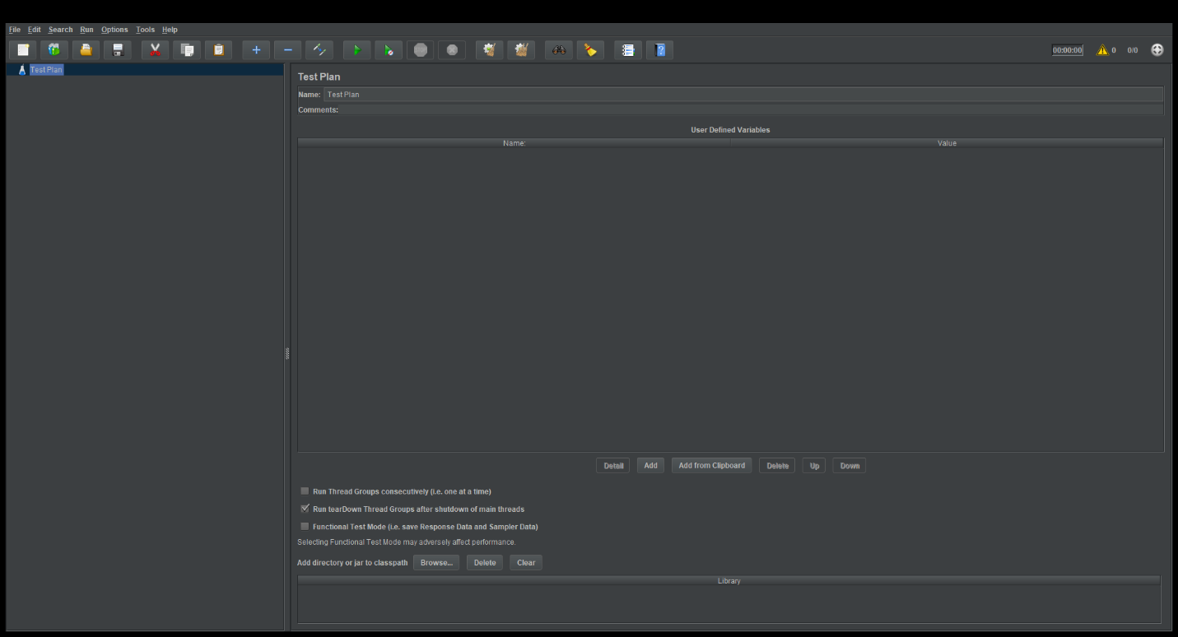
- Right-click on the Test Plan element => Add => Threads (Users) => Thread Group.
- In the Number of Threads (users) field (this is the number of requests of each type that will be added), enter the value "1000". In the Ramp-Up Period (seconds) field (the period over which these requests will be sent) – "1". In the Loop Count field (this field specifies how many times the request will be executed) – "1".
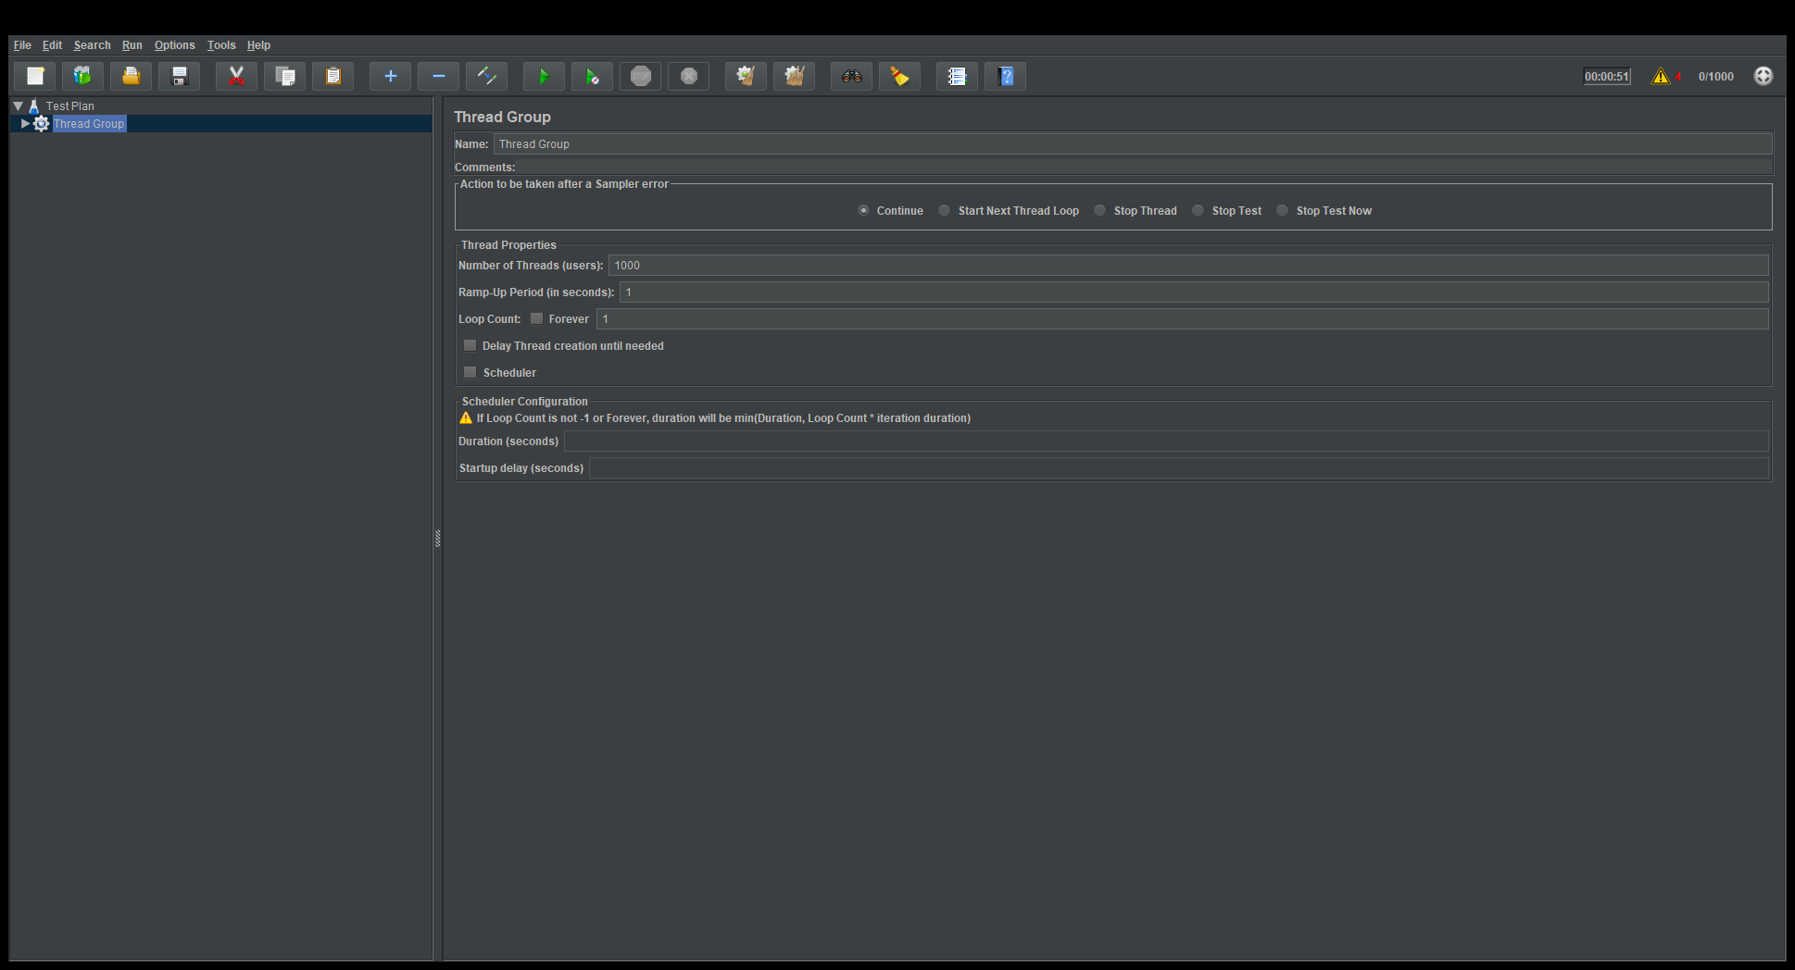

- Right-click on the Thread Group element => Add => Config Element => HTTP Request Defaults to add the settings for the website we will be testing.
- In the Protocol field, enter "http", and in Server Name or IP – "jsonplaceholder.typicode.com":
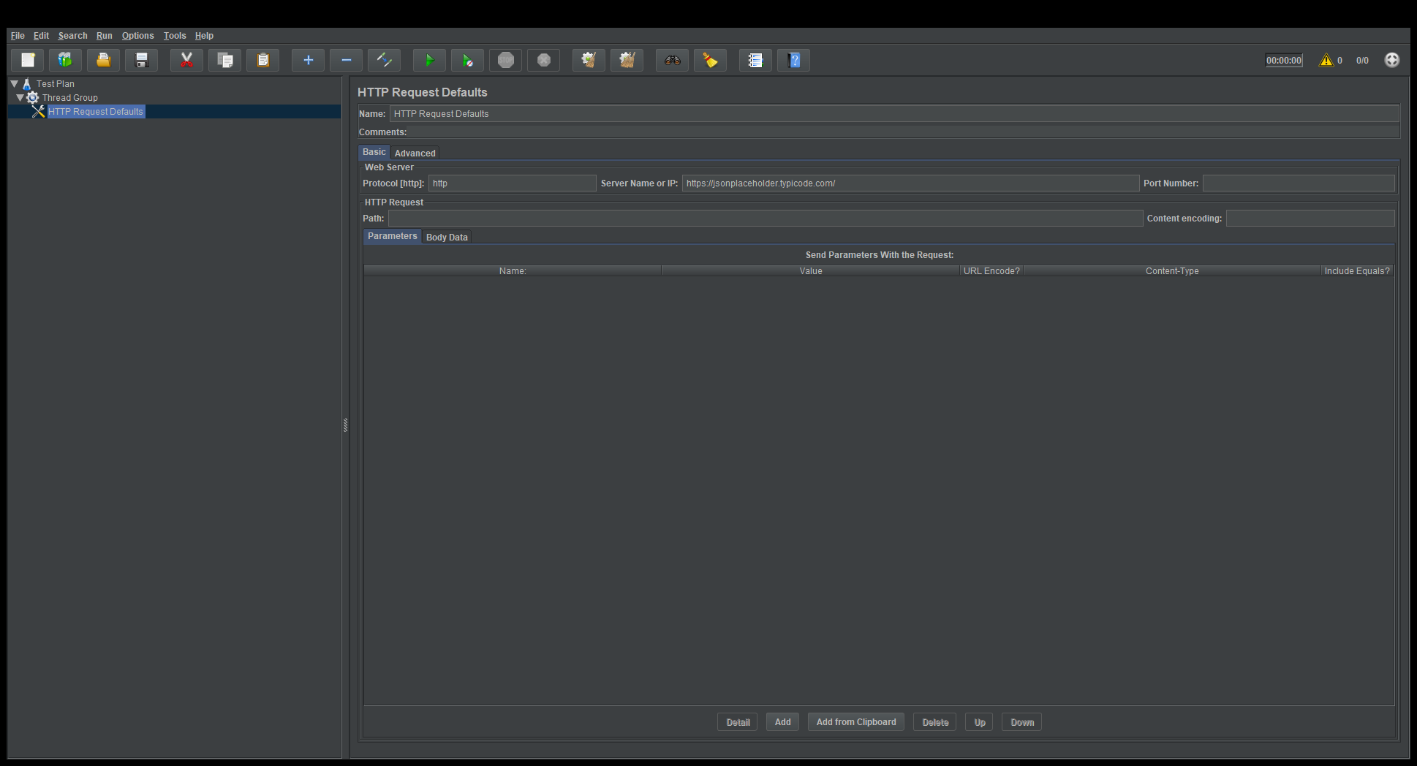
- Add two requests, GET and POST. To do this, right-click on the Thread Group element => Add => Sampler => HTTP Request.
- For the GET request, select "GET" in the Method field. For the POST request, select "POST" in the Method field. In the Path field for both requests, enter the value "/posts".
For the POST request, click the Add button with the left mouse button. In the Name field, add the value "userId", and in the Value field – "1".
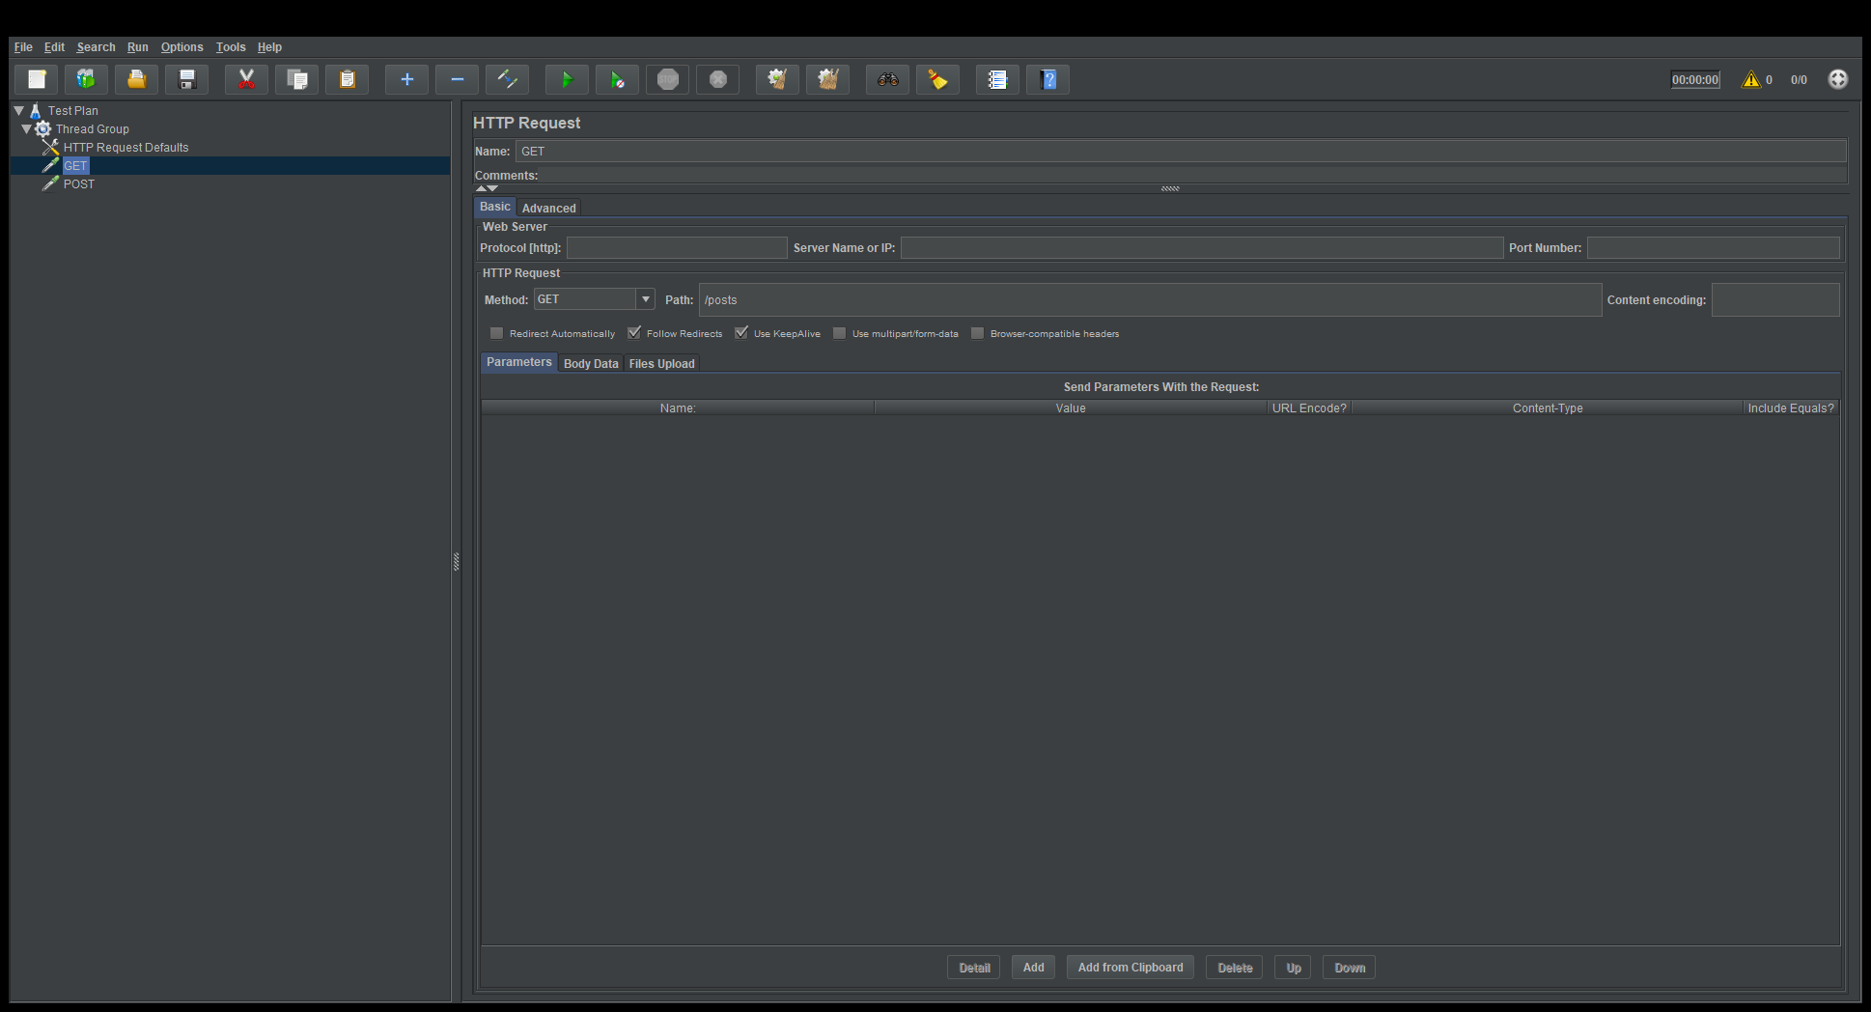
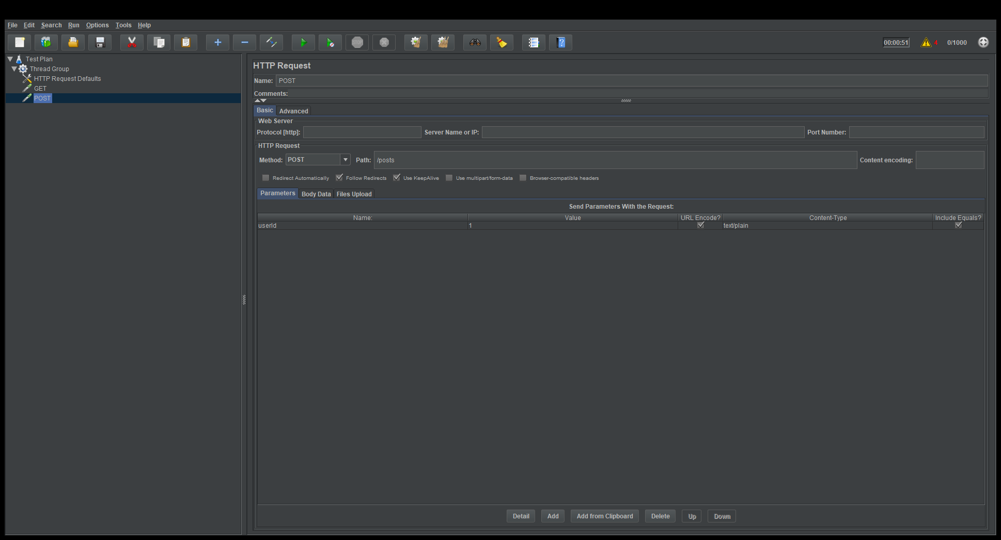
Each GET and POST request will be executed 1000 times, as defined in step 3.
- To view the test results, right-click on the Thread Group element and add the following listeners: View Results Tree, Summary Report, Graph Results, Response Time Graph (via Add => Listener).
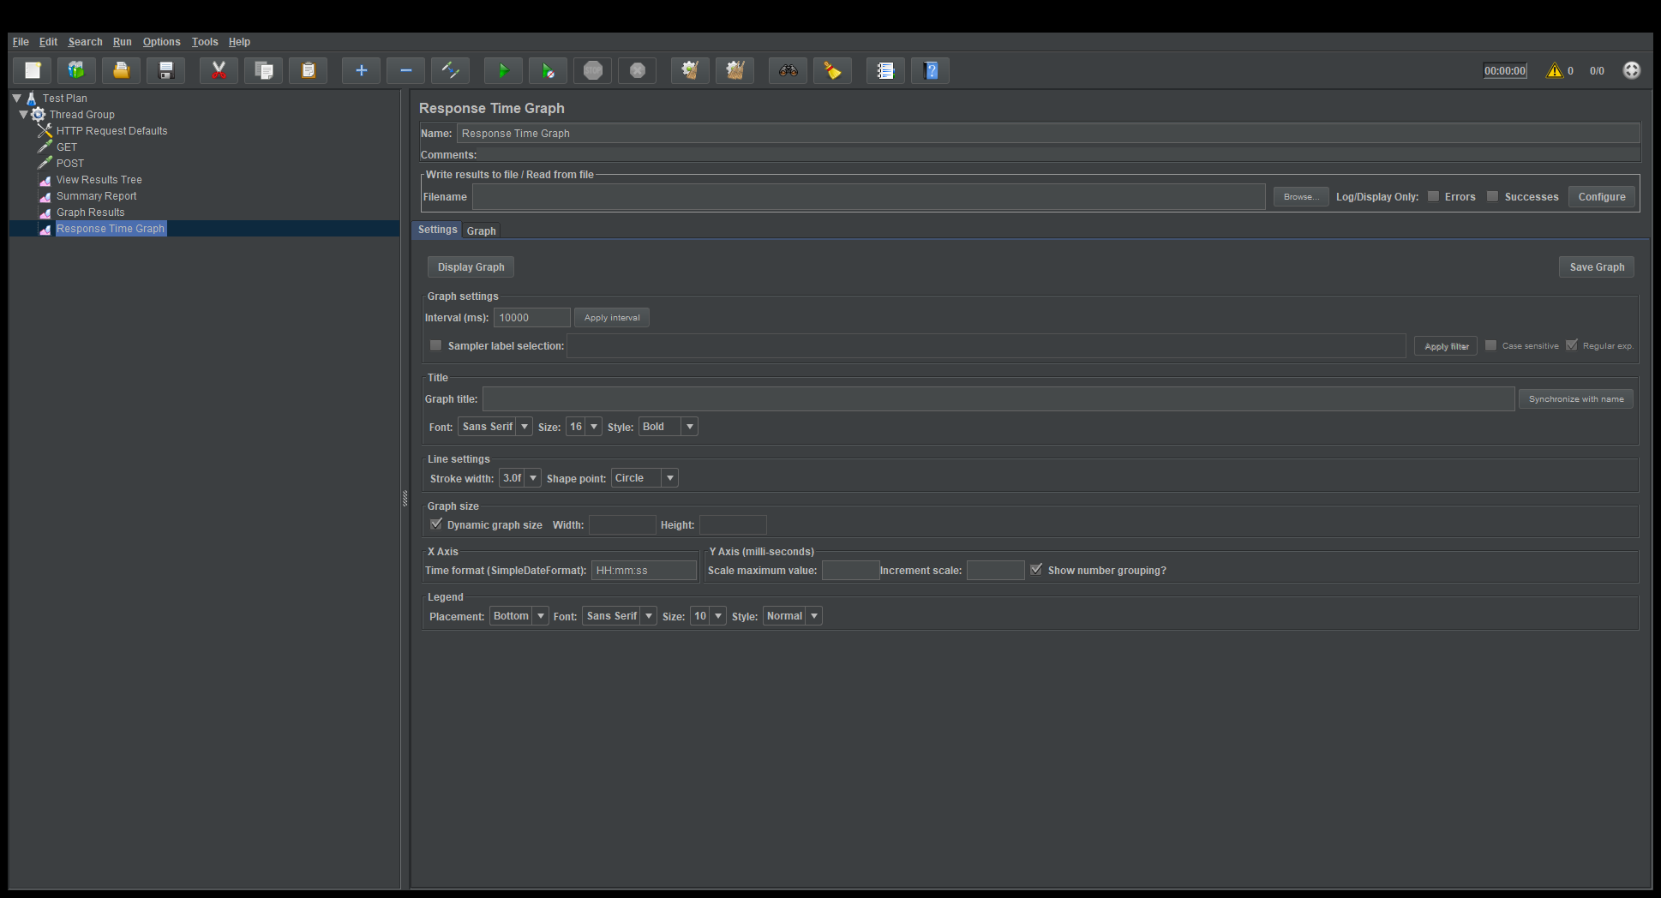
- To send the requests, left-click on the Run (Start) button.
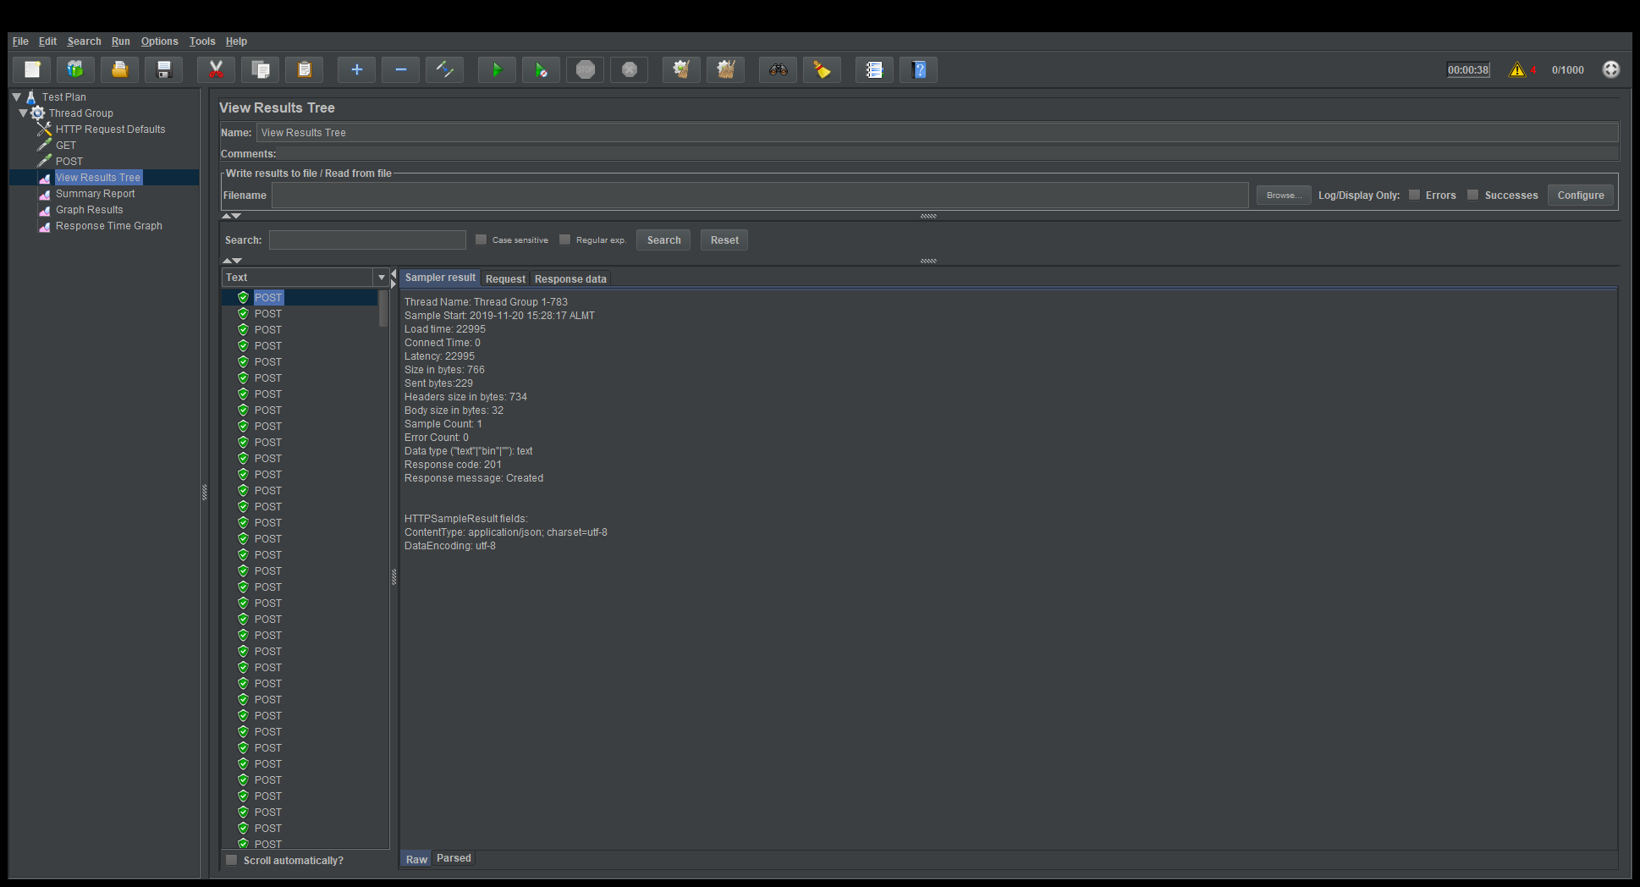
View Results Tree displays what the server responded to each specific request and how many requests were completed successfully.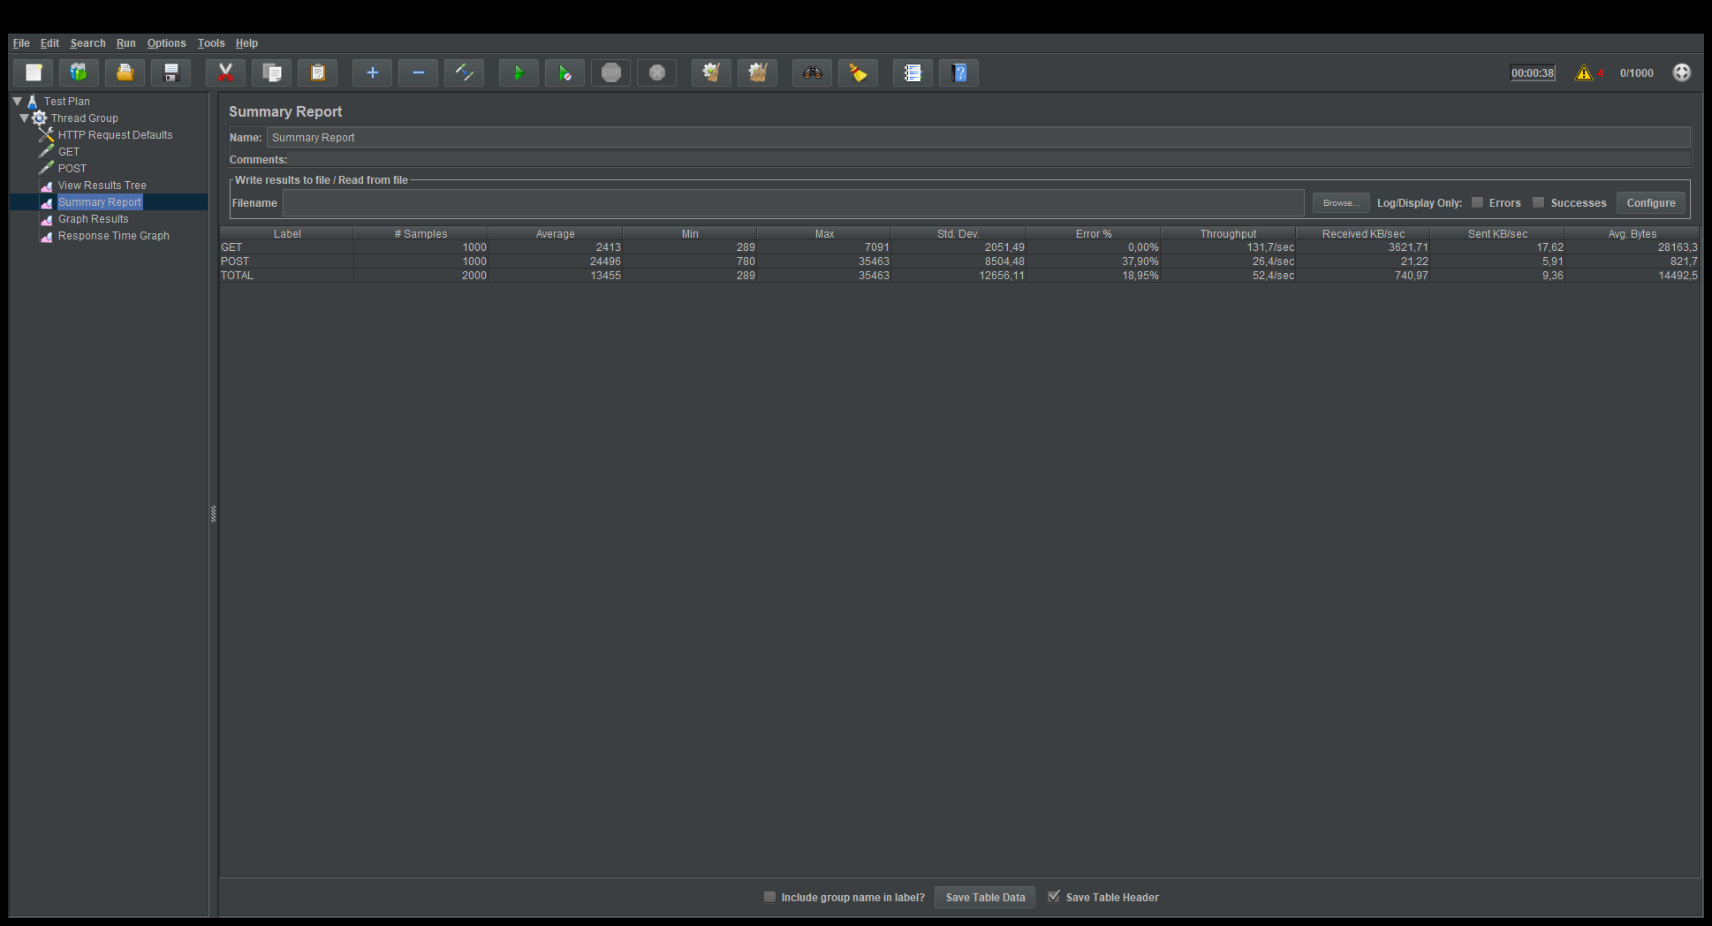
Summary Report displays data for each type of request.
Values are provided in milliseconds.
- Data: The response time for each individual data unit, i.e., each tested URL.
- Average: The average response time, an objective indicator of load changes.
- Median: The median value (used in statistics; I do not use this data).
- Deviation: Error, standard deviation.
- Throughput: The throughput of executed requests.
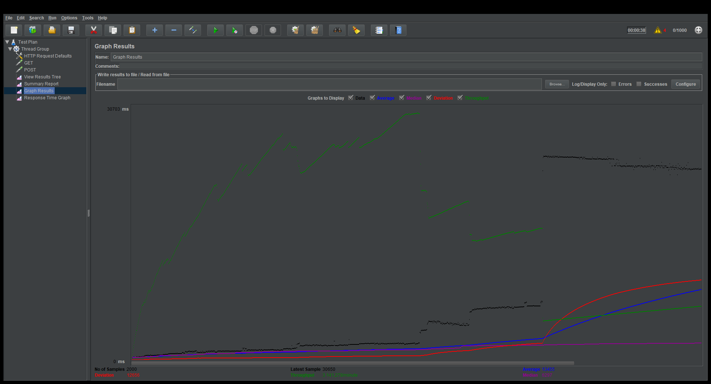
Graph Results displays the data from the Summary Report in a graphical form.

