**Software Testing**

**Lab 1: Debugging**

**Kodirkulov Zhenis ID:22MD0242**

1. **Introduction**
2. **Some useful vocabulary:** 
   * Debugging

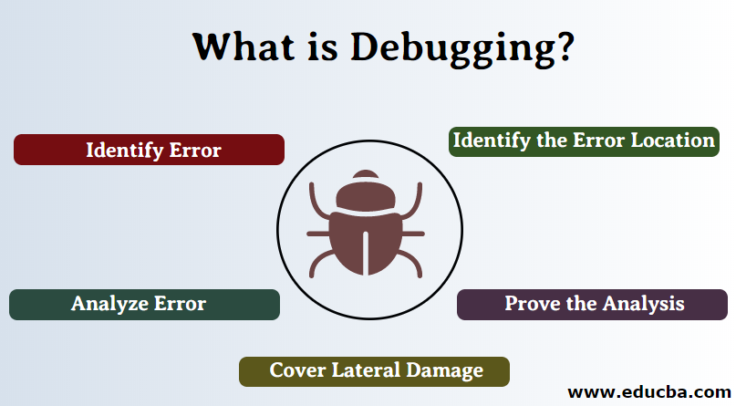

* Debugger

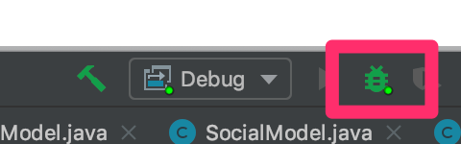

* Breakpoints

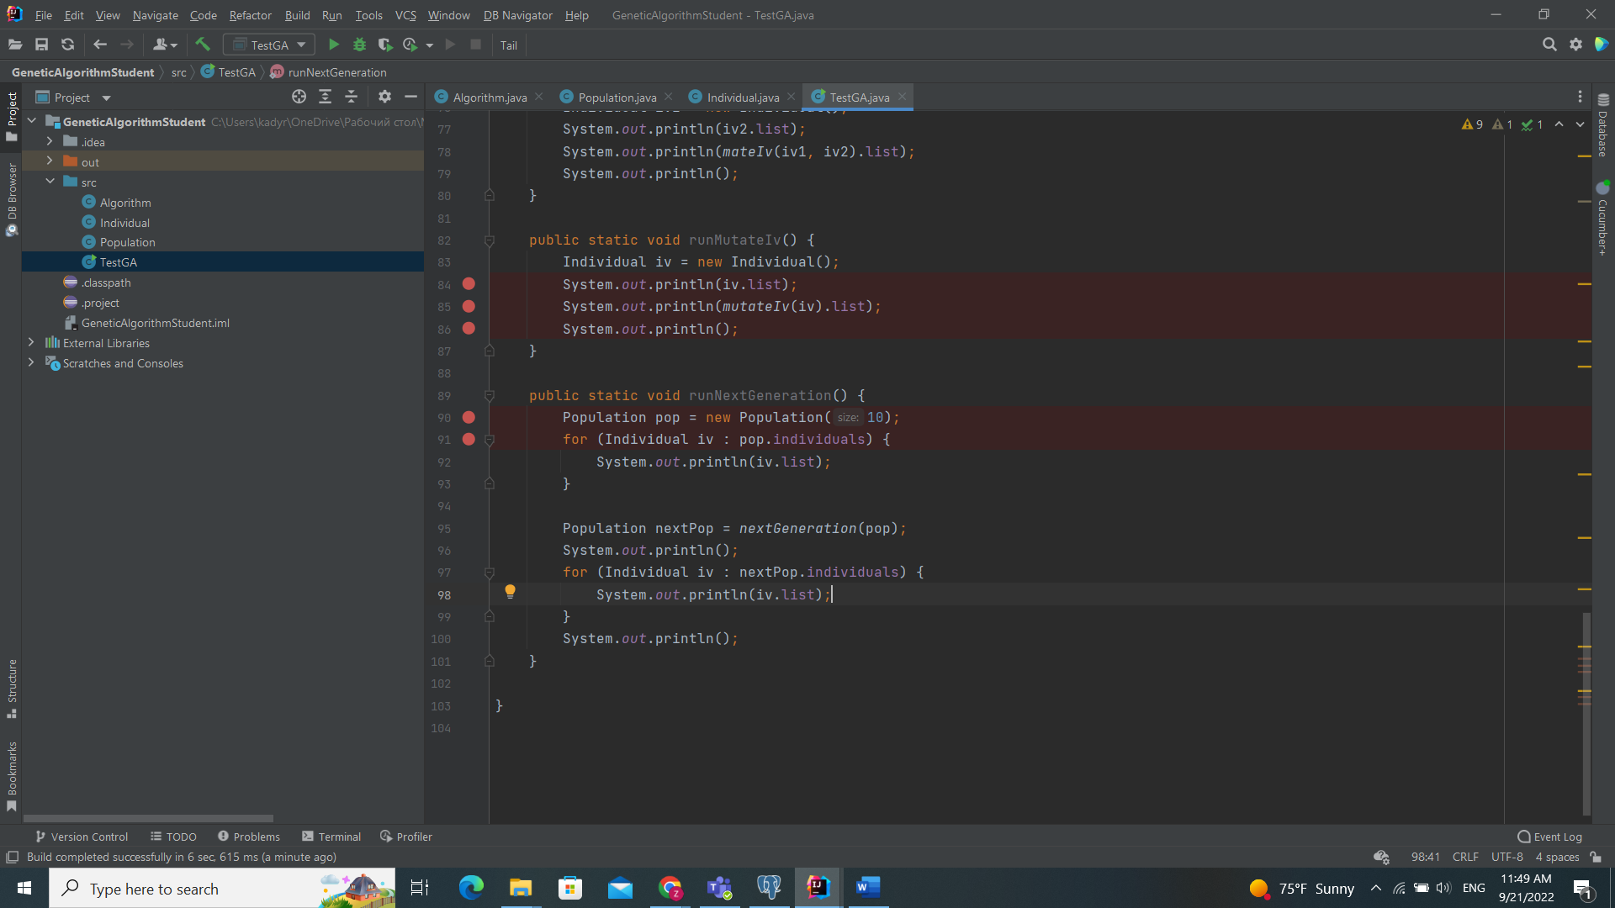

* Watchpoints

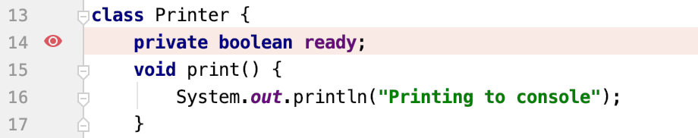

1. **Eclipse and IntelliJ buttons and meanings: Here I choose IntelliJ idea**

* **Step into change next line with function**

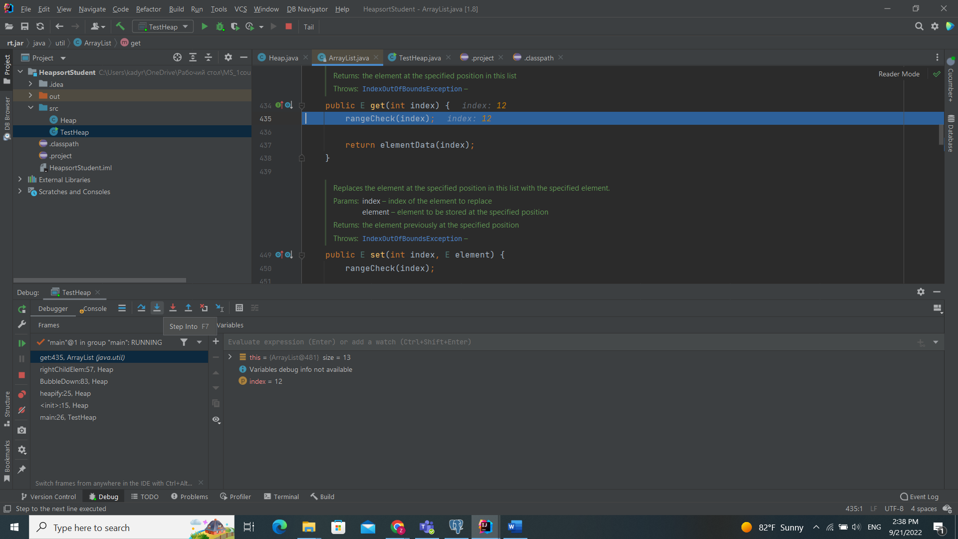

* **Step over change next line without function**

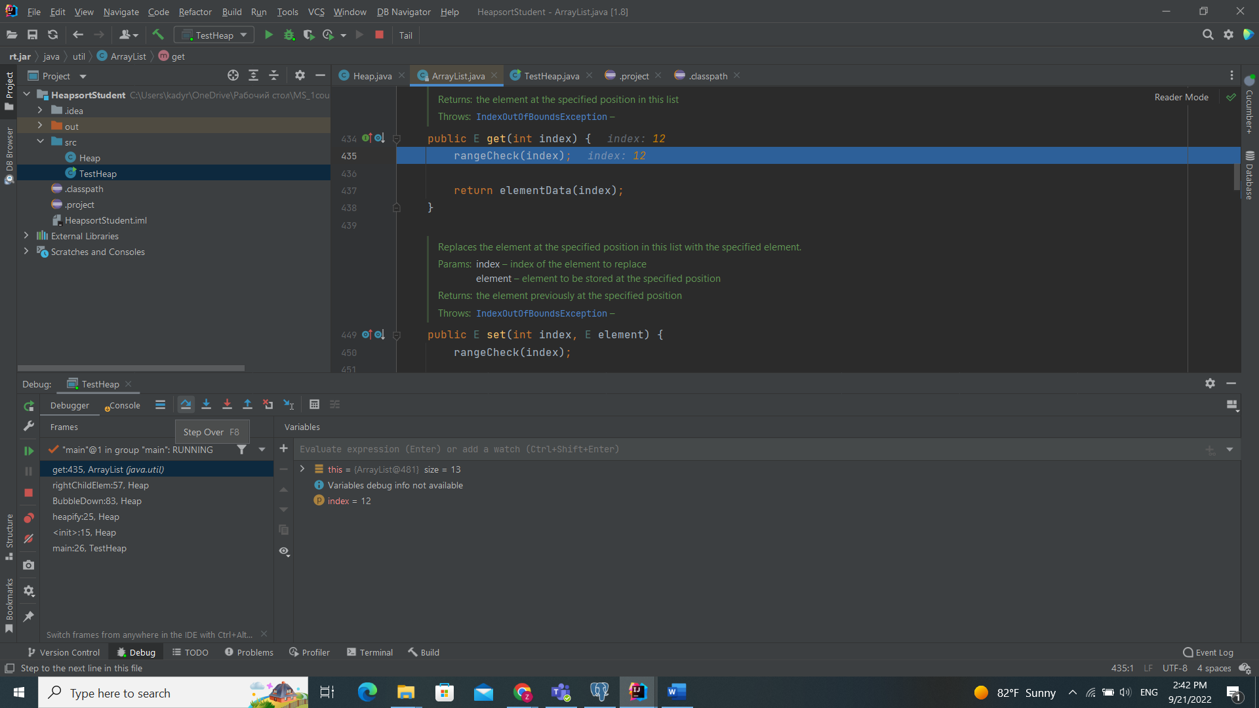

* 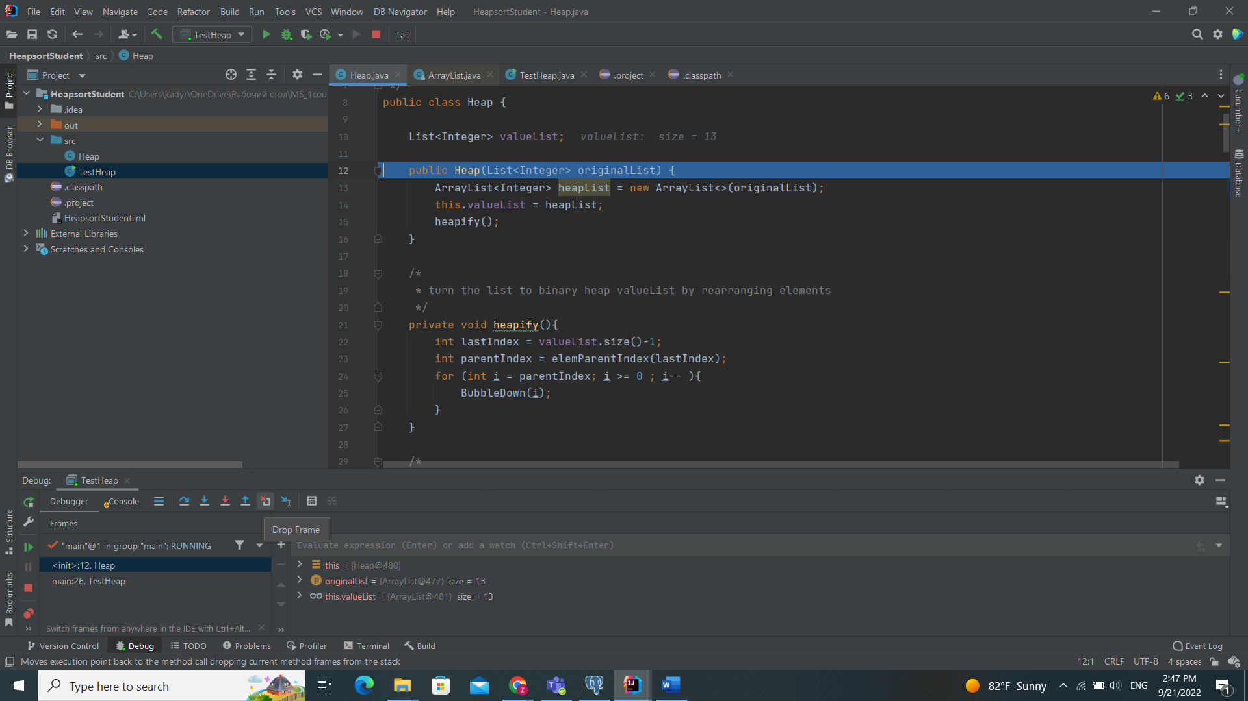**Drop frame - this go back function you are in**

* **Resume- change breakpoints or jump another point**

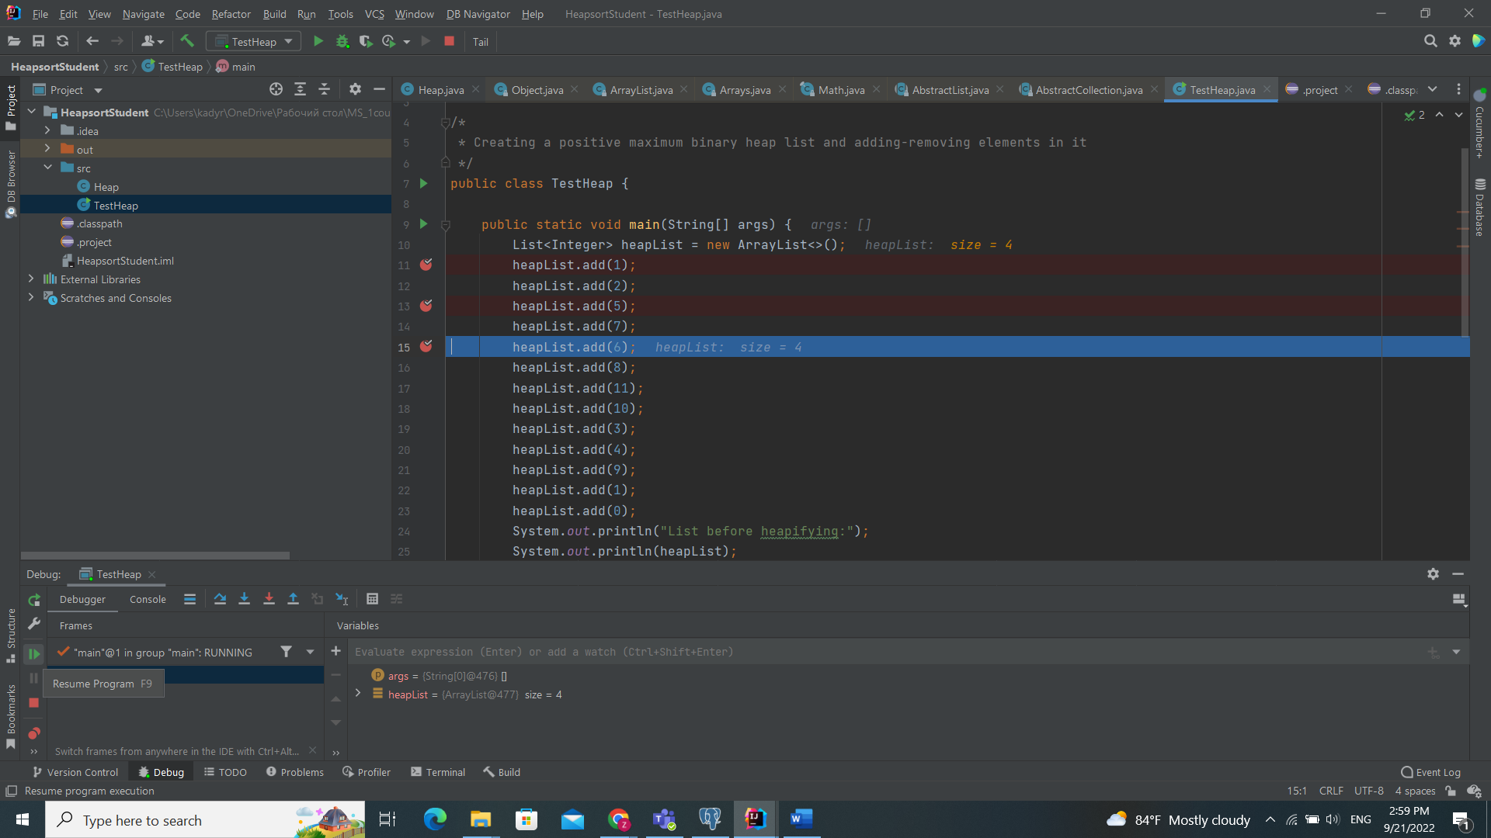

1. **Homework Tasks and Reporting**

**Task 1 HeapSort**

Issue report 1: Description: The program should heapify any given list of positive integers but the resulting tree (and list) does not meet the max binary heap structure

**After debugging I found tree bugs**

**First: Heap.java file 35 and 36 line**

**Before: After:**

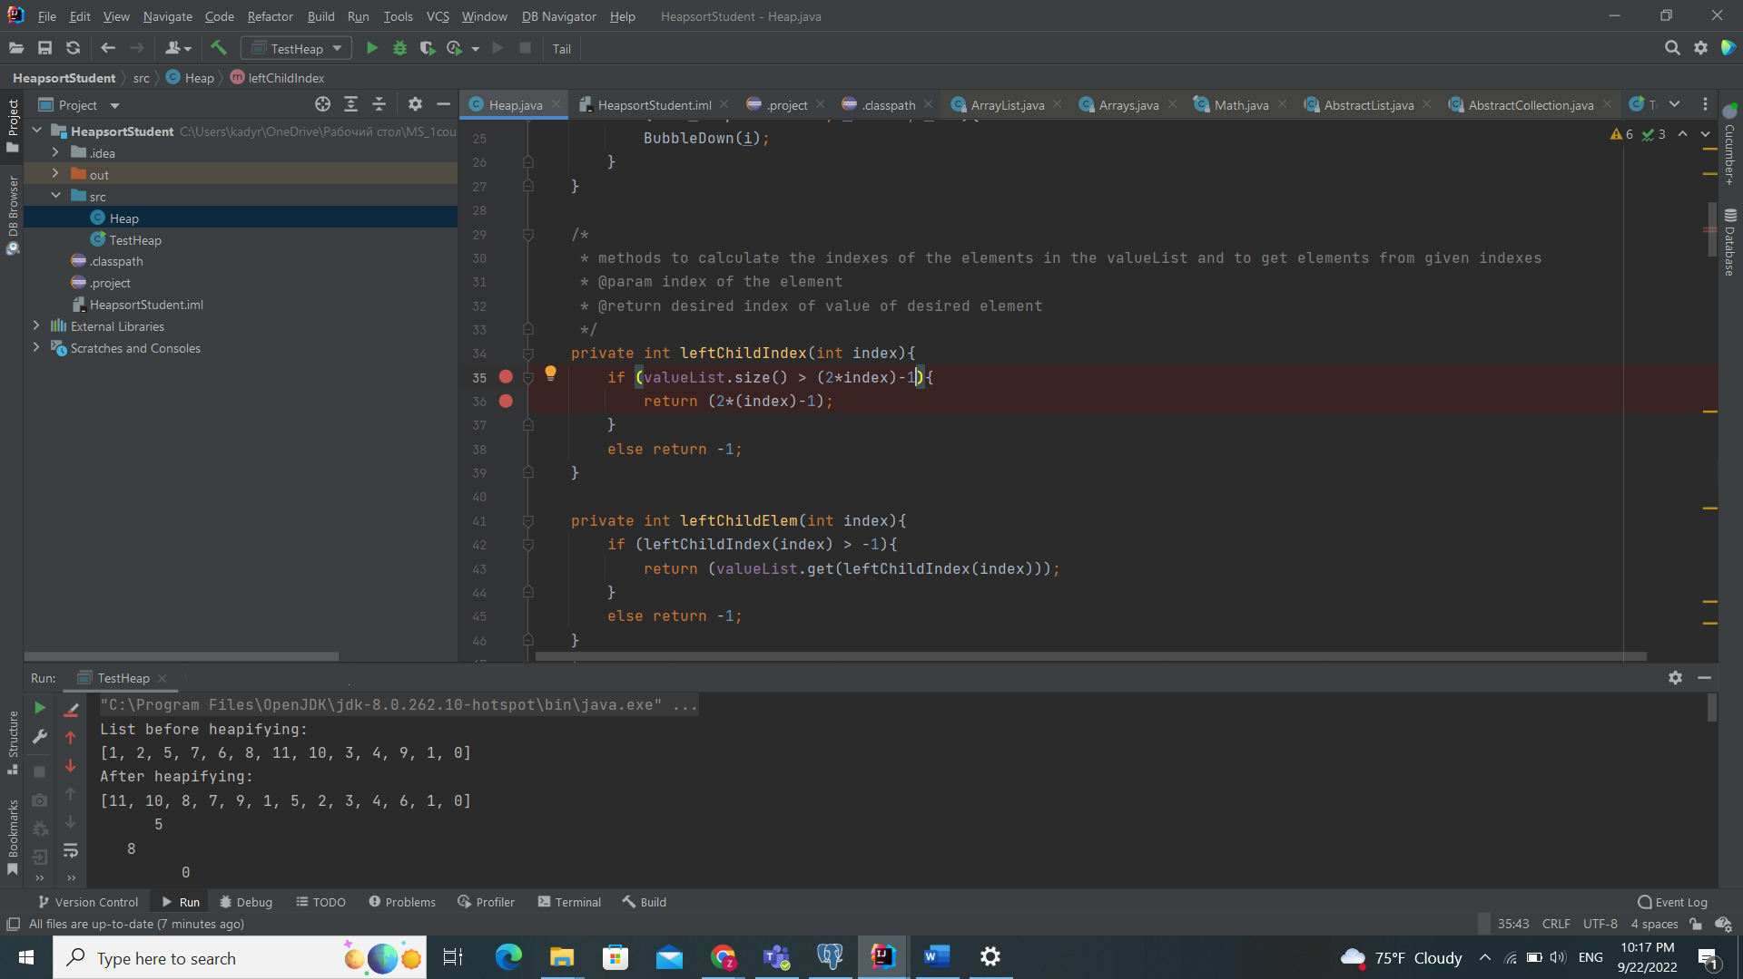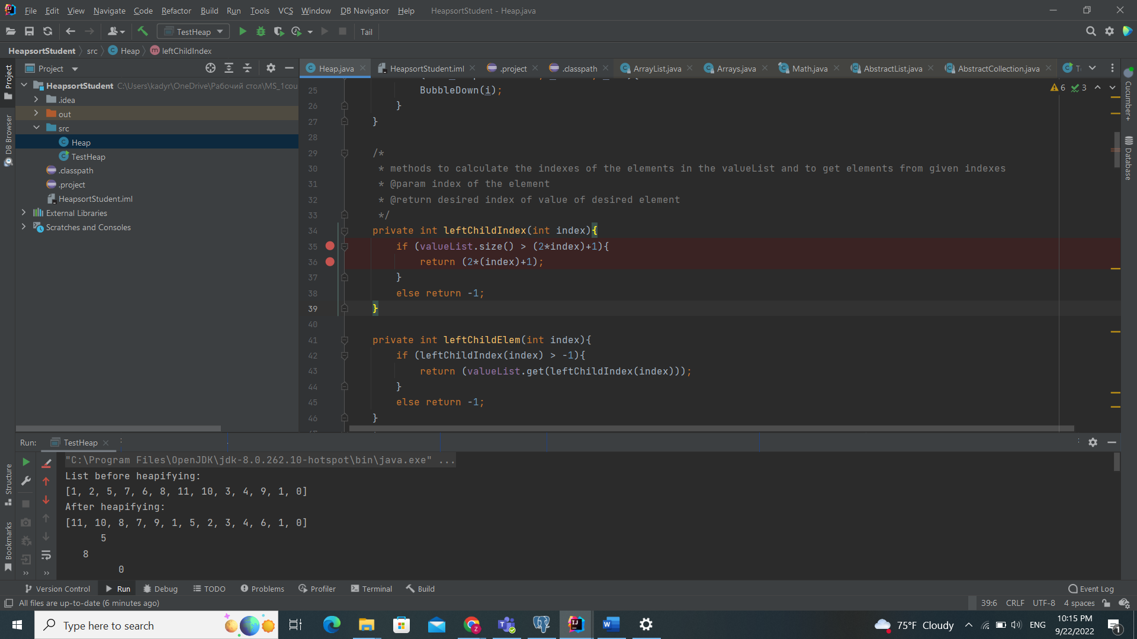 **code**

**outputs**

