Design document for the personal challenge

Introduction:
In this document, I will describe the initial design of my project. I will discuss the overall project structure, dataset preprocessing, my functional and non functional requirments combined with MoSCoW, and the cooperation between multiple models.

Project Justification and Requirements Specification based on Iteration Zero and EDA:

1. Introduction & Baseline Results: The initial K-Nearest Neighbors (KNN) model was developed strictly as a Proof of Concept to test the viability of automated tagging. The baseline algorithm yielded an accuracy of 0.07 and a micro F1-Score of 0.38. These metrics clearly demonstrate that simple distance-based algorithms cannot effectively process the complex, multi-dimensional metadata structure of TTRPGs, necessitating the shift to an advanced two-stage neural network architecture.

2. Architecture Justification Based on EDA: The new architecture is directly informed by the Exploratory Data Analysis (EDA) conducted on a dataset of 1,994 spells:

Class Imbalance: Analysis of the top 20 most frequent tags and tag density per spell confirmed severe class imbalance. This requires the use of a Sigmoid activation function and Binary Cross Entropy loss (BCEWithLogitsLoss) for independent multi-label classification.
Feature Extraction (NLP): Frequency analysis of words with a count below 2,000 proved the existence of strong lexical patterns. The first model utilizes an Embedding Layer to translate these semantic patterns into dense numeric vectors.
Contextual Dependencies: The tag co-occurrence matrix highlighted stable relationships between specific magical schools and mechanical effects. The second model is designed to recognize and resolve these probability matrices.
Spell Level Correlation: EDA findings suggest that spell rank influences the average word count and text structure. Consequently, the Spell Rank is fed into the network as a distinct structured feature (X2) to improve predictive accuracy.

MoSCoW Requirements (Functional & Non-Functional)

Must Have:
- Functional:
  - Text Preprocessing Pipeline: The system must accurately clean raw text by stripping HTML markup, removing special characters, and tokenizing the data.
  - Multi-Label Classification: The output layer must use a Sigmoid activation function to generate independent probabilities for each tag.
  - JSON Generation: The application must format the predicted tags and spell text into a valid .json file.
  - VTT Auto-Routing: The generated JSON must be strictly structured so that Foundry VTT automatically sorts spells into predefined folders (Cantrip, Rank 1 through Rank 10, Focus, Rituals, and Impossible Spells) upon import.
- Non-Functional:
  - Imbalance Handling: The model's primary evaluation metric must be the Macro and Micro F1-Score to ensure reliable prediction of rare tags.
  - Cloud Deployment: Both models must be hosted in a Hugging Face Space for reliable inference and accessibility.

Should Have:
- Functional:
  - User Interface: A front-end interface (e.g., Streamlit) should be deployed to allow Game Masters to easily input custom spell text and select the Spell Rank (X2 feature).
  - Co-occurrence Optimization: The model should leverage the learned co-occurrence matrix to accurately suggest secondary tags based on primary tag predictions.
- Non-Functional:
  - Inference Speed: The prediction generation and JSON compilation should occur rapidly enough to provide a seamless, disruption-free experience for content creators.

Could Have:
- Functional:
  - Batch Processing: The UI could allow users to upload a document containing multiple custom spells and process them into a single, bulk JSON compendium.
- Non-Functional:
  - Continuous Integration: The system could feature a pipeline to scrape and retrain on new data when official updates are published to the Archives of Nethys.

Workflow Diagram
This diagram illustrates the complete, two-stage machine learning architecture designed to automatically assign accurate metadata (keywords and official game traits) to Pathfinder 2e spell descriptions. Its primary purpose is to visualize how the system breaks down a complex multi-label classification problem into a "generate-and-refine" pipeline, moving from broad predictions to a filtered, conflict-free final output.
Here is exactly what the flowchart shows across its three main sections:
- Input and Preprocessing: The raw data is prepared for the neural network. The spell text undergoes cleaning (removing HTML tags and internal UUID links) and is split into tokens (tokenized). Simultaneously, the spell's level (rank) is normalized into a standard numeric format.
- Model 1 (Candidate Generator): This is the baseline predictive model. It uses an embedding layer and a Bidirectional GRU to create a shared mathematical representation of the text, which is then concatenated with the normalized rank. A shared classifier processes this data before splitting it into two distinct output heads: one calculating probabilities for 3705 possible keywords, and the other for 100 possible traits. After applying a probability threshold and selecting the highest-scoring items (top-k), this model outputs a preliminary list of candidate tags. Dashed lines indicate that these heads are trained against the ground-truth data (multi-hot vectors).
- Model 2 (Candidate Reranker): This stage acts as the final quality control filter. It takes the initial, potentially imperfect candidates generated by Model 1 and re-evaluates them alongside the original spell description and rank. It scores the true relevance of each candidate, deliberately removing weak predictions or logically conflicting tags (e.g., ensuring a spell isn't tagged as both "fire" and "water" if the rules forbid it), ultimately outputting the final, polished list of spell traits.

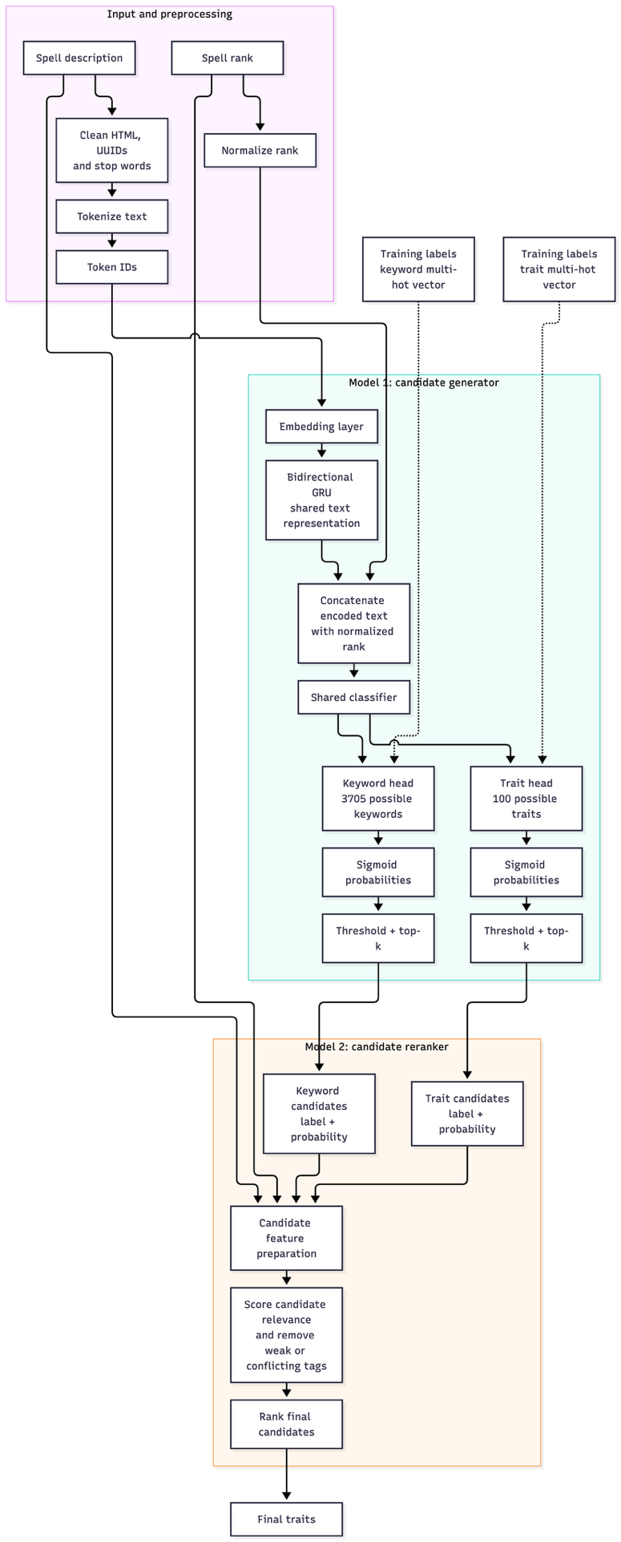

Conclusion:
This project transitions from a basic proof-of-concept to a robust, data-driven machine learning solution for automating Pathfinder 2e spell tagging. By implementing a two-stage neural network architecture—a candidate generator followed by a logical reranker—the system effectively addresses the severe class imbalances and complex tag dependencies identified during the exploratory data analysis. Ultimately, this pipeline will deliver a highly practical, cloud-hosted tool that generates Foundry VTT-ready JSON compendiums, significantly streamlining the workflow for Game Masters and content creators.

