Katelyn Charbonneau

EE320 Spring 2018 Exam 1 CADENCE Caps

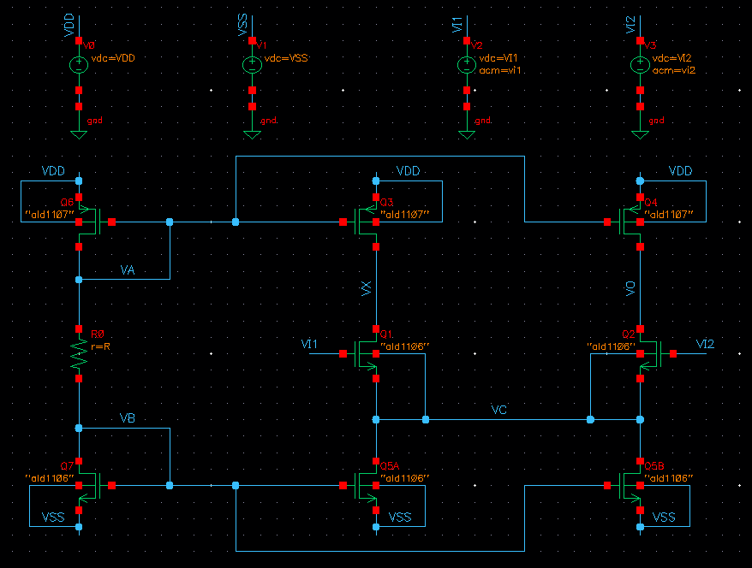

Figure 1. Schematic used for Acm and Ad

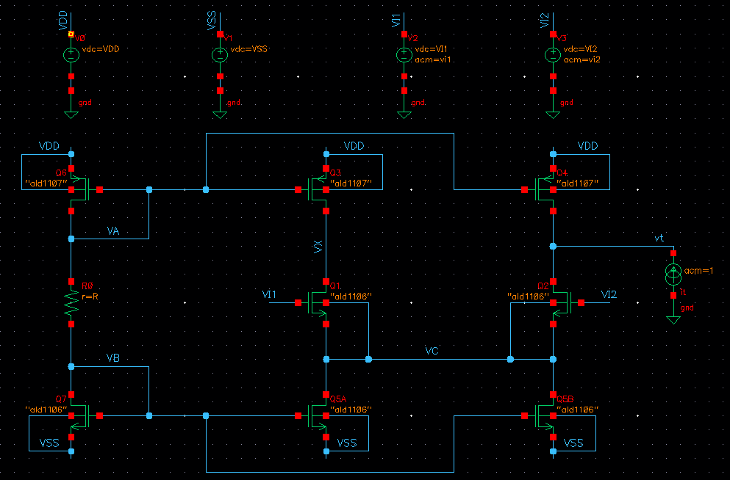

Figure 2. Schematic used for Ro

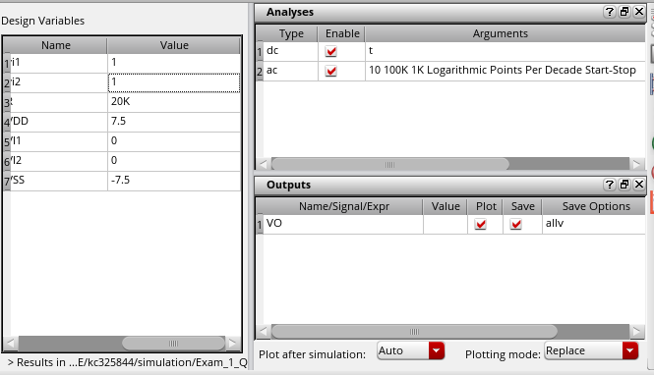

Figure 3. Simulation Setup for Acm

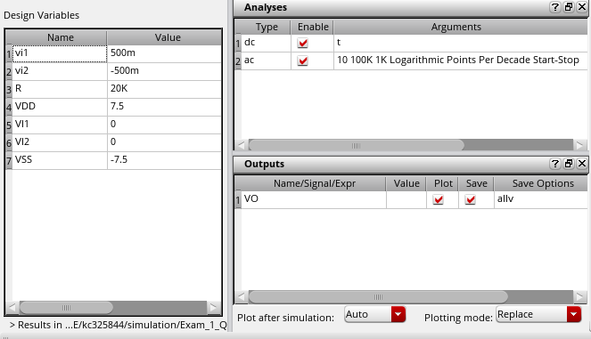

Figure 4. Simulation Setup for Ad

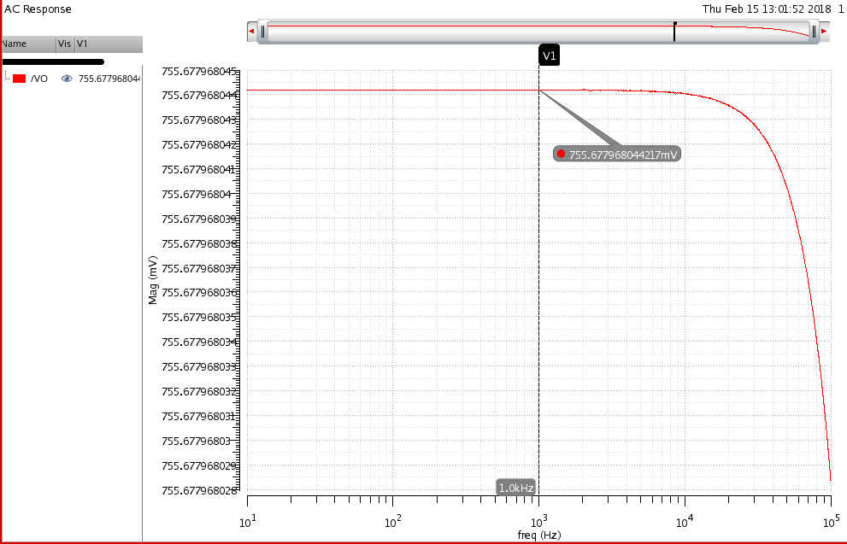

Figure 5. Simulation results for Acm

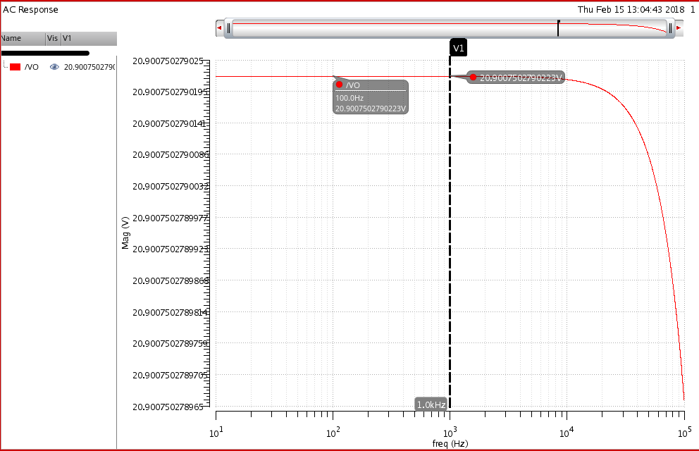

Figure 6. Simulation Results for Ad

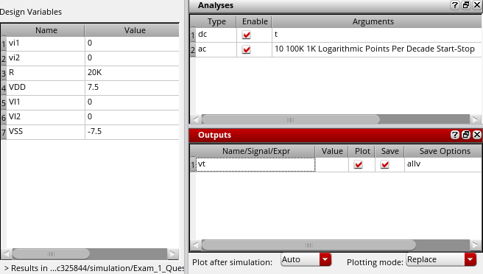

Figure 7. Simulation Setup for Ro

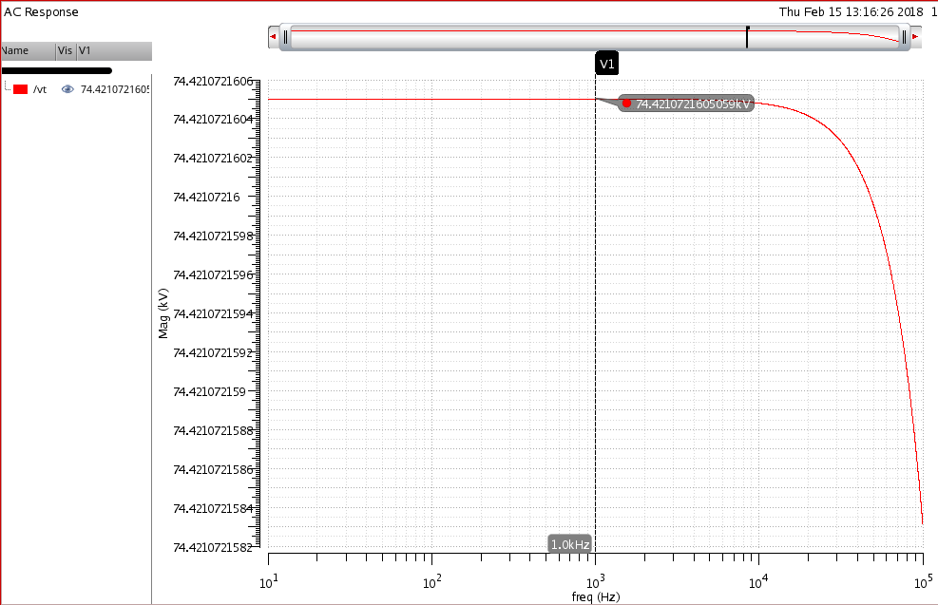

Figure 8. Simulation Results for Ro