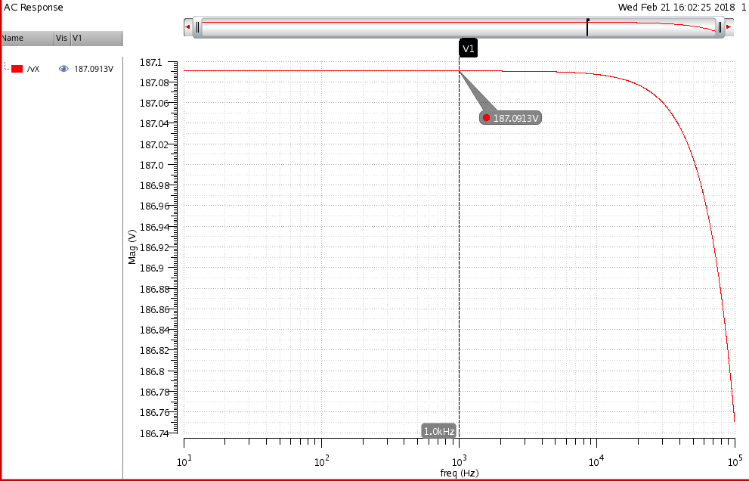

Figure 1. SPICE simulated graph of *Avo*

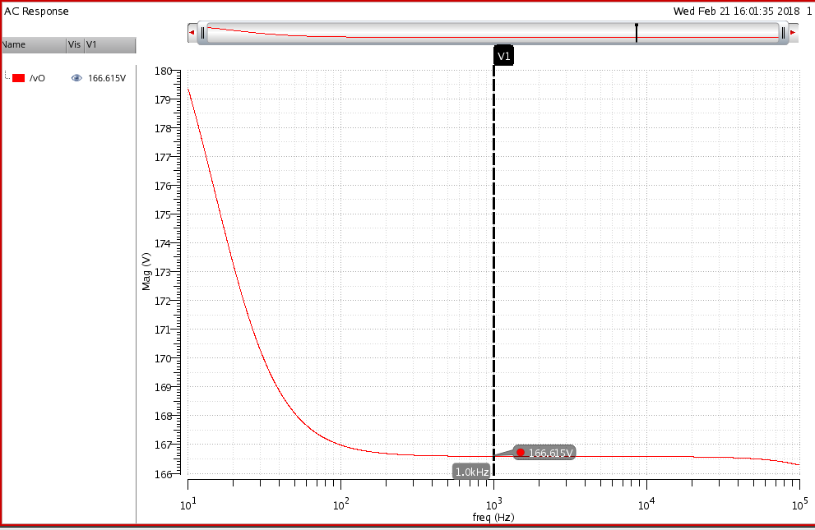

Figure 2. SPICE simulated graph of *Av*

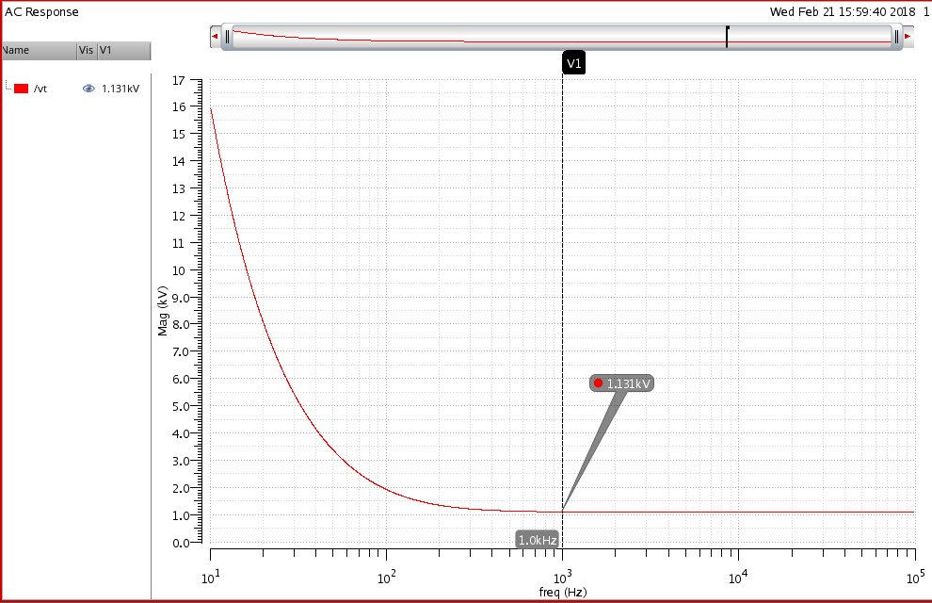

Figure 3. SPICE simulated graph of *Ro*