Group 7 – Kaedyn Kessler, Cameron Angelilli, Mark Hilton

SRS Outline

Introduction

Welcome to our final project, creating a webpage for a store. In this paper we will tell you step by step how we plan to do this, what we intend to implement, and our general requirements for this project.

1.1 Purpose

The purpose of this is to create an application to display the menu from which customers can order food and check out through our system. Further in this outline we will show how we intend to implement that and extra features (elaborate if you some specific things in your mind) that come with it.

1.2 Intended Audience

While the general audience for the application is customers it will also serve a second purpose for the management of the restaurant. Customers will be able to place orders, view last order, and see most popular ordered food. Meanwhile management will be able to add or delete any item menu and will be able to update prices of the food. (Check SRS PART 1)

Write Inception and elicitation requirements (Check SRS PART 2).

1.3 Intended use

As explained above the intended use of this application is to have customers be able to place orders for food. As well as management being able to make changes within the website through their own log in.

1.4 Scope

The scope of this project is to create a web application for a single restaurant. We intend to have the restaurant be able to use this with ease of access to the customers and the management.

2. Overall Description

Create Usage scenario (Check SRS PART 2).

2.1 User Needs

The users needs in this case are Placing orders, displaying receipts, and being able to see the previous order placed. Also if authenticated as management they will be able to edit the menu as needed.

2.2 Assumptions and Dependencies

The general assumptions for the application is that users should be able to create an account, a static admin login will be implemented, and it should be hosted simply.

3. System Features

3.1 Functional Requirements

The following is what we would like to implement as far as functional requirements go: Entering a name for the order, Directing the customer to the menu page, The customer would be able to select items from the menu, The customer will be given the flexibility to add and remove items from their cart, The customer will be given the option to pay with card or cash and we plan to implement an extra field to add a tip, The customers order will place successfully, The customer will be provided a receipt after their order is placed showing their name, the total amount, and the time required to complete the order.

3.2 System Features

The features we plan to implement include, but are not limited to: a payment system where the customer can enter card details or select they are paying with cash, User authentication to distinguish the account logging in as a customer, Admin authentication to distinguish the account logging in as an Admin/management, Menu options to add or remove items from the menu (this is intended for admins only), A button that changes the websites branding and what is featured on the website (i.e adding a special Halloween logo or a Christmas logo), Users last purchased items and the ability to re-order their last order, and a menu that shows the most popular food ordered above the menu.

3.3 Non-Functional Requirements

A button we are planning on adding that is not required for the web application to function is a dark mode option for users that prefer dark mode.

4. Diagrams

4.1 Use Case Diagram

Elaborate (Check SRS PART 3).

Who are primary and secondary actors.

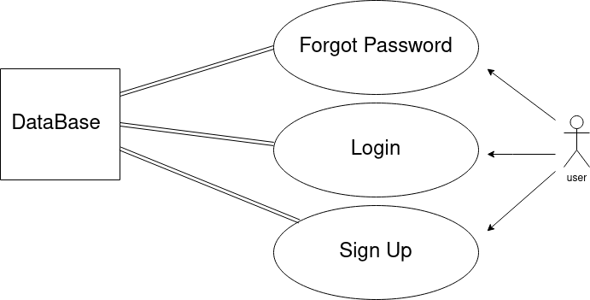

4.2 Activity Diagram (Authentication)

Add application Activity Diagram

Add search Activity Diagram (if applicable)

Add customer capabilities Activity Diagram

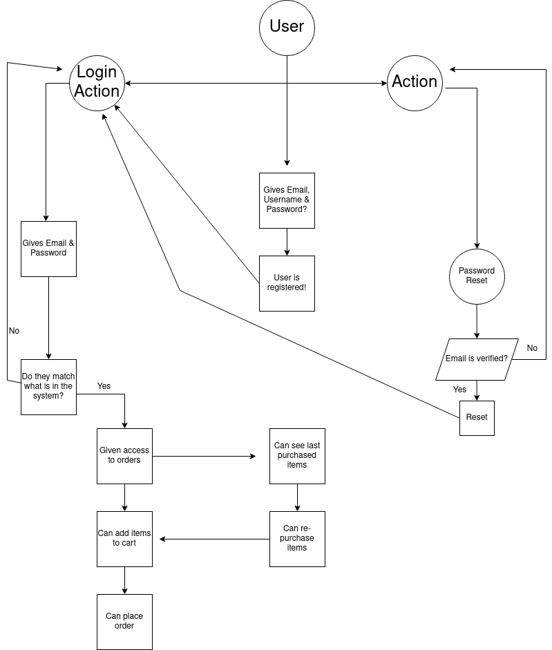

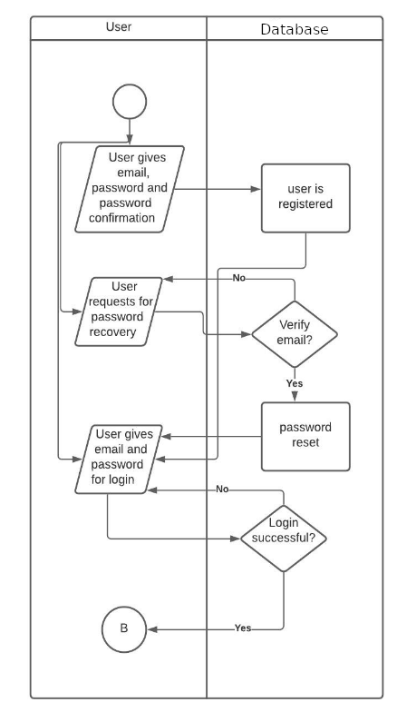4.3 Overall Diagram (Authentication)

Add memorization