Kaela Gentry and David Reid

1. We will be using SQL server 2016 Enterprise Edition for our final project.
2. It will be located locally on our laptop.
3. We already have SQL Server Enterprise Edition installed and configured. Having a local version of SQL Server means we don’t have to worry about any connections with other servers or networks, and can move large amounts of data in less time than if we had to share a network with a lot of other people (i.e. the University Network).

Screenshot of our Python Script

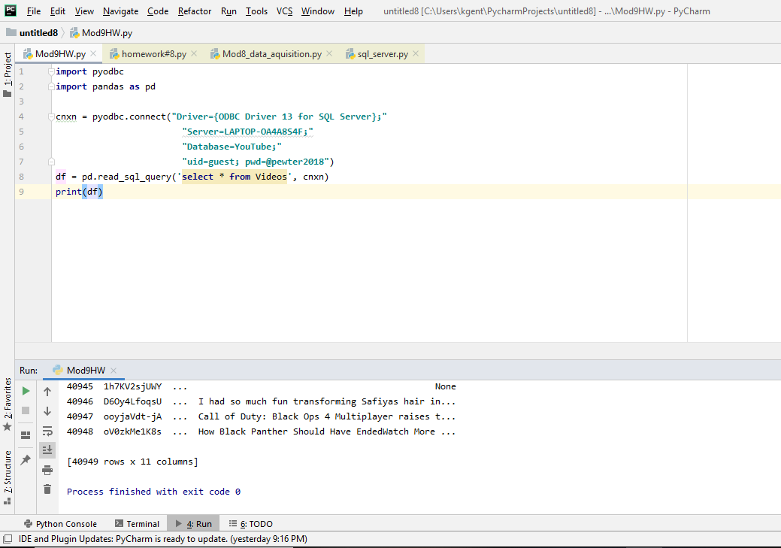

Screenshot of our table schema

