CCAUTOMA · Section COM244 · 1st AY2026
Course Project
PharmaHub
A Smart Pattern Recognition System for Pharmacy Product Codes
Regular Expression → NFA → DFA → Minimized DFA → Working Simulator
Submitted by
[Member 1 full name] — Project Leader
[Member 2 full name] — Language Analyst
[Member 3 full name] — RE/NFA Designer
[Member 4 full name] — DFA Designer
[Member 5 full name] — Automata Optimizer
[Member 6 full name] — Programmer
[Member 7 full name] — Tester/QA
[Member 8 full name] — Documentation/Presentation Lead
Submitted to
[Instructor's name]
[Submission date] · Defense: Week 12
Repository: github.com/kaela122/pharmacy-inventory-recognizer

2. Table of Contents

1. Cover Page 1
2. Table of Contents 2
3. Introduction 3
4. Problem Description 4
5. Project Objectives 5
6. Scope and Limitations 6
7. Formal Language Definition 7
8. Alphabet and Strings 8
9. Accepted and Rejected Input Examples 9
10. Regular Expression 10
11. NFA Formal Definition 11
12. NFA Transition Table and Diagram 12
13. NFA-to-DFA Conversion 13
14. DFA Transition Table and Diagram 15
15. DFA Minimization 16
16. Minimized DFA Diagram 19
17. System Design 20
18. Implementation / Source Code 22
19. Test Cases and Results 25
20. Screenshots of the Working System 27
21. Discussion of Results 37
22. Conclusion 38
23. References 39
24. Individual Contribution Matrix 40

(If you edit the report and page numbers change, right-click the table in Word and choose Update Field → Update entire table.)

3. Introduction
Pharmacies depend on product codes to find, count and reorder medicines. When staff type codes by hand, small mistakes such as a missing digit (M01), an extra letter (MM123), a lowercase letter (m123) or a stray space create records that cannot be matched to anything else in the system. Over time these mistakes cause wrong stock counts and missed reorders.
This project treats the set of valid pharmacy product codes as a formal language and builds a machine that recognizes it. Following the path taught in Automata Theory and Formal Languages, the group defined the language, wrote a regular expression for it, constructed a nondeterministic finite automaton (NFA), converted it to a deterministic finite automaton (DFA) using subset construction, minimized that DFA, and implemented the minimized DFA as a working simulator.
The result is PharmaHub, a pharmacy inventory system with the recognizer built in. The recognizer is available as a command-line simulator, as a web screen that animates each state transition, and as a rule inside the inventory itself: a medicine cannot be saved unless its code is ACCEPTED by the DFA. This shows the direct connection between the mathematical model and a practical input-validation problem.

4. Problem Description

4.1 What problem does the system solve?
The system decides whether a pharmacy product code is well-formed. It outputs ACCEPTED for a valid code and REJECTED for anything else, and explains where an invalid code went wrong. In the inventory, this check runs before a new or edited medicine is saved, so malformed codes never reach the database.

4.2 Who might use the system?
- Pharmacists and inventory managers who add and edit medicines.
- System administrators who maintain the code rules and user accounts.
- Developers who need a dependable validation step, through the REST endpoint POST /api/recognizer/validate.

4.3 What input does the system receive?
A string of characters typed by the user, such as M001.

4.4 What constitutes a valid input?
Exactly four symbols: one category letter followed by three digits.
Letter | Category | Example
M | Medicine | M001 Paracetamol 500mg
S | Supplement | S001 Vitamin C 500mg
C | Consumable | C001 Surgical mask

4.5 What constitutes an invalid input?
Any other string: a missing or wrong category letter, fewer or more than three digits, letters and digits in the wrong order, lowercase letters, spaces, or any symbol outside the alphabet.

4.6 Why can the problem be represented using finite automata?
To check a code, the machine only needs to remember how far through the pattern it is: nothing read yet, category letter read, one, two or three digits read, or already failed. That is a small, fixed amount of memory, which is exactly what a finite automaton provides. The check never needs to count without limit or match nested structures, which would require a more powerful machine such as a pushdown automaton. In addition, the language contains a finite number of strings (3,000), and every finite language is regular.

5. Project Objectives
At the end of the project, the group should be able to:
- Analyze a practical problem (pharmacy product-code validation) that can be represented using a formal language.
- Construct finite automata capable of recognizing the specified language.
- Apply Regular Expression, NFA, DFA, NFA-to-DFA conversion and DFA minimization.
- Demonstrate the equivalence of different representations of a regular language.
- Implement a simple program that simulates the designed automaton.
How each objective is met:
Objective | Where it is met
1. Analyze a practical problem | Sections 4 and 6
2. Construct finite automata | Sections 11–16
3. RE, NFA, DFA, conversion, minimization | Sections 10, 11–12, 13–14, 15–16
4. Equivalence of representations | Section 15.7, and the automated test test_equivalence.py (Section 19.4)
5. Working simulator | Sections 17, 18 and 20

6. Scope and Limitations

6.1 Scope
- Recognizes pharmacy product codes of the form <category letter><digit><digit><digit> with categories M, S and C.
- Provides a command-line simulator with interactive, batch, demo and theory modes.
- Provides a web interface with an animated Code Recognizer screen and a full inventory (medicines, categories, suppliers, orders, stock movements, users and analytics).
- Enforces the DFA on every medicine that is added or edited.
- Includes automated tests for the accepted and rejected sets and for the equivalence of the RE, NFA, DFA and minimized DFA.

6.2 Limitations
- The recognizer checks the format of a code only. Whether a code already exists is checked separately by a database lookup.
- Exactly three digits are allowed, so each category holds at most 1,000 codes (000–999).
- Only three categories are supported. Adding one requires a new letter in Σ and one new transition from q0.
- Lowercase letters are not in Σ. The Medicines form converts input to uppercase before validation for convenience; this is preprocessing by the application, not part of the automaton. The Code Recognizer screen and the CLI apply no preprocessing.
- The demo login system is intended for classroom demonstration, not for production security.

7. Formal Language Definition
The language of valid pharmacy product codes is:
L = { x d₁ d₂ d₃ | x ∈ {M, S, C} and d₁, d₂, d₃ ∈ {0, 1, …, 9} }
Acceptance rules:
- The first symbol must be one of the category letters M, S or C.
- The second, third and fourth symbols must each be a digit 0–9.
- The string must end after the fourth symbol (length exactly 4).
- Every symbol must belong to Σ; anything else causes rejection.
Size of the language: |L| = 3 × 10 × 10 × 10 = 3,000 strings. The shortest and longest strings in L both have length 4.

8. Alphabet and Strings

8.1 Alphabet (Σ)
Σ = { M, S, C, 0, 1, 2, 3, 4, 5, 6, 7, 8, 9 }
Σ contains 13 symbols. For readability, the category letters are grouped as {M, S, C} and the digits as D = {0, 1, …, 9}. All ten digits behave identically in every state, so transition tables show a single column for D. In the implementation, each digit remains its own symbol.

8.2 Strings
A string over Σ is any finite sequence of symbols from Σ, including the empty string ε. The set of all strings over Σ is Σ*. For example, M001, S, 123, MM and C0012 are all strings over Σ, but only M001 belongs to L. A string such as m123 is not a string over Σ, because m is not a symbol of the alphabet.
String | In Σ*? | In L?
M001 | yes | yes
S | yes | no (too short)
123 | yes | no (no category letter)
C0012 | yes | no (too long)
ε | yes | no (empty)
m123 | no | no

9. Accepted and Rejected Input Examples

9.1 Accepted strings
# | String | Category | Why it is in L
1 | M001 | Medicine | category letter + three digits
2 | M123 | Medicine | category letter + three digits
3 | S001 | Supplement | category letter + three digits
4 | S002 | Supplement | category letter + three digits
5 | C001 | Consumable | category letter + three digits
6 | C002 | Consumable | category letter + three digits
7 | M999 | Medicine | category letter + three digits
8 | S250 | Supplement | category letter + three digits
9 | C500 | Consumable | category letter + three digits
10 | M042 | Medicine | category letter + three digits

9.2 Rejected strings
# | String | Why it is not in L
1 | M01 | only 2 digits (too short)
2 | C0012 | 4 digits (too long)
3 | A123 | A is not in Σ
4 | 123 | no category letter
5 | MM123 | two letters
6 | C12A | A is not in Σ; a letter where a digit is required
7 | ε (empty) | length 0
8 | m123 | lowercase m is not in Σ
9 | S12 | only 2 digits
10 | S1234 | 4 digits (too long)

10. Regular Expression

10.1 The expression
R = (M | S | C) D D D, where D = (0 | 1 | 2 | 3 | 4 | 5 | 6 | 7 | 8 | 9)
Written out in full: (M|S|C)(0|1|…|9)(0|1|…|9)(0|1|…|9). In the practical regex syntax used by the automated tests, the same language is written ^(M|S|C)[0-9][0-9][0-9]$.

10.2 Components and their meaning
Component | Operator | Meaning
(M | S | C) | union | exactly one category letter: Medicine, Supplement or Consumable
D = (0 | 1 | … | 9) | union | exactly one digit
D D D | concatenation | three digits in a row: the item number 000–999
(M|S|C) · DDD | concatenation | the letter comes first, then the digits

The expression uses only union and concatenation. It has no Kleene star, so it cannot generate strings longer than four symbols. This is why over-long inputs such as S1234 are rejected.

10.3 How valid strings match
M042: M matches (M|S|C) by choosing the first alternative. 0, 4 and 2 each match one D. All four symbols are consumed and the expression is complete, so the string matches.
C500: C matches the third alternative of (M|S|C). 5, 0 and 0 match D D D. The string matches.

10.4 Why invalid strings are rejected
String | Where matching fails
123 | 1 cannot match (M|S|C)
MM123 | the second M cannot match the first D
M01 | input runs out before the third D
S1234 | after D D D the expression is finished, but 4 is left over
m123 | m is not in Σ, so no part of R can match it
ε | (M|S|C) requires one symbol and there is none

11. NFA Formal Definition
The ε-NFA is built directly from R. The union (M|S|C) becomes three branches, one per category. ε-transitions join the branches, and the concatenation D D D becomes a chain of three digit transitions.
M_N = (Q, Σ, δ, q₀, F)
- Q = { p0, p1, p2, p3, p4, p5, p6, p7 }
- Σ = { M, S, C, 0, 1, …, 9 }
- δ : Q × (Σ ∪ {ε}) → P(Q), given in Section 12
- q₀ = p0
- F = { p7 }
State | Meaning
p0 | start
p1 | read M (Medicine branch)
p2 | read S (Supplement branch)
p3 | read C (Consumable branch)
p4 | category done, expecting digit 1
p5 | 1 digit read
p6 | 2 digits read
p7 | 3 digits read (accepting)

Why this is an NFA: it has ε-transitions (p1, p2 and p3 move to p4 without reading input), and many (state, symbol) pairs have no transition at all. A DFA must have exactly one transition for every state and symbol.

12. NFA Transition Table and Diagram

12.1 Transition table
δ | M | S | C | D (0–9) | ε
→ p0 | {p1} | {p2} | {p3} | ∅ | ∅
p1 | ∅ | ∅ | ∅ | ∅ | {p4}
p2 | ∅ | ∅ | ∅ | ∅ | {p4}
p3 | ∅ | ∅ | ∅ | ∅ | {p4}
p4 | ∅ | ∅ | ∅ | {p5} | ∅
p5 | ∅ | ∅ | ∅ | {p6} | ∅
p6 | ∅ | ∅ | ∅ | {p7} | ∅
* p7 | ∅ | ∅ | ∅ | ∅ | ∅

→ marks the start state; * marks the accepting state.

12.2 State diagram
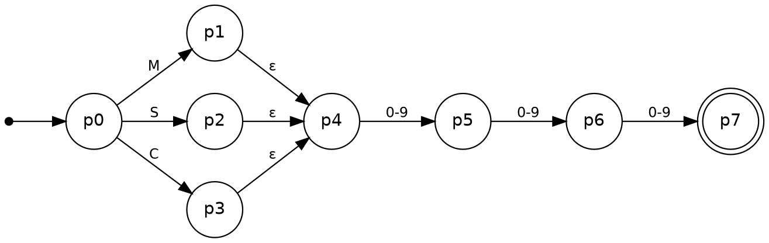
Figure 1. ε-NFA for R = (M|S|C)DDD. The double circle marks the accepting state p7.

13. NFA-to-DFA Conversion
The NFA is converted with subset construction. Each DFA state represents a set of NFA states. For a DFA state T and a symbol a:
δ′(T, a) = ε-closure( move(T, a) )
Here move(T, a) is the set of NFA states reachable from any state in T by reading a, and ε-closure adds every state reachable from those by ε-moves alone. DFA states are named T0, T1, … rather than A, B, C, D, because C and D are already symbols in this project.

13.1 Initial state
ε-closure({p0}) = {p0}, since p0 has no ε-moves. This subset is T0, the DFA start state.

13.2 Step-by-step construction
Step | DFA state | Symbol | move | ε-closure | Result
1 | T0 = {p0} | M | {p1} | {p1, p4} | T1 (new)
2 | T0 | S | {p2} | {p2, p4} | T2 (new)
3 | T0 | C | {p3} | {p3, p4} | T3 (new)
4 | T0 | D | ∅ | ∅ | ∅ (new, dead)
5 | T1 = {p1, p4} | M, S, C | ∅ | ∅ | ∅
6 | T1 | D | {p5} | {p5} | T4 (new)
7 | T2 = {p2, p4} | M, S, C | ∅ | ∅ | ∅
8 | T2 | D | {p5} | {p5} | T4
9 | T3 = {p3, p4} | M, S, C | ∅ | ∅ | ∅
10 | T3 | D | {p5} | {p5} | T4
11 | ∅ | any | ∅ | ∅ | ∅
12 | T4 = {p5} | M, S, C | ∅ | ∅ | ∅
13 | T4 | D | {p6} | {p6} | T5 (new)
14 | T5 = {p6} | M, S, C | ∅ | ∅ | ∅
15 | T5 | D | {p7} | {p7} | T6 (new)
16 | T6 = {p7} | any | ∅ | ∅ | ∅

After step 16, every discovered subset has been processed and no new subsets appear, so the construction stops.

13.3 Reachable subsets
T0 = {p0}, T1 = {p1, p4}, T2 = {p2, p4}, T3 = {p3, p4}, T4 = {p5}, T5 = {p6}, T6 = {p7}, and ∅ (the dead state). Only 8 of the 2⁸ = 256 possible subsets of Q are reachable; the other 248 are never generated.

13.4 Accepting states
A DFA state is accepting if its subset contains the NFA accepting state p7. Only T6 = {p7} qualifies.

13.5 Verification in code
The same construction is implemented in backend/app/automata/construction.py. Running python cli/simulator.py --theory prints every step above and confirms the result (see Figure 5). The web app shows the same construction interactively on its Automata Theory page (Figures 17–19).

14. DFA Transition Table and Diagram

14.1 DFA transition table
DFA state | NFA subset | M | S | C | D (0–9)
→ T0 | {p0} | T1 | T2 | T3 | ∅
T1 | {p1, p4} | ∅ | ∅ | ∅ | T4
T2 | {p2, p4} | ∅ | ∅ | ∅ | T4
T3 | {p3, p4} | ∅ | ∅ | ∅ | T4
T4 | {p5} | ∅ | ∅ | ∅ | T5
T5 | {p6} | ∅ | ∅ | ∅ | T6
* T6 | {p7} | ∅ | ∅ | ∅ | ∅
∅ (dead) | ∅ | ∅ | ∅ | ∅ | ∅

Every state now has exactly one transition on every symbol, so the machine is deterministic. The dead state ∅ absorbs every input that can no longer lead to acceptance.

14.2 DFA state diagram
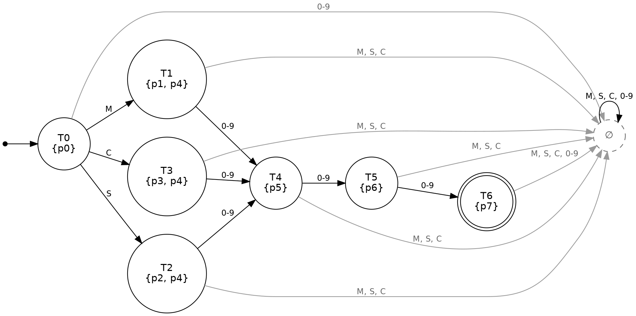
Figure 2. DFA obtained by subset construction (8 states). Grey edges lead to the dead state ∅.

15. DFA Minimization

15.1 Unreachable states
Starting from T0 and following every transition reaches T1, T2, T3, T4, T5, T6 and ∅. There are no unreachable states, so none are removed.

15.2 Final and non-final partitioning
P₀ = { T0, T1, T2, T3, T4, T5, ∅ } , { T6 }
The first block holds the non-final states; the second holds the only final state.

15.3 Equivalent-state analysis
The partition is refined repeatedly. Two states stay in the same block only if, for every symbol, their transitions lead into the same block.
Round 1. On a digit, T5 moves into the final block {T6}; every other non-final state moves into a non-final block. T5 is split off.
P₁ = { T0, T1, T2, T3, T4, ∅ } , { T5 } , { T6 }
Round 2. On a digit, T4 moves into {T5}; no other state in its block does. T4 is split off.
P₂ = { T0, T1, T2, T3, ∅ } , { T4 } , { T5 } , { T6 }
Round 3. On a digit, T1, T2 and T3 move into {T4}, while T0 and ∅ move to ∅. The block splits.
P₃ = { T0, ∅ } , { T1, T2, T3 } , { T4 } , { T5 } , { T6 }
Round 4. On M, T0 moves to T1 (block {T1, T2, T3}), while ∅ stays in ∅. The block splits.
P₄ = { T0 } , { ∅ } , { T1, T2, T3 } , { T4 } , { T5 } , { T6 }
Round 5. The only block with more than one state is {T1, T2, T3}:
State | M | S | C | D | Final?
T1 | ∅ | ∅ | ∅ | T4 | no
T2 | ∅ | ∅ | ∅ | T4 | no
T3 | ∅ | ∅ | ∅ | T4 | no

The three rows are identical, so the block cannot be split. P₅ = P₄ and the algorithm stops.
Distinguishing strings. Each block of the final partition accepts a different shortest string, which proves that no two blocks can be merged:
Block | Shortest string accepted from this block
{T6} | ε
{T5} | 0
{T4} | 00
{T1, T2, T3} | 000
{T0} | M000
{∅} | none (accepts nothing)

T1, T2 and T3 have no distinguishing string: after reading M, S or C, the rest of a valid code must be exactly three digits in every case. They are equivalent.

15.4 State merging
Block | New state | Meaning
{T0} | q0 | start, waiting for a category letter
{T1, T2, T3} | q1 | letter read, waiting for digit 1
{T4} | q2 | 1 digit read
{T5} | q3 | 2 digits read
{T6} | q4 | 3 digits read (accepting)
{∅} | qDead | trap state, can never accept

15.5 Minimized DFA formal definition
M_min = (Q′, Σ, δ′, q0, F′)
- Q′ = { q0, q1, q2, q3, q4, qDead }
- Σ = { M, S, C, 0, 1, …, 9 }
- q0 is the start state
- F′ = { q4 }
- δ′ is given in Section 16.1

15.6 Comparison: DFA versus minimized DFA
 | NFA | DFA (subset construction) | Minimized DFA
States | 8 | 8 | 6
ε-transitions | 3 | 0 | 0
Deterministic | no | yes | yes
Accepting states | {p7} | {T6} | {q4}

Did minimization improve the model? Yes. It removed 2 of the 8 DFA states (25%). The subset DFA kept a separate state for each category letter (T1, T2, T3) because the NFA had one branch per letter. Those states behave identically, since the category never changes which symbols may follow, so minimization merged them into q1. The result is the smallest possible DFA for L: each remaining state is distinguished by a different string, so no further merging is possible.
A smaller DFA means a smaller transition table to store and explain, fewer states to trace during a demonstration, and one clear state for each step of the pattern. Recognition time is unchanged, since any DFA reads exactly one symbol per step.

15.7 Equivalence of the representations
The automated test backend/tests/test_equivalence.py runs every string of length 0 to 5 over the symbols M, S, C, two digits and three symbols outside Σ (m, X and a space) through all four representations: the regular expression, the NFA, the subset DFA and the minimized DFA. They agree on every one of the more than 30,000 strings, and the test also confirms that exactly 3,000 strings are accepted. This demonstrates that R, M_N, the subset DFA and M_min all define the same language L.

16. Minimized DFA Diagram

16.1 Final minimized transition table
State | M | S | C | D (0–9) | Meaning
→ q0 | q1 | q1 | q1 | qDead | start
q1 | qDead | qDead | qDead | q2 | letter read
q2 | qDead | qDead | qDead | q3 | 1 digit read
q3 | qDead | qDead | qDead | q4 | 2 digits read
* q4 | qDead | qDead | qDead | qDead | valid code
qDead | qDead | qDead | qDead | qDead | trap

This is the exact table stored in backend/app/automata/definitions.py and used by the CLI simulator, the REST API and the inventory screens.

16.2 Minimized DFA diagram
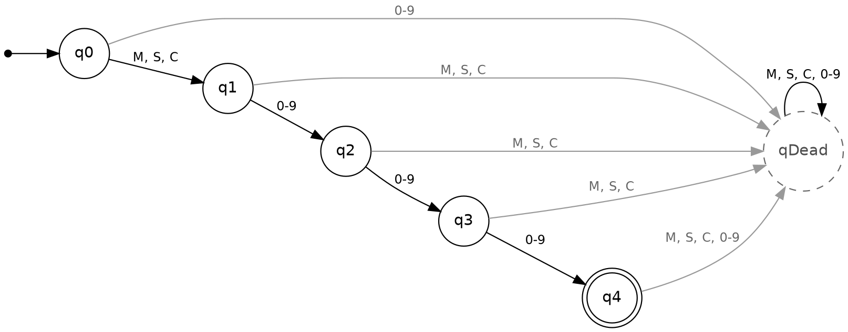
Figure 3. Minimized DFA (6 states). q4 is the only accepting state; qDead is the trap state.

17. System Design

17.1 Overview
PharmaHub has two connected parts. The automata core decides whether a code is ACCEPTED or REJECTED. The inventory system is a web application for medicines, categories, suppliers, orders and stock, and it uses the automata core as a gatekeeper.
The DFA is defined once, in definitions.py. The CLI simulator, the REST API and the inventory service all import this single definition, so they cannot disagree. The web front end keeps a small TypeScript mirror (frontend/src/lib/dfa.ts) so that the Code Recognizer screen can animate without waiting for the server; it uses the same states and transitions.

17.2 Architecture
User
│
├──▶ CLI simulator (cli/simulator.py)
│ interactive · batch · --demo · --theory
│
└──▶ React web app (Vite)
Code Recognizer · Automata Theory · Medicines · ...
│ HTTP /api
▼
FastAPI backend
/api/recognizer/validate, /info, /theory
ProductService (checks every SKU with the DFA)
│
▼
Automata core backend/app/automata/
definitions.py Σ, δ, q0, F (single source of truth)
dfa.py runs the DFA symbol by symbol
recognizer.py verdict + reason + decoded category
construction.py ε-NFA → subset construction → minimization
│
▼
SQLite (default) or PostgreSQL

17.3 Processing an input string
- The user enters a code, for example M001.
- The runner starts in state q0.
- For each symbol, it checks whether the symbol belongs to Σ. A symbol outside Σ sends the machine to qDead.
- Otherwise it applies δ(state, symbol) and records the step, e.g. q0 --M--> q1.
- After the last symbol, it reports the final state.
- If the final state is q4 the verdict is ACCEPTED; otherwise it is REJECTED, with a reason pointing to the first place the input broke the pattern.

17.4 Modules
Module | Responsibility
definitions.py | Alphabet, states, transition function, start and accepting states
dfa.py | Generic DFA runner: symbol-by-symbol processing, transition trace, final state
recognizer.py | Adds a human-readable reason and decodes the category and item number
construction.py | Builds the ε-NFA, performs subset construction and minimization, and checks the result against definitions.py
cli/simulator.py | Command-line simulator (required program)
api/routes/recognizer.py | REST endpoints for validation and automaton information
services/product_service.py | Refuses to save a medicine whose code is rejected
RecognizerPage.tsx, MedicinesPage.tsx | Web screens: animated recognizer and live validation in the Add Medicine form
TheoryPage.tsx + GET /api/recognizer/theory | Automata Theory screen: ε-NFA, step-by-step subset construction and minimization, computed live by construction.py

17.5 Technology
Layer | Technology
Automata core and simulator | Python 3.11, standard library only
API | FastAPI, Pydantic
Database | SQLAlchemy with SQLite (default) or PostgreSQL
Front end | React with TypeScript, built with Vite
Tests | pytest
Diagrams | Graphviz, generated from the automata code

18. Implementation / Source Code
The complete source code is in the repository. The listings below are the core of the automaton: the minimized DFA definition, the DFA runner, and the part of the simulator that processes one input and prints the result.

18.1 definitions.py (minimized DFA)
LETTERS = ("M", "S", "C")
DIGITS = tuple("0123456789")
ALPHABET = frozenset(LETTERS + DIGITS)

REGEX = "(M|S|C)DDD, D = (0|1|2|3|4|5|6|7|8|9)"
REGEX_PRACTICAL = "^(M|S|C)[0-9][0-9][0-9]$" # same language, Python re syntax
TABLE_COLUMNS = ("M", "S", "C", "0-9")

# Minimized DFA: q0 -letter-> q1 -digit-> q2 -digit-> q3 -digit-> q4 (accept)
START_STATE = "q0"
DEAD_STATE = "qDead"
ACCEPTING_STATES = frozenset({"q4"})
STATES = ("q0", "q1", "q2", "q3", "q4", DEAD_STATE)

STATE_MEANING = {
"q0": "start - waiting for a category letter (M, S or C)",
"q1": "letter read - waiting for digit 1 of 3",
"q2": "1 digit read - waiting for digit 2 of 3",
"q3": "2 digits read - waiting for digit 3 of 3",
"q4": "3 digits read - VALID CODE (accepting)",
DEAD_STATE: "trap - input can never be accepted from here",
}

def _digits_to(target):
return {d: target for d in DIGITS}

DELTA = {
"q0": {"M": "q1", "S": "q1", "C": "q1", **_digits_to(DEAD_STATE)},
"q1": {"M": DEAD_STATE, "S": DEAD_STATE, "C": DEAD_STATE, **_digits_to("q2")},
"q2": {"M": DEAD_STATE, "S": DEAD_STATE, "C": DEAD_STATE, **_digits_to("q3")},
"q3": {"M": DEAD_STATE, "S": DEAD_STATE, "C": DEAD_STATE, **_digits_to("q4")},
"q4": {"M": DEAD_STATE, "S": DEAD_STATE, "C": DEAD_STATE, **_digits_to(DEAD_STATE)},
DEAD_STATE: {"M": DEAD_STATE, "S": DEAD_STATE, "C": DEAD_STATE, **_digits_to(DEAD_STATE)},
}

def symbol_class(symbol):
return "0-9" if symbol in DIGITS else symbol

def step(state, symbol):
if symbol not in ALPHABET:
return DEAD_STATE
return DELTA.get(state, {}).get(symbol, DEAD_STATE)

def is_accepting(state):
return state in ACCEPTING_STATES

18.2 dfa.py (symbol-by-symbol runner)
def run(input_string: str) -> RunResult:
"""
Feed `input_string` to the minimized DFA one symbol at a time.

Returns a RunResult holding the verdict, the final state, and the
complete transition trace.
"""
state = d.START_STATE
steps: list[TransitionStep] = []
invalid: list[str] = []

for i, ch in enumerate(input_string):
in_alphabet = ch in d.ALPHABET
if not in_alphabet and ch not in invalid:
invalid.append(ch)
next_state = d.step(state, ch)
steps.append(
TransitionStep(
index=i,
symbol=ch,
from_state=state,
to_state=next_state,
in_alphabet=in_alphabet,
)
)
state = next_state

return RunResult(
input_string=input_string,
accepted=d.is_accepting(state),
final_state=state,
steps=steps,
invalid_symbols=invalid,
)

18.3 simulator.py (processing and output)
def simulate(code: str) -> bool:
"""Run one code through the DFA and print the full trace + verdict."""
result = run(code)
recog = recognize(code)

print(f"\nInput: {code!r} (length {len(code)})")

if not code:
print(" (no symbols to process)")
else:
print(" Step-by-step processing:")
for step in result.steps:
flag = "" if step.in_alphabet else " <-- not in alphabet"
print(
f" [{step.index}] read {step.symbol!r:>4} : "
f"{step.from_state} -> {step.to_state}{flag}"
)

print(f" Final state : {result.final_state}")
print(f" Reason : {recog.reason}")
print(f" VERDICT : {result.verdict}")
if result.accepted:
print(f" Decoded : category={recog.category}, item={recog.item_number}")
return result.accepted

18.4 How the program meets the required features
Required feature | Implementation
1. Accept user input | Interactive prompt code>; codes can also be passed as arguments
2. Validate symbols against the alphabet | in_alphabet = ch in d.ALPHABET; symbols outside Σ are flagged and lead to qDead
3. Process symbol by symbol | for i, ch in enumerate(input_string) in dfa.run
4. Display state transitions | Each step is printed, e.g. [0] read 'M' : q0 -> q1
5. Identify the final state | Final state : q4
6. Display ACCEPTED or REJECTED | VERDICT : ACCEPTED / REJECTED, with a reason
7. Allow multiple test cases | The prompt repeats until quit; --demo runs 20 cases in one go

18.5 How to run
python cli/simulator.py interactive mode
python cli/simulator.py M001 S12 batch mode
python cli/simulator.py --demo 10 accepted + 10 rejected cases
python cli/simulator.py --theory NFA -> DFA -> minimized DFA, step by step
cd backend && python -m pytest -v automated tests

19. Test Cases and Results
All results below come from running the simulator and the automated test suite. Each row shows the complete state path taken by the minimized DFA.

19.1 Accepted set
# | Input | State path | Final | Expected | Actual | Pass
1 | M001 | q0 → q1 → q2 → q3 → q4 | q4 | ACCEPTED | ACCEPTED | PASS
2 | M123 | q0 → q1 → q2 → q3 → q4 | q4 | ACCEPTED | ACCEPTED | PASS
3 | S001 | q0 → q1 → q2 → q3 → q4 | q4 | ACCEPTED | ACCEPTED | PASS
4 | S002 | q0 → q1 → q2 → q3 → q4 | q4 | ACCEPTED | ACCEPTED | PASS
5 | C001 | q0 → q1 → q2 → q3 → q4 | q4 | ACCEPTED | ACCEPTED | PASS
6 | C002 | q0 → q1 → q2 → q3 → q4 | q4 | ACCEPTED | ACCEPTED | PASS
7 | M999 | q0 → q1 → q2 → q3 → q4 | q4 | ACCEPTED | ACCEPTED | PASS
8 | S250 | q0 → q1 → q2 → q3 → q4 | q4 | ACCEPTED | ACCEPTED | PASS
9 | C500 | q0 → q1 → q2 → q3 → q4 | q4 | ACCEPTED | ACCEPTED | PASS
10 | M042 | q0 → q1 → q2 → q3 → q4 | q4 | ACCEPTED | ACCEPTED | PASS

19.2 Rejected set
# | Input | State path | Final | Reason given by the system | Pass
11 | M01 | q0 → q1 → q2 → q3 | q3 | too short (3 symbols) - expected exactly 4 | PASS
12 | C0012 | q0 → q1 → q2 → q3 → q4 → qDead | qDead | too long (5 symbols) - expected exactly 4 | PASS
13 | A123 | q0 → qDead → qDead → qDead → qDead | qDead | contains symbol(s) not in the alphabet: 'A' | PASS
14 | 123 | q0 → qDead → qDead → qDead | qDead | first symbol must be a category letter (M, S or C) | PASS
15 | MM123 | q0 → q1 → qDead → qDead → qDead → qDead | qDead | symbol 2 must be a digit, found 'M' | PASS
16 | C12A | q0 → q1 → q2 → q3 → qDead | qDead | contains symbol(s) not in the alphabet: 'A' | PASS
17 | ε (empty) | q0 | q0 | empty input - a code must be a letter followed by 3 digits | PASS
18 | m123 | q0 → qDead → qDead → qDead → qDead | qDead | contains symbol(s) not in the alphabet: 'm' | PASS
19 | S12 | q0 → q1 → q2 → q3 | q3 | too short (3 symbols) - expected exactly 4 | PASS
20 | S1234 | q0 → q1 → q2 → q3 → q4 → qDead | qDead | too long (5 symbols) - expected exactly 4 | PASS

19.3 Edge cases
# | Input | What it tests | State path | Final | Pass
21 | M 12 | space is not in Σ | q0 → q1 → qDead → qDead → qDead | qDead | PASS
22 | 0M12 | digit before letter | q0 → qDead → qDead → qDead → qDead | qDead | PASS
23 | MS12 | two letters | q0 → q1 → qDead → qDead → qDead | qDead | PASS
24 | C1S2 | letter in a digit position | q0 → q1 → q2 → qDead → qDead | qDead | PASS
25 | M00 | 3 symbols, one digit short | q0 → q1 → q2 → q3 | q3 | PASS

19.4 Automated tests
Test | What it checks | Result
test_all_accepted_strings_are_accepted | all 10 accepted strings end in q4 | PASS
test_all_rejected_strings_are_rejected | all 10 rejected strings are rejected | PASS
test_symbols_outside_alphabet_are_flagged | m123 is rejected and m is reported | PASS
test_wrong_length_is_rejected | too short and too long inputs | PASS
test_trace_length_matches_input_length | one transition recorded per symbol | PASS
test_recognizer_decodes_valid_codes | category and item number are decoded | PASS
test_recognizer_gives_a_reason_when_rejecting | every rejection has a reason | PASS
test_minimized_dfa_is_rebuilt_from_nfa | subset construction + minimization reproduce definitions.py | PASS
test_state_counts | NFA 8, DFA 8, minimized DFA 6, no unreachable states | PASS
test_re_nfa_dfa_mindfa_agree_on_every_string | RE, NFA, DFA and minimized DFA agree on 30,000+ strings | PASS
test_theory_report_for_web_page | Automata Theory page data: 8 → 8 → 6 states, T1, T2, T3 merged | PASS
test_language_size_is_3000 | exactly 3,000 codes are accepted | PASS

Summary: 25 of 25 simulator cases and 12 of 12 automated tests pass.

20. Screenshots of the Working System

20.1 Command-line simulator
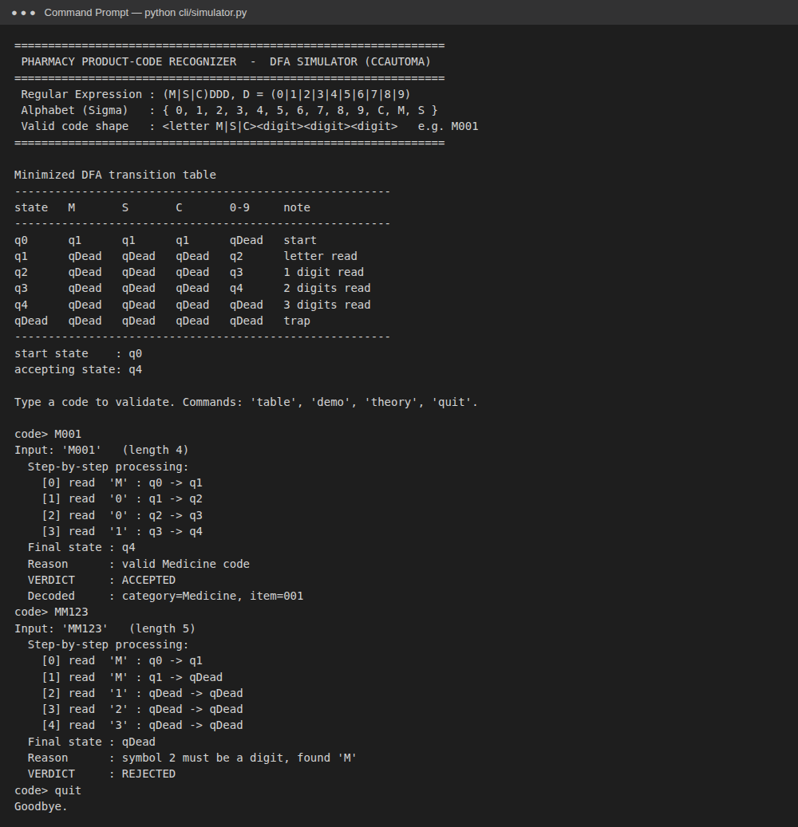
Figure 4. CLI simulator: transition table, then an ACCEPTED input (M001) and a REJECTED input (MM123) with the full trace.
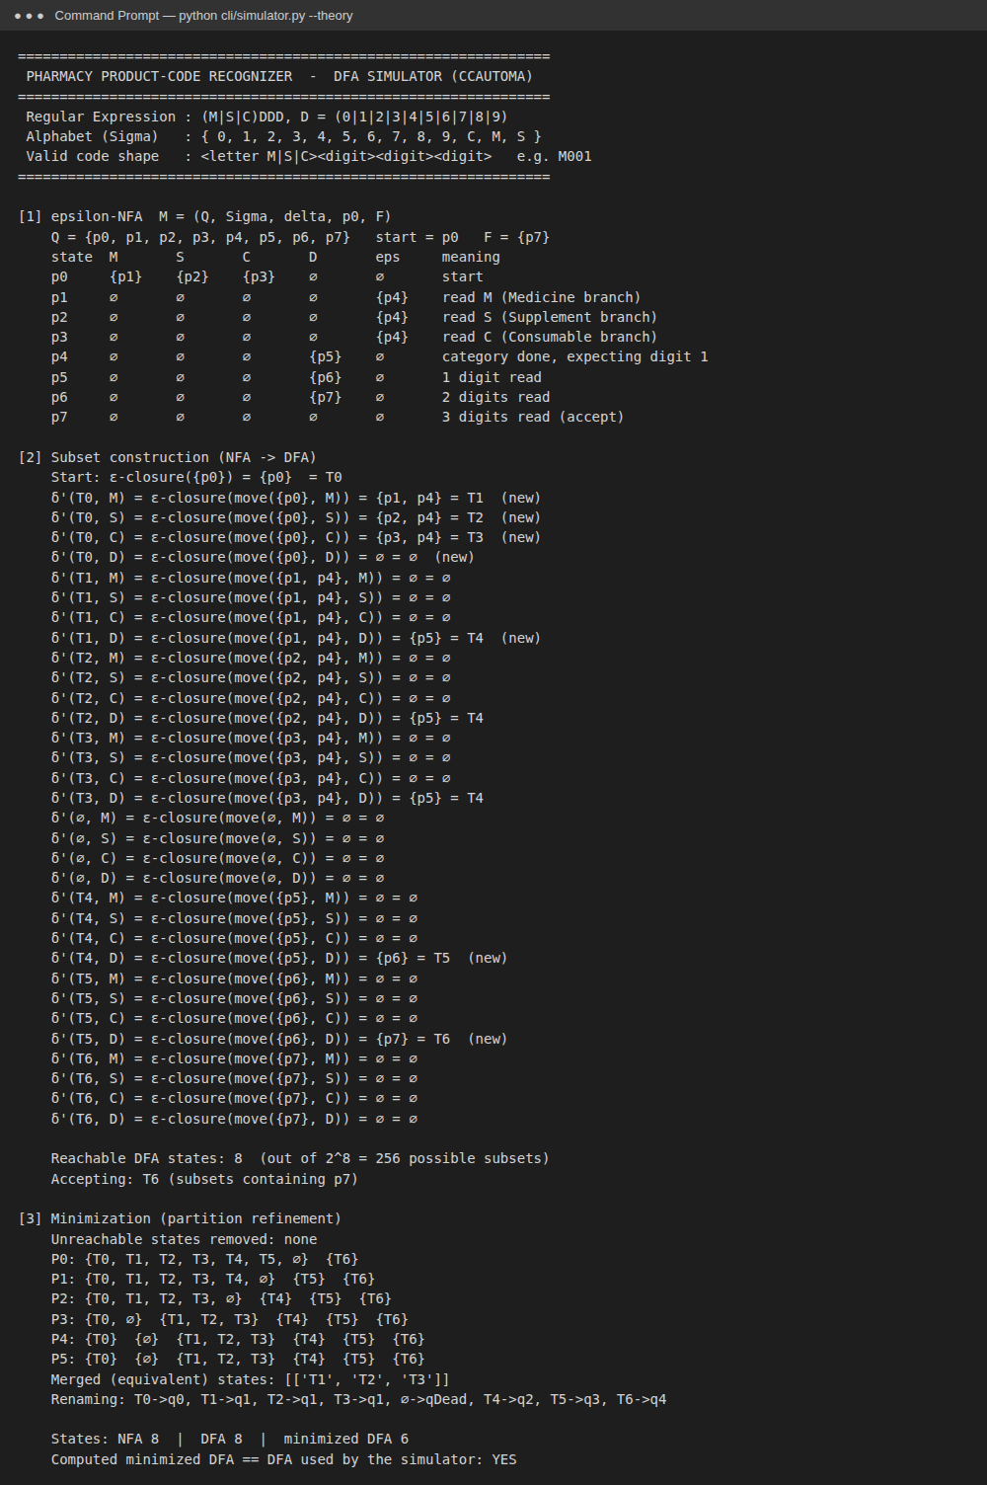
Figure 5. CLI simulator in --theory mode: ε-NFA, subset construction, minimization, and confirmation that the result matches the simulator's DFA.

20.2 Web application
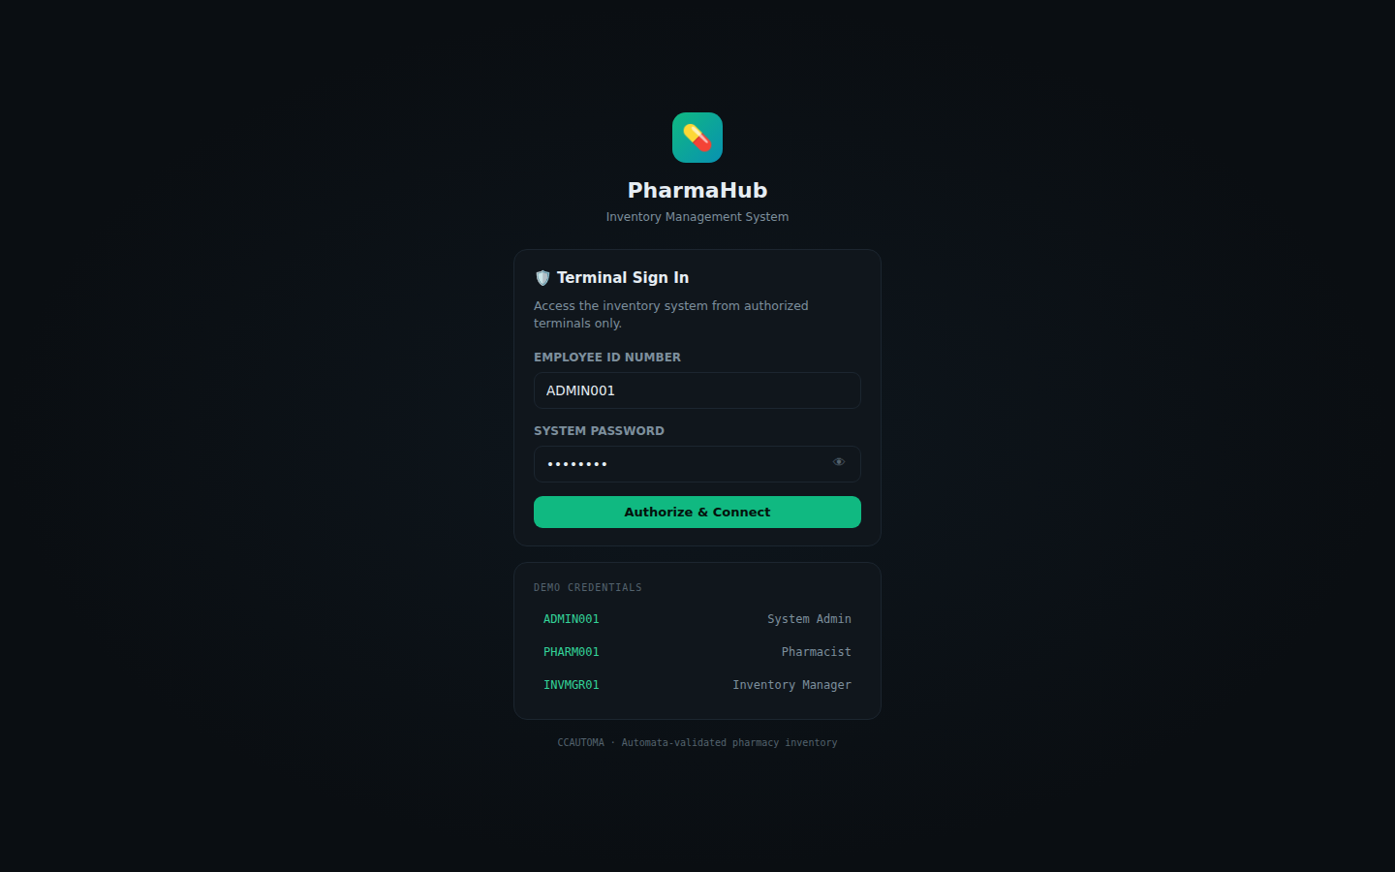
Figure 6. Login screen with role-based demo accounts.
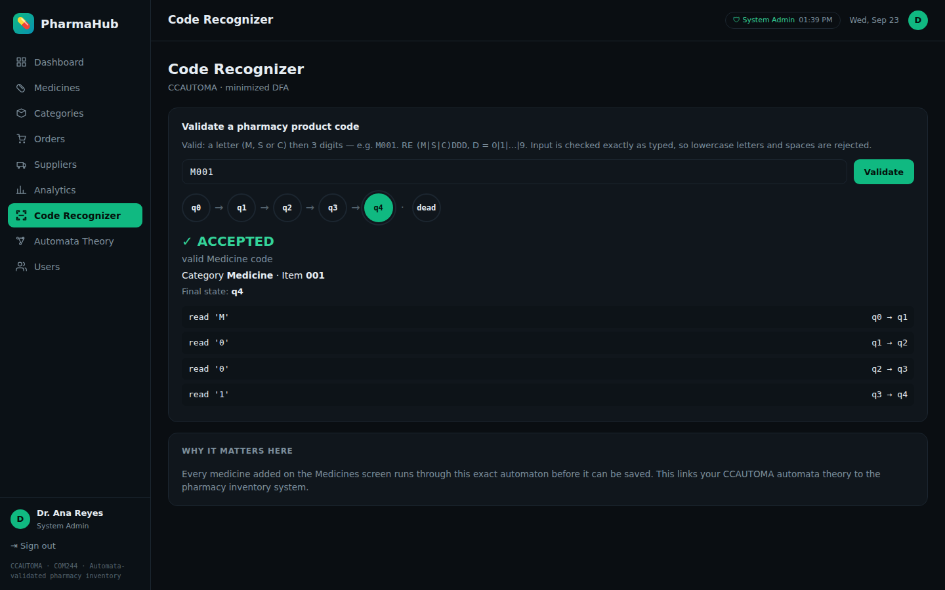
Figure 7. Code Recognizer: M001 is ACCEPTED. The state chain animates q0 → q4 and every transition is listed.
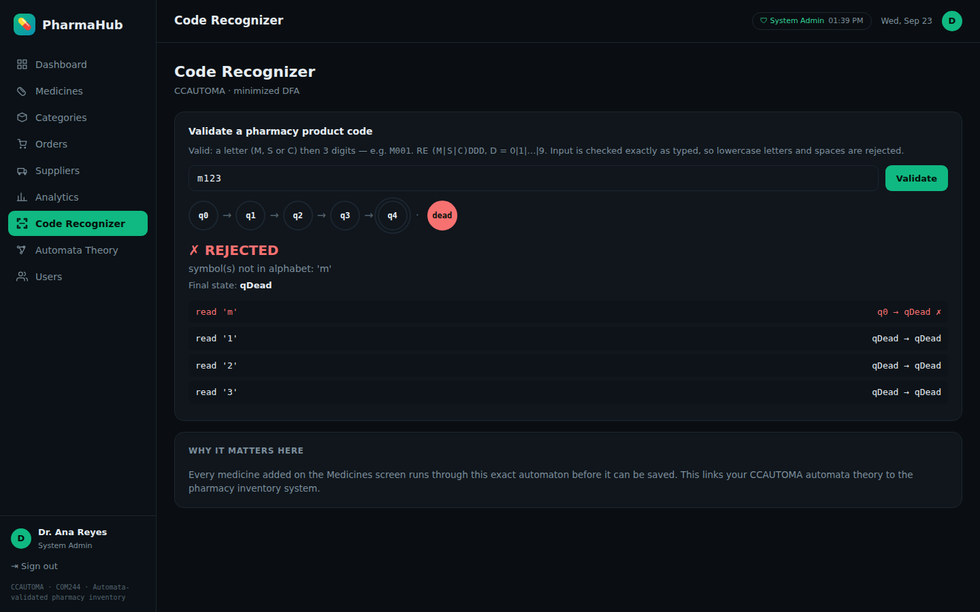
Figure 8. Code Recognizer: m123 is REJECTED because lowercase m is not in Σ; the machine goes to the dead state.
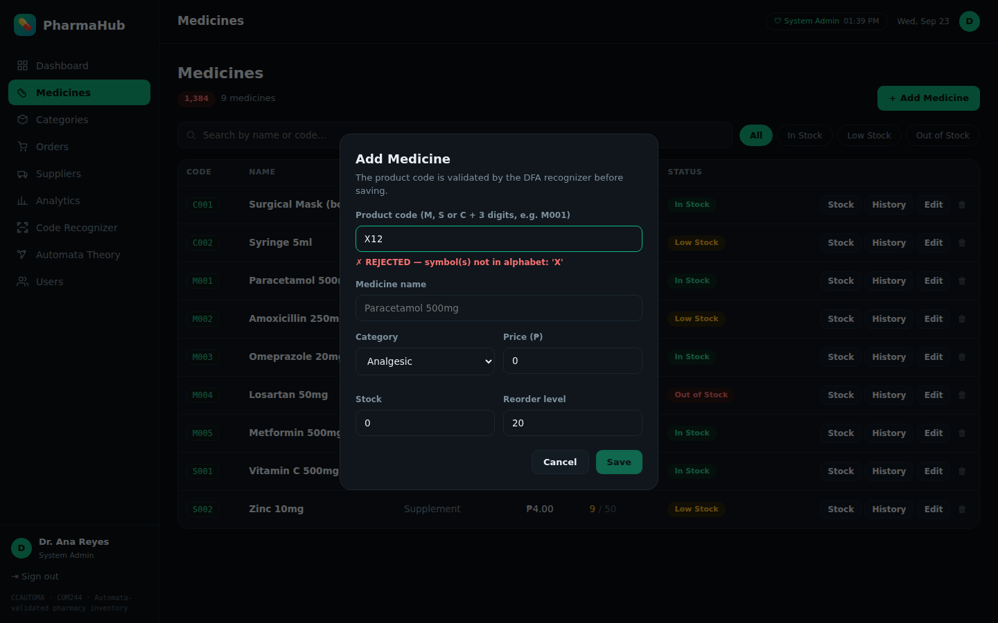
Figure 9. Add Medicine: the code X12 is rejected by the DFA, so the medicine cannot be saved.
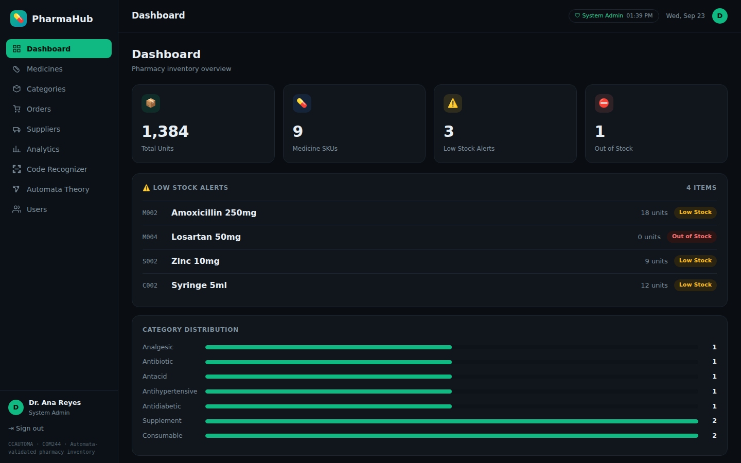
Figure 10. Dashboard: stock totals, low-stock alerts and category distribution.
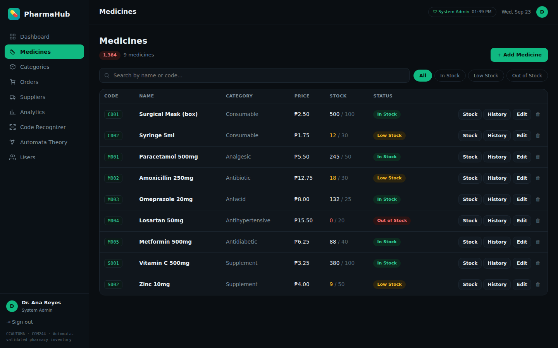
Figure 11. Medicines list. Every code shown was accepted by the DFA.
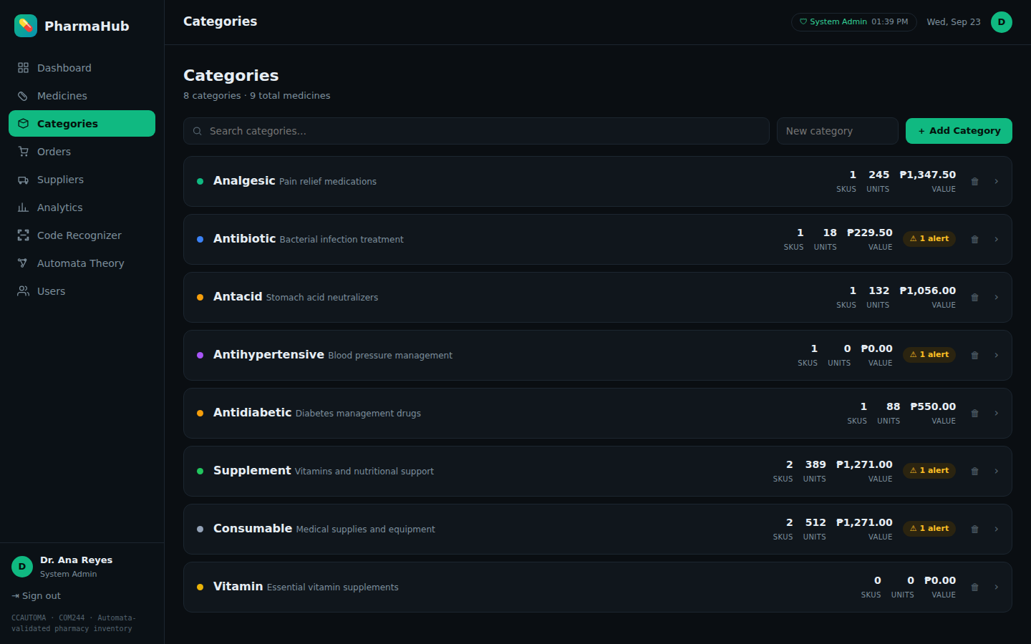
Figure 12. Categories with SKU counts and inventory value.
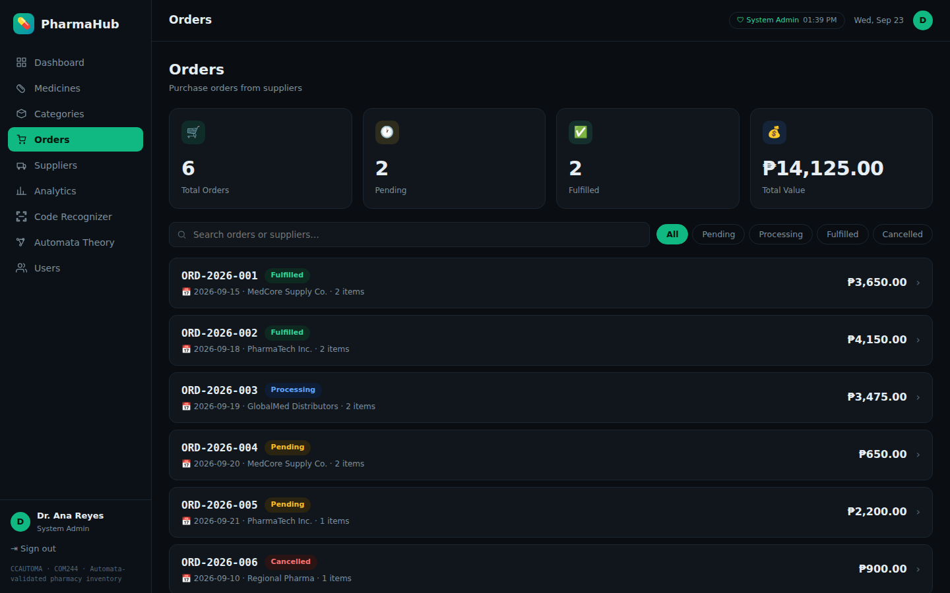
Figure 13. Purchase orders from suppliers.
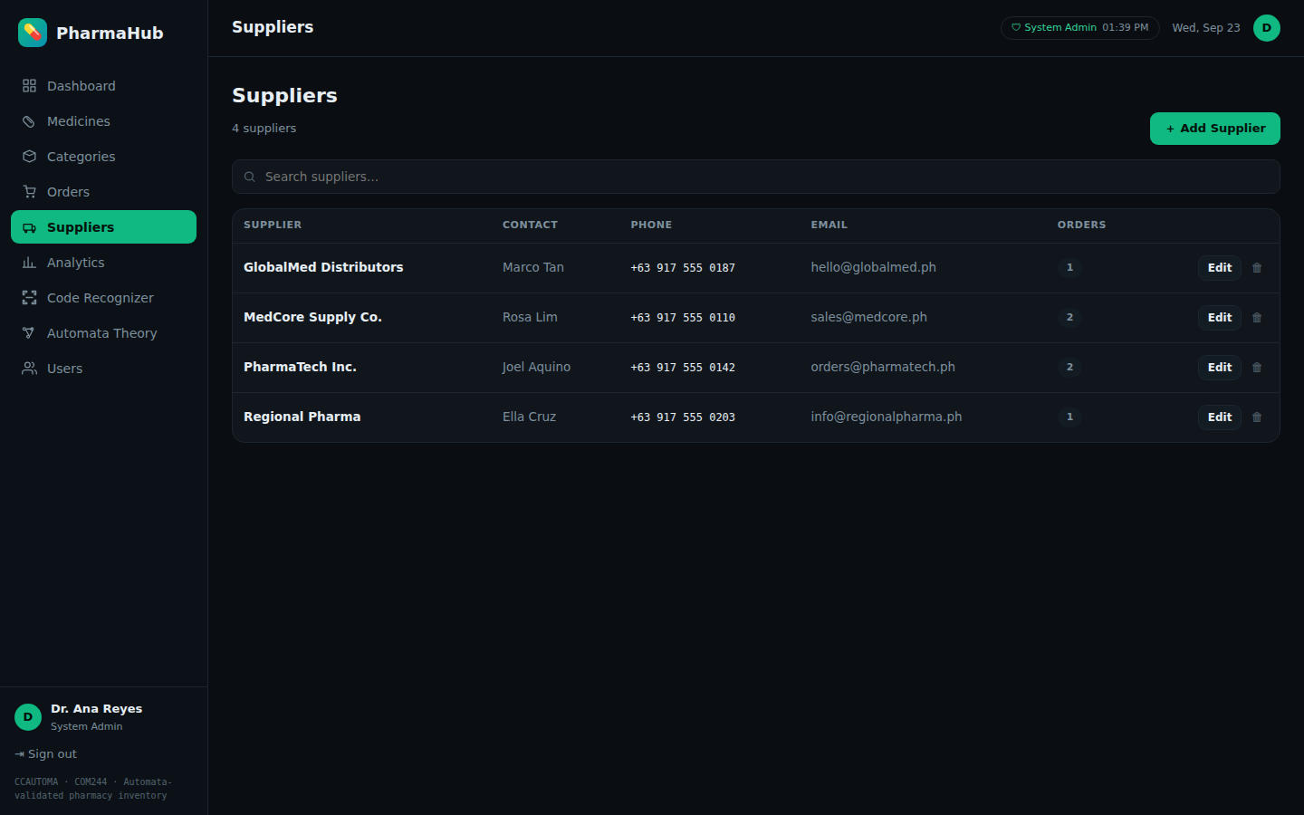
Figure 14. Supplier directory.
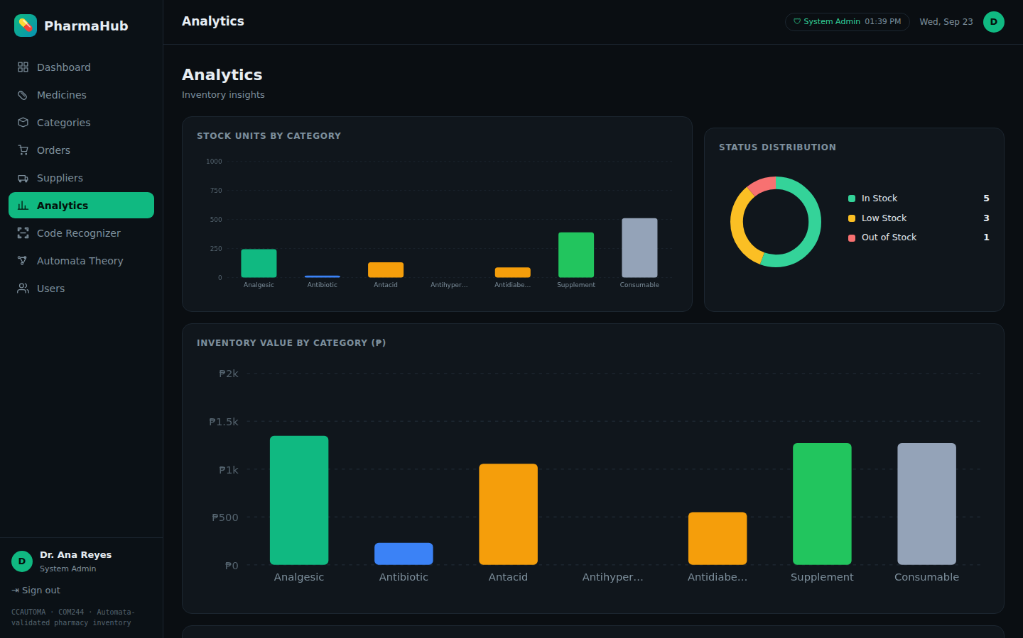
Figure 15. Analytics: stock and value by category, and items needing restock.
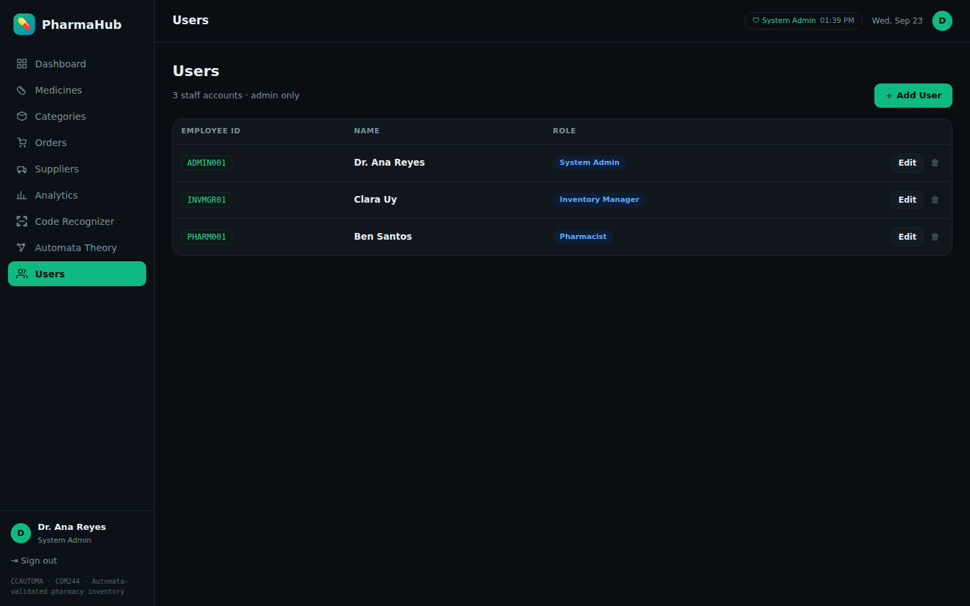
Figure 16. User management (administrator only).
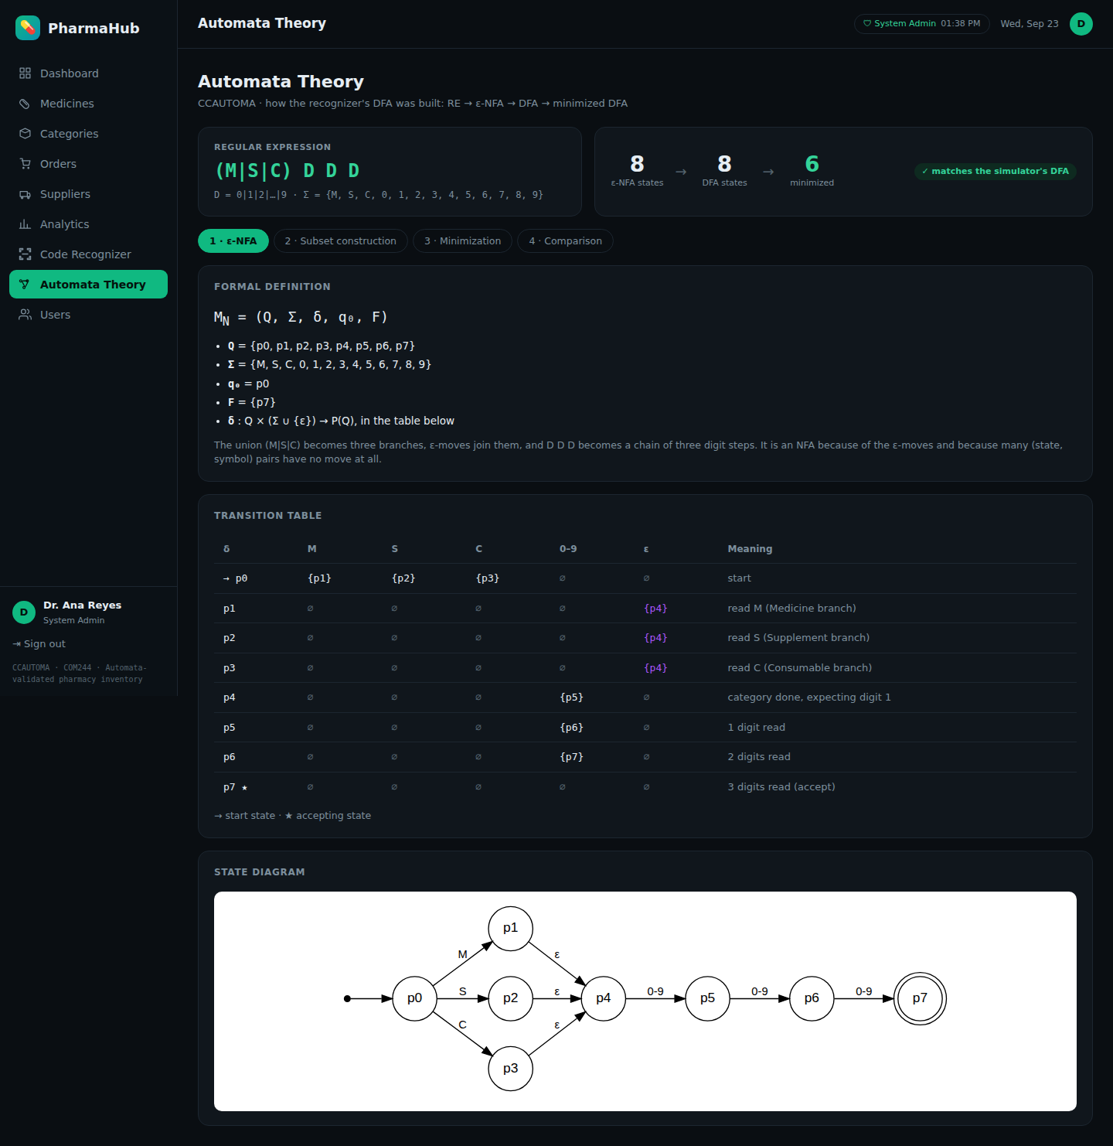
Figure 17. Automata Theory page: formal definition, transition table and diagram of the ε-NFA.
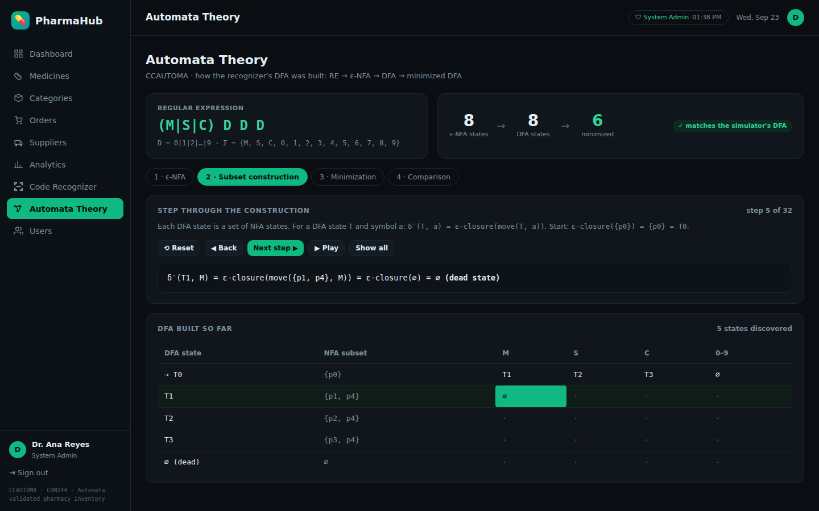
Figure 18. Automata Theory page: subset construction stepped one move at a time; the DFA table fills in as each step is computed.
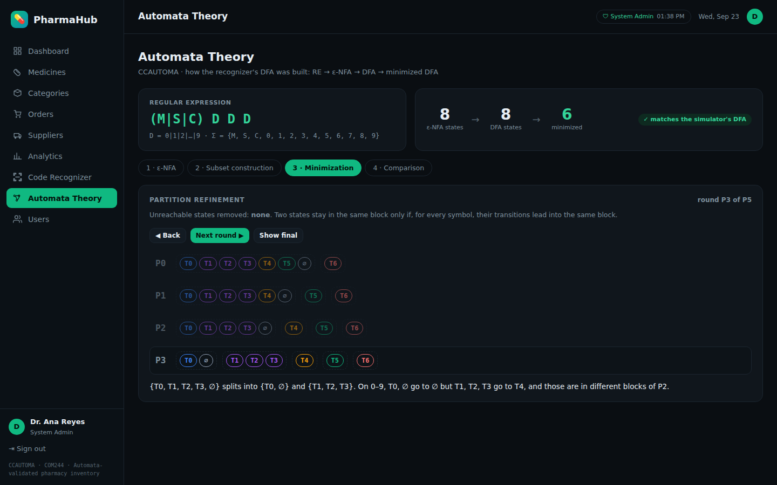
Figure 19. Automata Theory page: partition refinement round by round, with the symbol that separates each block explained.

21. Discussion of Results
Correctness. All 25 simulator cases and all 12 automated tests passed. Every valid code followed the path q0 → q1 → q2 → q3 → q4 and was accepted. Invalid codes ended in one of three non-accepting states, and each ending has a clear meaning: q0 for empty input, q3 for a code one digit short, and qDead for every other error. Because the dead state has no way out, the machine can stop caring about the rest of the input once a mistake is found, while still reading it symbol by symbol as required.
Equivalence. The RE, NFA, subset DFA and minimized DFA gave the same answer on every tested string. This is strong practical evidence of the theoretical result that these four representations describe the same regular language.
Effect of each step. Subset construction removed nondeterminism and ε-moves but did not reduce the number of states (8 → 8), because the three category branches of the NFA became three separate DFA states. Minimization then recognized that these three states are equivalent and merged them, giving 6 states. The subset construction also showed how much of the theoretical worst case is avoided: only 8 of 256 possible subsets were reachable.
Teaching value. The Automata Theory page in the web app replays the subset construction and minimization step by step from the same code that powers the recognizer. This made it easy to check the hand-drawn tables against the program, and it lets anyone watch how T1, T2 and T3 end up merged.
Practical value. Connecting the DFA to the inventory showed that the model is useful beyond the classroom. The same six-state machine that is traced by hand in Section 16 is the rule that blocks invalid codes such as X12 in the Add Medicine form.
Design decisions. Keeping the DFA in a single definition file prevented the simulator, API and inventory from drifting apart. During testing, the group found that the web recognizer converted input to uppercase before validation, which made it accept m123 while the CLI rejected it. The recognizer now validates input exactly as typed, and uppercase conversion is kept only as an explicit convenience on the Medicines form (Section 6.2).
Limitations. The language is small and fixed. Longer item numbers, more categories or optional parts (such as a batch suffix) would require extending Σ and the RE, then repeating the construction. The modular design, where the construction is computed from the NFA, makes such changes straightforward to verify.

22. Conclusion
The group identified a practical validation problem, pharmacy product codes, and showed that it can be described as a regular language L over a 13-symbol alphabet. L was expressed as the regular expression (M|S|C)DDD, recognized by an 8-state ε-NFA, converted by subset construction into an 8-state DFA, and minimized to a 6-state DFA in which the three category branches merge into a single state.
The minimized DFA was implemented as a working simulator that meets all seven required program features, and it was integrated into a full pharmacy inventory system where it prevents malformed codes from being saved. Automated tests confirmed that the regular expression, NFA, DFA and minimized DFA are equivalent.
The project shows that the formal models studied in Automata Theory are not only mathematical objects but direct blueprints for dependable software: the same states and transitions drawn on paper are the ones running in the program.

23. References
Aho, A. V., Lam, M. S., Sethi, R., & Ullman, J. D. (2007). Compilers: Principles, techniques, and tools (2nd ed.). Pearson/Addison-Wesley.
Hopcroft, J. E., Motwani, R., & Ullman, J. D. (2007). Introduction to automata theory, languages, and computation (3rd ed.). Pearson/Addison-Wesley.
Moore, E. F. (1956). Gedanken-experiments on sequential machines. In C. E. Shannon & J. McCarthy (Eds.), Automata studies (pp. 129–153). Princeton University Press.
Rabin, M. O., & Scott, D. (1959). Finite automata and their decision problems. IBM Journal of Research and Development, 3(2), 114–125.
Sipser, M. (2013). Introduction to the theory of computation (3rd ed.). Cengage Learning.
Python Software Foundation. (n.d.). re — Regular expression operations. Python documentation. https://docs.python.org/3/library/re.html
FastAPI. (n.d.). FastAPI documentation. https://fastapi.tiangolo.com/
React. (n.d.). React documentation. https://react.dev/
Add any lecture notes or course materials your instructor expects you to cite.

24. Individual Contribution Matrix
Replace each highlighted name, and edit the contributions so they match what each member actually did. All members reviewed the complete project and are prepared to answer questions on any part of it.
Member | Role | Main contributions | Report sections
Member 1 | Project Leader | Coordinated schedule and tasks; integrated all outputs; reviewed the final report and system | 3, 5, 22
Member 2 | Language Analyst | Defined Σ, strings and L; wrote the acceptance rules and the 10 accepted / 10 rejected examples | 7, 8, 9
Member 3 | RE/NFA Designer | Developed the regular expression and its explanation; constructed the ε-NFA, its table and diagram | 10, 11, 12
Member 4 | DFA Designer | Performed subset construction; built the DFA transition table and diagram | 13, 14
Member 5 | Automata Optimizer | Performed minimization and the equivalent-state analysis; validated equivalence of all representations | 15, 16
Member 6 | Programmer | Implemented the simulator, the automata core and the web recognizer; integrated the DFA with the inventory | 17, 18
Member 7 | Tester/QA | Designed and ran the test cases and automated tests; documented results | 19, 21
Member 8 | Documentation/Presentation Lead | Organized the report, diagrams, screenshots and presentation | 1, 2, 4, 6, 20, 23, 24

24.1 Participation by project component
Member | Language | RE / NFA | Subset | Minimize | Simulator | Testing | Report | Defense
Member 1 | Lead | Support | Support | Support | Support | Support | Review | ✓
Member 2 | Lead | Review | Review | Review | Support | Support | Support | ✓
Member 3 | Support | Lead | Support | Review | Review | Review | Support | ✓
Member 4 | Review | Support | Lead | Support | Review | Review | Support | ✓
Member 5 | Review | Review | Support | Lead | Review | Support | Support | ✓
Member 6 | Support | Review | Review | Review | Lead | Support | Support | ✓
Member 7 | Support | Review | Review | Support | Support | Lead | Support | ✓
Member 8 | Support | Review | Review | Review | Review | Support | Lead | ✓

Language = problem & language · Subset = subset construction · Report = report & slides. Lead = primary responsibility · Support = contributed directly · Review = checked and can explain · ✓ = presents during the defense

