**Gaussian Distribution:**

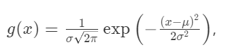

the exact form of which is unimportant, except that it is dependent on two parameters, the *mean*, \mu*μ*, where the curve is centred, and the *standard deviation*, \sigma*σ*, which is the characteristic width of the bell curve (measured from the mean).

We can put these two parameters in a vector, 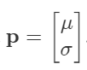

Model Performance can be measured using Sum of Squared Residuals (SSR)

