
Faculty of Computer Technology and Cybersecurity
Department: Software Engineering
Course: Architecture and Design of Software
PROJECT REPORT
Project Title: Developing an AI-powered Mobile Application for Sleep and Stress Analysis

Done by:
Sartay Sayat IT2-2202
Bertaiyz Nuraskan IT2-2202
Alizhan Syrym IT2-2202

Instructor:
Barlykbai Nazym Telmukhambetkyzy

International University of Information Technology
Almaty, 2025
Table of Contents
- Title
- Introduction
- Domain Analysis
- System Requirements
- Architectural Design
- System Modeling
- Interface Design
- Design Patterns
- Architecture Analysis
- Testing
- Conclusion
- References
- Appendices

2. Introduction

The project aims to develop an intelligent mobile application for monitoring and analyzing a user's sleep quality and stress levels. In today's fast-paced world, issues related to chronic stress and sleep disorders are increasingly prevalent, yet most people lack accessible tools for an objective assessment of their condition.
The application will utilize data passively collected from smartphone sensors (accelerometer, microphone) to analyze physiological indicators. Its key feature is the application of an artificial intelligence (AI) model, which will identify non-obvious patterns between the user's lifestyle, habits, and physical state. Based on this analysis, the system will generate personalized recommendations aimed at improving well-being.
The platform's implementation is expected to increase users' awareness of their own health, provide them with practical tools to reduce stress and improve sleep quality, and ultimately promote the formation of healthier habits.

3. Domain Analysis

3.1. Problem Description In the modern fast-paced environment, issues related to chronic stress and sleep disorders are becoming increasingly prevalent. However, most individuals lack accessible and objective tools to assess their condition. The core problem this system solves is the difficulty of interpreting raw physiological data (such as movement during sleep or audio events) without professional medical assistance. The system bridges this gap by transforming raw sensor data into actionable, personalized insights.
3.2. Users and Usage Scenarios The primary actor in the system is the User, typically a student or working professional seeking to improve their well-being. Key usage scenarios include:
- Sleep Tracking: The user initiates a sleep session; the app records sensor data overnight and presents a quality report in the morning.
- Stress Measurement: The user utilizes the camera to measure Heart Rate Variability (HRV) or logs their subjective stress level.
- Journaling: The user logs daily events and mood tags to help the AI find correlations between lifestyle and health.
- Receiving Recommendations: The user views personalized advice generated by the AI model based on the analyzed patterns.
3.3. Constraints and Assumptions
- Non-Medical Device: The application is designed for self-monitoring and informational purposes only. It is not a medical diagnostic tool.
- Data Privacy: User data, especially audio recordings and health metrics, must be processed in compliance with privacy standards (GDPR/Local Laws).
- Hardware Dependence: The accuracy of sleep analysis relies on the quality of the accelerometer and microphone sensors in the user's smartphone.
4. System Requirements
4.1. Functional Requirements (FR) The functional requirements define the specific behaviors and functions the system must support to meet user needs.
- User Authentication: The system must allow users to register, log in, and manage their account security settings.
- Sleep Tracking: The application shall allow users to manually start and stop sleep analysis sessions. During these sessions, the system must collect data from the device's sensors (accelerometer, microphone).
- Stress Monitoring: The system must provide functionality for users to measure their current stress levels (e.g., via camera-based HRV analysis) and perform guided breathing exercises.
- Journaling: Users must be able to create daily journal entries, logging their mood, energy levels, and specific activities using tags.
- Data Visualization: The application shall display detailed sleep reports (stages, quality score) and provide historical statistics over weeks and months.
- AI Recommendations: The system must generate and display personalized text-based recommendations derived from the AI analysis of the user's sleep and stress patterns.
4.2. Non-Functional Requirements (NFR) These requirements define the quality attributes of the system, such as security, performance, and reliability.
- Security: The system must ensure data confidentiality. Authentication shall be handled via Spring Security using JWT (JSON Web Tokens). All sensitive user data must be transmitted over encrypted channels.
- Performance: The backend API should process requests with low latency. The sensor data collector on the mobile app must buffer data efficiently to minimize battery drain and ensure no data is lost during tracking.
- Scalability: The system architecture must be modular. Specifically, the AI analysis model should be deployed as a separate microservice to handle computational loads independently of the main application logic.
- Compatibility: The mobile application must be cross-platform (developed using React Native or Flutter) to ensure consistent functionality on both Android and iOS devices.
- Reliability: The system must validate incoming sensor data. If the data quality is insufficient for analysis, the system should gracefully terminate the process and notify the user rather than producing incorrect results.

5. Architectural Design
5.1. Architectural Style Selection The system is designed using a Client-Server architecture utilizing a Microservices-oriented approach for specific high-load components.
- Justification: This style was chosen to ensure a clear separation of concerns. The mobile client focuses on data collection and UI rendering, while the heavy lifting of data processing and storage is handled by the server.
- Hybrid Approach: While the core backend is monolithic (Java Spring Boot) for ease of development and consistency, the AI Analysis module is decoupled as an independent microservice. This allows the AI component (Python) to be scaled, updated, or replaced independently without affecting the core application logic.
5.2. System Structure The system consists of three main logical modules interacting via RESTful APIs:
- Mobile Client (Frontend):
  - Responsible for user interaction and collecting raw data from smartphone sensors (accelerometer, microphone).
  - Buffers data and transmits it to the backend via secure HTTP requests.
- Backend Application (Core):
  - Acts as the central orchestrator. It handles authentication (Spring Security), validates incoming data, and manages business logic.
  - Interacts with the database using the Repository pattern.
- AI Analysis Service:
  - A specialized module that receives pre-processed data from the backend.
  - Returns structured insights (JSON) regarding sleep quality and stress levels.
5.3. Technology Stack Selection The following technologies were selected to implement the architecture:
- Backend: Java with Spring Boot Framework.
  - Reason: Java offers strong typing and high performance. Spring Boot provides a robust ecosystem for building REST APIs, managing security via JWT, and interacting with databases via Spring Data JPA (Hibernate) .
- Frontend: Cross-platform Mobile Framework (React Native or Flutter).
  - Reason: Allows for the development of a single codebase that runs on both iOS and Android, significantly reducing development time and maintenance costs.
- Database: PostgreSQL.
  - Reason: A reliable object-relational database system (ORDBMS) suitable for storing structured user profiles and relational links between sleep sessions and journal entries.
- Artificial Intelligence: Python with TensorFlow / PyTorch.
  - Reason: Python is the industry standard for machine learning. It supports powerful libraries for signal processing and neural network development, which are essential for analyzing sensor data patterns.

6. System Modeling

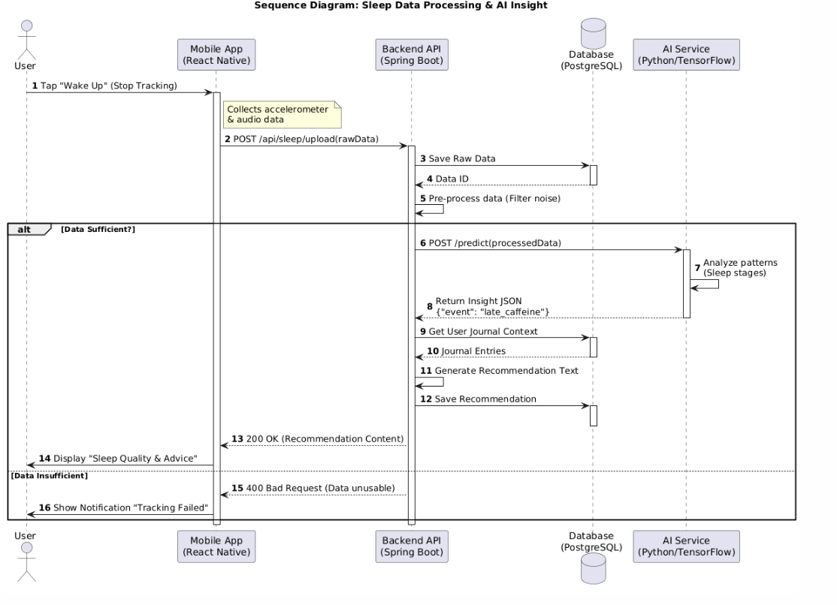
Sequence Diagram

This diagram details the sequence of interactions for the "Analyze Sleep" scenario.
- The User triggers the "Stop Tracking" action in the Mobile App.
- The App sends a POST request with sensor data to the Backend API.
- The Backend validates the data and makes an internal API call to the AI Service (Python).
- The AI Service processes the raw signals and returns a JSON object containing the sleep stages and stress index.
- Finally, the Backend saves the results to the Database and returns a summary to the User.

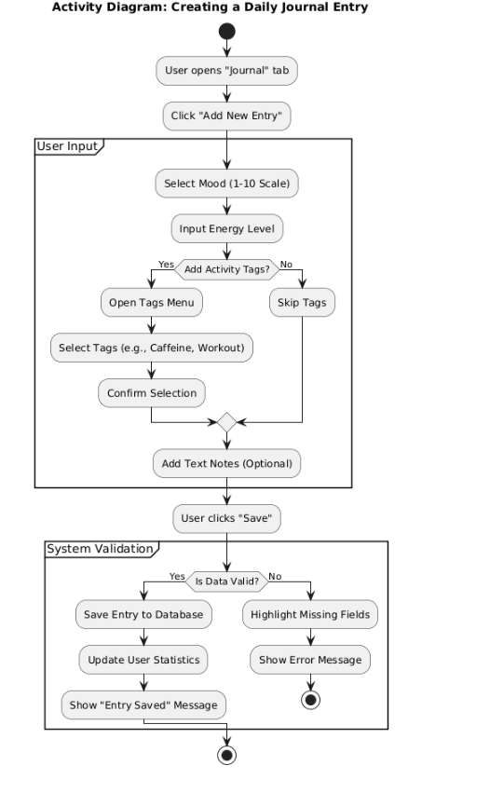
Activity Diagram

This diagram illustrates the workflow of the Sleep Tracking Process. The activity begins when the user initiates a sleep session. The system enters a loop of continuous data collection from sensors (accelerometer, microphone). Once the user wakes up and stops the session, the system validates the collected data.
- Decision Node: If the data duration is too short (< 30 minutes) or corrupted, the session is discarded.
- Alternative Path: If the data is valid, it is compressed and sent to the server for analysis. The process concludes with the database updating the user's dashboard with the new sleep score.

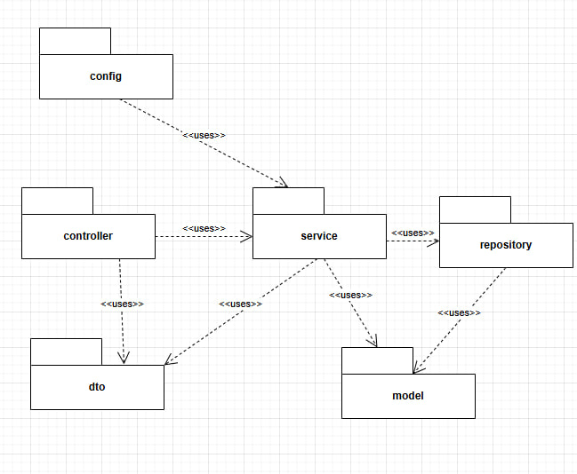
Package Diagram

The Package Diagram depicts the modular organization of the backend codebase, following the Layered Architecture pattern.
- com.app.controller: Contains REST controllers (e.g., AuthController, SleepController) that handle incoming HTTP requests.
- com.app.service: Encapsulates business logic and communicates with the AI microservice.
- com.app.repository: Manages data persistence using Spring Data JPA interfaces.
- com.app.model: Defines the data entities (User, SleepLog) and DTOs.
- ai_service: A separate Python package responsible for ML model inference.

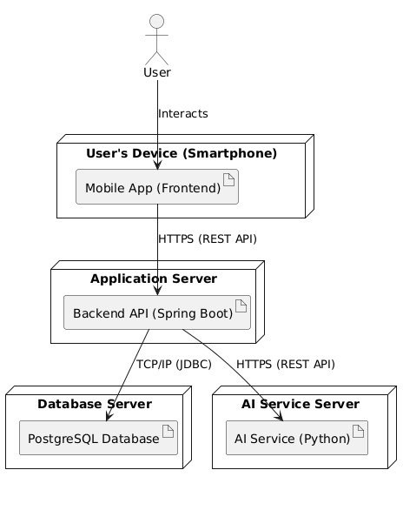
Deployment Diagram
The Deployment Diagram shows the physical mapping of software artifacts to hardware nodes.
- Client Node: The user's smartphone (Android/iOS) running the React Native application. It communicates with the server via HTTPS.
- Application Server: A cloud instance hosting the Spring Boot container (Tomcat) and the Python AI worker.
- Database Server: A dedicated node running PostgreSQL for persistent data storage.
- Communication Protocols: The interaction between the Client and Server uses REST (JSON over HTTP), while the Server connects to the Database via JDBC.

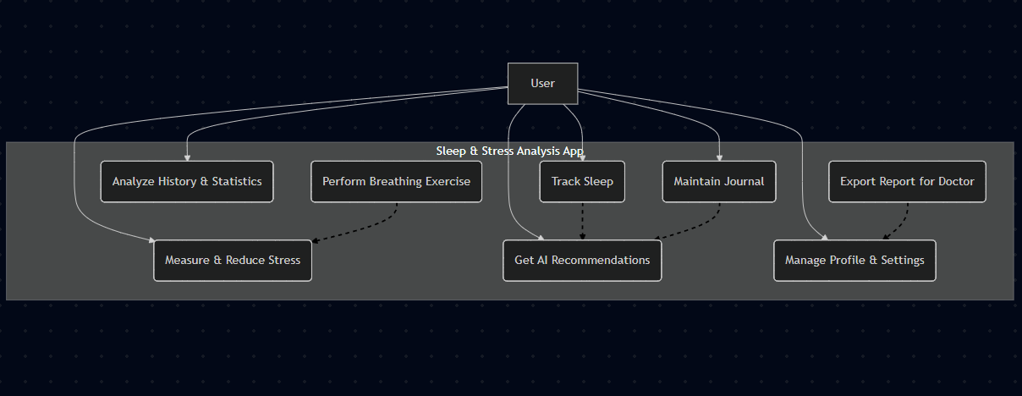
Use Case Diagram
Description: The Use Case diagram illustrates the primary interactions between the user and the system. The main actor is the User. Key use cases include managing sleep sessions (starting/stopping tracking), maintaining a daily well-being journal, and viewing analytical insights generated by the AI service.
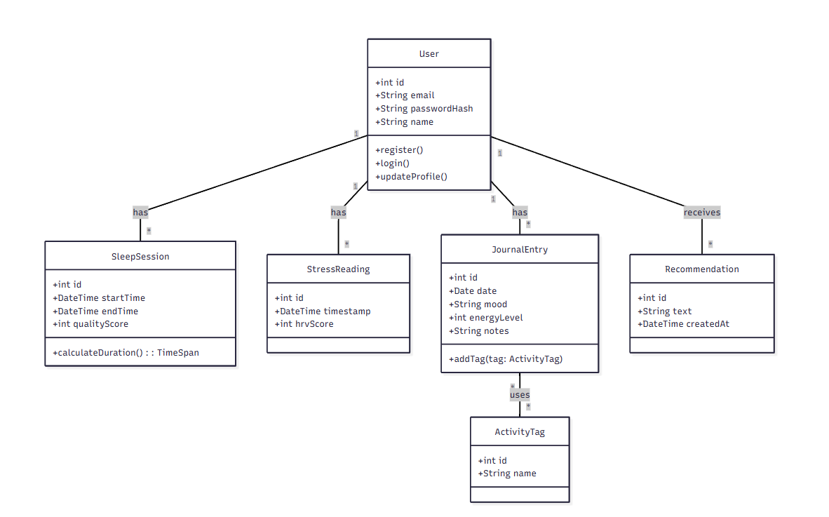
Class Diagram
Description: The Class Diagram represents the static structure of the backend entities and database schema.
- User: The central entity containing credentials and settings.
- SleepSession: Stores sleep data (start/end time, quality score, raw sensor data reference). It has a Many-to-One relationship with the User.
- JournalEntry: Represents daily logs (mood, energy, tags). Linked to the User.
- Recommendation: AI-generated advice linked to specific analysis results.

7. Interface Design
7.1. Sitemap The mobile application structure is designed for intuitive navigation and quick access to core functions:
- Authentication Screen: Login / Registration / Password Recovery.
- Dashboard (Home): Current status, "Start Sleep" button, summary of the last night.
- Sleep Tab: Detailed graphs of sleep stages, audio analysis, session history.
- Journal Tab: Entry creation form (mood sliders, activity tag selection).
- Profile Tab: Account settings, notification preferences, data export.
7.2. User Scenarios
- Scenario 1: Sleep Tracking. The user opens the app before bed and taps "Start Sleep". The screen enters a low-power "Dark Mode". In the morning, the user taps "Wake Up". The app uploads the buffered data to the server. Moments later, a push notification appears: "Your sleep report is ready," displaying the sleep quality score.
- Scenario 2: Stress Analysis & Journaling. Feeling tired during the day, the user opens the "Journal" tab. They select "Low Energy" on the slider and add the tag "Late Caffeine". The system saves this context, which the AI will later use to correlate the caffeine intake with sleep latency in the next recommendation.
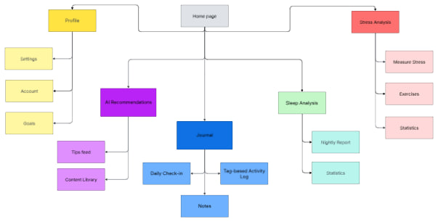

8. Design Patterns
To ensure code flexibility, testability, and maintainability, the following standard Spring Boot design patterns were applied:
- Repository Pattern:
  - Usage: Located in the repository package (e.g., UserRepository, SleepSessionRepository).
  - Purpose: Abstracts the data access layer. Business logic does not handle SQL queries directly but uses interface methods (save, findById). This allows for easier database migration if needed.
  - Verification: See the Package Diagram; notice the dependency between Service and Repository.
- Data Transfer Object (DTO):
  - Usage: Located in the dto package (e.g., SleepDataDTO, AuthRequestDTO).
  - Purpose: Decouples the internal database model (Entities) from the data sent to the client. This enhances security (hiding passwords or technical IDs) and optimizes network traffic.
- Singleton:
  - Usage: Applied to Services (SleepService) and Controllers (SleepController).
  - Purpose: The Spring Container creates beans as singletons by default. This ensures memory efficiency by using a single instance to handle concurrent requests.
- Facade:
  - Usage: The Controller layer acting as a facade.
  - Purpose: The controller provides a simplified interface for the mobile client, hiding the complex underlying logic of validation, security checks, and AI microservice communication.

9. Architectural Decisions and Alternatives Analysis
The current Client-Server architecture with a Hybrid approach (Monolith + AI Microservice) was selected based on the following analysis:
9.1. Database Selection: PostgreSQL (SQL) vs. MongoDB (NoSQL)
- Selected: PostgreSQL.
- Alternative: MongoDB.
- Justification: User data, sleep sessions, and journals have a strict structure and strong relational links (One User has Many Sessions). SQL ensures data integrity via Foreign Keys, which is critical for accurate analytics. While NoSQL is good for raw logs, PostgreSQL's JSONB type effectively handles the semi-structured sensor data requirements.
9.2. Backend Architecture: Hybrid vs. Monolith vs. Microservices
- Selected: Hybrid (Monolithic Core + Python AI Service).
- Alternative 1 (Pure Monolith): Integrating Python libraries (TensorFlow) directly into a Java monolith is complex and inefficient.
- Alternative 2 (Full Microservices): Would introduce unnecessary complexity (Service Discovery, Distributed Tracing) for a project of this scale.
- Justification: Decoupling only the AI module allows us to use the best tool for the job (Python/ML) and scale the most resource-intensive component independently.
9.3. Mobile Development: React Native vs. Native (Swift/Kotlin)
- Selected: React Native.
- Justification: It allows for a single codebase for both iOS and Android, reducing development time by approximately 40%. Modern cross-platform performance is sufficient for background sensor data collection.

10. Testing and Architecture Verification
To ensure system reliability and robustness, a three-tiered testing strategy is defined:
- Unit Testing:
  - Tools: JUnit 5, Mockito (Java); PyTest (Python).
  - Scope: Testing business logic in isolation (e.g., calculating sleep duration, validating email formats).
- Integration Testing:
  - Tools: Spring Boot Test, TestContainers.
  - Scope: Verifying component interactions (e.g., ensuring the REST Controller correctly saves entities to PostgreSQL and that the Backend parses JSON responses from the AI Service correctly).
- Performance/Load Testing:
  - Tools: Apache JMeter.
  - Scenario: Simulating 500 concurrent users uploading sleep data simultaneously.
  - Success Criteria: API response time under 200ms; zero data loss.
Risk Mitigation:
- Risk: Data loss due to network failure during upload.
- Solution: The mobile app implements local buffering. Data is stored on the device and retried automatically when the connection is restored.

11. Conclusion
In this course project, the architecture for an intelligent sleep and stress analysis mobile application was designed and partially implemented.
Key Outcomes:
- Designed a Hybrid Architecture combining the reliability of Java Spring Boot with the analytical power of Python.
- Developed a PostgreSQL database schema capable of storing heterogeneous data (profiles, time-series sensor data, journals).
- Implemented a secure data exchange protocol using JWT authentication.
Prospects: Future development will focus on integrating wearable device APIs (HealthKit, Google Fit) to obtain high-precision biometric data (heart rate, SpO2), further improving the accuracy of the AI recommendations.

12. References
- Walls, C. (2020). Spring Boot in Action. Manning Publications.
- Martin, R. C. (2017). Clean Architecture: A Craftsman's Guide to Software Structure and Design. Prentice Hall.
- React Native Documentation. Available at: https://reactnative.dev/
- PostgreSQL 14 Documentation. Available at: https://www.postgresql.org/docs/
- Chollet, F. (2021). Deep Learning with Python. Manning Publications.

13. Appendices
- Appendix A: REST API Specification (Swagger/OpenAPI).
- Appendix B: Example JSON Request/Response for the AI Service.

