1. I plan on building a bike share application. This application will allow users to coordinate using community bikes within a small city. It is very similar to a rental system in that users will pick a location to pickup a bike, use it for some time, then select a location to drop it off within the same city. Ten user stories for the system are as follows:

1. As a city dweller, I want to be able to check the availability of bike share bikes to rent, so that I can see if one is available nearby.
2. As a city dweller, I want to be able to reserve a bike, so that I can ride around the city.
3. As a city dweller, I want to be able to extend my rental time on a bike if needed, so that I can continue to use the bike in the event I misjudged the time I need it for.
4. As a city dweller, I want to be able to see all drop off locations for my rented bike, so that I can use the most coinvent available one to return the bike.
5. As a city dweller, I want to be able to see the types of bikes available for rental, so that I can choose the bike best suited for my ride style.
6. As a bike share coordinator, I want to be able to monitor the inventory of bikes for a city, so that I can ensure there is a good balance of bikes available.
7. As a city dweller, I want to be able to indicate there is an issue with my bike, so that I can get a new one and someone can fix the broken one.
8. As a bike share coordinator, I want to be able to track bikes with issues, so that I can have them picked up and fixed.
9. As a bike share coordinator, I want to be able to mark bikes as inactive, so that I can keep them from being reserved while they are out on maintenance.
10. As a bike share coordinator, I want to be able to see a heat map of pick up and drop off locations, so that I can use that data in logistical planning.

**Use Case Diagram**

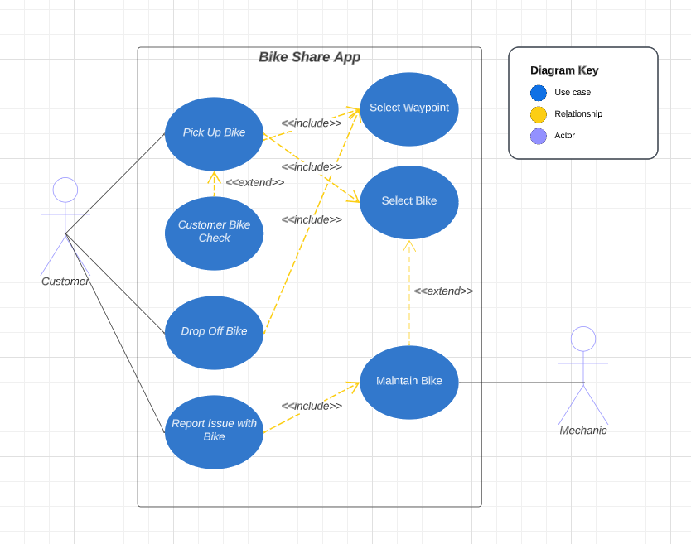

**Initial Sequence Diagram**

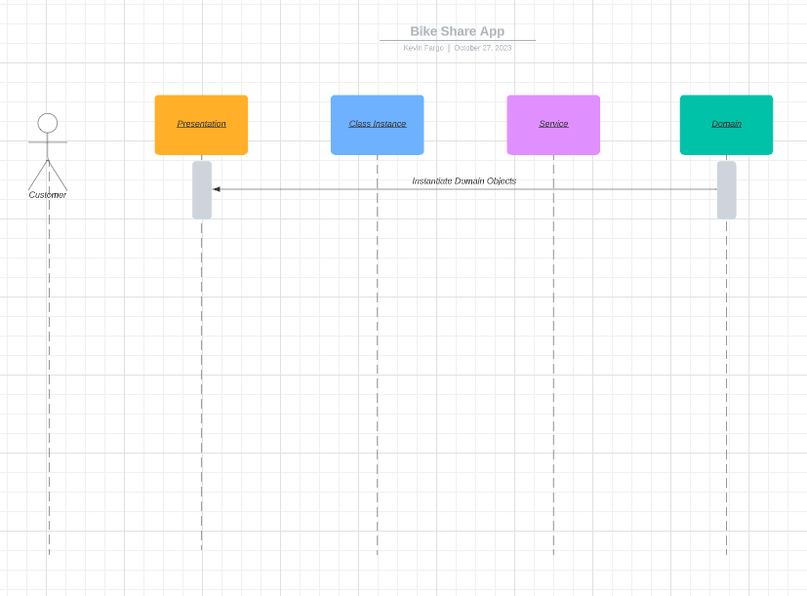

**Class Diagram**

Passing Tests:

Running Program:

