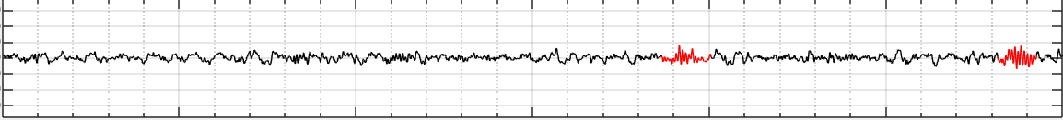 **SLEEP SPINDLES**

**BACKGROUND**

Spindles are bursts of neural oscillatory activity that are generated by interplay of the thalamic reticular nucleus (TRN) and other thalamic nuclei during NREM2 sleep (cite).

**IDENTIFICATION**

This activity presents as a train of distinct sinusoidal waves with a frequency of 9–16 Hz (most commonly 12–14 Hz) with a duration ≥0.5 seconds, usually maximal in amplitude in the central derivations (cite). Often, sleep spindles are brief bursts of symmetric waveforms that increase then decrease in amplitude.

*Characteristics*

* Amplitude: Distinct.
  + Typically stand out from background EEG.
* Shape: Sinusoidal.
  + Having the shape of a sine curve.
* Frequency: 9-16 Hz.
  + Need to be 9-16 cycles per second.
* Duration: ≥ 0.5 seconds.

*Example*

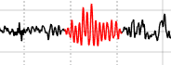

1 second

* This waveform stands out from the background EEG.
* The waves are sinusoidal in shape.
* This waveform frequency is >9 Hz.
* This waveform is longer than 0.5 seconds.

**EXAMPLES OF SPINDLE ACTIVITY**

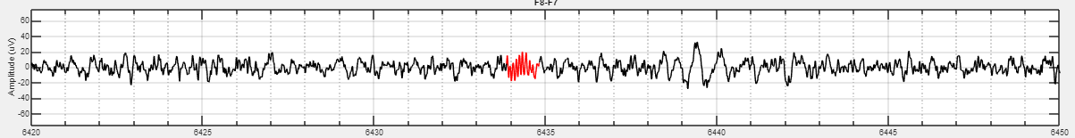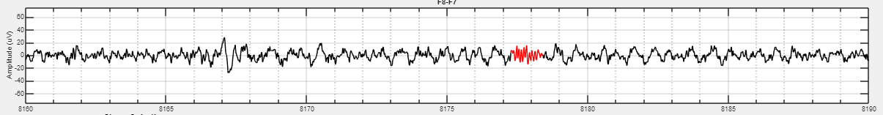

1.0s

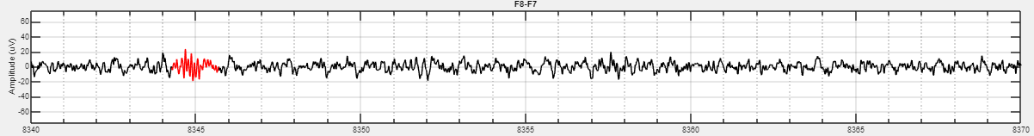

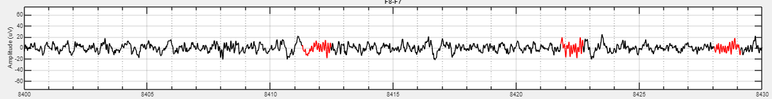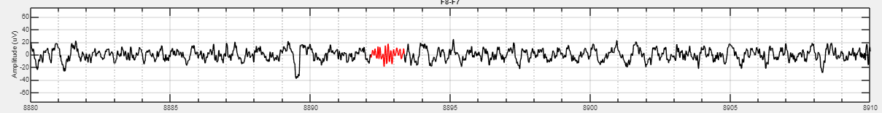

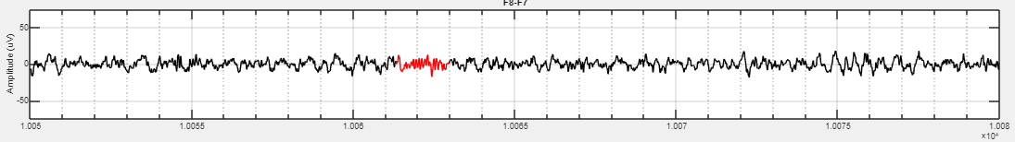

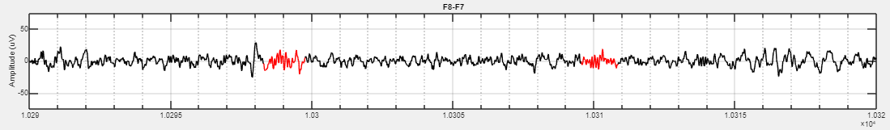

**EXAMPLES OF NON-SPINDLE ACTIVITY**

*Too Slow*

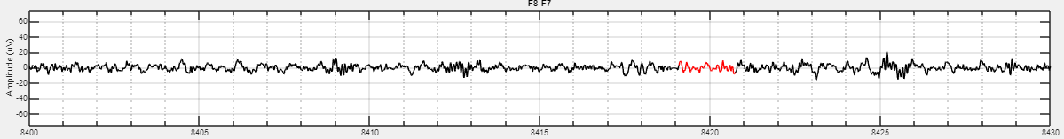

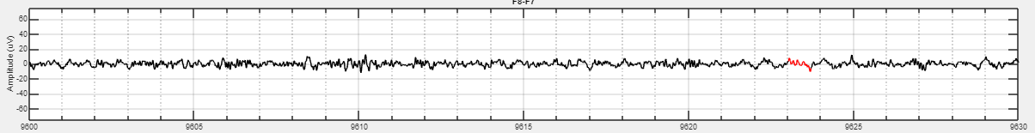

*Not Distinct or Sinusoidal*

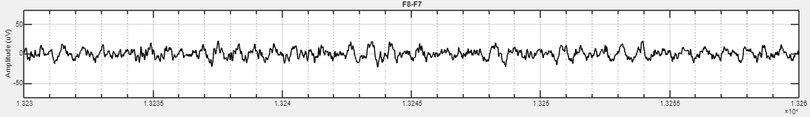

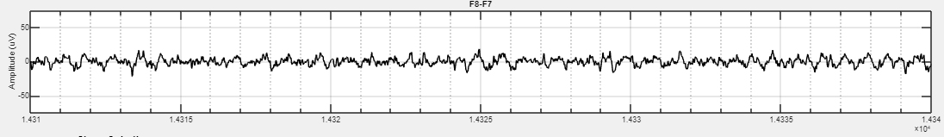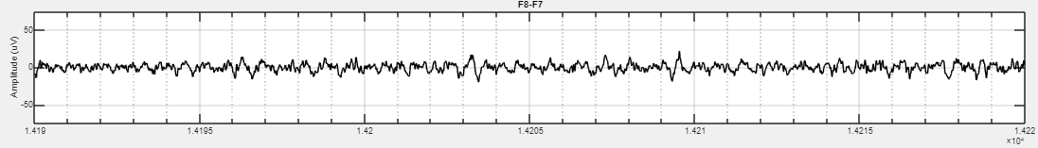

**REVIEW**

**Amplitude:**

Is the waveform distinct?

**Shape:**

Is the waveform sinusoidal?

**Frequency:**

Is the waveform 9-16Hz?

**Duration:**

Is the waveform greater than 0.5 seconds?