AI-QA Master Project - Phase 1 Setup Commands
This document includes the setup commands we used so far, the tech stack, steps completed, and what we learned.

1. Create Master Project Folder
cd Desktop
mkdir AI-QA-Master-Project
cd AI-QA-Master-Project

2. Create Phase 1 Folders
mkdir phase-01-foundation
cd phase-01-foundation
mkdir ollama-demo langchain-basics prompt-engineering

3. Open Project in VS Code
code .

4. Create Python Virtual Environment
python -m venv venv
venv\Scripts\activate

5. Verify Setup
python --version
pip --version
ollama --version
ollama list

6. Install Required Python Packages
pip install langchain
pip install langchain-community
pip install langchain-ollama

7. Go to Ollama Demo Folder
cd phase-01-foundation\ollama-demo

8. Create First Python File
Create this file:
test_case_generator.py

9. First Working Code
from langchain_ollama import OllamaLLM
llm = OllamaLLM(
model="llama3.2:1b"
)
requirement = """
User should be able to login using valid username and password.
"""
prompt = f"""
You are a Senior QA Engineer.
Generate:
1. Positive Test Cases
2. Negative Test Cases
3. Boundary Test Cases
Requirement:
{requirement}
"""
response = llm.invoke(prompt)
print("\nGenerated Test Cases:\n")
print(response)

10. Run the Script
python test_case_generator.py
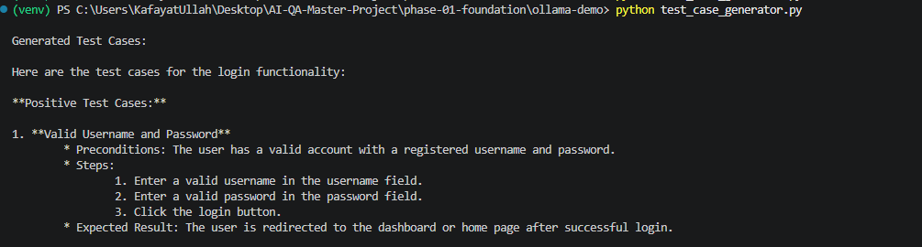

11. Tech Stack Covered So Far
- Python
- Virtual Environment (venv)
- VS Code
- Ollama
- Llama 3.2 Local LLM
- LangChain
- Prompt Engineering Basics

12. What We Learned
- How to create a project folder structure
- How to create and activate Python virtual environment
- How to verify Python, pip and Ollama installation
- How to install LangChain packages
- How to connect LangChain with Ollama
- How to use a local LLM model
- How to create a prompt
- How to send prompt using llm.invoke()
- How to generate QA test cases from a requirement

13. Architecture
Requirement -> Prompt -> LangChain -> Ollama -> Llama 3.2 -> AI Response -> Generated Test Cases

14. Next Step
Read requirement from a text file instead of hardcoding it in Python.

