**Lab worksheet 1: Introduction to Program Components**

Q1.

Code:

|  |
| --- |
| ***package Q_01;***  ***import javax.swing.*;***  ***public class Q_01{***  ***public static void main(String[] args) {***  ***JFrame myWindow;***  ***myWindow = new JFrame();***  ***myWindow.setSize(800, 600);***  ***myWindow.setTitle(" Welcome to Java");***  ***myWindow.setVisible(true);***  ***}***  ***}*** |

Output:

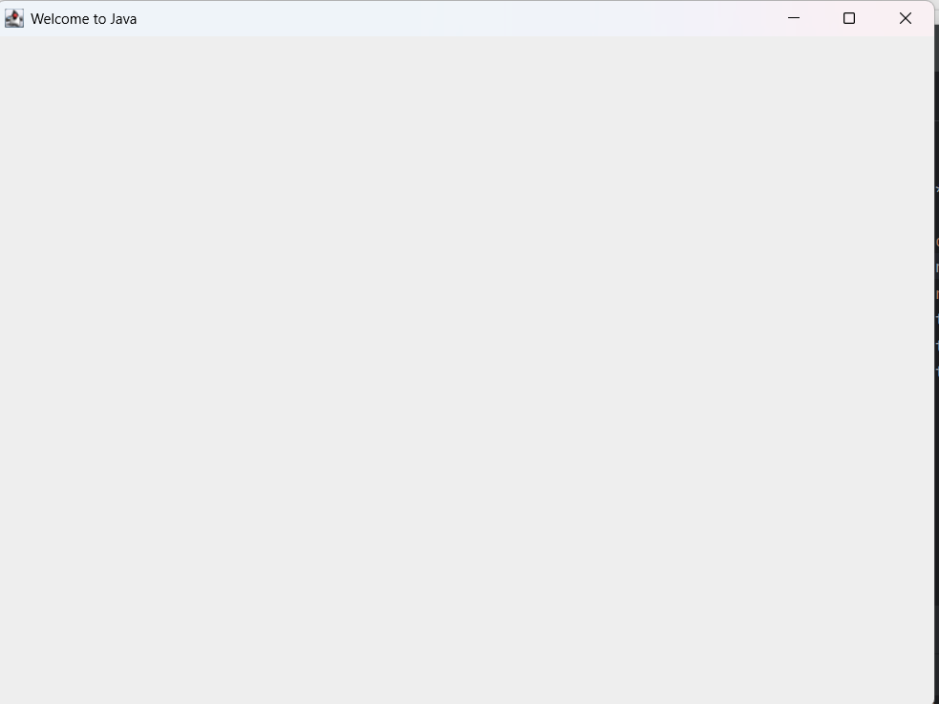

Q2.

Code

|  |
| --- |
| ***package Q_02;***  ***import javax.swing.*;***  ***import java.util.*;***  ***public class Q_02 {***  ***public static void main(String[] args) {***  ***Scanner scanner = new Scanner(System.in);***  ***String firstname , lastname , fullname;***  ***System.out.println("Enter your firstname : ");***  ***firstname = scanner.next();***  ***System.out.println("Enter your lastname : ");***  ***lastname = scanner.next();***  ***fullname = firstname + " " + lastname ;***  ***JFrame myWindow;***  ***myWindow = new JFrame();***  ***myWindow.setSize(800,600);***  ***myWindow.setTitle(fullname);***  ***myWindow.setVisible(true);***  ***}***  ***}*** |

Output:

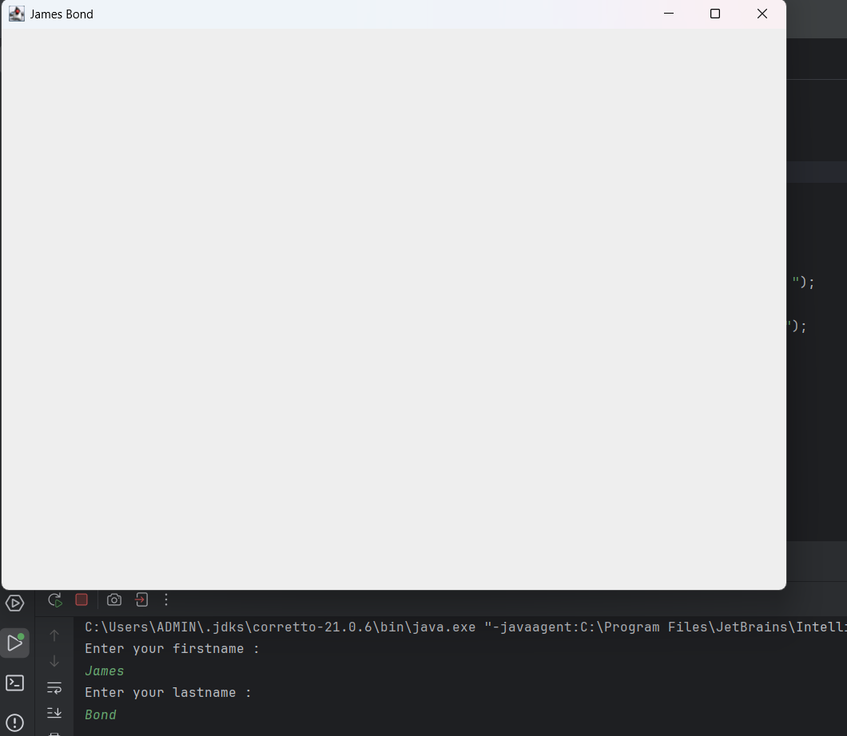

Q3.

Code

|  |
| --- |
| ***import java.util.Scanner;***  ***public class Q_03 {***  ***public static void main(String[] args) {***  ***Scanner scanner = new Scanner(System.in);***  ***String firstname, lastname,middlename , fullname;***  ***char middle_name_initial;***  ***System.out.println("Enter your firstname : ");***  ***firstname = scanner.next();***  ***System.out.println("Enter your middlename : ");***  ***middlename = scanner.next();***  ***middle_name_initial = middlename.charAt(0);***  ***System.out.println("Enter your lastname : ");***  ***lastname = scanner.next();***  ***fullname = firstname+" "+ middle_name_initial +". "+ lastname +"." ;***  ***System.out.println(fullname);***  ***}***  ***}*** |

Output:

Q4.

Code

|  |
| --- |
| ***package Q_04;***  ***import java.text.SimpleDateFormat;***  ***import java.util.*;***  ***public class Q_04 {***  ***public static void main(String[] args) {***  ***Date today;***  ***SimpleDateFormat sdf;***  ***today = new Date( );***  ***sdf = new SimpleDateFormat("dd MMM yyyy");***  ***System.out.println(sdf.format(today));***  ***}***  ***}*** |

Output:

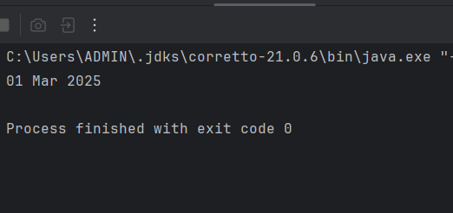

Q5.

Code

|  |
| --- |
| ***package Q_05;***  ***import java.text.SimpleDateFormat;***  ***import java.util.*;***  ***public class Q_05 {***  ***public static void main(String[] args) {***  ***Date today;***  ***SimpleDateFormat sdf;***  ***today = new Date( );***  ***sdf = new SimpleDateFormat("EEEE, MMM dd,yyyy");***  ***System.out.println(sdf.format(today));***  }  } |

Output:

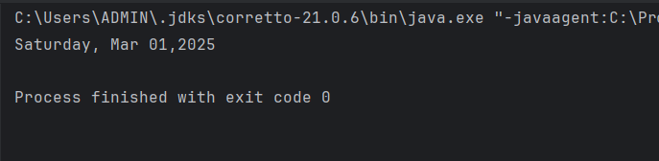

Q6.

Code

|  |
| --- |
| ***package Q_06;***  ***import javax.swing.*;***  ***import java.util.*;***  ***public class Q_06{***  ***public static void main(String[] args) {***  ***Scanner scanner = new Scanner(System.in);***  ***//getting user input***  ***int w ,h ;***  ***String title;***  ***System.out.println("enter the Title of the window :");***  ***title = scanner.nextLine();***  ***System.out.println("enter the width :");***  ***w = scanner.nextInt();***  ***System.out.println("enter the height :");***  ***h = scanner.nextInt();***  ***//window process***  ***JFrame myWindow;***  ***myWindow = new JFrame();***  ***myWindow.setSize(w,h);***  ***myWindow.setTitle(title);***  ***myWindow.setVisible(true);***  ***}***  ***}*** |

Output:

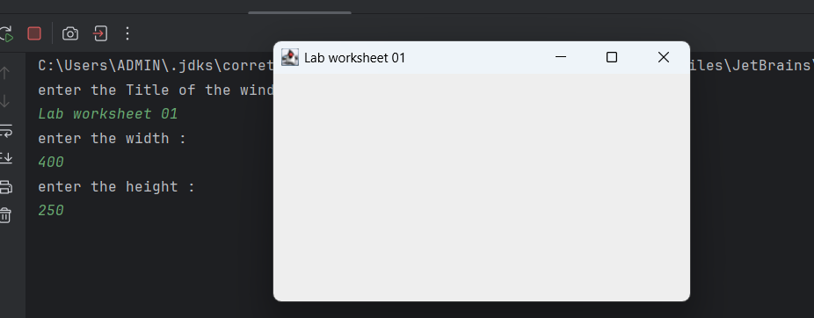

Q7.

Code

|  |
| --- |
| ***package Q_07;***  ***import java.text.SimpleDateFormat;***  ***import java.util.*;***  ***import javax.swing.*;***  ***public class Q_07 {***  ***public static void main(String[] args) {***  ***Date today;***  ***SimpleDateFormat sdf;***  ***today = new Date( );***  ***sdf = new SimpleDateFormat("hh:mm:ss a.");***  ***//System.out.println(sdf.format(today));***  ***JFrame myWindow;***  ***myWindow = new JFrame();***  ***myWindow.setSize(600,400);***  ***myWindow.setTitle(sdf.format(today));***  ***myWindow.setVisible(true);***  ***}***  ***}*** |

Output:

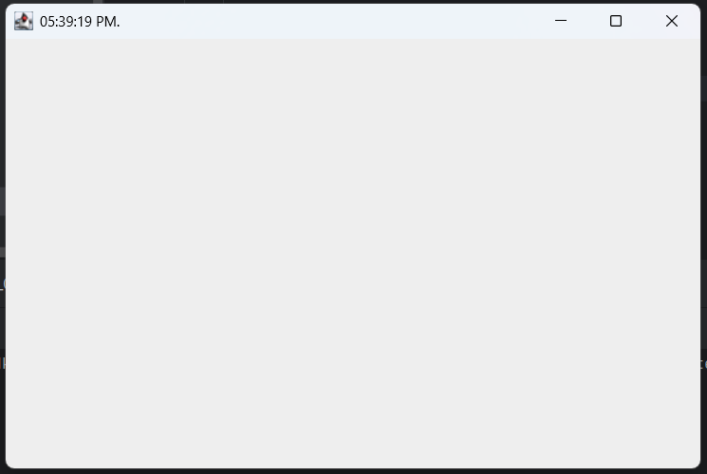

Q8.

Code

|  |
| --- |
| ***package Q_08;***  ***import java.util.Scanner;***  ***public class Q_08 {***  ***public static void main(String[] args) {***  ***Scanner scanner= new Scanner(System.in);***  ***System.out.println(" Enter a string that contains a single exclamation mark:");***  ***String word= scanner.nextLine();***  ***int index = word.indexOf('!');***  ***System.out.println(word.substring(0, index));***  ***System.out.println(word.substring(index+2));***  ***}***  ***}*** |

Output:

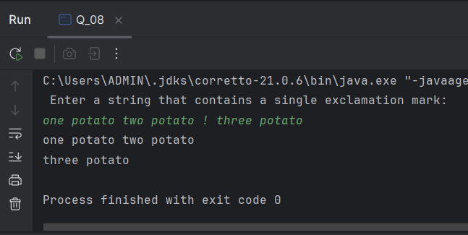

Q9

Code

|  |
| --- |
| ***package Q_09;***  ***import java.util.*;***  ***public class Q_09 {***  ***public static void main(String[] args) {***  ***Scanner scanner = new Scanner(System.in);***  ***System.out.println("Enter the text : ");***  ***String text = scanner.nextLine();***  ***int length = text.length();***  ***System.out.println(length);***  ***System.out.println(text.charAt(0));***  ***System.out.println(text.charAt(length-1));***  ***}***  ***}*** |

Output:

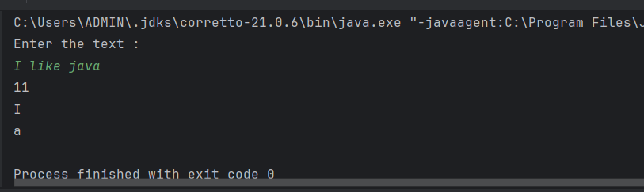

Q10.

Code

|  |
| --- |
| ***package Q_10;***  ***import java.util.Scanner;***  ***public class Q_10 {***  ***public static void main(String[] args) {***  ***Scanner scanner =new Scanner(System.in);***  ***System.out.println("Enter the odd length String : ");***  ***String text = scanner.nextLine();***  ***int length = text.length();***  ***char middle_letter;***  ***middle_letter = text.charAt((length / 2));***  ***System.out.println(middle_letter);***  ***}***  ***}*** |

Output:

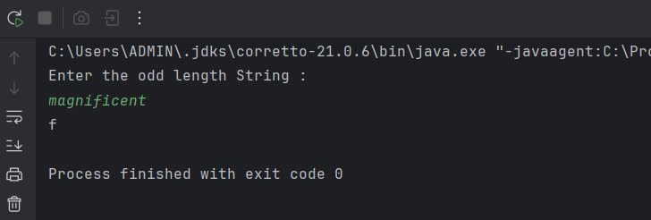

Q11

Code

|  |
| --- |
| ***package Q_11;***  ***import java.util.*;***  ***public class Q_11 {***  ***public static void main(String[] args) {***  ***Scanner scanner = new Scanner(System.in);***  ***System.out.println("Enter the full name (order - first middle last) with spaces :");***  ***String text = scanner.nextLine();***  ***String[] parts = text.split(" ");***  ***String firstname = parts[0];***  ***String middlename = parts[1];***  ***String lastname = parts[2];***  ***System.out.println(lastname +","+" "+firstname+" "+middlename.charAt(0)+".");***  ***}***  ***}*** |

Output:

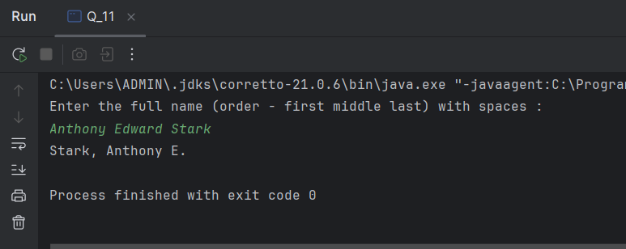

Q12

Code

|  |
| --- |
| ***package Q_12;***  ***import javax.swing.*;***  ***public class Q_12 {***  ***public static void main(String[] args) {***  ***JFrame myWindow;***  ***myWindow = new JFrame();***  ***myWindow.setSize(300,200);***  ***myWindow.setLocation(50,100);***  ***myWindow.setTitle("My First Frame");***  ***myWindow.setVisible(true);***  ***}***  ***}*** |

Output:

Q13.

Code

|  |
| --- |
| ***import javax.swing.*; class SampleWindow {  public static void main(String[] args) {  JFrame myWindow;  myWindow = new JFrame();  myWindow.setSize(500, 250);  myWindow.setTitle("UOK");  myWindow.setVisible(true);  try {Thread.sleep(500);} catch(Exception e) { }  myWindow.setVisible(false);  try {Thread.sleep(500);} catch(Exception e) { }  myWindow.setVisible(true);  } }*** |

Output:

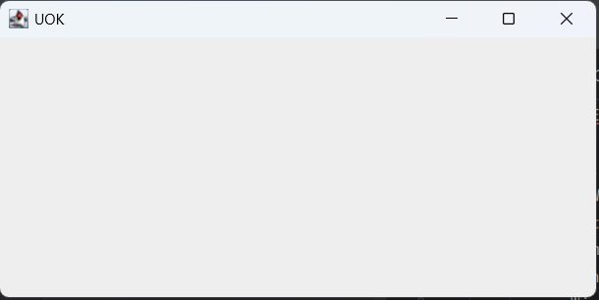

**how it works ?**

This program creates a window with the title "UOK" and a size of width 500 and height 250 pixels. It first shows the window, then hides it after 500 milliseconds, and shows it again after another 500 milliseconds. The {Thread.sleep(millis:500);} method pauses the program to create this blinking effect.