ShredNote
UI / UX Concept Document
A local-first paper-note app built around physical paper movement, a two-column workspace, and permanent shredding.
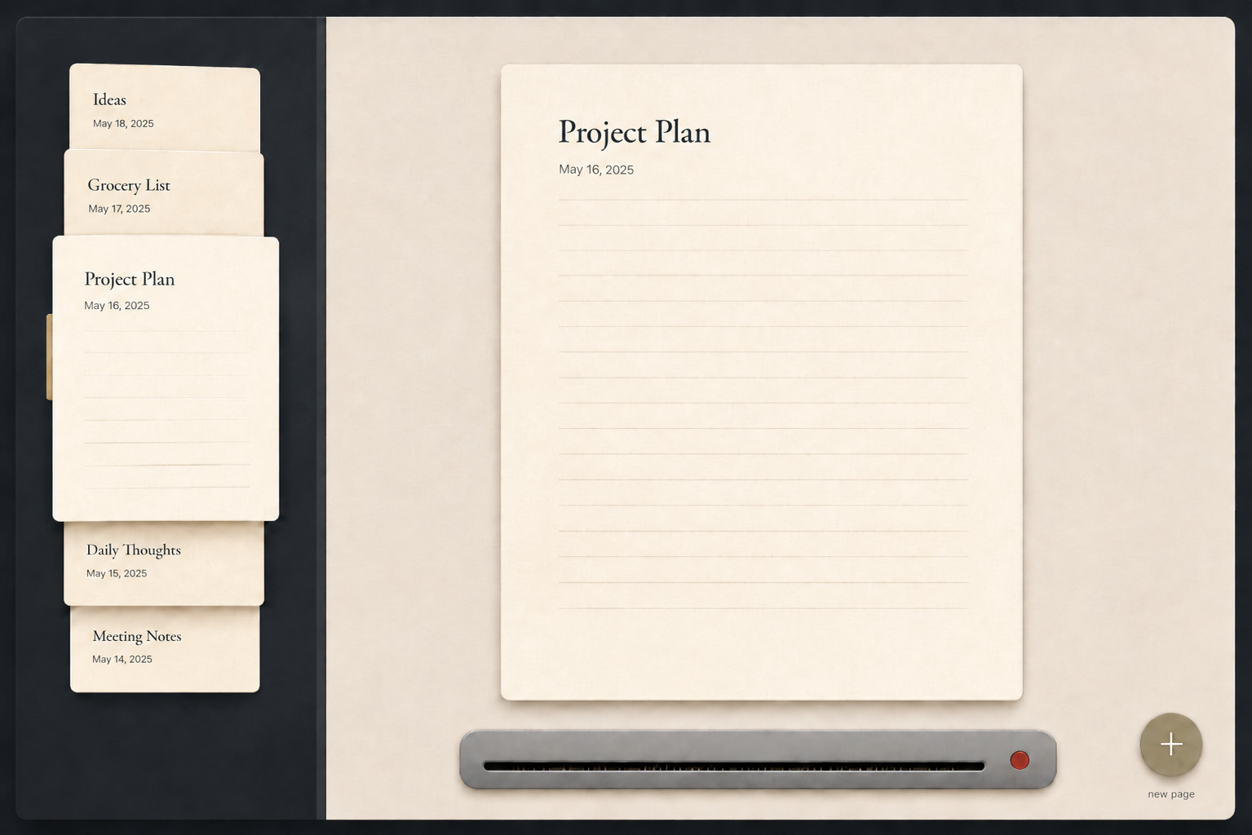
Current visual direction: left paper stack, main paper workspace, plus button, and shredder delete zone.

1. Product Direction
ShredNote should feel like a small physical desk for simple notes. The interface should avoid feeling like a generic sidebar-and-editor app. The key metaphor is that papers are real objects: they can be taken from a stack, placed on the desk, dragged around, and permanently shredded.

Core product sentence:
A small desk where users create, browse, write on, move, and permanently shred paper notes.
Area | Meaning | Main UX Responsibility
Left column | Stored paper stack / paper library | Browse existing papers sorted by creation date.
Right column | Desk workspace / active paper | Write and edit the currently selected paper.
Plus button | New paper source | Create a fresh blank paper instantly.
Shredder | Permanent delete zone | Destroy a paper only after an intentional drag-and-hold gesture.

2. Chosen Design Layout
The chosen layout uses a two-column system with a physical-paper metaphor.
- Left column: an overlapping stack of paper previews, ordered by created date.
- Right column: a larger active paper placed on the desk for editing.
- Bottom / side action area: a plus button for new paper and a shredder for deletion.
- Minimal controls: the app should not expose many buttons or toolbars by default.

2.1 Left Column
The left column should behave as a paper stack, not as a conventional note list. It should show paper cards/previews that users can select or drag.
- Papers are always sorted by created date.
- Users cannot manually reorder papers by dragging.
- Dragging is used for physical interaction and shredding, not for organization.
- The selected paper should not remain visible as a full preview in the left column after it moves to the right column.

2.2 Right Column
The right column is the active desk area. It should contain the one paper currently being edited. This active paper is not a copy of the left-column paper; it is the same paper moved out of the stack.
- Clicking/selecting a paper from the left stack moves it into the right column.
- The main paper should feel like it has been taken out and placed on the desk.
- Only the active paper should be editable.
- The body editor should remain simple and text-focused; decorative paper lines should not restrict typing behavior.

3. Left Column and Right Column System
The selected paper should be treated as one physical object. It should not exist as both a left preview and a right main paper at the same time.

3.1 Final Selected-Paper Rule
Only one real paper exists visually at a time:
- When stored, the paper is in the left stack.
- When selected, the paper leaves the left stack and becomes the main paper on the right.
- The left-column preview disappears because the paper has physically moved to the desk.

3.2 Selection Flow
- User clicks or holds a paper in the left column.
- The paper lifts slightly from the stack.
- It slides and enlarges into the right column.
- The left stack closes naturally after the paper leaves.
- The paper becomes editable in the main workspace.

3.3 Switching to Another Paper
- The current main paper shrinks and returns to the left stack.
- It returns according to created-date order, not a manually chosen position.
- The newly selected paper lifts out of the left stack.
- The newly selected paper slides into the right column and becomes active.
This avoids the duplicate-paper illusion and preserves the physical metaphor: put one paper back, take another one out.

4. Creating and Editing Papers

4.1 New Paper
- Pressing the plus button creates a new blank paper instantly.
- Avoid modal dialogs for basic creation.
- The new paper appears directly in the right workspace.
- The new paper receives a created date immediately and enters the left-column order when returned to the stack.

4.2 Editing
- Click the title area to rename the paper.
- Click the body area to write normally.
- Autosave should happen silently without a visible save button.
- The created date should stay fixed and should not change after edits.
- Updated date can be stored internally, but created date should control the left-column order.

5. Drag and Hold Logic
Dragging should feel playful and physical, but it should not change organization. Papers return to their original location when released unless they are intentionally shredded.

5.1 General Drag Rules
- Holding a paper selects it and allows it to be dragged freely.
- The dragged paper rises above the interface with stronger shadow and slight motion.
- Dragging does not reorder the left column.
- If released outside the active shredder condition, the paper flies back to its original position.
- If the paper came from the left stack, it returns to its created-date position.
- If the paper came from the right workspace, it returns to the right workspace.
Action | Result
Hold paper | Paper is selected and becomes draggable.
Drag around desk | Paper follows pointer; no data changes.
Release outside shredder | Paper flies back to original position.
Drag over shredder for less than 1 second, then release | No deletion; paper returns.
Drag over shredder for 1 second until green, then release | Paper is shredded and deleted immediately.

6. Shredder Deletion System
The shredder is the app’s signature delete interaction. It should be satisfying, but strict enough to avoid accidental deletion.

6.1 Permanent Delete Concept
When a paper is shredded, it is deleted immediately. There is no undo. This is part of the app concept. Because deletion is permanent, the interaction must clearly require intent before the shred happens.

6.2 Shredder States
State | Visual | Behavior
Idle | Red dot | Shredder is inactive.
Hovering | Red dot remains red | Paper is inside shredder area, but the 1-second safety timer has not finished. Releasing now does not delete.
Armed | Dot turns green | Paper has stayed inside shredder area for 1 second. Releasing now shreds the paper.
Shredding | Paper pulled into slot | Paper is permanently deleted and removed from the app.

6.3 Exact Shredder Flow
- User drags a paper into the shredder area.
- The shredder remains red and inactive at first.
- A 1-second timer starts only while the paper remains inside the shredder area.
- If the paper leaves the area, the timer cancels and resets.
- After 1 full second inside the area, the shredder dot turns green.
- If the user releases the paper while the shredder is green and the paper is still inside the shredder area, the paper is shredded.
- After shredding, the paper is deleted immediately with no undo state.

7. Settings Scope
Settings should stay small. The app should not feel like a complex productivity suite. It should support the core paper-note experience, local storage, manual export/import, and accessibility preferences.
Section | Recommended Settings
Appearance | Theme: Light / Dark / System. Paper style: Plain / Lined / Dotted / Grid. Accent color. Optional subtle paper texture.
Writing | Font size, line spacing, spellcheck, optional first-line-as-title behavior.
Paper Behavior | Newest first / oldest first by created date, open last paper on launch, reduce motion. No manual reorder setting.
Shredder | Hold delay, shredder animation, shredder sound. No undo setting because shredding is permanent by concept.
Data | Export ShredNote file, import ShredNote file, export readable Markdown, reset local data.

7.1 Settings to Avoid in Early Versions
- Cloud sync.
- Accounts and login.
- Collaboration.
- Folders and tags, unless the app later needs more organization.
- Complex rich-text toolbar settings.
- AI features.
- Calendar integration.

8. Manual Export / Import Between Devices
Because the app is built in Flutter and is local-only for now, multi-device usage should be handled through manual file transfer. The user exports notes on one device, moves the file manually, then imports it on another device.
Use Case | Recommended Format | Purpose
Transfer between ShredNote apps | .shrednote | Main backup and import format. Internally JSON-based.
Readable export outside the app | .md | Human-readable Markdown copy for viewing in editors like VS Code, Obsidian, or plain text readers.

8.1 Primary Format: .shrednote
Use a custom .shrednote file extension for app-to-app transfer. Internally, the file can store JSON. This keeps the implementation simple while making the file feel like a native ShredNote export instead of a technical developer file.
- Works across Windows, macOS, Linux, Android, and iOS.
- Preserves paper metadata such as created date, updated date, paper style, and stable ID.
- Allows full restoration of note order because created_at is preserved.
- Can support exporting all papers or only selected papers.
- Can evolve with format_version in future app updates.

8.2 Suggested .shrednote JSON Structure
{
"app": "ShredNote",
"format_version": 1,
"export_id": "exp_20260716_abc123",
"exported_at": "2026-07-16T16:45:00+07:00",
"export_type": "all_papers",
"papers": [
{
"id": "paper_8f3a2c",
"title": "Project Ideas",
"body": "Build a notes app with a shredder...",
"created_at": "2026-07-10T09:12:00+07:00",
"updated_at": "2026-07-16T15:30:00+07:00",
"paper_style": "lined"
}
]
}

8.3 Import Behavior
- Import should default to adding papers to the current device instead of replacing everything.
- Replace all papers should exist only as a clearly dangerous option.
- Stable paper IDs should prevent accidental duplicate imports.
- If a paper ID already exists, the default behavior should be to skip duplicates.
Import Option | Recommended Default? | Explanation
Add to current papers | Yes | Safest behavior for manual transfer.
Replace all papers | No | Destructive; should require clear confirmation.
Skip duplicates | Yes | Prevents repeated imports from creating duplicates.
Replace duplicates | No | Useful later, but riskier.
Import as copies | Optional later | Useful if the user intentionally wants duplicate versions.

8.4 Markdown Export
Markdown should be used as a readable export format, not as the main transfer format. It is useful when users want to view, archive, or move their notes into external tools.
- Export as one combined .md file for v1 because it is simple.
- Later, support exporting as a folder with one .md file per paper.
- Do not rely on Markdown for full restoration because metadata and stable IDs are harder to preserve cleanly.

9. UX Principles to Keep
- One paper should not appear in two places at once.
- The right-column paper is the actual active paper, not a duplicate preview.
- Dragging is physical interaction, not manual sorting.
- Created date controls left-column order.
- Deletion is permanent, so the 1-second red-to-green shredder delay is required.
- Avoid popup confirmations for normal shredding if the red-to-green safety delay is clear enough.
- Keep settings small and tied to the paper-note concept.
- Keep the app local-only in the first version.
- Use .shrednote for app-to-app transfer and .md for readable export.

10. Recommended MVP Feature Set
Feature | Include in MVP? | Notes
Two-column paper layout | Yes | Core identity of the app.
Paper selection animation | Yes | Selected paper leaves left stack and moves to right workspace.
Basic text editing | Yes | Title and body are enough.
Autosave | Yes | No manual save button.
Created-date ordering | Yes | No manual reorder.
Drag paper freely | Yes | Release outside shredder returns paper to origin.
Permanent shredder delete | Yes | Requires 1-second hold before green release.
Undo after delete | No | Not part of the app concept.
Cloud sync | No | Not in current concept.
.shrednote export/import | Yes | Main manual multi-device transfer method.
Markdown export | Yes | Readable export only.
Folders/tags | No | Avoid complexity in v1.

