 | Eötvös Loránd University  Faculty of Informatics  Dept. of Software Technology and Methodology

Interactive Machine Learning Model Explanation Web Tool for Credit Risk Prediction

Supervisor: |  | Author:
Md. Easin Arafat |  | Kafi MD Abdullah Hel
PhD Candidate |  | Computer Science BSc
Budapest, 2025
Declaration of Authorship
I, Kafi MD Abdullah Hel, computer science BSc student, author of this thesis, declare that except where noted, all work is my own and no part of this thesis has been submitted for a degree to any other university or institution. Furthermore, I declare that in the preparation of this thesis I have complied with the requirements of the university regarding the avoidance of plagiarism.
............................................
Signature
Budapest, 2025.
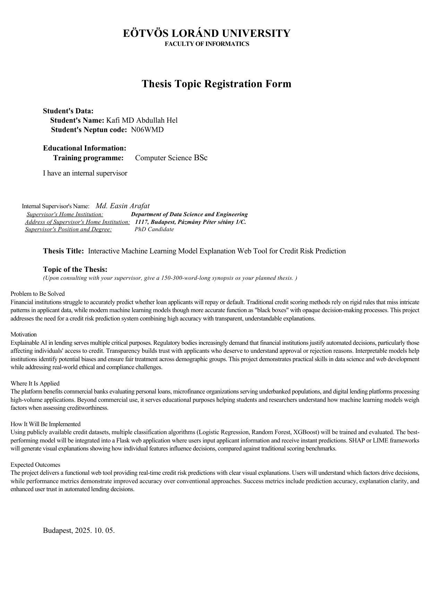
Appendix: UML Diagrams
System Architecture Diagram
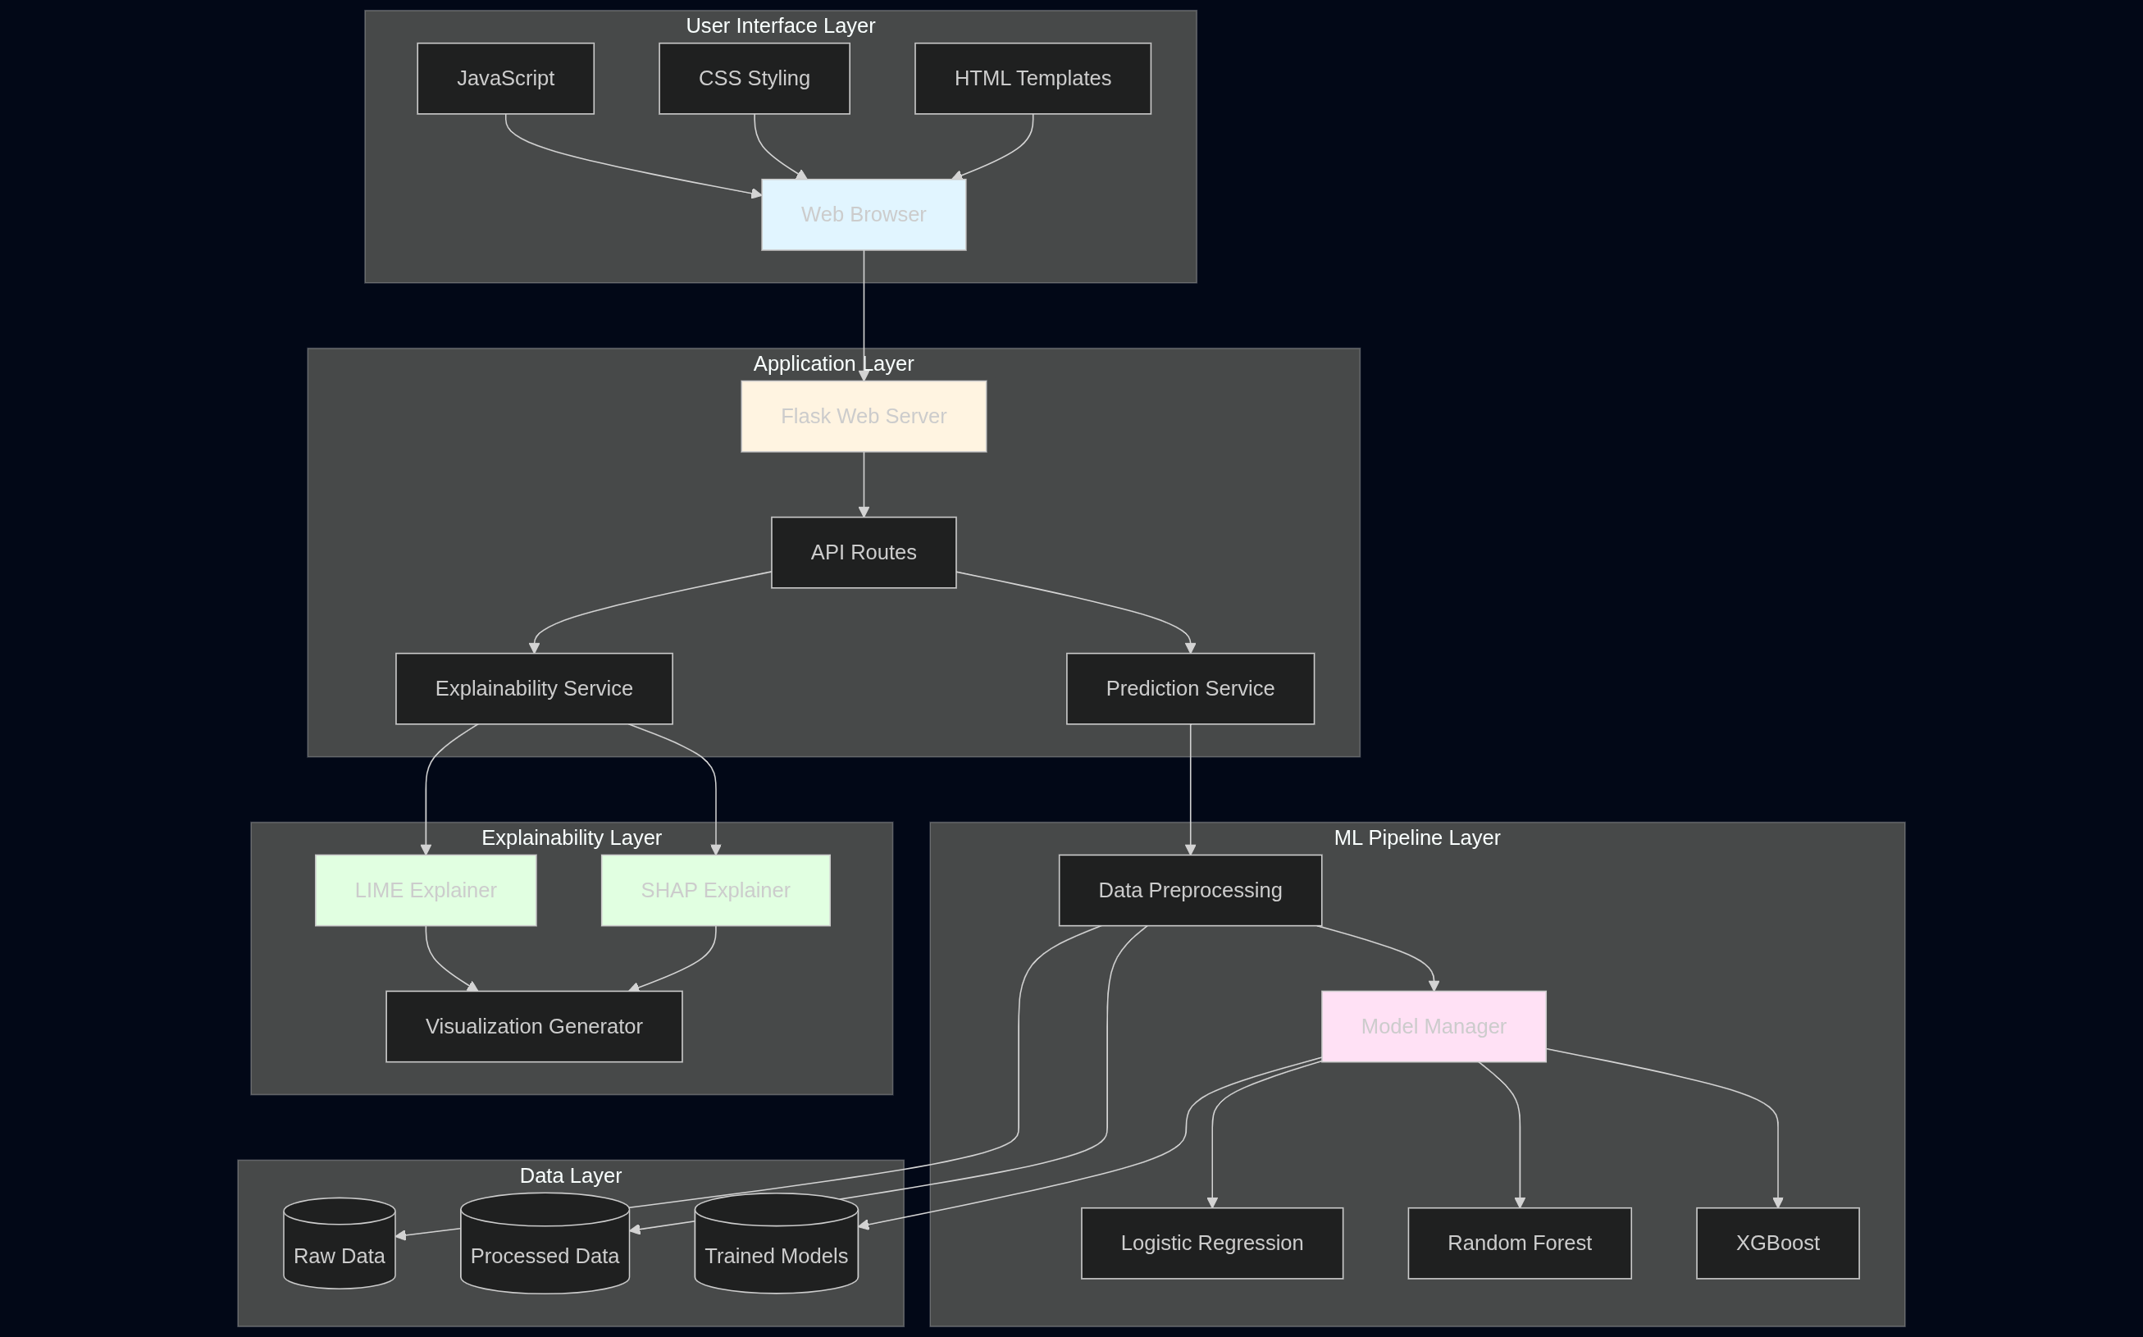

component diagram
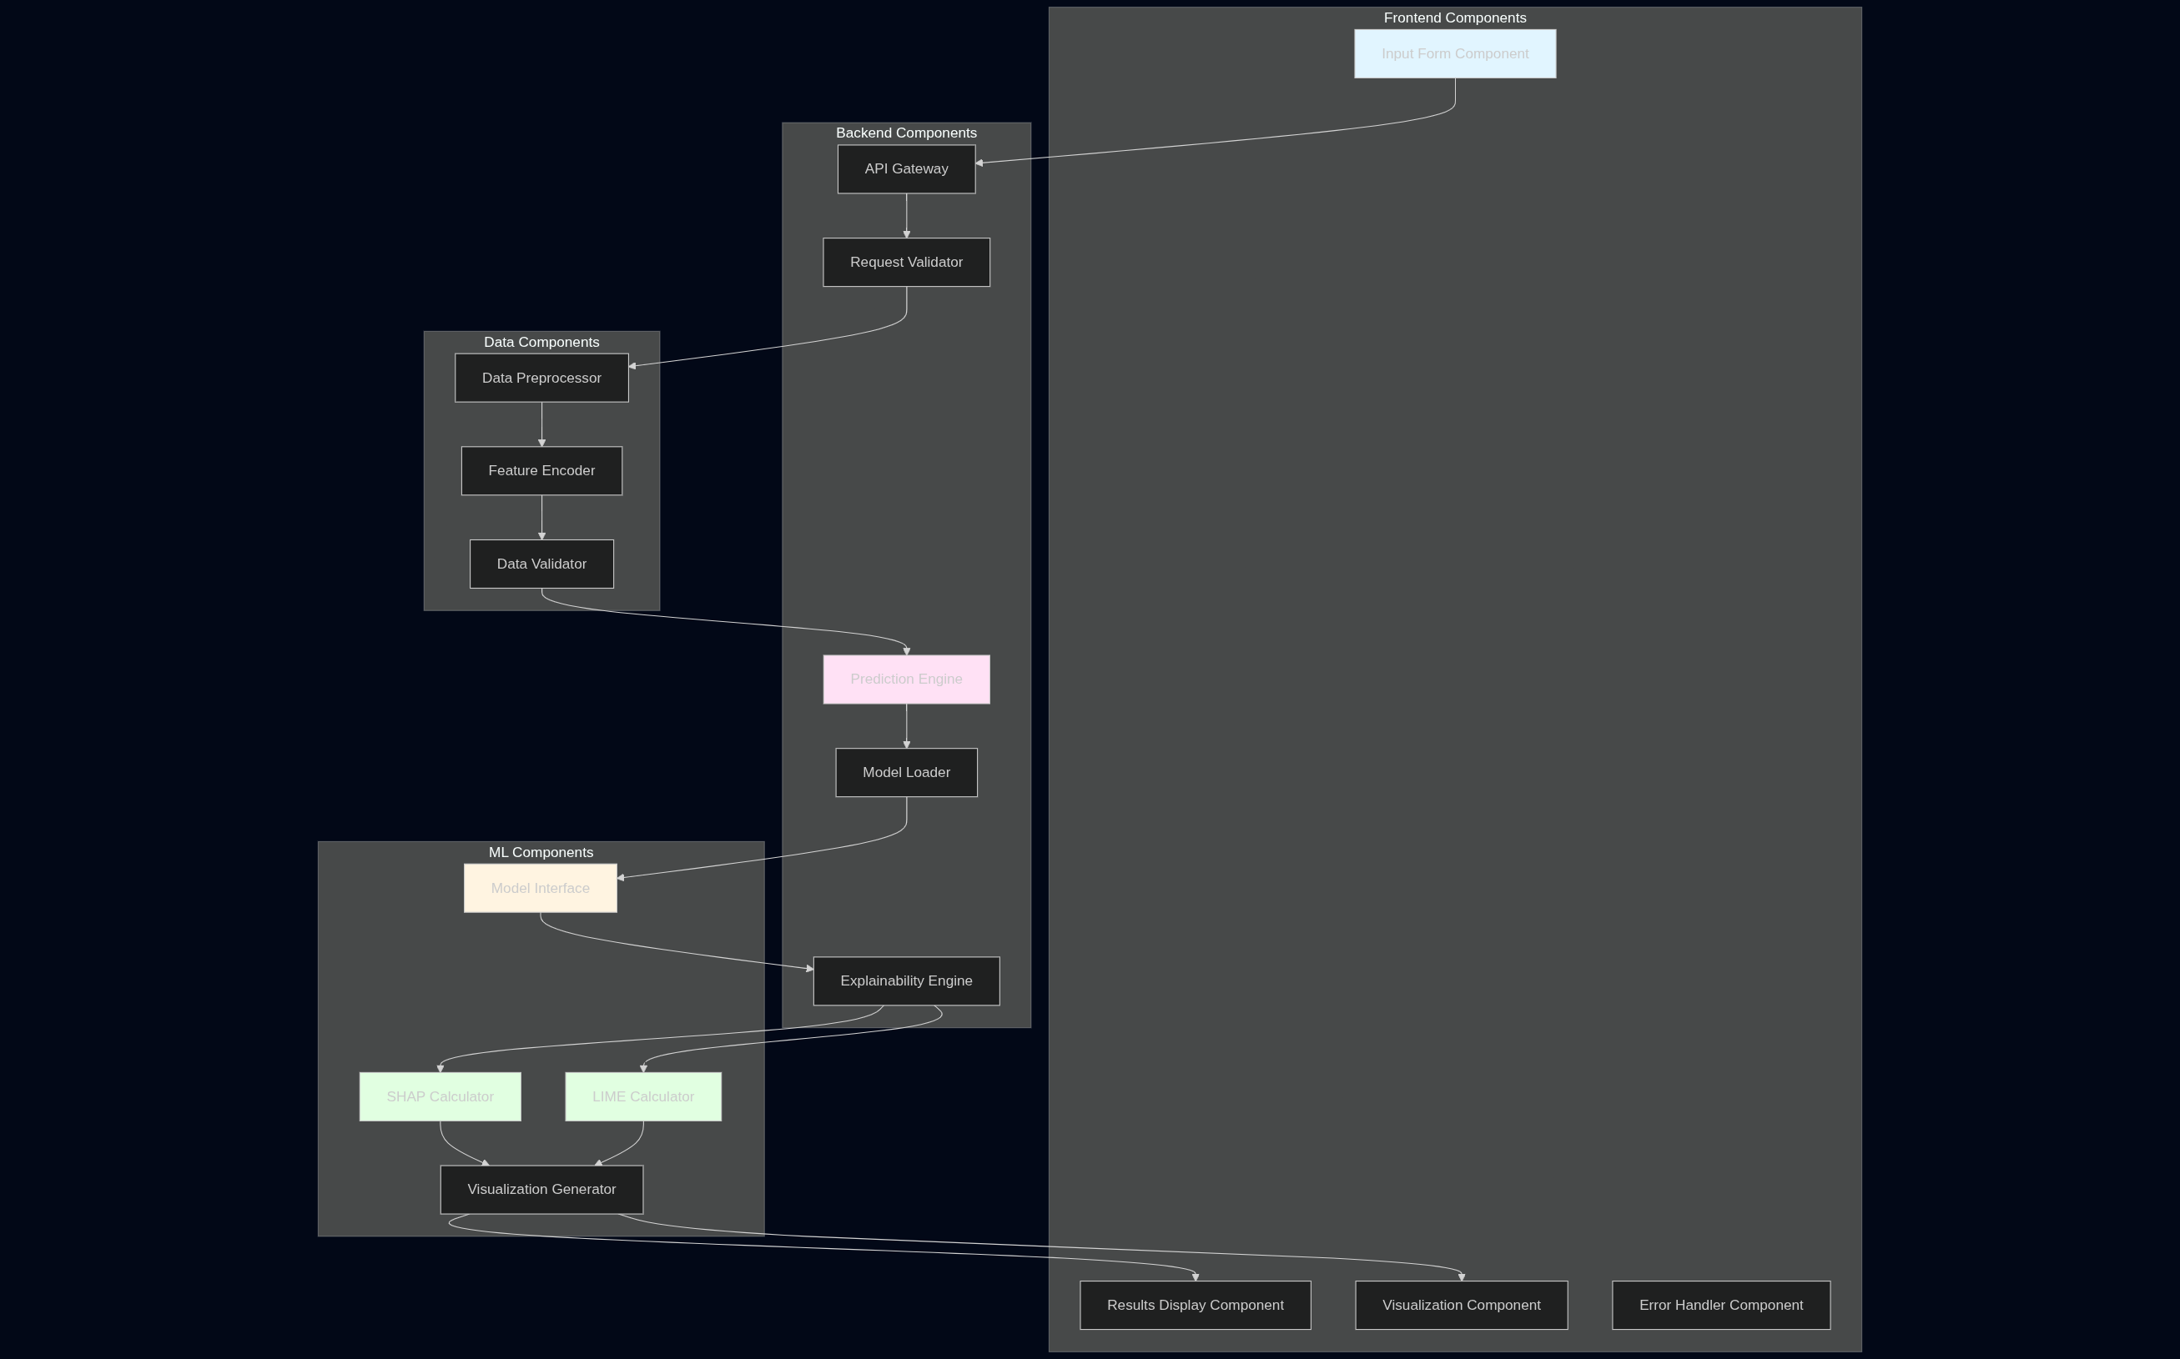

Class Daigram
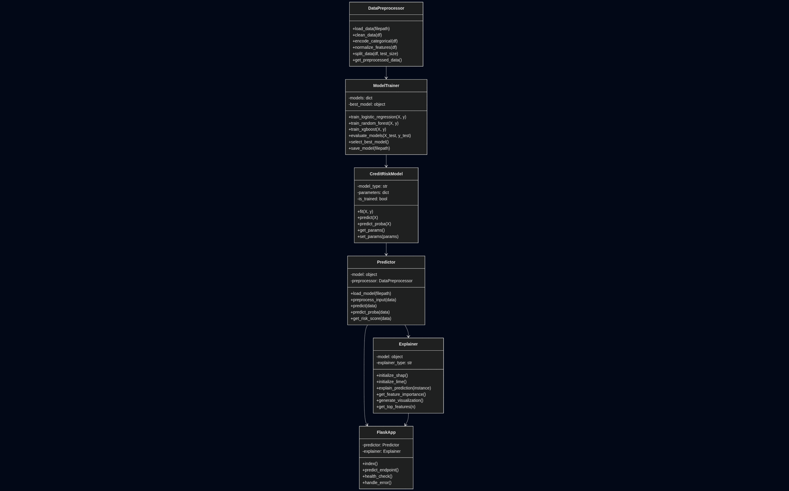

Sequence Diagram - Prediction Flow
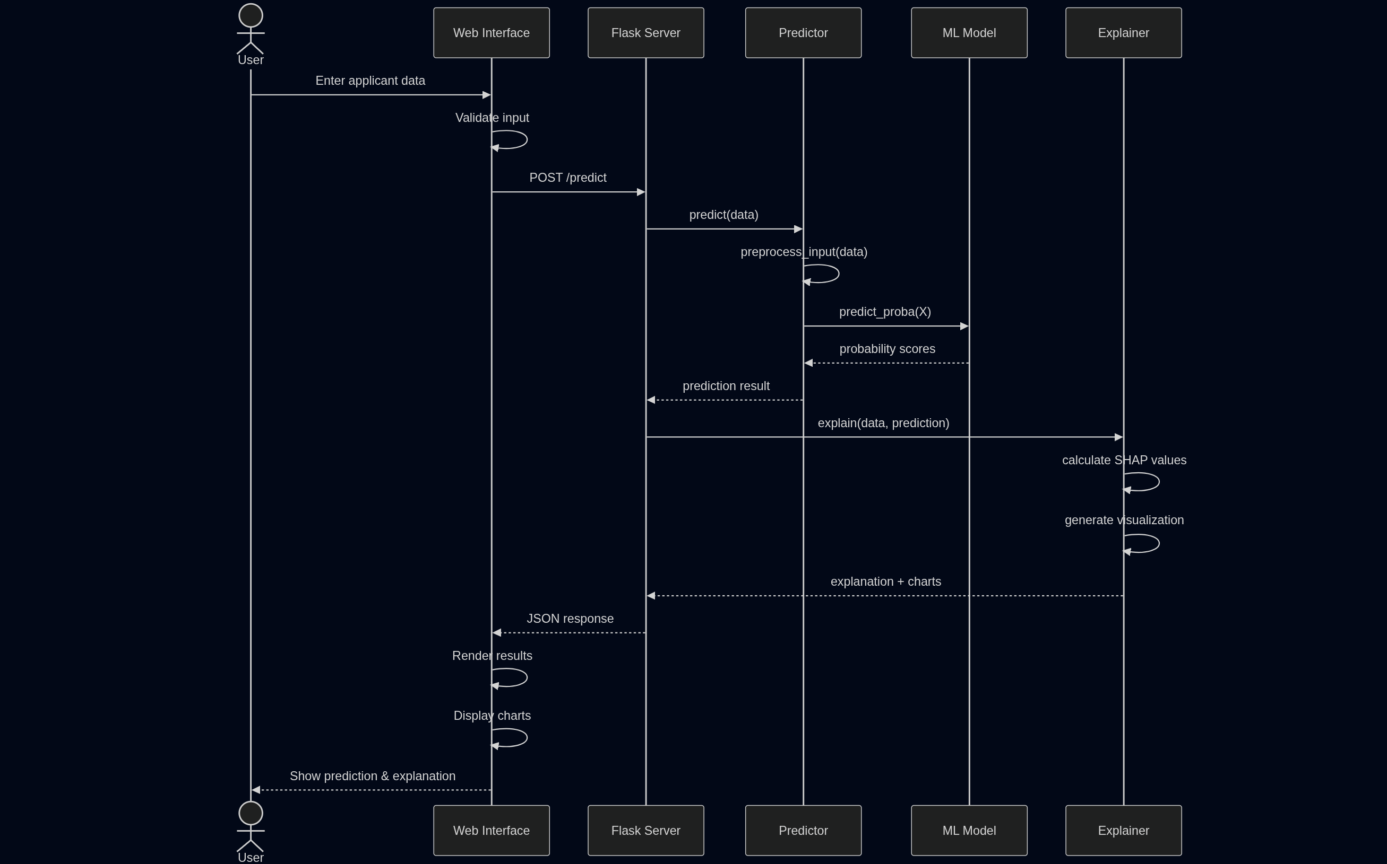

User Flow Diagram
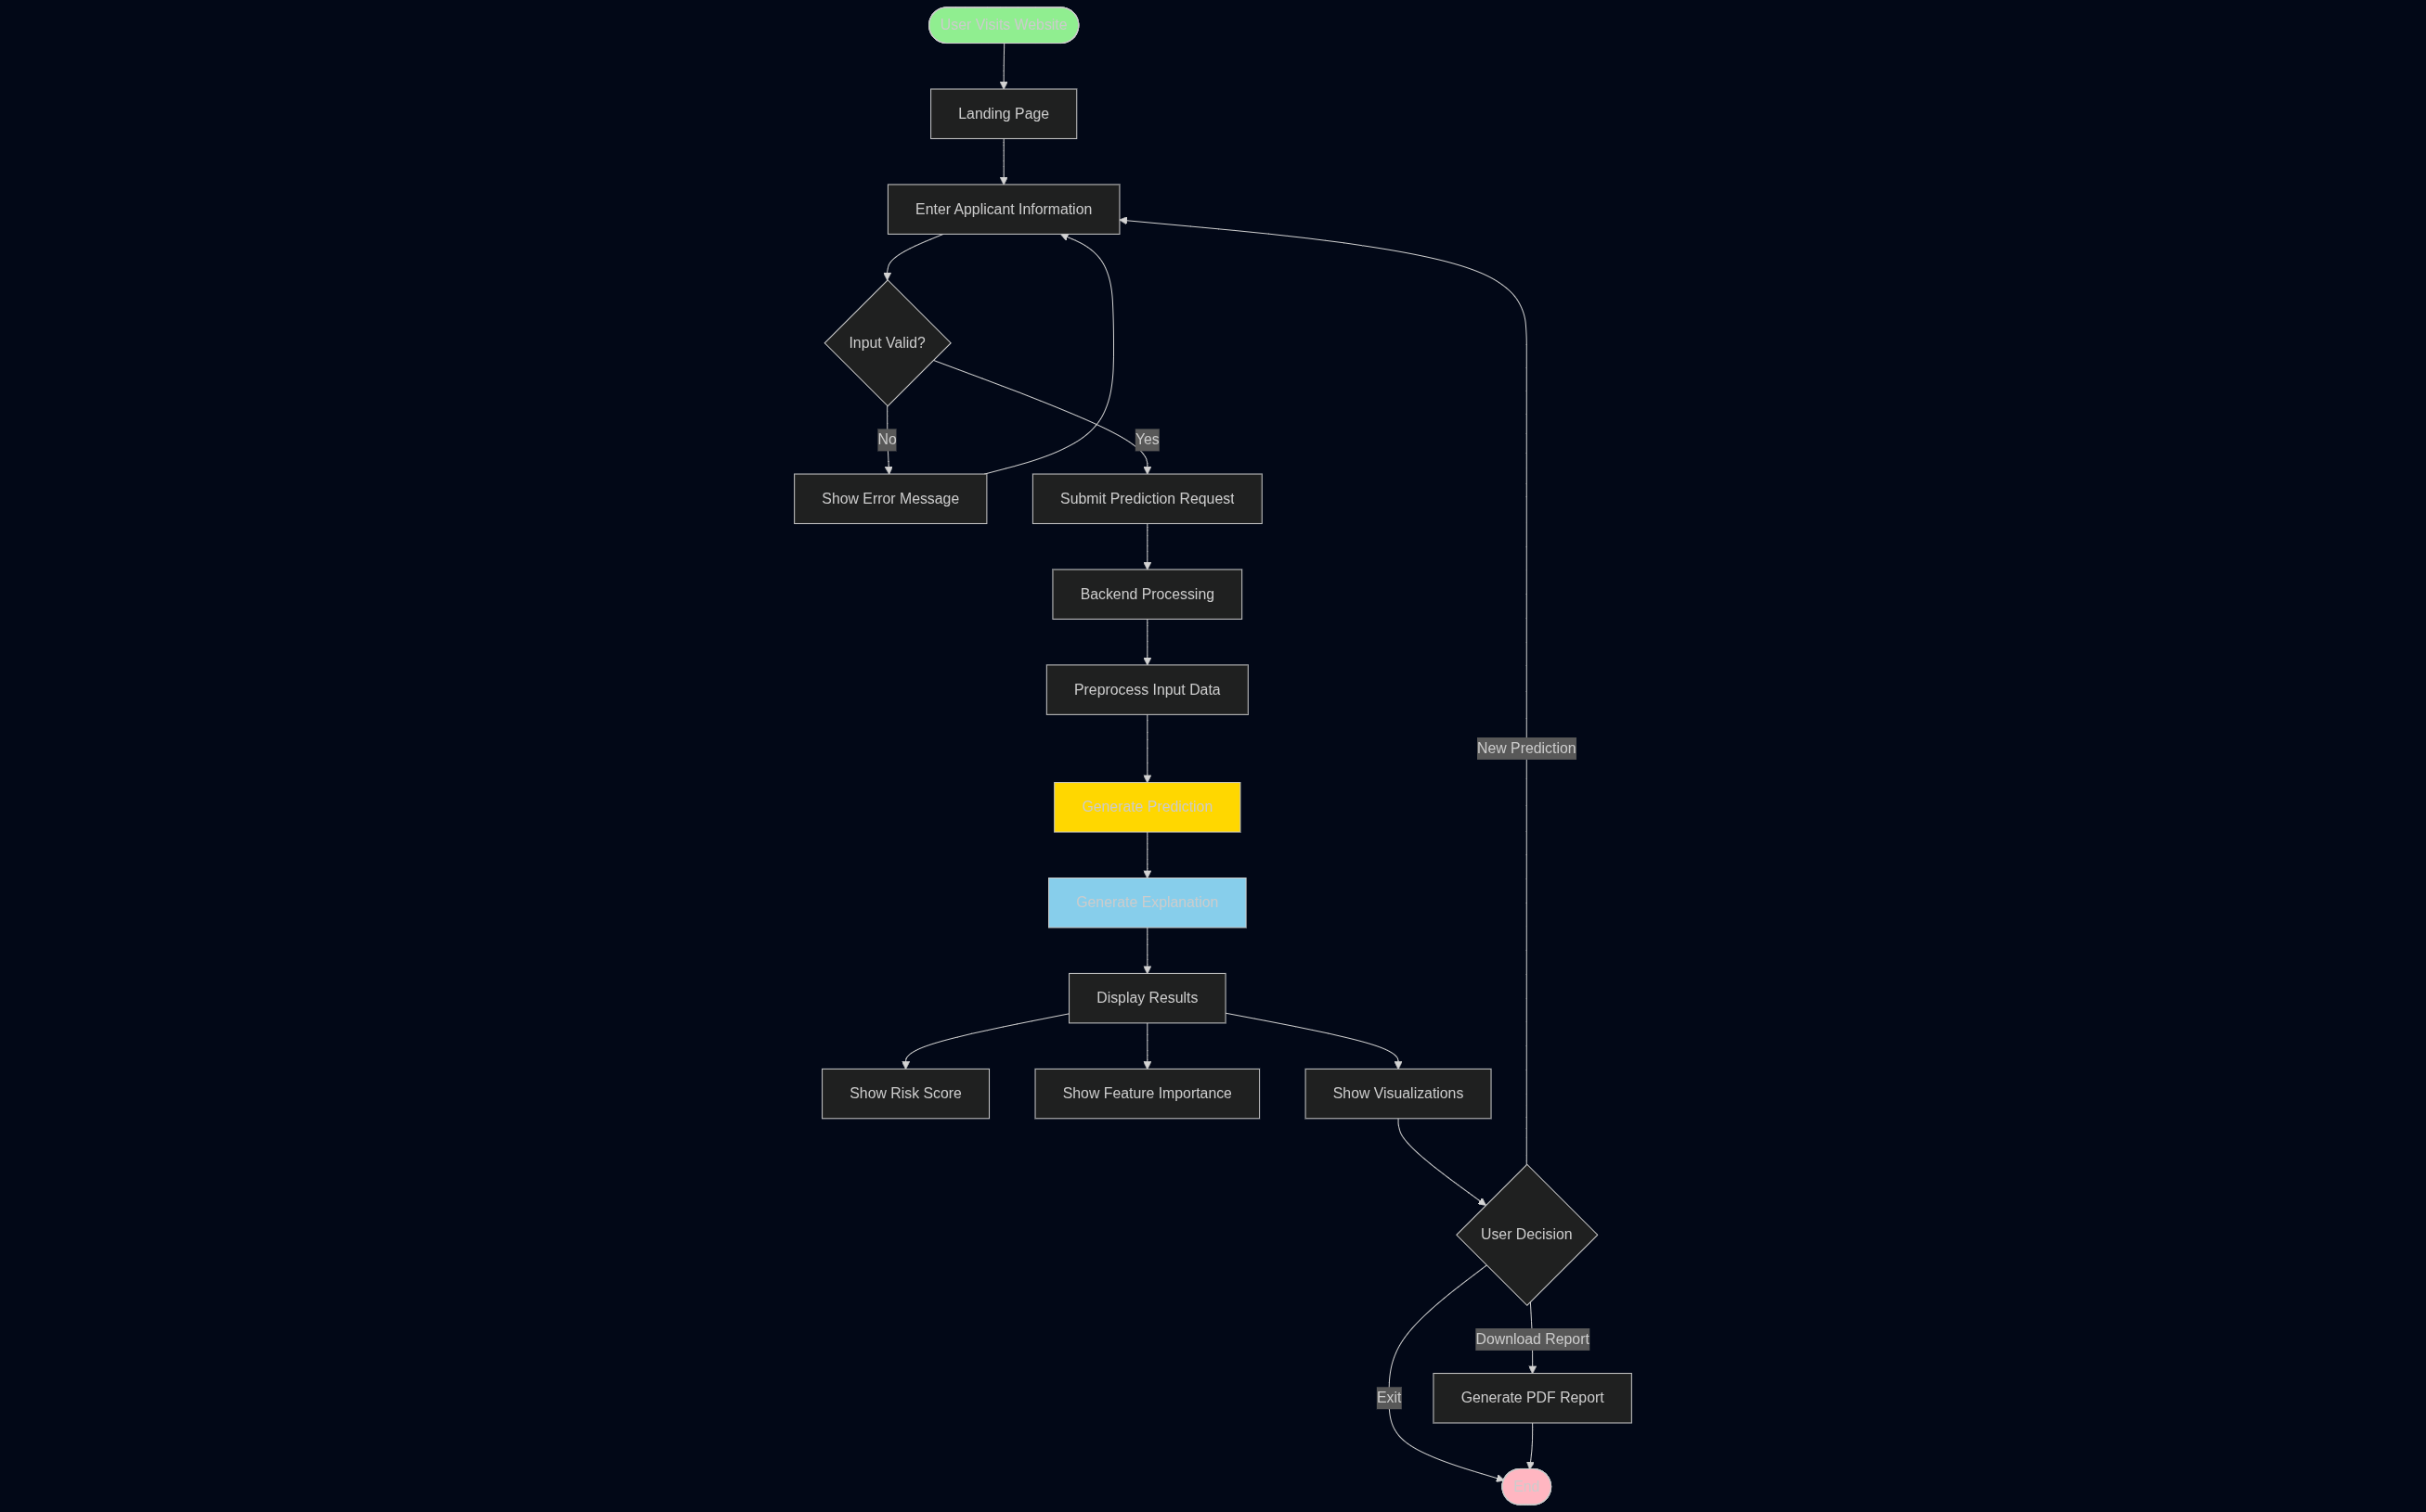

Data Flow
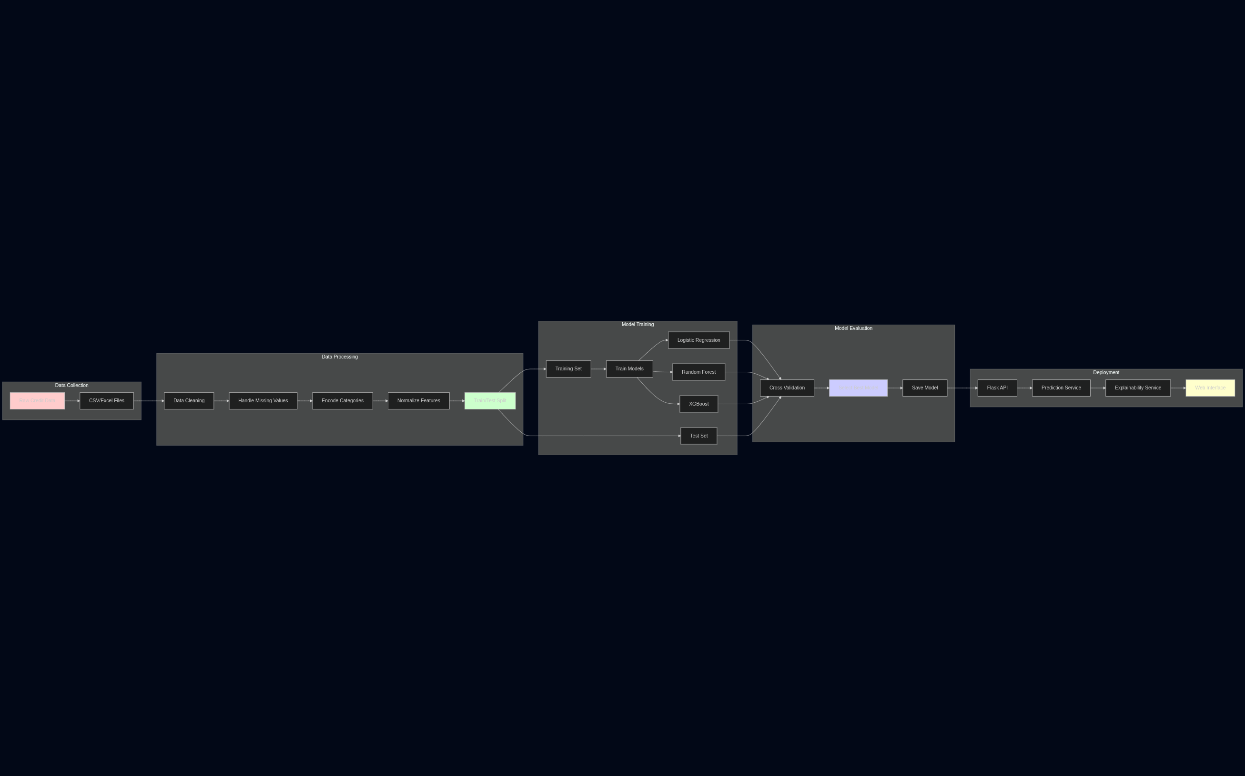

state diagram
