 | Eötvös Loránd University  Faculty of Informatics  Dept. of Software Technology and Methodology

Interactive Machine Learning Model Explanation Web Tool for Credit Risk Prediction

Supervisor: |  | Author:
Md. Easin Arafat |  | Kafi MD Abdullah Hel
PhD Candidate |  | Computer Science BSc
Budapest, 2025

Declaration of Authorship
I, Kafi MD Abdullah Hel, computer science BSc student, author of this thesis, declare that except where noted, all work is my own and no part of this thesis has been submitted for a degree to any other university or institution. Furthermore, I declare that in the preparation of this thesis I have complied with the requirements of the university regarding the avoidance of plagiarism.
............................................
Signature
Budapest, 2025.



Table of Contents
Chapter 1: Introduction and Motivation 2
1.1 Introduction 2
1.2 Problem Statement 3
1.3 Motivation 4
1.4 Background 4
1.5 Aims and Objectives 6
1.6 Structure of the Documentation 6
Chapter 2: User Documentation 7
2.1 System Requirements 7
2.2 Installation and Setup 8
2.3 Interface Overview 9
2.4 Main Features and Functionalities 10
2.4.1 Module A: Model Selection 10
2.4.2 Module B: Dynamic Input Form 11
2.4.3 Module C: Prediction Execution 12
2.4.4 Module D: Decision Result and Confidence 12
2.4.5 Module E: Explainability Chart (SHAP) 13
2.4.6 Module F: Error Handling and Validation Feedback 14
2.5 User Roles and Permissions 15
2.6 Troubleshooting 15
Chapter 3: Developer Documentation 16
3.1 System Architecture 16
3.2 Technology Stack 17
3.3 Data Model and Structures 18
3.4 Implementation Logic and Key Algorithms 18
3.5 API and Module Documentation 20
3.6 Security and Optimization 21
Chapter 4: Conclusion 21
4.1 Summary of Results 21
4.2 Critical Evaluation and Discussion 22
4.3 Limitations 23
4.4 Future Work 23
4.5 Concluding Remarks 24

Chapter 1: Introduction and Motivation

1.1 Introduction
Credit risk assessment is one of the most consequential analytical tasks in modern financial services, because the decision to approve, reject, or further investigate a credit application directly affects both institutional profitability and individual access to financial opportunity. From a broader perspective, the problem belongs to the wider field of decision support under uncertainty, where predictive systems are expected not only to estimate the likelihood of an adverse outcome, but also to do so in a way that is operationally efficient and societally defensible. In banking, the stakes are particularly high: an inaccurate approval decision can lead to financial loss and portfolio deterioration, while an overly conservative rejection policy can exclude qualified applicants and reduce the fairness of lending practice.
Historically, credit evaluation was dominated by rule-based scorecards and expert judgment. These approaches remain valuable because they are transparent, auditable, and aligned with regulatory expectations. However, they are often limited in their ability to capture complex, non-linear interactions among applicant characteristics. Modern machine learning methods offer a stronger predictive capacity by learning patterns directly from data, but this improvement typically comes at the cost of interpretability. The present project is situated exactly within this tension: it aims to build a system that combines predictive modelling with explanation mechanisms so that the model output can be understood, questioned, and communicated in practical lending contexts.
The implemented software addresses this challenge through a complete pipeline built around the German Credit dataset. The dataset is suitable for academic and methodological study because it contains a mixture of numerical and categorical attributes that reflect typical loan-application information. In the codebase, the data is first normalized into a human-readable schema, then transformed by a preprocessing pipeline, and finally used to train and evaluate several supervised learning models. This structure is important not only from an engineering standpoint, but also from a research perspective: it allows the thesis to discuss how data preparation, model choice, and explanation strategy jointly shape the quality of a credit-risk system.

1.2 Problem Statement
The central problem targeted by the project is the gap between predictive performance and decision transparency in credit-risk modelling. Many automated scoring systems are optimized primarily for accuracy or ranking ability, yet a lender cannot rely on numerical performance alone when the decision affects financial responsibility and customer trust. A model that produces strong metrics on historical data may still be hard to use in practice if it cannot explain why a given applicant is classified as high risk, which attributes influenced the prediction, or whether the result changes under alternative modelling assumptions.
This gap is visible in the code architecture. The system does not stop at model training; it also includes an input validator, a schema generator for dynamic forms, and SHAP- and LIME-based explanation layers. These components indicate that the project is not merely a classifier, but a decision-support application that has to accept structured user input, enforce schema consistency, and return interpretable output. Without such mechanisms, the system would be vulnerable to common practical failures: malformed user input, inconsistent preprocessing between training and inference, and outputs that are mathematically valid but unusable for explanation-driven human decision making.
A further contradiction in existing solutions is that many business-facing machine learning applications treat interpretability as an optional add-on rather than a design requirement. In the present project, explainability is integrated into the inference path itself. The web endpoint returns not only a class prediction and probability score, but also a risk band and feature-level contributions derived from SHAP. This design choice reflects a deeper problem in applied machine learning: if the system cannot communicate the reasoning behind a result, then the decision may be technically correct yet operationally weak, because users cannot validate, challenge, or trust it effectively.

1.3 Motivation
The motivation for building this software is both methodological and practical. From a methodological standpoint, credit-risk prediction is a canonical classification task that allows the thesis to examine the full machine-learning lifecycle: data acquisition, feature engineering, model comparison, evaluation, and post-hoc explanation. From a practical standpoint, lending institutions increasingly need tools that support rapid decisions without sacrificing accountability. This is especially relevant in environments where an analyst, loan officer, or customer service representative must justify a decision in real time and must be able to identify the dominant factors behind the system output.
The codebase shows that the project was motivated by the need to move beyond a single-model demonstration. Three model families are implemented: logistic regression, random forest, and XGBoost. This is not a superficial comparison. Each model represents a different point in the trade-off space between interpretability, non-linearity, and ensemble performance. Logistic regression offers a comparatively transparent linear baseline; random forest captures feature interactions while retaining tree-based explainability tools; XGBoost provides a more optimized gradient-boosted alternative that is often stronger on tabular data. By implementing all three, the project can compare not only predictive scores but also the practical implications of different modelling philosophies.
Another source of motivation is the educational value of making the complete system inspectable. The repository separates preprocessing, training, prediction, explainability, and web presentation into distinct modules. This architecture supports a thesis narrative in which every design decision can be justified: why the target is encoded as good versus bad credit, why categorical variables are decoded into readable labels, why the preprocessing pipeline is fitted only on training data, and why SHAP explanations are computed at inference time with a background sample. For an academic project at ELTE, this kind of traceability is especially important because it demonstrates not only that the software works, but that its behaviour is grounded in reproducible engineering choices.

1.4 Background
The technical background of the project combines classical supervised learning, tabular data preprocessing, and explainable artificial intelligence. The problem is framed as binary classification, where the target variable distinguishes between acceptable and risky credit outcomes. This setting is well matched to scikit-learn, whose pipeline abstractions make it possible to encode the full preprocessing logic as a reusable, serializable transformation. In the code, numerical variables are imputed with medians and standardized, while categorical variables are imputed with a constant placeholder and one-hot encoded. This combination is standard for mixed-type tabular data because it reduces the effect of missing values, preserves numerical scale for linear models, and converts nominal categories into a machine-readable representation.
The selected dataset, the German Credit dataset from the UCI repository, is widely used in academic credit-scoring literature because it is compact, well documented, and sufficiently realistic to support methodological comparison. Its structure is valuable for studying the relationship between applicant attributes and default risk, but it also introduces typical engineering issues: class imbalance, heterogeneous feature types, and the need to preserve the semantics of domain-specific categories. The preprocessing layer in the project responds to these issues by providing a consistent schema, a stratified train-test split, optional SMOTE-based balancing for training, and serialization of the fitted preprocessor so that the same transformation can be applied during inference.
The explainability background is equally important. SHAP is used because it is grounded in cooperative game theory and provides feature-attribution values that sum to the difference between the model output and a baseline expectation. This is suitable for both global and local explanation, which makes it particularly useful in a credit-risk context. The codebase supports TreeExplainer for tree-based models, LinearExplainer for logistic regression, and a KernelExplainer fallback when compatibility issues arise. LIME is also included as a complementary technique because it approximates a local decision boundary with an interpretable surrogate model. The presence of both methods reflects an important theoretical point: explainability in practice is rarely achieved through one universally best algorithm; instead, the choice of explainer must follow the model family, the computational budget, and the intended audience.
The project’s web stack uses Flask, HTML, CSS, and JavaScript to expose the model as an interactive application. The frontend does not hard-code the form schema; it queries the backend for the current list of models and the structured input specification. This is a sound design pattern because it reduces duplication and helps the UI stay synchronized with the backend schema. The application therefore demonstrates an important applied software-engineering principle: predictive systems are not only models, but also interfaces, validation layers, storage conventions, and explanation services that must remain consistent over time.

1.5 Aims and Objectives
The first objective is to develop an end-to-end credit-risk prediction pipeline that can reliably transform raw applicant data into a machine-learning prediction. This includes loading the dataset, decoding the categorical codes into readable labels, constructing a stable preprocessing pipeline, and persisting both processed data and trained models for later reuse.
The second objective is to compare multiple supervised learning approaches on the same problem setting and to evaluate them using metrics that are meaningful for imbalanced classification. The implementation of logistic regression, random forest, and XGBoost makes it possible to discuss the relative strengths of linear and ensemble methods on structured financial data, not only in terms of accuracy, but also in terms of recall, precision, F1 score, ROC-AUC, and precision-recall behaviour.
The third objective is to ensure that predictions are interpretable and operationally usable. To achieve this, the software generates SHAP-based feature contributions for individual cases and presents the result through a web interface that can be used without direct interaction with the Python backend. The system therefore aims to support both model analysis and decision communication, which is essential for a thesis project focused on explainable AI in finance.

1.6 Structure of the Documentation
The remainder of this thesis documentation is organised into three chapters. Chapter 2 provides user documentation, explaining how the application is installed, how the data preparation and model workflow are executed, and how the web interface is used in practice. Chapter 3 presents developer documentation, including the software architecture, the preprocessing and training design, the explanation mechanisms, and the implementation details that make the system reproducible. Chapter 4 concludes the thesis by interpreting the results, reflecting on the strengths and limitations of the approach, and summarising the main findings together with possible directions for future work.

Chapter 2: User Documentation

2.1 System Requirements
This application is a browser-based decision-support interface for credit risk prediction. End users do not need to interact with Python code directly once the system is deployed, but the host machine must be able to run a Flask backend and machine-learning dependencies. For stable operation in a local or departmental environment, a modern dual-core CPU, at least 8 GB RAM, and 2 GB free storage are recommended. Although prediction for a single applicant record is computationally light, model loading and SHAP explanation generation benefit from additional memory headroom.
Software prerequisites include Python 3.10 or newer, pip package management, and a modern web browser (Chrome, Edge, or Firefox). The backend depends on libraries such as Flask, scikit-learn, XGBoost, SHAP, LIME, pandas, and numpy. The user interface relies on server-side HTML templates and client-side JavaScript to dynamically construct the form from the backend schema. Network access is only required for initial dependency installation and optional dataset download; day-to-day prediction can run locally after setup is complete.
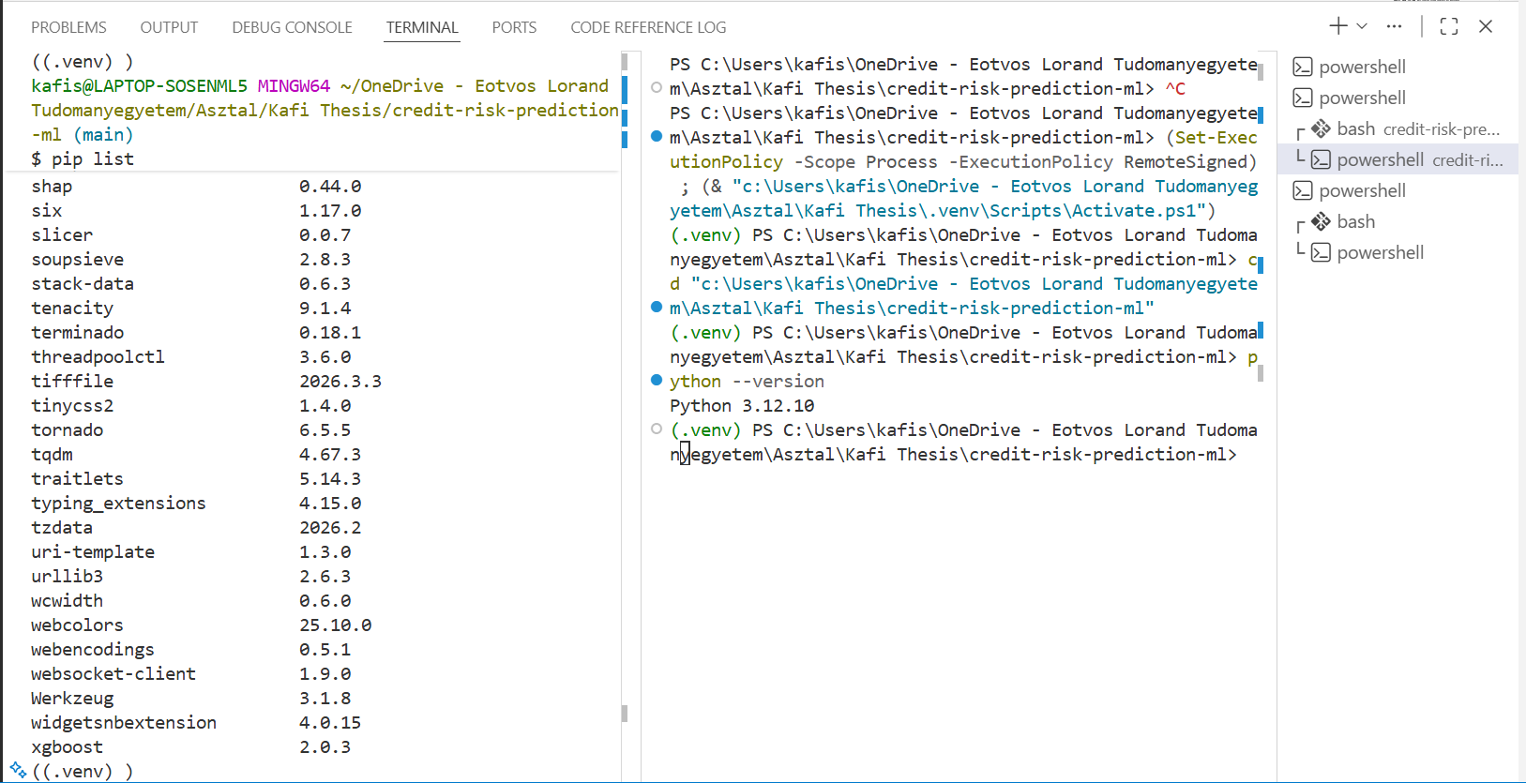
Figure 2.1: Python Environment and Dependency Validation

2.2 Installation and Setup
The installation process follows a reproducible sequence designed for users who may not be machine-learning specialists. Step 1 is repository acquisition. Clone the project and enter the root directory. Step 2 is environment preparation. Create and activate an isolated virtual environment to avoid package conflicts with system-wide Python modules. Step 3 is dependency installation through requirements.txt. Step 4 is data preparation. Execute the data loader and preprocessing modules so that the training and inference artifacts are generated in their expected directories. Step 5 is model training. Run the training module to produce saved models in the model storage folder. Step 6 is application startup. Launch the Flask application and open the provided URL in the browser.
Environment variables are optional but recommended for controlled deployment. The Flask host, port, and debug behavior can be configured through FLASK_HOST, FLASK_PORT, and FLASK_DEBUG. In production-like settings, the secret key should be set explicitly instead of relying on a default value. This setup pattern allows both a quick local demonstration and a more disciplined deployment profile for shared use.
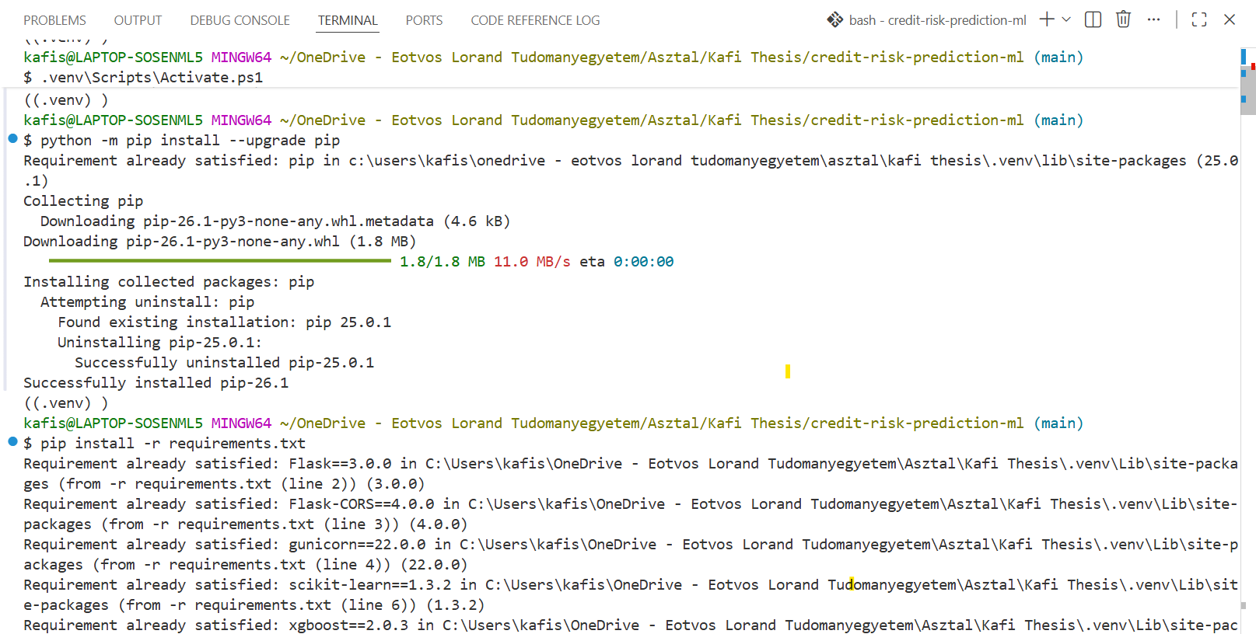
Figure 2.2: Virtual Environment Setup and Dependency Installation
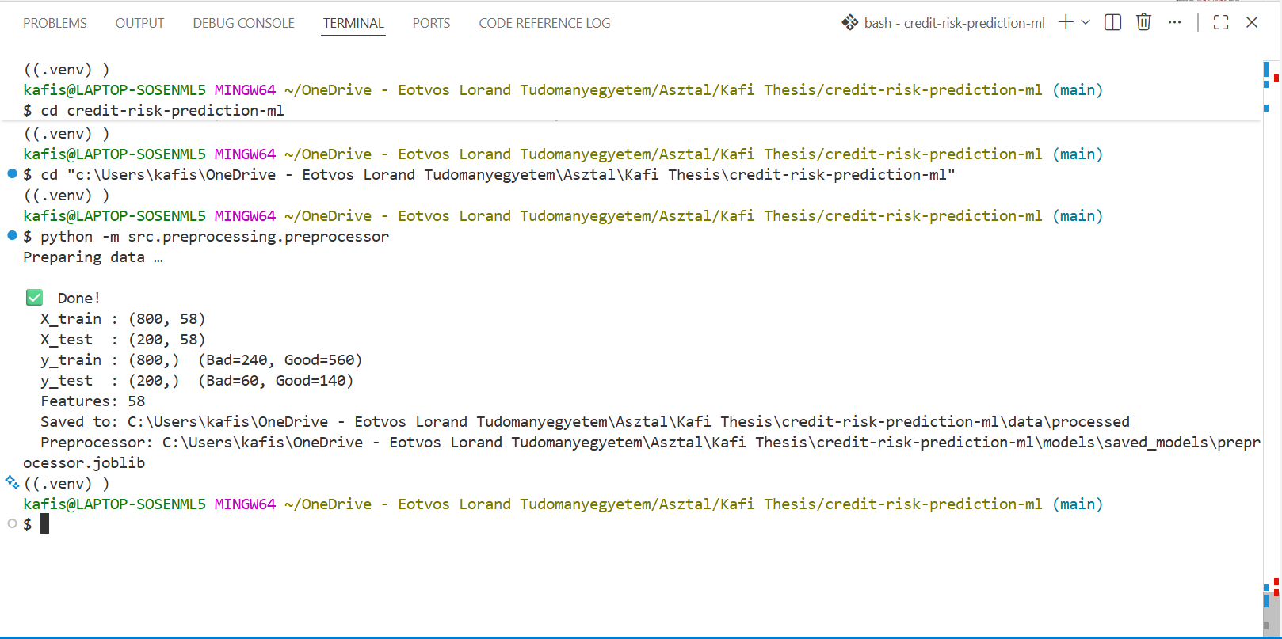
Figure 2.3: Data Preprocessing and Model Training Execution

2.3 Interface Overview
The interface is implemented as a single-page workflow optimized for guided data entry and immediate feedback. The page begins with a project header and a short welcome section, followed by the prediction workspace. The left panel contains a model-selection dropdown and a dynamically generated input form that is fetched from the backend schema endpoint. The right panel is initially hidden and becomes visible only after a successful prediction request. This panel displays the risk decision and a SHAP-based contribution chart that helps users understand the factors behind the output.
The design supports non-technical use by ensuring that field constraints and valid categorical values are obtained from the backend rather than hardcoded in the browser. Consequently, if schema options change in the backend, the form adapts without requiring manual frontend code edits for each field. This architecture minimizes UI drift and reduces user confusion caused by stale forms.
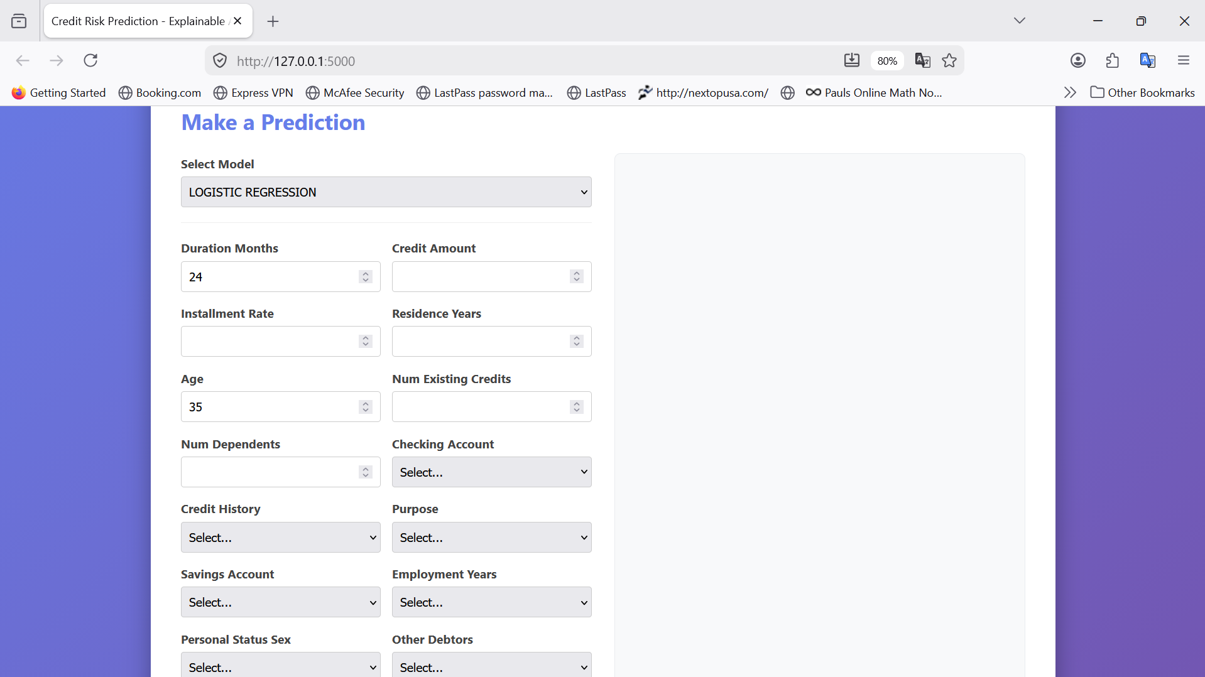
Figure 2.3: Overall Interface

2.4 Main Features and Functionalities
The software is organized around practical user-facing modules that correspond to the actual route and interaction design of the application.

2.4.1 Module A: Model Selection
User Flow: After page load, the system automatically queries the models endpoint and populates the model dropdown. The user clicks the Select Model field and chooses one of the available trained models, such as random_forest, logistic_regression, or xgboost. Expected Result: the selected model is included in the prediction request and the backend uses that model for scoring and explanation.
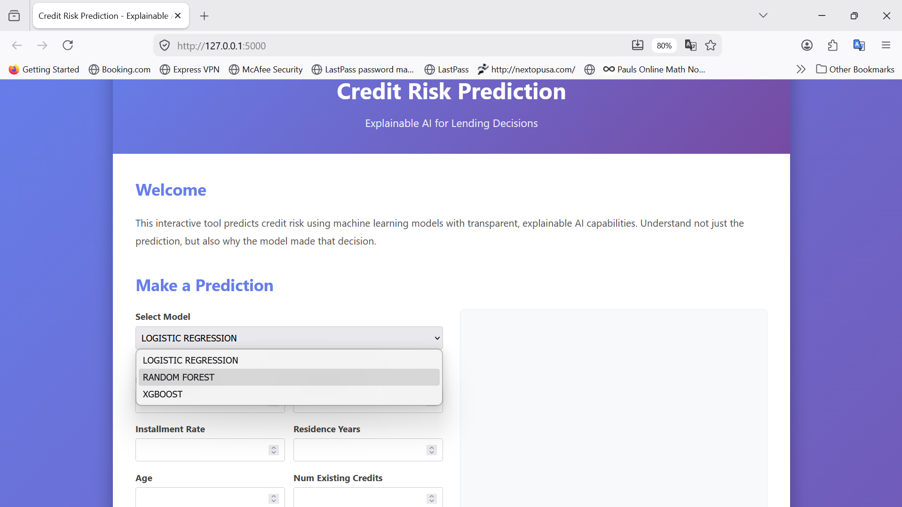
Figure 2.4.1: Model Selection Interface

2.4.2 Module B: Dynamic Input Form
User Flow: The frontend calls the schema endpoint and renders numerical and categorical fields automatically. The user fills all required fields, including numeric values such as age and credit amount, and categorical values such as employment status or housing type. Expected Result: the form enforces required inputs and valid option lists so only schema-compliant data can be submitted.
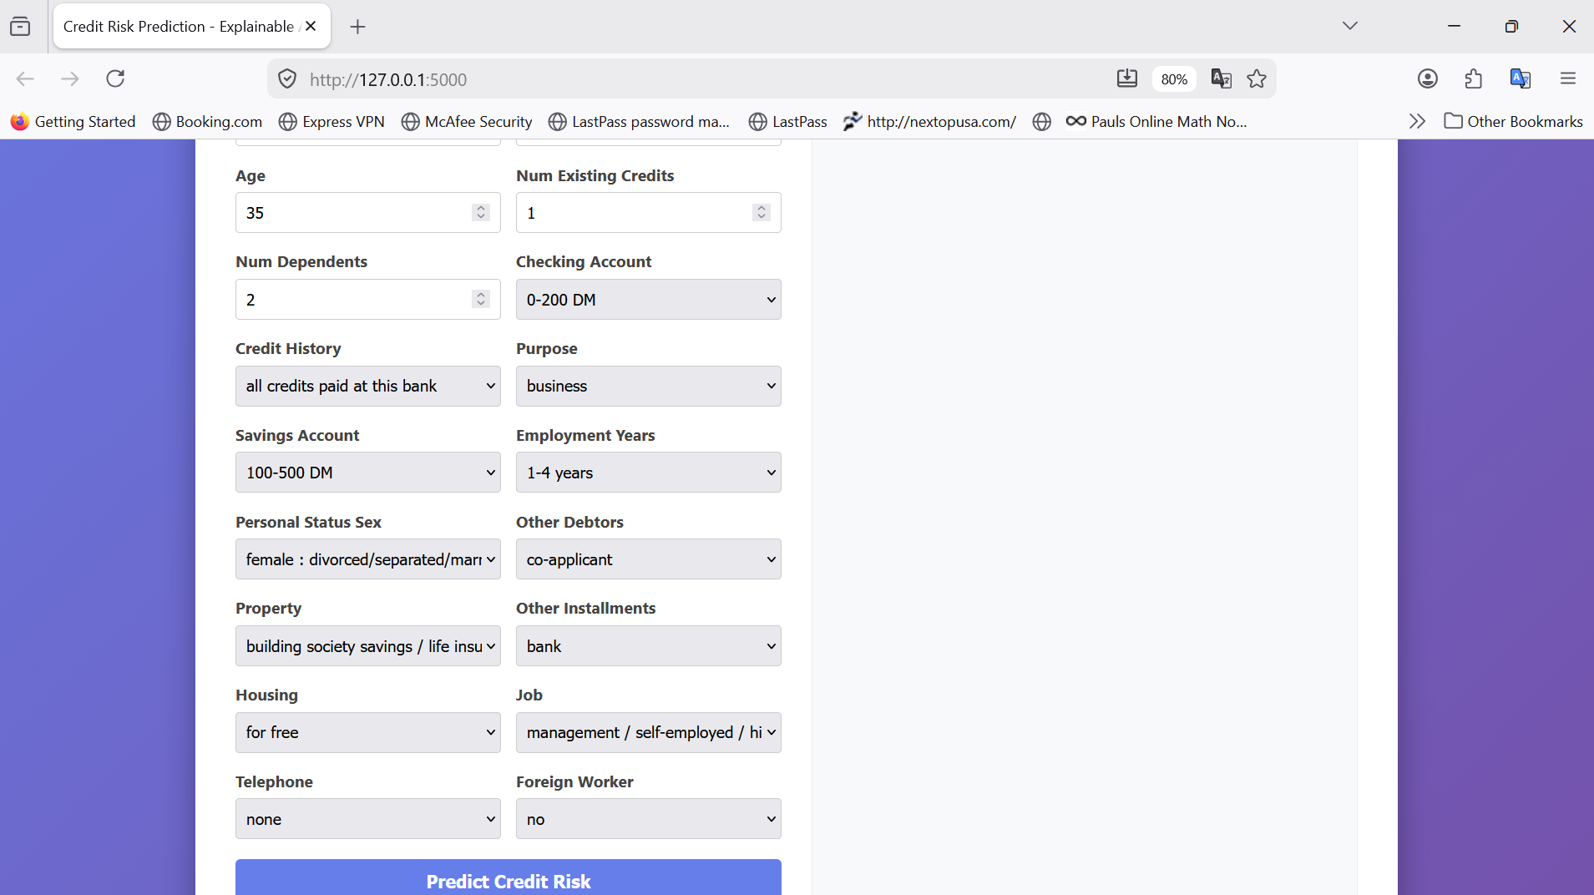
Figure 2.4.2: Input Form with Sample Data

2.4.3 Module C: Prediction Execution
User Flow: The user clicks Predict Credit Risk. The button enters a temporary Predicting state while the browser sends a JSON request to the predict endpoint. Expected Result: when validation succeeds, the backend returns status, class prediction, probability, risk level, model identifier, and explanation payload. The interface then displays the result card.

2.4.4 Module D: Decision Result and Confidence
User Flow: After receiving a successful response, the user reads the decision banner in the result panel. The banner shows either a low-risk good-credit outcome or a high-risk bad-credit outcome, together with confidence percentage derived from probability. Expected Result: users obtain an immediately interpretable decision summary suitable for first-level screening.
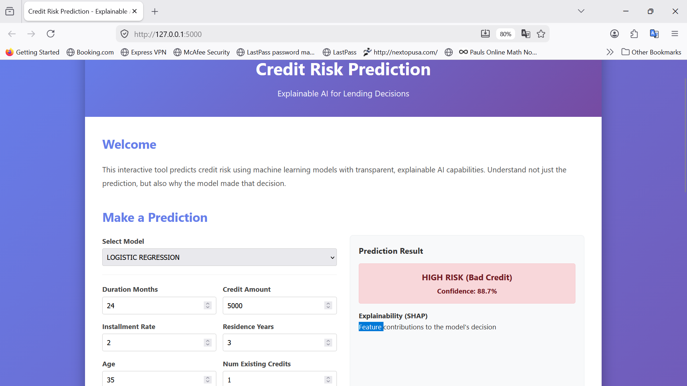
Figure 2.4.4: Decision Result and Confidence

2.4.5 Module E: Explainability Chart (SHAP)
User Flow: In the same result panel, the user inspects the horizontal bar chart that lists top SHAP feature contributions. Positive contributions indicate increased predicted risk, while negative contributions indicate decreased risk. Expected Result: the user can identify the most influential factors and understand the direction of each feature's effect on the final score.

Figure 2.4.5: Prediction Result with SHAP Explanation

2.4.6 Module F: Error Handling and Validation Feedback
User Flow: If fields are missing, out of range, or incorrectly typed, the backend returns validation errors and the frontend shows an error alert. Expected Result: users receive actionable feedback, correct the form inputs, and resubmit without restarting the page.
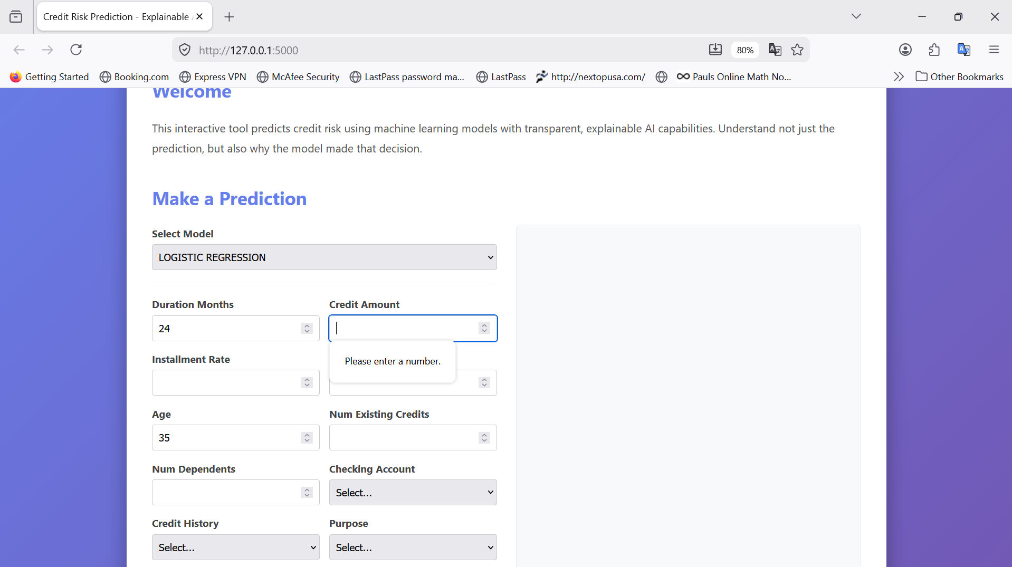
Figure 2.4.6: Input Validation and Error Feedback

2.5 User Roles and Permissions
In the current implementation, the system does not define account-based authorization layers such as Guest, User, and Admin. There is no login route, no role database, and no permission middleware in the Flask application. Functionally, this means all users who can access the web endpoint have identical capabilities: view the form, submit prediction requests, and inspect explanations.
For thesis completeness, this section should be interpreted as not applicable in the present version and as a design opportunity for future extension. A future role model could separate read-only demonstration access from privileged operational actions, such as model switching restrictions, prediction logging controls, or administrative model lifecycle operations.

2.6 Troubleshooting
Users may encounter setup and runtime issues that are typical for Python web applications with ML dependencies. If the page does not load, confirm that Flask is running and the configured host and port are correct. If form fields do not appear, verify that the schema endpoint is reachable and not blocked by backend startup failure. If prediction fails, check that trained model artifacts and the serialized preprocessor exist in the expected models directory and that input values remain within allowed ranges.
Dependency-related errors are also common, especially missing packages such as python-docx for documentation tooling or model libraries for inference. These should be resolved by reinstalling requirements in the active virtual environment. For incorrect prediction behavior or unexpected explanations, retrain models from a clean preprocessed dataset and restart the application to clear stale in-memory model instances. The health endpoint can be used as a quick operational check before deeper diagnosis.
Practical quick checks for non-technical users are: open the health route in a browser, ensure model names are listed in the model selector, ensure every required input field is filled, and retry prediction with a known valid test sample. For technical support, preserve terminal logs and the exact input scenario so the issue can be reproduced.

Chapter 3: Developer Documentation

3.1 System Architecture
The implemented system follows a layered pipeline architecture with clear separation between presentation, orchestration, machine-learning workflow, and persistence artifacts. At runtime, the web interface acts as the presentation layer, while Flask routes provide an application service layer that orchestrates request handling. The prediction core resides in the CreditRiskPredictor class, which coordinates input validation, feature transformation through a persisted preprocessor, model inference, and post-hoc explainability. In architectural terms, this combines service-layer orchestration with a modular domain pipeline, rather than a strict MVC pattern, because business logic is concentrated in reusable Python modules outside the route handlers.
Two design decisions are especially significant. First, the project uses serialized artifacts for the preprocessor and models, ensuring that training-time transformations and inference-time transformations are consistent. This directly supports the thesis objective of reproducibility and trustworthy evaluation. Second, the prediction service adopts a Singleton pattern for model access in web mode through get_instance. This reduces repeated disk I/O and deserialization overhead when handling multiple requests, while preserving model-switch support by re-instantiating when a different model slug is requested.
The interaction pattern can be described as request-driven deterministic flow. The frontend obtains the form schema and model list from dedicated endpoints, builds the UI dynamically, and submits one structured applicant record. The backend then executes an invariant sequence: validate input schema and ranges, transform by fitted pipeline, compute class and probability, derive risk level, then compute explanation vectors. This sequencing enforces a stable contract between modules and avoids route-level code duplication.
[IMAGE PLACEHOLDER: System Architecture Diagram / UML Class Diagram]
Instruction: Provide a detailed UML or flow diagram showing how the main components communicate.

3.2 Technology Stack
Python is selected as the implementation language because it offers mature libraries for machine learning, interpretability, and scientific data handling in a single ecosystem. Flask is chosen as the backend framework due to its lightweight routing model and low ceremony, which is appropriate for an academic prototype where control over endpoint behavior is preferred over framework abstraction. The frontend is intentionally minimal (HTML, CSS, JavaScript with Chart.js) to keep the focus on model interaction quality rather than framework complexity.
For modelling, scikit-learn is used for preprocessing, classic estimators, and cross-validation utilities, while XGBoost is included for high-performing boosted trees on tabular data. SHAP and LIME are both integrated for explainability, but with different roles: SHAP is in the primary prediction response path, whereas LIME serves as a complementary local explanation method and experimentation utility. Pandas and NumPy provide data-frame and array-level operations that make the pipeline testable and deterministic.
This stack reflects a deliberate trade-off aligned with Chapter 1 objectives: maximize interpretability and reproducibility without introducing unnecessary platform complexity such as a database server or frontend SPA framework. Because the dataset is static and bounded, file-based artifact persistence through NumPy and joblib is sufficient and keeps deployment simple for examination environments.

3.3 Data Model and Structures
The application does not use a relational database schema in its current form. Instead, it uses a file-backed data model and in-memory tabular structures. The raw source is the German Credit file with 20 input attributes and one target attribute. Inputs are partitioned into two explicit lists: numerical columns and categorical columns. This separation is not cosmetic; it drives the ColumnTransformer branches and ensures type-aware preprocessing. Category mapping dictionaries convert encoded domain codes into human-readable labels, which are then reused by validation and schema generation to guarantee frontend-backend consistency.
Primary structures include: DataFrame rows for raw and validated records; NumPy arrays for transformed train/test matrices; serialized preprocessor and model objects as joblib artifacts; and structured JSON dictionaries for API contracts. Validation constraints are represented as dictionary-based range and option sets, yielding explicit and inspectable rule definitions. The schema endpoint exports these structures into frontend-consumable field descriptors, which is effectively a lightweight metadata model for dynamic form generation.
Key classes and objects in the developer data model are the CreditRiskPredictor service object, the fitted ColumnTransformer pipeline, estimator instances for Logistic Regression, Random Forest, and XGBoost, and explainer objects generated per model family. Together they form a typed transformation graph from user payload to interpreted decision output.
[IMAGE PLACEHOLDER: ER Diagram or Database Schema]
Instruction: Since no relational database is used, provide a data-structure diagram showing raw dataset fields, transformed feature matrix, model artifacts, and API JSON contracts.

3.4 Implementation Logic and Key Algorithms
The computational engine of the application is the predict method of the CreditRiskPredictor module. This method operationalizes a multi-stage decision function where every stage has explicit failure behavior. Stage 1 performs schema and semantic validation, preventing malformed requests from reaching model inference. Stage 2 applies the persisted preprocessing pipeline to enforce training-inference parity. Stage 3 performs probabilistic inference via predict_proba and class inference via predict. Stage 4 computes explanation vectors and extracts top positive and negative feature contributors. The final output object merges machine output and interpretability metadata into one stable response contract.
The training engine is similarly modular. Data is split with stratification to preserve class distribution in train and test sets, avoiding optimistic evaluation due to imbalance distortion. The preprocessing pipeline uses imputation and encoding before model fit, and optional SMOTE can be applied only to the training subset to avoid leakage. Model training supports optional hyperparameter tuning for tree-based models using GridSearchCV. Evaluation computes both threshold-based and ranking-based metrics, then supplements holdout metrics with stratified cross-validation summary statistics to improve robustness of model comparison.
Explainability logic includes model-sensitive explainer selection. Tree models use TreeExplainer when possible; logistic regression uses LinearExplainer; and compatibility fallback can use KernelExplainer with background summarization. This strategy acknowledges that interpretability algorithms have model-dependent assumptions and runtime profiles. Therefore, explanation is treated as a first-class algorithmic branch, not as a visualization afterthought.
Pseudocode: End-to-End Prediction Pipeline
FUNCTION Predict(raw_input, model_name, explain=True):
model_service <- CreditRiskPredictor.get_instance(model_name)
validated_df, errors <- validate_input(raw_input)
IF errors NOT EMPTY: RETURN error_response(errors)
x_transformed <- model_service.preprocessor.transform(validated_df)
probability <- model.predict_proba(x_transformed)[class_1]
prediction <- model.predict(x_transformed)
risk <- map_probability_to_risk_level(probability)
response <- {prediction, probability, risk, model_name}
IF explain:
explanation <- shap_explain(model, x_transformed[0], feature_names, background)
response.explanation <- top_positive_negative(explanation)
RETURN success_response(response)

Pseudocode: Training and Evaluation Workflow
FUNCTION TrainAndEvaluate(use_smote=False, tune=False):
X_train, X_test, y_train, y_test, preprocessor <- prepare_data(use_smote)
models <- {LogisticRegression, RandomForest, XGBoost(scale_pos_weight)}
FOR each model IN models:
IF tune AND model supports grid-search: model <- GridSearchCV(model)
fit(model, X_train, y_train)
metrics_test <- evaluate_model(model, X_test, y_test)
metrics_cv <- cross_validate_model(fresh_model_instance, X_all, y_all)
persist(model)
RETURN ranked_models_by_metric(metrics_test, metric='roc_auc')

3.5 API and Module Documentation
The public API layer consists of five Flask routes. The root route serves the interface template. The schema route returns input metadata for all required fields, including numerical bounds and categorical options. The models route lists persisted model slugs available for inference. The predict route accepts JSON input, optionally with model selection, and returns status, decision outputs, and explanation payload. The health route returns a minimal heartbeat status for operational checks.
Module-level responsibilities are intentionally strict. The data_loader module encapsulates dataset column definitions and categorical decoding. The preprocessor module encapsulates transformation pipeline creation, splitting strategy, and artifact persistence. The train_models module defines model factories, training orchestration, tuning branch logic, and model loading utilities. The evaluate module provides metrics and cross-validation abstractions. The prediction subsystem encapsulates validation and orchestration logic, while explainability modules isolate SHAP and LIME mechanics. This cohesion reduces side effects and supports targeted unit testing.
The frontend JavaScript layer consumes backend contracts instead of duplicating domain rules. It loads model and schema metadata, serializes form values to JSON, sends asynchronous prediction requests, and renders response data into decision banners and chart views. This contract-driven frontend design minimizes mismatch risk and simplifies future schema evolution.

3.6 Security and Optimization
From a security perspective, the dominant controls in the current release are input validation, constrained schema options, and controlled error handling. Validation ensures required fields, type correctness, and bounded numerical ranges. Categorical values are checked against explicit whitelists, reducing the chance of malformed payload propagation. The API returns structured error objects rather than failing silently, improving diagnosability while preserving endpoint stability.
The system does not yet implement authentication, authorization, CSRF protection, or encrypted secret management beyond configurable environment variables. For a production extension, these should be prioritized together with request rate limiting and audit logging. Nevertheless, for thesis scope and local deployment, the present controls are adequate to demonstrate integrity at the data-validation and pipeline-consistency levels.
Performance optimization decisions are explicit in the architecture: singleton-based model reuse avoids repeated model deserialization, preprocessing artifacts are persisted and reused, and SHAP background sampling caps explainability cost. The training subsystem supports parallelism through estimator-level n_jobs and GridSearchCV parallel execution. These optimizations target the real bottlenecks in tabular ML applications: repeated initialization overhead and expensive explanation computations.
In relation to Chapter 1 goals, the architecture achieves a balanced engineering profile: it is sufficiently rigorous to support reproducible scientific discussion, yet sufficiently lightweight for demonstrable user-facing deployment. The resulting developer design is coherent around one central principle: transparent, testable, and explainable credit-risk decision support.

Chapter 4: Conclusion

4.1 Summary of Results
The project achieved the three core objectives set in Chapter 1 through an integrated technical implementation. First, it delivered a complete end-to-end prediction system: user input is validated, transformed by the persisted preprocessing pipeline, evaluated by a selectable trained model, and returned with an interpretable risk output. Second, it implemented comparative modelling with Logistic Regression, Random Forest, and XGBoost, together with holdout and cross-validated evaluation metrics, enabling methodologically meaningful model selection rather than single-model reporting. Third, it operationalized explainable AI in the runtime path by attaching SHAP-based feature contributions to each prediction response, thereby addressing the transparency requirement that motivated the thesis.
At software-engineering level, these results are supported by modularization and reproducibility controls. Data loading, preprocessing, training, evaluation, prediction, and explainability were separated into dedicated modules with focused responsibilities. Serialized artifacts (preprocessor and model objects) ensured consistency between training and inference phases, and the web interface consumed backend schema metadata dynamically, reducing form drift and maintaining contract alignment. This confirms that the practical software objective was not only algorithmic performance, but also deployable and inspectable behavior for non-technical stakeholders.

4.2 Critical Evaluation and Discussion
The most significant achievement is the synthesis of predictive modelling and interpretability in one coherent application workflow. Many baseline credit-scoring demonstrations terminate at probability output, whereas this system delivers a user-facing explanation artifact for each prediction. This is a material improvement over opaque scoring prototypes because decision consumers can inspect directional feature impact instead of trusting a scalar score in isolation. The inclusion of model alternatives further strengthens the contribution by exposing trade-offs among linear transparency, ensemble robustness, and boosted-tree performance.
Compared with the background solutions discussed in Chapter 1, the project occupies an intermediate but valuable position. It is more transparent than black-box-only implementations, yet more expressive than rigid rule-based scoring approaches that cannot model higher-order interactions effectively. From a research perspective, this balance is important: the work demonstrates that explainability does not need to be postponed to offline analytics, but can be integrated into the operational inference path. From a software perspective, the architecture shows that this integration is feasible with modest infrastructure using Python and Flask, which is relevant for academic and small-team deployment contexts.

4.3 Limitations
Several limitations remain and should be interpreted carefully. The dataset is a standard benchmark with fixed size and historical context, which constrains external validity when extrapolating to contemporary multi-source banking environments. The current application also lacks authentication and role-based authorization, so all users with endpoint access share identical operational privileges. For thesis scope this was acceptable, but for institutional deployment it is insufficient.
From a technical standpoint, explanation latency can become a bottleneck when SHAP computations are requested at high throughput, especially for more computationally expensive explainers or larger background sets. Model lifecycle governance is also minimal: there is no automated drift detection, no model version registry, and no persistent prediction audit trail. Error handling is structured and user-visible, but observability remains lightweight without centralized logging, tracing, or alerting. Finally, frontend interaction is intentionally simple and does not yet offer workflow features such as batch inference, saved scenarios, or report export for audit use.

4.4 Future Work
Future development can proceed along four dimensions. First, governance and security: add authentication, role-aware permissions, request-level audit logging, and stricter secret/key management. Second, MLOps maturity: introduce model versioning, automated retraining triggers, drift monitoring, and reproducible experiment tracking. Third, scalability and architecture: migrate from single-process Flask serving to containerized deployment with reverse proxying, horizontal scaling, and asynchronous task offloading for expensive explanation jobs. Fourth, user-facing capability: support batch uploads, downloadable explanation reports, and configurable threshold policies aligned with institutional risk appetite.
Methodologically, future research can also evaluate calibration quality, fairness-sensitive metrics across protected groups, and scenario-based stress testing under distribution shift. Alternative modelling approaches such as calibrated gradient boosting variants, monotonic constraints, or hybrid scorecard-ML ensembles may further improve the balance between interpretability and predictive stability. These extensions would preserve the thesis core principle while extending practical relevance for production credit ecosystems.

4.5 Concluding Remarks
This thesis contributes to the identified niche by demonstrating a concrete, working bridge between accurate tabular credit-risk prediction and explainable decision support. The final system is not merely a model benchmark; it is an integrated software artifact that operationalizes validation, inference, explanation, and human-readable interaction in one pipeline. The resulting contribution is therefore both technical and methodological: it offers a reproducible implementation pattern for explainable credit analytics and provides a foundation for subsequent academic and industrial extensions.
Reference List
Biecek, P., & Burzykowski, T. (2021). Explanatory Model Analysis: Explore, Explain, and Examine Predictive Models. Chapman and Hall/CRC.
Breiman, L. (2001). Random forests. Machine Learning, 45(1), 5-32.
Chen, T., & Guestrin, C. (2016). XGBoost: A scalable tree boosting system. Proceedings of the 22nd ACM SIGKDD International Conference on Knowledge Discovery and Data Mining, 785-794.
Dua, D., & Graff, C. (2019). UCI Machine Learning Repository [German Credit Data]. University of California, Irvine, School of Information and Computer Sciences. http://archive.ics.uci.edu/ml
Flask Documentation. (2026). Flask: Web development, one drop at a time. https://flask.palletsprojects.com/
Lundberg, S. M., & Lee, S.-I. (2017). A unified approach to interpreting model predictions. Advances in Neural Information Processing Systems, 30.
Molnar, C. (2022). Interpretable Machine Learning (2nd ed.). https://christophm.github.io/interpretable-ml-book/
Pedregosa, F., Varoquaux, G., Gramfort, A., Michel, V., Thirion, B., Grisel, O., Blondel, M., Prettenhofer, P., Weiss, R., Dubourg, V., Vanderplas, J., Passos, A., Cournapeau, D., Brucher, M., Perrot, M., & Duchesnay, E. (2011). Scikit-learn: Machine learning in Python. Journal of Machine Learning Research, 12, 2825-2830.
Ribeiro, M. T., Singh, S., & Guestrin, C. (2016). Why should I trust you? Explaining the predictions of any classifier. Proceedings of the 22nd ACM SIGKDD International Conference on Knowledge Discovery and Data Mining, 1135-1144.
Wes McKinney. (2010). Data structures for statistical computing in Python. Proceedings of the 9th Python in Science Conference, 56-61.
Appendix: AI Usage Declaration
This appendix declares the use of AI-assisted drafting support during thesis documentation preparation. AI support was used to organize chapter structure, produce candidate wording, and transform codebase observations into technical prose. The final scientific interpretation, argument selection, and acceptance of written content remained under student control.
A.1 Prompt Summary by Chapter
Chapter 1 prompts focused on establishing introduction, motivation, problem framing, background, and objective alignment based on real code architecture and thesis requirements. Purpose: structuring and initial drafting of academic narrative from validated implementation details.
Chapter 2 prompts focused on user documentation workflows, UI behavior, endpoint-driven interaction, setup steps, and troubleshooting guidance, including mandatory screenshot placeholders and capture instructions. Purpose: practical procedural writing for non-technical users.
Chapter 3 prompts focused on developer-level synthesis of architecture, module responsibilities, data flow, algorithmic pipeline logic, and design rationale with implementation-aware depth. Purpose: technical synthesis and critical architectural explanation.
Chapter 4 prompts focused on critical reflection, limitations, future work, and academic closure, plus document-wide finalization tasks (TOC, references, and declaration). Purpose: evaluative interpretation and completion of the thesis narrative.
A.2 Verification Statement
The student author reviewed and verified the final interpretations, technical claims, and conclusions before submission. AI-generated text was treated as draft assistance, and responsibility for correctness, citation quality, and academic integrity remains with the student.

