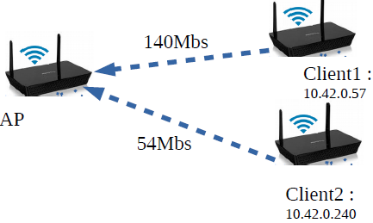
Classe root
Rate=150Mbs
ceil=150Mbs
Filtre 1
Discipline
de file 1
Discipline
de file 2
Filtre 2
Classe1
Classe2
Rate=13Mbs
ceil=26Mbs
Rate=55Mbs
ceil=110Mbs
IP dest=.57
IP dest=.240

