802.11 BSS1 802.11 BSS2 802.11 BSS3
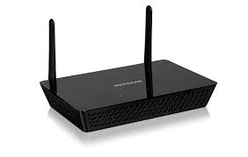


Ethernet Switch

Ethernet

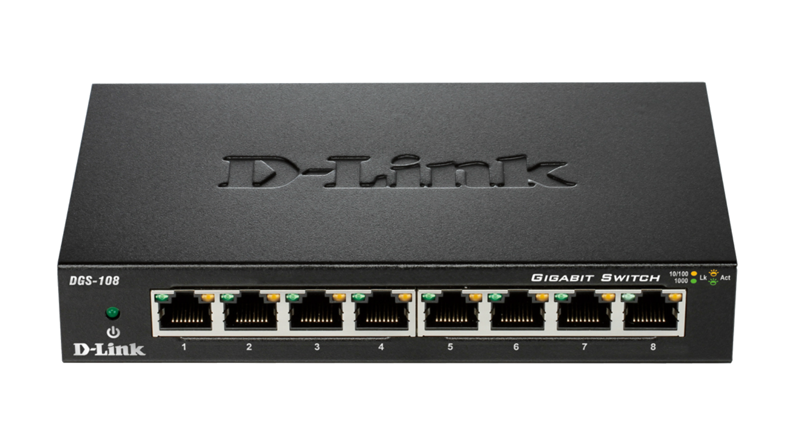
Ethernet Switch

802.3 LAN segment 2

802.3 LAN segment 2

