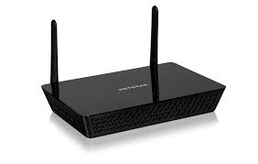
802.11
BSS 2
802.11
BSS 3
802.11
BSS 3
802.11
BSS 3
802.11
BSS 2
802.11
BSS 1
802.11
BSS 1
802.11
BSS 2
802.11
BSS 1


LAN
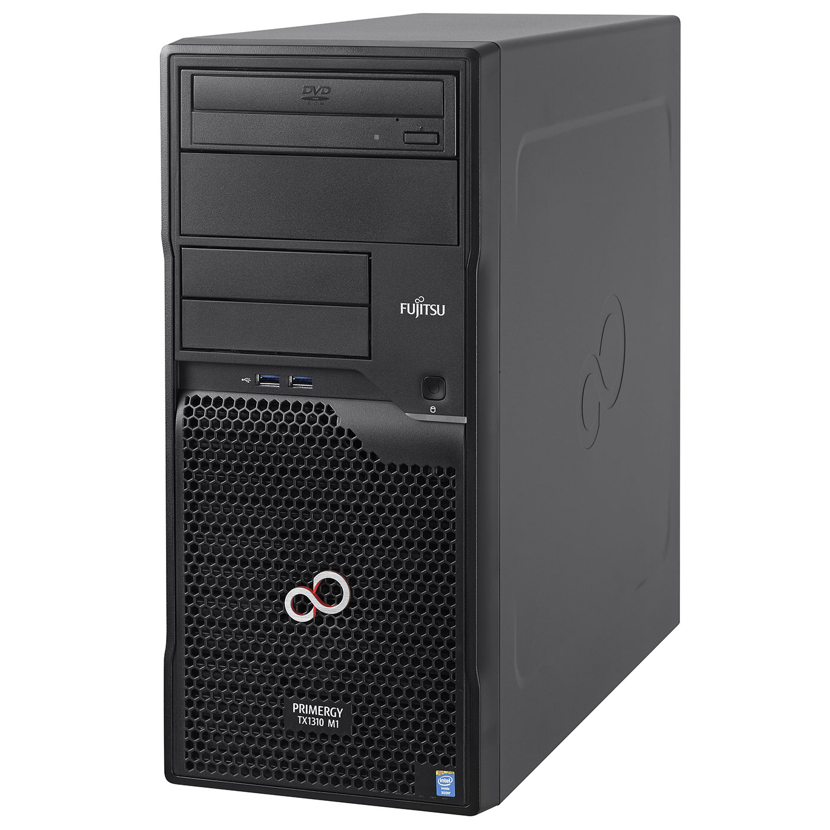
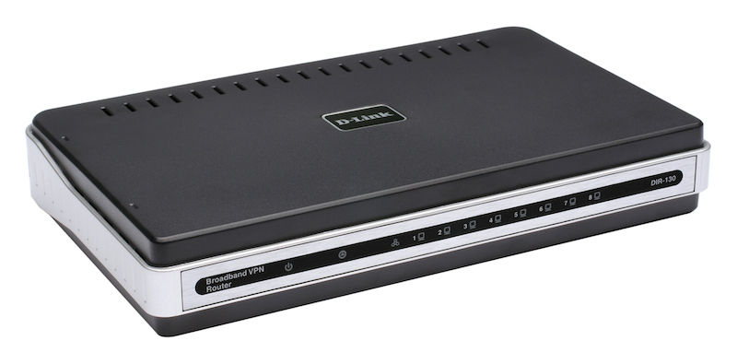
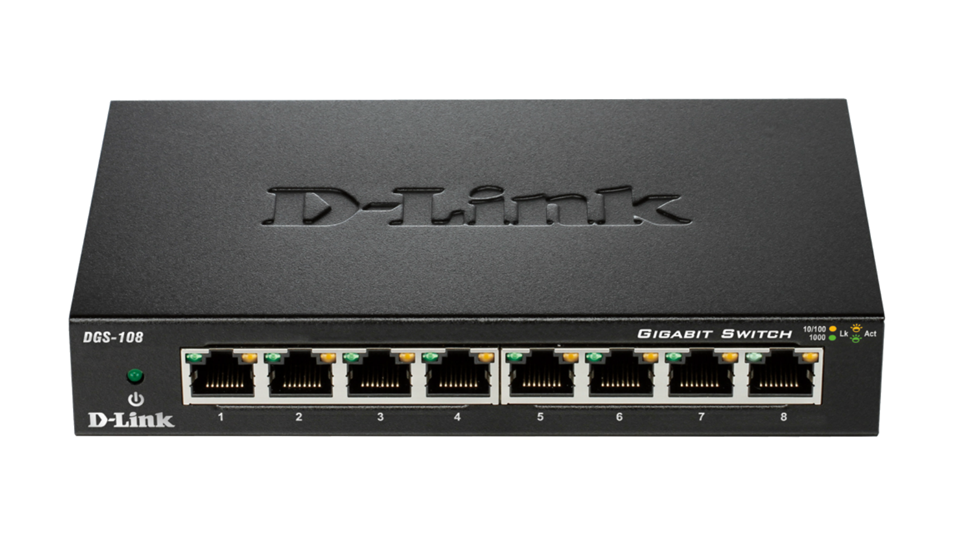
Switch
Router
AC
AC
AC
LAN
LAN
LAN

(a) Direct Connection (b) switched Connection (c) Routed Connection

