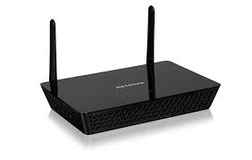

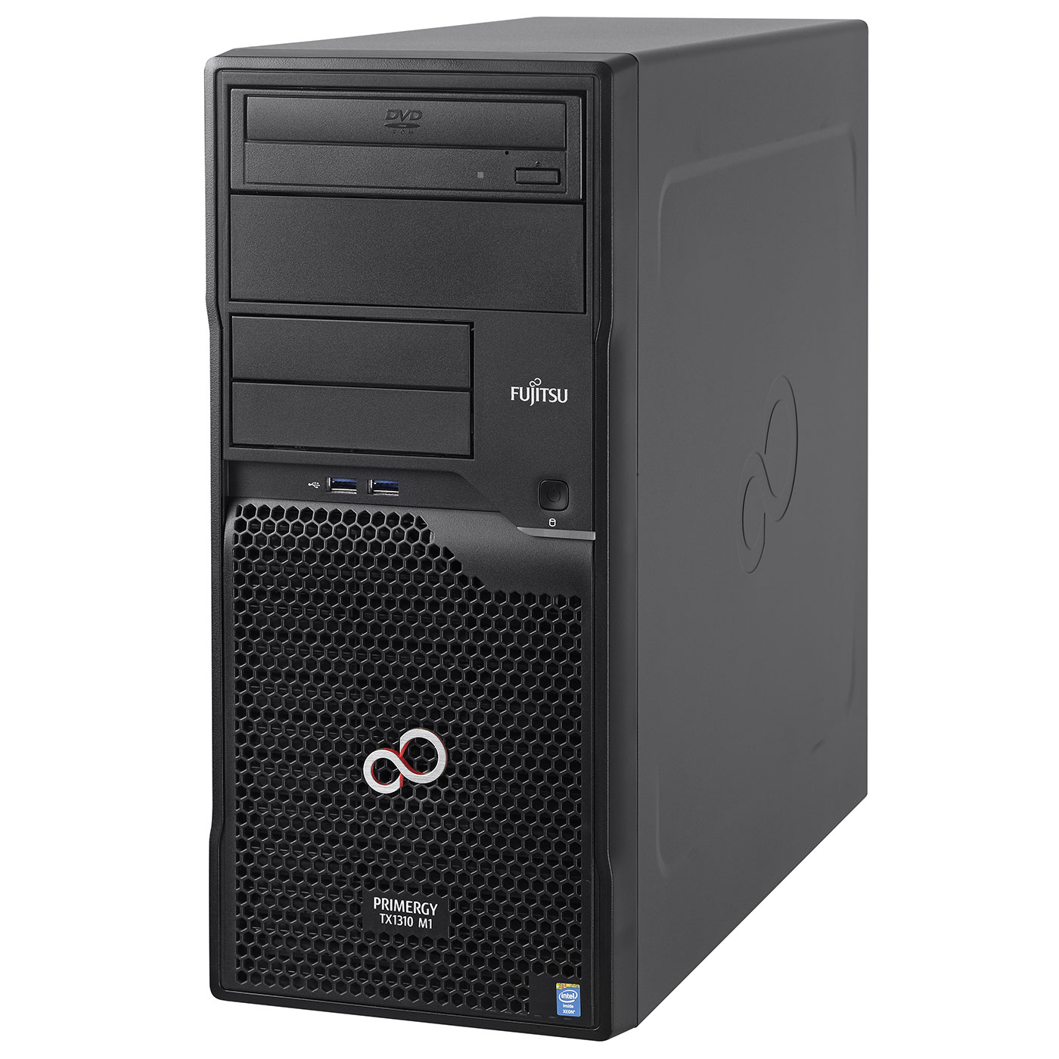


Prioritisation
Localisation
Client-AP association /
Load Balancing
Decision
Making
Data
Base
SDN Controller
Cloud/Internet
Cooperation
Access Point
Mobile Clients

