


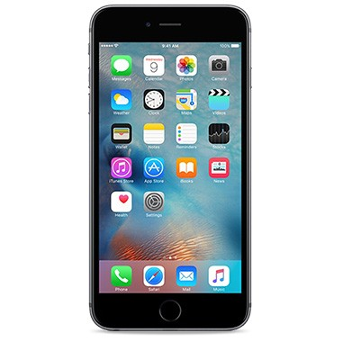
2
2
16
10
3
User 1
User 2
user3
AP1
AP2
Time Fairness
Case 1
AP1
AP2
1
User 1
8
User 2
2
User 3
Time Fairness
Case 2
Access Fairness
AP1
AP1
AP2
AP2
16/9
User 1
2
User 1
16/9
User2
3/2
User 2
2
User 3
1
User 3
Aggregate throughput=11
Aggregate throughput= 50/9 =5,55
Aggregate throughput=9/2 =4,5
1/2 Second
1/2 Second
1/9 Second
8/9 Second

