

**BANGLADESH UNIVERSITY OF ENGINEERING AND TECHNOLOGY**

**Department of Electrical and Electronic Engineering**

**Course No:** EEE 306 **Course Title:** Power System I Laboratory

**Project Report Title:**

**Placement of FACTS Device**

**to Improve Load Flow in Power System using MATLAB**

**Submitted to:**

Md. Fatin Ishraq Faruqui

Lecturer (PT), Department of EEE

Bangladesh University of Engineering & Technology.

&

Kazi Ishrak Ahmed

Lecturer (PT), Department of EEE

Bangladesh University of Engineering & Technology.

**Submitted by:**

Muktadir Hasan Wafi 2006039 Department : EEE

Kafi Anan 2006040 Level : 3

Md. Zobayer Nabil 2006041 Term : 1

Md. Ariful Islam 2006042 Section : A2

Zubairul Hasan Souhardo 2006043 Group : 02

# Table of Contents

1. Table of Contents ii

2. List of Figures: iii

3. Abstract 1

4. Introduction 1

5. Design 3

Introduction to Newton-Raphson Method 3

Algorithm for Newton Raphson Load Flow Method 3

Algorithm Flow Chart 7

GIPFC (Generalized Interline Power Flow Controller): 9

Power mismatches equations of GIPFC 12

Jacobian elements related to Current Injection Model of GIPFC: 12

6. Implementation 14

IEEE 30-Bus System: 14

Results and Analysis: 17

Combination Matrix of GIPFC Locations 17

Normal Loading Condition: 19

At 125% Loading Condition: 21

At 150% Loading Condition: 22

175% Loading Condition: 24

200% Loading Condition: 25

Recovery of Dysfunctional Generators: 27

7. Reflection on Individual and Teamwork Individual Contribution of Each Member 28

Mode of Teamwork 29

Diversity Statement of Team 29

Logbook of Project Implementation 30

8. Discussion 30

9. References 31

# List of Figures:

Figure 1: System of equations in vector-matrix form for a 4 bus system 5

Figure 2: Algorithm Flow Chart 7

Figure 3: GIPFC circuit diagram 10

Figure 4: GIPFC current injection model 10

Figure 5: IEEE 30-Bus System 14

Figure 6: Results of 5-Bus System from textbook 17

Figure 7: Results of 5-Bus System from code 17

Figure 8: Bus Voltage and Reactive Power Condition 19

Figure 9: Bus Voltage and Reactive Power Condition 21

Figure 10: Bus Voltage and Reactive Power Condition 23

Figure 11: Bus Voltage and Reactive Power Condition 24

Figure 12: Bus Voltage and Reactive Power Condition 26

# Abstract

The reliability and stability of power systems are paramount considerations in the face of increasing demand, renewable energy integration, and the need for sustainable energy solutions. This project investigates the impact of Flexible AC Transmission Systems (FACTS) devices on the IEEE-30 bus system, focusing on the enhancement of voltage profile, power flow, and the minimization of transmission line losses. FACTS devices, known for their ability to dynamically control and optimize power system parameters, have gained prominence in addressing the challenges associated with modern power grids. The study employs advanced simulation techniques to integrate FACTS devices into the IEEE-30 bus system, evaluating their effectiveness in mitigating voltage fluctuations, improving power flow distribution, and reducing transmission line losses. Through detailed analysis and simulation runs, the project demonstrates the tangible benefits of FACTS devices in optimizing the overall performance and efficiency of the power system. Results indicate a substantial improvement in voltage stability at excess load demand, with a notable enhancement in the voltage profile across the network. The incorporation of FACTS devices also leads to a more balanced and efficient power flow distribution, addressing potential bottlenecks and enhancing the overall reliability of the system. Furthermore, a significant reduction in transmission line losses is observed, contributing to increased energy efficiency and economic viability.

# **Introduction**

In the field of electrical engineering, the power flow problem is a fundamental aspect of power system analysis, aiming to determine the steady-state operating conditions of an electrical network. This project focuses on the improvement of voltage profile and power flow using FACTS device which is one of the most widely used techniques for enhancing the stability of power system.

Flexible Alternating Current Transmission Systems (FACTS) devices have revolutionized the field of power system control and operation. These devices provide dynamic control of AC transmission systems, offering flexibility and efficiency in managing power flow, voltage stability, and grid reliability. FACTS devices are a family of power electronics-based systems designed to enhance the controllability and flexibility of AC transmission systems. These devices utilize advanced power electronics technology to dynamically control the voltage, current, and phase angle of electricity flowing through the transmission lines. By exerting precise control over these parameters, FACTS devices enable utilities to optimize power flow, mitigate voltage fluctuations, and improve overall system stability.

There are several types of FACTS devices, each tailored to address specific challenges encountered in power transmission systems. These devices include Static Var Compensators (SVCs), Static Synchronous Compensators (STATCOMs), Thyristor-Controlled Series Capacitors (TCSCs), Unified Power Flow Controllers (UPFCs) and Gate-injected Power Flow Controller (GIPFC) among others. Each type of FACTS device offers unique capabilities in regulating voltage, enhancing transient stability, and controlling power flow within the grid.

The working principle of FACTS devices revolves around their ability to inject or absorb reactive power into the transmission system. Reactive power, which oscillates between sources and loads, plays a crucial role in maintaining voltage levels and ensuring the efficient transfer of electrical energy. FACTS devices leverage this principle by dynamically adjusting the phase angle and magnitude of voltage across transmission lines, thereby influencing the flow of reactive power and optimizing system performance.

FACTS devices operate by continuously monitoring the electrical parameters of the transmission system and dynamically adjusting their control elements to maintain desired operating conditions. Through rapid and precise modulation of voltage and current, FACTS devices offer utilities unprecedented control over power transmission, enabling them to enhance grid stability, increase transmission capacity, and improve overall system reliability.

The GIPFC is used in our project. The Gate-Injected Power Flow Controller (GIPFC) is a sophisticated FACTS device designed to optimize power flow control in AC transmission systems. GIPFC is a relatively recent addition to the family of FACTS devices, offering enhanced capabilities for managing power flow and voltage stability within the grid. At the heart of GIPFC lies its innovative control mechanism, which utilizes power electronic converters and gate-injected thyristors to regulate power flow through transmission lines. Unlike traditional FACTS devices, which primarily focus on voltage and reactive power control, GIPFC introduces a novel approach by directly manipulating the active power flow within the system.

The GIPFC system consists of two main components: the gate-injected thyristor-based phase shifter and the power flow controller. The phase shifter module employs gate-injected thyristors to dynamically adjust the phase angle of the AC voltage, enabling precise control over power flow direction and magnitude. This phase-shifting capability allows GIPFC to actively manage power flow in real-time, facilitating congestion relief and optimal utilization of transmission assets.

# Design

## Introduction to Newton-Raphson Method

The Newton-Raphson method, named after Isaac Newton and Joseph Raphson, is an iterative numerical technique for finding the roots of a non-linear system of equations. Originally developed for solving general equations, the method has found widespread application in power system analysis due to its efficiency and accuracy. Tailor’s series expansion for a function of two or more variables is the basis for the newton Raphson method of solving the power flow problem.

## Algorithm for Newton Raphson Load Flow Method

**1. Initialization:**

* Start with initial guesses for the voltage magnitudes and phase angles at all buses. The voltage and angle (|v| and δ) at slack bus are fixed, assume |v| and δ at all PQ buses and δ at PV buses. (Generally flat voltage start is assumed, i.e. |v| = 1.0 and δ = 0).
* Set a convergence criterion (ε) and a maximum number of iterations (max_iter).

**2.Iterative Process:**

* Calculate the power mismatches at each bus by comparing calculated power injections with specified power injections.
* Check if the maximum mismatch is smaller than the convergence criterion (ε). If so, exit the loop as the solution has converged.
* Here if reactive power limits of generator bus are violated (i.e. Qg is greater than Qmax or Qg is less than Qmin), PV bus is changed to PQ bus during that iteration and the value of Q is taken as its upper/lower limit Qmax/Qmin depending on type of violation.
* Construct the Jacobian matrix, which represents the sensitivity of power mismatches to changes in voltage magnitudes and phase angles.
* Solve a linear system of equations to find voltage increments (changes in voltage magnitudes and phase angles).
* Update the voltage magnitudes and phase angles using the calculated increments.
* Here if the voltage limits of PQ bus are violated (i.e. |V| is greater than |Vmax| or |V| is less than |Vmin|), PQ bus is changed to PV bus during that iteration and the value of V is taken as its upper/lower limit |Vmax|/|Vmin| depending on type of violation.
* Repeat the loop until convergence or until the maximum number of iterations is reached.

**3. Convergence Check:**

* After each iteration, check if the power mismatches are below the convergence criterion. If so, the solution has converged.

**4. Output:**

* Once the solution converges, output the final values of voltage magnitudes and phase angles.

In essence, the Newton-Raphson method iteratively adjusts voltage magnitudes and phase angles at each bus until the calculated power injections match the specified injections within a certain tolerance. This iterative process converges to a solution that satisfies the power flow equations for the entire network.

**5. Mathematical Formulation**

The power flow equations describe the relationship between nodal voltages, power injections, and network parameters in an electrical system. These equations are derived from Kirchhoff's laws and power balance principles, resulting in a set of non-linear equations that must be solved simultaneously.

The power flow equations can be represented as follows:

Pi = |Vi|2Gii +

Qi = -|Vi|𝟐Bii +

Using the above two formulas, we computed the Calculated Values

(Pi,calc, Qi,calc) of real and reactive power flowing through the transmission line from bus (i).

The power mismatches for typical load bus (i),

∆Pi = Pi,sch – Pi,calc

= (Pgi - Pdi) – Pi,calc

∆Qi=Qi,sch – Qi,calc

= (Qgi - Qdi) – Qi,calc

Pgi = scheduled real power being generated at bus (i)

Pdi = scheduled real power demand by load at bus (i)

Therefore, net real and reactive power being injected at bus (i),

Pi,sch = (Pgi - Pdi)

Qi,sch = (Qgi - Qdi)

However, with these unknown parameters a Jacobian matrix is formed. Here we have shown a 4 bus systems Jacobian matrix for example:

Figure 1: System of equations in vector-matrix form for a 4 bus system

Here for Jacobian J11:

=- |Vi Vj Yij| sin(𝜃ij+ δj – δi) when i≠j

and,

=sin(𝜃ij+ δj – δi) when i=j

Here for Jacobian J21:

=- |Vi Vj Yij| cos(𝜃ij+ δj – δi) when i≠j

and,

=sin(𝜃ij+ δj – δi) when i=j

Here for Jacobian J12:

=|Vi ||Vj Yij| cos(𝜃ij+ δj – δi) when i≠j

And,

==|Vi|[2|Vi|Gii+cos(𝜃in + δn – δi)] when i=j

Here for Jacobian J22:

=-|Vi|| Vj Yij| sin(𝜃ij+ δj – δi) when i≠j

And,

=*Qi-*|*Vi*|2*Bii*

= -2|Vi|𝟐Bii +when i=j

After determining the Jacobian matrix with the known values of and

We can determine the corrections matrix and

[corrections] =[J]-1[Mismatch]

After getting the corrections bus voltages and angles must be updated as follows.

= +

And,

|*Vi*|(k+1) = |*Vi*|(k) +|*Vi*|(k)

We will do the same procedure unless it converges with our assumed tolerance value.

After convergence we will get corresponding voltage and angles of all buses hence the reactive and real power.

## A diagram of a flowchart Description automatically generatedAlgorithm Flow Chart

Here is the algorithm flow chart which we have implemented through our project. A short description of each step is given bellow:

1. **Start:** This is the initiation point of the algorithm, where the execution begins.
2. **Read Data:** The algorithm retrieves relevant data such as bus and line parameters from an Excel file. This data includes information about the network configuration, such as bus voltages, line admittances, and loads.
3. **Form Admittance Matrix:** Using the data read from the Excel file, the algorithm constructs the admittance matrix, which represents the electrical characteristics of the power system. The admittance matrix incorporates information about the conductance and susceptance of the lines connecting different buses in the power network.

Figure 2: Algorithm Flow Chart

1. **Flat Start:** Initially, all bus voltages are set to 1 per unit (pu), and the phase angles are set to 0 degrees. This serves as the starting point for the iterative solution process.
2. **Set Tolerance and Max Iteration Values:** The algorithm defines two key parameters:

* **Tolerance:** This is the acceptable level of error or mismatch between calculated and specified power values. The algorithm aims to minimize this error.
* **Max Iteration:** This parameter specifies the maximum number of iterations allowed for the algorithm to converge to a solution. It prevents infinite looping in case convergence is not achieved.

1. **Calculate Power:** The algorithm computes the active and reactive power for each bus in the power system based on the current voltage and phase angle settings.
2. **Calculate Mismatches:** After calculating the power at each bus, the algorithm determines the mismatches between the calculated and specified power values. These mismatches indicate the deviation from the desired power flow conditions.
3. **Calculate Sub-Jacobians:** Sub-Jacobians are partial derivatives of power flow equations with respect to bus voltage magnitudes and phase angles. These derivatives are calculated to facilitate the formation of the Jacobian matrix used in the Newton-Raphson method.
4. **Form Jacobians for GIPFC:** For our GIPFC device new Jacobians are formed in this stage.
5. **Solve Corrections:** Using the Newton-Raphson method, the algorithm solves corrections to the bus voltage magnitudes and phase angles. These corrections are computed based on the mismatches and the Jacobian matrix.
6. **Update Bus Voltage and Angles:** The algorithm updates the bus voltage magnitudes and phase angles using the calculated corrections. This step iteratively improves the solution towards convergence.
7. **Check Error:** The algorithm evaluates whether the error, defined as the mismatch between calculated and specified power values, exceeds the specified tolerance level. If the error is greater than the tolerance, the algorithm continues iterating. Otherwise, it stops iterating if the error is within tolerance or the maximum iteration limit is reached.
8. **Write Results:** Upon convergence or reaching the maximum iteration limit, the algorithm writes the results, including the final bus voltages and phase angles, to an Excel file for further analysis and reporting.
9. **Finish:** The algorithm concludes its operation after writing the results, completing the iterative process for solving the power flow problem using the Newton-Raphson method.

## GIPFC (Generalized Interline Power Flow Controller):

GIPFC is a static convertible controller which has the ability to control the multiple lines simultaneously. The basic arrangement of GIPFC is depicted in Figure 1. Assume that the device is located between buses i, j, m, and n. Basically it consists of two series converters which are placed at two different transmission lines which are coupled through a shunt converter placed at the sending end side of any one of the contemplated transmission lines.

Current Injection Model:

The current based model of GIPFC is shown in Figure 2, and the two flowing currents can be written as (1):

The current based model of GIPFC is shown in Figure 2, and the two flowing currents can be written as (1):

**𝐼𝑠𝑒,𝑖𝑗**= 𝑗𝐵𝑠𝑒,𝑖𝑗(𝑉𝑠𝑒,𝑖𝑗), **𝐼𝑠𝑒,𝑚𝑛**= 𝑗𝐵𝑠𝑒,𝑚𝑛(𝑉𝑠𝑒,𝑚𝑛) , **𝐼𝑠ℎ** = 𝑗𝐵𝑠ℎ(𝑉𝑠ℎ)

where, **𝑉𝑠𝑒,𝑖𝑗**= V𝑠𝑒,𝑖𝑗𝑒𝑗𝜃𝑠𝑒,𝑖𝑗, **𝑉𝑠𝑒,𝑚𝑛** = 𝑉𝑠𝑒,𝑚𝑛𝑒𝑗𝜃𝑠𝑒,𝑚𝑛 , **𝑉𝑠ℎ** = 𝑉𝑠ℎ𝑒𝑗𝜃𝑠ℎ

𝐼𝑠𝑒,𝑖𝑗 and 𝐼𝑠𝑒,𝑚𝑛 are the series converter currents operating in ranges of

0 ≤ 𝑉𝑠𝑒 ≤ 𝑉𝑠𝑒,𝑚𝑎𝑥 and 0 ≤𝜃𝑠𝑒 ≤ 𝜃𝑠𝑒,𝑚𝑎𝑥. 𝐼𝑠*ℎ* is the shunt converter current operating in range of 0 ≤ 𝑉𝑠*ℎ* ≤𝑉𝑠*ℎ*,𝑚𝑎𝑥 and 0 ≤ 𝜃𝑠*ℎ* ≤ 𝜃𝑠*ℎ*,𝑚𝑎𝑥. 𝐵𝑠𝑒,𝑖𝑗, 𝐵𝑠𝑒,𝑚𝑛 are the susceptance of series converters and 𝐵𝑠*ℎ* is the susceptance of shunt converter.

Figure 3: Arrangement of GIPFC

Figure 4: GIPFC current injection model

Current injected in transmission line between 𝑖𝑡*ℎ* and 𝑗𝑡*ℎ* buses can be expressed as

**𝐼𝑖𝑗**= (**𝑉𝑖**− **𝑉𝑗**+ **𝑉𝑠𝑒,𝑖𝑗**)*𝑗𝐵𝑠𝑒,𝑖𝑗 + **𝑉𝑠*ℎ***𝑗𝐵𝑠*ℎ*

Current injected in transmission line between 𝑚𝑡*ℎ* and 𝑛𝑡*ℎ*

**𝐼𝑚𝑛**= (**𝑉𝑚** – **𝑉𝑛** + **𝑉𝑠𝑒,𝑚𝑛**)*𝑗𝐵𝑠𝑒,𝑚𝑛

where, **𝑉𝑖** = 𝑉𝑖𝑒𝑗𝛿𝑖 , **𝑉𝑗** = 𝑉𝑗𝑒𝑗𝛿𝑗 , **𝑉𝑚** = 𝑉𝑚𝑒𝑗𝛿𝑚 and **𝑉𝑛** = 𝑉𝑛𝑒𝑗𝛿𝑛 are the bus voltages.

1. **a) GIPFC injecting power at Bus-i:**

**𝑆𝑠𝑖** = 𝑃𝑠𝑖+𝑗𝑄𝑠𝑖 = **𝑉𝑖**(**𝐼𝑖𝑗**)*

Substituting from (2) and on solving we get

𝑃𝑠𝑖 = 𝑉𝑖𝑉𝑗𝐵𝑠𝑒,𝑖𝑗 𝑠𝑖𝑛𝛿𝑖𝑗 − 𝑉𝑖𝑉𝑠𝑒,𝑖𝑗 𝐵𝑠𝑒,𝑖𝑗 𝑠𝑖𝑛(𝛿𝑖 − 𝜃𝑠𝑒,𝑖𝑗 ) − 𝑉𝑖𝑉𝑠*ℎ*𝐵𝑠*ℎ* 𝑠𝑖𝑛(𝛿𝑖 − 𝜃𝑠*ℎ*)

where, 𝛿𝑖𝑗 = 𝛿𝑖 − 𝛿𝑗

𝑄𝑠𝑖 = 𝑉𝑖𝑉𝑗𝐵𝑠𝑒,𝑖𝑗 𝑐𝑜𝑠𝛿𝑖𝑗 − 𝑉𝑖𝑉𝑠𝑒,𝑖𝑗 𝐵𝑠𝑒,𝑖𝑗 𝑐𝑜𝑠(𝛿𝑖 − 𝜃𝑠𝑒,𝑖𝑗) − 𝑉𝑖𝑉𝑠*ℎ* 𝐵𝑠*ℎ* 𝑐𝑜𝑠(𝛿𝑖 − 𝜃𝑠*ℎ*) –

*Vi2*𝐵𝑠𝑒,𝑖𝑗

1. **b) GIPFC injecting power at Bus-j:**

**𝑆𝑠𝑗** = 𝑃𝑠𝑗 + 𝑗𝑄𝑠𝑗 = **𝑉𝑗**(−**𝐼𝑖𝑗**)*

On solving we get:

𝑃𝑠𝑗 = −𝑉𝑖𝑉𝑗𝐵𝑠𝑒,𝑖𝑗 𝑠𝑖𝑛𝛿𝑖𝑗 + 𝑉𝑗𝑉𝑠𝑒,𝑖𝑗 𝐵𝑠𝑒,𝑖𝑗 𝑠𝑖𝑛(𝛿𝑗 − 𝜃𝑠𝑒,𝑖𝑗)

𝑄𝑠𝑗 = 𝑉𝑖𝑉𝑗𝐵𝑠𝑒,𝑖𝑗 𝑐𝑜𝑠𝛿𝑖𝑗 + 𝑉𝑗𝑉𝑠𝑒,𝑖𝑗 𝐵𝑠𝑒,𝑖𝑗 𝑐𝑜𝑠(𝛿𝑗 − 𝜃𝑠𝑒,𝑖𝑗) − *Vj2*𝐵𝑠𝑒,𝑖𝑗

1. **c) GIPFC injecting power at Bus-m :**

**𝑆𝑠𝑚** = 𝑃𝑠𝑚 + 𝑗𝑄𝑠𝑚 = **𝑉𝑚**(**𝐼𝑚𝑛**)∗

Substituting from (3) and on solving we get

𝑃𝑠𝑚 = 𝑉𝑚𝑉𝑛𝐵𝑠𝑒,𝑚𝑛 𝑠𝑖𝑛𝛿𝑚𝑛 − 𝑉𝑚𝑉𝑠𝑒,𝑚𝑛 𝐵𝑠𝑒,𝑚𝑛 𝑠𝑖𝑛(𝛿𝑚 − 𝜃𝑠𝑒,𝑚𝑛)

where, 𝛿𝑚𝑛 = 𝛿𝑚 − 𝛿𝑛

𝑄𝑠𝑚 = 𝑉𝑚𝑉𝑛𝐵𝑠𝑒,𝑚𝑛 𝑐𝑜𝑠𝛿𝑚𝑛 − 𝑉𝑚𝑉𝑠𝑒,𝑚𝑛 𝐵𝑠𝑒,𝑚𝑛 𝑐𝑜𝑠(𝛿𝑚 − 𝜃𝑠𝑒,𝑚𝑛) − Vm2𝐵𝑠𝑒,𝑚𝑛

1. **d) GIPFC injecting power at Bus-n :**

**𝑆𝑠𝑛** = 𝑃𝑠𝑛 + 𝑗𝑄𝑠𝑛 = **𝑉𝑛**(−**𝐼𝑚𝑛**)∗

On solving we get

𝑃𝑠𝑛 = −𝑉𝑚𝑉𝑛𝐵𝑠𝑒,𝑚𝑛 𝑠𝑖𝑛𝛿𝑚𝑛 + 𝑉𝑛𝑉𝑠𝑒,𝑚𝑛 𝐵𝑠𝑒,𝑚𝑛 𝑠𝑖𝑛(𝛿𝑛 − 𝜃𝑠𝑒,𝑚𝑛)

𝑄𝑠𝑛 = 𝑉𝑚𝑉𝑛𝐵𝑠𝑒,𝑚𝑛 𝑐𝑜𝑠𝛿𝑚𝑛 + 𝑉𝑛𝑉𝑠𝑒,𝑚𝑛 𝐵𝑠𝑒,𝑚𝑛 𝑐𝑜𝑠(𝛿𝑛 − 𝜃𝑠𝑒,𝑚𝑛) − *Vn2*𝐵𝑠𝑒,𝑚𝑛

So, from here we get the real and reactive power that is being injected into the buses to which the GIPFC is connected to.

## Power mismatches equations of GIPFC

The proposed current injection model of GIPFC is easily incorporated into the system by modifying the Jacobian elements and power mismatch equations related to device connected buses. The existing Jacobian elements obtained from NR is modified by adding the variational derivative of real and reactive power occurring because of the incorporation of GIPFC. The final equation of NR load flow with GIPFC can be expressed as:

where,

ΔP, ΔQ: the vectors representing real and reactive power mismatches,

Δδ, ΔV: the vectors of incremental change in the angles and voltages,

H, N, J, L: the partial derivative of P and Q with respect to δ and V.

Now partially differentiating the obtained injected real and reactive power of the GIPFC with respect to the modulus of bus voltage and bus voltage angle we get the new entries of the Jacobian Matrix due to the GIPFC that need to be added to the previous GIPFC.

In the next page the necessary equations of the partial derivatives are mentioned:

## Jacobian elements related to Current Injection Model of GIPFC:

**Elements of H:**

**Elements of N:**

# Implementation

## IEEE 30-Bus System:

The single line diagram of the IEEE 30-Bus System is given below:

Figure 5: IEEE 30-Bus System

We prepared a datasheet which we later used during our Load Flow Studies. The data were stored in three different excel files:

* Bus Data: Data related to bus voltages, bus type (Slack, Load or Generator), bus voltage angles, etc.
* Line Data: Data related to the resistance and reactance of transmission lines, line charge, tap and MVA limit.
* Load Data: Data related to the load demand in each bus.

**Bus Data:**

|  |  |  |  |  |  |  |  |
| --- | --- | --- | --- | --- | --- | --- | --- |
| Line  No. | From Bus | To  Bus | Resistance | Reactance | Line  Charging | Tap | MVA Limit |
| 1 | 1 | 2 | 0.0192 | 0.0575 | 0.0264 | 1 | 130 |
| 2 | 1 | 3 | 0.0452 | 0.1852 | 0.0204 | 1 | 130 |
| 3 | 2 | 4 | 0.057 | 0.1737 | 0.0184 | 1 | 65 |
| 4 | 3 | 4 | 0.0132 | 0.0379 | 0.0042 | 1 | 130 |
| 5 | 2 | 5 | 0.0472 | 0.1983 | 0.0209 | 1 | 130 |
| 6 | 2 | 6 | 0.0581 | 0.1763 | 0.0187 | 1 | 65 |
| 7 | 4 | 6 | 0.0119 | 0.0414 | 0.0045 | 1 | 90 |
| 8 | 5 | 7 | 0.046 | 0.116 | 0.0102 | 1 | 70 |
| 9 | 6 | 7 | 0.0267 | 0.082 | 0.0085 | 1 | 130 |
| 10 | 6 | 8 | 0.012 | 0.042 | 0.0045 | 1 | 32 |
| 11 | 6 | 9 | 0.001 | 0.208 | 0 | 1.0155 | 65 |
| 12 | 6 | 10 | 0.001 | 0.556 | 0 | 0.9629 | 32 |
| 13 | 9 | 11 | 0.002 | 0.208 | 0 | 1 | 65 |
| 14 | 9 | 10 | 0.001 | 0.11 | 0 | 1 | 65 |
| 15 | 4 | 12 | 0.001 | 0.256 | 0 | 1.0129 | 65 |
| 16 | 12 | 13 | 0.005 | 0.14 | 0 | 1 | 65 |
| 17 | 12 | 14 | 0.1231 | 0.2559 | 0 | 1 | 32 |
| 18 | 12 | 15 | 0.0662 | 0.1304 | 0 | 1 | 32 |
| 19 | 12 | 16 | 0.0945 | 0.1987 | 0 | 1 | 32 |
| 20 | 14 | 15 | 0.221 | 0.1997 | 0 | 1 | 16 |
| 21 | 16 | 17 | 0.0824 | 0.1932 | 0 | 1 | 16 |
| 22 | 15 | 18 | 0.107 | 0.2185 | 0 | 1 | 16 |
| 23 | 18 | 19 | 0.0639 | 0.1292 | 0 | 1 | 16 |
| 24 | 19 | 20 | 0.034 | 0.068 | 0 | 1 | 32 |
| 25 | 10 | 20 | 0.0936 | 0.209 | 0 | 1 | 32 |
| 26 | 10 | 17 | 0.0324 | 0.0845 | 0 | 1 | 32 |
| 27 | 10 | 21 | 0.0348 | 0.0749 | 0 | 1 | 32 |
| 28 | 10 | 22 | 0.0727 | 0.1499 | 0 | 1 | 32 |
| 29 | 21 | 22 | 0.0116 | 0.0236 | 0 | 1 | 32 |
| 30 | 15 | 23 | 0.1 | 0.202 | 0 | 1 | 16 |
| 31 | 22 | 24 | 0.115 | 0.179 | 0 | 1 | 16 |
| 32 | 23 | 24 | 0.132 | 0.27 | 0 | 1 | 16 |
| 33 | 24 | 25 | 0.1885 | 0.3292 | 0 | 1 | 16 |
| 34 | 25 | 26 | 0.2544 | 0.38 | 0 | 1 | 16 |
| 35 | 25 | 27 | 0.1093 | 0.2087 | 0 | 1 | 16 |
| 36 | 28 | 27 | 0 | 0.369 | 0 | 0.9581 | 65 |
| 37 | 27 | 29 | 0.2198 | 0.4153 | 0 | 1 | 16 |
| 38 | 27 | 30 | 0.3202 | 0.6027 | 0 | 1 | 16 |
| 39 | 29 | 30 | 0.2399 | 0.4533 | 0 | 1 | 16 |
| 40 | 8 | 28 | 0.0636 | 0.2 | 0.0214 | 1 | 32 |
| 41 | 6 | 28 | 0.0169 | 0.0599 | 0.0065 | 1 | 32 |

**Line Data:**

|  |  |  |  |  |  |  |  |  |  |  |
| --- | --- | --- | --- | --- | --- | --- | --- | --- | --- | --- |
| Bus  No | Type | Voltage | Theta | PGEN | QGEN | PLOAD | QLOAD | QMIN | QMAX | QSHUNT |
| 1 | 1 | 1.1 | 0 | 0 | 0 | 0 | 0 | -20 | 200 | 0 |
| 2 | 2 | 1.03 | 0 | 76 | 0 | 21.7 | 12.7 | -20 | 100 | 0 |
| 3 | 3 | 1 | 0 | 0 | 0 | 2.4 | 1.2 | 0 | 0 | 0 |
| 4 | 3 | 1 | 0 | 0 | 0 | 7.6 | 1.6 | 0 | 0 | 0 |
| 5 | 2 | 0.99 | 0 | 29 | 0 | 94.2 | 19 | -15 | 80 | 0 |
| 6 | 3 | 1 | 0 | 0 | 0 | 0 | 0 | 0 | 0 | 0 |
| 7 | 3 | 1 | 0 | 0 | 0 | 22.8 | 10.9 | 0 | 0 | 0 |
| 8 | 2 | 1 | 0 | 19 | 0 | 30 | 30 | -15 | 60 | 0 |
| 9 | 3 | 1 | 0 | 0 | 0 | 0 | 0 | 0 | 0 | 0 |
| 10 | 3 | 1 | 0 | 0 | 0 | 5.8 | 2 | 0 | 0 | 30 |
| 11 | 2 | 1.02 | 0 | 15 | 0 | 0 | 0 | -10 | 50 | 0 |
| 12 | 3 | 1 | 0 | 0 | 0 | 11.2 | 7.5 | 0 | 0 | 0 |
| 13 | 2 | 1.02 | 0 | 24 | 0 | 0 | 0 | -15 | 60 | 0 |
| 14 | 3 | 1 | 0 | 0 | 0 | 6.2 | 1.6 | 0 | 0 | 0 |
| 15 | 3 | 1 | 0 | 0 | 0 | 8.2 | 2.5 | 0 | 0 | 0 |
| 16 | 3 | 1 | 0 | 0 | 0 | 3.5 | 1.8 | 0 | 0 | 0 |
| 17 | 3 | 1 | 0 | 0 | 0 | 9 | 5.8 | 0 | 0 | 0 |
| 18 | 3 | 1 | 0 | 0 | 0 | 3.2 | 0.9 | 0 | 0 | 0 |
| 19 | 3 | 1 | 0 | 0 | 0 | 9.5 | 3.4 | 0 | 0 | 0 |
| 20 | 3 | 1 | 0 | 0 | 0 | 2.2 | 0.7 | 0 | 0 | 0 |
| 21 | 3 | 1 | 0 | 0 | 0 | 17.5 | 11.2 | 0 | 0 | 0 |
| 22 | 3 | 1 | 0 | 0 | 0 | 0 | 0 | 0 | 0 | 0 |
| 23 | 3 | 1 | 0 | 0 | 0 | 3.2 | 1.6 | 0 | 0 | 0 |
| 24 | 3 | 1 | 0 | 0 | 0 | 8.7 | 6.7 | 0 | 0 | 5 |
| 25 | 3 | 1 | 0 | 0 | 0 | 0 | 0 | 0 | 0 | 0 |
| 26 | 3 | 1 | 0 | 0 | 0 | 3.5 | 2.3 | 0 | 0 | 0 |
| 27 | 3 | 1 | 0 | 0 | 0 | 0 | 0 | 0 | 0 | 0 |
| 28 | 3 | 1 | 0 | 0 | 0 | 0 | 0 | 0 | 0 | 0 |
| 29 | 3 | 1 | 0 | 0 | 0 | 2.4 | 0.9 | 0 | 0 | 0 |
| 30 | 3 | 1 | 0 | 0 | 0 | 10.6 | 1.9 | 0 | 0 | 0 |

For convenience, we have included the load data in this same table in the 7th and 8th column.

## Results and Analysis:

After completing our code, we first verified our code with a 5-Bus System from the example 9.5 of our textbook – “Power System Analysis” by Grainger. The result from the textbook is attached below:

Figure 6: Results of 5-Bus System from textbook

The results obtained from our code:

Figure 7: Results of 5-Bus System from code

As we can see, the results match completely.

So after the verification, we have to apply our code to the selected 30-Bus System and performed analysis of results at different loading conditions.

## Combination Matrix of GIPFC Locations

The GIPFC could be incorporated only where a line is present. Also, it could not be installed at a bus where a generator or a shunt capacitor is present. So, we built a combination matrix where each row of the matrix is a possible GIPFC location.

There are some constraints that we followed while selecting the locations for the incorporation of GIPFC.

* The device was not placed in PV buses.
* The device was not placed in buses where there were already shunt capacitors.
* Lines in which tap changing transformers are already present are avoided.

**Formation Procedure:**

* At first, we imported bus numbers connected to corresponding lines from the dataset that we prepared.
* Then we removed the buses that are connected to generators and shunt capacitors. Then we removed the buses corresponding to lines that are connected to tap changing transformers. Then we form a combination of how a bus can be connected to another bus through the lines. So, we get a N*2 matrix where each row represents a line that is connected between two buses.
* Now we take a row as reference and iterate through all other rows and find if any elements of the reference row are present in any of the iterated rows. If any repeated element is found, we eliminate that row. Like this, we take all other rows as reference and find through the remaining rows to find if any element is repetitive in any of the iterated rows.
* Now we form a M*4 matrix by concatenating the reference row with the filtered rows column wise.

And finally performing this step we get our combination matrix which shows all the possible locations in which we can connect our GIPFC. It should be kept in mind that the parameter values of the GIPFC will be changed if the location of the device is changed.

Due to complexity with optimization algorithms, we randomly selected a GIPFC location to be located between the bus numbers **3-4 and 12-14**. As the location of the GIPFCis changed, the parameters that control the operation of GIPFC is also changed. Again, at different loading conditions, the parameter values change too.

## Normal Loading Condition:

Since at no loading conditions, there isn’t any excess load demand and also there is no faults introduced to our system, it is customary that we won’t notice any major abnormalities in the results.

A comparison of the bus voltages before and after the incorporation of GIPFC is attached below:

|  |  |  |  |  |  |
| --- | --- | --- | --- | --- | --- |
| Bus No. | Before  GIPFC | After GIPFC | Bus No. | Before  GIPFC | After  GIPFC |
| 1 | 1.1 | 1.1 | 16 | 1.019143 | 1.022262 |
| 2 | 1.060546 | 1.056108 | 17 | 1.023802 | 1.024431 |
| 3 | 1.090611 | 1.055376 | 18 | 1.010336 | 0.999485 |
| 4 | 1.046689 | 1.056368 | 19 | 1.012353 | 1.004779 |
| 5 | 0.993894 | 0.992781 | 20 | 1.016877 | 1.011059 |
| 6 | 1.040835 | 1.043195 | 21 | 1.023199 | 1.021637 |
| 7 | 1.013836 | 1.014286 | 22 | 1.024391 | 1.022504 |
| 8 | 1.050503 | 1.051641 | 23 | 1.012472 | 1.000227 |
| 9 | 1.027449 | 1.027667 | 24 | 1.021243 | 1.014595 |
| 10 | 1.033654 | 1.033119 | 25 | 1.048375 | 1.040828 |
| 11 | 1.02 | 1.02 | 26 | 1.031241 | 1.023565 |
| 12 | 1.021727 | 1.02712 | 27 | 1.073673 | 1.065863 |
| 13 | 1.02 | 1.02 | 28 | 1.039979 | 1.035251 |
| 14 | 0.95418 | 1.015653 | 29 | 1.076722 | 1.068922 |
| 15 | 1.012375 | 0.996038 | 30 | 1.068777 | 1.060916 |

As we can see, there are improvements at bus no. 3 and 14 and some minor improvements at bus no. 23, 24, 26 and 27. A graph is attached below showing the bus voltage and reactive power condition before and after incorporation of GIPFC:

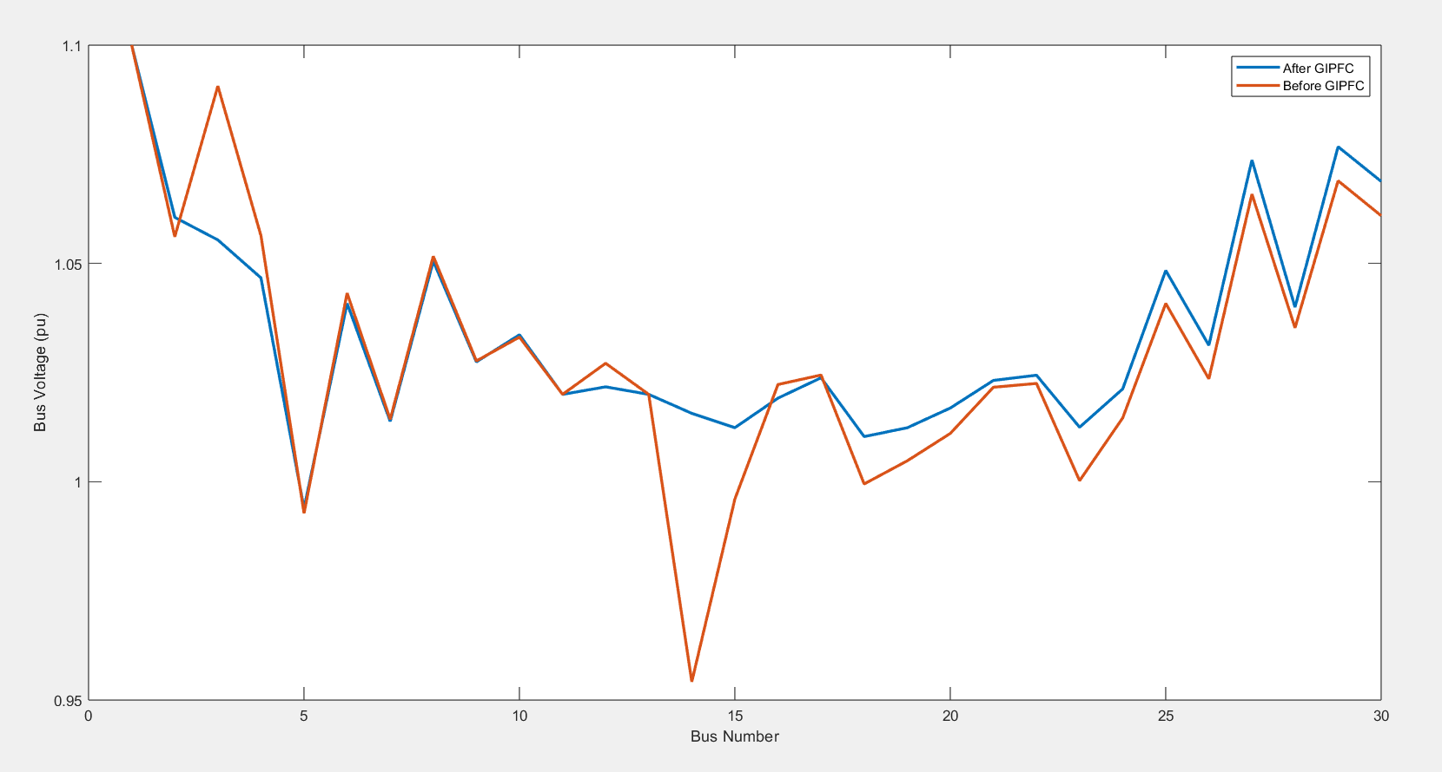

Figure 8: Bus Voltage and Reactive Power Condition

From the graph it is evident that the GIPFC is injecting extra Reactive Power to Bus numbers 3 and 13,14 and thereby controlling the voltages (minimizing the sudden spikes and falls) of the buses.

And from the load flow studies, we have calculated the power flow through all the lines and from that we have calculated the total power loss occurring in the power system. The transmission line losses before and after the incorporation of GIPFC is shown below:

|  |  |  |  |
| --- | --- | --- | --- |
| Before GIPFC | | After GIPFC | |
| PLOSS (MW) | QLOSS (MVAR) | PLOSS (MW) | QLOSS (MVAR) |
| 9.5645 | 8.6521 | 8.4125 | 6.1587 |

Since the GIPFC is injecting reactive power into the system, it is reducing line current and thereby reducing the transmission line losses and hence improving the bus voltages.

The parameter values of the GIPFC selected at this loading condition is attached below:

|  |  |  |  |  |  |  |  |  |
| --- | --- | --- | --- | --- | --- | --- | --- | --- |
| Vse1 | Vse2 | Thse1 | Thse2 | Xse1 | Xse2 | Xsh | Vsh | Thsh |
| 0.26 | 0.63 | 95 | 290 | 0.35 | 1 | 0.25 | 0.1 | 120 |

Using these parameter values, we got the optimum results for the placement of GIPFC in the bus system.

## At 125% Loading Condition:

In this condition, we increased the load demand at every bus by 25%. A comparison of bus voltages before and after the incorporation of GIPFC at this loading condition is presented through a table below:

|  |  |  |  |  |  |
| --- | --- | --- | --- | --- | --- |
| Bus No. | Before  GIPFC | After GIPFC | Bus No. | Before  GIPFC | After  GIPFC |
| 1 | 1.1 | 1.1 | 16 | 0.99565 | 1.001349 |
| 2 | 1.048428 | 1.052161 | 17 | 0.997441 | 1.003809 |
| 3 | 1.040046 | 1.034211 | 18 | 0.976295 | 0.983949 |
| 4 | 1.026632 | 1.037848 | 19 | 0.976074 | 0.983452 |
| 5 | 0.99 | 0.99 | 20 | 0.983057 | 0.990237 |
| 6 | 1.016923 | 1.025573 | 21 | 0.992663 | 0.999412 |
| 7 | 0.995738 | 1.000919 | 22 | 0.993533 | 1.000293 |
| 8 | 1.02257 | 1.028247 | 23 | 0.977677 | 0.98512 |
| 9 | 1.00873 | 1.014089 | 24 | 0.980777 | 0.987441 |
| 10 | 1.008243 | 1.014823 | 25 | 0.994376 | 0.99982 |
| 11 | 1.02 | 1.02 | 26 | 0.97163 | 0.977205 |
| 12 | 1.003234 | 1.008128 | 27 | 1.013943 | 1.018903 |
| 13 | 1.02 | 1.02 | 28 | 1.010627 | 1.002263 |
| 14 | 0.986924 | 1.008904 | 29 | 0.968537 | 1.008522 |
| 15 | 0.983719 | 0.991808 | 30 | 0.953857 | 0.987706 |

The bus voltage conditions and reactive power flow of each bus through graphs is shown below:

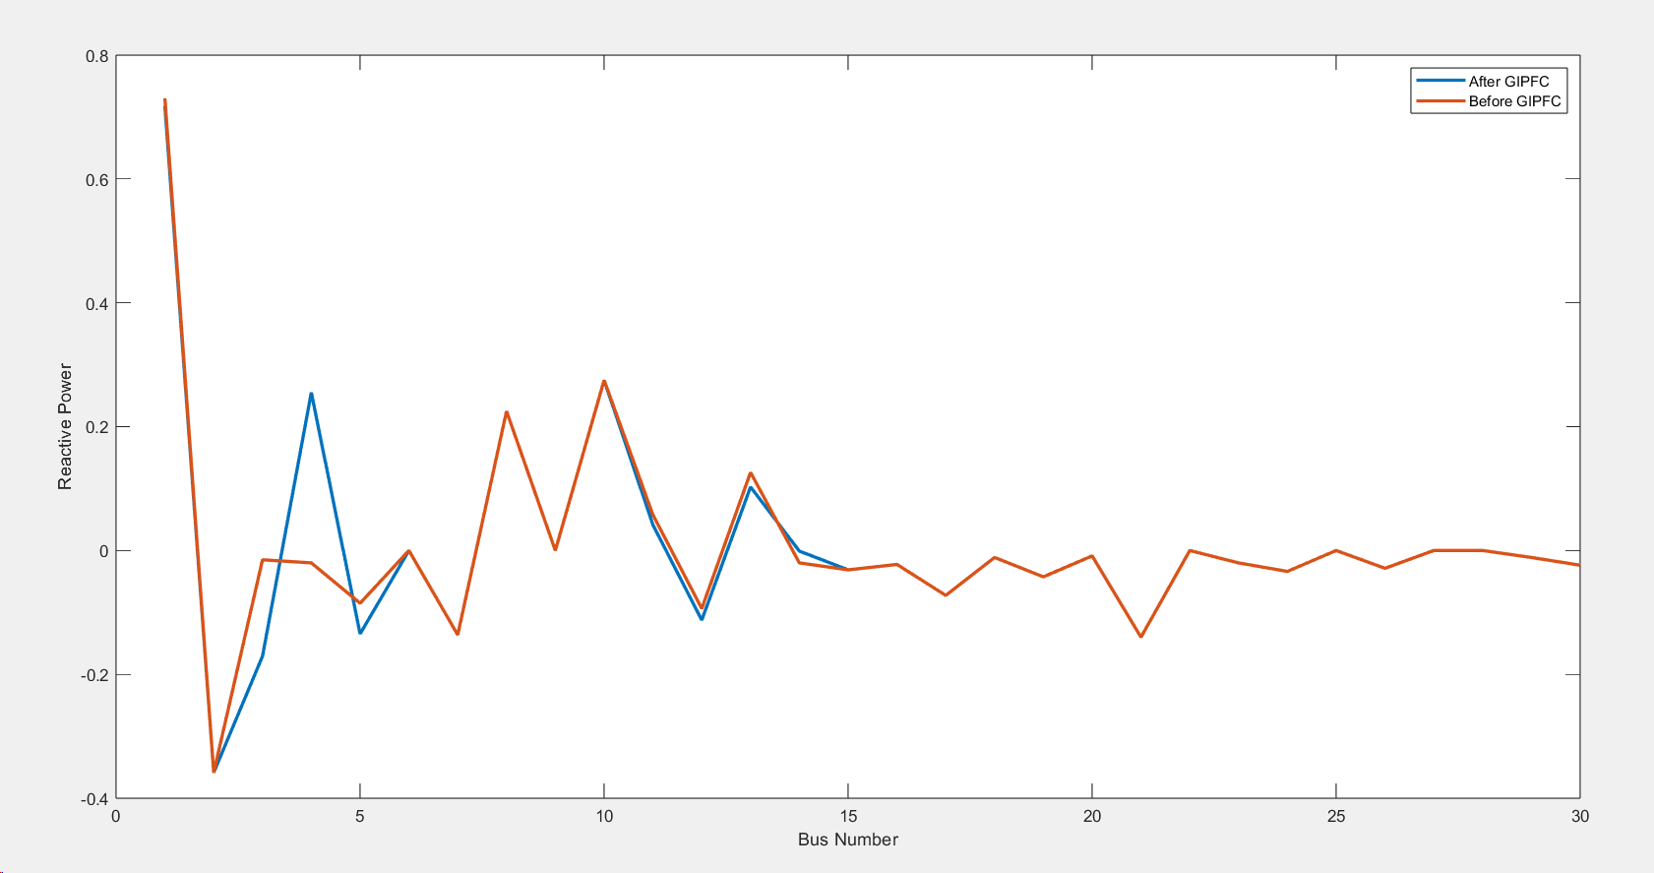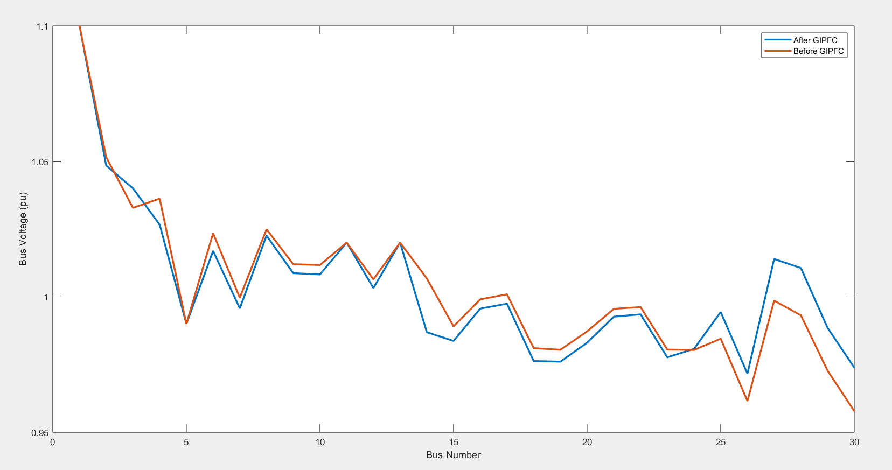

Figure 9: Bus Voltage and Reactive Power Condition

As we can see, the voltages got improved at 27-30 number buses. And an extra reactive power injection by the GIPFC is also noticeable at bus number 3.

The transmission line losses before and after the incorporation of GIPFC is shown below:

|  |  |  |  |
| --- | --- | --- | --- |
| Before GIPFC | | After GIPFC | |
| PLOSS (MW) | QLOSS (MVAR) | PLOSS (MW) | QLOSS (MVAR) |
| 14.81001 | 23.88523 | 12.70064 | 15.1059 |

From the graph we can see that the power losses got minimized after the inclusion of the GIPFC in the bus network. The parameter values of the GIPFC that optimized this improvement are:

|  |  |  |  |  |  |  |  |  |
| --- | --- | --- | --- | --- | --- | --- | --- | --- |
| Vse1 | Vse2 | Thse1 | Thse2 | Xse1 | Xse2 | Xsh | Vsh | Thsh |
| 0.65 | 0.12 | 280 | 265 | 0.7 | 0.75 | 0.88 | 0.12 | 200 |

## At 150% Loading Condition:

In this condition, we increased the load demand at every bus by 50%. A comparison of bus voltages before and after the incorporation of GIPFC at this loading condition is presented through a table below:

|  |  |  |  |  |  |
| --- | --- | --- | --- | --- | --- |
| Bus No. | Before  GIPFC | After GIPFC | Bus No. | Before  GIPFC | After  GIPFC |
| 1 | 1.1 | 1.1 | 16 | 0.975433 | 0.997998 |
| 2 | 1.0363 | 1.051975 | 17 | 0.973995 | 0.99825 |
| 3 | 1.023404 | 1.092135 | 18 | 0.950569 | 0.977491 |
| 4 | 1.007218 | 1.062749 | 19 | 0.948888 | 0.975421 |
| 5 | 0.99 | 0.99 | 20 | 0.956772 | 0.982858 |
| 6 | 0.995986 | 1.03426 | 21 | 0.966695 | 0.991407 |
| 7 | 0.980833 | 1.003817 | 22 | 0.967842 | 0.992396 |
| 8 | 0.998177 | 1.031356 | 23 | 0.952394 | 0.977868 |
| 9 | 0.992058 | 1.013726 | 24 | 0.953151 | 0.975947 |
| 10 | 0.985674 | 1.010309 | 25 | 0.971591 | 0.986869 |
| 11 | 1.02 | 1.02 | 26 | 0.943466 | 0.959209 |
| 12 | 0.988444 | 1.008786 | 27 | 0.996805 | 1.00755 |
| 13 | 1.02 | 1.02 | 28 | 0.988565 | 0.997908 |
| 14 | 0.96712 | 1.023831 | 29 | 0.980602 | 0.991569 |
| 15 | 0.962123 | 0.989519 | 30 | 0.956032 | 0.967293 |

The bus voltage conditions and reactive power flow of each bus through graphs is shown below:

Figure 10: Bus Voltage and Reactive Power Condition

As the loading condition is increased to 150%, we can see that the bus voltages when GIPFC was not connected, started to deteriorate. But when the GIPFC was included, the voltages improved to a reasonable level. The extra reactive power injected into the system is causing this improvement and also we can observe how the reactive power supplied by the slack generator also reduced, thereby reducing the stress on the slack generator which had to supply most of the reactive power into the system.

The transmission line losses before and after the incorporation of GIPFC is shown below:

|  |  |  |  |
| --- | --- | --- | --- |
| Before GIPFC | | After GIPFC | |
| PLOSS (MW) | QLOSS (MVAR) | PLOSS (MW) | QLOSS (MVAR) |
| 25.13731 | 65.26775 | 15.30665 | 56.42629 |

As we can see, the transmission line loss has reduced to a great extent in this case. This minimization of line losses reduces the cost of power transmission, enhances the transmission system longevity, and also enhance the efficiency of the power system.

The parameter values of the GIPFC that optimized this improvement are:

|  |  |  |  |  |  |  |  |  |
| --- | --- | --- | --- | --- | --- | --- | --- | --- |
| Vse1 | Vse2 | Thse1 | Thse2 | Xse1 | Xse2 | Xsh | Vsh | Thsh |
| 0.5 | 0.25 | 10 | 265 | 1 | 0.8 | 0.75 | 0.9 | 175 |

## 175% Loading Condition:

In this condition, we increased the load demand at every bus by 50%. A comparison of bus voltages before and after the incorporation of GIPFC at this loading condition is presented through a table below:

|  |  |  |  |  |  |
| --- | --- | --- | --- | --- | --- |
| Bus No. | Before  GIPFC | After GIPFC | Bus No. | Before  GIPFC | After  GIPFC |
| 1 | 1.1 | 1.1 | 16 | 0.948757 | 1.001718 |
| 2 | 1.016819 | 1.061543 | 17 | 0.941508 | 0.998336 |
| 3 | 0.996 | 1.15761 | 18 | 0.921998 | 0.979918 |
| 4 | 0.977251 | 1.151591 | 19 | 0.919235 | 0.977865 |
| 5 | 0.975483 | 0.99 | 20 | 0.926136 | 0.984633 |
| 6 | 0.96394 | 1.053106 | 21 | 0.930608 | 0.98948 |
| 7 | 0.952973 | 1.012731 | 22 | 0.932138 | 0.990863 |
| 8 | 0.962442 | 1.0456 | 23 | 0.921112 | 0.97851 |
| 9 | 0.967594 | 1.018416 | 24 | 0.916183 | 0.974557 |
| 10 | 0.953194 | 1.010877 | 25 | 0.937806 | 0.993652 |
| 11 | 1.02 | 1.02 | 26 | 0.903521 | 0.961444 |
| 12 | 0.970037 | 1.018342 | 27 | 0.968039 | 1.021725 |
| 13 | 1.02 | 1.02 | 28 | 0.955154 | 1.009308 |
| 14 | 0.947569 | 1.017642 | 29 | 0.954335 | 0.97854 |
| 15 | 0.937214 | 0.993334 | 30 | 0.93577 | 0.96612 |

As we can see, the bus voltages of almost all of the buses got improved to a great amount. The graphs of bus voltages and reactive power flow is attached below:

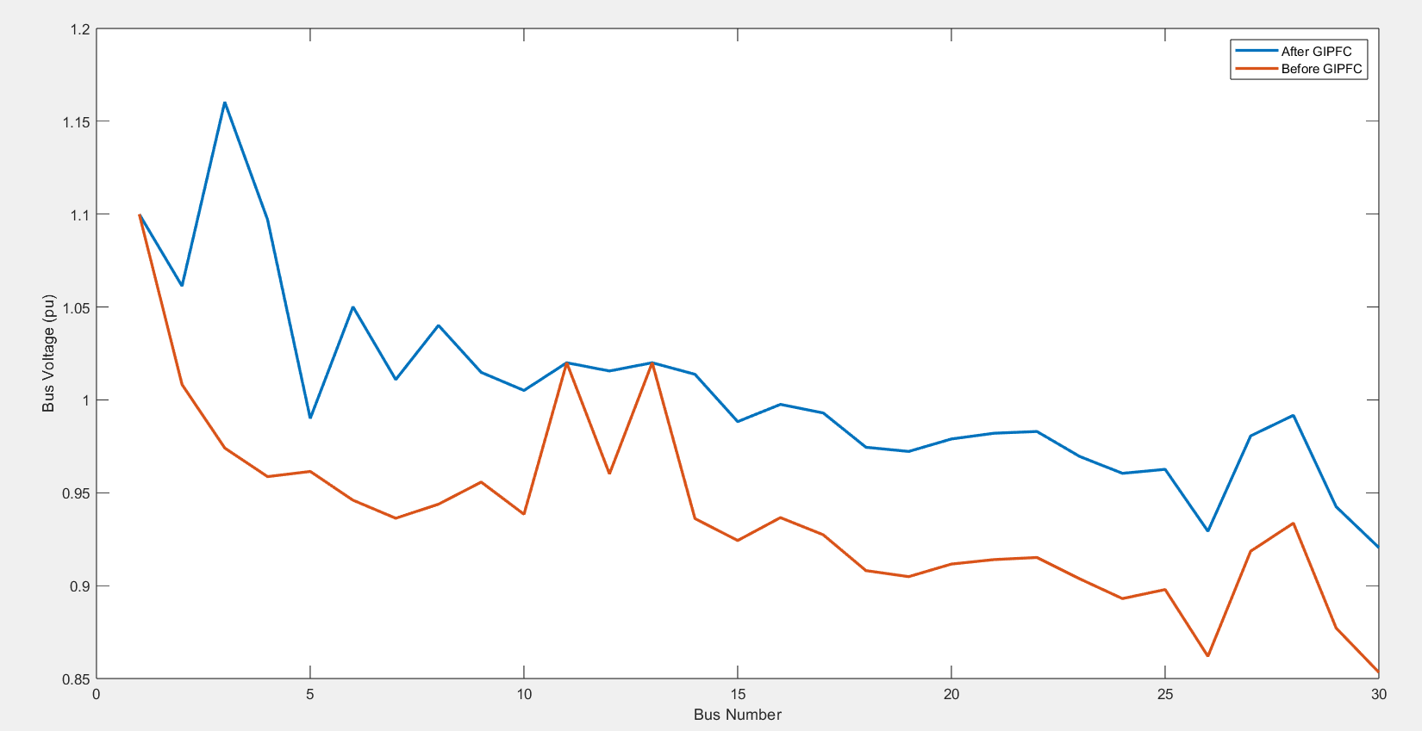

Figure 11: Bus Voltage and Reactive Power Condition

But the bus voltage of bus number 3 and 4 got overloaded as we can see from the graph, as well as from the chart. This happened because the GIPFC is injecting a large amount of reactive power to the bus number 3, which is causing the voltage to shoot up. But as we can see, it has improved the voltage condition of all other buses in the power system. There are two peaks in the voltage graph, which are basically the synchronous generators, whose voltage is not changing in the load flow studies. Also, the stress on the slack generator is released due to the incorporation of the GIPFC.

The transmission line losses at this loading condition is given below:

|  |  |  |  |
| --- | --- | --- | --- |
| Before GIPFC | | After GIPFC | |
| PLOSS (MW) | QLOSS (MVAR) | PLOSS (MW) | QLOSS (MVAR) |
| 40.45714 | 127.4548 | 27.88968 | 76.44375 |

Evidently, the line losses have reduced by a great margin here.

The parameter values of the GIPFC that optimized this improvement are:

|  |  |  |  |  |  |  |  |  |
| --- | --- | --- | --- | --- | --- | --- | --- | --- |
| Vse1 | Vse2 | Thse1 | Thse2 | Xse1 | Xse2 | Xsh | Vsh | Thsh |
| 0.2 | 0.1 | 290 | 275 | 0.6 | 0.6 | 0.4 | 1 | 140 |

## 200% Loading Condition:

|  |  |  |  |  |  |
| --- | --- | --- | --- | --- | --- |
| Bus No. | Before  GIPFC | After GIPFC | Bus No. | Before  GIPFC | After  GIPFC |
| 1 | 1.1 | 1.1 | 16 | 0.883233 | 1.017733 |
| 2 | 0.97008 | 1.08 | 17 | 0.871009 | 1.008507 |
| 3 | 0.941349 | 1.072263 | 18 | 0.841297 | 0.982316 |
| 4 | 0.911511 | 1.073648 | 19 | 0.835279 | 0.97773 |
| 5 | 0.887532 | 1.027851 | 20 | 0.845418 | 0.986673 |
| 6 | 0.888124 | 1.04065 | 21 | 0.853637 | 0.992901 |
| 7 | 0.867389 | 1.018195 | 22 | 0.854841 | 0.993504 |
| 8 | 0.881511 | 1.025984 | 23 | 0.839081 | 0.976772 |
| 9 | 0.912029 | 1.039704 | 24 | 0.825656 | 0.961967 |
| 10 | 0.884038 | 1.020343 | 25 | 0.831 | 0.951416 |
| 11 | 1.014067 | 1.1 | 26 | 0.785882 | 0.912609 |
| 12 | 0.912883 | 1.042013 | 27 | 0.856539 | 0.964163 |
| 13 | 0.996551 | 1.1 | 28 | 0.873001 | 0.974289 |
| 14 | 0.876502 | 1.008707 | 29 | 0.822156 | 0.91887 |
| 15 | 0.864754 | 1.001285 | 30 | 0.784308 | 0.89277 |

As we can see in this case, due to this excess loading condition, the power demand increased at each of the buses, so they were drawing more current to meet the requirements. In such condition, the transmission line loss increases and reduces the receiving end voltage. Similar case we are observing here. Most of the bus voltages reduced drastically below 0.92pu. So in order to address for this problem, we incorporated our selected FACTS device, GIPFC into the network. And we can readily observe how the GIPFC has improved the stability of the bus network.

A graphical comparison of bus voltages and reactive power before and after the incorporation of GIPFC into the network is presented below:

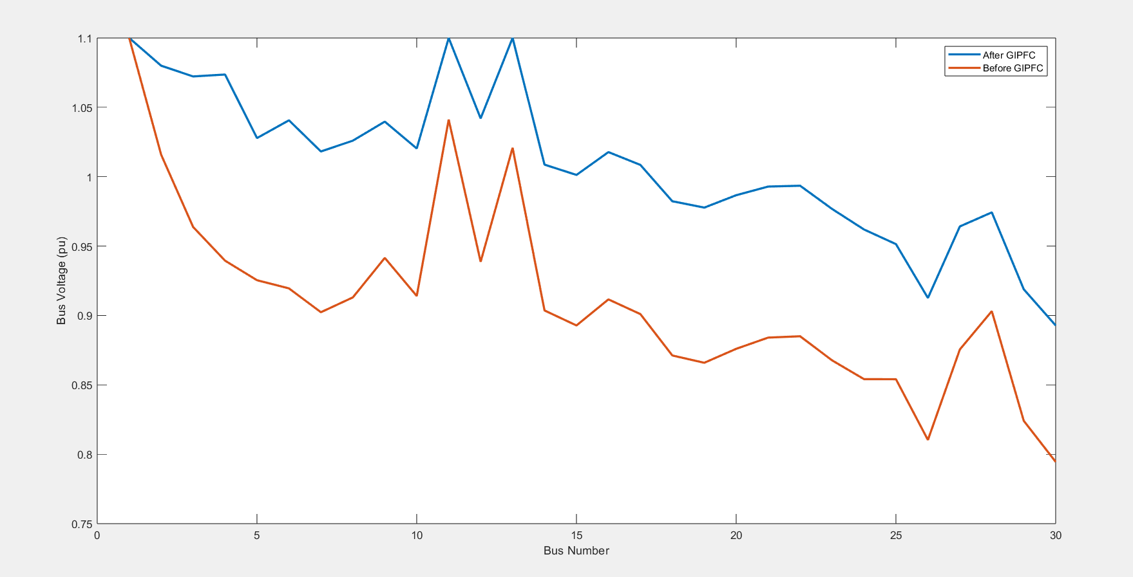

Figure 12: Bus Voltage and Reactive Power Condition

From the graph it is evident that the GIPFC is performing really well at high loading conditions. The bus voltages got improved tremendously. The reactive power injection due to GIPFC has improved the overall stability of the power system and also reduced the stress on the slack generator.

The transmission line losses at this loading condition is given below:

|  |  |  |  |
| --- | --- | --- | --- |
| Before GIPFC | | After GIPFC | |
| PLOSS (MW) | QLOSS (MVAR) | PLOSS (MW) | QLOSS (MVAR) |
| 71.30524 | 256.1073 | 37.65575 | 122.5889 |

The transmission line losses also got reduced by almost 50% at this loading condition. We can state that, the more the loading condition is, the better our GIPFC performs. Since we couldn’t introduce a fault into our network as we completed this project through coding, we couldn’t observe how GIPFC would perform under fault conditions. But we can say from this observation that the GIPFC should perform quite well if any fault occurs in the network.

## Recovery of Dysfunctional Generators:

During periods of excess load, some generators experienced dysfunction, resulting in the transformation of PV buses into Load buses. However, following the integration of a FACTS (Flexible Alternating Current Transmission System) device, the generators were successfully restored to functionality. This highlights the dynamic response and effective intervention of FACTS devices in mitigating and reversing failures caused by excessive loads.

At 175% loading condition:

|  |  |  |
| --- | --- | --- |
| Bus No. | Without GIPFC | With GIPFC |
| 5 | 0.975483 pu | 0.99 pu |

The bus voltage of bus 11 and 13 was changed to 1.1 (Generator connected)

At 200% loading condition:

|  |  |  |
| --- | --- | --- |
| Bus No. | Without GIPFC | With GIPFC |
| 11 | 1.014067 pu | 1.1 pu |
| 13 | 0.996551 pu | 1.1 pu |

At 200% loading condition: (GIPFC connected between 3-4-24-25 buses)

|  |  |  |
| --- | --- | --- |
| Bus No. | Without GIPFC | With GIPFC |
| 11 | 1.04117 pu | 1.1 pu |
| 13 | 1.020833 pu | 1.1 pu |

The change of voltage of a PV bus indicates that the bus has turned into a Load Bus upon imposing of excess load. As we can see, the voltage of the bus recovered to the voltage of the PV bus which signifies that the generator is now functional again.

So basically, we observed the following improvements after the incorporation of GIPFC in our bus network:

* Improvement of Voltage Profile
* Generators that were dysfunctional due to excess loading, became functional
* Minimization of transmission line losses -> Efficiency enhancement
* Improvement of Power Flow

# Reflection on Individual and Teamwork Individual Contribution of Each Member

**2006039-**

Research and analyzing FACTS devices and their modeling, verifying Newton-Raphson code by solving example 9.5 from ‘Power System Analysis’ by “John J. Grainger” and “William D. Stevenson, Jr”, export data in excel file, compare results, report writing.

**2006040-**

Project proposal, research and analyzing FACTS devices and their modeling, creating excel file of input data of IEEE-30 bus system, writing code in MATLAB to solve n-bus system using Newton-Raphson method, solving IEEE-30 bus system, verifying Newton-Raphson code by solving example 9.5 from ‘Power System Analysis’ by “John J. Grainger” and “William D. Stevenson, Jr”, writing code for finding GIPFC locations, update the code to incorporate GIPFC, re-solve IEEE-30 bus system at different overloading with different parameters for improvement of power system conditions, graphical analysis, exporting results into excel files, report writing and assembly.

**2006041-**

Data collection, creating excel file of input data, verifying code by solving example 9.5 from ‘Power System Analysis’ by “John J. Grainger” and “William D. Stevenson, Jr”, report writing.

**2006042-**

Data collection, creating excel file of input data, verifying code by solving example 9.5 from ‘Power System Analysis’ by “John J. Grainger” and “William D. Stevenson, Jr”, apply GIPFC (FACTS) at appropriate line, export data in excel file, creating graph and compare results, report writing.

**2006043-**

Project proposal, creating excel file of input data of IEEE-30 bus system, writing code in MATLAB to solve n-bus system using Newton-Raphson method, solving IEEE-30 bus system, verifying Newton-Raphson code by solving example 9.5 from ‘Power System Analysis’ by “John J. Grainger” and “William D. Stevenson, Jr”, writing code for finding GIPFC locations, update the code to incorporate GIPFC, re-solve IEEE-30 bus system with GIPFC for improvement of power system conditions, graphical analysis, report writing and assembly.

## Mode of Teamwork

Each team member brought a unique set of abilities, perspectives, and experiences to the table. The approach that our team cooperates and works together to accomplish team goals is.

**Dedication to a Common Objective:**

Our group was dedicated to creating a MATLAB code that could solve the voltage and power of IEEE-30 bus system and apply GIPFC (FACTS) at the appropriate line. We collaborated to finish it in the allotted time.

**Cooperating with one another:**

We worked together closely, shared ideas, responsibilities, and made decisions. Our team members actively contributed and collaborated towards a common goal.

**Leadership:**

**Kafi Anan** led our team to achieve our desired outcome of the project.

## Diversity Statement of Team

We believe that diversity is not only a source of strength but also a fundamental principle that drives innovation, creativity, and success. We are dedicated to providing equal access to opportunities, resources, and support for all team members. Some of our team members are good at handling excel file, some are good at coding, calculating, describing graph. We split up the tasks in the same way. In the end, by combining our abilities, we enabled the project.

# Discussion

Power system is a large and complex system. Maintenance of power quality and stability is important to provide safe, economical, and optimized operation of power system. Underloaded and overloaded voltage profile, power flow conditions severely hamper these desired properties. To tackle these inefficiencies, power electronics-based FACTS devices are greatly useful in modern power systems. Incorporation of FACTS device in power system needs complex optimization.

In our project, we tried to find a solution for the overloaded IEEE-30 bus system where placement of a single FACTS device with adjusted parameters will significantly improve the power system performance. Enabling automatic parameterization, optimization algorithm will enhance this improvement process to a higher dimension.

# References

1. Balasubbareddy, M., Dwivedi, D., Murthy, G. V. K., & Kumar, K. S. (2023, February 1). Optimal power flow solution with current injection model of generalized interline power flow controller using ameliorated ant lion optimization. *International Journal of Electrical and Computer Engineering (IJECE)*, *13*(1), 1060.

<http://doi.org/10.11591/ijece.v13i1.pp1060-1077>

1. <https://al-roomi.org/multimedia/Power_Flow/30BusSystem/IEEE30BusSystemDATA2.pdf>