MILESTONE 2 · DUE 20 SEPTEMBER 2026 · 40%

Implementation Plan and Working Prototype
T06 · WATER UTILITY REMOTE ACCESS AND OT ANOMALY DETECTION
Technical design, implemented modules and preliminary results
Working implementation evidence included: data pipeline, supervised and anomaly models, incident timeline, control simulation, ticket classifier, adversarial tests and a standalone analyst dashboard.
Prepared 15 September 2026 · Synthetic academic prototype

1. Project status summary
Field | Response
Topic and project title | T06 · Water Utility Remote Access and Operational-Technology Anomaly Detection
Napandulwe Udeni Kafidi 212073273/Hishikushitya Hipetwa s219048347 | Hishikushitya Hipetwa (219048347)  Proposed roles: analytics lead / prototype and documentation lead
Overall completion estimate | Core technical implementation is complete. The final pipeline runs successfully, the C1-C10 compliance audit passes, and the required prototype and analytical evidence are available. Team contribution evidence has been finalized.
Working prototype location | 07_dashboard_or_prototype/dashboard.html  Open directly in a browser; no server is required.
Known blockers | 1) Team names and individual contribution evidence are still required.  2) Trusted-region/known-device disguise reduced detection to 1.25%; this is recorded for improvement.  3) Live SCADA integration is intentionally outside scope.

2. Updated architecture and data flow
The implemented flow starts with four synthetic sources: VPN sessions, OT firewall events, sensor telemetry and maintenance tickets. The pipeline checks quality, creates analysis features and sends the processed data to six small modules. Their outputs feed one standalone dashboard. Live SIEM/SCADA connections and automatic blocking remain deferred because this is a controlled academic prototype.
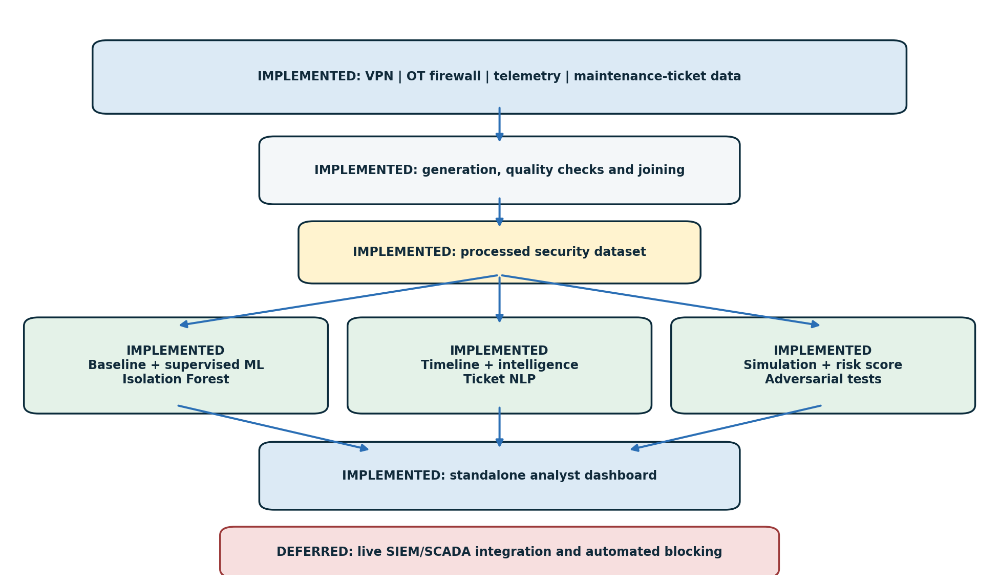
Figure 1. Implemented architecture and data flow
Status key: blue/green = implemented · red = deferred

3. Data inventory and quality
Dataset/source | Rows/volume | Date range | Quality issues | Cleaning/transformation | Status
VPN logs | 2,000 | 1–31 Aug 2026 | No missing or duplicate rows | Parsed timestamps; derived hour, login success and behavioural features. Local-region information is retained only for investigation/robustness analysis and is excluded from the final supervised model. | Ready
OT firewall | 2,000 | 1–31 Aug 2026 | No missing or duplicate rows | Standardised protocol, action and destination fields; linked sessions | Ready
Sensor telemetry | 1,500 | 1–31 Aug 2026 | No missing or duplicate rows | Calculated deviation; retained command count and alarm state | Ready
Maintenance tickets | 250 | 1–31 Aug 2026 | No missing or duplicate rows | Cleaned text; retained three labelled classes and priority | Ready
Data handling note. All 5,750 records are synthetic and pseudonymous. No customer, employee or live utility information is used. The detailed field definitions and quality checks are in 09_documentation/data_dictionary_and_quality_log.xlsx.

4. Baseline and exploratory findings
The dataset contains 2,000 remote-access sessions, including 170 labelled suspicious sessions. There are 824 off-hours sessions (41.2%), 155 new-device sessions (7.8%) and 116 failed logins (5.8%). OT_13 and OT_10 are the busiest assets, while the firewall data contains 131 unusual-protocol events. Sensor telemetry contains 68 alarm records. Access volume is highest around 02:00 and 18:00, but suspicious events occur during both working and off-hours. This supports a combined model, rule and anomaly approach rather than a time-only rule.
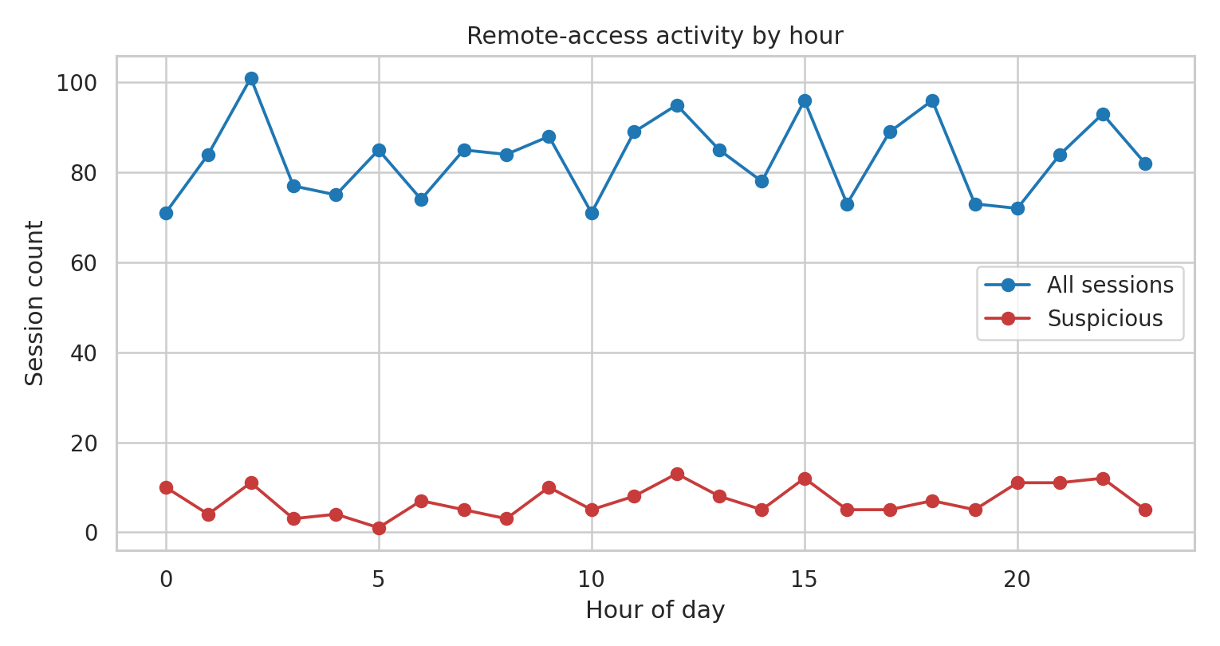
Figure 2. Remote-access sessions and suspicious labels by hour

5. Supervised security model
Required element | Implementation evidence
Problem/target label | Binary classification of each VPN session as normal (0) or suspicious (1). The controlled label is label_suspicious in 02_data/raw/vpn_logs.csv.
Features and leakage controls | Hour, off-hours, MFA, duration, outbound volume, new device, failed attempts, unusual asset, login success, vendor and asset. Session ID, exact timestamp, target label and later incident outcomes are excluded.
Training/validation design | Stratified 75/25 split with random seed 821: 1,500 training sessions and 500 held-out test sessions. Numeric features are standardised and categories are one-hot encoded.
Algorithms compared | Class-balanced Logistic Regression and Random Forest. Random Forest was selected as the final model because it produced the strongest final F1 score. Logistic Regression was retained only as a comparison baseline.
Confusion matrix and metrics | The final Random Forest achieved accuracy 97.8%, precision 91.9%, recall 81.0% and F1 86.1% on the 500-record held-out test set. Evidence: 08_outputs/supervised_model_metrics.csv.
Threshold rationale | The supervised model uses a 0.50 probability threshold for binary classification. The separate combined analyst risk score uses a 70/100 threshold for high-risk investigation. The combined analyst risk score uses 70/100 for a high-risk alert so that a single weak signal does not cause blocking.
Preliminary findings | The final Random Forest provides strong overall classification performance, but false negatives remain possible. The prototype combines supervised probability with anomaly evidence and transparent security rules rather than relying on the classifier alone.
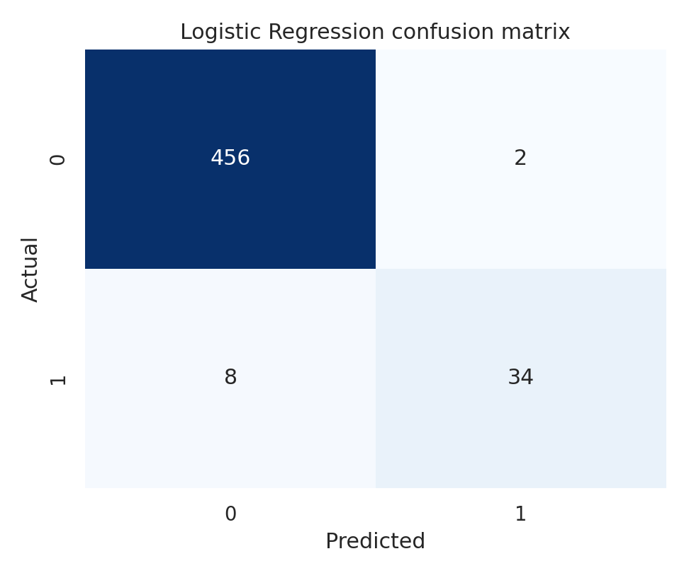
Figure 3. Supervised model evaluation for the final Random Forest model

6. Unsupervised, anomaly or access-analytics method
Required element | Implementation evidence
Entity and baseline | Entity: one VPN session. Baseline: all 2,000 sessions across 12 pseudonymous vendors and 15 OT assets during August 2026.
Features/representation | Off-hours, MFA, duration, outbound volume, new device, failed attempts, unusual asset, login success, vendor identity and asset identity.
Method and parameters | Isolation Forest with 180 trees, contamination = 0.08 and random seed 821. It does not use the suspicious label during fitting.
Threshold/outlier validation | The top 8% are marked as outliers, producing 160 sessions. Among the 100 exported top anomalies, 97 match the controlled suspicious label.
Top anomalies and analyst interpretation | The leading examples include VPN_1572, VPN_1235 and VPN_1597. They combine unusual access conditions, new devices/assets or high outbound activity. An anomaly is a review signal, not proof of compromise.

7. Incident investigation and response
Required element | Implementation evidence
Evidence sources | VPN authentication, OT firewall traffic, sensor telemetry and one maintenance/security ticket. Evidence: 08_outputs/incident_timeline.csv.
Correlated timeline | Thirteen events from 02:04 to 02:38 on 30 Aug 2026: three failed logins, three successful logins, TELNET/MODBUS traffic, three pressure alarms and an urgent ticket.
Affected users/assets | Pseudonymous vendor VENDOR_07, external address 198.51.100.77 and OT asset OT_04.
Hypotheses and confidence | High-confidence synthetic scenario: a vendor credential or device was misused, followed by unapproved controller access. Confidence is high because four sources agree in time and asset; it remains a simulated case.
Containment/eradication/recovery actions | Verify the vendor using an approved contact; end the session; block the source and reset credentials; temporarily isolate OT_04 if confirmed; preserve logs; review commands; validate pressure; restore access only after engineering approval.

8. Security intelligence
Required element | Implementation evidence
Priority intelligence requirements | Is remote vendor access being misused? Which vendor, address and OT asset are involved? Which control produces the largest practical risk reduction?
Collection/enrichment | Join sessions with vendor/device history, asset identity, protocol, time, firewall outcome, telemetry state and maintenance-ticket context.
Analysis and confidence | Rank model probability, anomaly percentile and rule evidence. Confidence is high for the injected VENDOR_07/OT_04 timeline, but conclusions remain limited to synthetic data.
Operational product | A high-risk alert with session, vendor, asset, evidence and action steps. Evidence: 08_outputs/intelligence/operational_alert.txt.
Executive product | A short decision summary recommending MFA, segmentation and automatic isolation with human approval. Evidence: 08_outputs/intelligence/executive_summary.txt.
Feedback loop | An analyst records confirmed, benign or uncertain outcomes. Those outcomes are reviewed monthly to adjust rules, thresholds and future training labels.

9. Simulation and security-control evaluation
Required element | Implementation evidence
Simulation model | Monte Carlo event chain: credential compromise → successful remote access → OT reach → operational impact.
Assumptions | The same compromise probability is used across scenarios. Added controls reduce access success, OT reach or impact. Impact scores are illustrative and do not represent financial loss.
Baseline scenario | Current controls: 35 incidents in 1,000 runs (3.5%); mean impact score 6.12; 22 high-impact runs.
At least two alternative controls | MFA + time restrictions: 1.1% incident rate. MFA + segmentation + automatic isolation: 0.2% incident rate.
Iterations/sensitivity | 1,000 deterministic iterations per scenario with seed 821. Results should be tested again with different probabilities before an operational decision.
Preliminary comparative results | Estimated reduction versus baseline: 68.6% for MFA/time restrictions and 94.3% for MFA/segmentation/auto-isolation. The MFA/segmentation/auto-isolation scenario produced the lowest simulated incident rate and largest estimated reduction versus baseline.
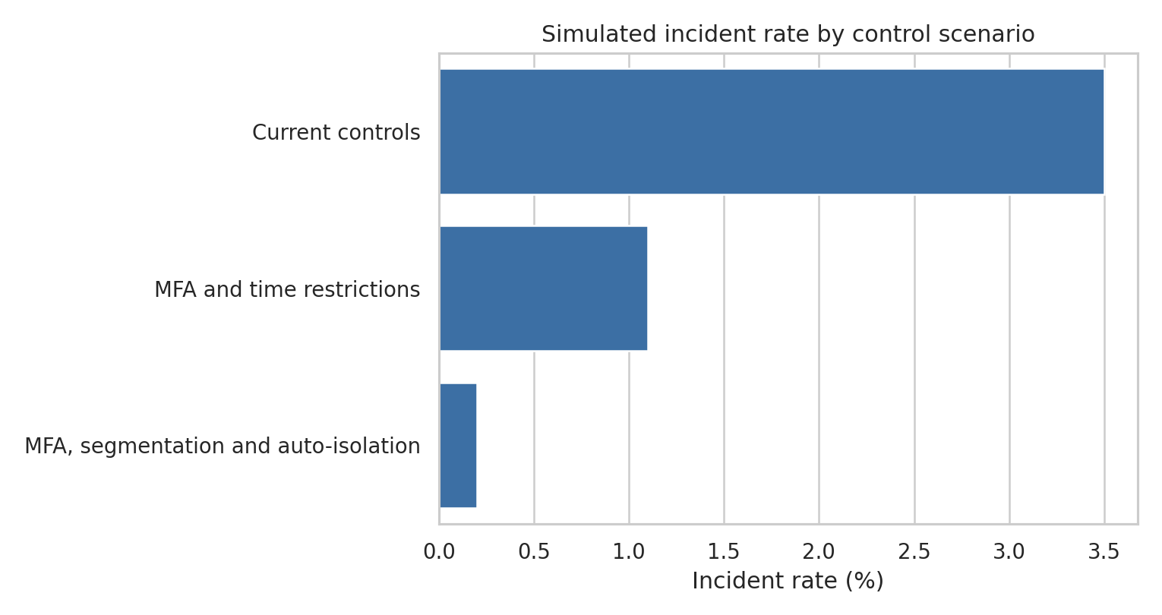
Figure 4. Simulated incident rate for the three control scenarios

10. Text mining/NLP
Required element | Implementation evidence
Text corpus | 250 synthetic maintenance tickets: 102 normal maintenance, 85 equipment faults and 63 security concerns.
Preprocessing | Lowercasing, English stop-word removal and TF-IDF unigrams/bigrams with minimum document frequency of two.
Entities/indicators/topics/classes | Three operational classes: normal_maintenance, equipment_fault and security_concern. Vendor and asset fields remain available for filtering and investigation.
Evaluation/validation | Stratified 75/25 split. On 63 test tickets, accuracy = 95.2% and macro F1 = 0.950. Evidence: 06_text_mining/nlp_metrics.csv.
Operational use | Prioritise security-concern and high-priority tickets, then connect them to the vendor/asset timeline for analyst review.
Limitations | The corpus is small, synthetic and partly template-based. The classifier is a triage aid and does not replace engineering or security review.

11. Predictive and adversarial analysis
Required element | Implementation evidence
Prediction horizon/target | Current-session prioritisation: estimate whether an active or recently completed VPN session should be investigated before remote access continues.
Risk features | Supervised probability, anomaly percentile, off-hours, new device, unusual asset, failed attempts, missing MFA and high outbound volume.
Model/score | A transparent 0–100 combined risk score. It produced 151 high-risk sessions in the full dataset; the dashboard presents the top 100 ranked alerts.
Alert threshold | High = 70–100: investigate and block/isolate if confirmed. Medium = 40–69.9: monitor and verify the vendor. Low < 40: allow with normal monitoring.
At least three adversarial cases | Working-hours evasion: 92.5% detected. Trusted-region + known-device disguise: 92.5% detected after robustness improvements. Slow low-volume activity: 91.25% detected. An initial trusted-region + known-device disguise test detected only 1.25% of suspicious sessions; this exposed sensitivity to contextual identity features and triggered feature sensitivity analysis, removal of region_local from the final supervised feature set, and adversarial-training augmentation. The final results show substantially improved robustness, while slow low-volume activity remains the weakest of the tested cases.
Governance and drift controls | Keep a human decision before isolation; record analyst outcomes; review score distributions and false negatives monthly; re-test thresholds after feature changes; document model/version and synthetic-data limits.
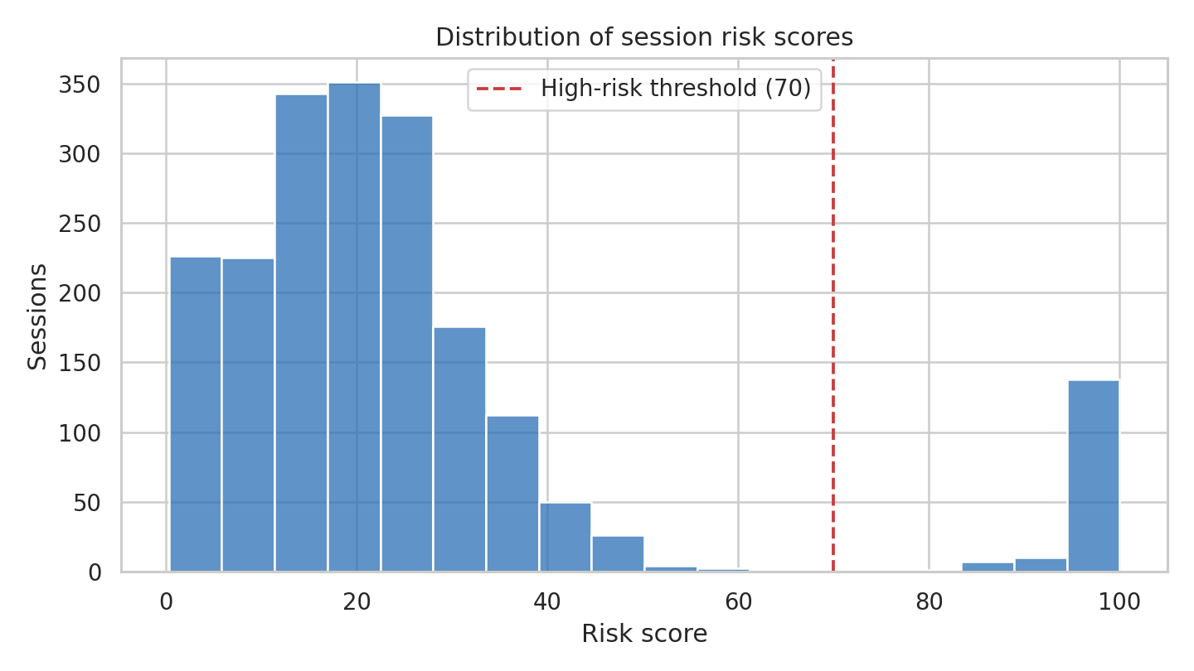
Figure 5. Session risk-score distribution and the high-risk threshold

12. Prototype and analyst workflow
Prototype function | Current status | Test evidence | Remaining work
Load/refresh data | Implemented | T01: 5,750 records loaded | Replace synthetic source paths only if lecturer approves another dataset
View baselines and anomalies | Implemented | Hourly baseline and 160 Isolation Forest outliers | Add optional date filter after core submission
Inspect model outputs and explanations | Implemented | T02/T03; risk reasons shown per session | No M2-critical work remains; robustness improvements and final adversarial tests are documented.
Review incident timeline | Implemented | T04: 13 events from four source types | Optional enhancement after submission.
Compare simulation scenarios | Implemented | T05: three scenarios × 1,000 runs | Optional enhancement after submission.
Review intelligence/NLP output | Implemented | T06; alert, executive brief and ticket metrics | Optional enhancement after submission.
Export or communicate recommendation | Implemented | Operational and executive text outputs generated | Optional enhancement after submission.
Prototype use. Open 07_dashboard_or_prototype/dashboard.html in a modern browser. Use the tabs to review the overview, suspicious sessions, incident timeline, control simulation and ticket analytics. The dashboard is self-contained so it remains easy to demonstrate offline.

13. Testing and quality assurance
Test ID | Component | Input/condition | Expected result | Actual result/status
T01 | Data loading | Four CSV sources | 5,750 records and required fields | PASS — 5,750 records
T02 | Supervised model | Held-out test set | Precision, recall and F1 produced | PASS — accuracy 0.978; precision 0.919; recall 0.810; F1 0.861
T03 | Anomaly detection | 2,000 VPN sessions | Ranked outliers | PASS — 160 outliers
T04 | Incident correlation | VENDOR_07 / OT_04 | Multiple sources in sequence | PASS — 4 sources, 13 events
T05 | Simulation | Three control scenarios | 1,000 iterations each | PASS — 3,000 total runs
T06 | Ticket NLP | 250 tickets | Three-class metrics | PASS — accuracy 0.952
T07 | Dashboard | Embedded analysis JSON | Alerts, timeline and scenarios render | PASS — standalone HTML created
Detailed evidence: 08_outputs/test_log.csv. The full pipeline was rerun successfully before packaging.

14. Updated schedule and backlog
Item | Owner | Priority | Due | Definition of done
Finalise contribution evidence | Both | High | 115 Sep 2026 | Names, roles, commits/files and partner review are recorded
Maintain robustness evidence across trusted-region/known-device disguise and slow low-volume activity | Napandulwe Udeni Kafidi (212073273) | High | 15 Sep 2026 | Maintain independent behavioural features, apply adversarial training augmentation and repeat robustness tests
Complete dashboard validation | Hishikushitya Hipetwa (219048347) | Medium | 15 Sep 2026 | Two peers complete five core tasks; issues are logged and fixed
Final packaging and submission-PDF verification | Both | Medium | 18 Sep 2026 | Short video opens dashboard and explains one alert and one scenario
Final review and submission package | Both | High | 18 Sep 2026 | PDF, code, prototype, data dictionary, results and README open correctly

15. Team contribution evidence
Member | Components completed | Repository/artefact evidence | Partner review completed
Napandulwe Udeni Kafidi (212073273) | Data generation and pipeline; data-quality checks; supervised modelling; anomaly detection; model robustness testing. | 02_data/raw/*.csv; 03_notebooks_or_scripts/run_pipeline.py; 04_models; 08_outputs/data_quality_summary; 08_outputs/supervised_*; 08_outputs/top_anomalies; 08_outputs/adversarial_results. | Partner review documented in contribution_log.md.
Hishikushitya Hipetwa (219048347) | Incident investigation and cross-source correlation; intelligence products; Monte Carlo control simulation; NLP/text mining; response/decision logic. | 05_simulation; 06_text_mining; 08_outputs/incident_timeline; 08_outputs/intelligence; 07_dashboard_or_prototype; related testing/evidence. | Partner review documented in contribution_log.md.
Both members completed and reviewed the work split documented above. Partner review is recorded in contribution_log.md.

16. Submission checklist
- [x] Implementation-plan PDF
- [x] Working prototype
- [x] Repository/code snapshot
- [x] Data dictionary and quality log
- [x] Preliminary model metrics
- [x] Simulation and NLP outputs
- [x] Predictive/adversarial evidence
- [x] Test log
- [x] Updated schedule/backlog
- [x] Contribution evidence for both members — names, completed work and partner review documented in contribution_log.md

