Download Selenium IDE from Chrome Extension Store

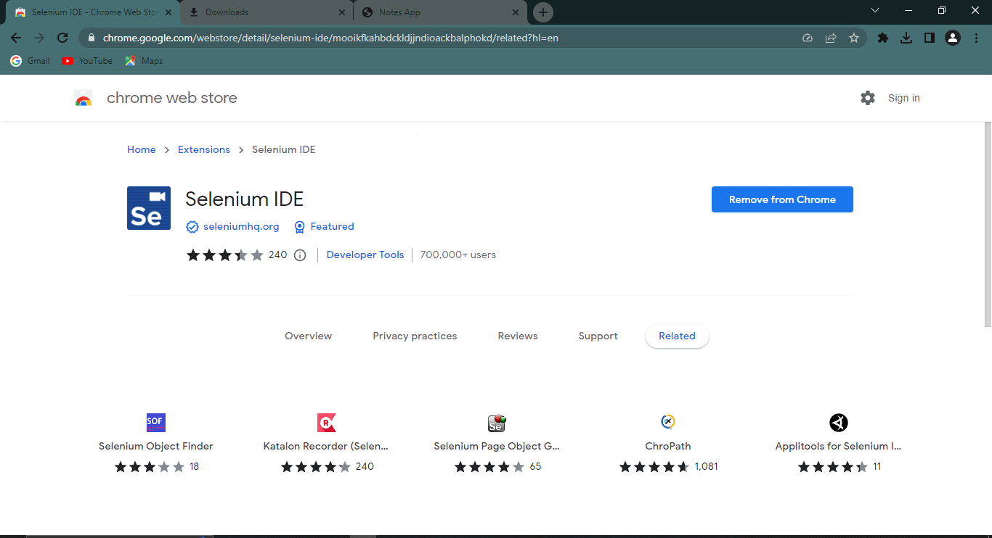

Start Selenium IDE from extensions tab

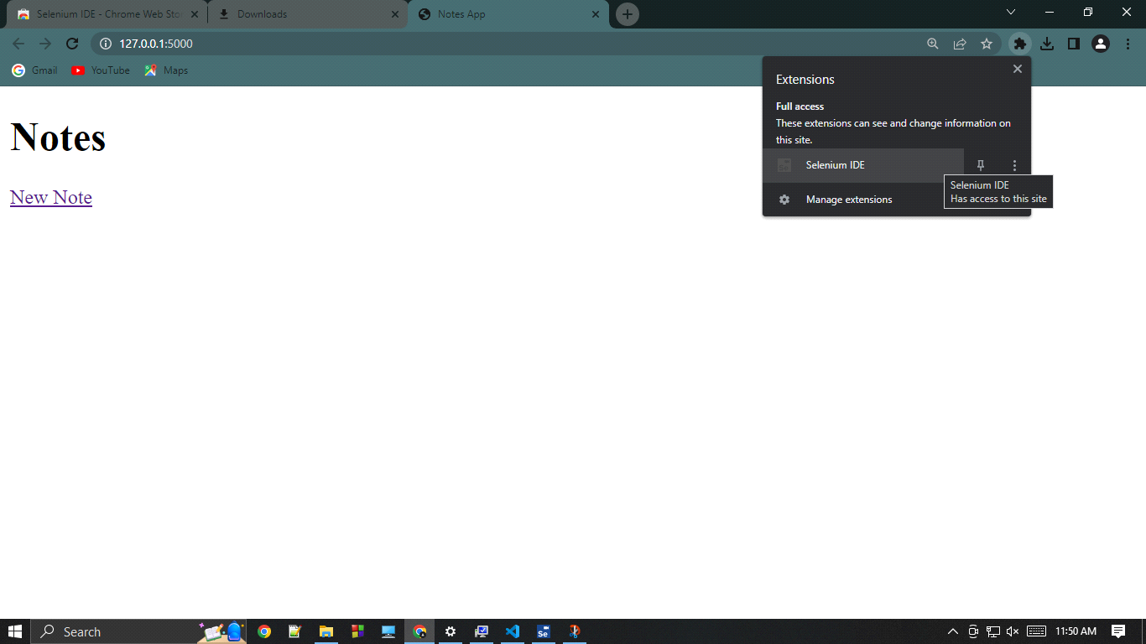

This will launch Selenium IDE. Click on "Record a new test in a new project"

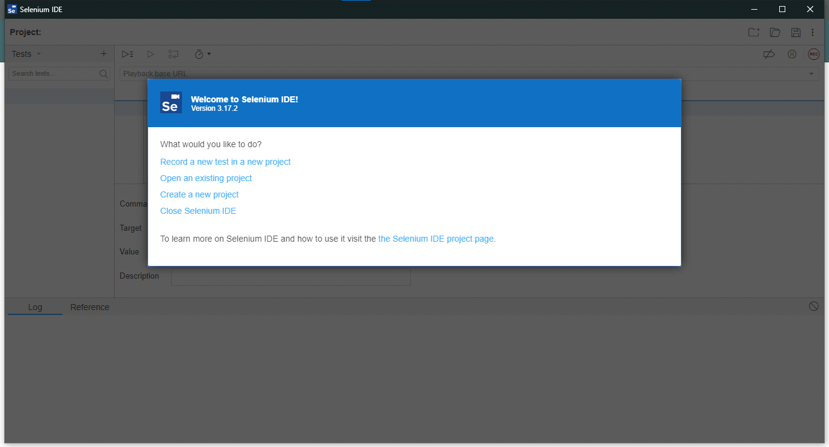

Give the project a name and press "OK"

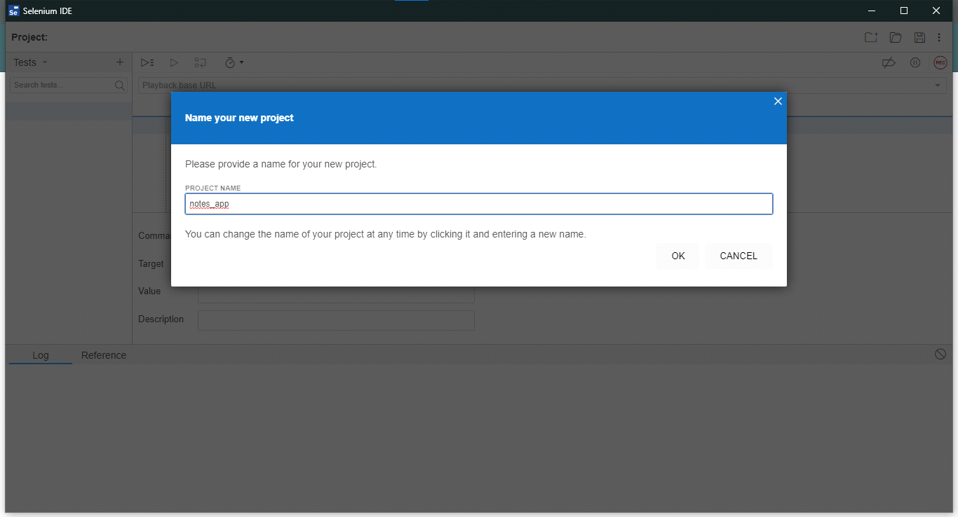

The IDE will ask for the URL, URL copied from the next screenshot

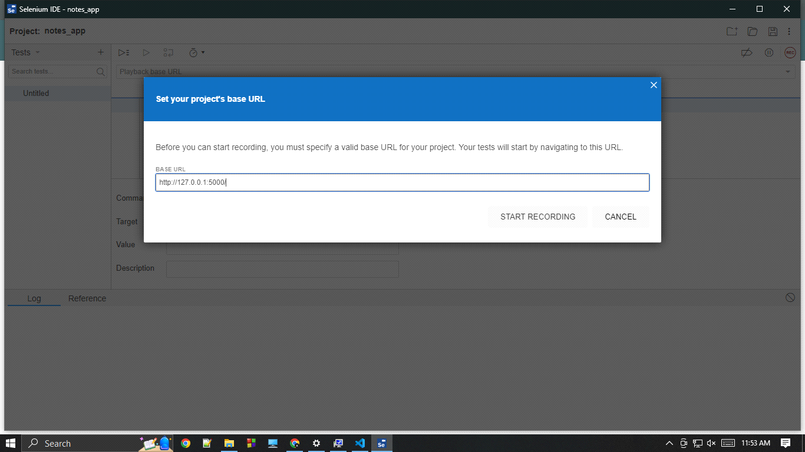

Run the app and copy the URL

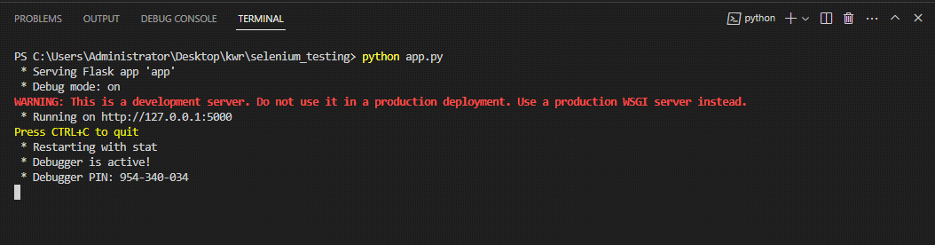

Selenium will automatically start a new window and start recording

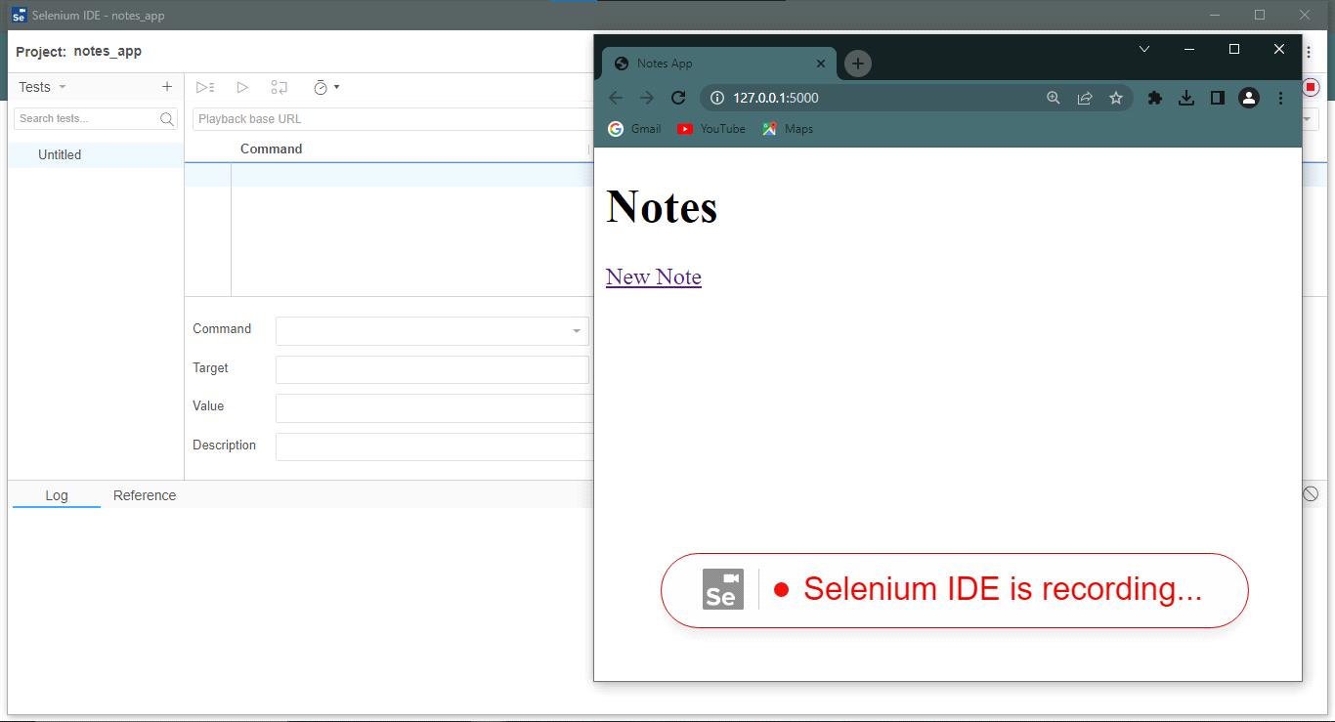

In the next steps, we will manually test the app and selenium IDE will record the test steps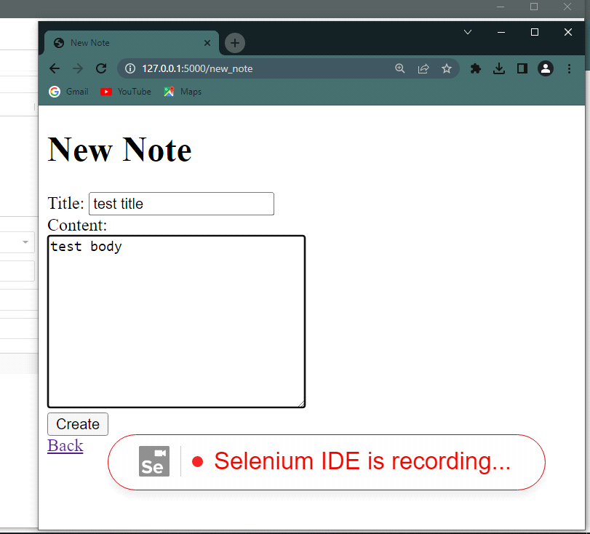

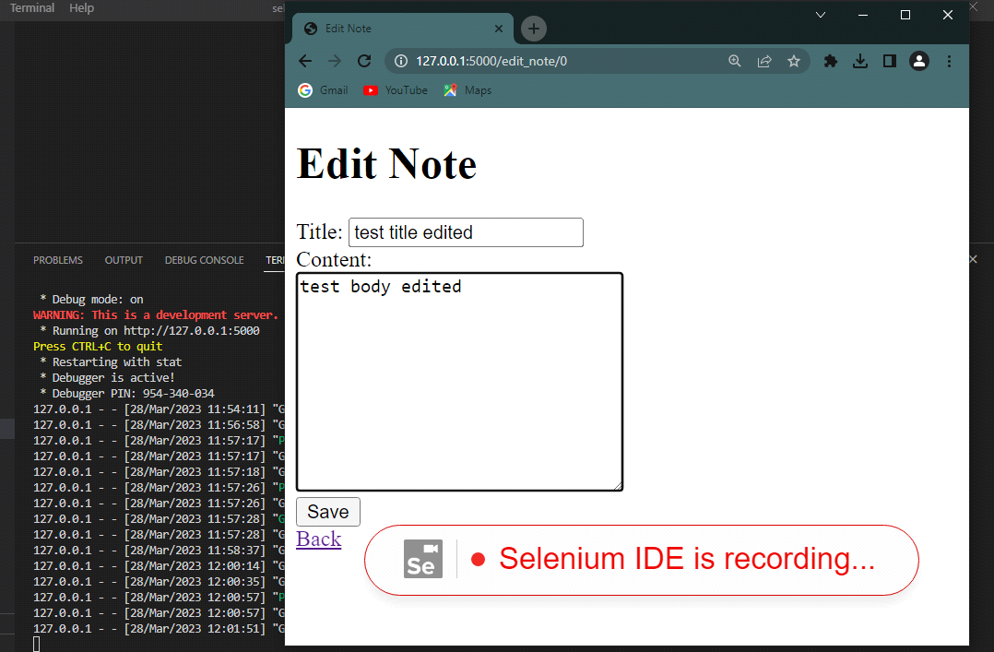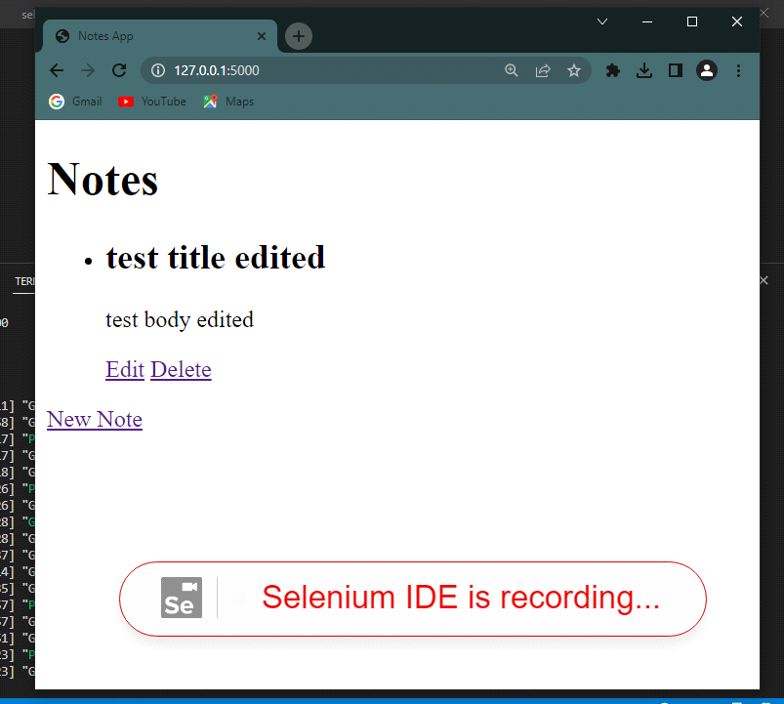

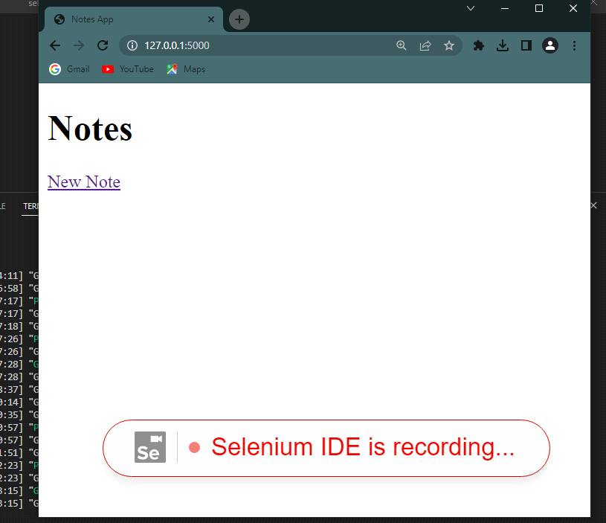

Upon completion of the test, we will be promted for a test name

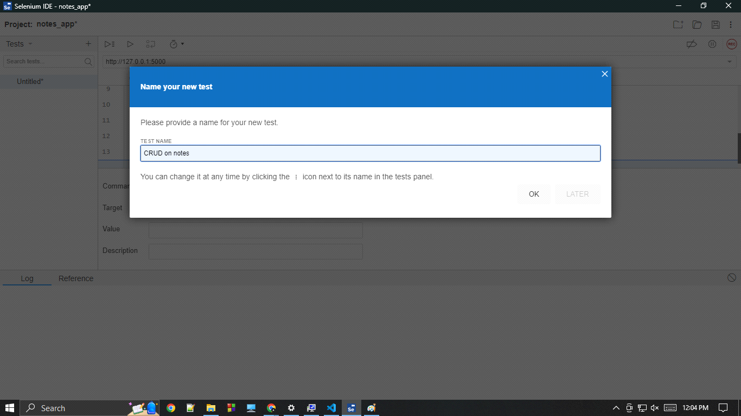

The test steps as recorded by Selenium IDE

We can change the test data from the "Value" column

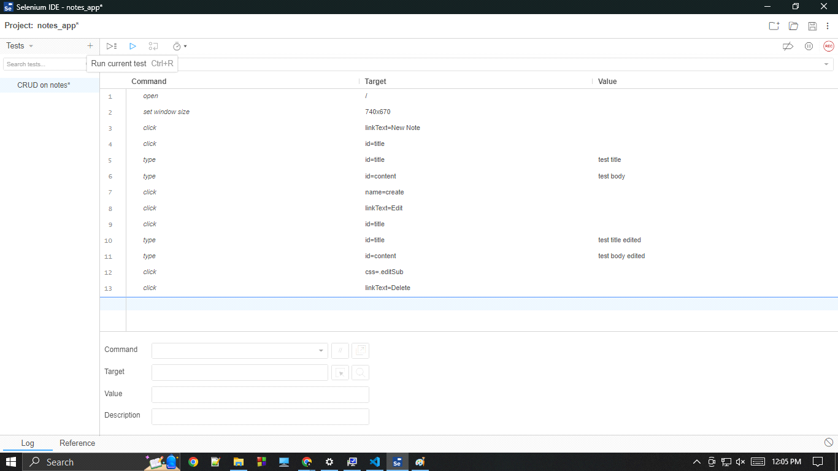

And then press "Run current test" to run the recorded test

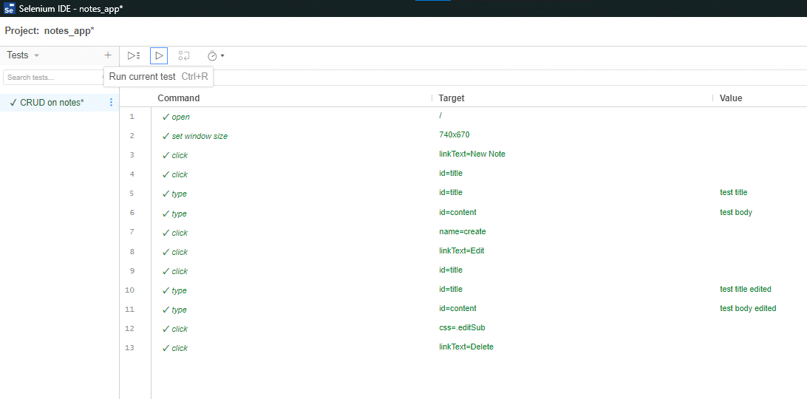

Upon completion of the test, the log can be seen

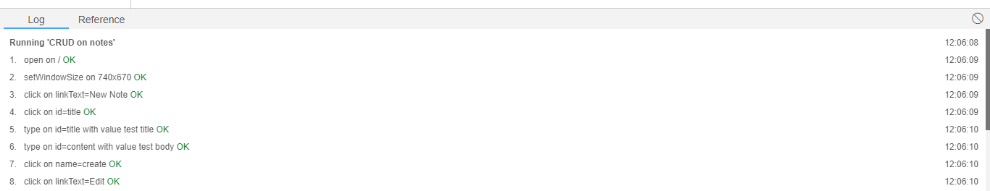

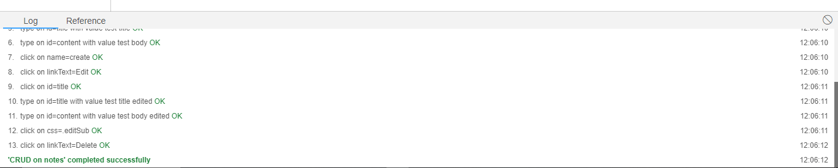

I also wrote a python script using selenium library to test this application. The messages displayed in terminal are custom.

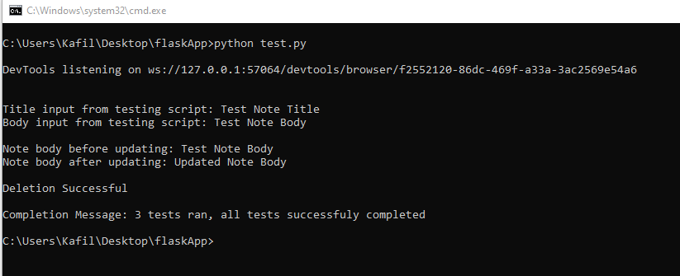

The code for this application and the test script can be found on the following repository:  
  
<https://github.com/kafil-wara/selenium_testing>