

DEPARTMENT OF COMPUTER ENGINEERING

FACULTY OF ENGINEERING

AHMADU BELLO UNIVERSITY ZARIA

COEN807: Machine Learning for Real-World Data Analytics

Term Project Technical Report

Data-Driven Disease and Pest Classification in Greenhouse Bell Pepper Leaves Using Convolutional Neural Networks and Transfer Learning

Submitted by:
Kafilat Musa
P25EGCP8001
June, 2026.

Abstract
Bacterial spot, Cercospora leaf spot, leaf curl, nutrition deficiency, and powdery mildew are among the most economically damaging conditions affecting bell pepper (Capsicum annuum) cultivation in greenhouse settings, where early and accurate diagnosis directly influences yield outcomes. This project addresses the problem of automated visual disease and pest classification in greenhouse pepper plants using a supervised image classification approach. A publicly available dataset comprising 9,283 labelled leaf images across six classes (Bacterial Spot, Cercospora Leaf Spot, Healthy, Leaf Curl, Nutrition Deficiency, and Powdery Mildew) was obtained from Mendeley Data. Three convolutional neural network architectures were implemented and rigorously compared: a baseline CNN trained from scratch, a MobileNetV2 model using transfer learning with frozen pretrained weights, and a ResNet50V2 model using the same transfer learning strategy. To address a severe class imbalance in the dataset (a 25:1 ratio between the largest and smallest classes), class-weighted loss was applied during training, and a stratified 70/15/15 train-validation-test split preserved class proportions across all subsets. The baseline CNN achieved 93.78% test accuracy but exhibited unstable validation behaviour across epochs. Both transfer learning models substantially outperformed the baseline, with MobileNetV2 achieving the best overall result at 98.50% test accuracy and a macro F1-score of 0.99, while using approximately 30 times fewer trainable parameters than the baseline CNN. A subsequent fine-tuning experiment, in which the final 20 layers of MobileNetV2 were unfrozen, did not improve performance and instead reduced test accuracy to 97.00%, an informative negative result attributed to the limited training set size relative to the number of newly trainable parameters. The final recommended model, frozen MobileNetV2, combines high diagnostic accuracy with computational efficiency suitable for deployment on resource-constrained greenhouse monitoring devices.

1. Introduction and Problem Definition
Greenhouse cultivation of bell pepper (Capsicum annuum) is widely practised to achieve controlled growing conditions and extended growing seasons, but the same enclosed environment that protects crops from external weather also creates favourable conditions for the rapid spread of fungal, bacterial, and physiological disorders once they take hold. Diseases such as bacterial spot and Cercospora leaf spot, alongside pest-related symptoms such as leaf curl and powdery mildew, can substantially reduce yield if not identified and treated early. Traditionally, diagnosis relies on visual inspection by trained agronomists or farmers, a process that is time-consuming, subjective, and difficult to scale across large greenhouse operations.
This project investigates whether a machine learning approach, specifically supervised image classification using convolutional neural networks, can reliably automate this diagnostic process. The central problem addressed is: given a digital photograph of a single bell pepper leaf, can a trained model correctly classify it into one of six categories describing its health status?
Among the project objectives include: To source and characterise a real-world, image-based dataset suitable for plant disease classification; To design and implement a complete preprocessing and data preparation pipeline appropriate for deep learning on image data; To implement and train multiple distinct classification approaches, specifically a CNN built from scratch and two transfer-learning architectures (MobileNetV2 and ResNet50V2); To apply systematic hyperparameter tuning and document its effect on model performance, including negative results; To evaluate all models using metrics appropriate to a multi-class, imbalanced classification problem.

2. Dataset Description and Justification
The dataset used in this project is the publicly available “Pepper Bell Leaf Disease” dataset, hosted on Mendeley Data (DOI: 10.17632/w9drvtxg9g.1) under a Creative Commons Attribution 4.0 (CC BY 4.0) licence. The dataset comprises 9,283 RGB JPEG images of bell pepper leaves, organized into six class folders corresponding to a Healthy state and five disease or deficiency conditions: Bacterial Spot, Cercospora Leaf Spot, Leaf Curl, Nutrition Deficiency, and Powdery Mildew. Initial inspection of image metadata revealed that, while all images share a consistent RGB colour mode and JPEG format, their pixel dimensions vary considerably across files (observed examples ranged from 256×256 up to 1000×1703 pixels), necessitating a standardized resizing step prior to model training.
Summarized Table 1 and Figure 1 shows a ratio of approximately 25:1 between the largest and smallest classes.
Class | Image Count | Percentage
Bacterial Spot | 4,901 | 52.8%
Cercospora Leaf Spot | 1,796 | 19.3%
Healthy | 1,524 | 16.4%
Nutrition Deficiency | 444 | 4.8%
Leaf Curl | 423 | 4.6%
Powdery Mildew | 195 | 2.1%
Total | 9,283 | 100%
Table 1: Image count and percentage share per disease class.
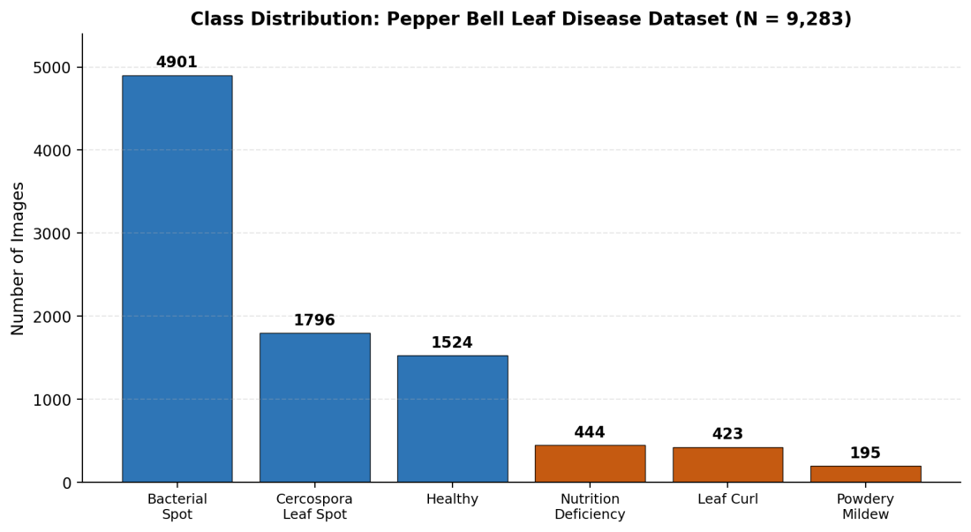
Figure 1: Bar chart visualising the class distribution, highlighting the severe imbalance between the majority class (Bacterial Spot) and the three smallest classes.
This imbalance is not a flaw introduced during data collection but a realistic reflection of disease prevalence in the field. Because an imbalance of this magnitude can cause a naively trained classifier to default to predicting the majority class, this characteristic directly informed two later design decisions: the use of class-weighted loss during training (Section 4.3) and the use of stratified splitting when partitioning the dataset (Section 6.1). Figure 2 presents one representative sample image from each of the six classes, illustrating the distinct visual symptoms associated with each condition
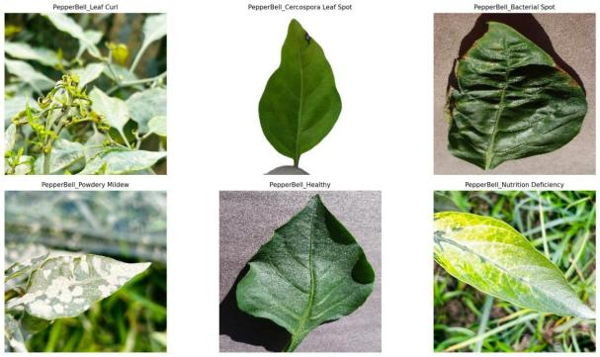
Figure 2: Representative sample images from each of the six classes in the dataset.

3. Data Preprocessing and Feature Engineering

3.1 Image Resizing and Normalization
All images were resized to a uniform 224×224 pixel resolution.

3.2 Data Augmentation
The training data generator applied real-time data augmentation, including random rotations of up to 30 degrees, horizontal and vertical shifts of up to 20% of image dimensions, shear transformations, zoom variation of up to 20%, and horizontal flipping. Validation and test images were resized and normalized but never augmented.

3.3 Addressing Class Imbalance: Class Weighting
Given the approximately 25:1 imbalance ratio identified in Section 2.1, class weights were computed using the balanced heuristic from scikit-learn. The resulting weights, shown in Table 2 mirrors the inverse of the underlying class size ratio. These weights were supplied to the loss function during training of all three models.
Class | Computed Class Weight
Bacterial Spot | 0.316
Cercospora Leaf Spot | 0.861
Healthy | 1.015
Leaf Curl | 3.657
Nutrition Deficiency | 3.492
Powdery Mildew | 7.960
Table 2: Class weights computed using the balanced heuristic, used to correct for class imbalance during training.

4. Methodology and Model Selection
Three distinct convolutional architectures were implemented:

4.1 Model 1: Baseline Convolutional Neural Network
A convolutional neural network was constructed from scratch as a baseline reference point. The architecture consists of four convolutional blocks of increasing filter depth (32, 64, 128, and 128 filters respectively), each comprising a convolutional layer, batch normalisation, and max pooling, followed by a flattening layer, a dense layer of 256 units with a dropout rate of 0.5 to mitigate overfitting, and a final softmax output layer producing probabilities across the six target classes. This architecture totalled 4,962,630 parameters, of which 4,961,926 were trainable.

4.2 Model 2: MobileNetV2 with Transfer Learning
MobileNetV2, pretrained on the ImageNet dataset of 1.4 million general images, was used as a feature extraction backbone. Its original 1,000-class classification head was removed and replaced with a custom head comprising global average pooling, a dense layer of 128 units, a dropout layer (rate 0.3), and a final six-class softmax output. All pretrained convolutional layers were initially frozen while the base network's 2,257,984 parameters remained fixed at their pretrained values.

4.3 Model 3: ResNet50V2 with Transfer Learning
ResNet50V2, a substantially deeper architecture (190 layers, 23,827,846 total parameters) also pretrained on ImageNet, was implemented using an identical transfer learning strategy and classification head structure to MobileNetV2.

4.4 Training Configuration
All three models were compiled using the Adam optimizer and categorical cross-entropy loss, and trained for up to 30 epochs with a batch size of 32. Two callbacks were applied uniformly across all training runs. The class weights described in Section 3.3 were applied during training of all models.

5. Experimental Design

5.1 Train, Validation, and Test Split
The dataset was partitioned into training (70%), validation (15%), and test (15%) subsets using stratified sampling with a fixed random seed of 42 to ensure reproducibility. The resulting split sizes are shown in Table 3.
Split | Image Count | % of Total | Target %
Training | 6,495 | 69.9% | 70%
Validation | 1,390 | 15.0% | 15%
Test | 1,398 | 15.1% | 15%
Total | 9,283 | 100% | 100%
Table 3: Stratified train/validation/test split sizes and proportions.

5.2 Evaluation Metrics and Justification
Four complementary metrics were adopted: Accuracy; Precision (per class); Recall (false negative); F1-score (per class, plus macro and weighted averages. A confusion matrix was additionally generated for each model to provide qualitative insight.

5.3 Hyperparameter Tuning Procedure
A fine-tuning experiment was conducted on the best-performing model, MobileNetV2. The final 20 layers of the MobileNetV2 base network were unfrozen, and the model was recompiled with a substantially reduced learning rate (1×10⁻⁵, a 100-fold reduction from the default). The model was then trained for up to 15 additional epochs under the same early stopping and checkpointing regime as the initial training runs.

6. Results and Evaluation

6.1 Baseline CNN Results
The baseline CNN was trained for 13 epochs before early stopping halted training, restoring weights from epoch 8, which achieved the best validation accuracy of 94.46%. The full per-class classification report is shown in Table 4.
Class | Precision | Recall | F1-Score | Support
Bacterial Spot | 0.97 | 0.95 | 0.96 | 736
Cercospora Leaf Spot | 0.98 | 0.94 | 0.96 | 270
Healthy | 0.84 | 0.91 | 0.87 | 230
Leaf Curl | 0.89 | 1.00 | 0.94 | 64
Nutrition Deficiency | 0.87 | 0.91 | 0.89 | 68
Powdery Mildew | 0.96 | 0.80 | 0.87 | 30
Table 4: Per-class precision, recall, and F1-score for the baseline CNN on the test set (overall accuracy 93.78%, macro F1 = 0.92, weighted F1 = 0.94).
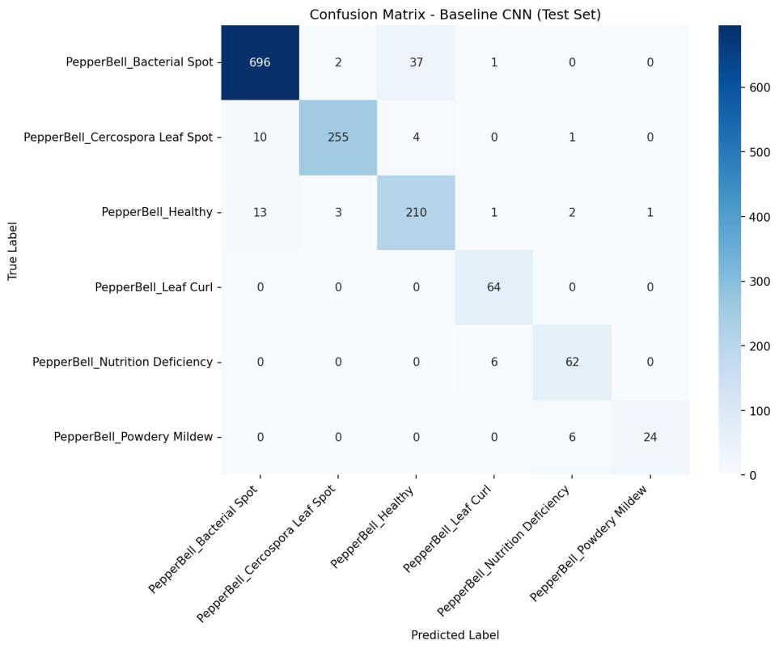
Figure 3: Confusion matrix for the baseline CNN on the test set.

6.2 MobileNetV2 Results
MobileNetV2 was trained for 25 epochs, with early stopping restoring weights from epoch 17. The complete per-class results are presented in Table 5.
Class | Precision | Recall | F1-Score | Support
Bacterial Spot | 0.99 | 0.99 | 0.99 | 736
Cercospora Leaf Spot | 0.98 | 0.99 | 0.98 | 270
Healthy | 0.98 | 0.97 | 0.98 | 230
Leaf Curl | 1.00 | 1.00 | 1.00 | 64
Nutrition Deficiency | 0.97 | 1.00 | 0.99 | 68
Powdery Mildew | 1.00 | 1.00 | 1.00 | 30
Table 5: Per-class precision, recall, and F1-score for MobileNetV2 on the test set (overall accuracy 98.50%, macro F1 = 0.99, weighted F1 = 0.98).
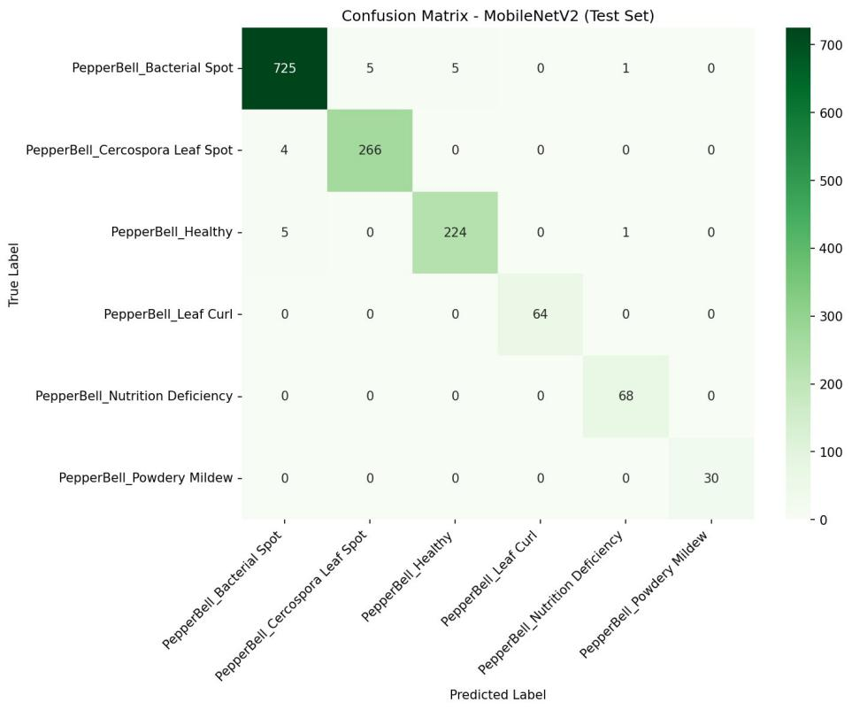
Figure 4: Confusion matrix for MobileNetV2 on the test set.

6.3 ResNet50V2 Results
ResNet50V2 was trained for 20 epochs, with early stopping restoring weights from epoch 15. Table 6 presents the full per-class breakdown.
Class | Precision | Recall | F1-Score | Support
Bacterial Spot | 0.99 | 0.98 | 0.99 | 736
Cercospora Leaf Spot | 0.99 | 0.98 | 0.98 | 270
Healthy | 0.96 | 0.99 | 0.97 | 230
Leaf Curl | 1.00 | 1.00 | 1.00 | 64
Nutrition Deficiency | 0.99 | 1.00 | 0.99 | 68
Powdery Mildew | 1.00 | 1.00 | 1.00 | 30
Table 6: Per-class precision, recall, and F1-score for ResNet50V2 on the test set (overall accuracy 98.43%, macro F1 = 0.99, weighted F1 = 0.98).
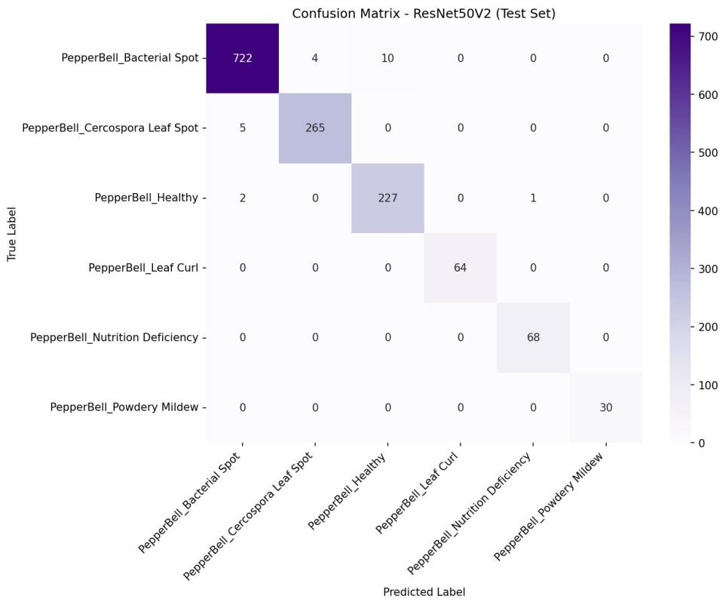
Figure 5: Confusion matrix for ResNet50V2 on the test set

6.4 Hyperparameter Tuning: Fine-Tuning MobileNetV2
The fine-tuning phase ran for 6 epochs before early stopping halted training. On the test set, the fine-tuned model achieved 97.00% accuracy, approximately 1.5 percentage points below the original frozen MobileNetV2 configuration.

7. Comparative Analysis and Discussion
Model | Test Accuracy | Macro F1 | Trainable Params | Stability
Baseline CNN | 93.78% | 0.92 | 4,961,926 | Unstable
MobileNetV2 (frozen) | 98.50% | 0.99 | 164,742 | Stable
ResNet50V2 (frozen) | 98.43% | 0.99 | 263,046 | Stable
MobileNetV2 (fine-tuned) | 97.00% | — | 164,742 | Declining
Table 7: Consolidated comparison of all four trained model configurations.
This project recommends the frozen MobileNetV2 configuration as the final model for greenhouse pepper disease classification. It achieves the highest test accuracy (98.50%) among all configurations tested.

8. Limitations, Biases, and Lessons Learned

8.1 Limitations and Biases
Class imbalance; Image acquisition conditions; Single-leaf, single-label assumption; Geographic and cultivar specificity; Single train/test split and Limited hyperparameter search.

8.2 Lessons Learned
Transfer learning, Addressing class; Not every optimisation technique improves results; Evaluating models using multiple metrics and confusion matrices, rather than accuracy alone, revealed practically important differences between models.

9. Conclusion and Future Work
Future work could extend this project in several directions. Cross-validation across multiple data splits. Deployment-oriented experiments and finally, extending the dataset to include images exhibiting multiple co-occurring conditions, combined with a multi-label rather than single-label classification framing, would more closely reflect the complexity of real-world greenhouse disease presentation.

10. References
Elvsava, R. (2026). Pepper Bell Leaf Disease [Data set]. Mendeley Data, V1. https://doi.org/10.17632/w9drvtxg9g.1
Howard, A. G., Zhu, M., Chen, B., Kalenichenko, D., Wang, W., Weyand, T., Andreetto, M., & Adam, H. (2017). MobileNets: Efficient convolutional neural networks for mobile vision applications. arXiv preprint arXiv:1704.04861.
He, K., Zhang, X., Ren, S., & Sun, J. (2016). Identity mappings in deep residual networks (ResNet50V2). In European Conference on Computer Vision (ECCV).
Pedregosa, F., et al. (2011). Scikit-learn: Machine learning in Python. Journal of Machine Learning Research, 12, 2825–2830.
Abadi, M., et al. (2015). TensorFlow: Large-scale machine learning on heterogeneous systems. https://www.tensorflow.org/

