Instructions
If you do not have SDL2 then install

$sudo apt-get install libsdl2-dev
Unzip and go to the root folder analogue_clock
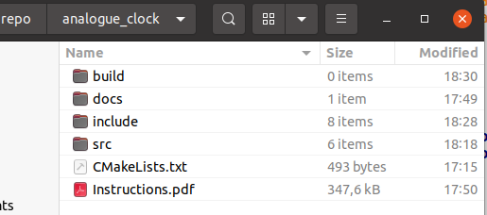

Open the terminal here
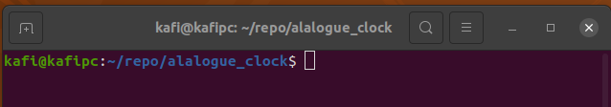

If it is needed to run CMake, then delete everything in folder build, and run

$ cmake -B build
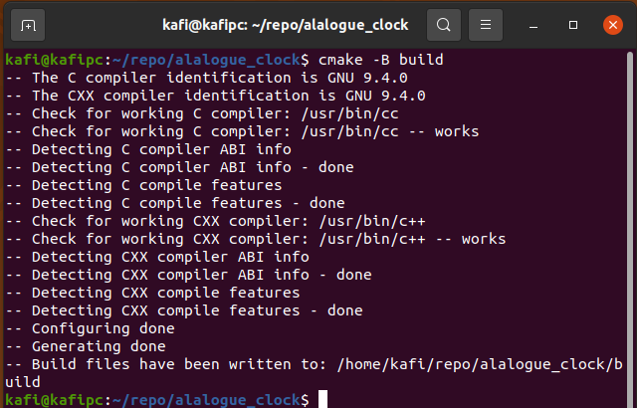
Go to folder build

$ cd build
Make the program

$ make
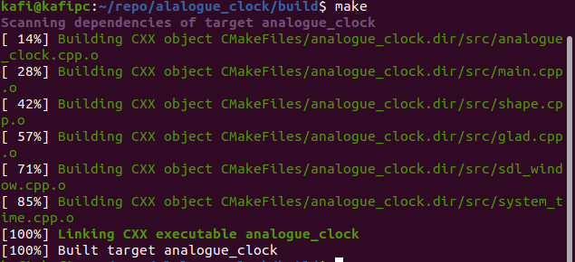

Run the program

$ ./analogue_clock

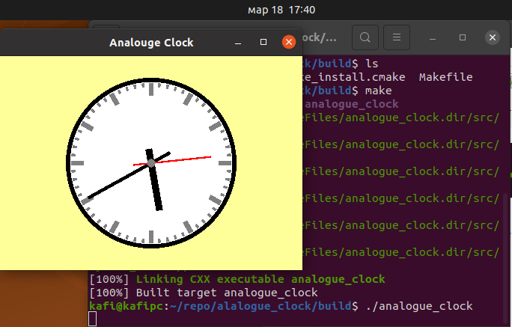
The clock shows the system time, as shown below:
