Problem:
for 20x20, the flow is stopped at about 30% saturation. Possible solution #1 was used, but law of conservation of a phase is violated.

Reason of the problem:
Floating point integers do not add up to one (1.000). It happens because there are lot of steps in the calculation, solving linear equation, finding time step, involving multiplication, division. In each step some precision is lost.

Example:
1/3 + 1/3 + 1/3 = 0.9999 not 1.00000
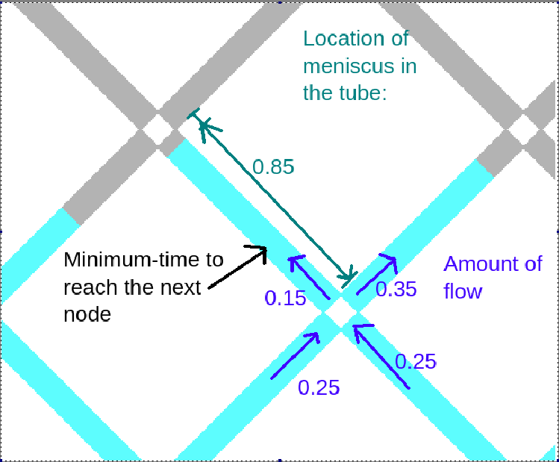
Figure before integration, here 0.85(0.84967) + 0.15(0.14948) = 0.99915, time step = 33.45s
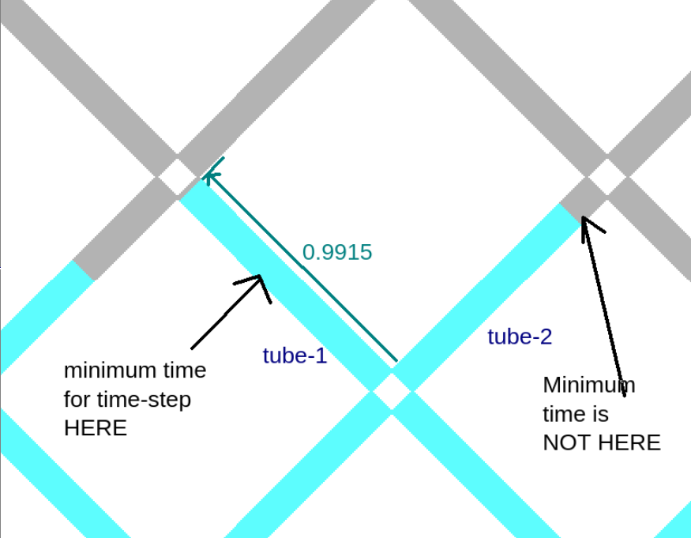
After integration, p = 0.9915, also new minimum time is again in tube-1 when it is supposed to be in tube-2, with time step = 0.00006021 which is associated with tube-1

Possible solution #1: Trimming
Let there be a small number e, for example e = 0.0001
If there are meniscus positions such as, p = {0.00005, 0.000083, 0.99991, 0.99994}
Here (1.0000 – p) < e or p < e, then p = 1.0000 or p = 0

Draw Back of Solution
For 20x20, there are 400 tubes, in each tube if a phase of volume 0.0001 is lost (by trimming), total loss = 400 x 0.001 = 0.04, which is 4% of the total volume of a phase. This is significant violation of law of conservation of volume.

Possible Solution #2:
- Determine the time step
- Record in which tube the meniscus reaches the node next
- Redefine the time step in such a way that the meniscus will reach the node with more precision (1.0000).
- Calculate the volume distributions in all other tubes based on this, ensuring that kirchoff’s law is valid in each of the nodes.

