19.02.2024
Report of Experiment of Capillary pressure vs saturation for various initial proportions of blue fluid.

Theory:
Capillary pressure of the system is defined by:

Only the tubes with an odd number of meniscus is considered.

Description:
- 10 experiments were conducted
- the initial saturation of the blue fluid was increased by increasing the proportion of blue fluid in the inner region
- Experiment 1 – 8 was done for 10,000 steps. Experiment 10 for 3400 steps and experiment 9 for 1000 steps. This is because in experiment 9 -10 complete equilibrium was achieved. There were no tubes with odd number of meniscus remaining in the system, therefore no capillary pressure to drive the flow.
- The average capillary pressure at the end is calculated by taking the average of P_c in the last 2000 steps of computation for experiments 1- 8. Averaging was done to smoothen the effects of the vibrations observed in the capillary pressure. However for experiments 9 – 10, the capillary pressure is not the average of some steps, but for the 1000th step and the 3400th step respectively.
- Note that at the step when the experiment was forced to be terminated, capillary pressure cannot be defined. Since the total area in the denominator is zero.
- Radii of {2, 3, 4, 5} +- 0.01 was used in the inner region. Radius of 6 +- 0.01 was used in the outer region. The outer region was approximately half of the total volume.

Note that it was compulsory to add 1% randomness to the radius distributions, because in lower initial saturation of blue fluid in the system, a flow will not start.



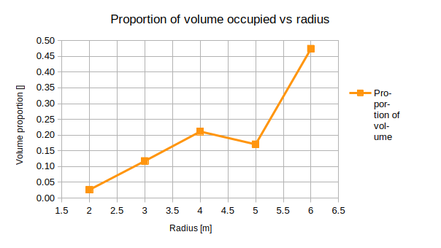
Figure 1: showing proportion of volume occupied by various tubes of similar radii to the total volume of the system (capillary space).

Results from Experiments:
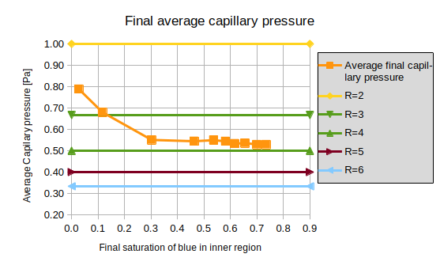
Figure 2: Average Capillary Pressure for Simulations for various final saturation in comparison with capillary pressures for 5 different tube radii.

The final saturation needed to be close to the volume of the thinnest tubes, as the average capillary pressure is mainly defined by the thinnest tubes.

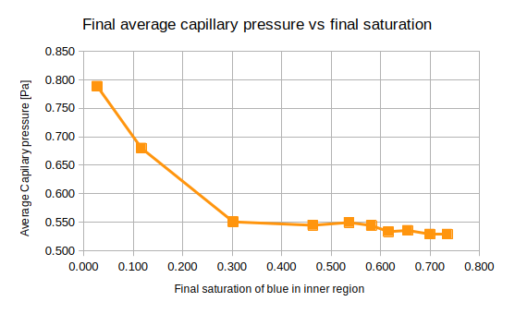

Figure 3: Showing the trend of average capillary pressure increasing in the system with the decrease of final equilibrium saturation of blue fluid in the inner region.

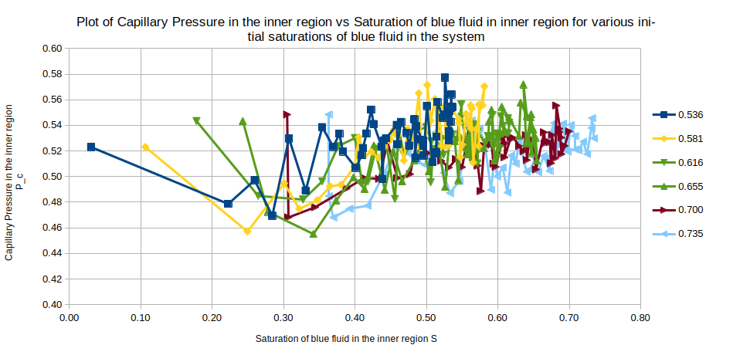
Figure 4: Capillary pressure vs saturation plots for various experiments denoted by the value of final blue saturation for Experiments 1- 6.

Conclusion:
The final average capillary pressure increased with decreasing the final saturation of blue(wetting) fluid in the inner region. However since overall less number of meniscus is created in the system is less, we face steps in the experiment where the there is no odd number of meniscus in any tube, and therefore no capillary pressure to continue flow. Therefore for lower than 0.35 initial proportions of blue fluid in the system, the experiment was required to be stopped after a certain number of steps. Since the values of Capillary pressure varied greatly between the 200 steps at which the measurement was recorded, an average of 1000 steps could not be made, therefore further investigation is required to be sure about the increase in capillary pressure.

