УДК 532.685

**Modeling Imbibition in Porous Media with Two-phase flow using a Two-Dimensional Network**

***K. Shabbir, O. Izvekov, A.Konyukhov***

Moscow Institute of Physics and Technology

Simulation of two-phase flow in porous media has many applications in oil recovery, hydrology, electricity production, etc. Classical continuum models consider permeability to be a function of only saturation. Classical continuum models are unable to explain non-equilibrium effects [1]. Advanced continuum models, such as the Kondaurov model considers permeability to be a function of a non-equilibrium parameter in addition to saturation. In order to better understand the non-equilibrium effects, it is necessary to develop models at the scale of the pores, for example a network model. Our model is similar to the network model developed by *Aker, Måløy et al.* [2]. However, cylindrical tubes are used in our model instead of hour glass shaped since it allows us to derive accurate flow rate equations [3]. Our model also uses a novel method of distributing different phases in the nodes. We modeled imbibition, where wetting fluid was located in the outer region with thicker radius, and non-wetting fluid in the inner region with thinner radius or finer pores. We measured the saturation of the wetting phase with respect to time in the region of finer pores.

The average capillary pressure is defined as:

$P_{c}=\frac{Σ\frac{2σ}{r_{i}}.πr_{i}^{2}}{Σπr_{i}^{2}}$ (1)

Here $σ$ is the coefficient of surface tension. $r$ is the radius of the tube.

The main steps of computation is: at first we determine the pressures in each node by solving a system of linear equations. Then from the known pressures we calculate the flow rates. Lastly we decide an appropriate time step, distribute the fluids in the nodes, and perform displacement of the fluids in the tubes. The fluids are distributed such that the wetting fluid first enters the thinnest tubes. Our network model successfully shows that the wetting fluid invades the region of finer pores, and the saturation with respect to time rests to an equilibrium value. Also when the radii in the inner region was varied we observe that the capillary pressure increases with decrease of final saturation. In the future we intend to extend our model to a 3D case[4] and create more complicated connection between the nodes, keeping in mind that ultimate goal of our research is to understand the physical meaning of the Kondaurov non-equilibrium parameter.

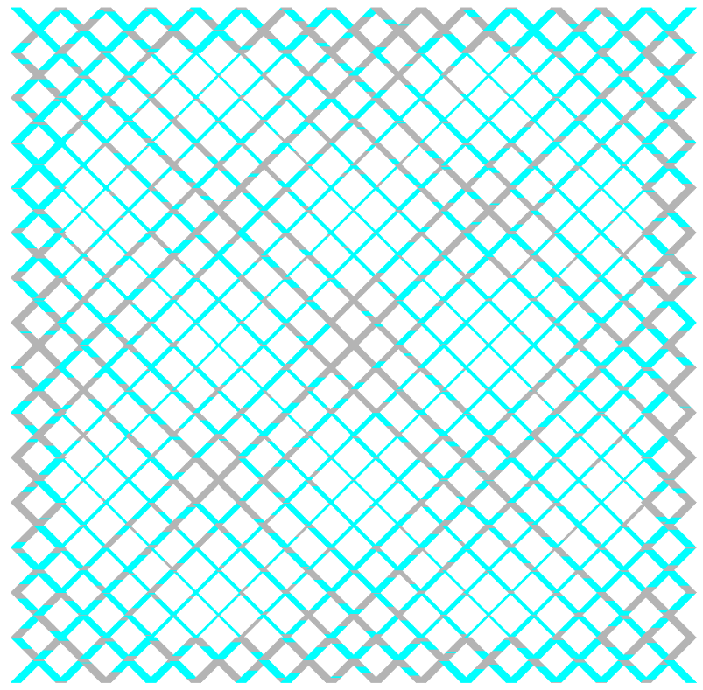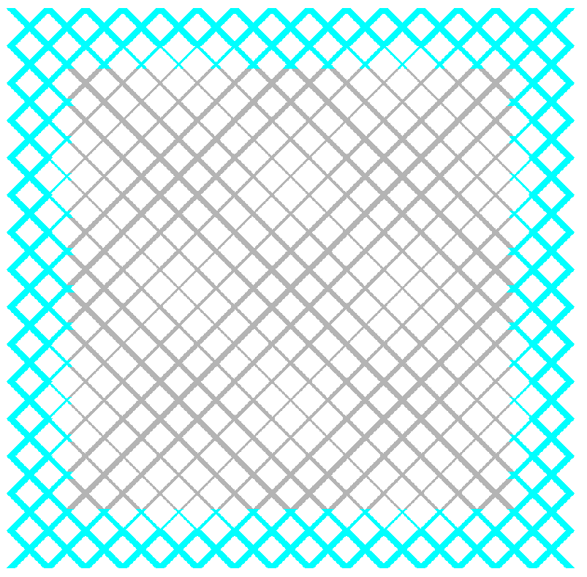

Fig 1: shows initial setup, where wetting fluid is located in the inner region, which contains tubes of thicker radius. Fig 2: shows invasion by wetting fluid into the inner region with thinner radius.

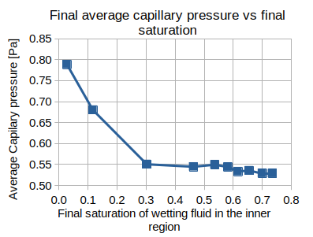 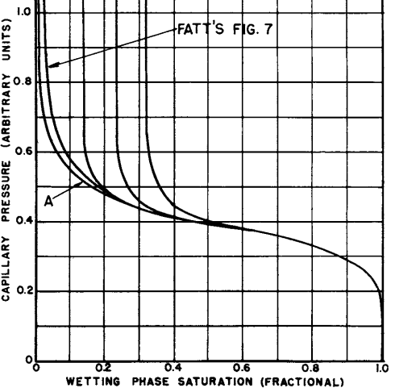

Fig 3: Shows results from various experiments where the initial saturation of wetting (cyan) fluid was varied in the system, which resulted in different final saturation on wetting fluid in the inner region, as the final saturation decreases the average capillary pressure increases, since there are menisci located in the thinnest tubes. Fig 4: shows plots of capillary pressure vs saturation of wetting fluid as measured experimentally and predicted by resistor network [5]

This work was supported by grant РНФ №23-21-00175.

**References**

1. *Raoof A., Hassanizadeh S.* A new method for generating pore-network models of porous media // Transp. Porous Med. 2010. V. 81. P. 391–407.
2. *Aker E., Måløy K. J., Hansen A., Batrouni G. G.* A two-dimensional network simulator for two-phase flow in porous media // Transp. Porous Med. 1998. V. 32. P. 163–186.
3. *K. Shabbir* Simulation of Two-Phase Flow in Porous Media using a Two-Dimensional Network Model // 65th All Russia MIPT Conference ISBN 978-5-89155-388-0 2023 V. 78 P. 205 - 206
4. *Sinha S. [et al.].* Effective rheology of two-phase flow in three-dimensional porous media: experiment and simulation // Transp. Porous Med. 2017. V. 119. P. 77–94.
5. *Fatt I.* The network model of porous media III. Dynamic properties of networks with tube radius distribution // Petroleum Trans. AIME 1956. V. 207. P. 164–181.