УДК 532.685

**Simulation of Two-Phase Flow in Porous Media using a Two-Dimensional Network Model**

***K. Shabbir***1

1Moscow Institute of Physics and Technology

The algorithms and methods used to simulate two-phase flow in porous media has many practical applications in oil recovery, hydrology, electricity production where pressurized water is passed through heated pipes and is transformed into steam, etc. Our algorithm presented here is used to find the saturation of a phase with respect to time, model imbibition, the hysteresis curve when the pressure across the porous body is reversed, total capillary pressure as a function of saturation[1], and determination of permeability which appears in Darcy’s law.

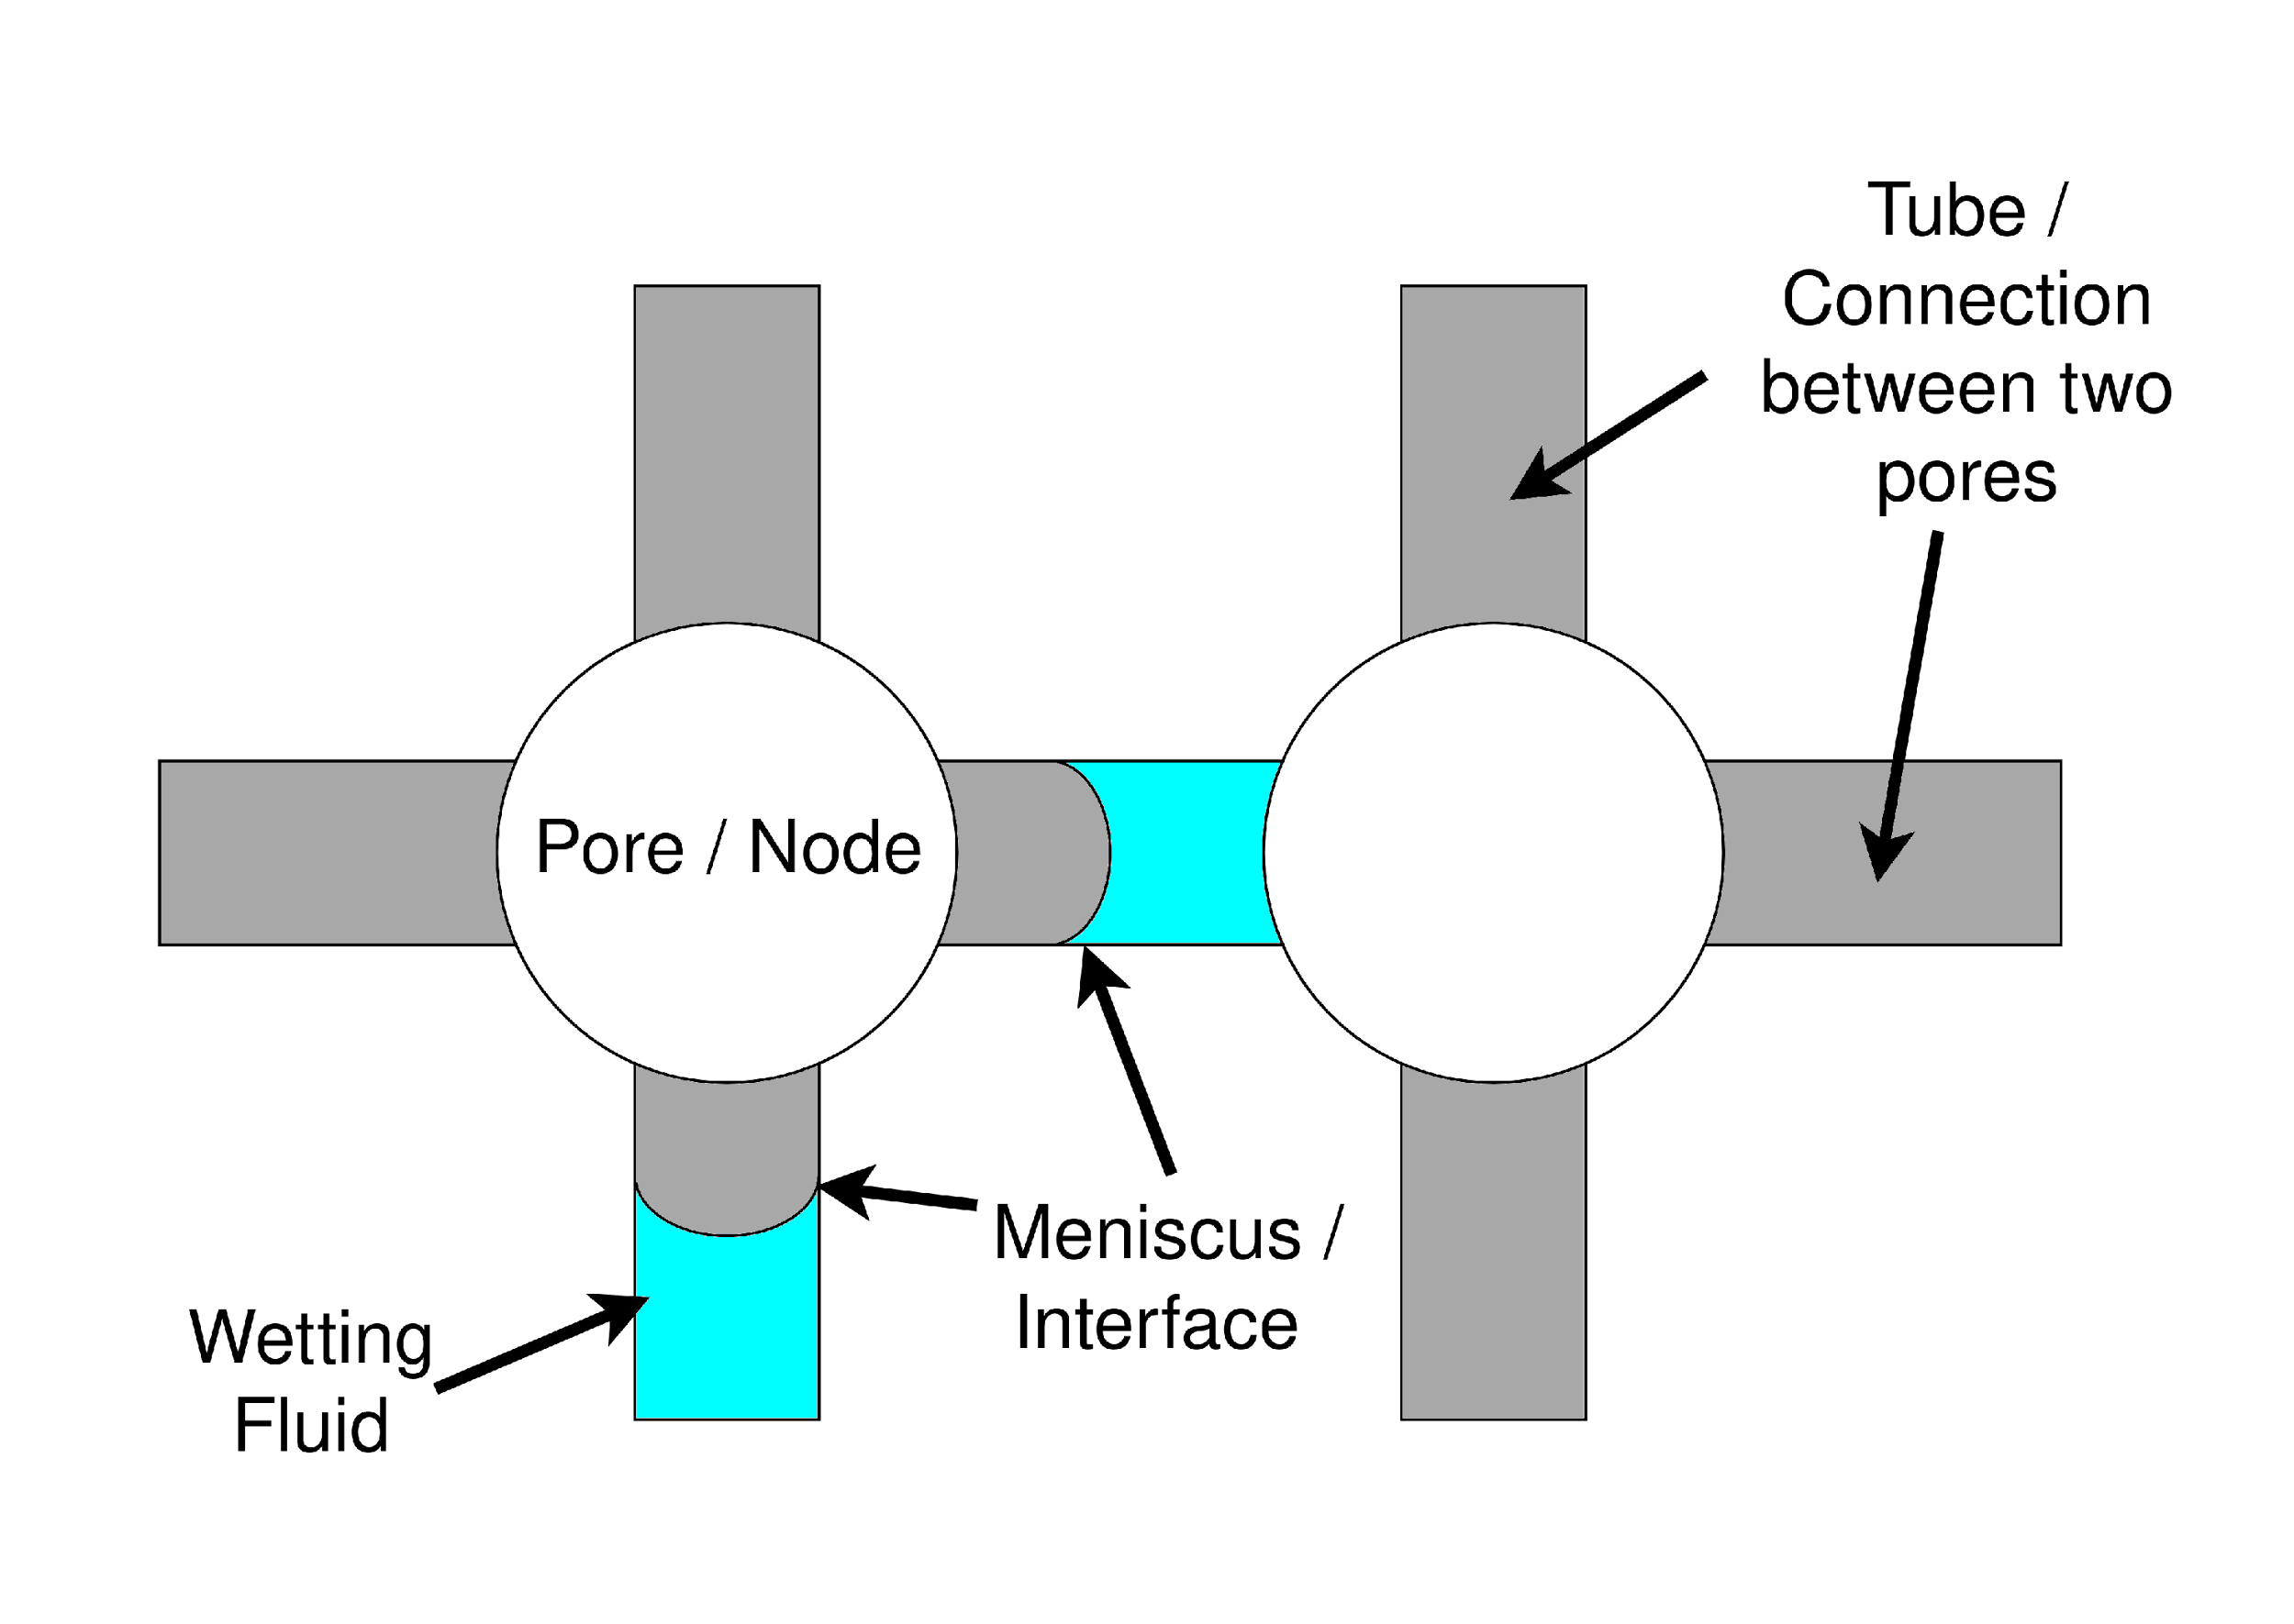 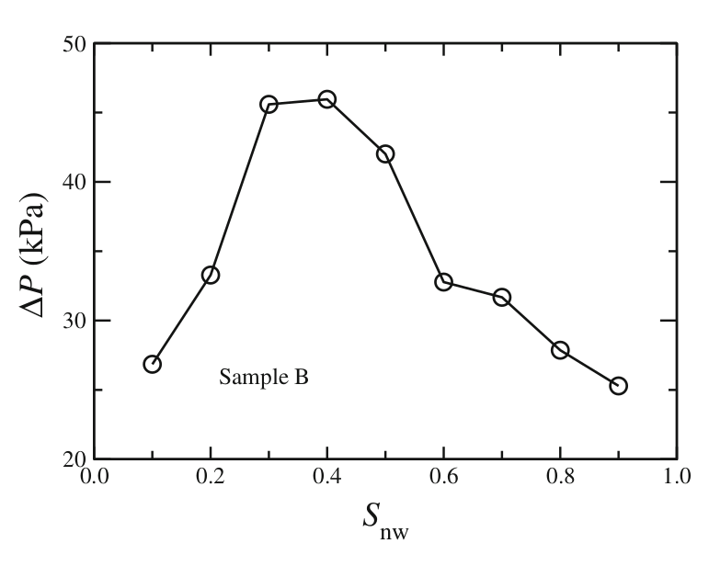

Figure 1: showing two nodes from the network where the size of the node is much larger than the radius such that the capillary force tends to zero when the meniscus enters a node. Figure 2: Showing the dependence of the average capillary pressure on the saturation of the wetting fluid, the average capillary pressure drop is maximum at the middle level of saturation, due to the maximum number of interfaces as also concluded by [2].

 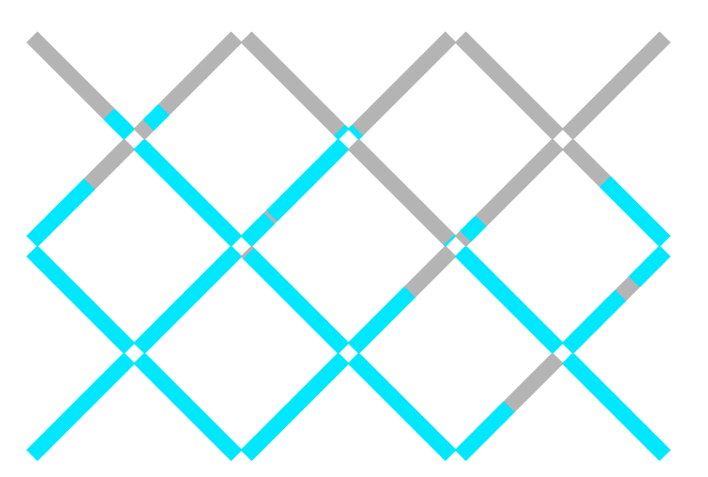  
Figure 3 & 4: showing invasion of wetting fluid into a porous body consisting of randomly distributed tube radii for a highly simplified model (4 x 6), at saturation levels of 22% and 61% using our model.

Our model is initially set up such that the wetting fluid is low in saturation and is confined to the bottom of our network. A higher pressure is fixed for all nodes at the bottom layer, while a low pressure is fixed for the top row. In all nodes, law of conservation of volume is applied, since mass is conserved and the phases are non-compressible. However for the bottom layer of nodes, the wetting fluid is injected as much required according to the sum of flow rates determined in the tubes connected to those nodes, while from the top layer of nodes a fluid is removed.

$\sum{Q_{i}=0}$ (1)

Where Q is the flow rate in [m3/s] in a tube connected to a particular node. The flow rate formula used is

$Q=\frac{πR^{4}}{8Ml}\left(ΔP+\frac{2sσ}{R}\right)$ (2)

s = {-1, 0, 1}, 0 when there are an even number of meniscus or no meniscus in a tube, +1 or -1 is due to the orientation. Here

$M=\sum{μ_{i}\frac{l_{i}}{l}}$ (3)

Note that the case when no meniscus is present (s = 0) the flow rate formula is reduced to the well known Poiseuille’s equation

$Q=\frac{πR^{4}}{8μ}\frac{ΔP}{l}$ (4)

From (1) we obtain an equation which relates five pressures. The number of equations obtained is equal to the number of nodes in our network. The equations are solved using Gauss-Jordan Elimination optimized for our case to determine the pressures in each of the nodes, then flow rates are calculated using (2). The time step is chosen according to the nearest meniscus reaching the node. At each of the nodes the flow is distributed to the outgoing tubes such that the tube with the smallest radius is filled first with the wetting fluid, this is due to the favor of energy. The tubes are inclined as suggested in [3], to ensure that a fluid flows equally well in tubes inclined right or left.

This algorithm can be extended to the case where there are more than 4 tube connections to a node, since for two phase flow into a node case, we distribute in an ascending order of radii, in our model it is distributed to a maximum number to two tubes, but for hexagonal model it can be 4. We only need to update the function which produces the connections. The same model can be used for a 3-dimensional case[4], where one surface has higher pressure than the opposite surface which has a lower pressure, it is to be used in order to more accurately represent the porous body.

This work is supported by grant РНФ №23-21-00175

**Literature**

1. *Fatt I.* The network model of porous media 3, dynamic properties of networks with tube radius distribution Petroleum Trans. AIME 1956. V. 207. P. 164
2. *S. Sinha et al.* Effective rheology of two-phase flow in three-dimensional porous media: experiment and simulation // Transp. Porous Med. 2017. V. 119. P. 77
3. *Aker, E., Måløy, K.J., Hansen, A., Batrouni, G.G.* A two-dimensional network simulator for two-phase flow in porous media // Transp. Porous Med. 1998 V. 32 P. 163
4. *Raoof A., Hassanizadeh S.* A new method for generating pore-network models of porous media // Transp. Porous Med. 2010. V. 81. P. 391