1. How to run AE/VAE in our project?

You can just run the main.py.

* The time series residual results for all files will be output in the file fold **test_residual** as txt format;
* The reconstruction image compared with original data will be output in the file fold **model_result;**
* The check point and best model for each file will be output in the file fold **model_save**(we have put the CNN-AE model for final output in the google drive,if you download it and put it in the model_save file fold, the program will load the model to predict);

*Google dirve: https://drive.google.com/drive/folders/1yyuTDxp8IJu4FOejOknHxzmOU9xDak7H?usp=sharing*

* The loss log will be output in the file fold **modelname_logs**
* The reconstruction situation in a window will be output in the file fold **window_recon_everyepoch**

2. Some notes:

(1) Main.py have two ways to load data

1. The first one is to load the validation data which are manual labeled by us for test the effect of model. You can load by canceling the comment line in the blue box, and add a comment at the line in red;
2. The second one is to load all the data for outputting all the results. You can load by canceling the comment line in the red box, and add a comment at the line in blue;
3. Default is load all the data

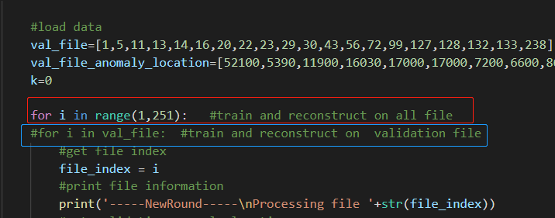

(2) You can choose to whether use the window function for each file.

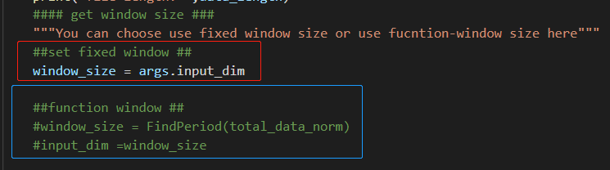 If you use red one , the model will use the set fixed window, which is 150; If you use blue one ,the model will calculate window by FindPeriod algorithm for each file and use the window for the following training.(You can not use the algorithm for the model based on CNN)

(3) The reconstruction for CNN-AE and AE are different

The blue one is for CNN-AE, red one is for AE

