ACL Logical Diagram
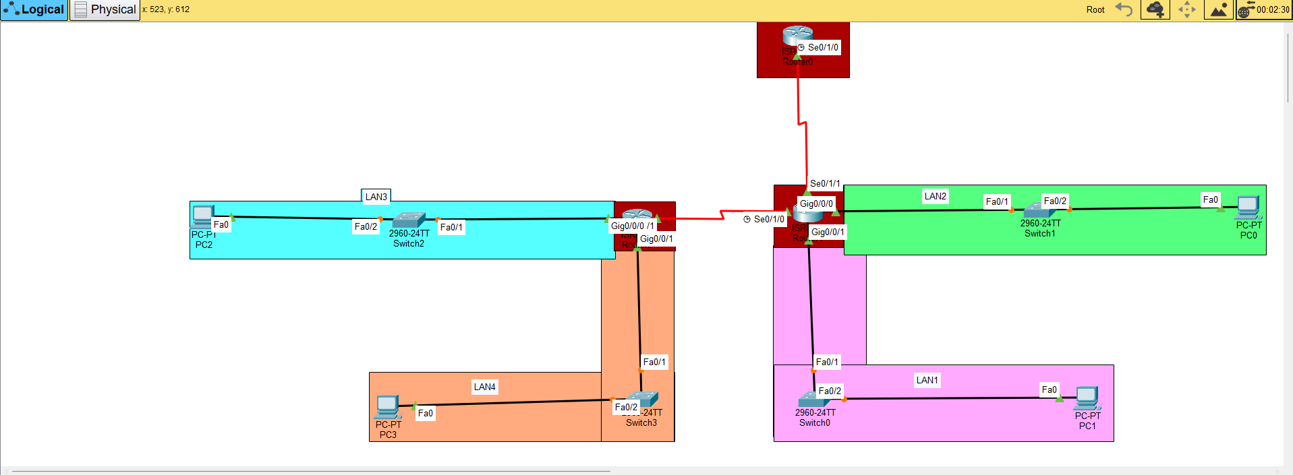

IP Addressing
Router | Interface | IP Address | Subnet Mask | Connected Network
R0_AnupRaj7985 | Serial0/1/0 | 10.0.0.1 | 255.255.255.252 | Point-to-Point Serial Link 1 (to R1 Se0/1/1)
R1_AnupRaj7985 | Serial0/1/1 | 10.0.0.2 | 255.255.255.252 | Point-to-Point Serial Link 1 (to R0 Se0/1/0)
R1_AnupRaj7985 | Serial0/1/0 | 10.0.0.6 | 255.255.255.252 | Point-to-Point Serial Link 2 (to R2 Se0/1/1)
R1_AnupRaj7985 | GigabitEthernet0/0/1 | 192.168.10.1 | 255.255.255.0 | Default Gateway for LAN 1
R1_AnupRaj7985 | GigabitEthernet0/0/0 | 192.168.20.1 | 255.255.255.0 | Default Gateway for LAN 2
R2_AnupRaj7985 | Serial0/1/1 | 10.0.0.5 | 255.255.255.252 | Point-to-Point Serial Link 2 (to R1 Se0/1/0)
R2_AnupRaj7985 | GigabitEthernet0/0/0 | 192.168.30.1 | 255.255.255.0 | Default Gateway for LAN 3
R2_AnupRaj7985 | GigabitEthernet0/0/1 | 192.168.40.1 | 255.255.255.0 | Default Gateway for LAN 4

End Hosts (PCs) IP Addressing
Host Name | Network | IP Address | Subnet Mask | Default Gateway
PC1 | LAN 1 | 192.168.10.10 | 255.255.255.0 | 192.168.10.1
PC0 | LAN 2 | 192.168.20.10 | 255.255.255.0 | 192.168.20.1
PC2 | LAN 3 | 192.168.30.10 | 255.255.255.0 | 192.168.30.1
PC3 | LAN 4 | 192.168.40.10 | 255.255.255.0 | 192.168.40.1

o Configured ACL statements. o Justification of ACL placement
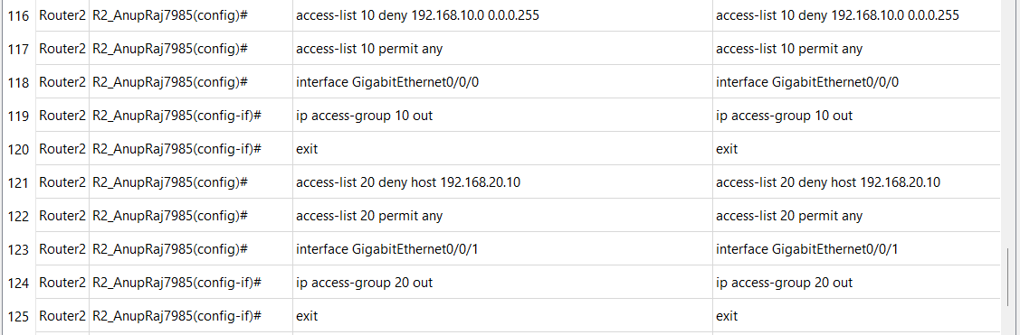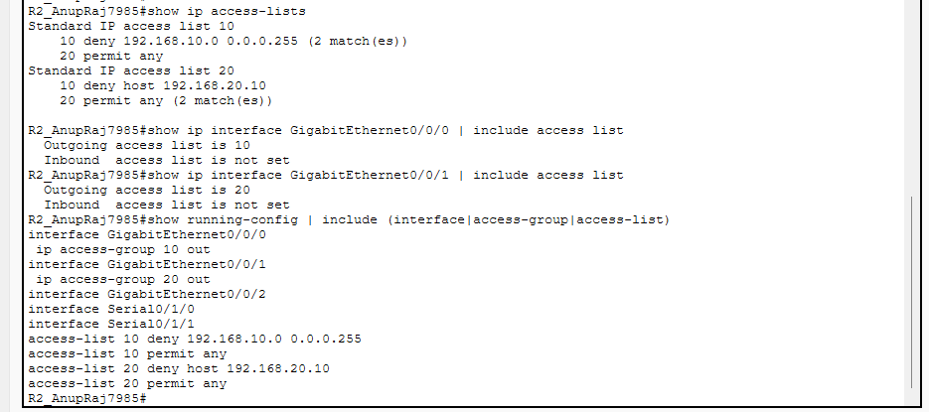

Before ACL
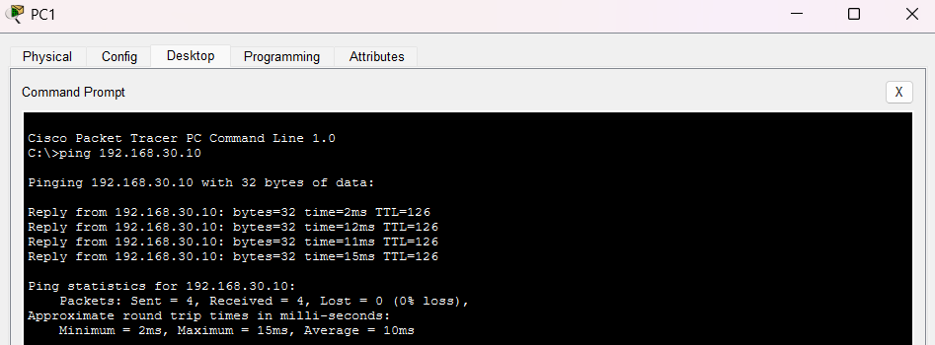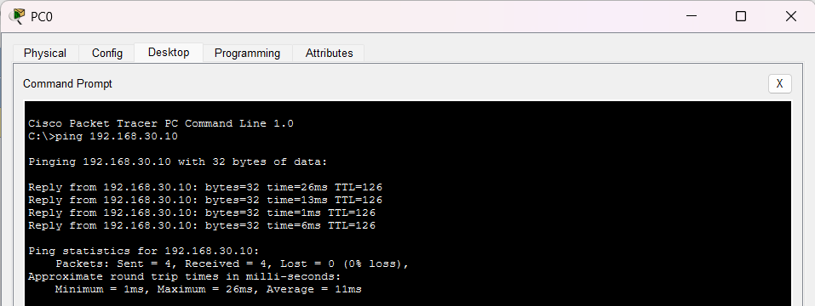

After ACL
