Network Topology Screenshot
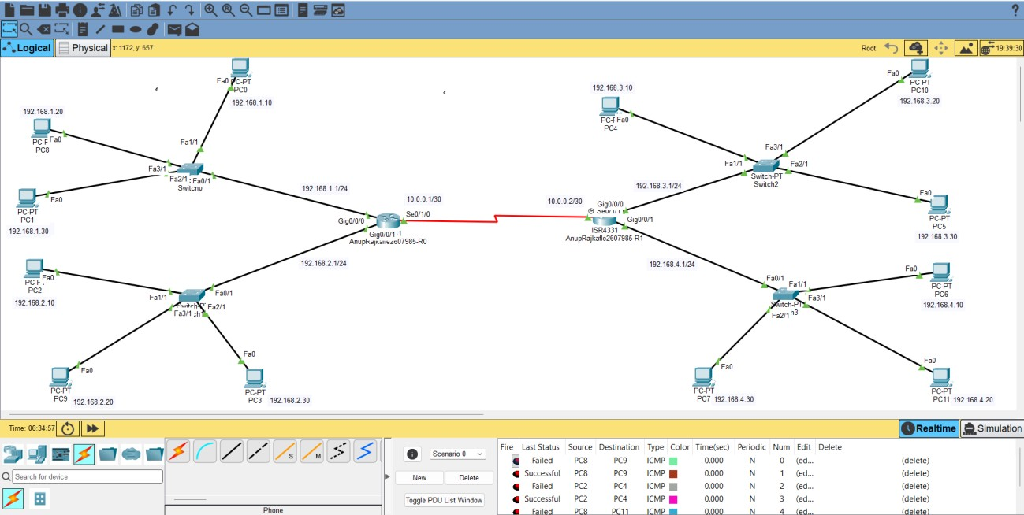

Router Configuration Logs
CLI commands from export log (hostname, interface setup, static routes).
Tue Aug 25 15:22:12 2026 Router0 Router>en
Tue Aug 25 15:23:45 2026 Router0 Router#config t
Tue Aug 25 15:25:34 2026 Router0 Router(config)#hostname AnupRajkafle2607985-R0
Tue Aug 25 15:26:11 2026 Router0 AnupRajkafle2607985-R0(config)#interface GigabitEthernet0/0/0
Tue Aug 25 15:27:42 2026 Router0 AnupRajkafle2607985-R0(config-if)#ip address 192.168.1.1 255.255.255.0
Tue Aug 25 15:27:56 2026 Router0 AnupRajkafle2607985-R0(config-if)#no shutdown
Tue Aug 25 15:28:23 2026 Router0 AnupRajkafle2607985-R0(config-if)#exit
Tue Aug 25 15:28:26 2026 Router0 AnupRajkafle2607985-R0(config)#interface GigabitEthernet0/0/0
Tue Aug 25 15:28:39 2026 Router0 AnupRajkafle2607985-R0(config-if)#exit
Tue Aug 25 15:28:39 2026 Router0 AnupRajkafle2607985-R0(config)#interface GigabitEthernet0/0/1
Tue Aug 25 15:29:48 2026 Router0 AnupRajkafle2607985-R0(config-if)#ip address 192.168.2.1 255.255.255.0
Tue Aug 25 15:29:55 2026 Router0 AnupRajkafle2607985-R0(config-if)#no shutdown
Tue Aug 25 15:30:01 2026 Router0 AnupRajkafle2607985-R0(config-if)#exit
Tue Aug 25 15:30:07 2026 Router0 AnupRajkafle2607985-R0(config)#interface GigabitEthernet0/0/1
Tue Aug 25 15:30:18 2026 Router0 AnupRajkafle2607985-R0(config-if)#exit
Tue Aug 25 15:30:19 2026 Router0 AnupRajkafle2607985-R0(config)#interface Serial0/1/0
Tue Aug 25 15:31:04 2026 Router0 AnupRajkafle2607985-R0(config-if)#ip address 10.0.0.1 255.255.255.252
Tue Aug 25 15:31:09 2026 Router0 AnupRajkafle2607985-R0(config-if)#no shutdown
Tue Aug 25 15:34:45 2026 Router0 AnupRajkafle2607985-R0(config-if)#exit
Tue Aug 25 15:34:45 2026 Router0 AnupRajkafle2607985-R0(config)#interface Serial0/1/0
Tue Aug 25 15:34:52 2026 Router0 AnupRajkafle2607985-R0(config-if)#shutdown
Tue Aug 25 15:34:53 2026 Router0 AnupRajkafle2607985-R0(config-if)#no shutdown
Tue Aug 25 15:38:02 2026 Router1 Router>en
Tue Aug 25 15:38:10 2026 Router1 Router#config t
Tue Aug 25 15:38:21 2026 Router1 Router(config)#hostname AnupRajkafle2607985-R1
Tue Aug 25 15:38:40 2026 Router1 AnupRajkafle2607985-R1(config)#interface GigabitEthernet0/0/0
Tue Aug 25 15:40:34 2026 Router1 AnupRajkafle2607985-R1(config-if)#ip address 192.168.3.1 255.255.255.0
Tue Aug 25 15:40:40 2026 Router1 AnupRajkafle2607985-R1(config-if)#no shutdown
Tue Aug 25 15:40:47 2026 Router1 AnupRajkafle2607985-R1(config-if)#exit
Tue Aug 25 15:40:49 2026 Router1 AnupRajkafle2607985-R1(config)#interface GigabitEthernet0/0/0
Tue Aug 25 15:40:51 2026 Router1 AnupRajkafle2607985-R1(config-if)#exit
Tue Aug 25 15:40:51 2026 Router1 AnupRajkafle2607985-R1(config)#interface GigabitEthernet0/0/1
Tue Aug 25 15:41:20 2026 Router1 AnupRajkafle2607985-R1(config-if)#ip address 192.168.4.1 255.255.255.0
Tue Aug 25 15:41:25 2026 Router1 AnupRajkafle2607985-R1(config-if)#no shutdown
Tue Aug 25 15:41:29 2026 Router1 AnupRajkafle2607985-R1(config-if)#exit
Tue Aug 25 15:41:32 2026 Router1 AnupRajkafle2607985-R1(config)#interface GigabitEthernet0/0/1
Tue Aug 25 15:41:41 2026 Router1 AnupRajkafle2607985-R1(config-if)#exit
Tue Aug 25 15:41:41 2026 Router1 AnupRajkafle2607985-R1(config)#interface Serial0/1/1
Tue Aug 25 15:42:16 2026 Router1 AnupRajkafle2607985-R1(config-if)#ip address 10.0.0.2 255.255.255.252
Tue Aug 25 15:42:22 2026 Router1 AnupRajkafle2607985-R1(config-if)#no shutdown
Tue Aug 25 15:46:17 2026 Router1 AnupRajkafle2607985-R1(config-if)#exit
Tue Aug 25 15:46:29 2026 Router1 AnupRajkafle2607985-R1(config)#exit
Tue Aug 25 15:49:42 2026 Router0 AnupRajkafle2607985-R0>en
Tue Aug 25 15:49:46 2026 Router0 AnupRajkafle2607985-R0#config t
Tue Aug 25 15:51:50 2026 Router0 AnupRajkafle2607985-R0(config)#ip route 192.168.3.0 255.255.255.0 10.0.0.2
Tue Aug 25 15:52:02 2026 Router0 AnupRajkafle2607985-R0(config)#ip route 192.168.4.0 255.255.255.0 10.0.0.2
Tue Aug 25 15:52:42 2026 Router1 AnupRajkafle2607985-R1#cinfig t
Tue Aug 25 15:52:50 2026 Router1 AnupRajkafle2607985-R1#config t
Tue Aug 25 15:53:50 2026 Router1 AnupRajkafle2607985-R1(config)#ip route 192.168.1.0 255.255.255.0 10.0.0.1
Tue Aug 25 15:54:06 2026 Router1 AnupRajkafle2607985-R1(config)#ip route 192.168.2.0 255.255.255.0 10.0.0.1
Tue Aug 25 16:26:19 2026 AnupRajkafle2607985-R0 AnupRajkafle2607985-R0>en
Tue Aug 25 16:26:37 2026 AnupRajkafle2607985-R0 AnupRajkafle2607985-R0#show ip interface brief
Tue Aug 25 16:26:58 2026 AnupRajkafle2607985-R0 AnupRajkafle2607985-R0#show ip route
Tue Aug 25 16:28:29 2026 AnupRajkafle2607985-R0 AnupRajkafle2607985-R0#ping 192.168.3.30
Tue Aug 25 16:29:19 2026 AnupRajkafle2607985-R0 AnupRajkafle2607985-R0#traceroute 192.168.3.30
Tue Aug 25 18:43:13 2026 AnupRajkafle2607985-R1 AnupRajkafle2607985-R1>EN
Tue Aug 25 18:49:36 2026 AnupRajkafle2607985-R1 AnupRajkafle2607985-R1#show ip interface brief
Tue Aug 25 18:49:55 2026 AnupRajkafle2607985-R1 AnupRajkafle2607985-R1#show ip route
Tue Aug 25 18:51:22 2026 AnupRajkafle2607985-R1 AnupRajkafle2607985-R1#ping 192.168.2.20
Tue Aug 25 18:52:48 2026 AnupRajkafle2607985-R1 AnupRajkafle2607985-R1#traceroute 192.168.2.20
Tue Aug 25 18:57:29 2026 PC5 C:\>en
Tue Aug 25 21:03:15 2026 AnupRajkafle2607985-R0 AnupRajkafle2607985-R0>en
Tue Aug 25 21:03:18 2026 AnupRajkafle2607985-R0 AnupRajkafle2607985-R0#config t
Tue Aug 25 21:07:20 2026 AnupRajkafle2607985-R0 AnupRajkafle2607985-R0(config)#interface GigabitEthernet0/0/0
Tue Aug 25 21:07:23 2026 AnupRajkafle2607985-R0 AnupRajkafle2607985-R0(config-if)#exit
Tue Aug 25 21:07:23 2026 AnupRajkafle2607985-R0 AnupRajkafle2607985-R0(config)#interface GigabitEthernet0/0/1

Mapping topology
LAN | Switch | Router Interface | PCs (from your labels)
LAN1 | Switch0 | Router0 Gig0/0/0 | PC0, PC1, PC4
LAN2 | Switch1 | Router0 Gig0/0/1 | PC2, PC3, PC9
LAN3 | Switch2 | Router1 Gig0/0/0 | PC5, PC8, PC10
LAN4 | Switch3 | Router1 Gig0/0/1 | PC6, PC7, PC11
WAN |  | Router0 Se0/1/0 ↔ Router1 Se0/1/1

IP Addressing Plan
Segment | Network | Router IP
LAN1 | 192.168.1.0/24 | 192.168.1.1 (R0 Gig0/0/0)
LAN2 | 192.168.2.0/24 | 192.168.2.1 (R0 Gig0/0/1)
LAN3 | 192.168.3.0/24 | 192.168.3.1 (R1 Gig0/0/0)
LAN4 | 192.168.4.0/24 | 192.168.4.1 (R1 Gig0/0/1)
WAN | 10.0.0.0/30 | R0 Se0/1/0: 10.0.0.1 / R1 Se0/1/1: 10.0.0.2

PC addressing:
PC | IP | Mask | Gateway
PC0 | 192.168.1.10 | 255.255.255.0 | 192.168.1.1
PC1 | 192.168.1.11 | 255.255.255.0 | 192.168.1.1
PC4 | 192.168.1.12 | 255.255.255.0 | 192.168.1.1
PC2 | 192.168.2.10 | 255.255.255.0 | 192.168.2.1
PC3 | 192.168.2.11 | 255.255.255.0 | 192.168.2.1
PC9 | 192.168.2.12 | 255.255.255.0 | 192.168.2.1
PC5 | 192.168.3.10 | 255.255.255.0 | 192.168.3.1
PC8 | 192.168.3.11 | 255.255.255.0 | 192.168.3.1
PC10 | 192.168.3.12 | 255.255.255.0 | 192.168.3.1
PC6 | 192.168.4.10 | 255.255.255.0 | 192.168.4.1
PC7 | 192.168.4.11 | 255.255.255.0 | 192.168.4.1
PC11 | 192.168.4.12 | 255.255.255.0 | 192.168.4.1

Verification Evidence Screenshots
Use the following commands for validation and include their screenshots in your report: show Ip interface brief, show ip route, ping traceroute. Verify successful connectivity between PCs in different LANs.
AnupRajkafle2607985-R0
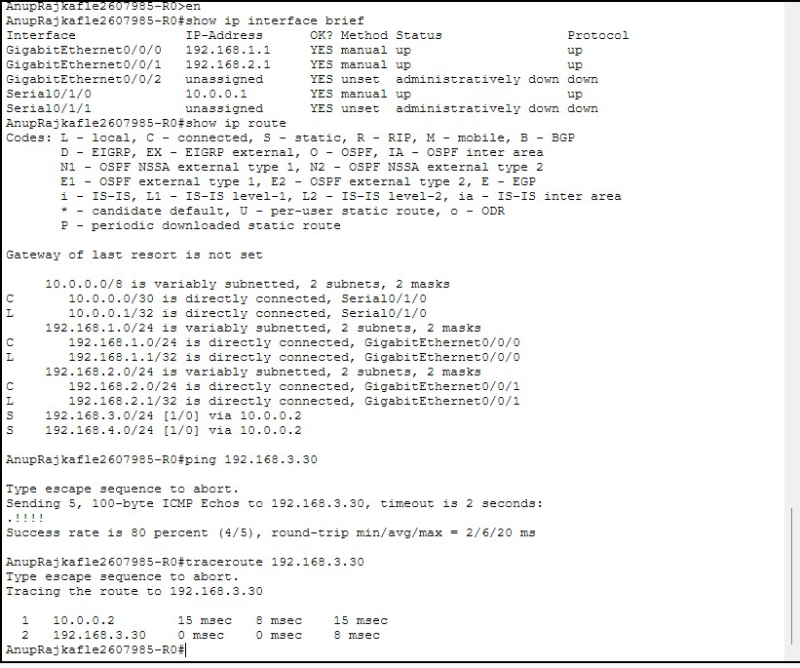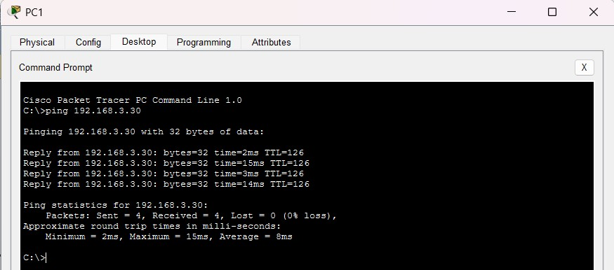
AnupRajkafle2607985-R1
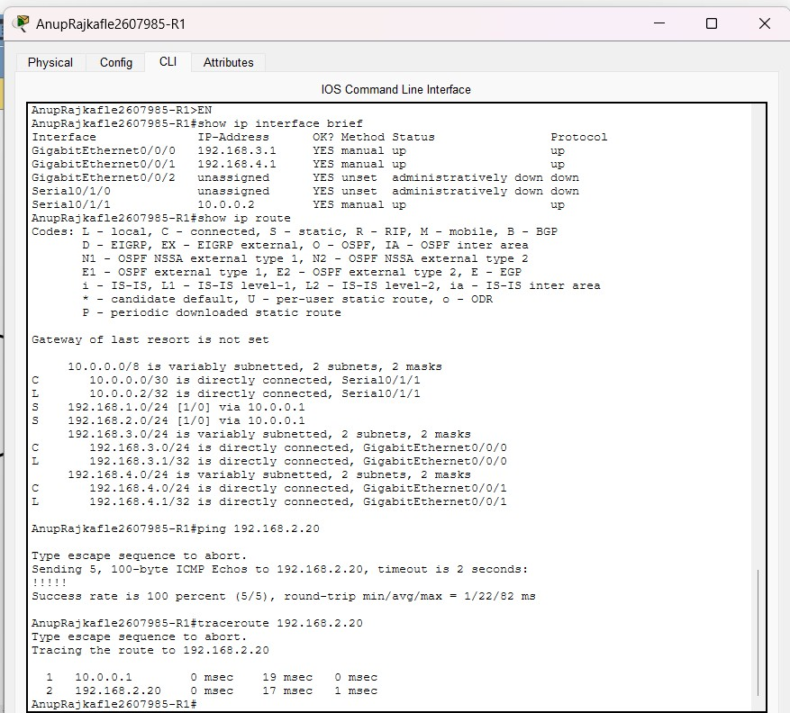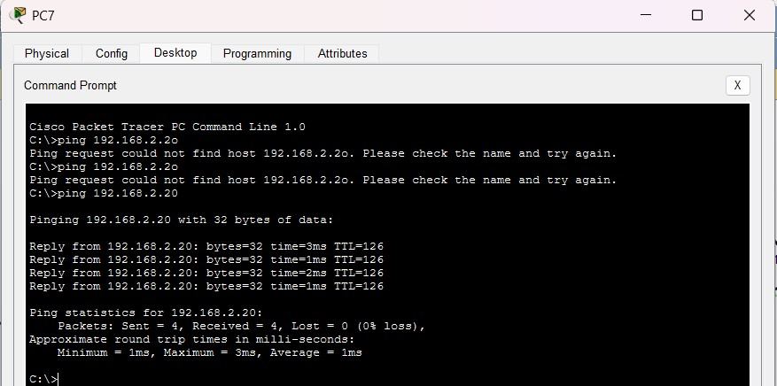

Brief Summary
Static routing is a method that allows routers to forward packets to other networks without any direct connection by specifying manually the next hop path to each remote network. In the current laboratory, all static routes of the routers will be pointing to the WAN side of the other router in order to allow the PCs from two separate networks, such as LAN1 and LAN3, to communicate through both routers. Otherwise, they would not be able to connect to each other at all.

