**Experiment 10**

**WAP to perform the empirical analysis of Greedy Huffman algorithm to find the prefix code of the input data.**

**Naïve algorithm**

**Program:-**

#include <stdio.h>

#include<string.h>

#include <stdlib.h>

#include <time.h>

#define MAX_CHARS 256

struct Node {

int freq;

char data;

struct Node *left, *right;

};

struct MinHeap {

int size;

int capacity;

struct Node** array;

};

struct MinHeap* createMinHeap(int capacity) {

struct MinHeap* minHeap = (struct MinHeap*)malloc(sizeof(struct MinHeap));

minHeap->size = 0;

minHeap->capacity = capacity;

minHeap->array = (struct Node**)malloc(capacity * sizeof(struct Node*));

return minHeap;

}

void swapMinHeapNode(struct Node** a, struct Node** b) {

struct Node* t = *a;

*a = *b;

*b = t;

}

void minHeapify(struct MinHeap* minHeap, int idx) {

int smallest = idx;

int left = 2 * idx + 1;

int right = 2 * idx + 2;

if (left < minHeap->size && minHeap->array[left]->freq < minHeap->array[smallest]->freq) {

smallest = left;

}

if (right < minHeap->size && minHeap->array[right]->freq < minHeap->array[smallest]->freq) {

smallest = right;

}

if (smallest != idx) {

swapMinHeapNode(&minHeap->array[smallest], &minHeap->array[idx]);

minHeapify(minHeap, smallest);

} }

int isSizeOne(struct MinHeap* minHeap) {

return (minHeap->size == 1);

}

struct Node* extractMin(struct MinHeap* minHeap) {

if (isSizeOne(minHeap)) {

return minHeap->array[0];

}

struct Node* root = minHeap->array[0];

minHeap->array[0] = minHeap->array[minHeap->size - 1];

--minHeap->size;

minHeapify(minHeap, 0);

return root;

}

void insertMinHeap(struct MinHeap* minHeap, struct Node* node) {

++minHeap->size;

int i = minHeap->size - 1;

while (i && node->freq < minHeap->array[(i - 1) / 2]->freq) {

minHeap->array[i] = minHeap->array[(i - 1) / 2];

i = (i - 1) / 2;

}

minHeap->array[i] = node;

}

// Function to create a Huffman tree

struct Node* createHuffmanTree(char data[], int freq[], int size) {

struct MinHeap* minHeap = createMinHeap(size);

for (int i = 0; i < size; ++i) {

struct Node* node = (struct Node*)malloc(sizeof(struct Node));

node->left = node->right = NULL;

node->data = data[i];

node->freq = freq[i];

insertMinHeap(minHeap, node);

}

// Build the Huffman tree

struct Node *left, *right, *top;

for (int i = 0; i < size - 1; ++i) {

left = extractMin(minHeap);

right = extractMin(minHeap);

top = (struct Node*)malloc(sizeof(struct Node));

top->freq = left->freq + right->freq;

top->data = '\0'; // Internal node doesn't hold a character

top->left = left;

top->right = right;

insertMinHeap(minHeap, top);

}

return extractMin(minHeap); // Root of the Huffman tree}

void generateCodes(struct Node* root, char arr[], int top){

if (root->left) {

arr[top] = '0';

generateCodes(root->left, arr, top + 1); }

if (root->right) {

arr[top] = '1';

generateCodes(root->right, arr, top + 1); }

if (root->left == NULL && root->right == NULL) {

printf("%c: %s\n", root->data, arr);

} }

int main() {

char data[MAX_CHARS]; // Input data

int freq[MAX_CHARS] = {0};

int size;

printf("Enter a string: ");

fgets(data, MAX_CHARS, stdin); // Get input from user

size = strlen(data) - 1;

for (int i = 0; i < size; ++i) {

++freq[data[i]];

}

clock_t start = clock();

struct Node* root = createHuffmanTree(data, freq, size);

char arr[MAX_CHARS];

generateCodes(root, arr, 0);

clock_t end = clock();

double runtime = ((double)(end - start)*1000) / CLOCKS_PER_SEC;

printf("Runtime: %f Miliseconds\n", runtime);

return 0;

}

**Result Analysis and Discussion:**

This experiment has been conducted in a 64-bit system with 16 GB RAM and Processor 12th Gen Intel(R) Core (TM) i5-12500H 3.10 GHz. The algorithm is implemented in C programming language in Visual Studio Code 1.85.1 Code Editor. In this experiment the algorithm to find the prefix code of the input data using Greedy Huffman algorithm has been implemented and executed.

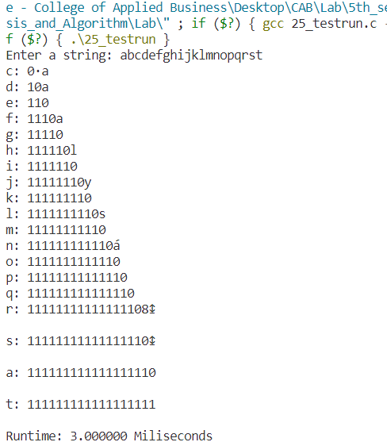

**Conclusion:**

The prefix code of the data was found by using Greedy Huffman algorithm. The running time is analyzed as O(nlogn)