**Experiment 13**

**Write a program to implement the Dynamic Floyd Warshwall Algorithm to solve the String editing problem**

**Program:-**

#include <stdio.h>

#include <stdlib.h>

#include <limits.h>

#include <time.h>

#include <string.h>

int min(int x, int y, int z) {

return x < y ? (x < z ? x : z) : (y < z ? y : z);

}

int editDistDP(char str1[], char str2[], int m, int n) {

int dp[m+1][n+1];

for (int i=0; i<=m; i++) {

for (int j=0; j<=n; j++) {

if (i==0)

dp[i][j] = j;

else if (j==0)

dp[i][j] = i;

else if (str1[i-1] == str2[j-1])

dp[i][j] = dp[i-1][j-1];

else

dp[i][j] = 1 + min(dp[i][j-1], // Insert

dp[i-1][j], // Remove

dp[i-1][j-1]); // Replace

}

}

return dp[m][n];

}

int main() {

char str1[100], str2[100];

double time;

clock_t start = clock();

printf("Enter first string\n");

scanf("%s", str1);

printf("Enter second string\n");

scanf("%s", str2);

int m = strlen(str1);

int n = strlen(str2);

printf("Minimum number of edits: %d\n", editDistDP(str1, str2, m, n));

clock_t end = clock();

time = ((double)(end - start) + 1000) / CLOCKS_PER_SEC;

printf("Time taken: %lf milliseconds\n", time);

return 0;

}

**Result Analysis and Discussion:**

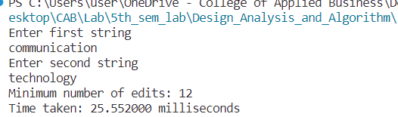

This experiment has been conducted in a 64-bit system with 16 GB RAM and Processor 12th Gen Intel(R) Core (TM) i5-12500H 3.10 GHz. The algorithm is implemented in C programming language in Visual Studio Code 1.85.1 Code Editor. The time taken by this algorithm for string “communication” and “technology” is 25.552 milliseconds.

**Conclusion:**

The running time of Dynamic Algorithm to solve string editing problem is analyzed as O(mn).