**Experiment 17**

**Write a program to implement the Backtracking algorithm to solve the Subset-sum problem.**

**Program:-**

#include <stdio.h>

#include <stdlib.h>

#include <time.h>

void printSubset(int A[], int size) {

for(int i = 0; i < size; i++) {

printf("%d ", A[i]);

}

printf("\n");

}

void subsetSum(int S[], int T[], int S_size, int T_size, int sum, int ite, int const target_sum) {

if(target_sum == sum) {

printSubset(T, T_size);

if(ite + 1 < S_size && sum - S[ite] + S[ite+1] <= target_sum) {

subsetSum(S, T, S_size, T_size-1, sum - S[ite], ite + 1, target_sum);

}

return;

}

else {

if(ite < S_size && sum + S[ite] <= target_sum) {

for(int i = ite; i < S_size; i++) {

T[T_size] = S[i];

if(sum + S[i] <= target_sum) {

subsetSum(S, T, S_size, T_size + 1, sum + S[i], i + 1, target_sum);

}

}

}

}

}

void generateSubsets(int S[], int size, int target_sum) {

int *tuplet_vector = (int *)malloc(size * sizeof(int));

subsetSum(S, tuplet_vector, size, 0, 0, 0, target_sum);

free(tuplet_vector);

}

int main() {

int weights[1000];

int i, n, sum;

double time;

clock_t start, end;

printf("Enter number of items:");

scanf("%d", &n);

printf("Enter target sum:");

scanf("%d", &sum);

start = clock();

for(i = 0; i < n; i++) {

weights[i] = rand() % 1000;

printf("Item :%d \n", weights[i]);

}

printf("Subsets with sum %d are:\n", sum);

generateSubsets(weights, n, sum);

end = clock();

time = ((double)(end - start) * 1000) / CLOCKS_PER_SEC;

printf("\nTime taken: %lf milliseconds\n", time);

return 0;

}

**Output:**

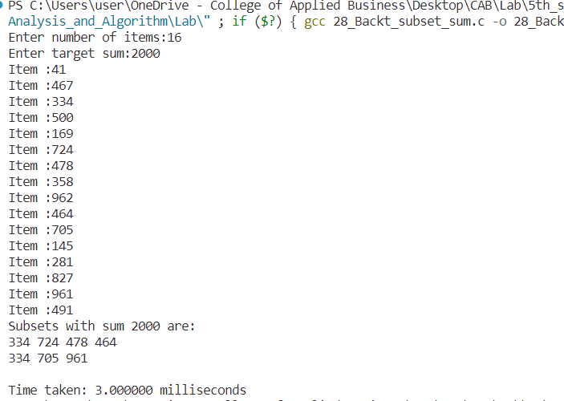

**Conclusion:**

This experiment had been conducted in a 64-bit system with 16 GB RAM and Processor 12th Gen Intel(R) Core (TM) i5-12500H 3.10 GHz. The algorithm was implemented in C programming language in Visual Studio Code 1.85.1 Code Editor. The time taken by this algorithm for 16 number of input size is 3 milliseconds.. The running time is analyzed as O(2n).