**Experiment 9**

**WAP to Perform the Comparative analysis of Naïve algorithm and greedy algorithm to solve the Job sequencing problem.**

**Naïve algorithm**

**Program:-**

#include <stdio.h>

#include <stdlib.h>

#include <time.h>

struct Job {

int id;

int deadline;

int profit;

};

int compareJobs(const void *a, const void *b) {

return ((struct Job *)b)->profit - ((struct Job *)a)->profit;

}

int main() {

int i, n, max_deadline = 0;

struct Job jobs[50000]; // Adjust array size if needed

printf("Enter the total number of jobs: ");

scanf("%d", &n);

srand(time(NULL)); // Seed the random number generator

// Generate random job details

for (i = 0; i < n; i++) {

jobs[i].id = i + 1;

jobs[i].deadline = rand() % 10000; // Random deadline between 1 and n

jobs[i].profit = rand() % 10000; // Random profit between 0 and 999

max_deadline = (jobs[i].deadline > max_deadline) ? jobs[i].deadline : max_deadline;

}

// Sort jobs based on profit in descending order

qsort(jobs, n, sizeof(struct Job), compareJobs);

int result[max_deadline];

for (i = 0; i < max_deadline; i++) {

result[i] = -1; // Initialize with -1 to indicate no job scheduled

}

clock_t start = clock();

for (i = 0; i < n; i++) {

for (int j = jobs[i].deadline - 1; j >= 0; j--) {

if (result[j] == -1) {

result[j] = jobs[i].id;

break;

}

}

}

printf("\nSelected jobs (in order of execution):\n");

for (i = 0; i < max_deadline; i++) {

if (result[i] != -1) {

printf("Job %d (deadline %d, profit %d)\n", result[i], jobs[result[i]].deadline, jobs[result[i]].profit);

}

}

clock_t end = clock();

double time_taken = ((double)(end - start)*1000) / CLOCKS_PER_SEC;

printf("\nTime taken to execute algorithm: %lf miliseconds\n", time_taken);

return 0;

}

**Result Analysis and Discussion:**

This experiment has been conducted in a 64-bit system with 16 GB RAM and Processor 12th Gen Intel(R) Core (TM) i5-12500H 3.10 GHz. The algorithm is implemented in C programming language in Visual Studio Code 1.85.1 Code Editor. In this experiment the algorithm to solve the Job sequencing problem of an array of size “n” using Naïve algorithm has been implemented and executed for different value of n. During this experiment for different value of n, the time taken by the algorithm has been measured and tabulated as shown in table below.

|  |  |
| --- | --- |
| **Input Size** | **Time (Milliseconds)** |
| 1000 | 125 |
| 3000 | 341 |
| 5000 | 569 |
| 7000 | 883 |
| 9000 | 1076 |
| 11000 | 1145 |
| 13000 | 1295 |
| 15000 | 1339 |

The graph shown below is the plot of input n and the time in milliseconds taken by the algorithm while running on a system recorded in table above.

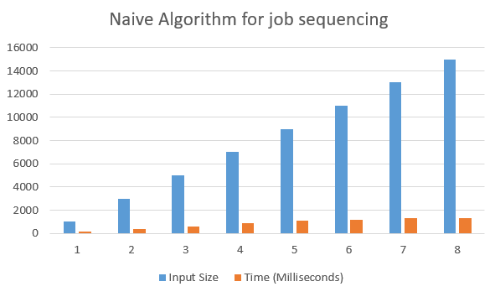

Based on the above table and graph it is clearly seen that the size of array n has linear relationship with the time taken by the system to sort an array.

**Greedy algorithm**

**Program:-**

#include <stdio.h>

#include <stdlib.h>

#include <time.h>

struct Job {

int id;

int deadline;

int profit;

};

int compareJobs(const void *a, const void *b) {

return ((struct Job *)b)->profit - ((struct Job *)a)->profit;

}

int main() {

int i, n, max_deadline = 0;

struct Job jobs[50000];

printf("Enter the total number of jobs: ");

scanf("%d", &n);

srand(time(NULL));

for (i = 0; i < n; i++) {

jobs[i].id = i + 1;

jobs[i].deadline = rand() % 10000; n

jobs[i].profit = rand() % 10000;

max_deadline = (jobs[i].deadline > max_deadline) ? jobs[i].deadline : max_deadline;

}

qsort(jobs, n, sizeof(struct Job), compareJobs);

int result[max_deadline];

for (i = 0; i < max_deadline; i++) {

result[i] = -1;

}

clock_t start = clock();

for (i = 0; i < max_deadline; i++) {

int max_profit_index = -1;

int max_profit = -1;

for (int j = 0; j < n; j++) {

if (jobs[j].deadline >= i + 1 && jobs[j].profit > max_profit) {

max_profit_index = j;

max_profit = jobs[j].profit;

}

}

if (max_profit_index != -1) {

result[i] = jobs[max_profit_index].id;

jobs[max_profit_index].deadline = 0;

}

}

printf("\nSelected jobs (in order of execution):\n");

for (i = 0; i < max_deadline; i++) {

if (result[i] != -1) {

printf("Job %d (deadline %d, profit %d)\n", result[i], jobs[result[i]].deadline, jobs[result[i]].profit);

}

}

clock_t end = clock();

double time_taken = ((double)(end - start)*1000) / CLOCKS_PER_SEC; printf("\nTime taken to execute algorithm: %lf miliseconds\n", time_taken);

return 0;

}

**Result Analysis and Discussion:**

This experiment has been conducted in a 64-bit system with 16 GB RAM and Processor 12th Gen Intel(R) Core (TM) i5-12500H 3.10 GHz. The algorithm is implemented in C programming language in Visual Studio Code 1.85.1 Code Editor. In this experiment the algorithm to solve the Job sequencing problem of an array of size “n” using greedy algorithm has been implemented and executed for different value of n. During this experiment for different value of n, the time taken by the algorithm has been measured and tabulated as shown in table below.

|  |  |
| --- | --- |
| **Input Size** | **Time (Milliseconds)** |
| 1000 | 149 |
| 3000 | 376 |
| 5000 | 486 |
| 7000 | 691 |
| 9000 | 837 |
| 11000 | 926 |
| 13000 | 1091 |
| 15000 | 1286 |

The graph shown below is the plot of input n and the time in milliseconds taken by the algorithm while running on a system recorded in table above.

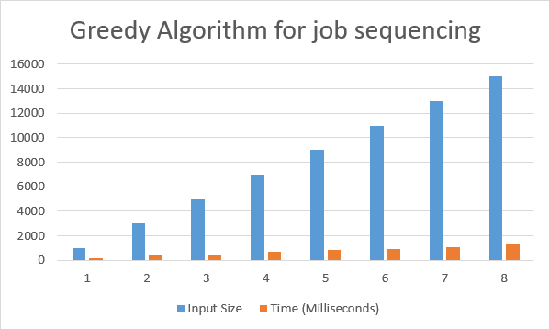

Based on the above table and graph it is clearly seen that the size of array n has linear relationship with the time taken by the system to sort an array.

**Conclusion:**

In this experiment, it has been found that the size of input “n” has linear relationship with the time taken by the system to solve the Job sequencing problem. So, Greedy algorithm is better than Naive algorithm to solve the Job sequencing problem.