**LAB-2**

**Lab 2.a: Using CSS and HTML design layout.**

**Background:**

HTML layouts provide a way to arrange web pages in well-mannered, well-structured, and in responsive form or we can say that HTML layout specifies a way in which the web pages can be arranged. Web-page layout works with arrangement of visual elements of an HTML document.

CSS layout is easy to design. We can use CSS layout to design our web page such as home page, contact us, about us etc.

**Source Code:**

**HTML:**

<!DOCTYPE html>

<html lang="en">

<head>

<meta charset="UTF-8">

<meta name="viewport" content="width=device-width, initial-scale=1.0">

<title>Layout Design</title>

<link rel="stylesheet" href="1_style1.css">

</head>

<body>

<div class="row1">

<h4>container1</h4>

</div>

<div class="row2">

<div class="container2">

<h4>container2</h4>

</div>

<div class="container3">

<h4>container3</h4>

</div>

<div class="container4">

<h4>container4</h4>

</div>

</div>

<div class="row3">

<div class="container5">

<h4>container5</h4>

</div>

<div class="container6">

<h4>container6</h4>

</div>

</div>

</body>

</html>

**CSS:**

.row1{

background-color: #bdeab5;

padding: 10px 0px;

margin: 0.1%;

text-align: center;

}

.row2::after{

content: " ";

display: table;

clear: both;

}

.container2, .container3, .container4{

float: left;

width: 33.13%;

background-color: #bdeab5;

margin: 0.1%;

text-align: center;

padding: 10px 0px;

}

.row3::after{

content: " ";

display: table;

clear: both;

}

.container5, .container6{

float: left;

width: 49.8%;

background-color: #bdeab5;

margin: 0.1%;

text-align: center;

padding: 10px 0px;

}

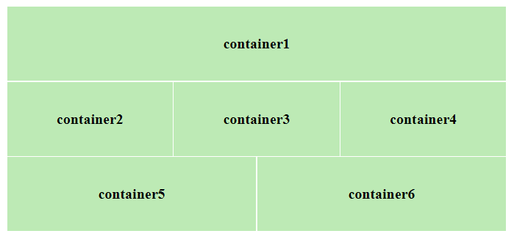

**Lab 2.b: Design your class routine using appropriate .**

**Background:**

HTML table tag is used to display data in tabular form (row * column). There can be many columns in a row. We can create a table to display data in tabular form, using <table> element, with the help of <tr> , <td>, and <th> elements. In Each table, table row is defined by <tr> tag, table header is defined by <th>, and table data is defined by <td> tags.

HTML tables are used to manage the layout of the page e.g. header section, navigation bar, body content, footer section etc.

**Source Code:**

**HTML:**

<!DOCTYPE html>

<html lang="en">

<head>

    <meta charset="UTF-8">

    <meta name="viewport" content="width=device-width, initial-scale=1.0">

    <title>Class Routine</title>

    <link rel="stylesheet" href="2_style2.css">

</head>

<body>

    <h2>Class Routine of BSc. CSIT 5<sup>th</sup> Semester 2023</h2>

    <table class="routine">

        <tr>

            <th>Day/ Time</th>

            <th> 7:00 - 9:00</th>

            <th> 9:00 - 9:30</th>

            <th> 9:30 - 11:30</th>

            <th> 11:30 - 1:30</th>

        </tr>

        <tr>

            <td class="day"> Sunday</td>

            <td>IP (SS2)</td>

            <td>BREAK</td>

            <td>SM (SS1)</td>

            <td>DAA (TNY)</td>

        </tr>

        <tr>

            <td class="day"> Monday</td>

            <td>EPC (IC)</td>

            <td colspan="3">Field Work</td>

        </tr>

        <tr>

            <td class="day"> Tuesday</td>

            <td>IP (SS2)</td>

            <td>BREAK</td>

            <td>SM (SS1)</td>

            <td></td>

        </tr>

        <tr>

            <td class="day"> Wedensday</td>

            <td>Crypto (RDB)</td>

            <td>BREAK</td>

            <td>WT (TK)</td>

            <td>SAD (MB)</td>

        </tr>

        <tr>

            <td class="day"> Thursday</td>

            <td>DAA (TNY)</td>

            <td colspan="3">Presentation</td>

        </tr>

        <tr>

            <td class="day"> Friday</td>

            <td>Crypto (RDB)</td>

            <td>BREAK</td>

            <td>WT (TK)</td>

            <td>SAD (MB)</td>

        </tr>

    </table>

</body>

</html>

**CSS:**

.routine{

    border-collapse: collapse ;

    width: 500px;

}

.routine td, th{

    border: 1px solid #040404;

    padding: 5px;

}

.routine th{

    background-color: aquamarine;

}

.day{

    font-weight: bold;

}

**Output:**

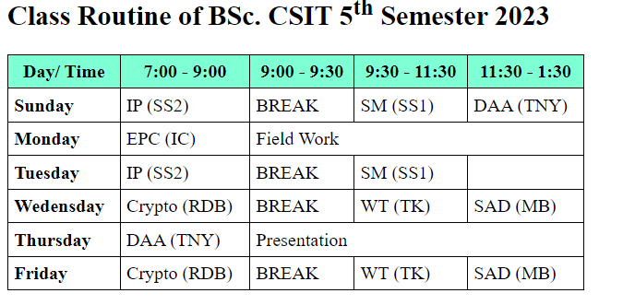

**Lab 3:**