**LAB 1**

**LAB 1.a: Create a simple page to demonstrate the usage of necessary html tags. The page should contains minimum places and their description (image and description). You can show your own creativity which will be evaluated accordingly.​**

**Background:**

HTML: HTML stands for Hypertext Markup Language. It is the most basic computer language that facilitates webpage creation. It is a combination of both hypertext and markup language. Text that is not restricted to a sequential format and that includes links to other text is called Hypertext and Markup Language is a language that is interpreted by the browser and it defines the elements within a document using “tags”.

HTML Tags: HTML tags are special keywords that specify how the data will be displayed by the web browsers. With tags, the web browser can make out in the document that, what is HTML content and what is the normal plain content. The start of the tags is given by angular brackets <> and the end by angular brackets, and / that is </>.

**Code:**

<!DOCTYPE html>

<html lang="en">

<head>

<meta charset="UTF-8">

    <meta name="viewport" content="width=device-width, initial-scale=1.0" >

    <title>Document</title>

</head>

<body>

    <table >

        <th>

            <div style="border: 10PX; background-color: rgb(226, 233, 233);">

                <img src="../Images/Html_Image.png" alt="Html_Image" style="width: 400px; height:250px; padding-top: 10px;">

                <p style="text-align: justify; font-weight: 100; padding: 0 20PX;">HyperText Markup Language is the computer language that facilitates website creation. The language, which has code words and syntax just like any other language, is relatively easy to comprehend and, as time goes on, increasingly powerful in what it allows someone to create. </p>

            </div>

        </th>

        <td>

            <th>

                <div style="border: 10PX; background-color: #ede4e4 ;">

                    <img src="../Images/Css_image.png" alt="Css_image" style="width: 400px; height:250px; padding-top: 10px;">

                    <p style="text-align: justify; font-weight: 100;padding: 0 20px;">Cascading Style Sheets, fondly referred to as CSS, is a simple design language intended to transform the presentation of a Web Pages.CSS handles the look and feel part of a web page. Strictly speaking CSS is not a programming language but it does require abstract thought.</p>

                </div>

            </th>

        </td>

        <td>

            <th>

                <div style="border: 10PX; background-color:#e6e8e6 ;">

                    <img src="../Images/Js_image.png" alt="Js_image" style="width: 400px; height:250px; padding-top: 10px;">

                    <p style="text-align: justify; font-weight: 100; padding: 0 20px;">JavaScript is a scripting or programming language that allows you to implement complex features on web pages, every time a web page does more than just sit there and display static information to look at, displaying timely content updates, maps, animated 2D/3D graphics, etc.</p>

                </div>

            </th>

        </td>

    </table>

</body>

</html>

**Output:**

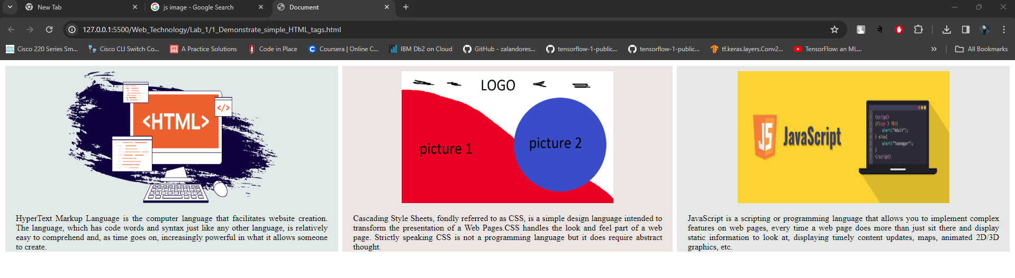

**Lab 1.b: Create a page that shows the course structure of B.Sc.CSIT using list. Also create organizational structure of College of Applied Business.**

**Background:**

A list is used to group together related pieces of information so they are clearly display the data or any information on web pages in the ordered or unordered form. Lists are good from a structural point of view as they help create a well-structured, more accessible, easy-to-maintain document. There are three list types in HTML:

* Unordered list - used to group a set of related items in no particular order
* Ordered list - used to group a set of related items in a specific order
* Description list - used to display name/value pairs such as terms and definitions

**Code:**

<!DOCTYPE html>

<html lang="en">

<head>

    <meta charset="UTF-8">

    <meta name="viewport" content="width=device-width, initial-scale=1.0">

    <title>Course Structure</title>

    <link rel="stylesheet" href="style2.css">

</head>

<body>

    <h2>Course Structure of CSIT</h2>

    <ol class="orderlist">

        <li> First Semester  </li>

                <ul>

                    <li>Introduction to Information Technology</li>

                    <li>C Programming</li>

                    <li>Digital Logic</li>

                    <li>Mathematics</li>

                    <li>Physics</li>

                </ul>

                <li>Second Semester </li>

                <ul>

                    <li>Introduction to Information Technology</li>

                    <li>C Programming</li>

                    <li>Digital Logic</li>

                    <li>Mathematics</li>

                    <li>Physics</li>

                </ul>

                <li>Third Semester </li>

                <ul>

                    <li>Introduction to Information Technology</li>

                    <li>C Programming</li>

                    <li>Digital Logic</li>

                    <li>Mathematics</li>

                    <li>Physics</li>

                </ul>

                <li>Fourth Semester </li>

                <ul>

                    <li>Introduction to Information Technology</li>

                    <li>C Programming</li>

                    <li>Digital Logic</li>

                    <li>Mathematics</li>

                    <li>Physics</li>

                </ul>

                <li>Fifth Semester </li>

                <ul>

                    <li>Introduction to Information Technology</li>

                    <li>C Programming</li>

                    <li>Digital Logic</li>

                    <li>Mathematics</li>

                    <li>Physics</li>

                </ul>

    </ol>

    <h2>Organizational Structure Of College Of Applied Business</h2>

    <div>

        <table border="1" style="margin:auto;">

            <tr>

                <th>College Management Committee</th>

            </tr>

        </table>

        <span style="margin: 50%;">&#8595;</span>

        <table border="1" style="margin:auto;">

            <tr>

                <th>Chairman</th>

            </tr>

        </table>

        <span style="margin: 50%;">&#8595;</span>

        <table border="1" style="margin:auto;">

            <tr>

                <th>Principal</th>

            </tr>

        </table>

        <span style="margin: 50%;">&#8595;</span>

        <table border="1" style="margin:auto;">

            <tr>

                <th>Vice Principal</th>

            </tr>

        </table>

        <span style="margin: 50%;">&#8595;</span>

        <table border="1" style="margin:auto;">

            <tr>

                <th>General Adminstration</th>

                <th>Academic Adminstration</th>

            </tr>

            <tr>

                <td>1. Adminstration Section</td>

                <td>1. BSc. CSIT Department</td>

            </tr>

            <tr>

                <td>2. Account Section</td>

                <td>2. BIM DEpatrment</td>

            </tr>

            <tr>

                <td>3. Library Section</td>

                <td>3. BBA DEpatrment</td>

            </tr>

            <tr>

                <td>4. Exam Section</td>

                <td></td>

            </tr>

        </table>

    </div>

</body>

</html>

**Output:**

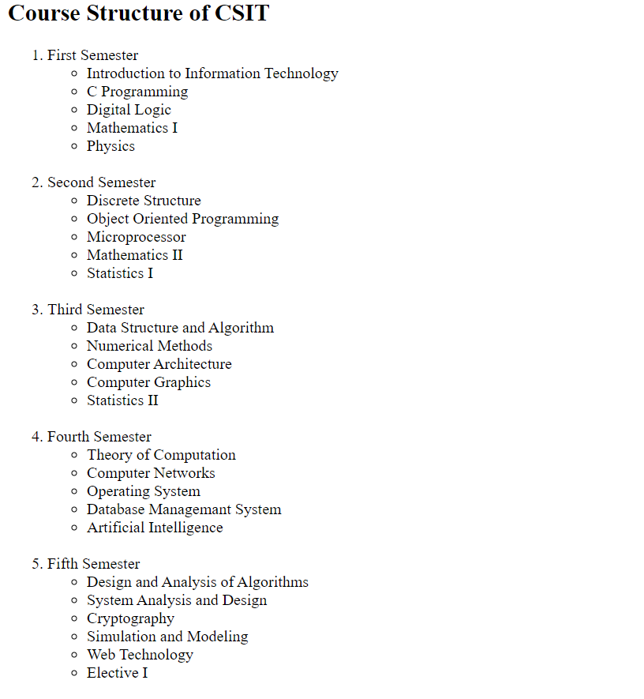

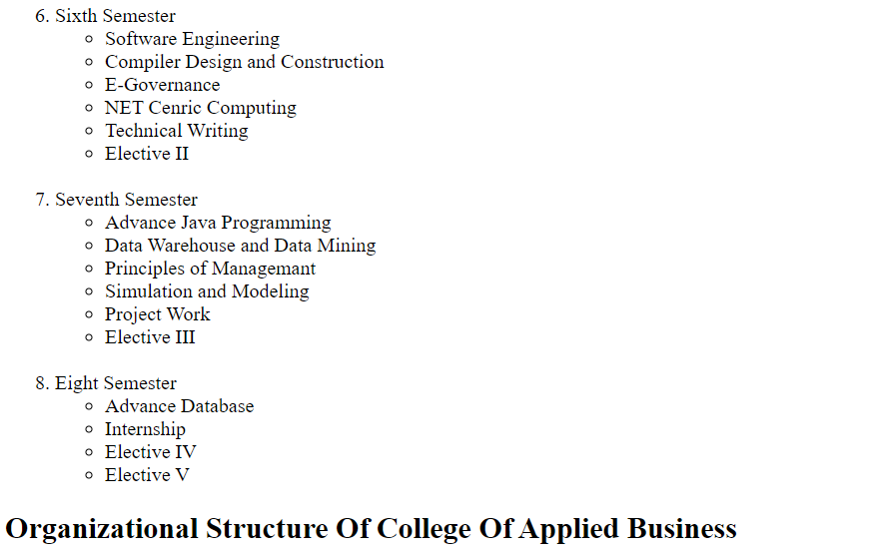

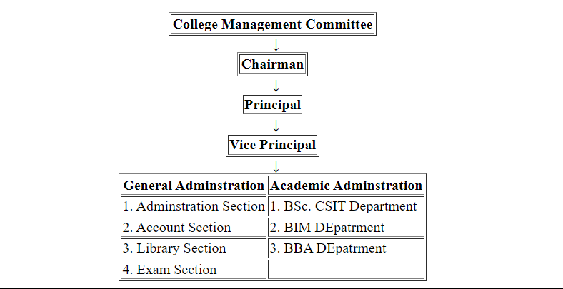

**Lab 1.c: Create a User registration form with necessary fields.**

**Background:**

An HTML form is a section of a document that collects input from the user. It is used to create forms in HTML. The <form> element is a container for different types of input elements, such as text fields, checkboxes, radio buttons, submit buttons, etc. The <input> element is the most used form element. It can be displayed in many ways, depending on the type attribute.

**Code:**

<!DOCTYPE html>

<html lang="en">

<head>

    <meta charset="UTF-8">

    <meta name="viewport" content="width=device-width, initial-scale=1.0">

    <title>Registration_form</title>

</head>

<body>

    <form action="/register" method="post">

        <input type="text" name="first_name" placeholder="First name" style="margin: 5px;"> <br>

        <input type="text" name="last_name" placeholder="Last name" style="margin: 5px;"> <br>

        <input type="email" name="email" placeholder="Email address" style="margin: 5px;"> <br>

        <input type="text" name="country" placeholder="Country" style="margin: 5px;"> <br>

        <input type="text" name="zip_code" placeholder="Zip code" style="margin: 5px;"> <br>

        <input type="tel" name="phone_number" placeholder="Phone number" style="margin: 5px;"> <br>

        <input type="date" name="date_of_birth" placeholder="Date of birth" style="margin: 5px;"> <br>

        <select name="gender" style="margin: 5px;">

          <option value="male">Male</option>

          <option value="female">Female</option>

          <option value="other">Other</option>

        </select> <br>

        <input type="file" name="profile_picture" placeholder="Profile picture" style="margin: 5px;"> <br>

        <input type="submit" value="Register" style="margin: 5px;"> <br>

      </form>

</body>

</html>

**Output:**

