**LAB-2**

**Lab 2.a: Using CSS and HTML design layout.**

**Background:**

HTML layouts provide a way to arrange web pages in well-mannered, well-structured, and in responsive form or we can say that HTML layout specifies a way in which the web pages can be arranged. Web-page layout works with arrangement of visual elements of an HTML document.

CSS layout is easy to design. We can use CSS layout to design our web page such as home page, contact us, about us etc.

**Source Code:**

**HTML:**

<!DOCTYPE html>

<html lang="en">

<head>

<meta charset="UTF-8">

<meta name="viewport" content="width=device-width, initial-scale=1.0">

<title>Layout Design</title>

<link rel="stylesheet" href="1_style1.css">

</head>

<body>

<div class="row1">

<h4>container1</h4>

</div>

<div class="row2">

<div class="container2">

<h4>container2</h4>

</div>

<div class="container3">

<h4>container3</h4>

</div>

<div class="container4">

<h4>container4</h4>

</div>

</div>

<div class="row3">

<div class="container5">

<h4>container5</h4>

</div>

<div class="container6">

<h4>container6</h4>

</div>

</div>

</body>

</html>

**CSS:**

.row1{

background-color: #bdeab5;

padding: 10px 0px;

margin: 0.1%;

text-align: center;

}

.row2::after{

content: " ";

display: table;

clear: both;

}

.container2, .container3, .container4{

float: left;

width: 33.13%;

background-color: #bdeab5;

margin: 0.1%;

text-align: center;

padding: 10px 0px;

}

.row3::after{

content: " ";

display: table;

clear: both;

}

.container5, .container6{

float: left;

width: 49.8%;

background-color: #bdeab5;

margin: 0.1%;

text-align: center;

padding: 10px 0px;

}

**Output:**

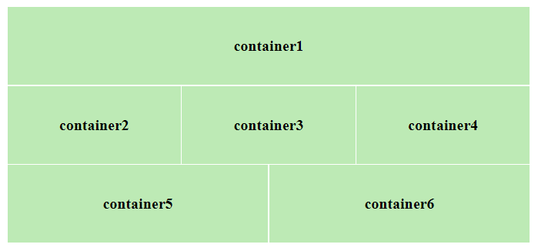

**Lab 2.b: Design your class routine using appropriate .**

**Background:**

HTML table tag is used to display data in tabular form (row * column). There can be many columns in a row. We can create a table to display data in tabular form, using <table> element, with the help of <tr> , <td>, and <th> elements. In Each table, table row is defined by <tr> tag, table header is defined by <th>, and table data is defined by <td> tags.

HTML tables are used to manage the layout of the page e.g. header section, navigation bar, body content, footer section etc.

**Source Code:**

**HTML:**

<!DOCTYPE html>

<html lang="en">

<head>

    <meta charset="UTF-8">

    <meta name="viewport" content="width=device-width, initial-scale=1.0">

    <title>Class Routine</title>

    <link rel="stylesheet" href="2_style2.css">

</head>

<body>

    <h2>Class Routine of BSc. CSIT 5<sup>th</sup> Semester 2023</h2>

    <table class="routine">

        <tr>

            <th>Day/ Time</th>

            <th> 7:00 - 9:00</th>

            <th> 9:00 - 9:30</th>

            <th> 9:30 - 11:30</th>

            <th> 11:30 - 1:30</th>

        </tr>

        <tr>

            <td class="day"> Sunday</td>

            <td>IP (SS2)</td>

            <td>BREAK</td>

            <td>SM (SS1)</td>

            <td>DAA (TNY)</td>

        </tr>

        <tr>

            <td class="day"> Monday</td>

            <td>EPC (IC)</td>

            <td colspan="3">Field Work</td>

        </tr>

        <tr>

            <td class="day"> Tuesday</td>

            <td>IP (SS2)</td>

            <td>BREAK</td>

            <td>SM (SS1)</td>

            <td></td>

        </tr>

        <tr>

            <td class="day"> Wedensday</td>

            <td>Crypto (RDB)</td>

            <td>BREAK</td>

            <td>WT (TK)</td>

            <td>SAD (MB)</td>

        </tr>

        <tr>

            <td class="day"> Thursday</td>

            <td>DAA (TNY)</td>

            <td colspan="3">Presentation</td>

        </tr>

        <tr>

            <td class="day"> Friday</td>

            <td>Crypto (RDB)</td>

            <td>BREAK</td>

            <td>WT (TK)</td>

            <td>SAD (MB)</td>

        </tr>

    </table>

</body>

</html>

**CSS:**

.routine{

    border-collapse: collapse ;

    width: 500px;

}

.routine td, th{

    border: 1px solid #040404;

    padding: 5px;

}

.routine th{

    background-color: aquamarine;

}

.day{

    font-weight: bold;

}

**Output:**

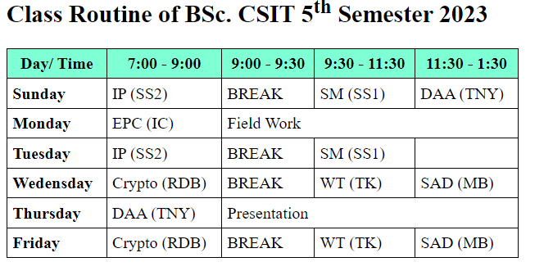

**Lab 2.c:** **Write a code for the position relative, absolute, fixed and make html page using CSS position.**

**Background:**

The position property in CSS tells about the method of positioning for an element or an HTML entity. The Position property works with the left, right, top, bottom and z-index properties to determine the final position of an element on a page.

Relative: An element with position: relative is positioned relatively with the other elements which are sitting on top of it.

Absolute: An element with position: absolute will be positioned with respect to its nearest Non-static ancestor. The positioning of this element does not depend upon its siblings or the elements which are at the same level.

Fixed: An element with fixed positioning allows it to remain in the same position even the page is scrolled.

**Source Code:**

**HTML:**

<!DOCTYPE html>

<html lang="en">

<head>

<meta charset="UTF-8">

<meta name="viewport" content="width=device-width, initial-scale=1.0">

<link rel="stylesheet" href="3_style3.css">

<title>Position</title>

</head>

<body id="body">

<div class="relative">

<h2>Relative Positioning</h2>

<img src="../Images/Html_Image.png">

<p>HyperText Markup Language is the computer language that facilitates website creation. The language, which has code words and syntax just like any other language, is relatively easy to comprehend and, as time goes on, increasingly powerful in what it allows someone to create. </p>

</div>

<div class="fixed">

<h2>Fixed Positioning</h2>

<img src="../Images/Css_image.png" alt="">

<p>Cascading Style Sheets, fondly referred to as CSS, is a simple design language intended to transform the presentation of a Web Pages.CSS handles the look and feel part of a web page. Strictly speaking CSS is not a programming language but it does require abstract thought. </p>

</div>

<div class="absolute">

<h2>Absolute Positioning</h2>

<img src="../Images/Js_image.png" alt="">

<p>JavaScript is a scripting or programming language that allows you to implement complex features on web pages, every time a web page does more than just sit there and display static information to look at, displaying timely content updates, maps, animated 2D/3D graphics, etc. </p>

</div>

</body>

</html>

**CSS:**

#body{

background-color: rgba(255, 255, 255, 0.74);

}

.relative {

position: relative;

top: 10px;

left: 30px;

border: 3px solid #73AD21;

width: 300px;

}

.relative p{

margin: 0px;

padding: 0 5px 0 5px;

text-align: justify;

}

.relative h2{

margin: 0px;

padding: 5px 0 5px 0;

}

.relative img{

width: 300px;

}

.fixed {

position: fixed;

top: 18px;

left: 400px;

width: 300px;

border: 3px solid #73AD21;

}

.fixed img{

width: 300px;

}

.fixed p{

margin: 0px;

padding: 0 5px 0 5px;

text-align: justify;

}

.fixed h2{

margin: 0px;

padding: 5px 0 5px 0;

}

.absolute {

position: absolute;

left: 38px;

width: 300px;

margin-top: 50px;

border: 3px solid #73AD21;

}

.absolute img{

width: 300px;

}

.absolute p{

margin: 0px;

padding: 0 5px 0 5px;

text-align: justify;

}

.absolute h2{

margin: 0px;

padding: 5px 0 5px 0;

}

**Output:**

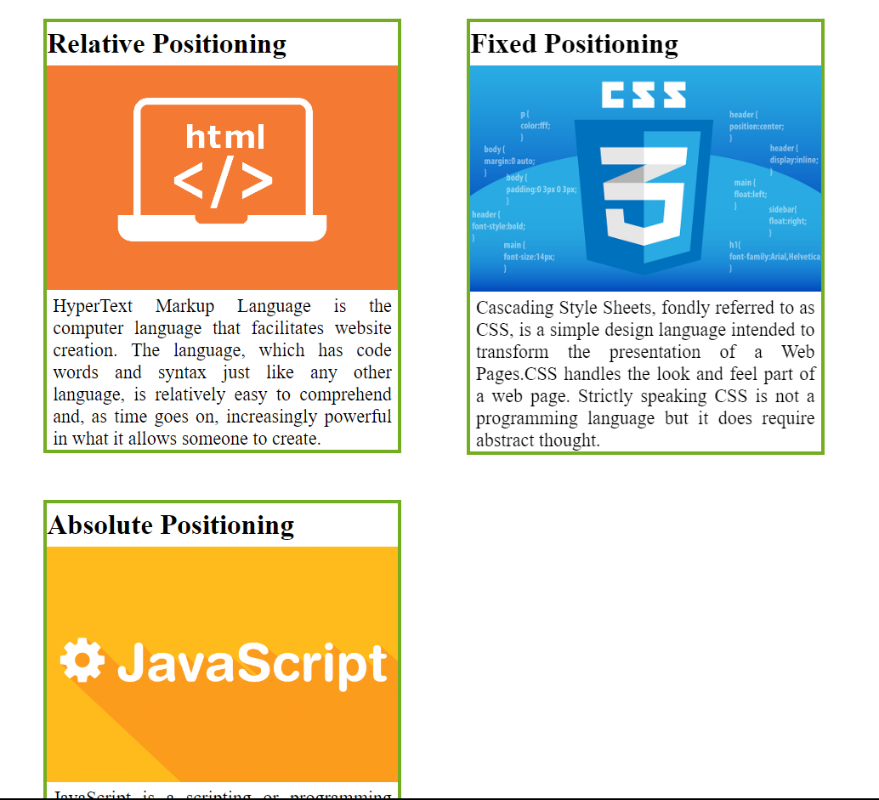

Fig: Output 1. before scrolling the web page

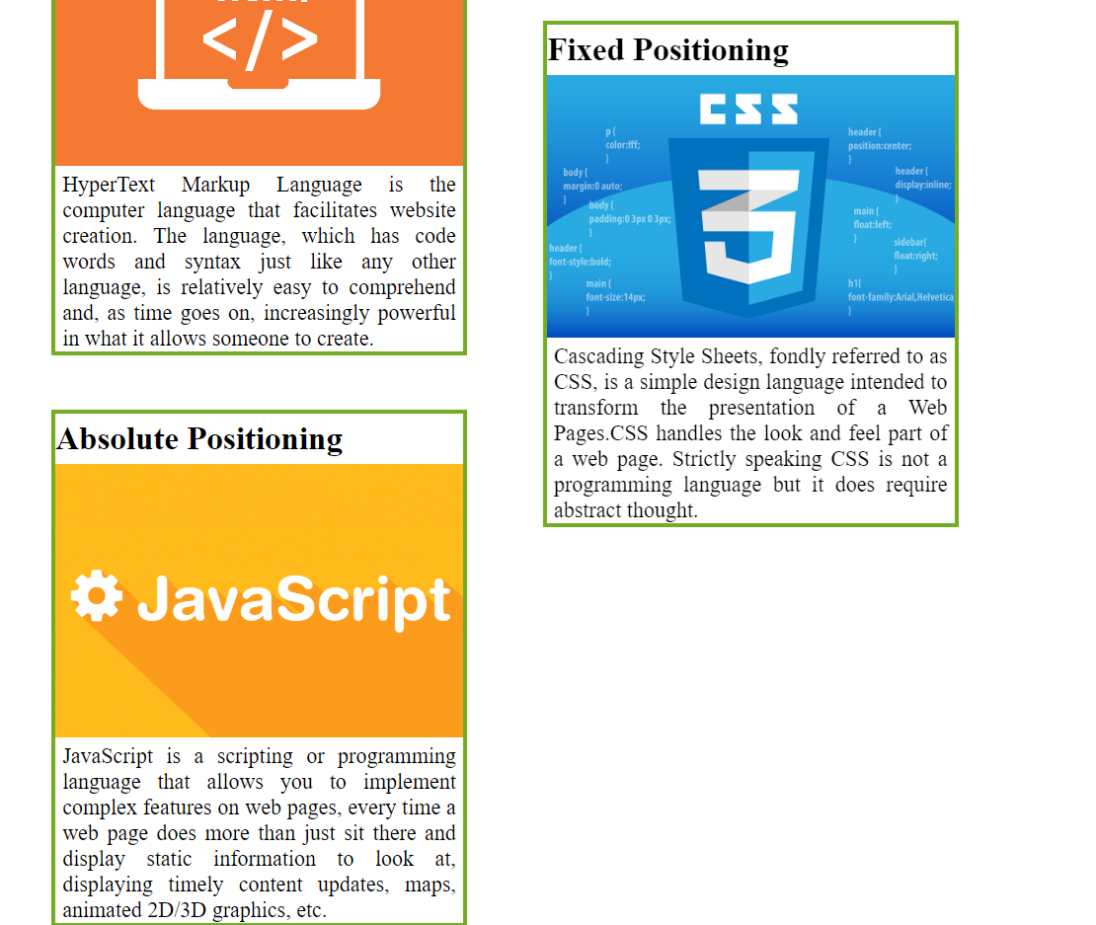

Fig: Output 2. after scrolling the web page

**LAB 2.d: Using CSS design attractive 3D effect buttons.**

**Background:**

The CSS Buttons are used to decorate the web pages by applying the various styling properties to the button. Buttons are used for event processing and interacting with the user. Button tag is used to create buttons in HTML.

Basic Styling in button: There are many CSS properties used to style the button element like background-color, color, border, background-image (gradient color), shadow, hover effects, etc.

**Source Code:**

**HTML:**

<!DOCTYPE html>

<html lang="en">

<head>

<meta charset="UTF-8">

<meta name="viewport" content="width=device-width, initial-scale=1.0">

<link rel="stylesheet" href="4_style4.css">

<title>3D Buttons</title>

</head>

<body>

<button class="signin">

<p>Sign in</p>

</button>

<button class="login">

<p>Login</p>

</button>

</body>

</html>

**CSS:**

.signin{

margin: 10px 10px 10px 20px;

border: none;

border-radius: 7px;

box-shadow: 0px 3px 1px #999595;

background-image: linear-gradient(35deg, rgb(29, 210, 230), rgb(246, 90, 225));

}

.signin p{

margin: 0;

font-weight:600;

font-size: medium;

padding: 5px;

color: rgb(51, 49, 49);

}

.signin:hover{

border: none;

font-weight: bold;

box-sizing: unset;

background-color: rgb(6, 255, 6);

box-shadow: 0px 3px 1px #3e3e3e;

}

.login{

margin: 10px 10px 10px 10px;

border: none;

border-radius: 15px;

box-shadow: 3px 3px 1px #999595;

background-image: linear-gradient(55deg,rgb(226, 74, 72),rgb(245, 245, 41));}

.login p{

margin: 0;

font-weight:600;

font-size: medium;

padding: 5px;

color: rgb(51, 49, 49);

}

**Output:**

