**COLLEGE OF APPLIED BUSINESS AND TECHNOLOGY**

Kathmandu, Nepal

(Affiliated to Tribhuvan University)

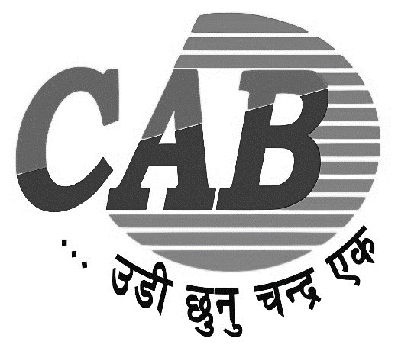

**E-COMMERCE PROJECT REPORT**

**ON**

**YATRISEWA**

|  |  |  |  |  |
| --- | --- | --- | --- | --- |
| **Submitted by:** |  |  |  | **Submitted to:** |
| **Names:** AZ Kafle (106) |  |  |  | Indra Chaudhary |
| Bishal Timalsina (109) |  |  |  | e-commerce Instructor |

Koshang Poudel (112)

Rojan Gurung(123)

**Semester:** Six

**Faculty:** Science and Technology

**Level:** Bachelor

**Program:** Computer Science and Information Technology

July, 2024

# ACKNOWLEDGEMENT

We wish to extend our heartfelt gratitude to everyone who enabled us to complete this report. Our special thanks go to our project supervisor, Mr. Indra Chaudhary, whose insightful suggestions, encouragement, and guidance were invaluable in coordinating our project and writing this report. We also want to acknowledge with deep appreciation the crucial support from the staff at CAB-Tech College, who provided us with the necessary materials. We are grateful for the continuous support from our seniors and the entire teaching staff of the B.Sc. CSIT department, which was instrumental in the successful completion of our project. Additionally, we appreciate each of our colleagues for their encouragement and support throughout the project development.

# ABSTRACT

This report focuses on the development of "Yatrisewa.com," an e-commerce mobile application dedicated to book bus tickets online. The project aims to create an efficient and user-friendly platform that caters to the evolving needs of customers in the online platform. The report outlines the goals, constraints, and development methodology employed, utilizing the waterfall model. It examines the effectiveness of various features and technologies in successful e-commerce platforms, emphasizing secure payment systems and intuitive user interfaces. Overall, the report provides valuable insights into the development and future growth of "YatriSewa" as a successful bus ticket booking ecommerce mobile application. A summary of the system's analysis, design, implementation, and testing is also included in the report, along with the conclusion and suggested next steps.

# TABLE OF CONTENTS

ACKNOWLEDGEMENT ii

ABSTRACT iii

TABLE OF CONTENTS iv

LIST OF FIGURES vi

LIST OF TABLES vii

INTRODUCTION 1

1.1 Project Introduction 1

1.2 Problem Statement 1

1.3 Objective 2

1.4 Limitations 2

1.5 Assignment of Roles and Responsibilities 2

1.6 Report Organization 3

REQUIREMENT ANALYSIS AND FEASIBILITY ANALYSIS 4

2.1 Existing System Overview 4

2.2 System Development Model 5

2.3 Requirement Analysis 6

2.4 Feasibility Study 8

SYSTEM DESIGN 10

3.1 Block diagram of the System 10

3.2 Database Design 11

3.3 Process Design 12

IMPLEMENTATION 17

4.1 Tools Used 17

4.2 Testing 18

4.2.1 Unit Testing 18

4.2.3 System Testing 19

CONCLUSION AND FUTURE ENHANCEMENT 20

5.1 Conclusion 20

5.2 Future Enhancement 20

REFERENCES 21

APPENDICES 22

# LIST OF FIGURES

Figure 1.: Use Case Diagram 7

Figure 2: Block diagram of the System 10

Figure 3: Class Diagram 11

Figure 4 Registration Flowchart 12

Figure 5: Login Flowchart 13

Figure 6: Bus Listing flowchart 14

Figure 7: Payment flowchart 15

Figure 8: Seat Reservation Flowchart 16

Figure 9: Landing and Get Started Page 22

Figure 10: Signup and Register page 22

Figure 11: Signin and Home page 23

Figure 12: Bus List And Seat Selection 23

Figure 13: Buy Or Reserve Seat Page 24

Figure 14: Payment And Ticket Page 24

# LIST OF TABLES

Table 1: Verifying The Login Credentials 18

Table 2: Verifying Registration form 19

Table 3: Verifying Home Page 19

**CHAPTER 1**

# INTRODUCTION

## 1.1 Project Introduction

"YatriSewa" is an e-commerce mobile application dedicated to book bus tickets online. The objective of this report is to delve into the key aspects of "YatriSewa" and explore its significance within the e-commerce landscape.

The project will begin by analyzing the website's overall design and user interface, assessing its visual appeal, ease of navigation, and mobile responsiveness. By understanding the user experience, we can gain insights into how "YatriSewa" optimizes the online booking journey for its customers.

The project will delve into the inventory management system of "YatriSewa" We will explore how the platform ensures a diverse and up-to-date collection of bus tickets, catering to various destinations, price points, and customer preferences. The efficient management of inventory plays a crucial role in meeting customer demands and maintaining a competitive edge.

Lastly, the project focus on customer service and support provided by "YatriSewa" Exceptional customer service is essential for building trust, addressing concerns, and fostering long-term customer loyalty. By examining the website's customer service channels, responsiveness, customer service, and dispute resolution processes, we can gauge the level of customer satisfaction and retention.

Overall, this report aims to provide a comprehensive analysis of "YatriSewa" as an ecommerce platform for online bus booking system. By delving into its design, user experience, marketing strategies, inventory management, and customer service, we can gain insights into the website's strengths, areas for improvement, and its impact.

## 1.2 Problem Statement

The traditional bus ticket booking is facing challenges with the rise of online booking. In the ticket booking industry, there is a problem because there are just few specialized ecommerce platforms just for booking tickets. This affects both customers and businesses.

For customers, they might face confusion in website layouts or instructions, can make the booking process frustrating, in general some customers might not be familiar with modern technologies. Some systems might have rigid policies on cancellations, seat changes, or adding luggage, making it difficult to adapt to unexpected situations. Real-time data is crucial, so outdated bus schedules, seat availability, or pricing can cause misunderstanding.

## 1.3 Objective

The main objective of this project is

* To develop an e-commerce mobile application for booking bus tickets.

## 1.4 Limitations

* Customers can book bus tickets only.
* Difficulties in payment integration.
* Limitations in availability of buses.
* Cannot cancel the booked tickets.
* Limited partnerships.

## 1.5 Assignment of Roles and Responsibilities

**Rojan Gurung and Bishal Timalsina: Documentation Team**

* Gathering requirements and documenting them.
* Creating project documentation, including project plans, user manuals, process flowcharts, and technical specifications.
* Writing user guides and manuals for the e-commerce website.
* Documenting technical details.
* Regularly updating and maintaining the project documentation.

**Koshang Poudel (Frontend Developer):**

* Designing the website's look and layout and developing interactive user interfaces.
* Ensuring responsive design for different devices.
* Integrating payment gateways for secure transactions.
* Optimizing website performance for fast loading times.
* Ensuring cross-browser compatibility.
* Collaborating with backend developers for integration.
* Focusing on user experience to enhance usability.

**AZ Kafle (Backend Developer):**

* Designing and managing the database that stores watch-related information.
* Setting up and configuring the server infrastructure to host the website.
* Connecting secure payment gateways for smooth online transactions.
* Order Processing and Inventory Management.
* Security and Data Protection.
* Connecting the website with external systems for functionality like shipping and analytics.
* Optimizing website performance for faster load times.

## 1.6 Report Organization

The report is broken down into five sections, of which each provides data on even a separate linked subject.

**Chapter 1:** This proposed system's introduction part is explained and specified. The introduction, problem statement, objectives, limitations, assignments of roles and responsibilities and report organization are just a few of the sections throughout this chapter.

**Chapter 2:** The requirements and analysis part for the project has been described.

**Chapter 3:** Overall system design along with necessary diagrams has been mentioned. **Chapter 4:** Implementation and testing details has been explained.

**Chapter 5:** The overall conclusion along with further enhancement part has been illustrated.

**CHAPTER 2**

# REQUIREMENT ANALYSIS AND FEASIBILITY ANALYSIS

## 2.1 Existing System Overview

With the rapid advancement of technology, the e-commerce industry has witnessed a significant proliferation of platforms catering to various online customers. In this context, we will explore two notable e-commerce platforms that have gained prominence in the market.

### 2.1.1 Bussewa.com

On bussewa.com [1], you can book your tickets online whenever you have to travel. Browse through hundreds of destinations across the country from eastern to the western part. They have served thousands of satisfied customers who have remained loyal.

**Pros**

* Wide option for selection of destinations
* Customer review and ratings
* Customer friendly experience
* Payment flexibility
* Discount and special offers

**Cons**

* Access limitations
* Competitive Pricing
* Lack of physical interaction

### 2.1.2 Makemytrip.com

Makemytrip.com [2] is an online bus ticket booking system for India, offering a seamless travel experience through secure and trusted portals. It provides customer friendly hospitality to customers traveling in various parts of India.

**Pros**

* Wide range of destinations
* Secure payment option
* Convenience and accessibility
* Customer reviews and rating
* Discounts and special offers

**Cons**

* Access limitation and Technical Issues
* Lack of physical interaction
* Customer Service challenge

## 2.2 System Development Model

The waterfall model is chosen as the system development model for this project. The waterfall model is a sequential and linear approach to software development, consisting of distinct phases that progress in a predefined order. This model is well-suited for projects with clear and well-defined requirements, where changes during the development process are expected to be minimal.

In the case of developing an online bus ticket booking e-commerce mobile application, the waterfall model offers several advantages. First, it emphasizes upfront planning and requirements gathering, ensuring a comprehensive understanding of the project scope and objectives. This is crucial for an e-commerce platform that requires careful consideration of user requirements, ticket management, payment systems, and integration with other services.

Second, the waterfall model promotes a systematic and structured approach to development, with each phase building upon the previous one. This allows for clear milestones and deliverables, facilitating better project management and progress tracking. For a complex project like an e-commerce web application, having a well-defined and structured development process can help manage the various components involved, such as front-end design, back-end development, database integration, and testing.

Furthermore, the waterfall model's linear nature enables early identification of potential issues or challenges in the development process. By conducting thorough analysis and design phases before implementation, the project team can identify any potential risks or roadblocks and address them proactively. This helps mitigate the chances of costly rework or delays during later stages of development.

## 2.3 Requirement Analysis

### 2.3.1 Functional Requirements

Essential features and capabilities define the functional requirements of an online bus ticket booking mobile application. These requirements shape the application’s development, ensuring it meets customer expectations and delivers a seamless ticket booking experience. By understanding and addressing these requirements, theapplication can enhance usability, satisfaction, and business success. Some functional requirements for this project are listed below:

* User Registration and Authentication
* Ticket Details and Descriptions
* Reserved Seats and Checkout
* User Friendly Payment Environment
* Customer Reviews and Ratings
* Customer Support
* Booking Management

**Use Case Diagram**

The system’s Use Case Diagram shows the different actions users and admins can perform and their relationships to the system. It helps with requirements gathering, system design, and stakeholder communication. 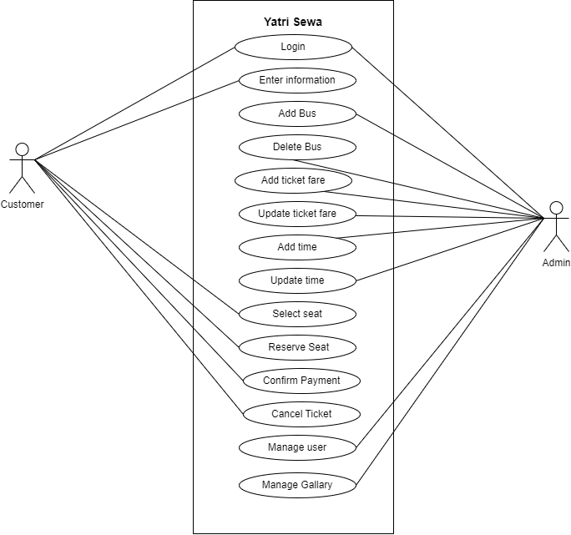

Figure 1: Use Case Diagram

### 2.3.2 Non-Functional Requirements

* **Usability:** The system ha**s** a user-friendly interface, with intuitive navigation and clear instructions, to ensure ease of use for both customers and administrators. It provide**s** a seamless and pleasant user experience.
* **Reliability** **&** **Availability**: The system is highly reliable and available, ensuring minimal downtime and uninterrupted access to the e-commerce application. It hasrobust backup and recovery mechanisms to prevent data loss and ensure system stability.
* **Performance**: The system is able to handle a large number of concurrent users and process transactions efficiently. It provide**s** fast response times, quick page loading, and smooth browsing and checkout experiences to ensure optimal performance.
* **Security**: The system implement**s** strong security measures to protect customer data, including personal information, payment details, and booking history. It ha**s** secure authentication and authorization mechanisms, encryption protocols, and robust protection against common security threats.
* **Scalability**: The system isdesigned to handle future growth and accommodate increasing user traffic and data volume. It isscalable and able to handle additional booking listings, users, and transactions without significant performance degradation.
* **Compatibility**: The system is compatible with multiple devices, operating systems, different screen sizes and resolutions and function optimally on 2G, 3G, 4G, and WiFi networks.
* **Maintainability**: The system is built using modular and well-structured code that is easy to maintain and update. It adhere**s** tocoding best practices and standards, allowing for future enhancements and modifications.
* **Compliance**: Thesystem adhere**s** to applicable laws, regulations, and industry standards, such as data protection and privacy laws, consumer rights, and e-commerce regulations. It ensure**s** compliance with relevant policies and guidelines to protect customer rights and maintain ethical practices.

## 2.4 Feasibility Study

We have evaluated the advantages and disadvantages of our method with the aid of such a feasibility analysis. We have used the information throughout this feasibility report as well as its considerations like a stable platform for evaluating where and when to move ahead. Furthermore, it aids in making choices regarding the most appropriate software and hardware combinations:

### 2.4.1 Technical Feasibility:

We have used the technologies that have been most suitable and reliable to reach the necessary requirements to build this system. The system is easily configurable as it is created using following technologies:

**Programming Language:**

**.NET:** .NET is used for backend development. We have used .NET MVC (ModelView-Controller) for clear separation of concerns, testability, and control over HTML, JavaScript, and CSS.

**Database:**

**SQL:** SQL is used to provide a reliable and efficient way to store, manage, and retrieve large volumes of structured data, such as customer information, ticket details and orders.

**Frontend**:

**HTML:** Html is used to structure and define the content of an application.

**CSS:** CSS is used in our application to style and visually enhance the appearance of HTML elements.

**JavaScript:** JavaScript is used in application to add interactivity and dynamic functionality to it, enabling features like form validation, real-time updates, and interactive user interfaces.

**Bootstrap:** Bootstrap is used for the collection of syntax for template design.

**System designing Tool:**

**Draw.io:** Draw.io is used for creating use case diagram, class diagram, block diagram and flowcharts.

### 2.4.2 Economic Feasibility:

With the usage of the available open-source technologies, there are no building expenses involved with this mobile application. This technique is simple to employ and grasp. As a result, spending in testing and training is not necessary. No additional hardware is needed for such a system. The recipient of all this technique does not need any additional equipment. This project is economically viable because its value outweighs its price.

### 2.4.3 Operational Feasibility:

There is no requirement for instruction to utilize the product because of its user-friendly design. This can be used effectively in a development environment with very little efforts. Since it addresses the challenges associated with traditional bus ticket booking methods and aims to provide a dedicated mobile application for the sale of bus tickets, this approach is operationally viable.

**CHAPTER 3**

# SYSTEM DESIGN

## Block diagram of the System

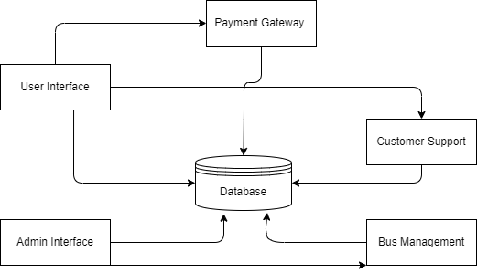

Figure 2: Block diagram of the System

### Working Procedure:

* **User Interaction:** Users interact with the system through the User Interface, which can be accessed via a mobile application. They can search for buses, tickets, view detailed bus information, and reserve the seats.
* **Admin Interface:** Admins interact with system through an Admin Interface. They can manage buses, ticket fares, users and services.
* **Payment Processing:** The system integrates with a Payment Gateway to securely process the payment transaction. It ensures the confidentiality and integrity of sensitive customer information and handles a payment method i.e. credit cards.
* **Customer Support:** The system offers customer support services to assist users with inquiries, issues, or requests. Users can access these services through the User Interface, enabling them to seek assistance and receive timely resolutions.
* **Bus Management:** Admin can add, remove and schedule the buses and ticket fares for better user experience.

## Database Design

This shown class diagram provides an overview of the database of the system.

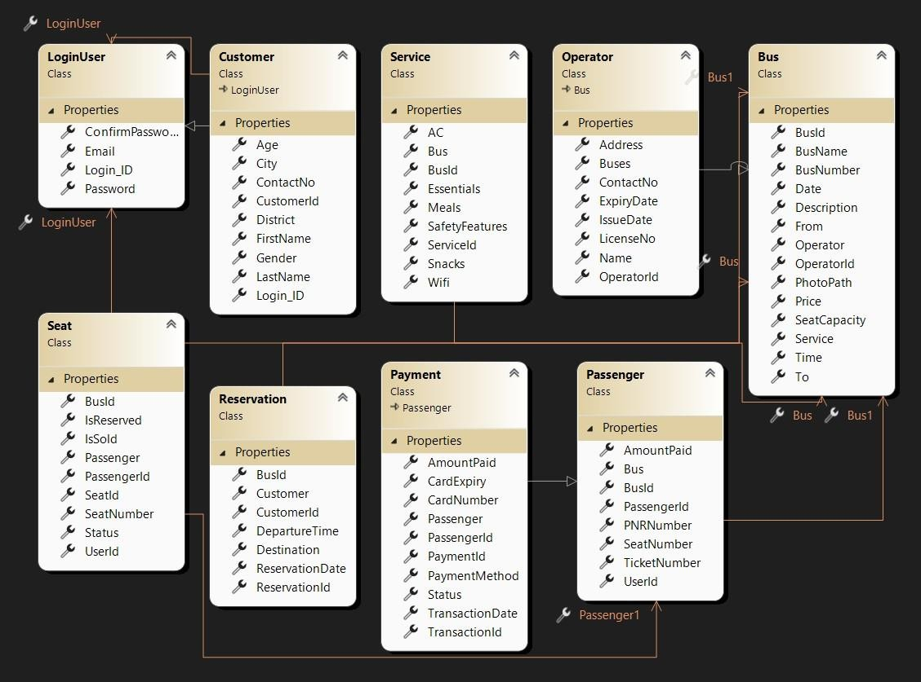

Figure 3: Class Diagram

## Process Design

**Flowchart for Registration:**

This flowchart represents the process of registration.

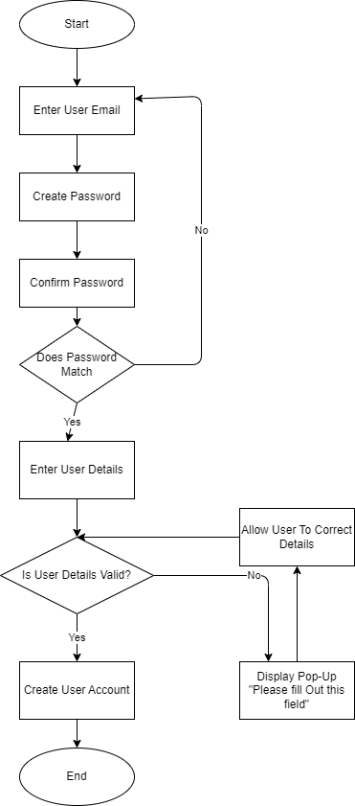

Figure 4 Registration Flowchart

**Flowchart for Login:**

This flowchart represents the process of Login.

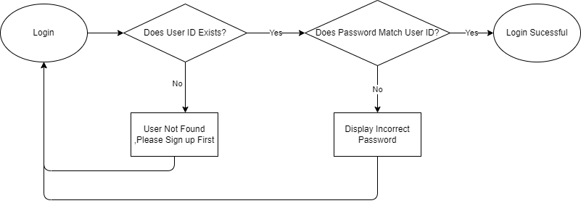

Figure 5: Login Flowchart

**Flowchart for Bus Listing:**

This flowchart represents the process of listing the buses.

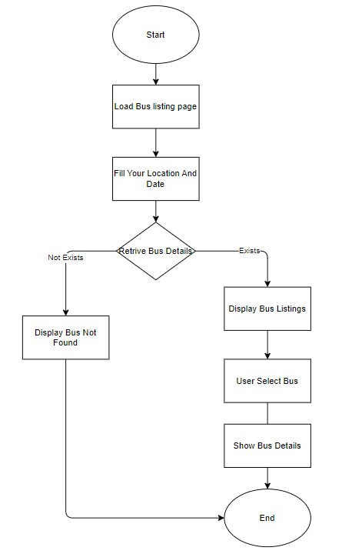

Figure 6: Bus Listing flowchart

**Flowchart for Payment:**

This flowchart represents the process of payment.

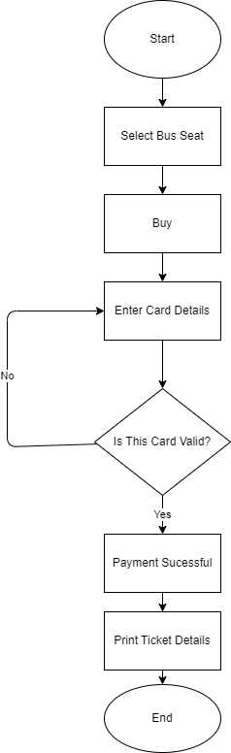

Figure 7: Payment flowchart

**Flowchart for Seat Reservation:**

This flowchart represents the process of seat reservation.

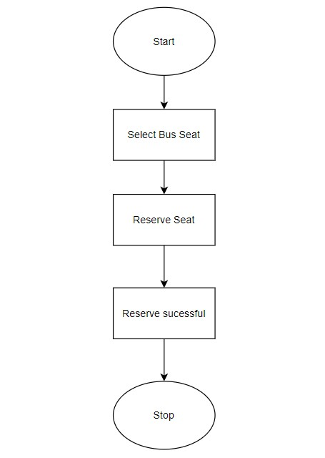

Figure 8: Seat Reservation Flowchart

**CHAPTER 4**

# IMPLEMENTATION

# 4.1 Tools Used

Multiple tools were employed to create the various diagrams and charts featured in this report, including use case diagrams, sequence diagrams, flowcharts, and class diagrams. Among these, Draw.io was the most commonly used, offering a versatile and user-friendly platform for depicting complex system interactions and structures.

* **Front-end:** Html, CSS, JavaScript
* **Back-end:** .NET
* **Database:** SQL
* **IDE:** Visual Studio
* **Framework:** ASP.NET MVC
* **Browser**: Google Chrome,Edge

# 4.2 Testing

## 4.2.1 Unit Testing

We employed an instance of input along its related outputs to conduct uniting testing. Unit tests separate a piece of code as well as ensure that it is valid.

Table 1: Verifying The Login Credentials

|  |  |  |  |  |
| --- | --- | --- | --- | --- |
| **TC_ID** | **Test case description** | **Expected**  **Output** | **Actual Output** | **Remarks** |
| TC_01 | Verify if user is able to login with invalid credentials. | An error  Message should be displayed. | An error  Message is displayed. | Pass |
| TC_02 | Verify if user is able to login with valid credentials. | The user should see the successful login and should be  redirected towards the  Home page. | User is able to login. | Pass |

Table 2: Verifying Registration form

|  |  |  |  |  |
| --- | --- | --- | --- | --- |
| **TC_ID** | **Test case description** | **Expected Output** | **Actual Output** | **Remarks** |
| TC_03 | Enter value that does not follow Email format | An error Message:  “Invalid Email  Format” | User should  receive the error Message. | Pass |
| TC_04 | Enter password ranging less than 6 characters | An error Message:  “Password must be 6 characters long” | User should receive the invalid message. | Pass |
| TC_05 | Enter contact number  more or than 10 digits | An error Message:  “Invalid contact number.” | User should receive the invalid message. | Pass |

## 4.2.3 System Testing

Table 3: Verifying Home Page

|  |  |  |  |  |
| --- | --- | --- | --- | --- |
| **TC_ID** | **Test case description** | **Expected Output** | **Actual Output** | **Remarks** |
| TC_01 | Select pick-up point, destination and travelling date. | User should be able to come across list of valid buses based upon entered credentials unless there’s no available bus which shows “No Bus Found” message. | User is able to browse through the list of buses to select a bus with preferred facilities. | Pass |

**CHAPTER 5**

# CONCLUSION AND FUTURE ENHANCEMENT

# 5.1 Conclusion

In conclusion, the completion of this project has resulted in the successful development and implementation of a specialized platform for the sale of tickets. Through thorough analysis, effective requirements gathering, and the utilization of a waterfall development methodology, we have overcome the challenges faced by the traditional travel industry in the digital age. The use of c#, along with frameworks like dot net, has provided a solid foundation for building a robust and efficient mobile application.

The system's key features, including user registration, ticket listing, payment processing, and booking management, have been meticulously designed and tested to ensure functionality, performance, security, and usability. By addressing the limitations of existing online ticket booking system, our platform offers a tailored and convenient experience for customers. With the successful implementation of the system, we have laid the groundwork for future enhancements and scalability, positioning our solution as a valuable asset in the ever-evolving digital landscape of the industry.

# 5.2 Future Enhancement

The future enhancements of this project are as follows:

**Enhanced Personalization:** Implement advanced personalization features to cater to individual customer preferences, such as personalized booking recommendations and tailored marketing campaigns.

**Integration with social media:** Integrate the ticket booking application with popular social media channels to expand reach and leverage the power of social sharing for increased visibility and customer acquisition.

# REFERENCES

1. Acharya, K. (2024). Online bus reservation system project report. *Authorea Preprints*.<https://bussewa.com/>
2. Nagar, V., Pallavaram, C., & Nadu, T. A Study On Customer Perception About

Experiential Value Of ‘Make My Trip’Travel Website. <https://www.makemytrip.com/bus-tickets/>

1. Tan, C. K. (2002). *Bus ticket reservation system/Tan Chin Kuang* (Doctoral dissertation, University of Malaya)
2. Cosmas, N. I., Etus, C., Ajere, I. U., & Godswill, A. U. (2015). Online bus ticket reservation system. *Int J Comput Sci Stat*, *1*(2).

# APPENDICES

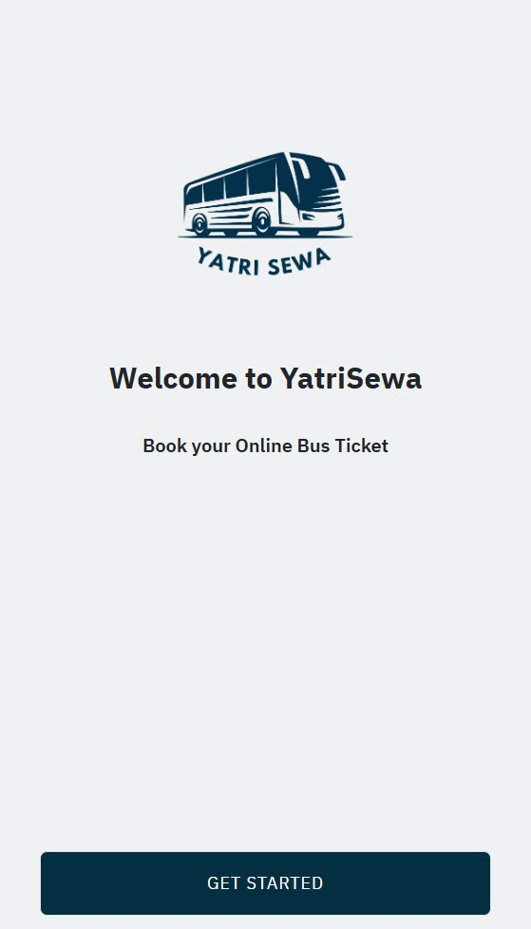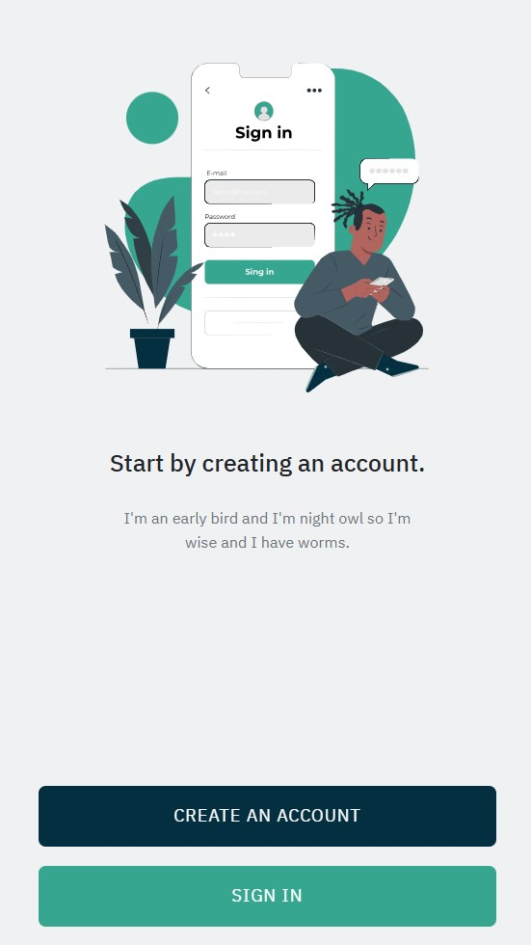

Figure 9: Landing and Get Started Page

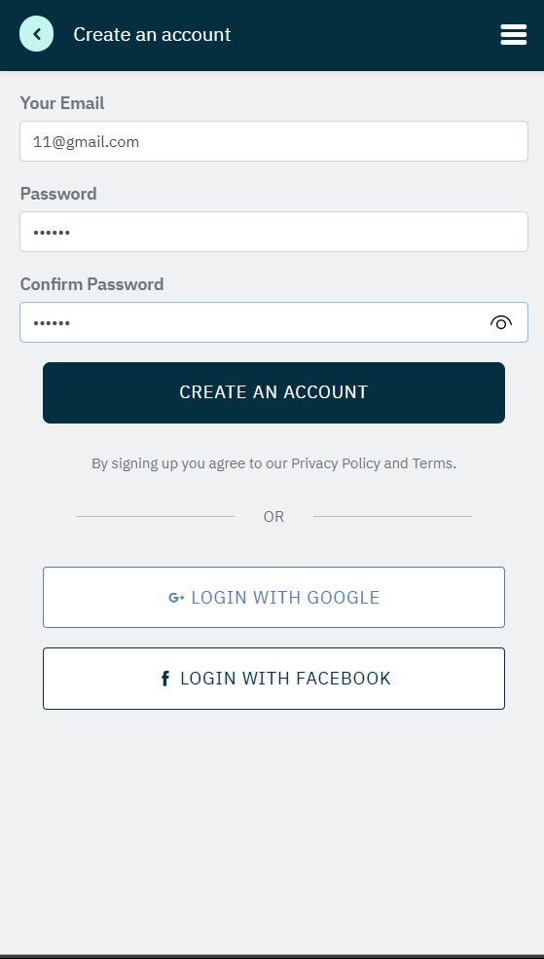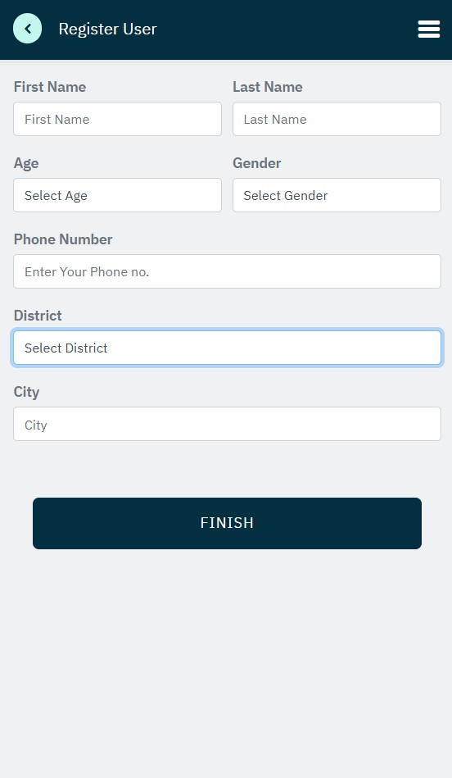

Figure 10: Signup and Register page

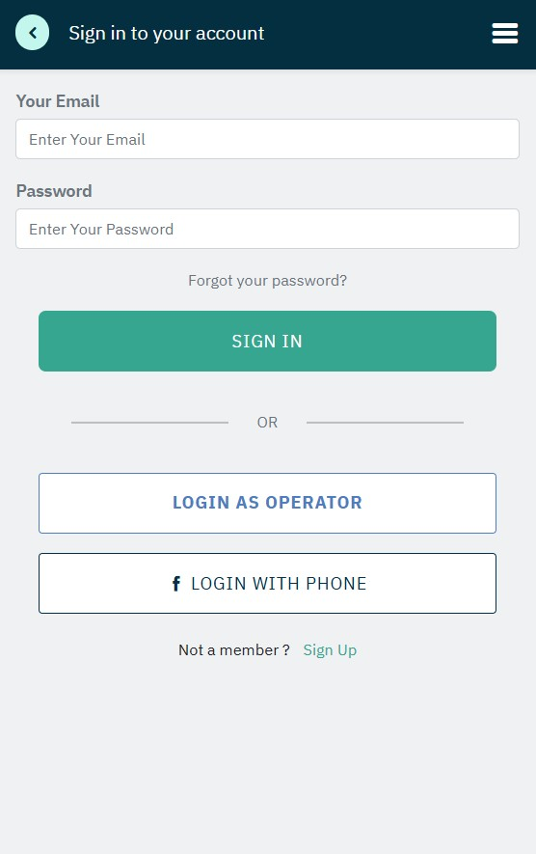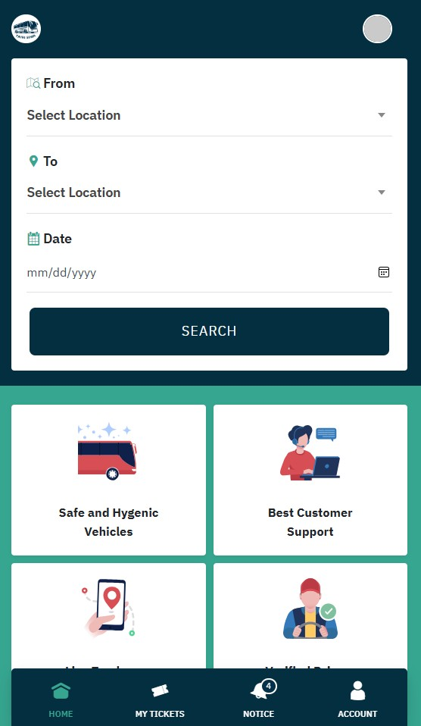

Figure 11: Signin and Home page

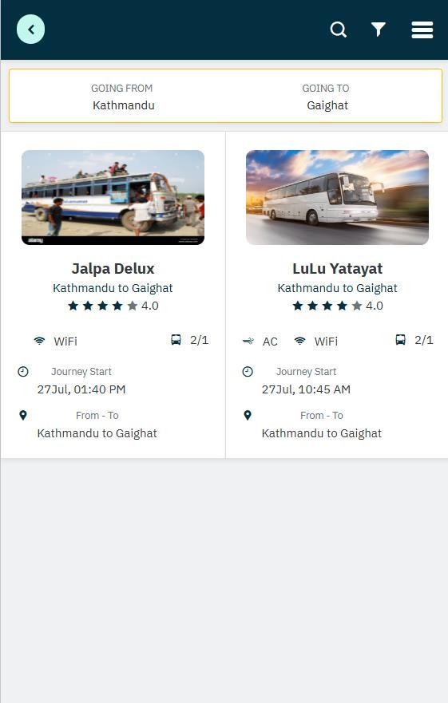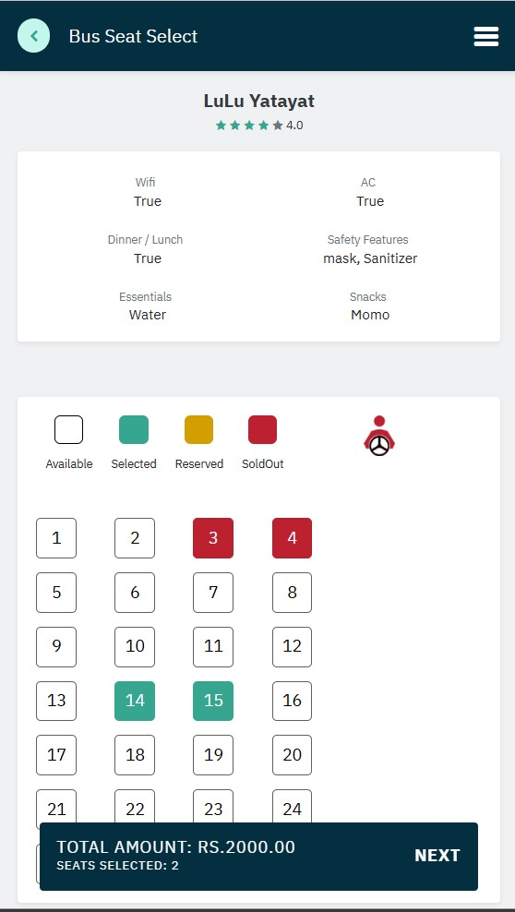

Figure 12: Bus List And Seat Selection

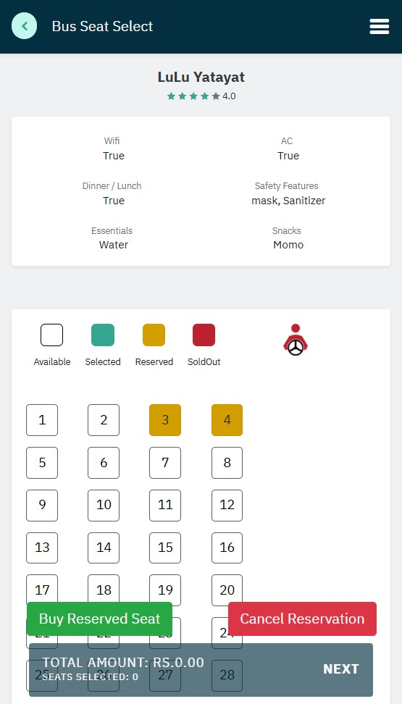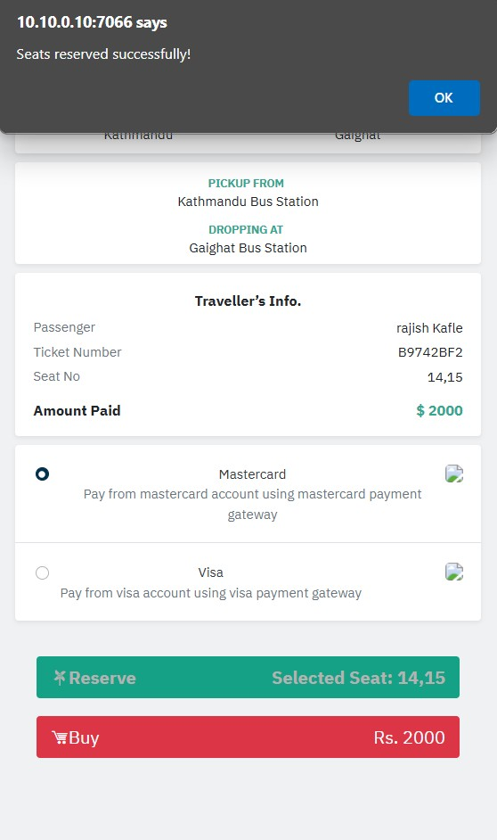

Figure 13: Buy Or Reserve Seat Page

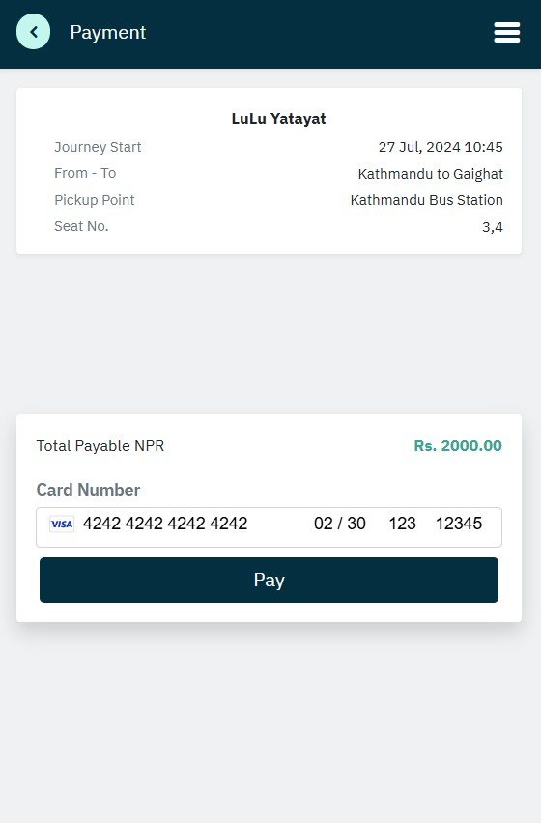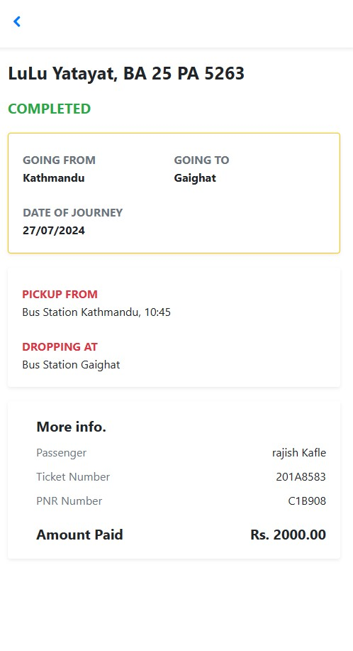

Figure 14: Payment and Ticket Page