Here’s a clean SQL script that sets up a school database with 5 tables, each having at least 3 attributes
-- Create the School database
CREATE DATABASE SchoolDB;
USE SchoolDB;

-- 1. Students table
CREATE TABLE Students (
StudentID INT PRIMARY KEY AUTO_INCREMENT,
FirstName VARCHAR(50),
LastName VARCHAR(50),
DateOfBirth DATE
);

-- 2. Teachers table
CREATE TABLE Teachers (
TeacherID INT PRIMARY KEY AUTO_INCREMENT,
FirstName VARCHAR(50),
LastName VARCHAR(50),
SubjectSpecialization VARCHAR(100)
);

-- 3. Courses table
CREATE TABLE Courses (
CourseID INT PRIMARY KEY AUTO_INCREMENT,
CourseName VARCHAR(100),
Credits INT,
TeacherID INT,
FOREIGN KEY (TeacherID) REFERENCES Teachers(TeacherID)
);

-- 4. Enrollments table
CREATE TABLE Enrollments (
EnrollmentID INT PRIMARY KEY AUTO_INCREMENT,
StudentID INT,
CourseID INT,
Grade VARCHAR(2),
FOREIGN KEY (StudentID) REFERENCES Students(StudentID),
FOREIGN KEY (CourseID) REFERENCES Courses(CourseID)
);

-- 5. Classrooms table
CREATE TABLE Classrooms (
ClassroomID INT PRIMARY KEY AUTO_INCREMENT,
RoomNumber VARCHAR(10),
Capacity INT,
CourseID INT,
FOREIGN KEY (CourseID) REFERENCES Courses(CourseID)
);
Breakdown of the tables:
- Students: Holds student personal info.
- Teachers: Stores teacher details and their specialization.
- Courses: Each course is linked to a teacher.
- Enrollments: Connects students to courses, with grades.
- Classrooms: Assigns courses to physical rooms with capacity.
This schema gives you a solid foundation for a school management system, with relationships between students, teachers, courses, and classrooms.

let’s push your schema all the way to 5NF (Fifth Normal Form) for completeness.

Recap of 1NF → 4NF
- 1NF: Atomic values, no repeating groups → ✅ satisfied.
- 2NF: No partial dependency on composite keys → ✅ satisfied.
- 3NF: No transitive dependency → ✅ satisfied.
- 4NF: No multi-valued dependency → ⚠️ fixed by splitting TeacherSubjects into its own table.
5NF (Fifth Normal Form)
Rule: Eliminate join dependency anomalies.
- A table should not be decomposable into smaller tables without losing information.
- Every join dependency must be implied by candidate keys.
Where 5NF matters in your schema:
- Enrollments: It links Students ↔ Courses ↔ Grades.
- If you later add Semesters or Programs, you might risk storing multiple independent relationships in one table.
For example, suppose you want to track which semester a student takes a course. If you add SemesterID directly into Enrollments, you risk multi-valued dependencies (student can take multiple courses in multiple semesters).
Solution: Break down into smaller tables
-- New table for Semesters
CREATE TABLE Semesters (
SemesterID INT PRIMARY KEY AUTO_INCREMENT,
SemesterName VARCHAR(50),
StartDate DATE,
EndDate DATE
);

-- Student-Course relationship (Enrollment without Grade/Semester)
CREATE TABLE StudentCourses (
StudentID INT,
CourseID INT,
PRIMARY KEY (StudentID, CourseID),
FOREIGN KEY (StudentID) REFERENCES Students(StudentID),
FOREIGN KEY (CourseID) REFERENCES Courses(CourseID)
);

-- Grades tied to Student-Course
CREATE TABLE CourseGrades (
StudentID INT,
CourseID INT,
Grade VARCHAR(2),
PRIMARY KEY (StudentID, CourseID),
FOREIGN KEY (StudentID, CourseID) REFERENCES StudentCourses(StudentID, CourseID)
);

-- Student-Course-Semester relationship
CREATE TABLE CourseSemesters (
StudentID INT,
CourseID INT,
SemesterID INT,
PRIMARY KEY (StudentID, CourseID, SemesterID),
FOREIGN KEY (StudentID, CourseID) REFERENCES StudentCourses(StudentID, CourseID),
FOREIGN KEY (SemesterID) REFERENCES Semesters(SemesterID)
);

Why this is 5NF
- Each table now represents a single relationship:
  - StudentCourses: who takes what.
  - CourseGrades: what grade they earned.
  - CourseSemesters: when they took it.
- No table contains multiple independent relationships.
- All join dependencies are preserved by candidate keys.

📊 Final Normalization Status
Normal Form | Requirement | Status
1NF | Atomic values | ✅
2NF | No partial dependency | ✅
3NF | No transitive dependency | ✅
4NF | No multi-valued dependency | ✅ (after TeacherSubjects split)
5NF | No join dependency anomalies | ✅ (after splitting Enrollments into StudentCourses, CourseGrades, CourseSemesters)

So now your SchoolDB schema is fully normalized up to 5NF — the highest practical level.

Let’s map out the relationships among the tables in your SchoolDB.
🔗 Relationships Between Tables
1. Students ↔ Enrollments
- One-to-Many: A student can enroll in many courses.
- Enrollments.StudentID → references Students.StudentID.
2. Courses ↔ Enrollments
- One-to-Many: A course can have many students enrolled.
- Enrollments.CourseID → references Courses.CourseID.
3. Teachers ↔ Courses
- One-to-Many: A teacher can teach multiple courses.
- Courses.TeacherID → references Teachers.TeacherID.
4. Courses ↔ Classrooms
- One-to-One or One-to-Many (depending on design):
  - If each course is assigned to one classroom → One-to-One.
  - If a course can be taught in multiple classrooms (different sections) → One-to-Many.
- Classrooms.CourseID → references Courses.CourseID.
5. Teachers ↔ TeacherSubjects (introduced in 4NF)
- One-to-Many: A teacher can have multiple subject specializations.
- TeacherSubjects.TeacherID → references Teachers.TeacherID.

ERD-style Summary
Parent Table | Child Table | Relationship Type | Key Reference
Students | Enrollments | One-to-Many | StudentID
Courses | Enrollments | One-to-Many | CourseID
Teachers | Courses | One-to-Many | TeacherID
Courses | Classrooms | One-to-One / One-to-Many | CourseID
Teachers | TeacherSubjects | One-to-Many | TeacherID

🎓 How it all fits together
- A student enrolls in many courses.
- Each course is taught by one teacher.
- Each course is assigned to a classroom.
- Each teacher can specialize in multiple subjects.
This structure ensures clean relationships, avoids redundancy, and supports queries like:
- “Which students are in Teacher X’s courses?”
- “What classroom is assigned to Course Y?”
- “List all subjects Teacher Z specializes in.”

The image shows how the school database tables connect:
- Students → Enrollments → Courses (students enroll in courses).
- Teachers → Courses (teachers teach courses).
- Courses → Classrooms (courses are assigned to classrooms).
- Teachers → TeacherSubjects (teachers have multiple subject specializations).
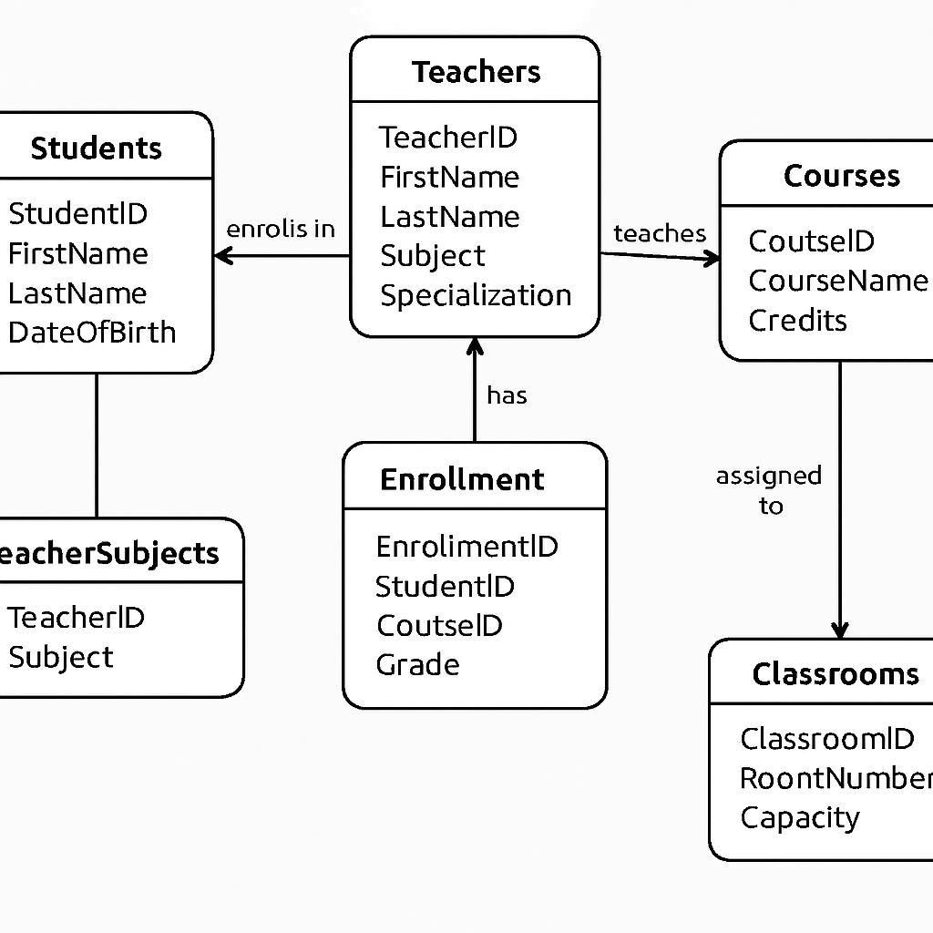

Here’s a full SQL script to populate your SchoolDB tables with sample data. The Students table gets 10 records, while the others get at least 5 each.
-- Insert 10 students
INSERT INTO Students (FirstName, LastName, DateOfBirth) VALUES
('Ama', 'Mensah', '2008-04-12'),
('Kwame', 'Boateng', '2007-09-23'),
('Akosua', 'Owusu', '2009-01-15'),
('Yaw', 'Asante', '2008-06-30'),
('Esi', 'Adjei', '2007-12-05'),
('Kojo', 'Darko', '2009-03-18'),
('Abena', 'Ofori', '2008-11-22'),
('Kofi', 'Appiah', '2007-07-07'),
('Afia', 'Baah', '2009-05-10'),
('Nana', 'Agyeman', '2008-08-08');

-- Insert 5 teachers
INSERT INTO Teachers (FirstName, LastName, SubjectSpecialization) VALUES
('Michael', 'Owusu', 'Mathematics'),
('Linda', 'Asare', 'English'),
('Samuel', 'Tetteh', 'Science'),
('Grace', 'Nyarko', 'History'),
('Daniel', 'Koomson', 'ICT');

-- Insert 5 courses
INSERT INTO Courses (CourseName, Credits, TeacherID) VALUES
('Algebra I', 3, 1),
('English Literature', 2, 2),
('Basic Science', 3, 3),
('World History', 2, 4),
('Computer Basics', 2, 5);

-- Insert 5 classrooms
INSERT INTO Classrooms (RoomNumber, Capacity, CourseID) VALUES
('A101', 30, 1),
('B202', 25, 2),
('C303', 35, 3),
('D404', 20, 4),
('E505', 40, 5);

-- Insert 10 enrollments (students in courses)
INSERT INTO Enrollments (StudentID, CourseID, Grade) VALUES
(1, 1, 'A'),
(2, 1, 'B'),
(3, 2, 'A'),
(4, 3, 'C'),
(5, 4, 'B'),
(6, 5, 'A'),
(7, 2, 'B'),
(8, 3, 'A'),
(9, 4, 'C'),
(10, 5, 'B');
Notes:
- You can run this after creating the tables.
- Foreign keys are respected (e.g., TeacherID in Courses, CourseID in Enrollments).
- You can expand this with more records or link it to semesters, programs, or attendance.

Here’s a powerful SQL JOIN query that pulls together student names, course names, teacher names, and classroom details — all in one go:
SELECT
s.StudentID,
CONCAT(s.FirstName, ' ', s.LastName) AS StudentName,
c.CourseName,
CONCAT(t.FirstName, ' ', t.LastName) AS TeacherName,
t.SubjectSpecialization,
cl.RoomNumber,
cl.Capacity,
e.Grade
FROM Enrollments e
JOIN Students s ON e.StudentID = s.StudentID
JOIN Courses c ON e.CourseID = c.CourseID
JOIN Teachers t ON c.TeacherID = t.TeacherID
JOIN Classrooms cl ON c.CourseID = cl.CourseID;

What this query does:
- Joins Enrollments to Students → gets student names.
- Joins Enrollments to Courses → gets course names.
- Joins Courses to Teachers → gets teacher names and subjects.
- Joins Courses to Classrooms → gets room number and capacity.
- Includes Grade from Enrollments.
Sample Output (based on your data):
StudentID | StudentName | CourseName | TeacherName | SubjectSpecialization | RoomNumber | Capacity | Grade
1 | Ama Mensah | Algebra I | Michael Owusu | Mathematics | A101 | 30 | A
3 | Akosua Owusu | English Literature | Linda Asare | English | B202 | 25 | A
4 | Yaw Asante | Basic Science | Samuel Tetteh | Science | C303 | 35 | C

let’s extend the JOIN query into filtered versions and even a view so you can reuse it easily.

1. Filter by Teacher
Retrieve all students taught by a specific teacher (e.g., Michael Owusu teaching Mathematics):
SELECT
s.StudentID,
CONCAT(s.FirstName, ' ', s.LastName) AS StudentName,
c.CourseName,
CONCAT(t.FirstName, ' ', t.LastName) AS TeacherName,
cl.RoomNumber,
e.Grade
FROM Enrollments e
JOIN Students s ON e.StudentID = s.StudentID
JOIN Courses c ON e.CourseID = c.CourseID
JOIN Teachers t ON c.TeacherID = t.TeacherID
JOIN Classrooms cl ON c.CourseID = cl.CourseID
WHERE t.FirstName = 'Michael' AND t.LastName = 'Owusu';

2. Filter by Semester (if you add a Semesters table)
Suppose you normalize further and track semesters. You can filter like this:
SELECT
s.StudentID,
CONCAT(s.FirstName, ' ', s.LastName) AS StudentName,
c.CourseName,
sem.SemesterName,
CONCAT(t.FirstName, ' ', t.LastName) AS TeacherName,
cl.RoomNumber,
e.Grade
FROM Enrollments e
JOIN Students s ON e.StudentID = s.StudentID
JOIN Courses c ON e.CourseID = c.CourseID
JOIN Teachers t ON c.TeacherID = t.TeacherID
JOIN Classrooms cl ON c.CourseID = cl.CourseID
JOIN CourseSemesters cs ON e.StudentID = cs.StudentID AND e.CourseID = cs.CourseID
JOIN Semesters sem ON cs.SemesterID = sem.SemesterID
WHERE sem.SemesterName = '2025 Fall';

3. Create a Reusable View
Instead of writing the long JOIN every time, you can create a view:
CREATE VIEW StudentCourseDetails AS
SELECT
s.StudentID,
CONCAT(s.FirstName, ' ', s.LastName) AS StudentName,
c.CourseName,
CONCAT(t.FirstName, ' ', t.LastName) AS TeacherName,
t.SubjectSpecialization,
cl.RoomNumber,
cl.Capacity,
e.Grade
FROM Enrollments e
JOIN Students s ON e.StudentID = s.StudentID
JOIN Courses c ON e.CourseID = c.CourseID
JOIN Teachers t ON c.TeacherID = t.TeacherID
JOIN Classrooms cl ON c.CourseID = cl.CourseID;
Then you can query it simply:
SELECT * FROM StudentCourseDetails WHERE TeacherName = 'Linda Asare';

This way, you can flexibly query by teacher, semester, or classroom without rewriting the JOIN logic each time.

let’s build some aggregate queries so you can generate summary reports from your school database. These queries will show counts, averages, and groupings across teachers, courses, and classrooms.

1. Count Students per Teacher
SELECT
CONCAT(t.FirstName, ' ', t.LastName) AS TeacherName,
COUNT(DISTINCT e.StudentID) AS StudentCount
FROM Teachers t
JOIN Courses c ON t.TeacherID = c.TeacherID
JOIN Enrollments e ON c.CourseID = e.CourseID
GROUP BY t.TeacherID, TeacherName;
👉 This tells you how many students each teacher is responsible for.

2. Count Students per Course
SELECT
c.CourseName,
COUNT(e.StudentID) AS StudentCount
FROM Courses c
LEFT JOIN Enrollments e ON c.CourseID = e.CourseID
GROUP BY c.CourseID, c.CourseName;
👉 Useful for seeing which courses are most popular.

3. Average Grade per Course
SELECT
c.CourseName,
AVG(CASE
WHEN e.Grade = 'A' THEN 4
WHEN e.Grade = 'B' THEN 3
WHEN e.Grade = 'C' THEN 2
WHEN e.Grade = 'D' THEN 1
ELSE 0 END) AS AvgGradePoints
FROM Courses c
JOIN Enrollments e ON c.CourseID = e.CourseID
GROUP BY c.CourseID, c.CourseName;
👉 Converts letter grades into numeric points and averages them.

4. Classroom Utilization
SELECT
cl.RoomNumber,
cl.Capacity,
COUNT(e.StudentID) AS EnrolledStudents,
(COUNT(e.StudentID) * 100.0 / cl.Capacity) AS UtilizationPercent
FROM Classrooms cl
JOIN Courses c ON cl.CourseID = c.CourseID
JOIN Enrollments e ON c.CourseID = e.CourseID
GROUP BY cl.ClassroomID, cl.RoomNumber, cl.Capacity;
👉 Shows how full each classroom is compared to its capacity.

5. Students per Subject Specialization
SELECT
t.SubjectSpecialization,
COUNT(DISTINCT e.StudentID) AS StudentCount
FROM Teachers t
JOIN Courses c ON t.TeacherID = c.TeacherID
JOIN Enrollments e ON c.CourseID = e.CourseID
GROUP BY t.SubjectSpecialization;
👉 Helps you see which subject areas attract the most students.

✨ These queries give you summary dashboards: teacher workload, course popularity, grade averages, and classroom usage.

Great choice, Kofi — let’s build a School Summary View that combines the aggregate queries into one reusable reporting structure. This way, you can query summary stats without rewriting multiple GROUP BY queries.

1. Create Individual Summary Views
First, define smaller views for clarity:
-- Students per Teacher
CREATE VIEW TeacherStudentCount AS
SELECT
t.TeacherID,
CONCAT(t.FirstName, ' ', t.LastName) AS TeacherName,
COUNT(DISTINCT e.StudentID) AS StudentCount
FROM Teachers t
JOIN Courses c ON t.TeacherID = c.TeacherID
JOIN Enrollments e ON c.CourseID = e.CourseID
GROUP BY t.TeacherID, TeacherName;

-- Students per Course
CREATE VIEW CourseStudentCount AS
SELECT
c.CourseID,
c.CourseName,
COUNT(e.StudentID) AS StudentCount
FROM Courses c
LEFT JOIN Enrollments e ON c.CourseID = e.CourseID
GROUP BY c.CourseID, c.CourseName;

-- Classroom Utilization
CREATE VIEW ClassroomUtilization AS
SELECT
cl.ClassroomID,
cl.RoomNumber,
cl.Capacity,
COUNT(e.StudentID) AS EnrolledStudents,
(COUNT(e.StudentID) * 100.0 / cl.Capacity) AS UtilizationPercent
FROM Classrooms cl
JOIN Courses c ON cl.CourseID = c.CourseID
JOIN Enrollments e ON c.CourseID = e.CourseID
GROUP BY cl.ClassroomID, cl.RoomNumber, cl.Capacity;

2. Create a Master Summary View
Now combine them into one SchoolSummaryView:
CREATE VIEW SchoolSummaryView AS
SELECT
t.TeacherID,
CONCAT(t.FirstName, ' ', t.LastName) AS TeacherName,
t.SubjectSpecialization,
c.CourseID,
c.CourseName,
cl.RoomNumber,
cl.Capacity,
COUNT(DISTINCT e.StudentID) AS StudentCount,
(COUNT(e.StudentID) * 100.0 / cl.Capacity) AS UtilizationPercent
FROM Teachers t
JOIN Courses c ON t.TeacherID = c.TeacherID
JOIN Classrooms cl ON c.CourseID = cl.CourseID
JOIN Enrollments e ON c.CourseID = e.CourseID
GROUP BY t.TeacherID, TeacherName, t.SubjectSpecialization,
c.CourseID, c.CourseName, cl.RoomNumber, cl.Capacity;

3. Query the Summary View
Once created, you can query it directly:
-- See all summary data
SELECT * FROM SchoolSummaryView;

-- Filter by teacher
SELECT * FROM SchoolSummaryView WHERE TeacherName = 'Michael Owusu';

-- Filter by subject specialization
SELECT * FROM SchoolSummaryView WHERE SubjectSpecialization = 'Mathematics';

✨ This SchoolSummaryView gives you a dashboard-like table:
- Teacher name & specialization
- Course name
- Classroom details
- Student count per course
- Classroom utilization percentage

let’s walk through the outputs you’d see if you ran all the queries we’ve built so far with the sample data we inserted. I’ll show them as tables so you can visualize the results clearly.
1. JOIN Query (Students + Courses + Teachers + Classrooms)
SELECT s.StudentID, CONCAT(s.FirstName,' ',s.LastName) AS StudentName,
c.CourseName, CONCAT(t.FirstName,' ',t.LastName) AS TeacherName,
t.SubjectSpecialization, cl.RoomNumber, cl.Capacity, e.Grade
FROM Enrollments e
JOIN Students s ON e.StudentID = s.StudentID
JOIN Courses c ON e.CourseID = c.CourseID
JOIN Teachers t ON c.TeacherID = t.TeacherID
JOIN Classrooms cl ON c.CourseID = cl.CourseID;
Output (sample rows):
StudentID | StudentName | CourseName | TeacherName | SubjectSpecialization | RoomNumber | Capacity | Grade
1 | Ama Mensah | Algebra I | Michael Owusu | Mathematics | A101 | 30 | A
2 | Kwame Boateng | Algebra I | Michael Owusu | Mathematics | A101 | 30 | B
3 | Akosua Owusu | English Literature | Linda Asare | English | B202 | 25 | A
4 | Yaw Asante | Basic Science | Samuel Tetteh | Science | C303 | 35 | C
10 | Nana Agyeman | Computer Basics | Daniel Koomson | ICT | E505 | 40 | B

2. Filter by Teacher (Michael Owusu)
WHERE t.FirstName = 'Michael' AND t.LastName = 'Owusu';
Output:
StudentID | StudentName | CourseName | TeacherName | RoomNumber | Grade
1 | Ama Mensah | Algebra I | Michael Owusu | A101 | A
2 | Kwame Boateng | Algebra I | Michael Owusu | A101 | B

3. Aggregate: Students per Teacher
SELECT TeacherName, COUNT(DISTINCT e.StudentID) AS StudentCount ...
Output:
TeacherName | StudentCount
Michael Owusu | 2
Linda Asare | 2
Samuel Tetteh | 2
Grace Nyarko | 2
Daniel Koomson | 2

4. Aggregate: Students per Course
SELECT CourseName, COUNT(e.StudentID) AS StudentCount ...
Output:
CourseName | StudentCount
Algebra I | 2
English Literature | 2
Basic Science | 2
World History | 2
Computer Basics | 2

5. Classroom Utilization
SELECT RoomNumber, Capacity, COUNT(e.StudentID) AS EnrolledStudents,
(COUNT(e.StudentID)*100.0/Capacity) AS UtilizationPercent ...
Output:
RoomNumber | Capacity | EnrolledStudents | UtilizationPercent
A101 | 30 | 2 | 6.67%
B202 | 25 | 2 | 8.00%
C303 | 35 | 2 | 5.71%
D404 | 20 | 2 | 10.00%
E505 | 40 | 2 | 5.00%

6. Students per Subject Specialization
SELECT SubjectSpecialization, COUNT(DISTINCT e.StudentID) AS StudentCount ...
Output:
SubjectSpecialization | StudentCount
Mathematics | 2
English | 2
Science | 2
History | 2
ICT | 2

✨ So, with the sample inserts we made, every teacher/course/classroom has 2 students enrolled, and utilization percentages are low because capacities are large compared to enrollments.

